A Tourism Plan for
The Uplands Center
Walton, NY

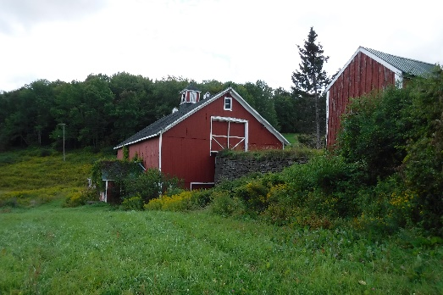 | 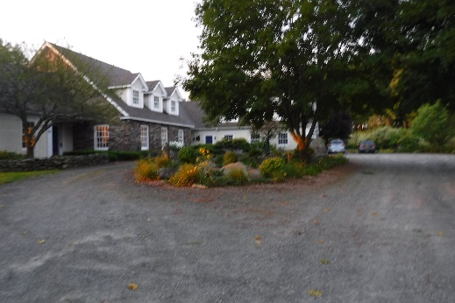 | 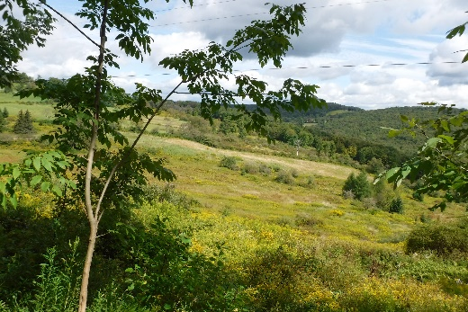

Erik Erbes  Matt Barkley  Aiden Murphy  Em Rodriguez  Annie Benson  Peter Huber  Ellie Sherman  Devin Reiss | Zac Babbit  Destiny Santos-Ferrer  Nathan Gourley  Shelby Woyciesjes  Lorella Lazaj  Lee Cornish  Jordan Card  Akosua Asabere

Edited by:
Diane Kuehn, Associate Professor

FOR 476/676 Ecotourism and Nature Tourism
SUNY College of Environmental Science and Forestry

March, 2020

TABLE OF CONTENTS
ACKNOWLEDGEMENTS 3
INTRODUCTION 4
THE UPLANDS CENTER SETTING 6
ASSESSMENT OF TUC AMENITIES & Facilities 8
TRAILS & ROADS ASSESSMENT 11
PROGRAMS, SERVICES, AND EVENTS ASSESSMENT 14
INTERPRETIVE ASSESSMENT 17
MARKET GROUPS ASSESSMENT 20
PROMOTION ASSESSMENT 23
TRANSPORTATION ASSESSMENT 26
ASSESSMENT FOR PARKS, ATTRACTIONS, & HISTORIC SITES 29
REGIONAL FESTIVALS AND EVENTS 32
WORKING WITH LOCAL BUSINESSES 35
LOCAL NON-FOR-PROFIT ASSESSMENT 39
WORKING WITH GOVERNMENT AGENCIES 43
EMERGENCY SERVICES AND VISITOR SAFTEY 47
ORGANIZATION STRUCTURE, STAFFING, AND MANAGEMENT 50
GRANTS AND FUNDING SOURCES ASSESSMENT 53
RECOMMENDATIONS 54
Overview & Priorities 54
Goal #1: Within five years, TUC will provide an environment that facilitates mental and emotional wellness and growth for all visitors. 57
Goal #2: Within five years, TUC’s buildings and trail system will be able to accommodate all ages and ability levels for community gatherings, events, and programs. 58
Goal #3: Within five years, TUC will have collaborative relationships in place with universities, schools, and organizations that encourage educational opportunities and research projects at the TUC property. 61
Goal #4: Within five years, TUC will offer seasonal environmental programs and activities that connect visitors to the natural world, illustrate the interrelation of all life, and demonstrate sustainable practices. 62
Goal #5: Within five years, TUC will meet the individual needs of staff and volunteers by fostering effective communications among staff, fair employment practices, and a safe work environment. 65
Goal #6: Within five years, TUC will have management strategies in place that promote and improve the health of the environment, while providing for human needs. 66

ACKNOWLEDGEMENTS

SUNY ESF’s FOR 476/676 Ecotourism and Nature Tourism class wishes to thank the many staff and volunteers from The Uplands Center (TUC) who made this report possible, and for making our visit to TUC so amazing!

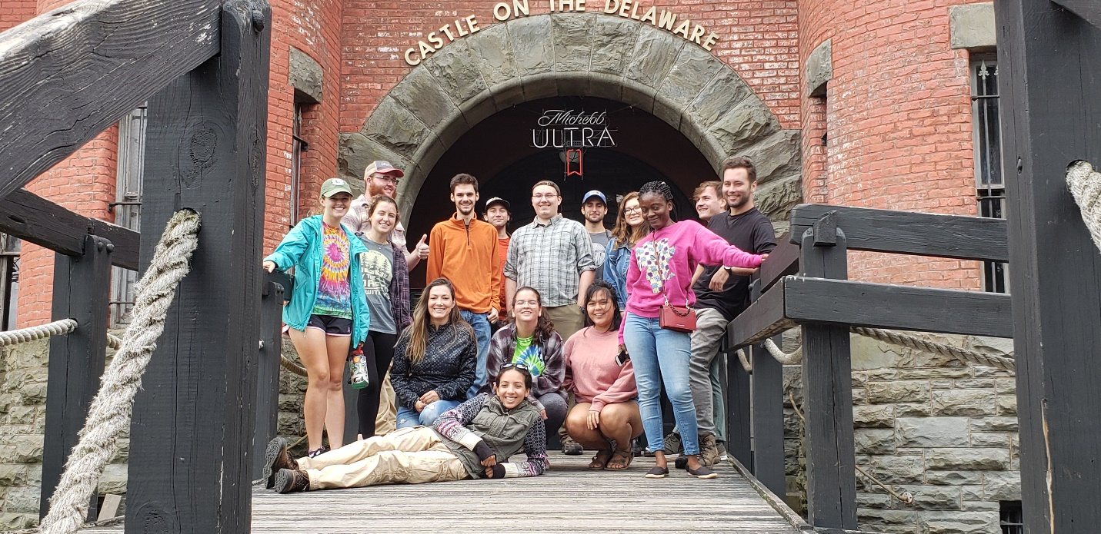
The FOR 476/676 class

INTRODUCTION

The Uplands Center is a retreat center for renewal, learning, and growth located in Walton, NY on the edge of the Catskill Mountains. The Center provides a wide range of opportunities such as spa amenities, yoga classes, workshops, restorative care, and outdoor recreation for a focused target group of “changemakers,” or people who help others, as well as local community members. The Center also offers its services for corporate retreats and private events.

This report was developed through the input of the staff and volunteers of TUC. A field trip for the class was conducted in September, 2019, to introduce the students in SUNY ESF’s Ecotourism and Nature Tourism class to the center. This field experience was followed by facilitated discussion sessions with TUC staff. Students also researched the information in this report through online sources and personal contact with agency and organization staff. The following report outlines the class’ findings.

Mission
The Uplands Center’s (TUC) mission is: 1) to provide a revitalizing experience for those who serve others, including first responders, health care providers, educators, and leaders of social service organizations that provide direct service to those in need, 2) to empower social change-makers by providing a dynamic setting for innovative program design, and 3) to offer opportunities for guests and community members to engage in educational and meaningful interactions with the natural environment and other guests at TUC. We seek to enhance personal and social well-being while inspiring care and respect for the natural environment (The Uplands Center: Environmental Vision, 2019).

Vision:
Within the next five years, we envision that TUC will:

- Be a place where individuals can pursue mental and emotional wellness and growth in a comfortable setting.

- Offer environmental education and recreational access for all experience levels, from novice to passionate enthusiast, encouraging life-long learning and awareness of natural systems.

- Host on-going, integrated research that supports the mission of TUC.

- Demonstrate sustainable and holistic practices related to consumer ethics, food system and land management, and healthy interactions with nature.

- Have a sufficient, professional staff and volunteer base that is well cared for.

- Be able to provide the facilities and setting for community gatherings, events, and programs.

Goals:
- Within five years, TUC will provide an environment that facilitates mental and emotional wellness and growth for all visitors.

- Within five years, TUC’s buildings and trail system will be able to accommodate all ages and ability levels for community gatherings, events, and programs.

- Within five years, TUC will have collaborative relationships in place with universities, schools, and organizations that encourage educational opportunities and research projects at the TUC property.

- Within five years, TUC will offer seasonal environmental programs and activities that connect visitors to the natural world, illustrate the interrelation of all life, and demonstrate sustainable practices.

- Within five years, TUC will meet the individual needs of staff and volunteers by fostering effective communications among staff, fair employment practices, and a safe work environment.

- Within five years, TUC will have management strategies in place that promote and improve the health of the environment, while providing for human needs.

Interpretive Theme:
By caring for the natural world, we can expand our awareness of nature, explore our connections to other life forms, and improve our health and well-being.

THE UPLANDS CENTER SETTING
Introduction
This chapter provides an analysis of The Uplands Center’s place in history, New York State, and the natural landscape, and provides suggestions as to how these factors may impact the Uplands’ functions and success.

Location
Located in the Town of Walton in Delaware County, The Uplands Center is near Walton, NY and other several small agricultural communities along New York State Route 10, the closest of these being the villages of Colchester and Hamden. Delaware County is situated in the Southern Tier region of New York and is separated from Pennsylvania by the Delaware River. The Uplands Center is settled in the foothills of the Catskill Mountains, a common destination for tourists from New York City. Marketing The Uplands Center as a “gateway to the Catskills” may prove to be a successful strategy in drawing in clientele who may otherwise not see Walton as a worthwhile destination.

History
The land on which the Uplands Center now stands has a long history of indigenous settlement, with the earliest traces of human habitation dating back to 10,500 BCE (The Uplands Center, 2019). Delaware County was the homeland of the Lenni-Lenape, an ancestral ethnic group which gave rise to numerous other tribal nations (Nanticoke Lenni-Lenape Tribal Nation, 2017). The remaining descendants of the Lenni-Lenape are currently represented by the Nanticoke Lenni-Lenape Tribal Nation.

Following the displacement of the Lenni-Lenape people and European colonization, the land of the Uplands Center fell under parcels 60 and 76 of the Peter Van Brugh Livingston Land Patent. The southernmost parcel was settled in 1808 by the family of Revolutionary War soldier and prisoner of war, Levi Hanford. The adjacent parcel was settled by Scottish immigrant Alexander Tweedy in 1849. Both families operated dairy farms on the property through the 19th and 20th centuries. The three historic barns on the property date back to these operations (The Uplands Center, 2019).

The joint-properties were purchased by philanthropists Arthur and Joann Rasmussen in the 1980s, who sought to preserve the land’s natural beauty and history. The main building of the Uplands was built by the Rasmussens in 1990, where they lived out their days. Upon their passing, the Uplands property and their remaining estate was donated to form The Uplands Foundation, a 501(c)(3) not-for-profit organization and primary funder of The Uplands Center (The Uplands Center, 2019).

Infrastructure
The property of The Uplands Center includes several historic and modern structures of varying uses. The house built by the Rasmussen’s in 1990 serves as the Uplands’ primary hub and includes staff and guest housing, wellness and recreational facilities, kitchen and dining areas, storage, and other multipurpose spaces. The Tweedy House, which served as the home of the Tweedy family, is used exclusively for guest housing. Down the road from the Tweedy House is a newly constructed house used specifically for staff housing. There are three historic barns on TUC property which date back to the Tweedy and Hanford family dairy farm operations. The Tweedy Barn is a three-story banked barn constructed in 1910, located adjacent to the Tweedy House; this barn will require extensive renovation to make it useable. Further down the road are two other barns referred to as the Banked Barn and the Two-story Barn. The first has similar attributes as the Tweedy Barn, having been used primarily as a dairy barn. The Two-Story barn was used as an animal barn, with the second story used for hay storage (The Uplands Center, 2019).

The mix of historic and newly-constructed buildings on the property provide both positives and negatives for The Uplands Center. The large distances between buildings provide abundant scenic views of the surrounding countryside. However, the fact that the buildings used for staff and guest housing are located so far from the main building provides a challenge for staff who may not have a personal vehicle. Additionally, large overnight groups may have to be split between the Tweedy House and the main building. While this may be inconvenient for large adult groups, for school groups this may pose a safety and liability risk. Another set of advantages and disadvantages stem from the historic nature of the Tweedy House and the three Barns. While these structure give the center a rustic charm, and provide many resources and opportunities for educational programming about the history of the property, they will require frequent repairs and maintenance as they continue to age. In addition, guests with mobility issues may find these structures unaccommodating.

Natural Resources
Sprawling across 280 acres, The Uplands Center property encompasses a diverse array of ecosystems and habitats that demonstrate a wide range of human impact and management. Mixed deciduous forests, natural and managed meadows, streams, former and current agricultural land, and cultivated landscapes support a variety of native and introduced flora and fauna (Johnston, 2019). The diversity of habitats and topography on the property provide abundant resources for environmental education programming and scenery for guests along the Upland’s hiking and walking trails.

Summary
The Uplands Center has at its disposal a wide array of natural and historical resources to draw from in terms of attracting visitors and designing educational programming. The rich history of the property, as well as its diverse topography, habitats, and species, provide The Uplands Center with a wealth of assets around which educational programming can be designed and conducted. However, in regard to the property’s historic structures and their placement, several issues may arise. These include accessibility barriers for staff and guests with mobility issues, possible separation of large overnight groups between housing facilities, and the required maintenance of the Center’s historic barns.

ASSESSMENT OF TUC AMENITIES & Facilities

Introduction
The Uplands Center is a multipurpose property which provides a place for people to get away, relax, and rejuvenate. The amenities available play a pivotal role in how visitors think about and remember their experience at The Uplands Center. The reliability, effectiveness, and cleanliness of the amenities are important to visitor experiences. TUC amenities and facilities discussed in this chapter include the buildings, rooms, and spaces that visitors will use during their stay at The Uplands Center.

Main house
Overall the main house is beautifully presented and organized. The main house provides a beautiful central location for the guests at The Uplands Center to relax. The main house is a little tight at times leading to some congestion near the entrance and in hallways, depending on the number of guests present. The waste system is well organized with trash, recycling, and compost bins that are well labeled. Some minor issues regarding lighting and accessibility are present. The following are amenities and spaces located at the main house.

Kitchen. The kitchen is in the middle of the house, and is small but well organized. The staff chef utilizes vegetables that are homegrown or bought locally, and provides meals for visitors that accommodate dietary restrictions or choices. The food is fantastic and creates a personal connection with the land through a farm-to-table cooking approach. Disposable dishware is not used, reducing the amount of waste produced, and composting of leftovers in highly encouraged.

Spa area. The spa area features three different aspects; a sauna, hot-tub and a lap swimming pool and the area is staffed when anyone is utilizing these amenities. The sauna can fit five people but four comfortably. It has a radio and controls for the sauna inside. The metal on the back was exposed due to backrests that are not secure, resulting in a burn hazard for visitors. The hot-tub is a decent size, allowing multiple people to sit in and enjoy it. Draining for the room appears sufficient. The lap pool is lacking signs relating to safety. The pool has different entrances allowing for different mobility types to enter comfortably. The dog was allowed in the pool resulting in some dog hair present which could be a problem. Overall the room is beautifully placed and is enclosed in glass with lots of natural light. This is a very nice space for the amenities here.

Yoga studio. The yoga studio is a where yoga lessons and meditation classes are held (if indoors). The Uplands Center has a certified yoga instructor. The studio has a lot of natural light, adding to the aesthetics of a meditative state. TUC provides blocks, mats, and other items for guests who may need them. The stairs leading to the studio are narrow, and accessibility is a concern. The space is limited in size but The Uplands Center plans to enlarge and improve this space.

Conference/dining room. The conference room and dining room is where groups can sit and talk. Seating is limited and may need to be expanded. The space allows for meals to be served buffet style. More space or seats may be needed to avoid congestion during meal time, or if accommodating a business meeting. Overall, the room appears professional and clean, and is a good gathering place.

Library. Currently the library is utilized as an office space. Security cameras are present. The space also has books and other items to view. It can be used as a relaxation space or for more personal conversations.

Living room. The living room provides a comfortable setting to relax and hear storytelling. The space is large enough for groups. This room adds to the relaxing and welcoming atmosphere of the main house. There appears to be plenty of seating available.

Back patio. The back patio has different areas of seating, including couches and benches. Yard games are also available. This is a nice place to eat food, relax, or just view the landscape. There is also a hammock to use, as well as a hanging chair.

Showers and bathroom. The showers and bathroom are located next to the spa and pool area. They include individual showers and a bathroom; another bathroom is located in the hallway of the main floor of the house. The showers are very nice, giving privacy to visitors. A hair drier and straightener is available for visitor use. The bathroom is a little small, and may be difficult for those with mobility issues to use. Everything worked and is clean.

Down the hall from the bathroom, washers and driers are available for clothes. This amenity is very convenient for visitors who have used the spa facilities and is an amenity guests will notice.

Bedrooms. The bedrooms for guests are located upstairs. The themed bedrooms have multiple beds in most of the rooms. The bedrooms allow for comfortable sleeping without leaving the main house.

Garden
The garden is an enclosed space just near the main house. The garden is maintained well, and effective agricultural techniques are implemented. Chickens are present. TUC implements a farm-to-table growing and cooking approach. The garden is also used for educational purposes to teach visitors about gardening. The food they grow is used for cooking and the rest is sold at a local farmers’ market. The area is surrounded by a live electric wire, creating a possible safety concern.

Pasture
The pasture is a field located near the garden and main house. Events can be held in this space, and it has been used for horse riding. The area is enclosed by a wooden fence.

Vista cabin
The vista cabin is a one-room building located about a 5-10 minute walk from the main house. This building has a beautiful view of the valley. The small space has a sliding door and small deck area. A light source is provided for night time. The nearest bathroom and source of water is at the main house. The vista cabin can accommodate a relatively small group of 4 visitors comfortably.

Tweedy House
The Tweedy house is a farmhouse located by the main road of the property. This building provides lodging for groups, as well as a kitchen, living room, dining room, double bathroom, and multiple themed bedrooms upstairs and on the first floor. This space is perfect for families and groups allowing for a more private stay away from the main house. Transportation to and from the main house could prove difficult for some.

Barns
Three barns are found on the property. All will require restoration and maintenance to turn them into useable space. The barns would be a great place to host events, due to their ample size.

Intern/staff housing
The intern house is located on the other side of the main road and is a shared space for staff. The building is very nice, and gives interns a private place to live that is away from the main house.

Driveway
The driveway really fits the farm feel, as it is composed of stone and dirt. The driveway is in rough shape and has many ruts and potholes, possibly providing difficulty for transport for visitors. The driveway is long and theoretically has plenty of room for cars to park near the house.

Summary
The amenities at The Uplands Center are, all-in-all, superb. With the expansion and growth planned, many concerns about the amenities will become less apparent. Restoration of the barns will provide indoor space for various events and youth-group activities. The amenities will effectively provide the relaxing and healing atmosphere that The Uplands Center requires.

TRAILS & ROADS ASSESSMENT

Introduction
In this section, all trails, roads, and pathways were recorded and assessed. Although several trails and roads have yet to be built, this section considers all proposed trails and roads to be viable for construction and reviews them as if they have been fully implemented. Table 1 outlines roads and pathways between areas on the site. Table 2 details the one flagged trail on TUC and the proposed trail on the east side of the property.

Roads
The main road (Dunk Hill Road) that provides access to TUC runs north to south through the middle of the property, effectively dividing it into two distinct areas of use. This is the only fully paved road on the property. The other vital access road is the gravel driveway that leads from the main road to the farmhouse, barn, parking area, and main building. Trail 1 intersects an old gravel road that it follows for a brief while until it reenters the woods and loops back to the Main House. This old road is an awkward disruption from the trail, as it is not marked, and directions for continuing on the trail rom this road are unclear.

Trails
One trail is currently flagged on TUC property (see Figure 1, trail 1), and one other trail has been planned and is currently being charted (Figure 1, trail 2). Portions of Trail 2 exist but are overgrown. Trail 3 is the only trail that has been completed.

Trail 1. Trail 1 is designed primarily to allow retreat center visitors to enjoy a hike near the main house that allows them to hike at their own pace while admiring local flora and fauna. This trail will likely incorporate both personal and non-personal interpretation methods (e.g., guided tours and interpretive signs/brochures, respectively). Trail 1 has issues related to elevation, with several steep pitch-grades not mediated by switchbacks. The two intersections of Trail 1 with the Old Road on the west side of the TUC property is not viable in its current state since it will cause visitor confusion, and will require directional signage to make it fully operational.

Trail 2. Trail 2 is designed for general use by the public, primarily through interpretive guide-led tours along the stream and forest fringe of the eastern half of the property. This trail will be a challenging trail for visitors to hike due to elevation changes, and will not be fully accessible by all members of the public. The trail, which has yet to be mapped completely, will begin and end near the staff housing area. A trailhead parking area will be needed here to accommodate visitors’ vehicles. Trail 2 contains several hazards left by previous land users including barbed wire, as well as natural hazards such as steep drop-offs and difficult rocky terrain. On the south side of the property, the trail hooks up with an old farm road that is overgrown and loops back to the staff housing. Safety measures such as hazard signs are required if the trail is constructed along its currently planned route.

Trail 3. Trail 3 is an existing mowed trail that connects the Main House to the Vista Shed area. This trail is maintained in excellent condition. This trail could provide emergency access to the back of the property if needed.

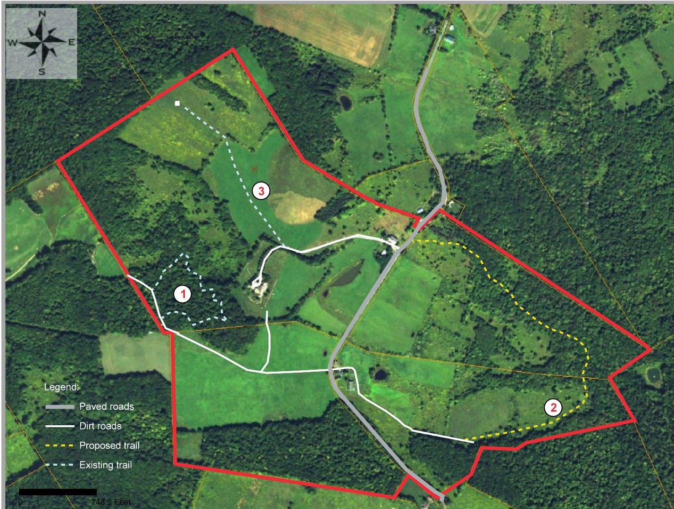
Fig. 1. The various trails and roads either in place or planned for TUC (source of base map: J. Johnston, The Uplands Center, 2019).

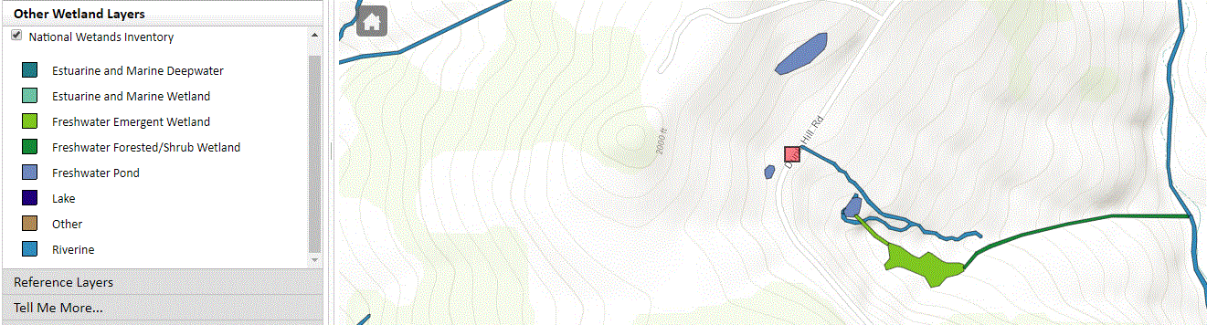

Fig. 2. Wetland and stream map for TUC (downloaded from Environmental Resource Mapper, NYS DEC, 2020).

Table 1. Dirt and paved roads.

Road | Relative Location | Construction Status | Relative Length | Purpose of Road
Dunk Hill Road | Runs north/south through middle of property | Paved, one lane each way | Long | Transportation to and from TUC; only fully accessible way to reach TUC
Driveway | Connects Dunk Hill Road to the main house | Gravel | Medium | Main access to TUC base of operations
Solar Field service road | Begins at Staff Housing, leads to Main Building | Somewhat mowed, not developed | Short | Shortcut from staff housing to main building, not intended for visitors
Old Road | Intersects with Trail 1 on west side of property | Gravel | Very Short | Connect two sections of Trail 1
Staff housing road | Dirt road behind staff housing | Packed dirt, overgrown | Short | Connects staff housing to Trail 2

Table 2. Hiking trails.

Trail # | Relative Location | Construction Status | Relative Length | Difficulty | Intended Audience
Trail 1 | North-West property | Flagged; to be completed spring 2020 | Medium | Medium | TUC retreat center participants
Trail 2 | East property | Proposed, investigated | Long | High | General public
Trail 3 | East property | Completed | Short | Easy | TUC retreat center participants

Summary
While the roads of TUC are generally in good condition, consistent inspection and maintenance will be continually required in the future. The path to the vista shed requires occasional mowing. Most roads and pathways are currently operational for small-scale tourism but will require further development, particularly along the main road and east of the main road where public use is expected. Trail 1 is flagged but not developed, Trail 2 is yet to be flagged, and Trail 3 is complete. Trails 1 and 2 contain issues regarding safety and difficulty but have significant potential for environmental interpretation; Trail 3 will be used for those needing access to the Vista Shed area. This assessment finds that while there is potential throughout TUC for recreation and accessibility, the trails are currently not yet ready for use by target groups such as school groups. As there is a substantial amount of work yet to be done, an organized timeline outlining all future trail development efforts is suggested.

PROGRAMS, SERVICES, AND EVENTS ASSESSMENT

Introduction
The programs, services, and events that currently exist at the Uplands Center were assessed. Table 1 has information on the retreats that have been held at TUC. This includes the name of the Group that used the center, the dates which they stayed, and a summary of the events that occurred in each retreat broken down by whether they were structured and unstructured events. Table 2 lays the Group’s mission, their goals for the retreat, and the outcomes of the retreat next to each other to examine if they have achieved their goals and if it was related to their mission. Table 3 has information on the single-day events that have been held at TUC. This includes the event name, the date or dates it occurred on, the activities that were part of the event, and information on the number and type of visitors (if available.)

Table 1. Retreat information.

Group Name | Dates | Structured Events | Unstructured Events
Iris Kaplan Center | 6/8 – 6/9 | None | -Walk through grounds  -Use of Spa  -Communal meals  -Yoga room use
NJ LEEP | 6/13 - 6/14 | -Strategic Planning  -Break-out sessions  -Program Design Brainstorming  -Guided hiking  -Self-regulation techniques education | None
She Wins! | 6/15 – 6/16, 9/20-9/22, 10/6 | -Discussions  -Art activities  -Guided Nature Walks | -Walk through grounds  -Use of Spa
Imagine | 7/27 – 7/28 | -Discussions  -Self-care sessions  -Mindfulness Activities  -Guided Nature Walks  -Journaling | -Walk through grounds  -Use of Spa
NCST Hospital Team | 8/9 – 8/11 | -“Speed Dating” exercise  -Self-care education  -Self-regulation exercise | -Walk through grounds  -Use of Spa

Table 2. Outcomes of retreats.

Group Mission | Goals of Retreat | Outcomes of Retreat
Iris Kaplan Center: “facilitate the facilitator” by supporting those who guide others. | -Take time together to bond and talk. | -Attendees left feeling more connected to and bonded to one another.
NJ LEEP: empower middle and high school students with both the academic and socio-emotional skills to succeed in college and beyond. | -Have program design brainstorming sessions to plan how to empower students. | -Learned self-regulation techniques for themselves, which can be shared with their students.
She Wins: leadership and social action organization for middle and high school girls in Newark NJ, primarily those that have been affected by inner city violence. | Retreats #1 and #2:  -youth leadership building.  Retreat #3:  -youth planning board with senior scholars to discuss gaps in current program offerings. | Retreats #1 and #2:  -Fostered peer leader’s ability to communicate effectively.  -Learned to navigate conflict.  -Learned to set goals and steer the organization towards goals.  Retreat #3:  -Laid down plans for concrete program offering expansion.
Imagine: A center for coping with loss, provides free and year-round grief support for families, children, and communities. | -Connect employees to self-care methods.  -Discuss setting boundaries around what their needs are, saying no, asking for help, and prioritizing their needs more often. | -Succeeded in all goals.  -Group commented that they appreciated the value of loving and caring for themselves and supporting each other.
NCST Hospital Team: Focused on reducing violence in Newark City. The hospital team engages in violence intervention by sending outreach workers to the hospital bedside of victims of violence. | -Repair the strained relationships between two groups within the hospital team.  -Learn self-care  -Pay attention to vicarious and personally suffered trauma that gets activated while working with trauma daily in Newark.  -Team building.  -Planning better team cohesiveness and processing during meetings to avert tensions. | -Succeeded in all goals.  -Group commented that their visit was inspiring and emotionally cathartic. Noted that bonding and new friendships in a beautiful location was enlightening and humbling.

Table 3. Local Day Events.

Event Name | Date | Activities | Attendance
Community gathering | 6/30 | -Introduction to The Upland Center’s Mission and Staff  -Tours of the grounds  -Brainstorm sessions on how TUC can best serve the community | 35 guests from the Walton community and local agencies and organizations
Walton Art Walk | 7/25 | -Note that the West Branch Artists sought a venue to gather after the Art Walk itself  -Tours of the grounds  -Strategy meeting, discussion, and planning for next year  -Use of spa  -Nature walk  -Meditation | A group from West Branch Artists, unknown number
Catskills Hospice strategy meeting | 9/5 | -Meeting to strategize shift in Branding.  -Tour through gardens. | 12 team members from Helios Care
Rehab Support Services | 9/12 and 9/24 | -Tour of the grounds  -Produce picking in the garden  -Meeting to discuss nature of their work  -Choice to use Spa, play games, or walk around property  -Nature walk  -Meditation | 12 team members for the 1st date, 11 team members for the 2nd date
Mandala Workshop | 9/14 | -Tour of the grounds  -Introduction to TUC’s Mission  -Art Workshop (mandala creation) | 14 individuals registered (most from Walton, some from as far as Binghamton)
West Kortright Barn Tour | 9/29 | -Both Barns toured | Over 100 people
Advisor Day | 10/4 and 10/8 | -Rotation of students through 5 team-building exercises | 6th and 7 th grade classes from Walton Middle School
Master Forest Owners | 10/28 | -Discussion of updates and ongoing collaborations with natural resource agencies  -Skills practice in assessing land use history, forest health, and economic viability | 8 MFO volunteers

Summary
To date, the Uplands Center has had a total of 7 retreats and 10 special daytime events, not counting the weekly yoga sessions that Renee leads. The average length of a retreat is 2.1 days. The goals of these retreats have generally been met in outcomes, and participants have reported a sense of wellbeing after a retreat—which aligns with the 1st vision statement of TUC, “Be a place where individuals can pursue mental and emotional wellness and growth in a comfortable setting.” The Uplands Center has also successfully held one meeting with the local community to discuss how it can “Be able to provide the facilities and setting for community gatherings, events, and programs” and accomplish its sixth vision element for the future of TUC. There are currently no services for individuals, as all services so far have focused on groups.

INTERPRETIVE ASSESSMENT

Introduction
Interpretive materials include items such as brochures, signage, guidebooks and other educational texts. At this point there are no interpretive materials implemented on-site at the Uplands Center or online on the center’s website. The website consists of text that advertises the center’s property, natural setting, and possible programs. No interpretive signage, information, or brochures were available on site or online. TUC staff currently provide groups tours upon request. This chapter provides an overview of existing interpretation at TUC and gives examples of interpretive efforts at other retreat centers.

Overview of TUC interpretation
The Uplands Center property includes amenities such as a vast produce garden, vista shed, spa, yoga studio, art studio, nature trail, and barn. No interpretive materials or tangible information is currently accessible to facility visitors, though TUC staff are readily available to provide personal interpretation, group tours, and to answer visitors’ questions.

Organic produce garden. The Upland’s Center garden is unique in that it involves the nearby community. Leftover crops are donated to the local food pantry. Foods harvested from the garden are also used in the kitchen for guest meals. The center emphasizes holistic, organic food. Information about the garden is currently verbally communicated by TUC staff. No tangible information sources (e.g., signs, brochures) are currently available at TUC regarding the Center’s produce garden. A sign describing TUC’s dedication to ethical and ecologically-responsible gardening methods was not present. The individual crops inside the garden are verbally described and identified by TUC staff; no produce labels are present.

The Upland Center website states the importance of implementing responsibly grown local grown produce in each meal. The Sharing Knowledge page of TUC’s website touches on important environmentally responsible agricultural practices. It states that the center encourages discussion on community gardening, organic pest control, fertilizer use, and drip irrigation. These techniques and practices are not further described. The information found is not implemented in a way that connects readers to the topic or center through further explanation. No interpretive materials are used in relation to the garden. Provided information does not have enough description to encourage participation and engagement in responsible agriculture.

A similar retreat center, the Tamarack Adventure and Retreat Center in Michigan, provides educational resources for facility visitors, a portion of which are related to the property’s farm (i.e., Farber Farm). The Center includes relevant interpretive text on the center’s website as well as within the property itself. Farber Farm runs programs catered towards school groups, personal retreats, corporate retreats and camps (About- Tamarack Adventure & Retreat Center, 2019). All crops are physically labeled within the garden. A web site is dedicated to the farm and provides information on the environmentally-responsible farming and gardening practices used on site, allowing potential visitors to get a better understanding of the purpose of the facility and what to expect during a visit. The website text describes farming practices used on-site such as the seasonal rotation of crops, which ensures that soils are replenished with nutrients. Examples of plants are included on the website as well. The farm webpage is considered to be interpretive because it provides readers with brief, engaging information that explains techniques used for responsible garden management (e.g., the rotation of garden crops such as broccoli and kale due to aggressive nutrient absorption; the importance of beans for rotation due to their nitrogen-fixing properties). This information connects website viewers to the site and its mission while communicating relevant information. The center’s webpage is a great example of online interpretation.

Vista Shed Information. Mountain views from the shed were beautiful and calming; however, these landscapes were not identified on any interpretive materials. There were no signs or brochures outlining the purpose, location, or surroundings of the vista shed on property. The center provided no interpretive materials regarding the vista shed, its setting or nearby wildlife or vegetation.

Yoga and meditation studio. The benefits of yoga and meditation practices were verbally communicated and participation was encouraged by TUC staff. No information regarding physical or mental health benefits was provided on program fliers, brochures, advertisements, or on the center’s website. No signage with educational or interpretive text was present in the yoga studio.

Nature trail. The nature trail weaves through beautiful scenery, potential wildlife habitats and vegetation. There were no physical interpretive materials present along the nature trail (e.g., interpretive signs) to describe these elements. There also are no materials about the nature trial in general and its surrounding environment (e.g., brochures). Native versus non-native plants are not identified. Local wildlife, bird, or tree species are not indicated or referenced in any interpretive materials. Current interpretation of the nature trail is implemented in-person by TUC staff who are extremely knowledgeable and helpful.

Although the Uplands Center has just one trail within the property, there is one intersection with an old road which could easily lead visitors in the wrong direction. This intersection is not labeled or marked. There are no interpretive materials that show this intersection, which is a concern as the intersection border’s private property. Without clear marking, visitors could easily find themselves lost in the woods or wandering onto the neighbor’s property.

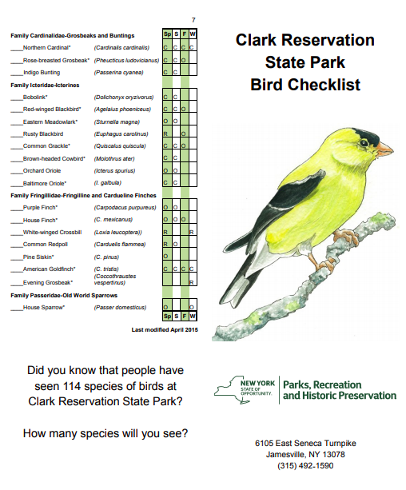
An example of trail-side interpretation is available in Clark Reservation State Park in Jamesville, NY. Trails within Clark Reservation are interpreted through both brochures and wayside exhibits. Several locations along its walking trails include wayside exhibits. For instance, the Park’s Mildred Faust Trail is home to a dry lake. A colorful, wayside exhibit is posted adjacent to the lake. Information includes the history of the site as well as ecological principles of dry lakes. This strategic location allows visitors to interact with the site, and gain relevant, experiential knowledge regarding this specific habitat.

The state park also provides interpretive materials via the park’s website and nature center. These materials include a local bird watching checklist (Figure 1). This type of information allows visitors to anticipate and prepare for their experience within the park. The checklist can be printed or downloaded to a mobile device; visitors are then encouraged to watch for specific bird species. This technique helps visitors to develop bird identification skills while in the field, and to form connections with the environment.

Figure 1. Bird identification checklist for Clark Reservation (Bird Checklist, 2015).

In addition, Clark Reservation nature trails implement navigational markings which help direct visitors along designated paths. Each trail is lined with blazes of different colors. These markers help guests to identify their location within the park. Trail and park maps are provided with each trail clearly marked. Trail intersections are somewhat frequent in the park, so all are clearly marked with trail names and arrows (Figure 2). This type of information allows guests to feel safe and comfortable while exploring the wooded property.

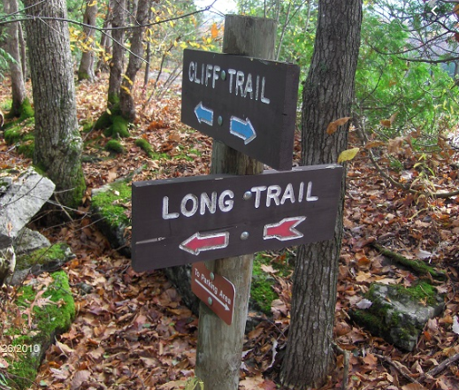
Figure 2. Directional signs at the intersection of Long Trail and Cliff Trail within Clark Reservation State Park. An arrow also points to the direction of the nearby parking area (Clark Reservation State Park, 2019).

Summary
The Uplands Center is home to many beautiful landscapes, wildlife, and vegetation. Visitors have the option to experience the yoga studio, nature trail, organic garden, and vista shed. No interpretive materials are given to guests, found on-site, or provided online. There are no trail markers or wayside exhibits along the nature trail. There is no displayed or provided information regarding meditation and yoga, or the studio itself. There are no materials describing the produce garden or environmentally responsible agricultural practices. Although interpretive materials are yet to be developed, TUC staff do provide excellent on-site tours. In addition, the lack of other interpretive elements provides opportunities for engaging local universities and schools in expanding the interpretation efforts at TUC.

MARKET GROUPS ASSESSMENT

Introduction
Knowing the people that the TUC wishes to market its goods and services to is crucial to crafting and implementing its message to the public. Using demographic data from a variety of stakeholder groups, The Upland Center will be able to identify groups of people that will benefit from the goods and services it provides. This assessment includes demographic data from three stakeholder groups: Delaware County, the village of Walton, NY, and the Walton Central School District. An analysis of service occupations in Walton, NY and Delaware County, NY is also included.

Delaware County demographics data
Delaware County is located in the Catskill Mountains area of New York State. The population is estimated to be about 44,527 as of July 1, 2018, which is a decrease of 7.2% since the 2010 Census. The population is estimated to be 50.5% male and 49.5% female. 16.5% of the population is estimated to be under the age of 18, and 24.5% of the population is estimated to be over the age of 65 (which is significantly high). The median age of residents is estimated to be 48.3 years, which is significantly higher than the national average of 38.1. There are an estimated 2,423 veterans in Delaware County, which has decreased by about 17.5% since 2013. Over 96% of Delaware County residents identify as white, 3.5% of residents identify as Hispanic/Latino, and 0.2% of residents identify as another race. The median household income of Delaware County residents is $47,921. The home ownership rate is 73.3%. The average property value in the county is $138,000. About 16% of Delaware County residents live in poverty.

Walton, NY demographics data
Walton, NY is located in Delaware County, and is the closest village to The Uplands Center. The population is estimated to be 2,947 residents (6% of the Delaware County population). No gender data were available for the village. There is estimated to be 151 veterans in Walton. The median age of Walton residents is 36, which is fairly consistent with the national average of 38. 31% of the Walton population is under the age of 18 (which is significantly high), while 19% of the population of Walton is age 65 or over. With regard to race, 94.4% of the population of Walton identifies as white, 5% identifies as Hispanic/Latino, 0.6% identifies as another race. The median household income in Walton is $30,907. The homeownership rate in Walton is 54%. The average property value is $96,200. Approximately one-third of Walton’s residents are estimated to live in poverty. The median household income, the homeownership rate, and average property value in Walton are significantly lower than in Delaware County. In general, the population of Walton is more impoverished than the population of Delaware County as a whole (US Census Bureau, 2019; “Data USA,” n.d.).

Walton Central School District
Employees at the Upland Center expressed an interest in meeting the needs of the Walton Central School District. The district is geographically large; TUC’s current efforts in the district are reaching a large geographic area. The Walton Central School District educates 922 students; 433 elementary students, 208 middle school students, and 271 high school students. The gender ratio is about 1:1. Over 95% of the students are white. According to the New York State (NYS) Department of Education, 35% of students in grades 3-8 are proficient in English Language Arts as measured through the Regents system (lower than the NYS average of 45%); 21% of students in grades 3-8 are proficient in Mathematics as measured through the Regents system (lower than the NYS average of 47%). As of the 2017-18 school year, 89% of Walton students graduate high school in 4 years, and 25% of Walton High School students are chronically absent from school. About 14% of those living in poverty in Walton, NY are under age 18, while 5% of those living in poverty in Delaware County are under age 18 (“WALTON CSD | NYSED Data Site,” n.d.) (“Walton High School Walton, NY School Boundaries Map & School Profile,” n.d.).

Table 1. Basic 2018 demographic data for Delaware County, NY and Walton, NY based on estimates (US Census Bureau, 2019; “Data USA,” n.d.).

Data Point | Walton, NY |  | Delaware County (DC), NY
 | Number | % Growth | Number | % Growth
Total population | 2,947  (6% of DC) | n/a | 44,527 | -7.2% (2010)
Gender ratio | n/a | n/a | ~1:1 | n/a
Number of veterans | 151 | 14.4% (2013) | 2,423 | -17.5% (2013)
Median Age  (38.1 in USA) | 35.8 | n/a | 48.3 | n/a
% pop. 65+ | 19% | n/a | 24.5% | n/a
% pop. under 18 | 31% | n/a | 16.5% | n/a
% pop. White | 94% | n/a | 96.3% | n/a
% pop. Hispanic/Latino | 5% | n/a | 3.5% | n/a
% pop. other races | <1% | n/a | 0.2% | n/a
Median household income | $30,907 | n/a | $47,921 | 7.7% (2013)
Homeownership rate | 53.8% | n/a | 73.3% | n/a
Average property value | $96,200 | 9.2% (2013) | $138,000 | 3.6% (2013)
% population in poverty | 31.3% | n/a | 16.5% | n/a

Service occupations in Delaware County and Walton, NY
Part of The Upland Center’s mission is “to provide revitalizing care to those who serve others, including first responders, health care providers, educators, and leaders of social service organizations that provide direct service to those in need” (The Upland Center Staff, n.d.). In order to focus on this mission, it is important to assess the market of those in service occupations in Delaware County. Service occupations are defined by Data USA as any food preparation & serving related job, law enforcement workers including supervisors, personal care & service occupations, building & grounds cleaning & maintenance occupations, and firefighting & prevention & other protective service workers including supervisors. Educators were not included in Data USA’s service occupations analysis. In Walton, NY, 21% of all occupations are labeled as service occupations, which has decreased by 52% since 2013. Education, training, & library occupations make up 6% of the workforce in Walton, NY, which has increased 144% since 2013. In Delaware County, NY, 20% of all occupations are labeled as service occupations, which has decreased by over 6% since 2013. Education, training, & library occupations make up 7% of the workforce in Delaware County, NY, which has increased by over 15% since 2013.

Table 2. Percentage of service occupation jobs and percent growth since 2013 in Walton, NY, and Delaware County, NY. All percentages are compared to the overall job occupation in the specified area.

Occupation | Walton, NY |  | Delaware County, NY
 | Occupation % (overall) | % growth (2013) | Occupation % (overall) | % growth (2013)
Service Occupations (general) | 20.9% | -51.6% | 20.3% | -6.5%
Food Preparation & Serving Related Occupations | 12.2% | -15.1% | 6.21% | -4.2%
Law Enforcement Workers/Supervisors | 3.53% | -33.3% | 1.69% | -17.2%
Personal Care & Service | 3.11% | -71.2% | 3.66% | -15.1%
Building & Grounds Cleaning & Maintenance | 1.97% | 82.2% | 5.79% | 5.6%
Fire Fighting & Prevention & Other Protective Service Workers/Supervisors | n/a | n/a | 0.7% | 49.4%
Education, Training, & Library | 6.33% | 144% | 7.48% | 15.5%

Summary
The general population of Walton, NY is average-aged and identifies as white. The general population of Delaware County is relatively similar, with the exception of the median age of Delaware County being significantly older. Walton, NY has a significantly larger population of those in poverty than in Delaware County, which could influence factors such as low homeownership rate and average property value. The large geographic size of the Walton Central School District lends itself to catering to non-formal education efforts to families from a large geographic area through the schools. There is a significant percentage of service occupations in Walton and Delaware County, NY, and a large number of veterans.

PROMOTION ASSESSMENT

Introduction
As a newly established not-for-profit organization in the rural town of Walton, The Uplands Center is seeking to increase the awareness of the local community about its programs and to increase visitation by both local residents and visitors outside of the area. Although the Center does not have many promotional materials available at this stage of development, the destination and visitor experiences curated by the site is unique. With the proper promotional materials, the Uplands Center should be able to increase recognition and visitation to the site from its targeted groups of retreat participants and changemakers, and the local community. This assessment examines the promotional materials that exist for the Uplands Center and Delaware County.

Information available on site and in Walton, NY
The promotional information available at the Uplands Center is limited currently. There is one map of the site located in the main building. There is one flyer available in the local community located at the William B. Ogden Free Library in the town of Walton that advertised yoga classes at the Center. The flyer provides an email address for the visitor to contact the Center for more information on yoga classes and other wellness and community events. The flyer does not provide a physical address for the Center.

Information available online
The online presence that currently exists for the Center is by far the most developed promotional item. The newly built website is easy to navigate since it states the TUC’s mission, exactly what they do, information about who they are, amenities on site, how to plan a retreat, and how to contact them. The most crucial piece of information that the website provides is the intention to cater to its focused target group of changemakers and members of the local community. The website also has a blog with three posts written by the employees which does not appear to be open to visitor posts. The gallery on the website accurately represents the site along with the other photos provided with the exception of some stock photos in rooms that do not exist at the Uplands Center. The website lists an option to provide an email address in order to receive an E-newsletter.

The Uplands Center currently has an E-newsletter and updates its Facebook page and blog. The Center has an active Facebook presence with thirty followers that lists their website, location, and contact information through Facebook messenger. The staff post on the page at least once every week and posts have less than or equal to twenty likes. Following a thorough search of the internet, it was found that the Uplands Center has one google review, some job listings for staff on Linkedin, and photos on Instagram marked with the Uplands Center’s location. The Uplands Center is also listed on Google Maps, but the exact location of the driveway is incorrect and misleads visitors (including the members of the FOR 476 class).

Information not available on site
The Uplands Center lacks informational brochures. Signage leading to the site on the rural backroads is nonexistent which makes it difficult to find the entrance to the Center. The trails lack proper signage for directional and interpretive purposes. The Center is not listed in the business directory of the Delaware County Chamber of Commerce or the Walton Chamber of Commerce. It is not listed on the Catskills regional website for the New York State Tourism “I Love NY” program. The center is lacking social media accounts (other than their Facebook page) such as Instagram, Snapchat, Twitter, or Youtube. The Center is also lacking an updated event calendar on its website and Facebook account. There is currently a general lack of promotional materials and advertisements available for the site.

Promotional materials for wellness centers in Delaware County
Table 1 provides an overview of the various forms of promotional materials available for the Uplands Center as well as other wellness centers located in Delaware County. The other wellness centers were found through the official tourism promotion agency for Delaware County, and the Great Western Catskills tourism website which is linked with the “I Love NY” tourism program. The Uplands Center currently has an updated website and Facebook page. They do not have a brochure for the site nor are they listed in the “I Love NY” program or the Delaware County Chamber of Commerce. All of the other wellness centers in Delaware County have a website, some easier to navigate than others, and they are all listed in the “I Love NY” program under the Great Western Catskills website. All of the sites had at least a Facebook page for social media except for the Rippling Waters Retreat center which solely relied on its website for an online presence. Rippling Waters Retreat and Harmony Hill Lodging and Retreat Center were the only two wellness centers that had a brochure. Out of all of these wellness centers, only the Harmony Hill Lodging and Retreat Center is listed in the business directory for the Delaware County Chamber of Commerce — surprising since all of the wellness centers are listed on the Great Western Catskills website which is directly linked to the Chamber’s website.

Table 1. Promotional materials for wellness centers in Delaware County.

Organization | Has Website? | Present on Facebook/ Social Media? | Has brochure? | Listed in Tourism Promotion Guidebooks? | Listed by Delaware County Chamber of Commerce?
Uplands Center | Yes | Yes | No | No | No
Spillian | Yes | Yes | Yes | Yes | No
Rippling Waters Retreat | Yes | No | No | Yes | No
Harmony Hill Lodging and Retreat Center | Yes | Yes | Yes | Yes | Yes
Blue Deer Center | Yes | Yes | No | Yes | No
Turquoise Barn | Yes | Yes | No | Yes | No

Promotional materials offered by the Delaware County Chamber of Commerce
The Delaware County Chamber of Commerce has a minimal website, but it offers many features that are beneficial to the promotion of local businesses in the county. These features could be beneficial to the Uplands Center if it became a member. The Chamber has a calendar of events on the website that lists upcoming events for the community. Although there are not many events listed at the moment, they do include networking events for local businesses. The Chamber’s section of updated news provides information about the Chamber’s goals and accomplishments, and includes articles and video content. The Chamber has a lengthy business directory and is connected with the Great Western Catskills website which includes attractions for the Catskills region.

The member benefits offered by the Chamber are extensive. Some include a free business listing in the Chamber’s directory and free media releases to media outlets throughout the region. The website has spaces for advertisements that include local companies and empty spaces for new members to advertise their organization. The Chamber provides chamber member business contacts through networking events. Members can sponsor specific parts of these events (e.g., dinner or music) to market their business, prove their commitment to the community, and provide revenue for the Chamber. One particular event is the Summer Hootenanny which is an event during the county fair in Walton that celebrates local food, music, and networking. There are also local chamber luncheons and First Friday membership breakfasts. Another benefit to becoming a member is that the Chamber will only refer Chamber member businesses for jobs needed around the area. The Chamber offers free exposure on their Catskills Commerce radio program and displays brochures in their Delhi office. Another benefit for advertising is that the Chamber offers free poster advertising on the Delaware and Ulster Railroad. The Chamber also provides money saving discounts and a healthcare program for members. Finally, the social media on the Chamber’s website takes you to their Facebook page as well as the Twitter page for the Great Western Catskills.

Summary
The Uplands Center lacks effective promotional materials at this stage in its development. However, it has the potential to achieve community recognition, increase its visitation, online and physical presence, and connections utilizing existing tourism promotion venues. Involving itself with the Delaware County Chamber of Commerce and the Western Catskills program within I Love NY would be beneficial for the Uplands Center. Expanding on its development of promotional materials such as its website, social media presence, and promotional brochures and flyers is also needed.

TRANSPORTATION ASSESSMENT

Introduction
The Uplands Center is located in the foothills of the western Catskills in the town of Walton, NY. Walton is a small, rural town with limited public transportation so many visitors rely on personal vehicles or chartered busses to visit the area. The majority of tourists in the Catskills are from New York City (NYC), which will be used as a reference point for some modes of travel to The Uplands Center. This chapter aims to examine the major travel routes to The Uplands Center via car, bus, plane, bike, and watercraft.

Travel to TUC
Driving. Guests visiting The Uplands Center from the NYC area would most likely take Interstate 87 north to Route 17 west and continue on Route 206 northwest to Walton. Interstate 87 entails typical two- or three-lane highway driving with speed limits ranging from 55-65 mph. This section of Route 17 runs along the southwestern border of the Catskills and features rolling hills in a rural landscape. Route 17 also has speed limits ranging from 55-65 mph and includes three-lane sections on uphills for tractor-trailer passing. Route 206 features scenic views of the Pepacton reservoir as well as farmland. This road is very windy with a speed limit of 55 so city drivers might find this route challenging.

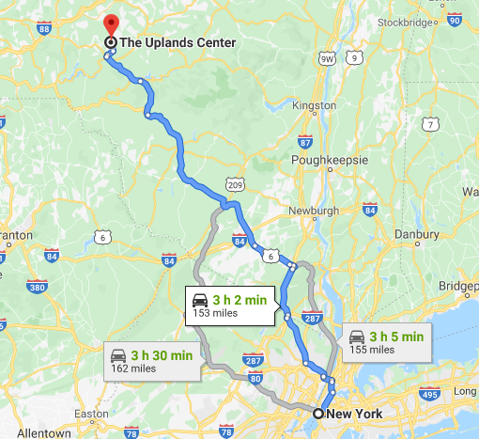
Figure 1. Map of driving routes from NYC to The Uplands Center (Google Maps).

Public transportation. Although public transportation is lacking in the village of Walton, there are bus options from New York City to the surrounding area. Shortline bus routes run daily from the Port Authority terminal to Monticello, and from Monticello to Roscoe, NY, with tickets starting at $68. Roscoe is a 46-minute drive to TUC via route 206; transportation can be arranged from Roscoe with local charter services such as Birnie Bus Services.

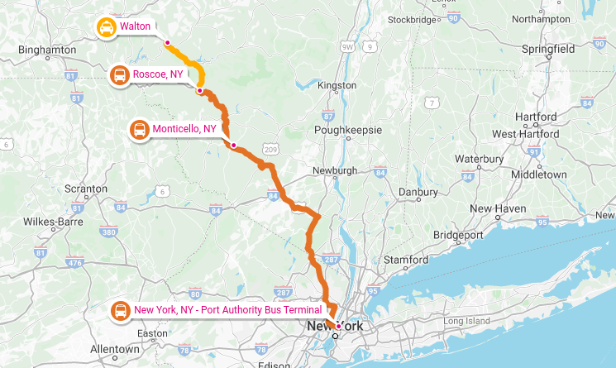
Figure 2. Map of bus routes from NYC to The Uplands Center (rome2rio.com).

Airports. Guests wishing to visit The Upland Center via aircraft can utilize the Greater Binghamton Airport which is located 65 miles west of The Uplands Center. The Greater Binghamton airport offers domestic flights, with Detroit, Michigan being its most popular destination (Bureau of transportation statistics, 2017). Patrons utilizing air travel will still need to arrange transport to and from the airport in order to arrive at The Uplands Center.

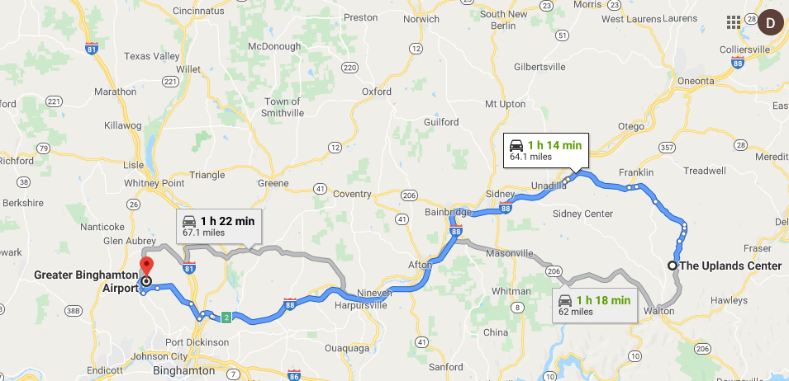
Figure 3. Driving routes from The Uplands Center to Greater Binghamton Airport. (Google maps)

Waterways. The East branch of the Delaware river bisects Delaware County and runs directly through Walton, NY. Non-motorized watercraft are allowed on the east branch. There are access points along the river and it provides fishing areas which could be utilized by guests of The Uplands Center.

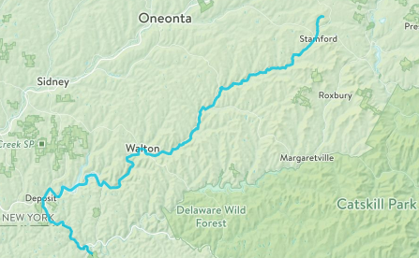
Figure 4. Water trail of The East Branch of the Delaware river (https://naturalatlas.com).

Biking. This mode of transportation is most applicable for locals as Walton is fairly isolated. Biking from Walton to The Uplands Center takes 45 minutes via East Brook and Dunk Hill road. This route is difficult and dangerous as it is mostly uphill and lacks an adequate road shoulder width for cyclists.

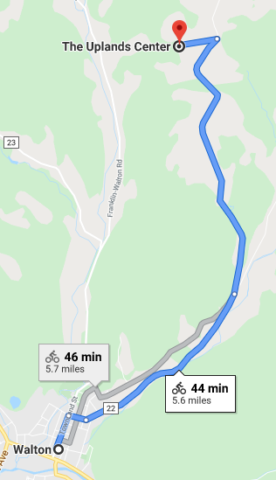
Figure 5. Biking routes from Walton to The Uplands Center. (Google Maps)

Summary. The Uplands Center is accessible to guests through many modes and routes of transportation. Public transportation is both available and economical for people traveling from New York City. Driving routes provide views of serene rural landscapes, although they might be challenging to those not used to twisty backroads. Water travel is available but probably isn't the most pragmatic route. Biking isn’t safe nor fast but is possible. Plane travel is available but requires additional transport for the remaining 65 miles from the airport to The Uplands Center.

ASSESSMENT FOR PARKS, ATTRACTIONS, & HISTORIC SITES

Introduction
At first glance, the land that surrounds The Uplands Center is beautifully preserved forest and farmland — a prime location for a retreat center. However, the location does present some limitations as to what activities guests can do. The Catskills region is a treasure chest full of activities for outdoor recreationists. Hiking, wildlife viewing, biking, water-based recreation, and rock climbing are just a few ways people can spend their time in this region. While the Uplands Center offers amazing opportunities for hiking and wildlife viewing, as well as freshly-prepared cuisine and educational courses, providing guests with access to the surrounding resources can provide a new catalog of experiences to guests.

State parks and preserves
Local state parks and preservations offer the owners of the Uplands Center the opportunity to collaborate with local rangers, tourism outfitters, and local museums (Table 1). The following three protected areas offer TUC the potential to seek permission of local rangers and DEC representatives to conduct special outings. Opportunities for backpacking and multi-day trips are available at the Delaware Wild Forest. Bear Spring Mountain Wildlife Management Area offers TUC staff a chance to lead trips aimed at wildlife enthusiasts, giving a larger and wider scoop of New York’s ecosystem and biological diversity. Lastly the Cannonsville Reservoir is an optimal source for water sport outing; such as guided fishing trips and canoe/kayak tours.

Table 1. Parks and preserved areas.

Park and Preserved Areas | Amenities | Programs Offered | Contact/ Website
Delaware Wild Forest | Four lean-to Shelters for backpacking | Hiking, Camping, Canoeing | https://www.dec.ny.gov/lands/50658.html
Bear Spring Mountain Wildlife Management Area | Restrooms, some handicap-accessible trails | Wildlife viewing, Hiking, Fishing | https://www.dec.ny.gov/outdoor/85850.html
Cannonsville Reservoir | Boat launch accessible via DEC Land | Kayaking, canoeing, nature tours, fishing | https://www.dec.ny.gov/outdoor/84906.html

Historic and cultural attractions
For guests interested in local history, tours on Iroquois culture are available at the Iroquois Indian Museum for individuals and large groups; this could potentially be a prime location for special events, as well (Table 2). Howe Caverns, possibly the most visited tourist attraction in Delaware County, offers boat tours inside the caves, accommodating all people. A collaboration with this attraction could prove beneficial, especially due to its close proximity to the Iroquois Indian Museum. Lastly the workshops conducted at the Hanford Mills Museum offer educational and hands on activities for interested individuals and families.

Table 2. Historic and cultural attractions.

Historic & Cultural Attractions | Amenities | Programs Offered | Contact/ Website
Iroquois Indian Museum | School programs  Collections  Special Exhibits  Annual Festival | Cultural education | (518) 296-8949  info@iroquoismuseum.org
Howe Caverns | Multiple guided tours: private, group, family oriented | Geological and niche habitat education | https://howecaverns.com
Hanford Mills Museum | Guided workshops  Tours  Exhibits | Traditional skill education | https://www.hanfordmills.org

Farms and Miscellaneous Attractions
Three local farms stand out as possible providers for food, giving local farmers more business and opening the door for potential farm tours (Table 3). Other wellness centers already exist in the area; however, rather than being seen as a source of competition, they should be seen as an opportunity for partnership (Table 4).

Table 3. Local farms.

Local Farms | Amenities | Programs Offered | Website
Greenane Farms | Onsite restaurant | Animals raised on site  Produce grown on site | http://www.greenanefarms.com
Stony Creek Farmstead | Accommodations  Dining | Workshops  Tours | http://www.stonycreekfarmstead.com
Maple Shade Farm | Easily accessible | Food festivals  Family fun activities  Weddings | http://www.mapleshadefarmny.com/activities

Table 4. Local wellness centers.

Local Wellness Centers | Amenities | Programs Offered | Website
Harmony Hills Wellness & Retreat Center | Lodging | Group retreats | https://harmonyhillretreat.com
Rippling Waters Retreat | Accommodations  Dining  Fireplaces | Horseback riding, mountain biking, fishing, boating | http://ripplingwatersretreat.net/events.html
Blue Deer Center | Easily accessible | Lessons through teachings and traditions of Native American culture. | http://www.bluedeer.org

REGIONAL FESTIVALS AND EVENTS

Introduction
This assessment will concentrate on the relationship between The Uplands Center (TUC) and the festivals and events that occur within their and around the region. Those from TUC mentioned concerns that they had with their relationship to the community. One way to bridge this gap is to consider regional festivals and events. Festivals and events draw locals and non-locals to participate in a celebration (i.e. a fair) or to engage in an activity of sorts (e.g. karaoke night). Festivals and events builds a strong sense of community and a positive relationship between people and different goods and services. It also helps people learn about different opportunities and make their own connections to organizations, companies, etc. This is an area of communication and connection to the public that TUC can capitalize on.

Current involvement
The Uplands Center, as it stands, has very limited experience with festivals and events outside the Walton area. Most of their interactions within their own community are also restricted to mainly attendance and promotional materials.

Potential opportunities and challenges
Table 1 lists specific events and festivals along with contact information to become a vendor at each location; farmers’ markets are listed in Table 2. With regard to benefits, festivals and events would help get TUC involved with the community, network with other businesses and attractions, and build community awareness. By participating in local festivals, TUC will get to better know their community and vice versa. They would also broaden their outreach to their visitor base by participating in these festivals. By joining these events they build a reputation for themselves and brand who they are firsthand.

Challenges exist in developing relationships with these festivals and events as well. The majority of events and festivals are held in the summer months, when the center is at its busiest. This means the timing and resources needed to bring visitors to the locations may prove to be a challenge. Another thing to consider is that along with obtaining permission to bring guests to each location or to rent exhibit space, materials and other assets may be needed for each festival or event.

Table 1. Festivals and events within the Delaware county and Catskill region.

Event/Festival | Location Held | Contact Information
Delaware County Fair | Walton, NY | Fair Street  PO Box 344  Walton, NY 13856  607-865-4763  Vendor Inquiry:  https://delawarecountyfair.org/contact-us/
Dairy Festival | Meridith, NY | 3575 Honest Brook Rd.  Meredith, NY 13757  Vendor Form (located on site):  https://www.meredithdairyfest.net/
Yoga Festival | Roxbury, NY | Raegan Reed  raegan@raegan.com  (607) 373-9000  Plattekill Mountain, 469 Plattekill Rd, Roxbury, New York 12474, United States  https://catskillmountainyogafestival.com/vendor-%26-sponsor-info
Catskill Forest Festival | Margaretville, NY | Catskill Forest Association  (845) 586-3054  43469 State Highway 28  PO BOX 336  Arkville, NY 12406  info@catskillforestfestival.com  www.catskillforest.org  https://www.catskillforestfestival.com/vendors
Castle on the Delaware | Walton, NY | 139 Stockton Avenue  Walton, NY 13856  917-348-7890  https://castleonthedelaware.com/contact/

Table 2. Farmer’s markets in the Delaware County area.

Contact Information
Andes Farmers’ Market at Dirty Girl Farm  Cyndi Wright  114 Delaware Avenue  Andes, NY 13731  PH: (845) 676-4000  Email: sindiderecha@hotmail.com  http://www.dirtygirlfarmny.com | Deposit Farmers' Market  Jeanne Darling  107 Second Street  United Methodist Church  Deposit , NY 13754  PH: (607) 865-6531  Email: vsd22@cornell.edu  http://www.ccedelware.org | Hobart Farmers' Market  Andrew Flach  Town Hall Green  101 Maple Avenue  Hobart, NY 13788  PH: (607) 538-4007  Email: hobartfarmersmarket@yahoo.com  http://www.hobartfarmersmarket.com | Walton Farmers' Market  Jeanne Darling  181 Delaware Street  Veterans Plaza  Walton, NY 13856  PH: (607) 865-6531  Email: vsd22@cornell.edu  http://www.ccedelaware.org
Delhi Farmers' Market  Meg Kennedy  Delhi Courthouse Square  Delhi, NY 13753  PH: (607) 293-8128  Email: megkennedy3@gmail.com  http://www.delhiareachamber.com/farmers-market | Franklin Farmers' Market  Patricia Tyrell  Chapel Hall  25 Institute Street  Franklin , NY 13775  PH: (607) 287-8853  Email: tkty21007@hotmail.com  http://www.franklinlocal.org | Pakatakan Farmers' Market  The Round Barn  46676 State Route 30  Halcottsville, NY 12438  PH: (845) 586-3326  Email: roundbarnmarket@gmail.com  http://www.roundbarnmarket.org/

Summary
Within Delaware County and the Catskill region there are several opportunities to be involved with events and festivals. Many of these opportunities draw people from all over the area to celebrate and learn about their community in a fun and interactive way. These experiences can greatly help The Uplands Center develop an image for itself, both within the Walton community and beyond.

WORKING WITH LOCAL BUSINESSES
Introduction
This assessment chapter contains a thorough list of local businesses and their contact information with the potential to partner with TUC. Although this assessment has a focus on small, locally owned businesses, a few commercially owned stores near Walton have been listed, due to the town’s limited number of businesses. Assessing the potential local businesses for partnerships with The Uplands Center (TUC) in just the town of Walton, NY proved to be difficult. To fully explore all the potential local businesses that could be used or promoted by TUC, the search for businesses in the local area included most of Delaware county.

Potential business partners
Businesses with potential partnerships with The Uplands Center have been listed according to business type within the tables below. Table 1 includes farms and orchards within Delaware county, the majority of which are organic certified. Table 2 includes music venues and music stores with the Town of Walton, as well as Delaware county. Table 3 includes businesses active in construction and road work within Delaware county. Table 4 includes restaurants within the town of Walton. Table 5 includes businesses that could provide outdoor gear and outfitting services. Every table contains the businesses’ name, a brief description, their contact information (including address, phone number, and website when applicable), and how The Uplands Center can benefit from their services or start a partnership with them. These businesses were chosen based on proximity to The Uplands Center, being locally owned, and their potential usefulness to TUC guests and services.

In this section the following terms are used to describe their potential use/relationship with The Uplands Center: advertisement placement, increased community involvement, structural development, culinary service, and activity expansion. Although some businesses are categorized according to several of these potential use categories, the extent to which each business can provide the service specified will vary from case to case. These categories are defined as follows:
- “Advertisement placement” refers to businesses or venues in the Delaware county area where TUC promotional materials could be displayed to increase facility outreach.
- “Increased community involvement” businesses could provide a service to or host an event at TUC or its own facility to increase local involvement.
- “Structural development” businesses could provide construction and development services to The Uplands Center to help with restorations and road/trail improvement and construction.
- “Culinary service” businesses could help The Uplands Center with catering events or provide produce to TUC.
- “Activity expansion” businesses have the potential to increase the type or amount of activities that occur at The Uplands Center.

Table 1. Delaware County farms and orchards.

Business | Description | Contact Information | Potential Use With/At Uplands Center
Betty Acres Organic Farm | Cheese manufacturer | 21529 NY-28, Delhi, NY 13753  (607) 746-9581 | Increased community involvement, culinary service, advertisement placement
Lucky Dog Farm | Local organic farm | 35796 NY-10, Hamden, NY 13782  (607) 746-9898  https://www.luckydogorganic.com | Increased community involvement, culinary service, advertisement placement
Berry Brook Farm | Local organic vegetables and CSA | 2369 Back River Rd, Delancey, NY 13752  (607) 267-0184  http://www.berrybrookfarmorganic.com/ | Increased community involvement, culinary service, advertisement placement
Wildflower Farm Organics | Local organic farm | 4721 Elk Creek Rd, Delhi, NY 13753  (607) 267-3693  https://www.wildflowerfarmorganics.com/ | Increased community involvement, culinary service, advertisement placement

Table 2. Delaware County Music/Performance

Business | Description | Contact Information | Potential Use With/At Uplands Center
Walton Music House | Musical instrument store offering music lessons | 208 Old Prospect Ave  Walton, NY 13856  (607) 865-5670  http://www.waltonmusichouse.com/ | Advertisement placement, increased community involvement, activity expansion
Spillian | Live music venue and storytelling | 50 Fleischmanns Heights Rd, Fleischmanns, NY 12430  (800) 811-3351  https://spillian.com/ | Advertisement placement, increased community involvement, activity expansion
Castle on the Delaware | Historical venue with live music and food | 139 Stockton Avenue  Walton NY 13856  917-348-7890  https://castleonthedelaware.com | Advertisement placement, increased community involvement
Eighth Note Music Store | Musical instrument store and music lessons | 10 S Main St.  Oneonta, NY 13820  (607) 432-0344  http://www.theeighthnote.com/ | Advertisement placement, increased community involvement, activity expansion
Table 3. Delaware County construction companies.

Business | Description | Contact Information | Potential Use With/At Uplands Center
Homestead Construction | Old building/barn restoration | 27 Shaver Hill Rd.  Andes, NY 13731  (845) 704-7172  https://www.homesteadconstruction13731.com/ | Structural development, increased community involvement
Day Builders Inc. | Log home builder and house construction | 65 Industrial Park Rd.  Walton, NY 13856  (607) 434-2783 | Structural development, increased community involvement
Springdale Construction | House construction | 15 Bridge St.  Walton, NY 13856  (607) 865-6800 | Structural development, increased community involvement
Delaware Bulldozing | Pavement/gravel driveway construction | 5700 Co Rd 18  Bloomville, NY 13739  (607) 538-1185  https://www.delawarebulldozing.net/ | Structural development

Table 4. Walton restaurants.

Business | Description | Contact Information | Potential Use With/At Uplands Center
Feather & Stone | American/comfort food | 38 West St 1 & 2  Walton, NY 13856  (607) 510-4027  http://www.featherandstonerestaurant.com | Increased community involvement, culinary service, advertisement placement
Danny’s Restaurant | Diner/comfort food | 14 Gardiner Pl.  Walton, NY 13856  (607) 865-8496 | Increased community involvement, culinary service, advertisement placement
The Rainbow Lodge | Quality food/ nature setting | 440 Rainbow Lodge Rd.  Walton, NY 13856  (607) 865-7534  https://the-rainbow-lodge.business.site/ | Increased community involvement, culinary service, advertisement placement
Molto Espresso | Cafe and coffee shop | 151 Delaware St.  Walton, NY 13856  (607) 865-7375 | Increased community involvement, culinary service, advertisement placement

Table 5. Delaware County outdoor gear stores.

Business | Description | Contact Information | Potential Use With/At Uplands Center
Marino's Outdoor World | Outdoor store selling camping and hunting goods | 95 E Front St.  Hancock, NY 13783  (607) 637-3573 | Advertisement placement, activity expansion, increased community involvement
Morgan Outdoor | Outdoor store selling camping and hunting goods | 46 Main St.  Livingston Manor, NY 12758  (845) 439-5507  https://morgan-outdoors.com/ | Advertisement placement, activity expansion, increased community involvement
Dick’s Sporting Goods | Commercial sports/outdoor retailer | 5006 NY-23 Ste 1C  Oneonta, NY 13820  (607) 432-0203  https://stores.dickssportinggoods.com/ny/oneonta  /1085/?seo=localpack | Advertisement placement, activity expansion

Summary
The five categories listed in the tables above include the most available types of businesses that fit The Uplands Center’s needs. Many of the businesses above are locally-owned and would most likely benefit from a partnership with The Uplands Center. Although many businesses are listed, not all businesses may be willing to work with The Uplands Center or have values that align with those of TUC. Although the businesses listed under the outdoor gear stores are locally owned, local stores might not be able to provide the specific services TUC is currently looking for, since most provide services and goods to hunters and not necessarily hikers.

LOCAL NON-FOR-PROFIT ASSESSMENT

Introduction
This assessment includes an overview of local non-for-profit organizations for possible partnerships with the Uplands Center. Tables 1 through 6 all encompass a variety of organizations that align with the goals, theme and mission of the Uplands Center. Each of the chosen non-for-profits have been sorted into one of six categories that are aimed at strengthening a different aspect of the Uplands Center operations. These six categories are promoting environmental sustainability and sustainable agriculture, sustaining ecotourism and agritourism ideals, repairing the connection to the local community, creating a partnership between the Uplands Center and local institutions for research and education, connecting the Uplands Center to their target demographic- change makers, those in high stress positions and creating partnerships with organizations that can lead programs on the property.

Table 1. Not-for-profit organizations focused on environmental sustainability and sustainable agriculture.

Not-for-Profit | Mission Statement | Contact Information
Cornell Cooperative Extension | Provides research-based solutions information to help New York State families and communities. | CCE Delaware County  34570 State Highway 10 Hamden, NY 13782  Phone: (607) 865-6531
Center for Agricultural Development and Entrepreneurship | Works with entrepreneurs to build a more viable food system. | Office Phone: 607-433-2545  Executive Director - Phoebe Schreiner - phoebe@cadefarms.org
Catskill Mountainkeeper | Grassroots advocacy organization dedicated to protecting and preserving the Catskill Region. | Catskill Mountainkeeper, P.O. Box 1000, Livingston Manor, NY 12758
School of Environmental and Vocational Arts Foundation | Promotes education on health, fitness, and the environment. | 607-538-1130 or email us at sevaprograms@gmail.com.
Catskill Center for Conservation and Development | Protects and fosters the environmental, cultural, and economic well-being of the Catskill Region. | 845.586.2611  cccd@catskillcenter.org  43355 State Highway 28, PO Box 504, Arkville, NY 12406 (Next to the fire station)
Delaware County Beekeepers Association | Educates members and the public about honeybees and benefits of beekeeping. | Delaware County Beekeepers Association Facebook Page

Table 2. Not-for-profit organizations focused on supporting ecotourism and agritourism.

Not-for-Profit | Mission Statement | Contact Information
National Agricultural Marketing Resource Center | National virtual resource center that provides producers and processors with information on value-added agricultural enterprises. | http://www.agmrc.org.
Farm Stay US | Connects guests with authentic farm and ranch stay vacations throughout the United States. | Farm Stay USA  20368 Honey Grove Rd  Alsea, OR 97324  info@farmstayus.com  (541) 487-4966 (PST/PDT)
New York Farm Tours | Provides tours that explore the care, craft, and history of farming and agriculture. | Albany, New York  800 CALL NYS · info@iloveny.com

Table 3. Not-for-profit organizations focused on connecting residents with their community.

Not-for-Profit | Mission Statement | Contact Information
Rehabilitation Support Services | Mental health agency whose mission is to provide its clients with services and opportunities for emotional, social vocational, and educational growth. | 132 Delaware Street, PO Box 240  Walton, NY 13856*  Tel: (607) 865-3158  Fax: (607) 865-8333
Walton Theatre | A historic theatre in Walton, NY that aims to bring music and entertainment to the community. | (607)865-6688  (607)865-NOTV

Table 4. Educational institutions focused on research and education.

Not-for-Profit | Programs of potential interest to TUC
SUNY ESF | Natural Resources Management  - Forestry; Ecotourism; Recreation Management; Sustainable energy  Environmental & Forest Biology  Environmental Studies  - Nature Interpretation
SUNY Delhi | Environmental Studies
Syracuse University | Civil engineering
SUNY Morrisville | Agriculture  Renewable energy  Environmental & Natural Resources Conservation  Aquatic Science  Nutrition
Colgate University | Environmental Studies  Native American Studies
Hamilton College | Environmental Studies
Binghamton University | Renewable energy  Environmental protection
SUNY College of Agriculture and Technology at Cobleskill | Sustainability  Agriculture  Natural resources management

Table 5. Not-for-profit organizations with potential connections to the target groups.

Not-for-Profit | Mission Statement | Contact Information
Delaware County Opportunities | Offers programs and services that meet the needs of the citizens of Delaware County for employment, education, emergency assistance, nutrition, and youth programs. | Delaware Opportunities Inc.  35430 State Highway 10  Hamden, New York 13782  Phone: (607) 746-1600  TTY Users: 711 or 800-662-1200  Fax: (607) 746-1605  info@delop.org
Safe against Violence | Offers comprehensive services for victims of domestic violence, sexual assault and other crimes. | Office: (607)746-1720  Email: sav@delop.org

Table 6. Not-for-profit organizations focused on programming and activities.

Not-for-Profit | Mission Statement | Contact Information
Isaac Walton League | Conserves, restores, and promotes the sustainable use of natural resources. | 530 State Route 41A  Homer, NY 13077  Phone: (607)756-1008
Delaware County Historical Association | Preserves “the past, in the present, for the future.” | (607)746-3849;  dcha@delhi.net
Food Demonstrations- Delaware County Opportunities | Free demonstrations on ways to prepare nutritious and economical meals. Samples, recipes, and some ingredients given out. | Grace Bartolillo, Nutrition Educator  (607) 746-1669  GBartolillo@delop.org

Summary
These tables include a list of many institutions and non-for-profits in New York State that have the potential to collaborate and create partnerships with The Uplands Center. Each is aimed at supporting a different aspect of the Center. A collaboration with any of these organizations has the potential to benefit the community, employees, and guests of the Uplands Center.

WORKING WITH GOVERNMENT AGENCIES

Introduction
Collaborating with government agencies is important to the Upland Center to effectively fulfill its objectives and goals. The Upland Center aims to be an important stakeholder in the area, regarding ​​environmental education and sustainable agriculture practices. It is willing to provide services to people in need and to create unique opportunities for visitors. The state organizations identified offer expertise and technical support in diverse fields, including environmental education, quality of service, sustainable resource management, and volunteer/staff trainings. The purpose of this report is to identify federal, state, county and city government agencies that would help the center efficiently perform and implement its planned activities.

Government agencies
In this assessment the governmental agencies have been grouped into four different groups: federal, state, county, and municipal. For each agency, information is provided on the mission/purpose and website.

Table 1. Federal government agencies.

Agency name |  | Mission | Contact Information
Natural Resources Conservation Service (NRCS) of Delaware County |  | Offers technical and financial assistance about natural resource management and conservation practices. Assists with conservation plans for all landscapes and offers training and certification in standards and procedures (NRCS, n.d.). | 1221 College Park Drive. Suite 100  Dover, Delaware  19904-8724  Phone:302-678-4160
Extension Disaster Education Network |  | Provides educational programs on disaster preparation and mitigation through educational materials, courses, webinars and Exercises (Extension Disaster Education Network, n.d.). | Ray A. Ali  National Program Leader  Division of Community and Education  ray.ali@usda.gov  Phone: (816) 926-1453
Federal Emergency Management Agency (FEMA) |  | Coordinates the federal government's role in preparing for, preventing, mitigating the effects of, responding to, and recovering from all domestic disasters. Offers trainings on communications, and safety and security (FEMA, n.d.). | No information. They allow communication through Contact us online form.
 | The Cooperative Ecosystem Studies Units (CESU) Network | Provides technical assistance and education regarding land management, environment and natural resources management. Creates and maintains effective partnerships among federal agencies, universities and other partners. | 1849 C Street NW, Room 2649. Washington, DC 20240. Phone: (202) 354-1825. E-mail: Tom_Fish@nps.gov

Table 2. New York State government agencies.

Agency name | Mission | Contact Information
Department of Environment Conservation | To conserve, protect, improve and promote the New York’s natural resources and environment. It provides regulations and enforcement on environmental protection, recreation, health and safety and promotes nature-based activities through licenses and permits (Department of Environment Conservation, n.d.). | Address: 625 Broadway. 12207 Albany, New York  Phone: +51 84 028044  Facebook: NYS Department of Environmental Conservation  Twitter: NYSDEC
Environmental Facilities Corporation | To help private entities, municipalities, businesses to comply with federal and State environmental protection and quality requirements in an efficient way, toward sustainability. To promote innovative environmental technologies and practices (Environmental Facilities Corporation, n.d.). | Address: 625 Broadway – 7th Floor, Albany, NY 12207  Phone: 518.402.6924  Facebook: NYS Environmental Facilities Corporation  Twitter: NYS EFC

Table 3. County government agencies.

Agency Name | Mission | Contact Information
Cornell Cooperative Extension of Delaware County | Promotes quality of life in Delaware County by combining expertise, scientific research, experiential learning, and innovation, with education(Cornell Cooperative Extension, 2019). | 34570 State Highway 10 Hamden, NY 13782. Phone: (607) 865-6531
Delaware County Soil and Water Conservation District | Provides technical assistance to landowners and local governments on how to wisely use natural resources. Provides environmental education in six subject areas: soils, aquatics, wildlife, forestry, current environmental issues and problem solving (Delaware County Soil and Water Conservation District, n.d.). | Address: 44 West St #1, Walton, NY 13856  Phone: (607) 865-7161
Delaware General Health District | Provides safe and healthy places for people to live and work but also for common public spaces (Delaware General Health District, 2019). | Address: 99 Main St. 13753 Delhi, New York.  Contact us online form.  Phone: (607) 832-5200
Delaware County Chamber of Commerce | Promotes the region for tourism development. Implements sustainable economic development programs (Delaware County Chamber of Commerce, 2019). | Delhi, New York 13753  Voice: 607.746.2281  Fax: 607.746.3571  Phone: 607-746-2281
Office for the aging | Assists elders with well-being and independent living opportunities (Office for the Aging, n.d.). | Address: 97 Main Street, Suite 2. Delhi, NY 13753  Phone: (607) 832-5750. Email: ofa@co.delaware.ny.us
The Alcohol and Drug Abuse Council of Delaware County (ADAC) | Provides education and information for effective communication, bullying, prescription drugs, substance use and abuse, alcohol, mental health, and the prevention of alcohol and substance abuse for schools and organizations (The Alcohol and Drug Abuse Council of Delaware County , 2019). | 116 Main Street Delhi, NY, 13753  Phone: (607) 746-8300
Walton County School District | General education, Field projects (Walton County School District, n.d.). | 145 Park St.  DeFuniak Springs, FL 32435. Phone: 850-892-1100

Table 4. Walton city government agencies.

Agency Name | Mission | Contact Information
Town of Walton | Provides information and access to legal forms, regulations and guiding documents for future development in the town (Town of Walton, n.d.). | Address: 129 North Street, Walton, NY 13856.  Contact us online form.
Walton Public Library | Provides a place for education and recreation activities (Walton Public Library, 2012). | Address: 110 North Main Street. Walton, Indiana 46994  Phone: (574) 626-2234  E-mail: waltonlibrary@walton.lib.in.us

Summary
Collaboration with local, state, and federal organizations is important for The Uplands Center, especially in the early stages of the center’s planning and implementation. Cooperation with government organizations will ensure that the activities are conducted in accordance with the law, are safe for visitors, and provide a great opportunity for education, recreation, research and conservation.

EMERGENCY SERVICES AND VISITOR SAFTEY

Introduction
The Uplands Center is a wellness retreat in Walton, NY sitting on nearly 300 acres of old farm land and forest. The property buildings are composed of three old large barns in mild to severe disrepair, a renovated farm house, vista shed, new main house with attached spa, and new staff housing. The driveway to the house is a dirt road in poor condition with limited parking. Water features include a creek at the far end of the property, a pond near visitor housing, and an indoor pool and hot tub. There is a marked trail on the property that is not yet developed, along with a few other trails to be implemented at a later date. Current safety features include miscellaneous medical supplies, an emergency contact sheet and limited security cameras on the outside of the house. This section will identify current visitor safety issues on the current property along with future concerns. Information concerning emergency services in the vicinity of The Uplands Center will also be provided.

Potential visitor hazards
Recreation-related hazards. Hiking is a recreational activity that comes with known minor risks such as twisted ankles, minor cuts and bruises that happen relatively frequently but are generally easily treatable. When you have a large number of unexperienced hikers, the chance of an injury occurring increases significantly. Types of potential hazards include falling trees/branches, dehydration, being unprepared for the elements, cliffs, and becoming lost. In addition, once trails are constructed on the property, visitors may need to cross Dunk Hill Road to reach trails on the east side of the property. Crossing can be dangerous due to fast moving vehicles and semi blind corners.

Wildlife-related hazards. On the property, it is important to know proper tick prevention techniques and removal methods to prevent Lyme disease. Along with ticks, it is important that visitors know not to leave food or garbage out because it could attract wild animals. Hazards of animals include rabies, attacks, and destruction of property.

Emergency access. Accessing all parts of the trail in a quick fashion if an emergency occurs is vital; if staff cannot retrieve a hurt visitor, the local EMS will have to be called and the time of rescue could be extended greatly. EMS may not be able to quickly find The Uplands Center due to limited signage and google map errors.

Emergency management plans. Not having emergency plans in place can result in confusion and disorganization when emergencies occur. Emergency plans pertaining to missing persons, fire, power outages, and severe injuries should be known to every employee. Staff without basic first aid training and improper organization of medical supplies could lead to long periods without basic treatment. Staff need to meet NYS-health code requirements and be able to uphold said codes to prevent visitor harm.

Emergency services
In the town of Walton, you have the Walton Fire Department & Emergency Squad (Table 1.), Walton police department, Delaware County Sherriff Department Patrol Garage (Table 2), the UHS Delaware Valley Hospital (Table 4.) and the David Station Towing and Garage (Table 5). These services are all located within 6 miles of The Uplands Center in the event of an emergency. The surrounding towns have fire, police, EMS and hospital services as well in the event that the Walton based services are unreachable. In the event of an emergency, a local 911 dispatch center will contact the appropriate emergency services to be sent to The Uplands Center.
Table 1. Fire departments and emergency medical services.

Service Provider | Address | Contact phone
Walton Fire Department & Emergency Squad | 61 West St, Walton, NY 13856 | (607) 865-4958
Delhi Fire Department Station 2 | 38495 NY-10, Hamden, NY 13782 | (607) 746-2221
Trout Creek Fire Department | County Route 27 Co Rd 27, Trout Creek, NY 13847 | (607) 865-4810

Table 2. Law enforcement agencies.

Service Provider | Address | Contact phone
Walton Police Department | 87 Mead St, Walton, NY 13856 | (607) 865-5400
Delaware County Sherriff Department Patrol Garage | 7 Water St, Walton, NY 13856 | (607) 865-4039
State of New York Police Department | 450 Co Rd 3, Margaretville, NY 12455 | (845) 586-3299
Beerston Police Precinct | 21852 NY-10, Walton, NY 13856 | (607) 865-4185

Table 3. Medical services.

Service Provider | Address | Contact phone
UHS Delaware Valley Hospital | 1 Titus Pl, Walton, NY 13856 | (607) 865-2100
Bassett Healthcare Network O'Connor Hospital | 460 Andes Rd, Delhi, NY 13753 | (607) 746-0300

Table 4. Mechanic and towing services.

Service Provider | Address | Contact phone
David Stanton Towing & Garage | 3386county, County Hwy 23, Walton, NY 13856 | (607) 865-6313
Palmer's Repair Shop | 152 Townsend St, Walton, NY 13856 | (607) 865-5002
Gray's Garage and Hauling | 6282 Steam Mill Rd  Masonville, NY 13804 | (607) 213-3060

Summary
The Uplands Center is located in the town of Walton which has a fire department, police department, ambulance service, mechanic and hospital in the event of an emergency. The center itself is not fully prepared for all potential visitor safety concerns; in this regard the necessary preparations will not be difficult to prepare for with proper planning. Emergency contact information should be available to each visitor in case a staff member cannot be reached, and should be informed to dial 911 immediately in the case of an emergency.

ORGANIZATION STRUCTURE, STAFFING, AND MANAGEMENT

Introduction
The Uplands Center (TUC) is an organization aimed to give back to the community. Its mission is to provide revitalization to those who help others, such as first responders, health care providers, educators, and other individuals who directly serve those in need. It also strives to empower social change-makers — the people innovating change through teamwork and collaboration. This mission of empowerment stems from the organization’s commitment to sustainable and innovative program design. Lastly, TUC wants to offer opportunities for community members and other guests at TUC to engage with the natural environment. The purpose of this assessment is to clarify the structure and management already in place at TUC to accomplish this mission.

Organizational structure and oversight
The organizational structure for TUC is currently centered around a team of ten workers. Each staff member has a position title and correlated responsibilities. However, there is a lot of overlap between some staff members and their responsibilities, due to the small number of full-time employees. In addition, several employees have multiple position titles, giving them more responsibilities at TUC. A list of position titles and corresponding number of staff with each title can be found below in Table 1.

Table 1. Position title(s) and corresponding number of staff with title(s).
Position Title(s) | Number of Staff with Title(s)
Co-Founder & Executive Director | 2
Co-Founder, Director of Creative Programming, Co-Director of Changemaker Programming | 1
Director of Naturalist Operations & Educational Programs | 1
Director of Agricultural Operations & Facilities | 1
Project Consultant | 2
Director of Retreat & Guest Experience | 1
Retreat Co-Facilitator & Consultant | 1
Director of Catering & Food Services | 1
Total Number of Staff: | 10

The staff responsible for oversight are the Director of Naturalist Operations & Educational Programs and the Director of Agricultural Operations & Facilities. However, the three Executive Directors are also partially responsible for oversight, but only on weekends during retreats when they travel from their homes in Newark, NJ. This means the first two staff members listed are fully responsible for the oversight the majority of the time, on top of their other responsibilities as Directors, respectively.

Volunteering
TUC does not have any active long-term volunteers or trainings designed for future volunteers. Without the help of volunteers, there is a smaller overall labor force able to complete projects. The projects TUC wishes to use volunteers for include community events and natural resource management on the property. The benefit of not currently having volunteers is that TUC has the ability to decide exactly what responsibilities they would like for their future volunteers, as well as the opportunity to create the trainings needed to get community members involved.

The only volunteers TUC has worked with so far are through the Bob Marshall Club at the SUNY College of Environmental Science and Forestry. This club is the outdoor/hiking club of the institution, and often participates in trail building and maintenance. The Bob Marshall Club will be sending officers and those with experience to volunteer their time at TUC. They plan to help with building the planned trails TUC has in mind, as well as cleaning up the trails that already exist. This volunteer opportunity is one example of the potential help TUC can receive from the outside community.

Staffing limitations and benefits
The small core of staff is a great team, but, with only ten people, there is a lot of work to cover. The staff may find themselves overwhelmed and/or overworked with their responsibilities. Along with this, there are simply not enough people to complete all the goals of the organization. Management of natural resources such as pulling invasive species, replanting native species, and general improvement of the habitat for wildlife, along with the priorities of organic agriculture, increasing biodiversity, and forest health management, may require an increase in the number of staff and volunteers.

There are also benefits with the current staffing team. Team members have diverse skills in psychology, ecology, biology, entrepreneurship, business, social change-making, and story-telling. Overall, the team is incredibly diverse and is able to bring different perspectives to TUC. The knowledge gathered between the ten staff from their respective fields can positively contribute to the functionality of the organization. Along with this, the staff is passionate about their work. Based on descriptions from each member on TUC’s website, each person holds their own personal connection to TUC (The Uplands Center, 2019), and is focused on completing the goals and visions of the organization.

Management and main concerns
TUC is managed in a team effort. Trail maintenance is handled by the Director of Naturalist Operations & Educational Programs and the Director of Agricultural Operations & Facilities. The facilities and buildings are managed by the Director of Agricultural Operations & Facilities, as well as a long-term groundskeeper. However, this role will shift in the future to be solely run by the Director of Agricultural Operations & Facilities as they learn more about the property. The driveway is plowed in the winter and graded in the spring by an outside contractor. Mowing and landscaping of the property is done by two outside contractors. Information on invasive species management for TUC is being handled by Jacob Johnston from Nature’s Touch Consulting, and the Director of Naturalist Operations & Educational Programs. After retreats, a cleaning crew is responsible for cleaning the rooms and there is a weekly garbage pick-up from the community.

Several concerns exist with regard to management of TUC. The first is related to the maintenance and management of natural resources —more specifically, the removal of invasive species, replanting of native species, and the overall improvement of the habitat for wildlife. Currently, there is no active management of invasive species on the property. Another concern is the hiring of volunteers and interns to complete long-term projects and host/participate in community events. Finally, due to the small number of staff, there is a concern of staff burnout because of the extensive responsibilities of each staff member.

Summary
Overall, the Uplands Center has a strong base of staff. However, the team is too small to complete all intended goals of the organization. The main oversight of the property is handled by two individuals full-time, while three other staff members help during retreats. There are no active volunteers or interns working at TUC, but they have made connections to work with a local club for trail building. TUC plans to invite volunteers and interns to help with community events, natural resources management, and general help on the property. The staff overall are incredibly passionate and knowledgeable in their respective fields. The small number of full-time workers can lead to burn-out and feeling overworked, making that a priority.

GRANTS AND FUNDING SOURCES ASSESSMENT

Introduction
This chapter focuses on the grant and funding sources of The Upland Center. The Upland Center has a 501(c) (3) status and is a not-for-profit organization. When an organization is declared a 501 (c) (3), the amount of taxes paid are drastically reduced. In view of the status granted them by the IRS, The Upland Center is functioning as a Private Operating Foundation. This chapter discusses this status and its implications for future funding.

Private Operating Foundation
Like other traditional private foundations, a private operating foundation is a federally tax-exempt organization under IRC Section 501(c) (3) that is funded primarily by one or a few donors. A private operating foundation usually operates one or more charitable programs. A private operating foundation can accept donations from the general public; if the foundation attracts donations from enough sources then it may qualify for public charity status. In general, private operating foundations are subject to the tax laws that apply to private foundations (Hurwit & Associates, 2019).

Funding sources of The Upland Center
As a 501(c) (3) not-for-profit organization, The Upland Center is currently being funded by an endowment fund which was created at the launch of the center. All facilities, services, and activities being run by the center are funded by the endowment. Financial endowments are typically structured so the principal amount invested remains intact, while investment income is available for immediate use.

Summary
The Uplands Center is a not-for-profit organization and has a 501(c) (3) status under the IRC. Based on their funding sources, the center is a private operating foundation. The center is currently being funded by an endowment fund. TUC has the opportunity to increase its funding sources through grants and other donations in the future.

RECOMMENDATIONS

Overview & Priorities
In order to accomplish its goals, it is recommended that TUC implement the recommendations in this chapter according to the priorities expressed in its mission. These priorities include opportunities for retreat participants (i.e., first responders, health care providers, change makers), as well as opportunities for the community (local residents, school groups). Because of the different needs of each of these groups, it is recommended that the TUC utilize “use zones” to focus its development efforts on the enhancement of one section of the TUC property at a time, separate visitors interested in different aspects of the TUC property, and prevent conflicts between users who have different goals for being at TUC. A suggested layout for the facility is shown in Figure 1. It is recommended that TUC prioritize recommendations according to these zones as follows:

- Retreat Zone: completion of Main House expansion and addition of nature trails.
- Vista Shed Zone: addition of vista sheds and solar-powered bathroom facility.
- Community and School Use Zone: addition of nature trails, bathroom facility, outdoor pavilion, parking, and trailhead kiosk; large group camping site is optional.
- Special Event Zone: refurbish barn near Tweedy House and add parking.

A more detailed list of recommendation (listed according to goals) follows.

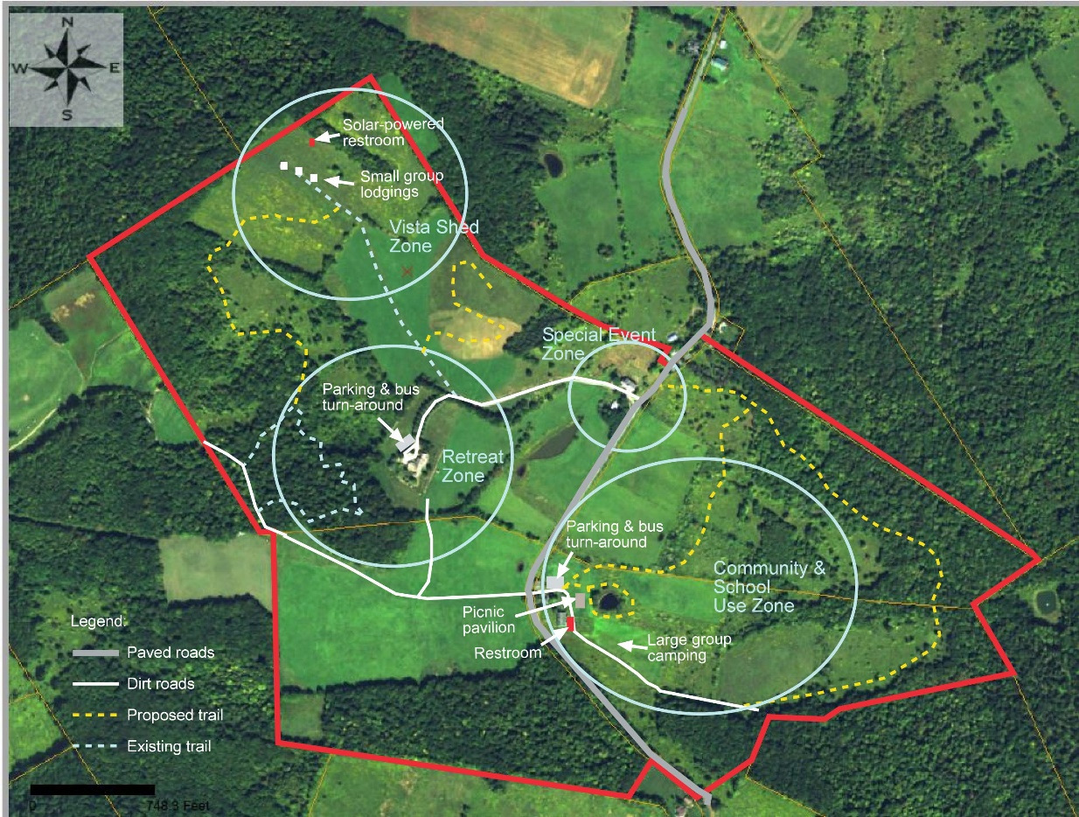

Figure 1. Proposed use zones within TUC.
Priority #1: Create a Retreat Zone. The retreat zone will cater to people and groups coming to TUC specifically for retreats (community/school group use of the property will be limited to the Community and School Use Zone only; see the recommendations for Goal #2 for more information on this zone). The Retreat Zone will include the following:
- Expanded Main House. This renovation is already underway and is not being considered further in this plan.
- Bus turn-around. This turnaround will be needed near the main house to accommodate easy access by large retreat groups arriving by bus. Buses will likely need to park in the larger parking lot proposed for the Community and School Group Zone.
- Parking. Because of the expansion of the Main House, parking in the retreat zone has been reduced. Two opportunities exist for expanding parking: 1). convert the field across the driveway from the house into parking. This option is not preferred because of the impact this change will have on the view from the house. 2). Widen the driveway to accommodate parking along the driveway. This is the preferred option, though it may increase the walking distance from their cars to the Main House for some visitors.
- Expanded trail system specifically for retreat goers. In addition to the Woodland Trail currently under construction near the main house, a Vista Shed Trail and a Meditation Trail are recommended. The Vista Shed Trail will make it easier for vista shed users to access the trail system. The meditation trail will make it possible for retreat-goers to connect with the sights and sounds of nature.

Priority #2: Expand Vista Shed zone. The current Vista Shed area includes only one vista shed. In order to accommodate large groups overnight in this zone, the following changes are recommended:
- Add two additional vista sheds. These additional cabins are needed to expand the lodging capacity of this area.
- Add a group gathering area. Adding a fire ring with rustic log seats in this area will provide the opportunity for groups using this site to gather and socialize.
- Add a solar-powered composting bathroom facility with water pump to this site. Because of the distance of the vista sheds to the bathroom facility in the Main House, a bathroom facility is needed. The possibility of having a water supply via hand pump will need to be explored for feasibility and potability of water.

Priority #3: Create a community/school group use zone. This zone, located east of Dunk Hill Road, will cater specifically to local residents who wish to hike the trails, and to school groups who visit TUC for educational programs. This zone will include the following:
- Parking area. This parking lot will provide a bus turn-around, one to two bus parking spaces, and car parking for at least 20 vehicles.
- Trailhead kiosk and trail registry. The Uplands Center will have many different user groups on site with varying degrees of knowledge of the outdoors. A trailhead kiosk will allow The Uplands Center to provide any necessary warnings about trail safety and information about wildlife and vegetation along the trails. The registry will assist in maintaining the safety of visitors, and will also allow managers to keep track of the number of visitors on site.
- Expand trails. A fully-accessible trail around the pond near the staff house is recommended, as is a longer nature trail. The Pond Trail may require a boardwalk; an observation platform is also recommended on this trail. The longer nature trail will be primarily for use by local residents, but will be available to retreat goers as well.
- Maintain old farm road on west side of property. The old farm road just east of Dunk Hill Road will be integrated with Trail #2, and will need to be mowed to prevent vegetation overgrowth. This road is important for providing access for staff and emergency service vehicles.
- Rest room facility. A large bathroom is recommended to accommodate school groups, without them needing to use bathroom facilities in the main house.
- Picnic pavilion. This facility will make it possible for school groups to eat at TUC in all types of weather, and can be used for outdoor educational programs as well.
- Restored barn. Restoring the barn adjacent to the staff housing will make it possible to have indoor classroom space. This type of space could be utilized by school groups and youth camps for diverse activities.

Priority #4: Create a special event zone. This zone will be located in the Tweedy House area.
- Restore barn. Repairing the barn is needed to accommodate large private events such as weddings and family reunions. The proximity of the Tweedy House makes it possible for special event guests to stay at TUC.
- Add parking lot. A 20-car parking lot adjacent to the barn is recommended.

Goal #1: Within five years, TUC will provide an environment that facilitates mental and emotional wellness and growth for all visitors.

Create a brochure for wellness practices. Information on physical health, mental health and nutrition should be included in an informative brochure that is distributed both at TUC and on TUC’s website. The pamphlet could focus on mental health practices, and could include the mental wellness benefits of forest bathing, yoga, and meditation. Information regarding on-site opportunities should be included, as well as information about off-site opportunities for mental health practices and support. Participants will be able to discover the importance of mental health techniques before, during, and after practicing them with staff.

Create a brochure about nutrition and eating healthy. This brochure could include information on the benefits of eating foods grown organically and locally. A section focused on the foods we eat and their importance to our wellbeing could create a stronger connection between visitors and the crops raised at TUC. If participants chose to utilize the center’s culinary staff, each attendee could receive information on the health benefits of foods served at the center. Adding a few relevant resources and recipes to this piece would help foster a connection between visitors and nutrition. Having this information available in at TUC and on the TUC website would encourage visitors to remain engaged with the new nutrition-related practices they gained during their stay at The Uplands Center.

Expand TUC market groups. Several market groups are proposed for the TUC to consider for future events and retreats, including:
- Veterans. Veterans, while not guaranteed to work a service occupation, are individuals who have served their community. Many veterans live in Delaware County, and are an important potential market group for TUC.
- Retired residents. 25% of the population in Delaware County, NY is age 65+. Catering experiences to this age group would provide an important benefit to this market group.
- Those in the community who live in poverty. 31% of residents in Walton, NY live in poverty. TUC has a great opportunity to support its community by creating and implementing programs that support those that live in poverty.
- Those recovering from addiction.
- Those recovering from domestic abuse.

Explore opportunities to market to local change-makers. Currently, many TUC guests come from the New York City area. Connecting to local non-profits can create an opportunity to connect the Center to change makers within the Delaware County region as well. Non-profits such as the Delaware County Opportunities Office offers a variety of programs that cater to individuals that the Uplands Center most wishes to serve. Delaware County Opportunity Office offers a food demonstrations program that educates families about local, healthy food -- something that is abundant at the Uplands Center.

Goal #2: Within five years, TUC’s buildings and trail system will be able to accommodate all ages and ability levels for community gatherings, events, and programs.

Correct Google maps. Currently Google maps displays the driveway to The Upland Center slightly up the road from where it actually is which directs guests to the wrong location. This mistake can be fixed by editing the location through TUC’s google business page. This will make The Upland Center more accessible and easier to find.

Set up emergency plans and procedures. Emergency plans will be critical for organization and time maximization in an emergency situation. When an incident occurs, being well prepared and having a plan in place can be the difference between life and death. Situations that should have plans include: fire, severe injury, missing person, and spa/water incident. Included in these reports should be who to contact, where to meet, what to do, how to handle the situation, and what to do with guests in a step-by-step process. The plan should also note to call 911 immediately in any emergency. All staff should be familiarized with these plans, and the plans should be made available to retreat goers.

Complete an emergency contact information form and have access routes for EMS. Response time for emergency services is key for a safe environment. By filling out an EMS response information form and providing it to local dispatch offices, the response time to TUC can be shortened. The form is found on the following webpage: http://www.dcdes.org/911%20page.htm.

Install a welcome sign. Currently there isn’t a sign for The Uplands Center at the end of the driveway, which makes finding the center difficult. A welcome sign could simply state “The Uplands Center: A place for renewal, learning, and growth”. This will welcome guests as well as make the center easier to find.

Improve driveway. To ensure that retreat groups are able to have a safe and comfortable journey to TUC, the driveway that provides access to the main house requires immediate improvement. Parking for busses and multiple cars needs to be added along this driveway. A bus turn-around area will be needed at the main house to accommodate the drop off of guests.

Expand TUC’s trail system. The large size of the TUC property makes it possible to expand it trail system. Figure 2 shows the suggested trail additions. These trail addition should be prioritized as follows:
- Trail 1 – Woodlands Trail. This trail will be primarily used by retreat goers and will be constructed of natural soil. Interpretive brochures will be created for this trail to educate visitors about the wildlife and plants along the trail. Directional signs will be needed at all intersections on the trail.
- Trail 2 – Meadow Brook Trail. This trail will be open for use to local residents, and can also be used by youth groups seeking a challenging hiking experience. It will be constructed of natural soil. An interpretive brochure is recommended to educate visitors about the trail’s resources. A 25-car parking area is recommended for this site. A kiosk with a trail map and educational information about trail resources will be needed in the parking lot at the trailhead. This trail connects with an old farm road on the west side of the property; this road should be maintained for emergency and staff vehicle access but should be closed off to other vehicles.
- Trail 3 – Vista Shed Trail. This existing trail provides access to the Vista Shed area, as well as to the Meditation Trail. It should be maintained as a mowed trail in the future.
- Trail 4 – Meditation Trail. This trail will slowly ascend the large observation hill near the main house, providing breathtaking views of the surrounding area. Switchbacks will be used on the trail to keep the slope of the trail to below the 10% needed for a fully accessible trail. To accommodate wheelchair use, 5-foot-long, flat resting areas will be needed along the route for every 30 feet of trail with a 10% slope (as specified by Final Guidelines for Outdoor Developed Areas; US Access Board, 2013). Each resting area should contain plant species that encourage contemplation and meditation through scents and touch, and a small sign containing a thought for meditation. The trail surface should be gravel to provide the hard surface needed for wheelchair use.
- Trail 5 – Birding Trail. This trail connects the Woodland Trail to the Vista Shed area. The edge habitat found along this trail between meadow and woodland will make this a prime spot for bird watching. The addition of this trail will also provide a second long hiking trail on the property (i.e., in addition to the Meadow Brook Trail). This trail’s surface will be natural soil.
- Trail 6 – Pond Trail. This will be a flat trail designed for those with physical disabilities. A boardwalk will likely we needed to raise visitors above wet ground and prevent harm to the wetland vegetation around the pond. A large platform area integrated with the boardwalk is recommended to provide a place for group discussions and wildlife observation.

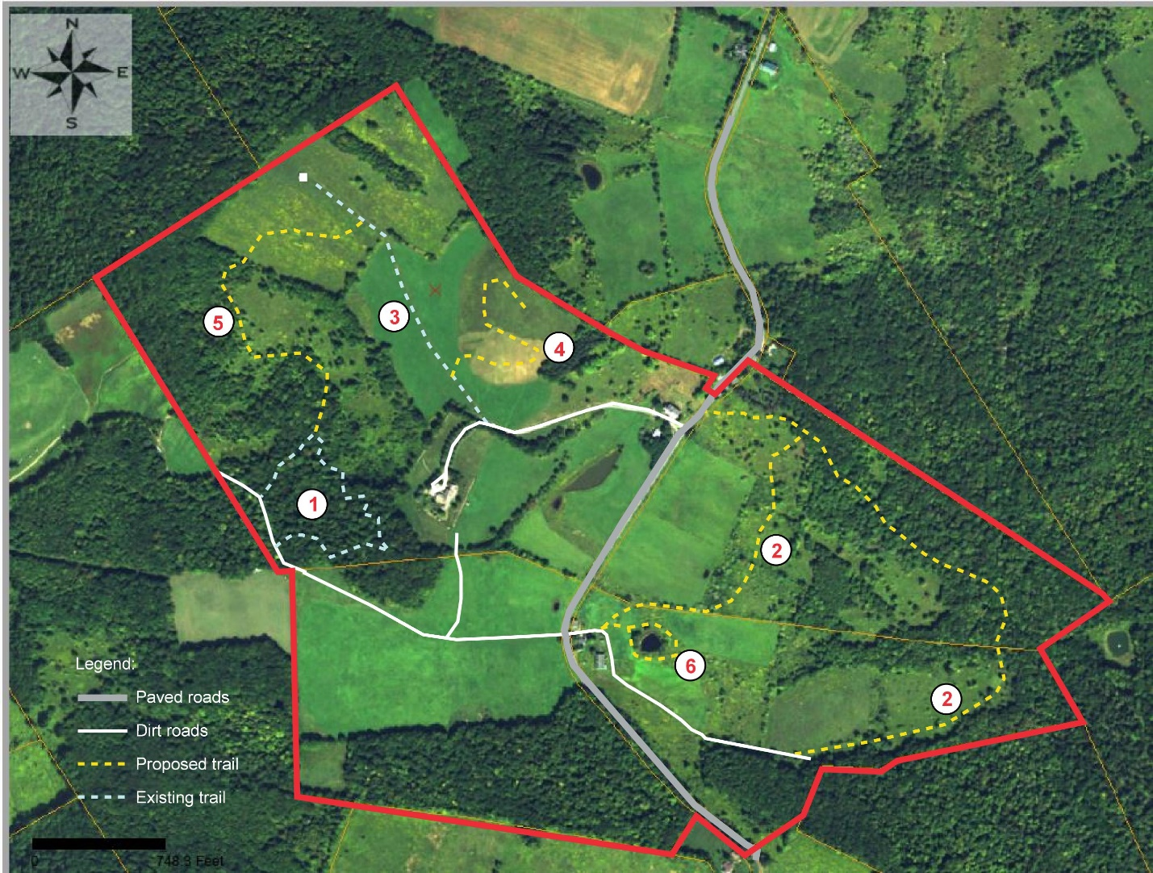
Figure 2. Proposed trail system at TUC.

Funding opportunities for new trail development: The Home Depot Foundation is offering grants awards up to $5,000 in the form of home depot gift cards for the purchase of tools, materials, and equipment. The Uplands Center can acquire tools through this foundation for the construction of trails and other building projects. Link (https://corporate.homedepot.com/grants/community-impact-grants ).

Add crosswalks on Dunk Hill Road. Two crosswalks should be constructed to create safe passage between the two sections of property bisected by Dunk Hill Rd. The first should be placed near the end of the driveway near the Tweedy house to connect the driveway with the Meadow Brook Trail. The second should be near the staff housing to connect the two dirt roads on either side of Dunk Hill Road. Having a pedestrian/child crossing sign put in place along with these crosswalks will help vehicles be more aware of pedestrians.

Add directional signs at all trail intersections. Directional signs should be added to all trail and road intersections on the property (e.g., the intersection of the nature trail and old road). This type of sign will keep visitors from getting lost.

Add cautionary signage near water hazards. Because the water hazards on the property include the creek, pond, and spa areas. It is important for employees to stress the dangers of these area to visitors, especially those with small children. In order to have this information available to visitors 24/7, hazard signage is recommended on the Meadow Brook Trail (near the brook), on the Pond Trail, and in the spa/pool area.

Use local resources to complete construction projects. Reach out to local construction companies in Delaware County to complete projects at The Uplands Center. These projects include grading the main driveway at the facility, as well as renovating barns that maintain the historic integrity of TUC. Refer to the suggested construction companies within the assessment portion of the report for assistance with these projects.

Source outdoor gear for visitor experiences. Work with local businesses to obtain outdoor gear needed for activities at The Uplands Center. Gear can include walking sticks, snowshoes, field guides, and binoculars, and can be either donated to TUC by sponsoring businesses or purchased by TUC from local businesses. The demand for recreational equipment will increase as more overnight and hiking-related activities become available at the facility. Using local businesses will help start partnerships with locals and keep transactions local while providing for the needs of participants.

Utilize non-permanent housing structures. The opportunity exists for TUC to add non-permanent housing to its property in the Community/School Group Zone. Canvas platform tents could serve as additional guest housing, and would be especially useful to youth groups or other large groups wishing to stay overnight on the property. TUC will need to decide if having groups stay overnight will help accomplish its mission before adding this type of structure.

Obtain a shuttle van. The purchase of some sort of shuttle could greatly enhance the ability for guests to arrive at TUC. Public transportation is limited and can only bring guests to Walton, not all the way to TUC. Having a shuttle could allow for larger groups to access TUC as it will allow for transportation from local airports, bus depots, and train stations. A shuttle could provide access to locals from Walton as well, and could be used to shuttle visitors to accommodations on the property.

Goal #3: Within five years, TUC will have collaborative relationships in place with universities, schools, and organizations that encourage educational opportunities and research projects at the TUC property.

Supporting partnerships with schools and universities. Encouraging partnerships with universities or local schools will be crucial for TUC to develop youth summer programs, internship programs, and research projects with universities. TUC’s property could become an important facility for university research in agriculture, environmental sustainability, and natural resources management. Many programs and classes at local institutions seek class projects and internships that will give their students hands-on experience. Connections to these local institutions could increase educational opportunities for students, provide more diverse programming at the Center, and aid the Center in the creation of programs and events, important materials (e.g., brochures, interpretive signs), and facilities (e.g., trails). Partnerships with these institutions will also make it possible for TUC to gain volunteers and interns in the future.

Cater programs and experiences to the Walton Central School District. The Walton Central School District encompasses a large geographic area within three schools in Walton, NY. The proximity of this school district poses a great opportunity to reach people in a large geographic area very easily, and also presents a great opportunity to advertise to families in a large geographic area. Catering to the Walton Central School District is a wonderful way to invest in the future of the community. According to the New York State Education Department, students in grades 3-8 in this school district are less proficient in English language arts and mathematics than the average student in New York State. Educational support through programs and experiences at TUC could be a good opportunity to nurture students in the community.

Strengthen collaborations with the Delaware County Chamber of Commerce. The Upland center is already a member of Delaware County Chamber of Commerce. Active engagement in the chamber’s activities and events will strengthen collaborations between TUC and the chamber, and assist TUC with its marketing efforts. Promoting TUC’s planned activities through the chamber’s website will help create opportunities for short- and long-term collaborations.

Build strong connections to the local community. Through partnerships with local community organizations, the Uplands Center can continue to create deep connections with the community. Organizations such as Delaware County Rehabilitation Support Services and the Walton Theater would provide the opportunity to advertise the Center, educate the community, and work to improve and unite the community. Walton Theater already has a strong partnership with the local Rehabilitation Support Services Office; a connection with these organization could potentially lead to more diverse program opportunity for guests, bringing a STEAM (Science, Technology, Engineering, the Arts and Mathematics) focused approach to the Uplands Center. With the inclusion of local music and arts groups, the Uplands Center can begin to explore different art and music therapy methods.

After-school programs. The New York Life Foundation is offering “2020 Aim High grants” to 501(c) (3) organizations that seek to offer afterschool and summer programs to middle school youth. The Upland Center can apply for this grant since part of their mission is to provide the school children in Walton afterschool education. Link: https://afterschoolalliance.smapply.io/ .

Goal #4: Within five years, TUC will offer seasonal environmental programs and activities that connect visitors to the natural world, illustrate the interrelation of all life, and demonstrate sustainable practices.

Create a system for monitoring events and programs. Have a physical or digital system in place to collect monitoring data for attendance and program outcomes. All program attendees should be asked to complete a program/retreat evaluation form so that outcomes from events can be monitored. This type of monitoring system would allow TUC to have a record that can be referred to for evaluating whether its goals are being achieved.

Incorporate indigenous representation. Acknowledging the history and legacy of indigenous peoples in the region, specifically the Lenni-Lenape who were forcibly displaced by colonial powers, can be done in part through reading formal land acknowledgements at the beginning of TUC programs and including this information on interpretive signs at TUC. A conscious effort will be needed to integrate indigenous issues into any discussions on the history of the land on which the Uplands Center stands, as well as the Catskills region broadly. Acknowledging indigenous history, and providing a platform for collaborating with local indigenous organizations, is critical in order to foster an inclusive and intersectional understanding of the Uplands Center’s place in history and the landscape.

Enhance TUC’s website. Several improvements are needed to enhance TUC’s website in order to better reach potential guests.
- Improve text on the website. Currently on the website the text referring to events at TUC includes phrases like “such activities might include” that give potential guests the impression that no events have happened so far. Replace these phrases with examples of events that have already happened to provide an additional bit of credibility to TUC’s online presence.
- Create an online calendar of events. Add a calendar onto the official website. Keep this calendar updated and mirror these updates on Facebook. Both platforms are useful for helping potential guests determine which events they’d like to attend. Note if an event is open to the public, ticket price, time, etc. for upcoming events.
- Use original photography online. Replace the stock photos currently used on TUC’s website with pictures that were actually taken at events at TUC. This lends an additional bit of credibility to the online presence and is an easy fix.
- Have guests sign waiver to have photos taken. In order to ensure that sufficient legal permission has been given by guests to use their photos online, have adult guests sign a waiver. Note that any child under 18 will need their parents to sign the waiver instead.
- Update existing blog with news of events at TUC. The blog is a currently unused opportunity to post details on the outcomes of events and programs at TUC. Updating this blog regularly, and allowing input from people who went to the event, will allow potential visitors to know a little bit beforehand about what they can expect their experience to be like.
- Provide wellness educational information. Information on wellness practices should have dedicated webpages within the center’s website. A page describing the in-depth benefits and methods of each practice will allow visitors to feel prepared and welcome upon arrival. Foundations of trust and connection can be built in advance of on-site arrival by providing quality information online to visitors.
- Include information about donations to local food banks. Information about the ways in which TUC’s crops benefit Walton, NY and the surrounding area should be accessible to visitors via TUC’s website. Website information explaining the connection between the center’s garden and the surrounding community is essential to building a strong relationship with visitors. Facts such as the average amount of food donated to food pantries per week should be included.
- Include information about sustainable farming practices. Information posted on the website should include ecologically responsible agricultural techniques practiced by the center (e.g., the use of organic pesticides and drip irrigation).

Implement crop labeling system. The on-site organic produce garden will benefit from an in-garden labeling system for each crop. This system will allow visitors to identify all crops within the garden, helping them to become more familiar with the crops visually. By making names of vegetation more accessible to visitors, a stronger connection between attendees and the center’s agriculture/food system will be formed. This system could be implemented by using stakes with small signs at the top for labeling.

Add a sign about sustainable farming practices. A sign should be posted near the entrance to the garden area that includes ecologically responsible agricultural techniques practiced by the center. Information on how visitors can make responsible choices when purchasing crops and the benefits of shopping at local farmer’s markets should be included.

Develop a resource for natural history observation. A brochure including photos and short descriptions of commonly found species should be developed for each trail at TUC. This brochure could include information on commonly observed ground vegetation, trees, mammals, and mosses. Tips for spotting wildlife could be included within the brochure. This brochure should be developed with an 8th grade reading level in mind, to ensure that the information is accessible to a maximum number of visitors. This brochure will give visitors the option to learn about nature without being disrupted along the trail with large or intrusive signage. A note should be included on the brochure encouraging participants to ask staff about wildlife and plants local to the area. Visitors will be able to walk away with both tangible and intangible information regarding the natural world.

Create a workbook for young visitors. A workbook designed for children would be useful to implement along the Pond Trail. The workbook could include a scavenger hunt page with small pictures of items to find such as a tree, leaf, rock, stick, moss, bird, squirrel etc. This type of book will allow children to engage with the natural setting of TUC, creating opportunities for hands-on learning. Upon completion of such activities, staff may opt for a small badge or reward for the child which displays the name of the Uplands Center. This will foster a positive, hands-on learning environment for young visitors that could be used by school groups as well.

Create off-site experiences for visitors. Numerous opportunities exist in the area for visitors to explore other nature-based tourism opportunities. These include:
- Wildlife viewing programs in local parks. Educating guests on local and unique biota is not only beneficial to the guests but also beneficial to conservation purposes. While the land TUC is located on is beautiful and biodiverse, surrounding areas can provide a much larger perspective on New York’s wildlife. Day trips to Delaware Wild Forest and the Bear Spring Mountain Wildlife Management Area allow for fantastic opportunities for outdoor educators and guides to conduct plant walks, birding walks, and even field herpetology programs. Day trips on weekends could become a new tradition for guests to try.
- Water sport opportunities for guests at Cannonsville Reservoir. While the Uplands Center already offers a large catalog of activities and programs, one type of program that is missing is water sports. Cannonsville Reservoir is 455 square miles in size, and provides the opportunity for activities such as canoeing, kayaking, fishing and wildlife viewing. Multiple launch points exist at the reservoir, allowing for day trips for activities such as fishing. Wildlife viewing can be easily done on kayaks or canoes, giving guests the chance to see more elusive animals such as otters, shorebirds, and mink. Programs like these could become amongst the Upland Centers’ most popular activities.
- Group trips to Howe Caverns and other local attractions. Interested groups visiting and using the ULC’s facilities have the opportunity to visit attractions such as Howe Caverns, the Hanford Mills Museum, and the Iroquois Indian Museum. Howe Caverns offers daily cave tours. The Hanford Mills Museum offers workshops and guided programs which can be useful for student education programs. The Iroquois Indian Museum provides a unique collection of relics from Native American nations allowing for a wonderful chance to teach about the area’s native culture.
- Overnight backpacking trips in Delaware Wild Forest. Delaware Wild Forest is close to TUC and offers an opportunity for more “advanced” trips. The forest provides four lean-tos and multiple campsites which can be used for multi-day trips. While multi-day trips might not always appeal to all TUC guests, there may be some guests interested in such activities. Trails and routes which are covered on these trips may vary, and should planned by guides and approved by rangers.
Develop a presence at local festivals and events. Many festivals and events exist in the Delaware County area that provide staff the opportunity to promote TUC. Materials developed about the sustainable practices and efforts at TUC could be presented at these events. Food and crafts sold at TUC could also be sold at these events. These festivals and events include:
- Dairy Festival. Become a vendor at this festival to provide promotional materials about TUC. Selling TUC goods at this festival could also help generate income. An effort such as this one is useful for networking and outreach to individuals and organizations that value local farm-based products.
- Delaware County Fair. Tabling at this week-long event would be a great opportunity to be involved in the Walton community while promoting TUC to those visiting from outside of Walton. Goods from the center could be sold to bring in revenue.
- Farmers markets in Delaware County. One or two locations could be chosen to reach the majority of the county throughout the summer. Provide free samples from the garden or local craft experiences to gain interest without distracting from the local community. Providing farm-to-table recipes could enhance the experience and display the values of the center.
- Catskill Mountain Yoga festival. This festival is for all types of yoga and promotes healthy living. It makes for a great place to gain the attention of those already interested in yoga. Hosting a session at his festival would provide TUC with promotional assistance for its yoga programs.
- Castle on the Delaware. As a popular event space, this facility draws a lot of attention from those outside the Walton community. Though many of the events are limited in relevance to TUC, hosting an event in this space would redirect this concern and be a great way to enhance interactions with the local community.

Increase partnerships with local businesses. Reach out to local businesses to post TUC program advertisements and create potential program sponsors at TUC. Businesses can also be integrated into community events hosted at the facility and allow community members the opportunity to experience TUC services and goods.

Goal #5: Within five years, TUC will meet the individual needs of staff and volunteers by fostering effective communications among staff, fair employment practices, and a safe work environment.

Staff training focusing on first aid and emergency preparedness. In the event of an emergency, having well-trained staff is critical. Employees should have basic first aid training (including CPR) to be able to treat minor to mild injuries. First aid supplies should be placed in all zones of TUC, and small, basic first aid kits should be carried by staff. Staff should be familiarized with TUC’s emergency plans. Emergency drills should be carried out at least twice a year, with all employees participating.

Seek grants from The J. Willard and Alice S. Marriott Foundation. The Marriott Foundation is a private foundation that provides single and multi-year grants for five focus areas: education, hospitality, opportunity, community, and health. Grants are focused on seeking community change through empowerment. Grants from this foundation could help train staff and volunteers at TUC with regard to how best to meet the needs of local residents and retreat goers.

Hire an experienced grant writer: It is recommended that a professional grant writer is hired under contract with TUC, or that a staff member or volunteer willing to write grants is identified. Having a designated grant writer in place will remove this responsibility from other staff members.

Goal #6: Within five years, TUC will have management strategies in place that promote and improve the health of the environment, while providing for human needs.

Promote environmental sustainability and sustainable agriculture in guest programming. Partnering with regional non-for-profit organizations such as the Cornell Cooperative Extension, Center for Agricultural Development and Entrepreneurship, the Catskill Center for Conservation and Development, the Delaware County Beekeepers Association, and the SEVA Foundation would provide ample opportunity for increased environmental awareness. These organizations have nearby regional offices, and could provide assistance for a variety of programs, lessons, and activities at TUC. Partnerships with these organizations to create and lead programs for guests would ease the burden placed on TUC staff. These organizations could also provide invaluable information and guidance on adding different sustainability programs to TUC, such as large-scale composting, regenerative agriculture, and beekeeping.

Establish connections with local farms. Integrate local produce into the culinary experience at TUC by reaching out to other farms in the area. The current garden at TUC is small and catering to more guests will stress this resource. Working with local farms will help supply enough food resources to The Uplands Center for an increasing number of guests. Local farms such as Greenane Farms and Stony Creek Farmstead provide prime opportunities for collaboration. In addition to providing food, the opportunity for farm staff to provide tours of their facilities to guests could be profitable. Keeping the outreach to local organic farms will maintain consistency with TUC’s values.
Construct greenhouse and expand garden. The USDA Community Facilities Direct Loan and Grant Program is providing grants to non-profit organizations that engage in essential community services. The Upland Center can apply for this fund and construct a greenhouse and at the same time expand the garden. Produce from the garden and greenhouse can be donated to the Walton community. Link (https://www.rd.usda.gov/programs-services/community-facilities-direct-loan-grant-program ).

Expand agriculture-related promotions. By listing TUC on sites such as New York Farm Tours and Farm Stays US, The Uplands Center could further promote itself as an agritourism enterprise. These websites connect farm stay businesses with potential guests that are interested in the care, craft, and history of farming and agriculture. Partnerships with these organizations would provide promotional opportunities for the Center, ultimately providing visitors with the opportunity for education, tours, and lodging on the property. This type of promotion could also bring in a much-needed stream of income revenue for the Uplands Center.

Utilize a rain collection system. Construct a rain harvesting system at the Main House to collect rainwater for use in the gardens. This collection system could also be used as an educational tool on lessons in sustainability. The system itself could be simple or robust, as budgeting constraints allow.

References

Alcohol and Drug Abuse Council of Delaware County . (2019). Retrieved from https://www.adaconline.org/

Binghamton University. (2019). Retrieved from https://www.binghamton.edu/

Bird Checklist. (2015). Retrieved from https://parks.ny.gov/parks/attachments/ClarkReservationClarkReservationBirdChecklist.pdf

Cooperative Ecosystem Studies Units. (2018). Retrieved from http://www.cesu.psu.edu/default.htm

CORNELL. (n.d.). Retrieved from https://www.esf.edu/

Cornell Cooperative Extension. (2019). Retrieved from http://ccebroomecounty.com/

Delaware County Chamber of Commerce. (2019). Retrieved from http://delawarecounty.org/

Delaware County Soil and Water Conservation District. (n.d.). Retrieved from https://www.dcswcd.org/

Delaware General Health District. (2019). Retrieved from http://delawarecountypublichealth.com/

Department of Environment Conservation. (n.d.). Retrieved from http://www.dec.ny.gov/index.html

Environmental Facilities Corporation. (n.d.). Retrieved from https://www.ny.gov/agencies/environmental-facilities-corporation

ESF. (2019). Retrieved from https://www.esf.edu/

Extension Disaster Education Network. (n.d.). Retrieved from https://nifa.usda.gov/extension-disaster-education-network

FEMA. (n.d.). Retrieved from https://www.fema.gov/

Hurwitt & Associates. (2019). FAQ: Private Operating Foundations. https://www.hurwitassociates.com/private-foundations/faq-private-operating-foundations.

Nanticoke Lenni-Lenape Tribal Nation. (2017). Retrieved from http://nanticoke-lenapetribalnation.org/about/.

Natural Atlas. (n.d.). Retrieved from https://naturalatlas.com/.

NRCS. (n.d.). Retrieved from nrcs.usda.gov/wps/portal/nrcs/site/de/home/

Office for the Aging. (n.d.). Retrieved from http://www.co.delaware.ny.us/departments/ofa/whoweare.htm

Parks.NY.Gov. (2019). "Clark Reservation State Park". https://parks.ny.gov/parks/126/details.aspx.

RITA: BTS: Transtats. (n.d.). Retrieved from https://www.transtats.bts.gov/airports.asp?pn=1&Airport=BGM&Airport_Name=Binghamton, NY: Greater Binghamton/Edwin A. Link Field&carrier=FACTS.

rome2rio Pty Ltd. (n.d.). Discover how to get anywhere. Retrieved from https://www.rome2rio.com/.

State University of New York at Delhi. (2019). Retrieved from https://www.delhi.edu/

State University of New York College of Agriculture and Technology at Cobleskill. (2018). Retrieved from https://www.cobleskill.edu/home.aspx

Tamarack Adventure & Retreat Center. (2019). "About - Tamarack Adventure & Retreat Center". https://tamarackadventure.com/about/.

Town of Walton. (n.d.). Retrieved from https://townofwalton.org/

US Census Bureau (n.d.). American FactFinder—Community Facts. Retrieved October 29, 2019, from https://factfinder.census.gov/faces/nav/jsf/pages/community_facts.xhtml?src=bkmk

United States Access Board. (2013). Final Guidelines for Outdoor Developed Areas. Available online at https://www.access-board.gov/guidelines-and-standards/recreation-facilities/outdoor-developed-areas/final-guidelines-for-outdoor-developed-areas/text-of-the-guidelines

The Upland Center Staff. (n.d.). The Uplands Center | Environmental Vision.

The Uplands Center. (2019). Not-for-Profit Retreat Center: Western Catskills, New York. Retrieved from https://www.uplandscenter.org/who-we-are/.

Walton Central School District. (n.d.). Retrieved from https://www.walton.k12.fl.us/

WALTON CSD | NYSED Data Site. (n.d.). Retrieved November 10, 2019, from https://data.nysed.gov/profile.php?instid=800000053499

Walton High School Walton, NY School Boundaries Map & School Profile. (n.d.). Retrieved November 18, 2019, from https://newyork.hometownlocator.com/schools/profiles,n,walton high school,z,13856,t,pb,i,1079372.cfm

Walton, NY & Delaware County, NY | Data USA. (n.d.). Retrieved October 29, 2019, from https://datausa.io/profile/geo/walton-ny?compare=delaware-county-ny

Walton Public Library. (2012). Retrieved from http://walton.avcnet.com/

