2017 BBD proposal Collaborators:
Gretchen Lasser Trey Turnblacer
07/05/2017 Daniel Hong
Dr. Mariann Johnston

Monitoring Beech Bark Disease progressions in Aftermath forests
Introduction
Beech bark disease (BBD) is a pathogenic complex that causes high mortality and morbidity of American Beech trees (Fagus grandifolia) in northern hardwood ecosystems (Mason M. E. et al, 2013). Beech is a dominating species in northeastern hardwood forests and its declining populations guarantee that changes in ecosystem dynamics will occur, if they have not already. Even after a century of study and observation the disease process of BBD is not entirely understood.
BBD is a disease complex involving both insect and fungus components. It results when one of two species of beech scale, Crytococcus fagisuga or Xylococculus betulae (Cale et al. 2015), attacks and alters the cork and cork cambrium, or bark, to access sugars that are being transported through the phloem of the tree. Scale insects are unique in that they will become immobile adults after they have successfully invaded a tree for a period of time, typically one winter. After this period, C. fagisuga and X. betulae will live out the rest of their lives feeding on the same tree (Wisconsin Department of Natural Resources, 2008). It is believed that the disruptive presence of beech scale precedes and predisposes beech to a fungal infection by Neonectria ditissima or Neonectria faginata, perhaps by means of weakening the bark barrier against fungal entrance, although the exact mechanism remains unclear (Kasson and Livingston, 2009). The fungi create lesions of dead tissue on the tree which turns into cankers as the tissue around the lesions continue to grow (Mason M. E. et al, 2013). The fungus eventually wraps circumferentially around the beech and girdles it, causing secondary effects to the tree such as dehydration, transportation disruption, and lowering the tree’s overall ability to fight off infection and invaders (Cale J. A., et al, 2014).
Recent studies have found that there are multiple biotic and abiotic predisposing factors that impact the susceptibility of F. grandifolia to Neonectria. These susceptibility factors include bark chemistry characteristics such as low levels of phosphorus and calcium, excessive or deficient amounts of nitrogen, and predisposal to scale insect colonization (Cale J. A., et al, 2014). On their own, C. fagisuga and X. betulae are not deadly to beech, but they create opportunities for Neonectria to invade tree bark (Wisconsin Department of Natural Resources, 2008). BBD is very deadly and the initial killing front, designated as 1 to 19 years after the arrival of the scale infection, has a 50% mortality rate with less than 1% of all American beech has shown resistance (Mason M. E. et al, 2013). Almost all beech in the North Eastern United States are infected. The final aftermath forest phase results in an ecological accommodation to the disease, resulting in either a change in species composition or the death of re-emergent beech (USFS, 2007).
Fagus grandifolia are the only trees immediately affected by the disease, but there are intermediate effects on overall forest health. When American beech trees are under stress, they send out root sprouts in response, creating large homogenous monoculture patches of beech sprouts (Personal communication, Johnston, M., 2015). The sprouts then compete for the nutrients and resources that other species (sugar maple, red maple, etc.) would utilize for growth and survival. This can eventually lower the overall biomass and presence of key species such as maples in northeastern forests.
The MELNHE project area contains multiple stands within Bartlett Experimental Forest. These along with two stands in Jeffers Brook, owned by the Forest Service, will be my area of study. These stands are classified by age (mature, mid-aged, and young). There are four plots in each stand, each with a different treatment (nitrogen, phosphorus, nitrogen & phosphorus, calcium, and a control). Within C1, C6, C8 and soon HBO & HBM, an additional 5th plot has been established and treated with calcium silicate. All plots are treated once annually. The calcium silicate plots were only treated once at the time of their creation because calcium silicate washes away much more slowly than nitrogen and phosphorus. There are buffer zones between each treatment plot to prevent crossing over of nutrients between plots. American beech above 10 cm DBH (diameter at breast height) were tagged. Out of all of the F. grandifolia in each stand, 281 of the previously tagged trees were then rated using the 2013 rating system (created by Adam Wilde & Jon Cale) and photographed. These photos were taken in seven stands in Bartlett (C2, C3, C4, C5, C7, C8, & C9). Ratings have been given separately to every tagged beech tree within the Jeffers Brook, Hubbard Brook, and Bartlett stands in 2011 using a rating system created by Matt Vadeboncoeur. This rating system observed the overall health of each beech tree. These rating systems can be seen in the methods section.
Objectives
I will be surveying trees for BBD in stands C2, C3, C4, C6, C7, C8, JB Old, HB Old. These stands were chosen for their varying levels of soil phosphorus, the number of beech trees present, and because biennial surveying has occurring since 2011. My objective will be to collect comprehensive assessments, rating and photo inventories (see methods below), for all tagged beech trees so that ratings can be added to our current data set to continue to monitor our aftermath forests for potential trends. If present in August I will be collecting fungal scrapings to correctly identify which fungi, Neonectria ditissima or Neonectria faginata, is most present.

Methods

I will be using multiple surveying methods for this study: a BBD scoring method to assess trees, a frame/photograph method to quantify C. fagisuga white wax masses, and a collecting method to identify Neonectria species.
- Dan Hong, Trey Turnblacer, and I will score tagged beech trees independently for scale and fungus using a powerpoint training document created by Adam Wild.
  - Scale:
0 - no colonies present
1 – Trace from one colony to light very scattered individual colonies. One or two larger colonies only
2 – Light, scattered colonies. Some larger colonies may be present
3 – Moderate infestation, many colonies visible. Substantial number of larger colonies may be present
4 – Heavy infestation. Many large colonies present. Some colonies coalescing.
5 – Very heavy infestation, most of bark conspicuously white.
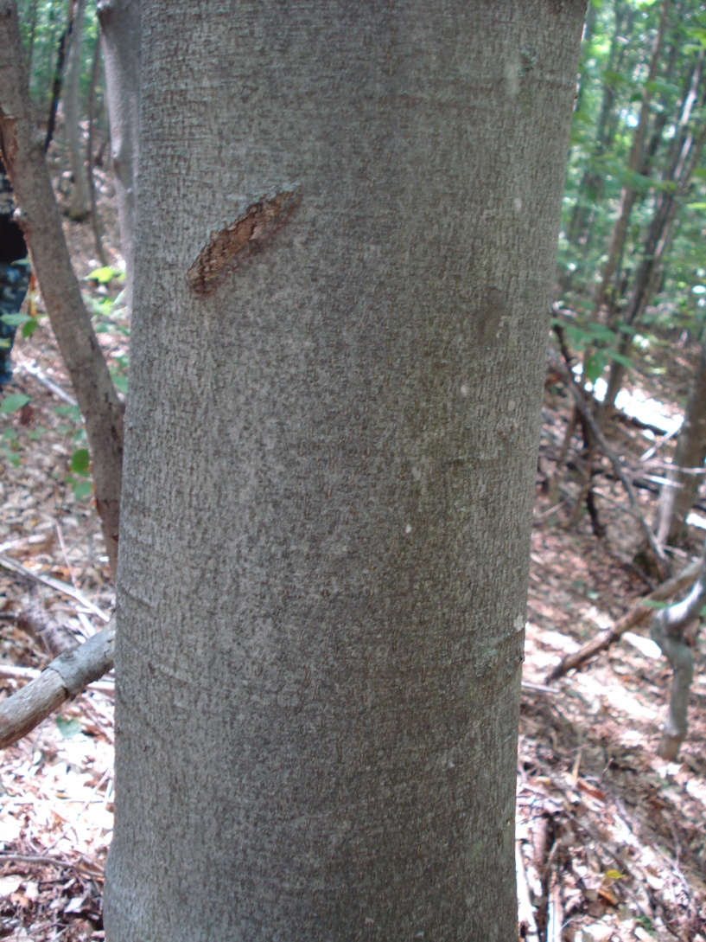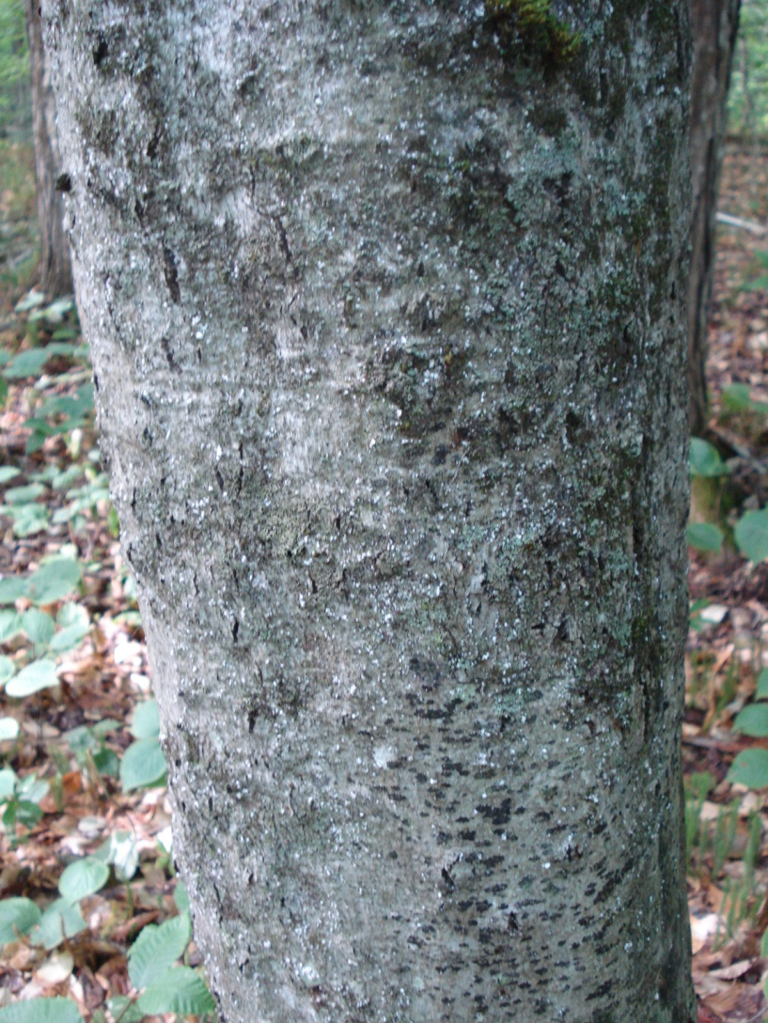
Scale score 0 (left) vs scale score 5 (right)
  - Fungal score:
0 – Absent.
1 – Sparse sunken legions. Sparse localized perithecia (perithecia not always present) or few scattered circular infections.
2 – Few sunken legions covering part of the tree.
3 – Sunken legions covering most of tree.
4 – Sunken Legions covering the entire trunk.
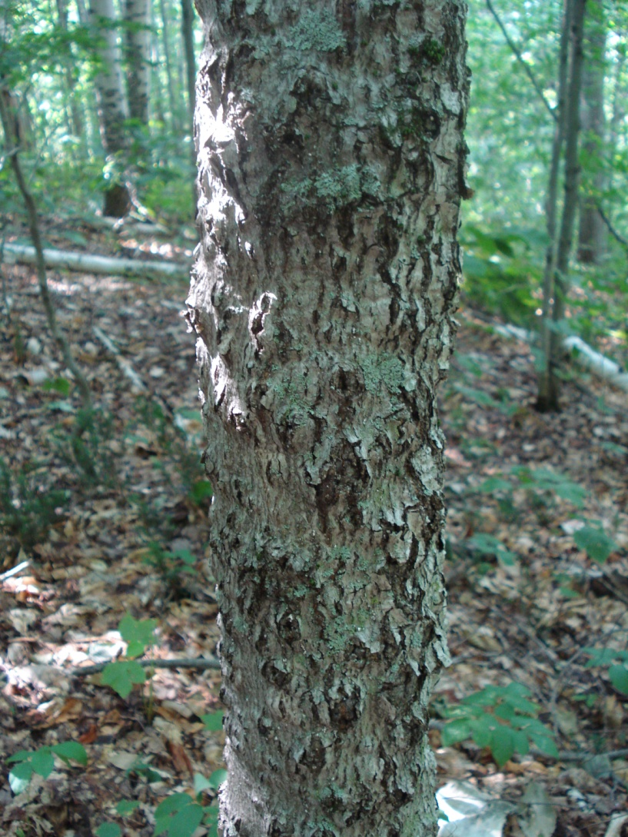
Fungal score 0 (left) vs fungal score 4 (right)
  - Tree condition:
1 – Good. Foliage green, <10% dead crown branches
2 – Fair. Foliage green to yellow green, 10-50% dead crown branches
3 – Poor. Foliage green to yellow green, >50% dead crown branches
- For the Frame/photography portion I will be photographing beech surfaces with two aluminum flashing frames with “L”s cut into them (“L frames”) with L dimensions of 10cm x 5cm that is 1cm wide to take 8 photos per tree. One frame will be used for “upper” level photos and the other for “bottom” level. Each level will have four photos taken at the four cardinal directions and will be in two colors, orange for upper and blue for bottom to help make photo sorting easy. Size of frame doesn’t matter as “L” size is most important for ImageJ analysis. The upper frame will be placed beneath each tree tag, at approximately 1.5m and the bottom frame will be at 0.5m. Five beech trees per plot will be selected for sampling totaling 20-25 trees per stand depending on the presence of Ca plots. Within each plot the five trees will be selected to represent a range of BBD infection and should be as far apart from each other as possible, ideally 20m, to avoid sampling genetically identical ramets. Trees exhibiting conks of decay fungi will be avoided. Sample trees should fall within a diameter at breast height (DBH; 1.4m) of 20-35cm and exhibit a range of symptoms of BBD. Lower DBH trees will be utilized if needed but all trees within a stand should remain within 10cm of each other. Pictures will be taken I will total eight per tree. No flash will be used and photos will line up with the L that has been painted on the tree. Photo order will be Tree tag, Top level in north, east, south, west then lower level in north, east, south, west order. The possibility of pushpins to designate cardinal direction will be considered.

Out of the field the number of scale wax masses in each frame will be counted up to 100; over 100 will be listed as (>100). An average number per tree will be calculated to quantify Cryptococcus. The number of excretory tubes within the frames will be counted and then also averaged per tree to quantify Xylococcus.
- Neonectria collection and culturing method:
Field methods: Using sterile 3 dram glass vials (60 per stand, 75 if including a Ca plot), a flat-edged metal blade, a jet-lighter (butane-powered), Lab tape, a marker for labeling vials, and Parafilm for extra sealant protection, collect samples of the neonectria’s asexual fruiting body, or sporodochia. Up to three lesions per tree will be collected via a sterilized blunt blade that gently balances the sporodochia and places it in the vial. Vials will be agitated to dislodge the material into the sterile water. The blade will be flame-sterilized and the process will be repeated to gather sufficient sporodochia from that lesion. The vial will be capped and labelled, sealed with parafilm and placed on ice. This procedure will be repeated on up to three lesions per tree, with each lesion being scraped into its own vial with a fresh vial for each lesion. It is possible to have both Neonectria species on one tree, which is why it is important to get multiple lesions per tree and keep them separate.
Lab methods: Vials will be filled to the top with sterile water using a sterile pipette and placed in a refrigerator. Spore solution will be examined with a microscope slide with a wet mount and examined for macroconidia, the size and shape of which identifies the species of neonectria.

An ideal specimen will look like the image to the left with the white sporodochia developing above the red perithcia.

Species | Macroconidia length | Macroconidia width | Macroconidia shape | 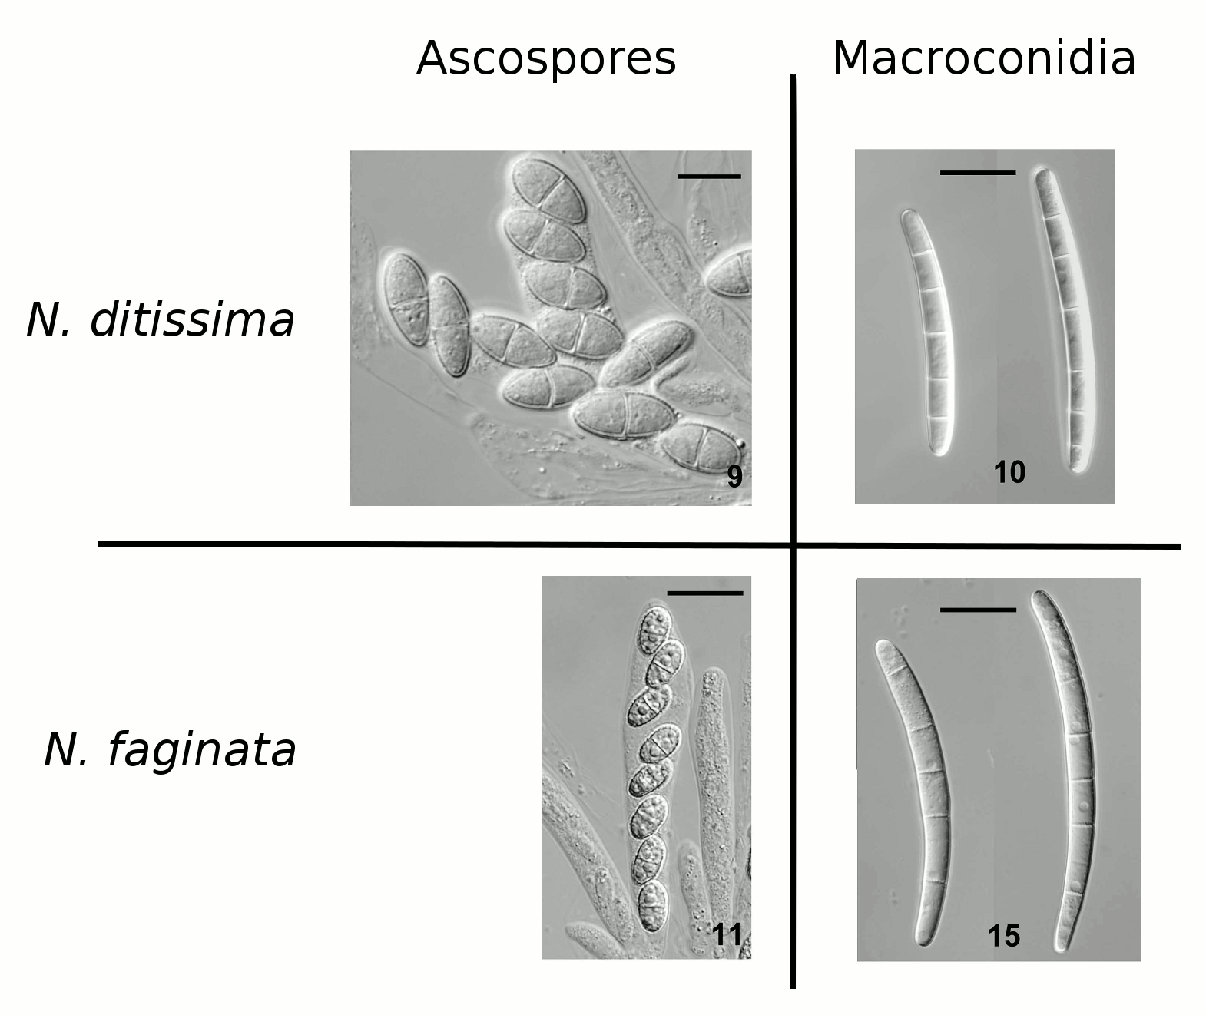
Neonectria ditissima/ Cylindrocarpon heteronema | Approx 65-75 um | Approx 7 um | Straight to slightly curved
Neonectria faginata/ Cylindrocarpon faginatum | Approx 90-100 um | Approx 9 um | Strongly curved, crooked or sigmoid (occasionally straight)

Budget
Assessment of all F. grandifolia located within the MELNHE stand will take approximately a week to complete. Daniel Hong, Trey Turnblacer, and I assisted with BBD assessment and rating. Aluminum frames for photographing cost $0.46/piece. One piece created 2 L frames. I am using the same high resolution digital camera that was used last year by An, provided by Mariann from the ranger school. Five nails and tags will be required to tag JBO control trees (material located in lab). 4 cans of tree marking paint from Labonville INC in Gorham to re-mark trees, ~ $22. Since I joined the work season late I am anticipating finishing any ratings this week and taking pictures during the month of august with fruiting bodies occurring in august.

Week 4 | Week 5 | Week 6 | Week 7 | Week 8 | Week 9 | Week 10
BBD Assesments | Proposal and presentation | L frame build and correct proposal | Pics | Pics | Neonectria  assessment  and collection | Neonectria  assessment  and collection

Hypothesis
- Trees in phosphorus plots will show a lower severity of beech bark disease.
- Trees in old stands will have higher incidence and severity of BBD
- No major changes in status of BBD on trees are anticipated
- We are anticipating some neonectria collection since last year was a dry year and no sporodochia was found. Historically there are higher amounts of sporodochia is produced after drought years.

Citations
Wild, A., Johnston, M., Cale, J. A (2013). Scoring beech bark disease.
Egan-Anderson, E., Turlip, J., Wild, A., Suttenberg, S., Littlefield, S. (2014). 2014 MELNHE mature stand stem mapping.
Cale J. A. et al. (2015). New ecological and physiological dimensions of beech bark disease development in aftermath forests: State University of New York College of Environmental Science and Forestry. Elsevier.
Kasson, M. T, & Livingston, W. H. (2009). Spatial distribution of Neonectria species associated with beech bark disease in northern Maine. Mycologia, 101(2), 190-195. doi: 10.3852/08-165
Mason, M. E., Koch, J. L., Krasowski, M., & Loo, J. (2013). Comparisons of protein profiles of beech bark disease resistant and susceptible American Beech (Fagus grandifolia): Ohio State University. Proteome Science.
Wisconsin Department of Natural Resources (June 2008). Preparing Wisconsin’s forests for beech bark disease. pg. 1-2. Retrieved June 2, 2015. dnr.wi.gov

Bartlett Experimental Forest (n.d.). Retrieved June 6, 2015. fs.fed.us
Melany Fisk, Pre-treatment soil P data for MELNHE stands
USFS, Northeastern Area, Forest Health Protection. (2007, July 11). Northeastern Area. Retrieved July 05, 2017, from https://www.na.fs.fed.us/fhp/bbd/

