**Beech Interference With Maple Regeneration: Future Change in Forest Composition**

Daniel S. Hong June 2016

Introduction:

Start with problem statement (big picture), funnel us into your study.  May include justification for this approach (e.g., which stands you are working in) or this could be in Methods.

Objectives and Hypotheses

Methods: site description

Thirteen temperate forest stands have been inventoried since the summer of 2004 within the White Mountain National Forest. Although not undertaken in a strictly consecutive manner, the stands have been revisited and reinventoried in the summers of 2005, 2008, 2009, 2010, 2011, 2012, 2014, and 2015. The stands were carefully selected with a variance of ages following clear cuts and include young (~20 yrs.), mid (30 yrs.), and old (>100 yrs.) growth stands. This approach resembles that of the Federer Chronosequence study [there was no publication/presentation on this...right? should I explain a bit more about this study? Probably. I want to focus on the MELNHE stands but still include this data in the Appendix], which date back to 1994, but differ in that it is a part of the Multiple Element Limitation in Northern Hardwood Ecosystems (MELNHE) project, studying N and P acquisition and limitation through a series of nutrient manipulations. Along with tree inventory, the stands have been used for various above- and below-ground studies over the course of the years such as leaf litter, foliar nutrient resorption, roots, and soil respiration studies by the MELNHE project researchers.

Thirteen stands in which trees have been inventoried are located throughout three study sites in New Hampshire: Bartlett Experimental Forest, Hubbard Brook Experimental Forest, and Jeffers Brook in the White Mountain National Forest (Figure 1). Three replicate stands of young, mid, and old stands are in Bartlett and two stands of mid and old are in each of Hubbard Brook and Jeffers Brook, yielding a total of 13 stands. [should I focus on Bartlett stands? Because I believe HB and JB stands were established and inventoried later. I may do all] Each of these stands has four 0.25 ha, or 50 m x 50 m, treatment plots, treated annually beginning in spring 2011, with N (30 kg N/ha/yr as NH4NO3), P (10 kg P/ha/yr as NaH2PO4), N+P, or nothing (an untreated control) (Figure 2). Applications of these nutrients stem from the resource optimization theory that suggests ecosystem productivity should be co-limited by multiple nutrients and represented in the Multi-Element Limitation (MEL) model (Rastetter et al. 2012).

[I would like to update/make my own maps]

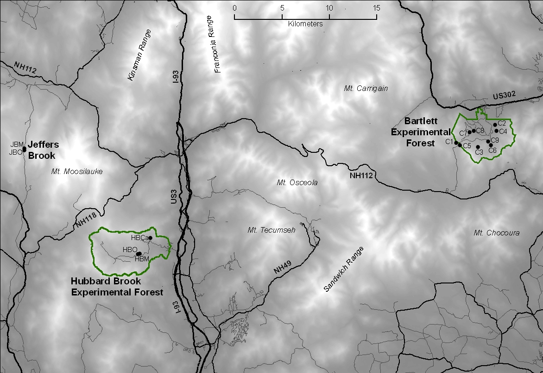

Figure 1. An overview map of the three study sites (Bartlett Experimental Forest, Hubbard Brook Experimental Forest, and Jeffers Brook) within the White Mountain National Forest, NH. Also depicted are the 13 stands throughout the three study sites as black dots. (Borrowed from the MELNHE website)

Macintosh HD:Users:danielhong:Downloads:MELNHE_sites_Bartlett_20111002.pdf

Figure 2. An overview map of the nine stands in Bartlett Experimental Forest, labeled C1 through C9. Also depicted are the four plots, sometimes with a fifth that had been treated with Ca (1150 kg Ca/ha as CaSiO3), as colored squares. However, for the purpose of this study, Ca-treated plots were not considered. (Borrowed from MELNHE website) [Ca plots? Should I include them?]

Tree species in northern hardwood ecosystems face numerous regeneration stressors such as invasive species, insects and diseases, herbivory, poor management, and climate change. As these ecosystems mature, species composition becomes an important part of vegetation management because hardwood species are used widely and variously as commercial products and as sources of wildlife food and habitat (Kochenderfer et al. 2001). For different species have their unique values and uses, it is imperative to maintain species diversity to sustain the production of desired benefits from these ecosystems (Miller and Kochenderfer 1998).

American beech, *Fagus grandifolia*, is common in the eastern deciduous forests of North America and considered a dominant species in northern hardwood ecosystems due to its great shade tolerance and moderately long lifespan. It reproduces from both seed and root sprouts, but mostly from the latter, and thus small American beech stems are often observed near larger beech trees (Kochenderfer et al. 2004, Tubbs and Houston 1990). Beech root sprouts were found to be more prevalent in the northern and western regions of North America where climates are severe (Held 1983).

Studies showed that dense understories of shade-tolerant beech interfered with reproduction and development of less shade-tolerant species such as sugar maple, *acer saccharum* (Horsely and Bjorkbom 1983, Horsley 1991). [Sugar maple is relatively shade-tolerant compared to others. I may have a section about sugar maple. Also I feel like my writing is biased against maple and that I should be more neutral since I want to find out what actually happens to both beach and maple] Beech bark disease and root injuries during logging and by natural causes such as deer herbivory promote new suckers that increase the density of understory beech in a stand. As beech thickets produce layers of shade, the forest floor conditions become less suitable for the small seedlings of other shade-intolerant species from developing (Nyland et al. 2004, Horsley et al. 2003).

Table 1. Vegetation data species codes. [Forgot to refer to this table earlier. Do I even need all these species? Can I keep just keep the ones that were inventoried?]

|  |  |  |
| --- | --- | --- |
| Code | Common Name (s) | Scientific Name (s) |
| ASH | White Ash | *Fraxinus americana* |
| ASP | Aspen (unspecified) | *Populus spp.* |
| BA | Bigtooth Aspen | *Populus grandidentata* |
| BASS | Basswood | *Tilia americana* |
| BC | Black Cherry | *Prunus serotina* |
| BE | American Beech | *Fagus grandifolia* |
| CC | American Hornbeam | *Carpinus caroliniana* |
| DOG | Alternateleaf Dogwood | *Cornus alternifolia* |
| FIR | Balsam Fir | *Abies balsamea* |
| GB | Gray Birch | *Betula populifola* |
| HEM | Eastern Hemlock | *Tsuga canadensis* |
| MM | Mountain Maple | *Acer spicatum* |
| MTASH | Mountain Ash | *Sorbus americana* |
| OV | Eastern Hophornbeam | *Ostrya virginiana* |
| PC | Pin Cherry | *Prunus pensylvanica* |
| QA | Quaking Aspen | *Populus tremuloides* |
| RM | Red Maple | *Acer rubrum* |
| RO | Northern Red Oak | *Quercus rubra* |
| RS | Red Spruce | *Picea rubens* |
| SM | Sugar Maple | *Acer saccharum* |
| STM | Striped Maple | *Acer pennsylvanicum* |
| VIB | Hobblebush | *Viburnum lantanoides* |
| WB | White Birch species complex | *Betula papyrifera or B. papyrifera var cordifolia* |
| WP | Eastern White Pine | *Pinus strobus* |
| YB | Yellow Birch | *Betula alleghaniensis* |
| YEW | Canadian Yew | *Taxus canadensis* |
| UNK | Unknown species (dead w/o recognizable bark) | |

The objective of this study is to show the comprehensive growth patterns in each MELNHE stand in the past 12 years. By analyzing the changes in beech and maple composition in the treatment plots, I aim to find the effects of nutrient manipulation on the growth and regeneration of beech and maple and further beech interference with maple regeneration. Data from the chronosequence stands of 18 years are also used for comparison and included in Appendix. [I wanted to focus on the MELNHE stands originally and see how nutrient manipulation affects the growths of beech and maple and the competition between the two (counts and basal area) but also include chronosequence data in the appendix at the end for comparison. But recently, I was told that Shinjini is working on the MELNHE stand tree inventory (>=10dbh). So as my other option, I thought I could just combine the chronosequence data with MELNHE data prior to 2012 because fertilization began in the summer of 2011]

Methods:

Each of the 50 x 50 (m) plots was divided into nine 10 x 10 (m) subplots in a nested subplot design, where the nine 10 x 10 (m) subplots form a 30 x 30 (m) surrounded by a buffer zone (Figure 3). Trees were inventoried across the subplots and/or within a series of overlying smaller subplots (5 x 5, 2 x 2, and 1 x 1) inside the four corner (A1, A3, C1, C3) and center (B2) subplots. Different size classes of trees were inventoried in the series of subplots. Diameter at breast height (DBH; 1.35 m from the ground surface) was used to classify trees into different size classes.

In the 30 x 30 m, overstory trees, defined as those greater or equal to 10cm DBH, were identified to species, tagged, and DBH was measured starting in 2004. In the 5 x 5 m) subplots, all trees between 2-10cm DBH were inventoried and measured. In the 2 x 2 (m) subplots, trees that are < 2 cm DBH but > 50 cm tall were inventoried and measured. Finally in the 1 x 1 (m) subplots, everything under 50cm tall were inventoried and measured.

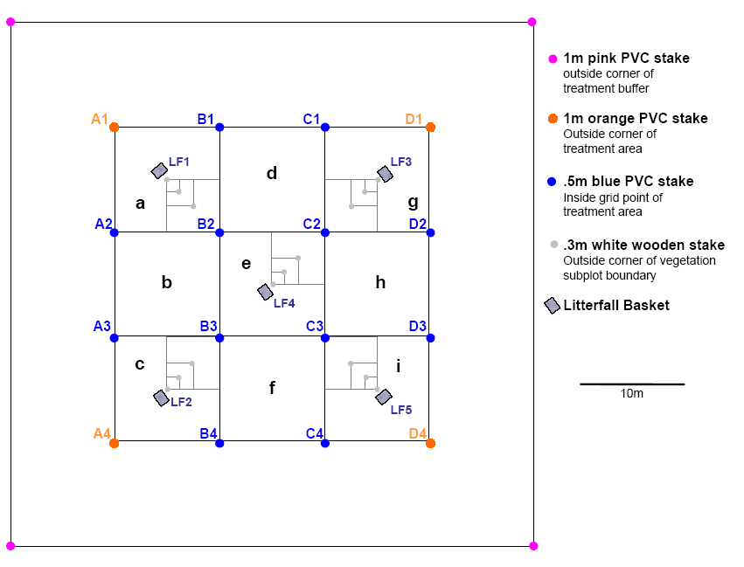

Figure 3. Site layout of 50 x 50 (m) plot displaying nine 10 x 10 (m) subplots, surrounded by a buffer zone. Series of overlying 5 x 5, 2 x 2, and 1 x 1 (m) smaller subplots in which understory trees were inventoried and measured are shown in the four corner and center subplots. The series of smaller subplots in the corner subplots stem from the center subplot (B2, B3, C2, and C3 vertices) whereas in the center subplot, they stem from C2 vertex. (Borrowed from Matt Vadeboncoeur) [according to Ben who did tree painting first with Shinjini in the beginning of the summer, the 2x2 and 1x1 were also anchored at B2, B3, C2, and C3 instead of at the center of the subplots]

Expected Results:

Implications:

References:

Held, M.E. 1983. Pattern of beech regeneration in the east-central United States. Bull. Torrey Bot. Club. 110:55-62.

Horsely, S.B. 1991. Using Roundup and Oust to control interfering understories in Allegheny hardwood stands. P. 281-290 *in* Proc. of 8th central hardwood forest conf. USDA For. Serv. Gen. Tech. Rep. NE-148. 605 p.

Horsley, S.B., and J.C. Bjorkbom. 1983. Herbicide treatment of striped maple and beech in Allegheny hardwood stands. For. Sci. 29:103-112.

Kochenderfer, J.D., J.N. Kochenderfer, D.A. Warner, and G.M. Miller. 2004. Preharvest manual herbicide treatments for controlling American beech in central West Virginia. North. J. Appl. For. 21:40-49.

Kochenderfer, J.D., S.M. Zedaker, J.E. Johnson, D.W. Smith, and G.M. Miller. 2001. Herbicide hardwood crop tree release in central West Virginia. North. J. Appl. For. 18:46-54.

Miller, G.M., and J.N. Kochenderfer. 1998. Maintaining species diversity in the central Appalachians. J. For. 96:28-33.

Nyland, R.D., A.L. Bashant, K.K. Bohn, and J.M. Verostek. 2004. Interference to hardwood regeneration in northeastern North America: Ecologic characteristics of American beech, striped maple, and hobblebush. North. J. Appl. For., 23(1):53-61.

Rastetter, E.B., R.D. Yanai, R.Q. Thomas, M.A. Vadeboncoeur, T.J. Fahey, M.C. Fisk, B.L. Kwiatkowski, and S.P. Hamburg. 2013. Recovery from disturbance requires resynchronization of ecosystem nutrient cycles. Ecological Applications 23:621-642.

Tubbs, C.H., and D.R. Houston. 1990. American beech (*Fagus grandifolia* Ehrh.). P. 325-332 *in* Silvics of North America, Vol. 2. Burns, R.M., and B.H. Hondala (eds.), USDA Agric. Handb. 654. 877 p.