The Effects of Nutrient Supplementation on Arbuscular Mycorrhizal Fungi Colonization, Morphology, and Species Composition in Acer rubrum

By
Carina Berlingeri and Eva Paradiso

Abstract
Arbuscular mycorrhizal (AM) fungi have an intimate association with the roots of their host plants and through their acquisition of nutrients for the host plants they are returned with vital photosynthates. The colonization intensity and morphological traits of AM fungi can exert a strong influence on below and above ground carbon allocation and morphological traits of host plants. In this study we study red maple seedling roots in nutrient amendment plots: control, P, N, and N+P to examine how these nutrient additions influence AM colonization, morphological traits of AM fungi and the morphology of their host plants’ roots.

Introduction
- How nutrients influence (a) mycorrhizal colonization (c) root morphology
- How does mycorrhizal morphology and colonization influence root morphology
- Justification:

Root characteristics are strongly linked to surrounding soil nutrients and moisture. Roots tend to grow towards patches of soil that are high in nutrient content and to grow towards the nutrient hotspots, roots alter their morphological traits (Hodge 2004). Roots have plasticity in their form and function and are likely to show morphological differences under different nutrient constraints (Falik et al. 2012). A study of first year maple seedlings in the MELNHE project found that SRL was 27% greater in the N vs no N plots (Goswami 2017). Increasingly studies are showing that root morphology is linked to associated mycorrhizal fungi. Mycorrhizal fungi help their host plant acquire nutrients from the soil by providing an extensive and increased surface area for nutrient and water absorption. The mycorrhizal fungi transfer the nutrients to the host plant in exchange for carbon that the host plant allocates belowground to the mycorrhizal fungi. Arbuscular mycorrhizal fungi are known to enhance plant phosphorus (P) uptake by capturing phosphate ions that are otherwise unavailable to plants through the hyphal network (Sanders and Tinker 1971 & 1973). It has been observed that increased nutrient supply had negative effects on colonization rates of mycorrhizal fungi in host’s roots (Neumann and George 2010). Suggesting that under conditions in which nutrients are more readily available the contribution of the AMF symbiosis is lessened or not needed. Previous research in red maple seedlings in the MELNHE plots that have examined AMF found that in nitrogen amended plots there was a decrease in vesicles which are AMF storage structures (Jimenez 2020 unpublished). There is also weak evidence of decreased hyphal colonization in phosphorus treated plots, suggesting phosphorus limitation (Jimenez 2020 unpublished).

Statement of Objectives
This research aims to further investigate how nutrient amendments will influence AM fungi colonization, and root morphology of the host plants’ roots. We have hypothesized that (1) there will be an decrease in vesicles, a morphological trait that is highly associated with the genera Glomus in the family Glomeraceae in nitrogen amended plots, (2) there will be an increase in coil structures in P -ammended stands (3) the genera Acaulospora in the Acaulosporaceae family colonization will be greatest in P amended plots (4) we expect to see decrease in mycorrhizal fungal diversity in amended stand in comparison to control, and expect to see the highest decrease in N+P amended stands (5) root morphology will vary depending on
treatment, thus root morphology will vary by treatment. Mycorrhizal colonization promoted the formation of lateral roots of high order, induced more fine roots and less coarse roots (Yao et al. 2009).

Methods
Study Site and Design
This study will take place at the Bartlett Experimental Forest (BEF) in Bartlett, New Hampshire. Data will be collected from four of the thirteen stands in the Multiple Element Limitation in Northern Hardwood Ecosystems (MELNHE) experiment: stands C1, C2, C4, and C6. These stands were chosen for their species composition and their accessibility. C1 and C2 are both young aged stands while C4 and C6 are mid aged stands. The soils at this site were formed from granitic glacial till and there is evidence of varying ranges of soil nutrient availability (Vadeboncoeur 2010, Cleavitt et al. personal communication). Treatment plots are 50 m x 50 m with 30 m x 30 m inner plots and 10 m x 10 m buffers. Nutrients were added annually beginning in 2011. Each stand is comprised of four plots, one that annually receives nitrogen (30 kg N/ha/yr as NH4NO3), phosphorus (10 kg P/ha/yr as NaH2PO4), nitrogen and phosphorus (30 kg N/ha/yr as NH4NO3 + 10 kg P/ha/yr as NaH2PO4), and one control plot that does not have any nutrients added.
Field collection
We will be collecting 5 second year red maple (Acer rubrum) seedlings per plot (C, N, P, NP) for a total 20 from each stand (C1, C2, C4, and C6) during the last week of June and the beginning of July. All samples will be scanned for root morphological traits including length and mean diameter. From the initial field collection, 2 seedlings from each plot will be oven dried for root biomass and 3 seedlings will be stained and analyzed for mycorrhizal colonization. In total 48 red maple seedlings will be stained for mycorrhizal colonization and 96 samples will be analyzed for dry biomass and root morphology.

Root morphology
Upon returning from the field, all roots will be rinsed with water to remove soil, placed in between plexiglass and scanned onto the computer using an HP Scanjet G3010. These root samples will then be processed using IJRhizo, a macro for ImageJ (1.52a) which measures root morphological traits (Pierret et al. 2013). These traits include the Kimura length (approximated total root length based on the Kimura algorithm which estimates root length through image analysis), mean diameter, surface area, and root volume. After being scanned, the samples will be randomly sorted into roots for staining and roots for drying. The roots for drying will be placed into an oven to dry 60°C for at least 48 hours to a constant weight. The dried samples will be weighed and then specific root length (SRL), total root length divided by root dry biomass (mm g -1 ); root tissue density (RTD), root dry biomass divided by total root volume (g mm -3 ); and mean root diameter (mm) will all be calculated for absorptive roots. Root branching ratio, the number of first order roots growing out of second order roots and branching intensity, the number of root tips per root length of first and second order roots (tips cm^-1) will be calculated.

Mycorrhizal Morphology and Colonization Lab methods
The preparation and analysis of seedling roots were done using a modified method used by Cleavitt et al. (not published yet). Roots being selected for mycorrhizal colonization will be stored in vials with 60% ethanol solution until staining. These roots will be placed in KOH solution and autoclaved for ~ 50 minutes in a 15 min liquid process. The KOH solution will help clear the root for staining. The roots will then be rinsed with tap water and placed in a bath of stain chlorazol black E and autoclaved for ~ 50 minutes in a 15 min liquid process using the ink and vinegar approach modified by Brundrett el al. (1995). After the roots have been stained, they will be removed from the staining bath and placed in vials with glycerol solution prior to mycorrhizal analysis. After staining and clearing, the fine lateral roots will be cut into two-cm segments and 5 segments will be selected randomly for the mycorrhizal analysis.

The roots will be observed under a compound microscope at 400x magnification. The observations will be taken at 2 mm intervals on a grid using the grid magnified intersection method suggested by McGonigle et al. (1990). The magnified intersection method suggested by McGonigle et al. (1990) allows for objective observation and measurement of AMF colonization in the root. The scoring of AMF structures will be conducted using a microscope eyepiece crosshair and observations will be drawn from the intersection of the microscope crosshair and the roots (McGonigle et al. 1990). For each root sample there will be a minimum of 50 observations and they will be scored on the presence of AMF structures that are within the field of view in the crosshair’s grid intersection. The following AMF structures will be scored at each intersection: coil, branched coil, arbuscules, clouds, appressoria, AMF hyphae, and vesicle. Clouds represent a category of AMF structures that were not able to be identified to the type of structure, but was definitely an AMF structure; they probably represent mostly partially degraded AM structures. In addition, we will be using the AMF structures and morphological traits to categorize them by family or genera. The previously mentioned AMF structures are all physiological structures of AMF. Additional structures such as non AMF hyphae (brown septate, blue septate, fine blue hyphae), and root hairs will be scored at each intersection, as its important for understanding fungal competition within the root.

Time needed for project completion!

It took us ~ 1 day to collect samples from all of the 4 stands. Upon returning from the field, it took us ~8 hours to scan in the roots. Process these samples using ImageJ will involve cropping all of the scanned images and then running them through the program. According to Rewcastle (2015), in an ImageJ—IJ Rhizo Protocol for Specific Root Length publication, it will take ~ 2 hours to process 35 samples. Cropping will likely take approximately 8 hours. Thus it will take us around 2 days to crop and process all the samples in ImageJ. Additionally these samples will be dried for a minimum of 48 hours.

Clearing and staining the roots took us one week. The duration of time that it will take to analyze colonization will vary depending on the amount of AMF structures present.

Tentative to-do list:
- Hypotheses -- research them
- Luz (unpublished) found a significant effect of N where the AMF vesicle abundance decreased, a small effect of P, with an increase in coils, and a small effect in the N+P plot where there was a decrease in vesicles.
- https://thecollege.syr.edu/people/faculty/becklin-katie-m/ -- email her at some point potentially…

Notes on DSE in relation to root morphology:
Roots with DSE had longer root length, greater surface area, and branching number than those without (He et al. 2019) while diameter decreased -- DSE can facilitate nutrient uptake of plants by improving soil nutrition and root system structure

Results Root morphology

There was no significant difference across stand and or treatment type for mean root diameter.
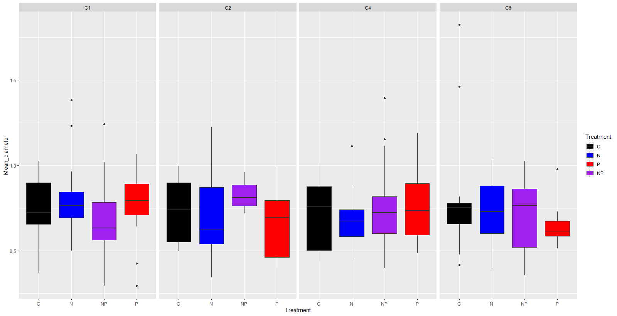

There was no significant difference across stand and or treatment type for RTD based on root order (1, 2, and 3rd).
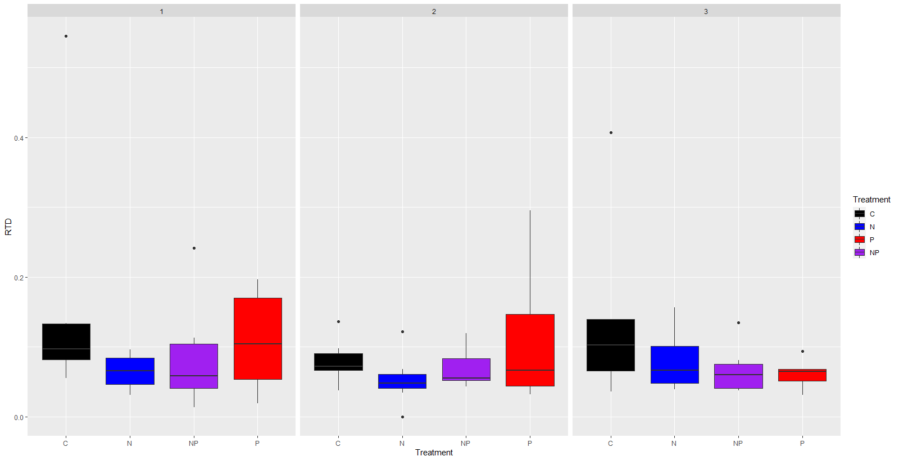

There was no significant difference in SRL based on treatment type though SRL was greater for first order roots as would be expected based on root resource allocation.
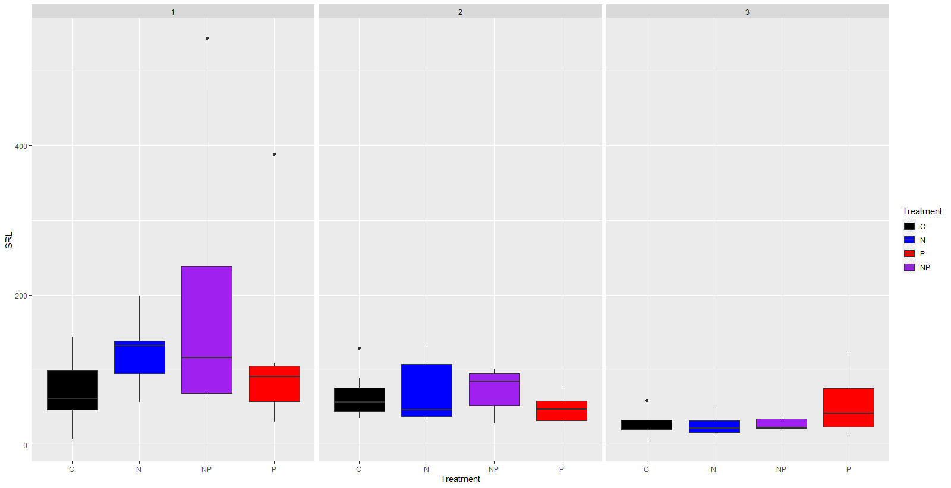

There was no difference in the number of root tips by treatment type.
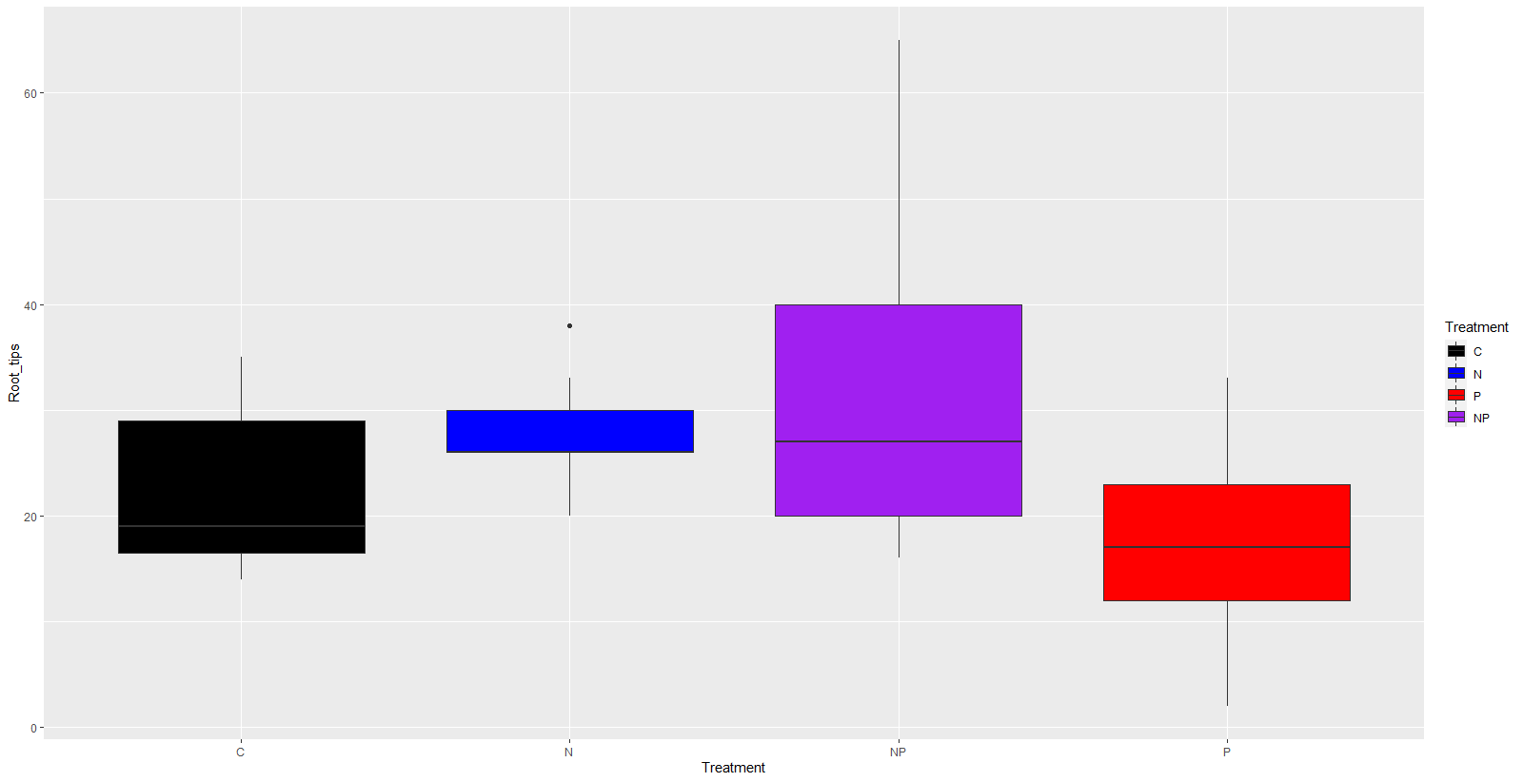

Additionally, there was no significant difference in root tip ratio by treatment type. 