Assessing Tree Canopy Complexity in Northern Hardwood Forests

Sarah Congress

Mentor: Bob Fahey and Ruth Yanai

8/19/19

**Abstract**

The composition and complexity of a forest’s canopy influences ecosystem functioning within the forest. Long-term Successional changes as well as short-term disturbance events and anthropogenic changes can cause canopy complexity to fluctuate over time. Ground-based LiDAR systems are being employed to gain a more in-depth understanding of the complexity of forest canopies. This study used a combination of ground-based LiDAR mapping and field-based data collection to begin to quantify the complexity of the forest canopy for northern hardwood forests. This study found that the successional stage of the forest was a driver of the differences in canopy composition and vegetation area index, but that fertilization treatments did not strongly affect canopy structure.

**Introduction**

Forest canopy composition and complexity is integral to the dynamics and function of the forest as a whole. The variability in canopy coverage creates microclimates within the forest, which can influence factors such as decomposition rates, photosynthetic activity and soil biota (Chen et al 1999, Falkowski et al 2009). Forest canopies also contribute to the biodiversity of the forest through both the species that comprise the canopy itself as well as wildlife that utilize the canopy for the services it provides such as shelter and food (Ishii et al 2004).

Because forest canopies can impact ecosystem functioning in forests, examination of the relationships between canopy variables is essential to understanding biogeochemical processes (Fahey et al 2015, Atkins et al 2017). A forest canopy’s structural complexity can be a factor in forest productivity as well as light use efficiency (Hardiman et al 2013). Canopies with higher complexity can boost photosynthetic rates and create more efficient N utilization (Hardiman et al 2013). Although hardwood forests in the White Mountains continue to recover from extensive logging and forest fire of the early 19th century they continue to face threat the threat of clearcutting (Goodale 2003). Because of this, biodiversity may decline leading to the parallel decline of stand productivity making it important to create sustainable ecosystem management plans (Ishii et al 2004).

To quantify the complexity of forest canopies, LiDAR (light detection and ranging) technology has been employed which has revolutionized the way scientists collect quantitative information regarding the structural complexity of forest canopies (Atkins et al 2018). The data collected by LiDAR is spatially explicit in three dimensions, extending beyond simple leaf area index measurement, which are inadequate for broadly measuring canopy complexity (Atkins et al 2018; Hardiman 2013, Parker et al 2004). Instead, the data collected by LiDAR can be used to estimate variables like ecosystem structural elements, forest canopy gap fraction, and aboveground biomass (Atkins et al 2018).

LiDAR continues to be important because of the depth of analysis its data can provide. The use of LiDAR data can help scientists understand how forests change over time in regard to net primary productivity (Hardiman et al 2013). It may also help scientists understand the reason for variation in C sequestration in different forests (Fahey et al 2015). Because canopy complexity has been shown to be an important factor in forest productivity and resilience following a disturbance, the findings made using LiDAR data will have the potential to impact public policy regarding the conservation and use of forested land, particularly old growth forest (Fahey et al 2015).

**Objective**

The objective of this experiment is to answer the following questions:

1. Does stand age and successional stage or fertilization treatments have more effect on the complexity of the forest canopy?
2. Does stand age and successional stage or fertilization have an effect on the positioning of species VAI in relation to other species within the canopy?

**Hypothesis**

1. Stand age and successional stage will have a greater effect on the leaf area dominance rather than fertilization.
2. Stand age and successional stage of forests will have a greater effect on the vertical distribution of VAI and the halfway height of canopy VAI.

**Methods**

Site Description

This study was conducted in the Bartlett Experimental Forest in Bartlett, New Hampshire and in the Hubbard Brook Experiemental Forest in Woodstock, NH. In this region, the climate is categorized as humid continental and receives an average of 1270 mm of precipitation per year (<https://www.nrs.fs.fed.us/ef/locations/nh/bartlett/>). The soils are comprised mainly Spodosols that developed during the glacial drift from granite and gneiss with large boulders and rocks throughout the forest floor (<https://www.nrs.fs.fed.us/ef/locations/nh/bartlett/>). Within the forest, permanent study sites have been established with stands that have an area of 30 meters by 30 meters with a 10-meter buffer.

Since 2011, 3 of the 4 plots within each stand have received, annually, additional nitrogen via ammonium nitrate, additional phosphorous via monosodium phosphate, or the addition of both nitrogen and phosphorous. The fourth plot serves as a control and is not treated. Two of the stands measured were young stands (19-24 years old), two other stands were intermediate aged stand (31-41 years old). The old stand in Bartlett Experimental Forest was between 119-126 while the old stand in the Hubbard Brook Experimental Forest were 80-98 years old. These ages are calculated based on the number of years passed since the original forest was clear cut for wood harvesting purposes (Fisk et al 2014). In the both the young and intermediate stands, early-successional species such as pin cherry, white birch (also known as paper birch), yellow birch, red maple and beech are present (Fisk et al, 2014).

Data were collected from two young stands in the Bartlett Experimental Forest, two mid-aged stands located in the Bartlett Experimental Forest and 2 old stands, one located in the Bartlett Experimental Forest and the other located in the Hubbard Brook Experimental Forest. Within the plots, each of the four transect that are 30 meters in length and 10 meters apart were used as a guide. A meter tape was laid along each of the transects in a straight line (Fig. 3). Starting at the zero-meter mark of the tape, data was collected at every half meter mark on the tape measure, using a hypsometer to measure the beginning height of each of the distinct layers of the canopy. This was repeated for each transect within the plot.

The average VAI (vegetation area index) was calculated using hitgrid files generated by LiDAR data. At each meter, the VAI was averaged per transect, per treatment plot. Each transect average was then averaged together to create an overall average VAI for the plot. The area occupied by each species was first calculated per point in each transect. At each point, the space occupied by each species was calculated using the beginning height of the next layer subtracted from the beginning height of the first layer. This continued until the final layer was reached. The space occupied by the tree in the final layer was calculated by using an estimated top that was chosen based on the tallest LiDAR hit for the stand. The species shown on the graphs (Fig. 4 and Fig. 5) were chosen because they were present in both C2 and C4.

**Results**

As forest stands age, beginning tree height for most of the species visibly increases (Fig. 7). There is also a transition from early successional species such as pin cherry, red maple and yellow birch to late successional species such as sugar maple. Although American Beech is considered to be a later successional species, it was found in all of the plots, but increased in height in older plots. Therefore, it seems that the change in species composition over time is driven more by forest stand age and successional stage rather than the different nutrient additions.



**Fig. 1: Chart charting the 7 most common tree species and their beginning height in each stand and treatment plot. C1, C2- young stands, C4, C5- middle-age stands, C8- old stand**

Vegetation area index (VAI) also followed this trend. The VAI for the young stand showed a concentration of vegetation at heights below 20 meters while the VAI for the middle age stand showed some stands with concentrations of vegetation above 20 meters. This is most likely due to the increasing height of the trees as the stand ages.

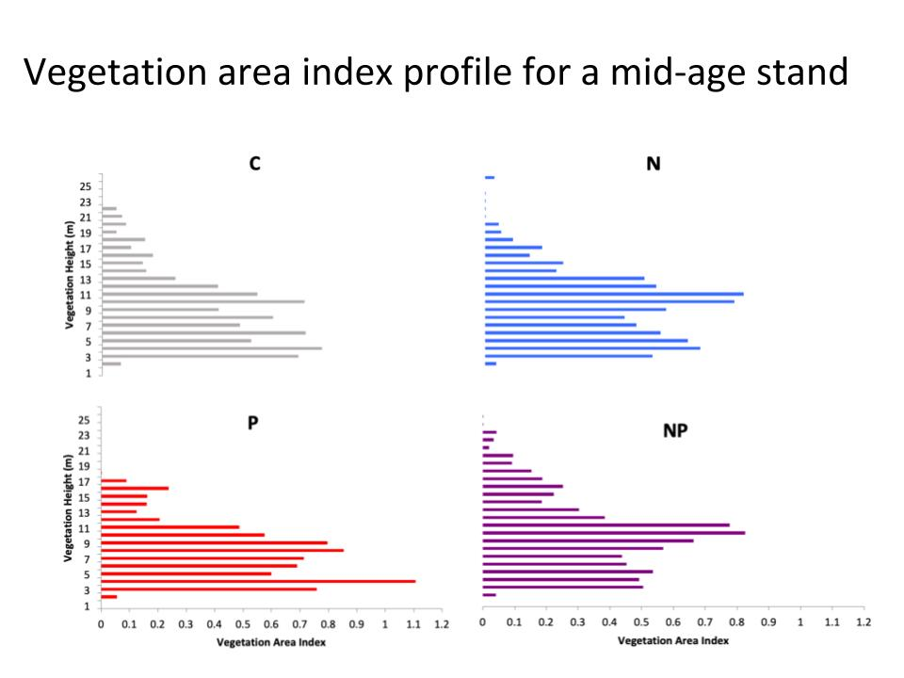

**Fig. 2: Average vegetation area index (VAI) for C4, a middle age stand**

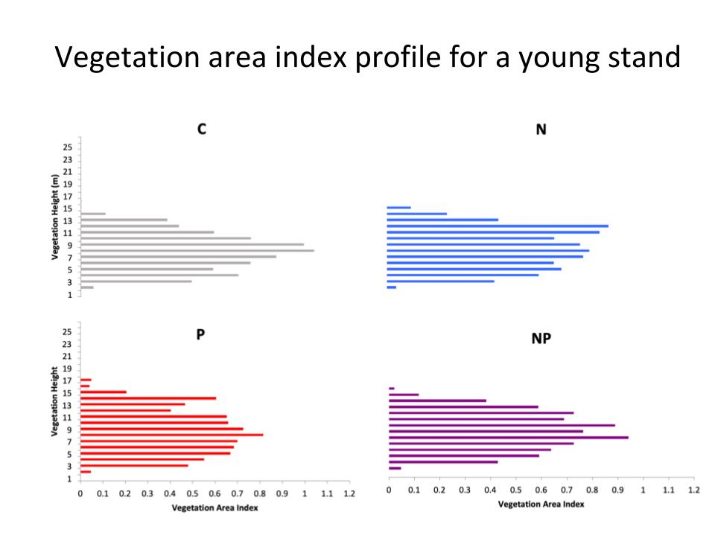

**Fig. 3: Average vegetation area index (VAI) for C2, a young stand**

In C4, a middle-age stand, there was not a significant difference between treatments in the amount of canopy each species occupied (p= 0.4761) (Fig. 4). Within treatment groups there was also not a significant difference in the amount of space occupied by each species (p= 0.0984).

**Fig 4:** Average area of the canopy occupied for 3 species in C2- young stand (AB= American Beech, PB= Paper Birch, YB= Yellow Birch)

In C2, a young-age stand, there was not a significant difference between treatments in the amount of canopy each species occupied (p= 0.1092) (Fig. 5). Within treatment groups there was also not a significant difference in the amount of space occupied by each species (p= 0.5009).

**Fig. 5:** Average area of the canopy occupied for 3 species in C4- mid-age stand (AB= American Beech, PB= Paper Birch, YB= Yellow Birch)

**Discussion**

From the data collected, the hypotheses were correct that successional stage of the forest seemed to have a greater effect on forest canopy complexity than fertilization treatment. The results of the VAI calculations also suggest that in younger stands, successional stage of the stand influence the canopy complexity more than the nutrient treatments. This may suggest that early successional species such as Pin Cherry and birch species are less affected by nutrient limitation than later successional species.

As discussed earlier, more accurate measurements of canopy complexity will allow for the creation of more precise models of biogeochemical cycles (Atkins et al 2017). As this data is combined with ground-based LiDAR imaging we can move towards having an in-depth understanding of nutrient and water cycling within northern hardwood forests. This study fills the growing need to begin quantifying complexity to create knowledge of the structure and function relationships between the canopy and the forest as a whole (Atkins et al 2018)

The results indicate we should be aware that during succession are the tree species appearing due to the nutrients within the forest or are they due to the age of the forest and the life history traits of specific species. However, change in canopy complexity can be mapped over time to understand the changes in the forest as they transition from young to mid age to old and mixed growth stands. As forests get older, if they are able to retain their canopy complexity, they may increase NPP and continuing their ability to be carbon sinks even as they age, and earlier successional species die (Hardiman et al 2011). Tracking this can help dictate land management and conservation plans for the forests in the future.

**Limitations and Future** **Directions**

Because this method has never been employed before there may be some difficulties in replicating it. Deciding which trees are directly overhead of the spot being measured is extremely subjective. While it helps to have another person aiding in the decision of what is directly overhead of the spot being measured and what is not, different people taking measurements may have two different opinions leading to different results. Incorrect identification is another limitation of this study. Although guidebooks and the tags from tree inventories were used to increase the probability of accurate identification, there may have been misidentification of some species that look similar such as paper birch and yellow birch or paper birch and aspen. However, with more training on how to identify common tree species, this can be mitigated. Another limitation of this study may also be the transects measured. Although the measurements for this study and the LiDAR data were collected going the same way for each transect (A4-A1 etc.) because the LiDAR data was taken separately, the path traveled to take the LiDAR measurements may not be the exact same as the path used to take the height measurements there may be conflicting results when trying to combine the two data sets.

For the future, more transects for mid aged and young age stands can be collected. As it becomes available, this data can be combined with LiDAR data to create VAI profiles and species specific VAI profiles for plots within each stand. As data begins to accumulate over multiple years, there may be the potential to answer the overarching question of whether nutrient limitation or forest age is a bigger factor in canopy complexity.

**Works** **Cited**

Atkins, J., Bohrer, G., Fahey, R., Hardiman, B., Morin, T., Stovall, A., Zimmerman, N., Gough, C. 2018. Quantifying Vegetation and Canopy Structural Complexity from Terrestrial LiDAR Data using the Forestr R Package. *Methods in Ecology and Evolution* 9: 2057-2066.

Chen, J., Saunders, S., Crow, T., Naiman, R., Brosofske, K., Mroz, G., Brookshire, B., Frankling, J. Microclimate in Forest Ecosystems and Landscape Ecology: Variations in Local Climate Can Be Used to Monitor and Compare the Effects of Different Management Regimes. *Bioscience* 49: 288-297.

Cramer, J., Fahey T., Battles J. 2000. Patterns of Leaf Mass, Area and Nitrogen in Young Northern Hardwood Forests. *The American Midland Naturalist* 144: 253- 264.

Fahey, R., Fotis, A., Woods, K. 2015. Quantifying Canopy Complexity and Effects on Productivity and Resilience in Late-Successional Hemlock-Hardwood Forests. *Ecological Applications* 23: 837-847.

Fahey, T., Battles, J., Wilson, G. 1998. Responses of Early Successional Northern Hardwood Forests to Change in Nutrient Availability. *Ecological Monographs* 68: 183-212.

Falkowski, M., Evans, J., Martinuzzi, S., Gessler, P., Hudak, A. 2009. Characterizing Forest Succession with LiDAR Data: An Evaluation for the Inland Northwest USA. *Remote Sensing of Envrionment* 113: 946-956

Fisk, M., Ratliff, T., Goswami, S., Yanai, R. 2014. Synergistic Soil Response to Nitrogen plus Phosphorous Fertilization in Hardwood Forests. *Biogeochemistry* 118: 195-204.

Goodale, C. 2003. Fire in the White Mountains: An Historical Perspective. *Appalachia*. 54: 60-75.

Hardiman, B., Gough, C., Halperin, A., Hofmeister, K., Nave, L., Bohrer, G., Curtis, P. 2013. Maintaining High Rates of Carbon Storage in Old Forests: A Mechanism Linking Canopy Structure to Forest Function. *Forest Ecology and Management.* 298: 111-119.

Ishii, H., Tanabe S., Hiura, T. 2004. Exploring the Relationships Among Canopy Structure, Stand Productivity, and Biodiversity of Temperate Forest Ecosystems. *Forest Science* 50: 342-355.

Parker, G., Harding, D., Berger, M. 2004. A Portable LIDAR System for Rapid Determination of Forest Canopy Structure. *Journal of Applied Ecology.* 41: 755-767.

Smith, M.L., Anderson, J., Fladeland, M. 2008. Forest Canopy Structural Properties. In: Hoover C.M. (eds) Field Measurements for Forest Carbon Monitoring. Springer, Dordrecht

Yanai, R., Walsh, G., Yang, Y., Blodgett, C., Bae, K., Bae Park, B. 2017. Nutrient Concentrations of Roots Vary With Diameter, Depth, and Site in New Hampshire Norther Hardwoods. *Canadian Journal of Forest Research.* 48: 32-41