Detecting foliar nutrient status from the sky:
Ground truthing NEON spectra in MELNHE plots
Marissa L. Gabriel Drexel University
Alexander R. Young, Ruth D. Yanai SUNY ESF

Final Report
Appendix I First Draft
Appendix II Second Draft

Introduction
Monitoring environmental health becomes more crucial as anthropogenic activities continue to alter natural resource availability and ecosystem stability. Developing technologies and fields such as spectronomics make assessing environmental health more accessible and efficient. Using remotely sensed data, entire landscapes can be observed from a mobile device.

Imaging spectroscopy records the intensity of electromagnetic radiation for a range of wavelengths that are reflected off the earth’s surface and can be used to infer a description of earth’s surface and vegetation characteristics. Aerial photography of vegetation across a landscape produces an image of visible red, green and blue (RGB) bands of light. Hyperspectral imaging captures a wider range of wavelengths across the electromagnetic spectrum than visible bands.

In an effort to increase the interpretation and decrease the size of remotely sensed hyperspectral data, vegetation indices have been established. Vegetation indices use the intensity of specific bands from their hyperspectral profile and use ratios that are not sensitive to absolute intensities.

The functional traits of the canopy refer to elemental and molecular properties that influence the way photons reflect back to the viewer (Asner et al 2016). Morphological and physiological traits include leaf mass per area, leaf thickness, and chlorophyll content. Differences in canopy reflectance may indicate differences in functional traits. Functional traits and corresponding spectral properties of tree canopies are conserved across plant taxa, but can vary across space, time, and with respect to vegetation health. Remotely sensing the forest canopies enables researchers to quantify changes in foliar properties across a landscape.

In the Bartlett Experimental Forest, there is an ongoing, multiple element limitation in northern hardwood ecosystem (MELNHE) experiment that is manipulating nutrient availability in nine forest stands. Experimental nutrient treatments began in 2011 with an addition of 30 kg/ha/year of nitrogen (N) as NH₄NO₃, 10 kg/ha/year of phosphorus (P) as NaH₂PO₄, a combined treatment of both N and P, and a control treatment where no fertilizer was added. There are several stands that also examine calcium (Ca) with a one time fertilization of 1,150 kg/ha as CaSiO₂. The spectral properties of foliage are expected to differ with the nutrient status.

As technology changes, new methods for modeling empirical observations are developed. This study aims to bridge the gap between traditional cartography and digital remote sensing by developing robust ground truthing methods.

Objectives
This project examined the possibility of detecting individual tree crown nutrient status remotely by comparing the intensity of wavelengths reflected off the nutrient treated foliage. Dominant tree crowns were spatially located within the nutrient plots in order to co-locate their corresponding hyperspectral data. Further research in this field has the potential to determine which forested areas are most in need of conservation and management efforts.

Methods
The dominant crowns captured in the aerial image were located by ground trothing in the MELNHE plots. Each tree on the stem map was located and noted as having a dominant, co-dominant, intermediate, or suppressed crown. Only dominant crowns were mapped and matched with their stem tag number. The location of the stems were also confirmed or corrected. The confirmed tree crown delineation with its specific identity were plotted into ArcGIS, co-locating crowns to their corresponding spectral signature and resulting vegetation index values. Photochemical Reflective Index values were compared between trees that have been fertilized for seven years. A preliminary analysis of variances was performed to quantify differences in index values across tree species and between nutrient treatments.

Site Description
There are nine MELNHE stands within the Bartlett Experimental Forest (Figure 1) located in the White Mountains National Forest, New Hampshire, USA. Within each stand is a nitrogen (N) plot, a phosphorus (P) plot, a nitrogen and phosphorus (N+P) plot and a control (C). The mature stands, C7 (Figure 2), C8 (Figure 3) and C9 (Figure 4) were clear cut in 1890, 1883, and 1890 respectively and will be used first for this study because older trees tend to be larger and spaced farther apart making it easier to the delineate their canopies.
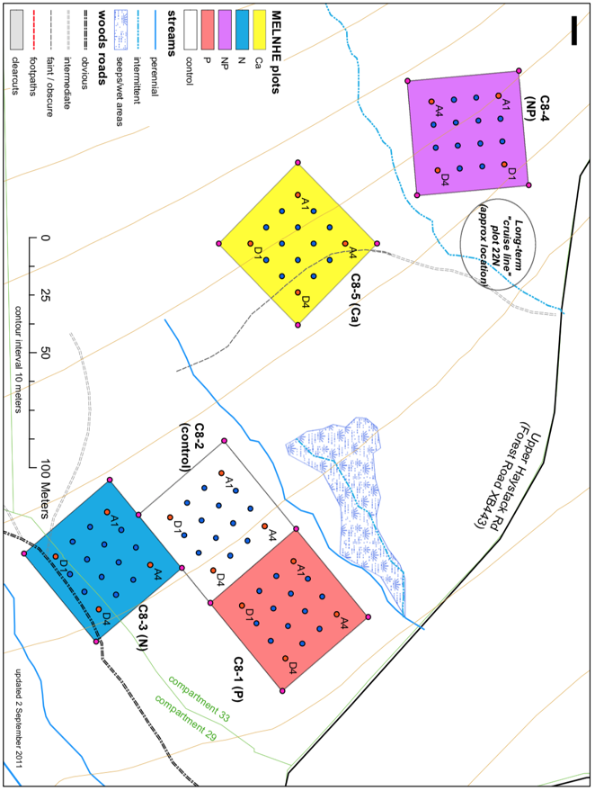
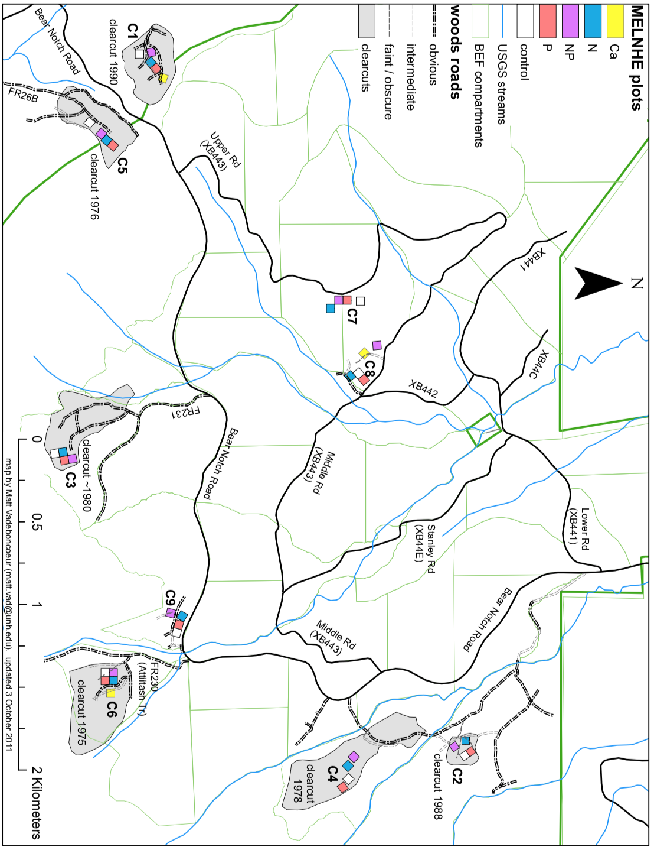
Figure 1. MELNHE 9 Bartlett stands. Priority study sites include C7, C8 and C9.
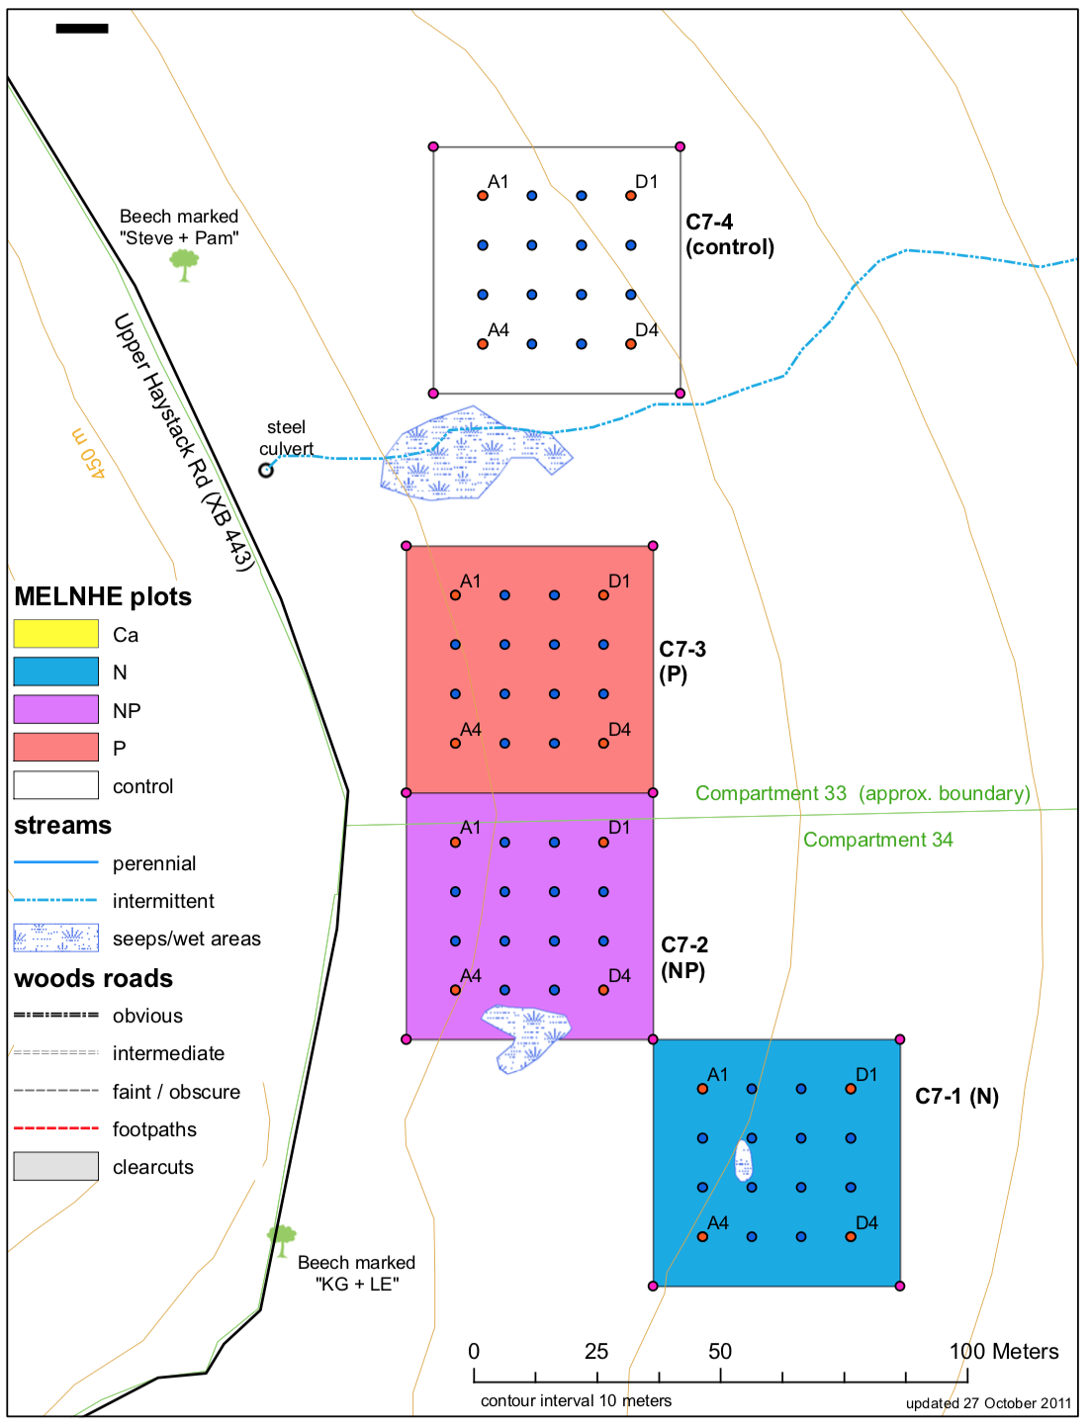
Figure 2. Stand C7. Figure 3. Stand C8.

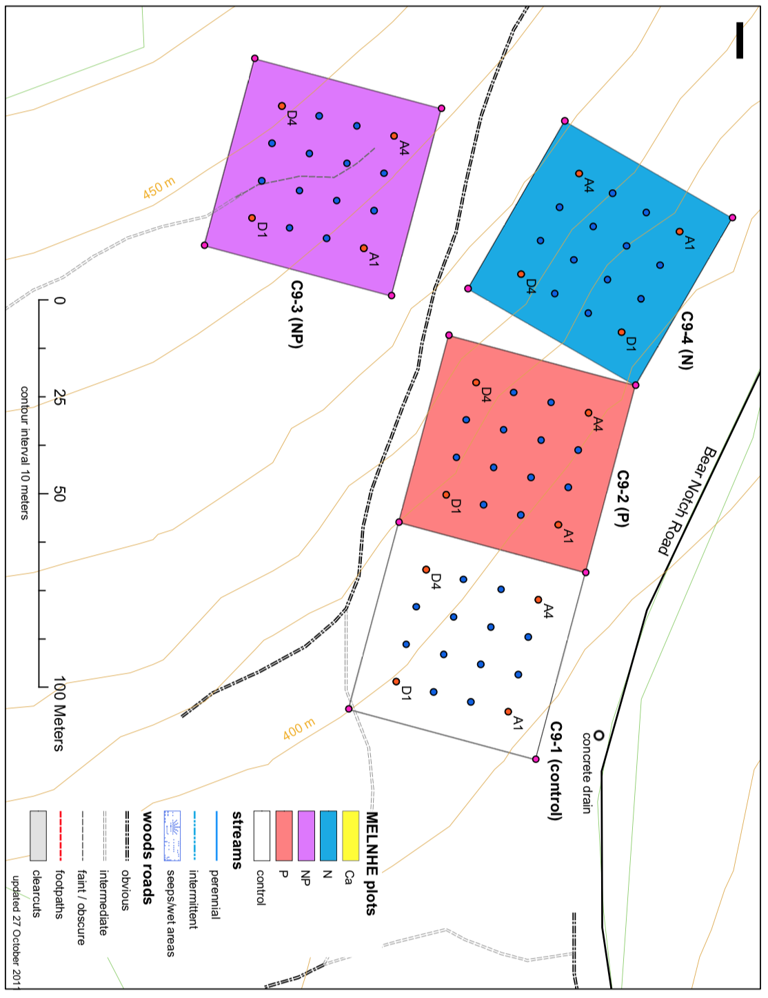
Figure 4. C9 Stand.

Data sources
The data used included NEON airborne hyperspectral data collected in 2017 using a Visible to Shortwave Infrared (VSWIR) imaging spectrometer. The aerial photo from this flight campaign was used in the field for spatial referencing. A calculated vegetation index, Photochemical Reflective Index (PRI), (Equation 1), was used for analysis. 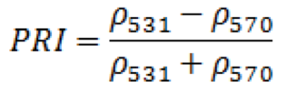 Eq. 1
Photochemical Reflective Index or Canopy Xanthophyll is sensitive to carotenoid pigments and is used as a proxy for photosynthetic light use efficiency, the rate of carbon dioxide uptake per unit energy. PRI values range from -1.0 to 1.0. PRI provides a physiologically meaningful interpretation of light use efficiency and is used to monitor vegetation productivity and stress. NEON Imaging Spectrometer level 1B reflectance dataset (NIS1) bands at 532.9 nm and 538.0 nm are used for the PRI algorithm. This PRI equation is from the description by Huslander 2015 in the NEON Algorithm Theoretical Basis Document.

Ground truthing
The purpose of ground truthing is to gather empirical information. The positions of the crowns were determined in the field by visual observations. The aerial RGB image of the plot was taken to the field with idealized stake coordinates overlaid. The aerial image was cropped to the spatial extent of each plot for stands C7, C8, and C9 (Figure 5). The tree stem maps for each plot were brought to the field to verify spatial locations. Each tree stem was found and identified in the plot using the unique tag number and it was verified if the recorded position on the stem map matched the true positon. It was then noted if the tree’s crown was dominant, co-dominant, intermediate or suppressed. It was difficult to delineate crowns from the ground and only the most certain crowns were mapped. Also, stem locations are not indicative of crown positions, as shown in Figures 8 and 9.
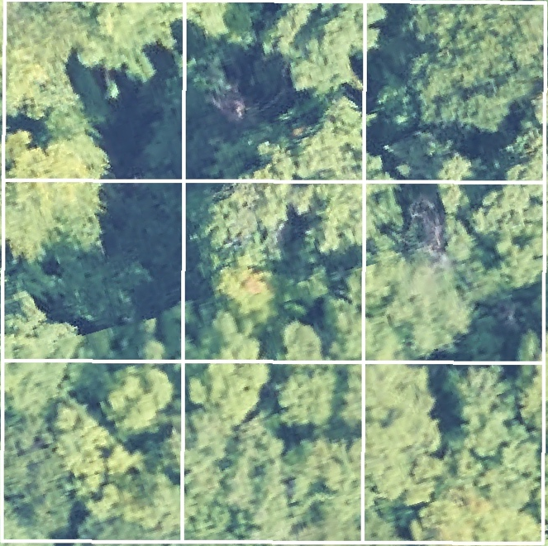
Figure 5. Example of cropped aerial image for one plot.

Processing
Tree crowns were drawn as a feature class in ArcGIS as point shapefiles. Where there was a confirmed crown matched with a tree tag, a point was drawn within the area of the crown, determining its spatial location. Points were used instead of drawing an area to reduce error. Crown points that were mapped on ArcGIS link the tree species and its nutrient treatment to the raster layer containing PRI values in each cell. Observed stem locations were used to update stem maps for stands C7, C8, C9, C5, C6, C4 and Hubbard Brook.

Analysis
This analysis examined if it is possible to detect individual tree crown nutrient status remotely. PRI values per crown per species per nutrient plot (C, N, P, N+P, Ca) were compared. A factorial ANOVA blocked by stand tested for differences in the mean of PRI values for each species in C, N, P, N+P, and Ca plots.

Results
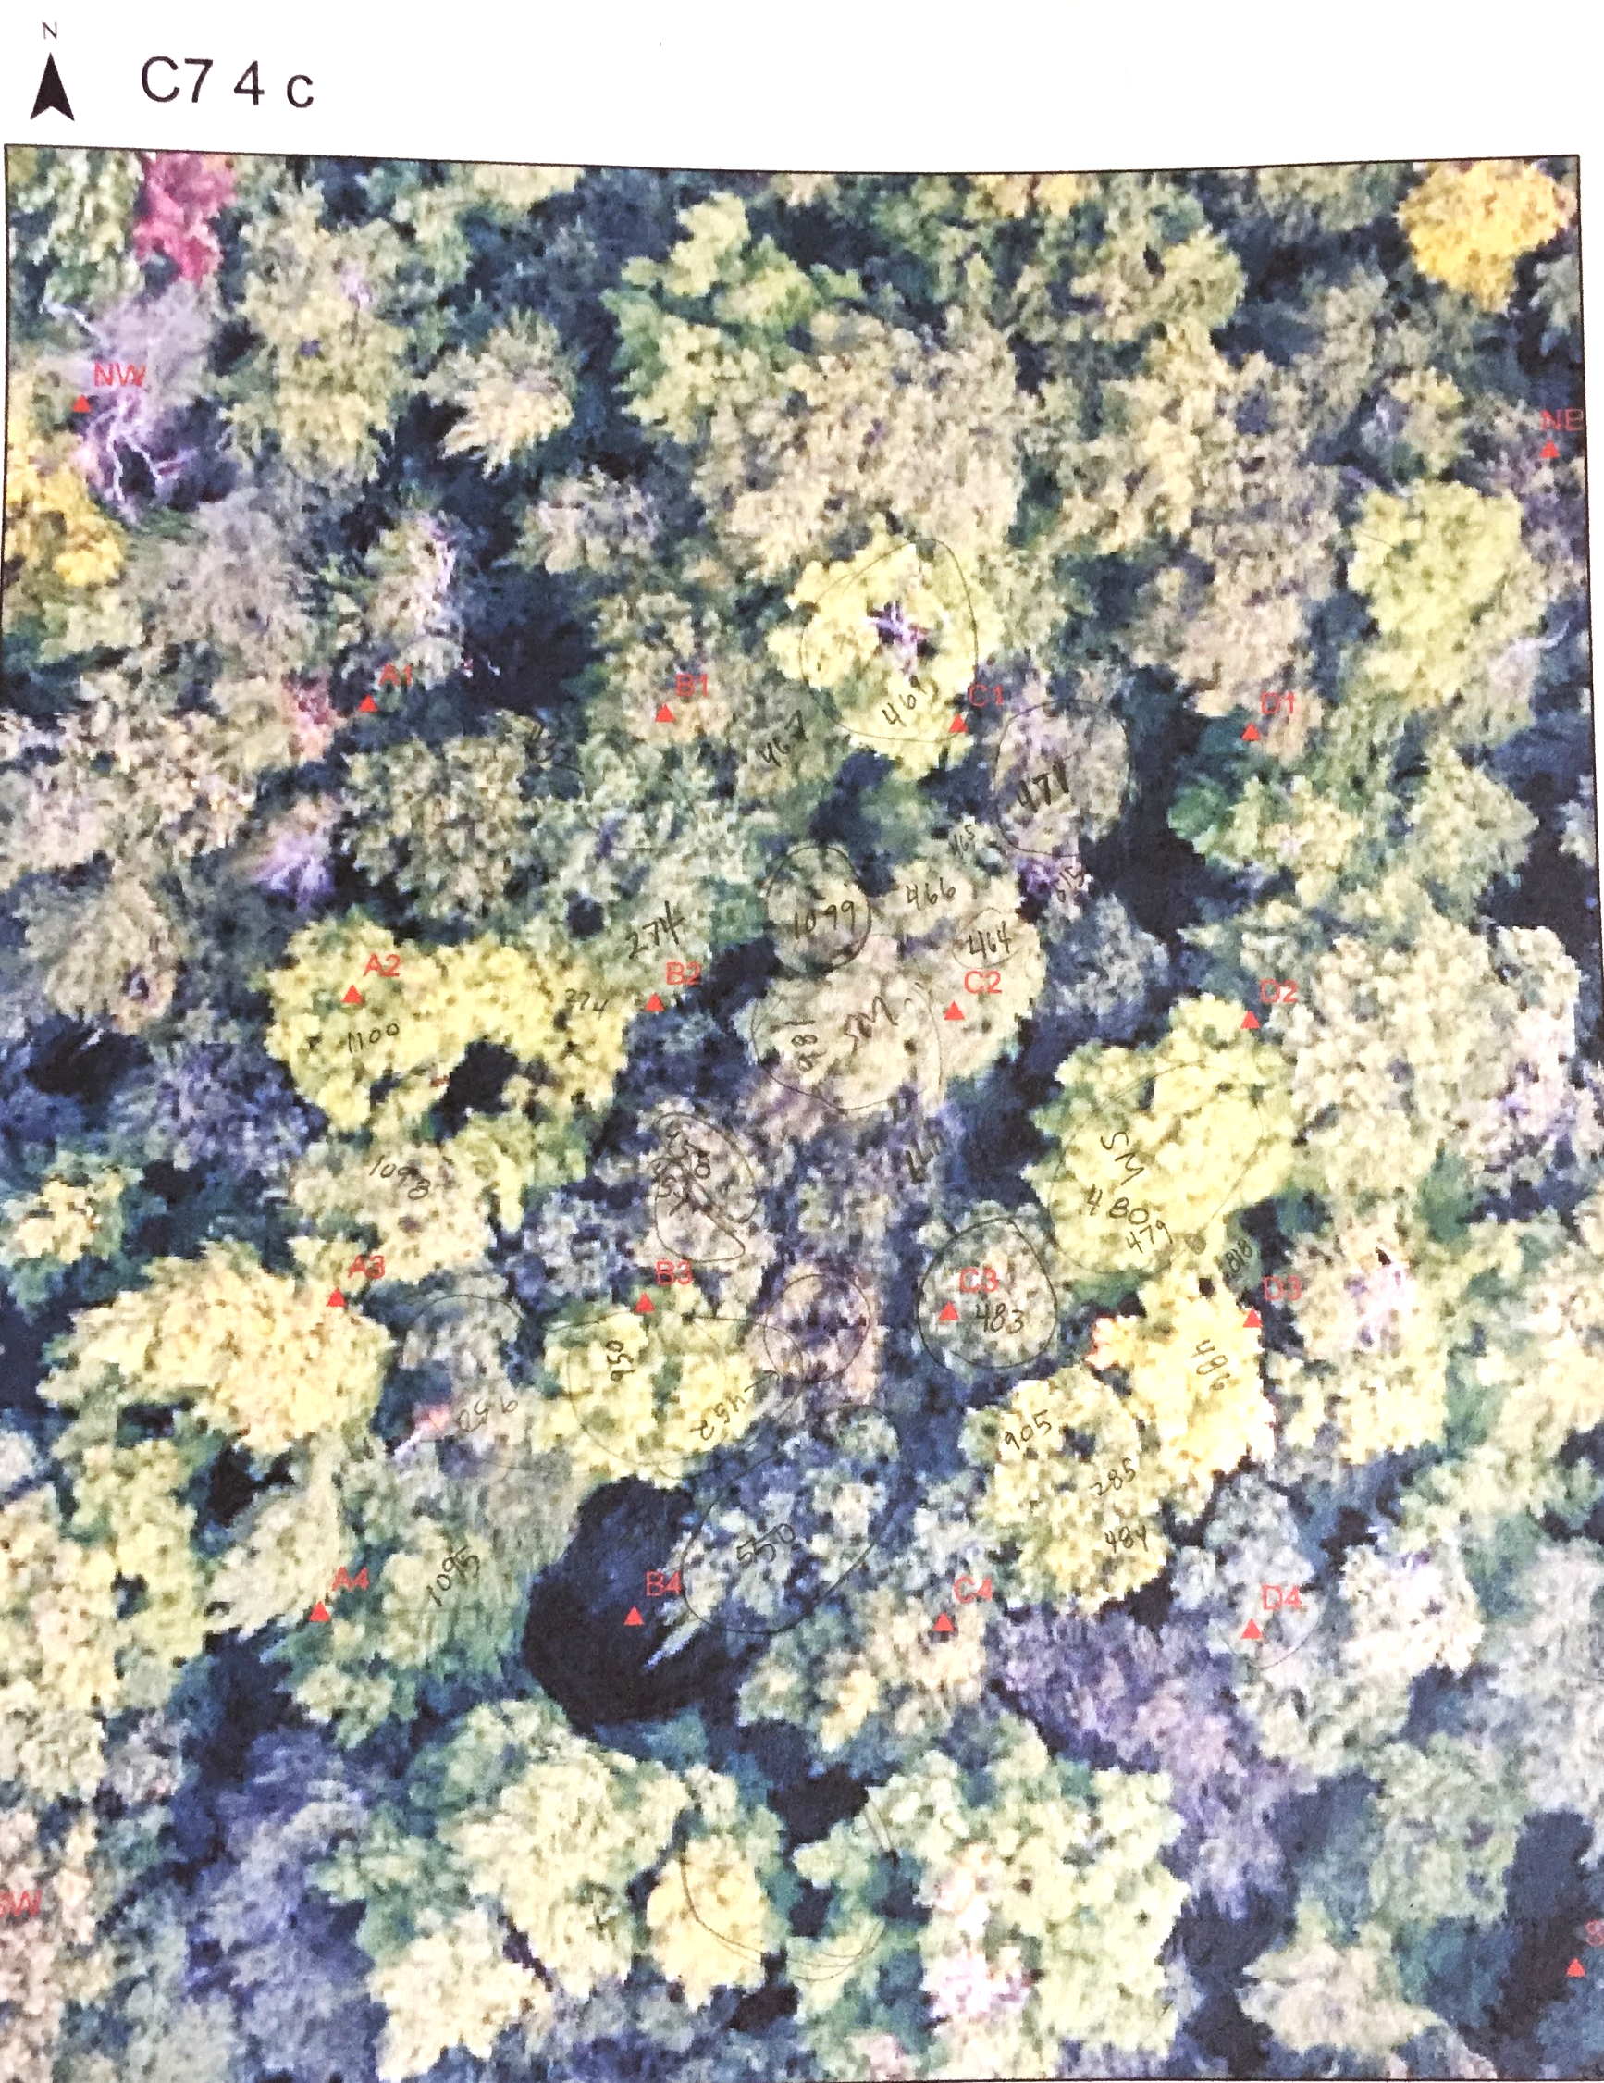
Figure 6. Example of field sketches on aerial photo with red stake locations overlaid. The located points of canopies, shown as tree tag numbers, were drawn into ArcGIS. There is one of these maps for each plot within the three stands.
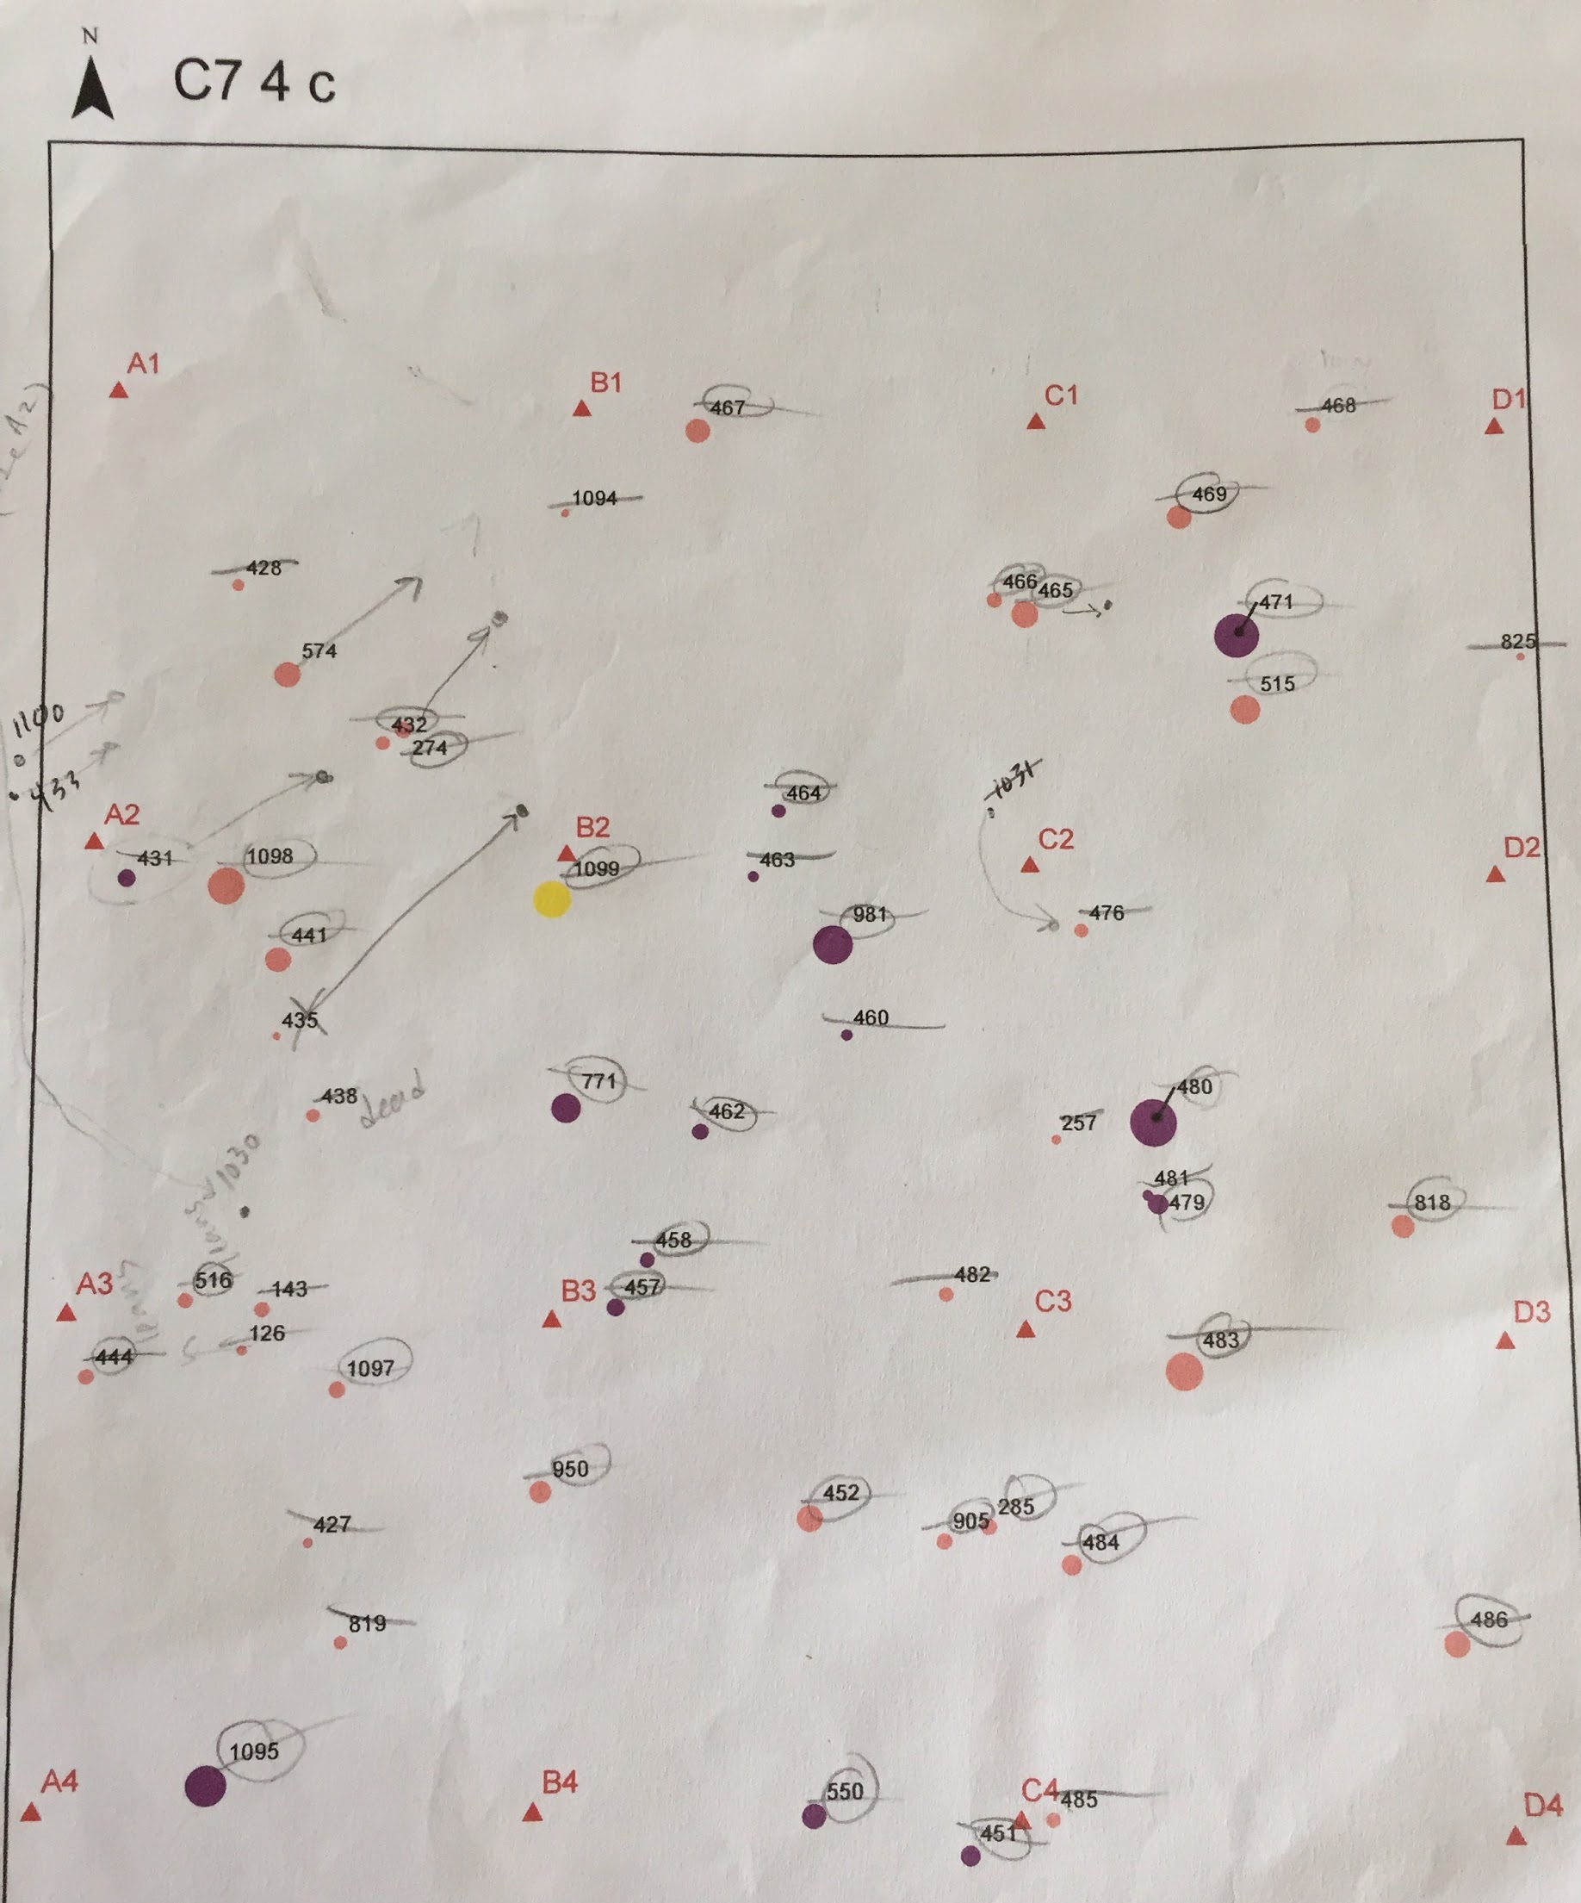
Figure 7. Example of field notes on map of stake locations and tree stem positions. The red triangles are the stakes. The different colored symbols are species. Each stem was crossed off after it was visited, and circled if the crown was dominant enough to show up in the aerial image. If the stem location on the map did not match the true stem location, arrows were drawn to where it was observed. Notes were taken on dead trees for future deadwood maps that could be used in calculations of carbon allocation.

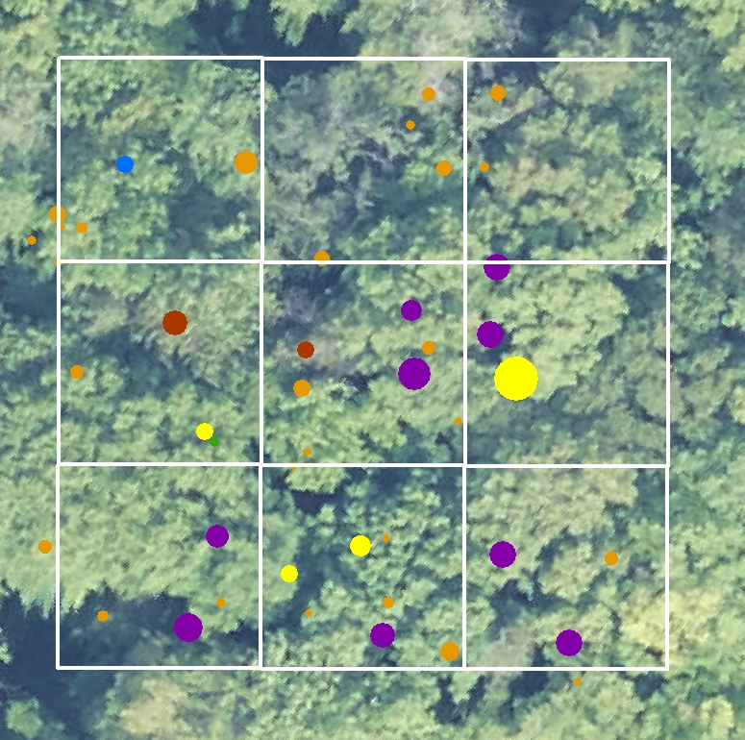
Figure 8. Example of one plot’s stem map, size of icons represent DBH and color represents species, purple for sugar maple, yellow for yellow birch, orange for beech, red for red maple and blue for ash.

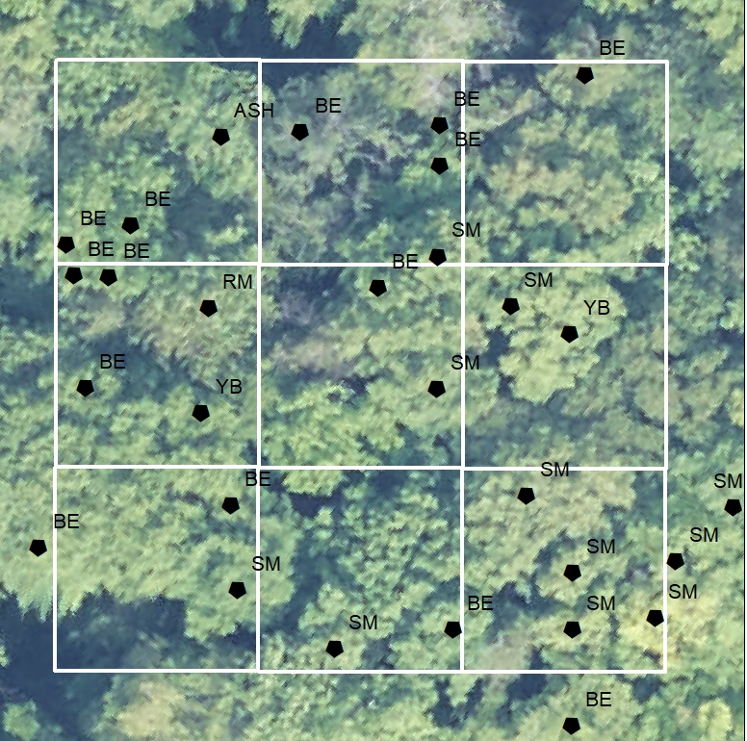
Figure 9. Example of the corresponding plotted canopy points and its species.
Figure 10. A comparison of the plot’s aerial photo and its corresponding PRI values. On the right, the squares are the mapped canopy points.
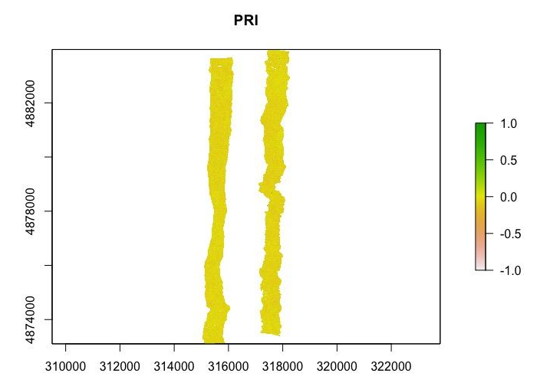

Figure 11. Visualizing photochemical reflective index (PRI) extent for C7, C8, C9.
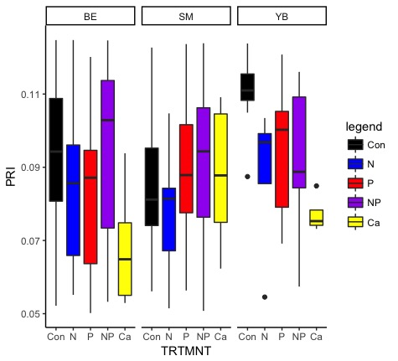
Figure 12. Treatment versus mean photochemical reflective index (PRI) for each nutrient treatment across four stands by species. This graph shows a pattern of lower PRI values for the Nitrogen treated trees compared to the control with a P value of 0.07.

Literature cited
Asner, G. and Martin, R. (2016). Spectranomics: Emerging science and conservation opportunities at the interface of biodiversity and remote sensing. Global Ecology and Conservation, 8, pp.212-219.

Chadwick, K. and Asner, G. (2018). Landscape evolution and nutrient rejuvenation reflected in Amazon forest canopy chemistry. Ecology Letters, 21(7), 978-988.

Hulslander, D. (2015). NEON Normalized Difference Vegetation Index (NDVI), Enhanced Vegetation Index (EVI), Atmospherically Resistant Vegetation Index (ARVI), Canopy Xanthophyll Cycle (PRI), and Canopy Lignin (NDLI) Algorithm Theoretical Basis Document. NEON Doc. # NEON.DOC.002391 http://data.neonscience.org/documents/10179/11204/NEON.DOC.002391vA/0b2a4472-95eb-42a7-a3cb-db6647de7ba9

Ollinger, S. V., & Smith, M. (2005). Net Primary Production and Canopy Nitrogen in a Temperate Forest Landscape: An Analysis Using Imaging Spectroscopy, Modeling and Field Data. Ecosystems, 8(7), 760-778.

Ollinger, S. V. (2010). Sources of variability in canopy reflectance and the convergent properties of plants. New Phytologist, 189(2), 375-394.

Appendix I

Detecting foliar nutrient status from the air: Ground truthing NEON spectra in the MELNHE plots
Marissa L. Gabriel, Drexel University
Alexander Young, Ruth Yanai

Introduction

Remote sensing

Monitoring the health of the environment becomes more crucial as anthropogenic activities continue to alter earth’s system of natural resources, but more accessible with developing technologies and fields such as spectronomics. Using remotely sensed data, entire landscapes can be observed from a desktop.

An aerial photo of the geographic distribution of species produces an image of visible RGB bands of light reflected off surfaces. LiDAR can be used to observe the physical structure of vegetation by calculating the return time from an object to the sensor. Imaging spectroscopy records the intensity of electromagnetic radiation wavelengths that are reflected off the earths surface and can produce a a detailed description of earth’s surface and vegetation characteristics.

The diverse functional traits of the foliage produces different interactions with solar radiation, called spectral properties. The functional traits of the canopy refer to elemental and molecular properties that influence the way photons reflect back to the viewer (Asner et al 2017). The functional traits and spectral properties of the canopy are conserved across plant taxa, and can vary across space, time, and with respect to vegetation health. temporally, or by differing nutrient content within the foliage, and the resulting spectral optical properties can be viewed remotely with an imaging spectrometer.

Spectranomics directly connects plants to ecosystem processes such as biogeochemical cycles, which is an essential link to the rest of the Earth system (Asner at al 2017)and a worldwide mapping of plant canopy traits will result in the first spatially-explicit estimates of biodiversity for Earth science (Asner et al 2017)

Nutrient addition, MELNHE

In the Bartlett Experimental Forest, there is an ongoing, multiple element limitation in northern hardwood ecosystem (MELNHE) experiment that is testing nutrient (co)limitation in ecosystem function. The experimental nutrient treatments began in 2011 with an addition of 30 kg/ha/year of nitrogen (as NH₄NO₃), 10 kg/ha/year of phosphorus (as NaH₂PO₄), a combined treatment of both N and P, and a control treatment where no fertilizer was added.The spectralproperties of each species’ foliage is expected to change with the addition of nutrient in each treatment of N, P and N+P. Vegetation indices are calculated from the spectral profile of each pixel and could be correlated with changes in foliar chemistry associated with nutrient addition.

Objectives and hypothesis

This project will be a stepping stone toward bridging the gap between traditional mapping and ground truthing with remotely sensing the field.

This will be the start of a training dataset to make classifications that predict the applied nutrient treatment and tree species within the MELNHE stands based on their spectral reflectance values andmonitor the foliar nutrient status of the entire biogeographic assembly remotely.

This project will develop a method for matching specific tree’s canopies to their corresponding 2017 NEON spectra data by ground truthing within the MELNHE plots within Bartlett Experimental Forest using the aerial imagery to identify trees in the field. I will plot confirmed canopy into ArcGIS which will co-locate spatially explicit areas to their corresponding spectral signature and resulting vegetation index values.

A preliminaryanalysis of variances will then be performed with one vegetation (specify which one, or say multiple will be tested) index to quantify differences in index values across tree species and between nutrient treatments.

Methods

Field site

There are nine MELNHE stands within the Bartlett Experimental Forest (Figure 1). Mature stands, C7 (Figure 2), C8 (Figure 3) and C9 (Figure 4), clear cut in the 1800s, will be used first for this study because older trees tend to be larger and more spaced out making it easier to delineate canopies, as well as have less change in the future, but the goal is to map the canopy in all stands. The stands are located in the White Mountains National Forest, NH, USA. Within each stand is a nitrogen (N) plot, a phosphorus (P) plot, a nitrogen and phosphorus (N+P) plot and a control. C1, C6, and C8 have a calcium (Ca) plot. Each plot is divided into nine 10 meter by 10 meter subplots with a 10 meter buffer (Figure 5).

Figure 1. MELNHE 9 Bartlett stands. Sample stands will be C7, C8 and C9.
Figure 2. C7 Stand.

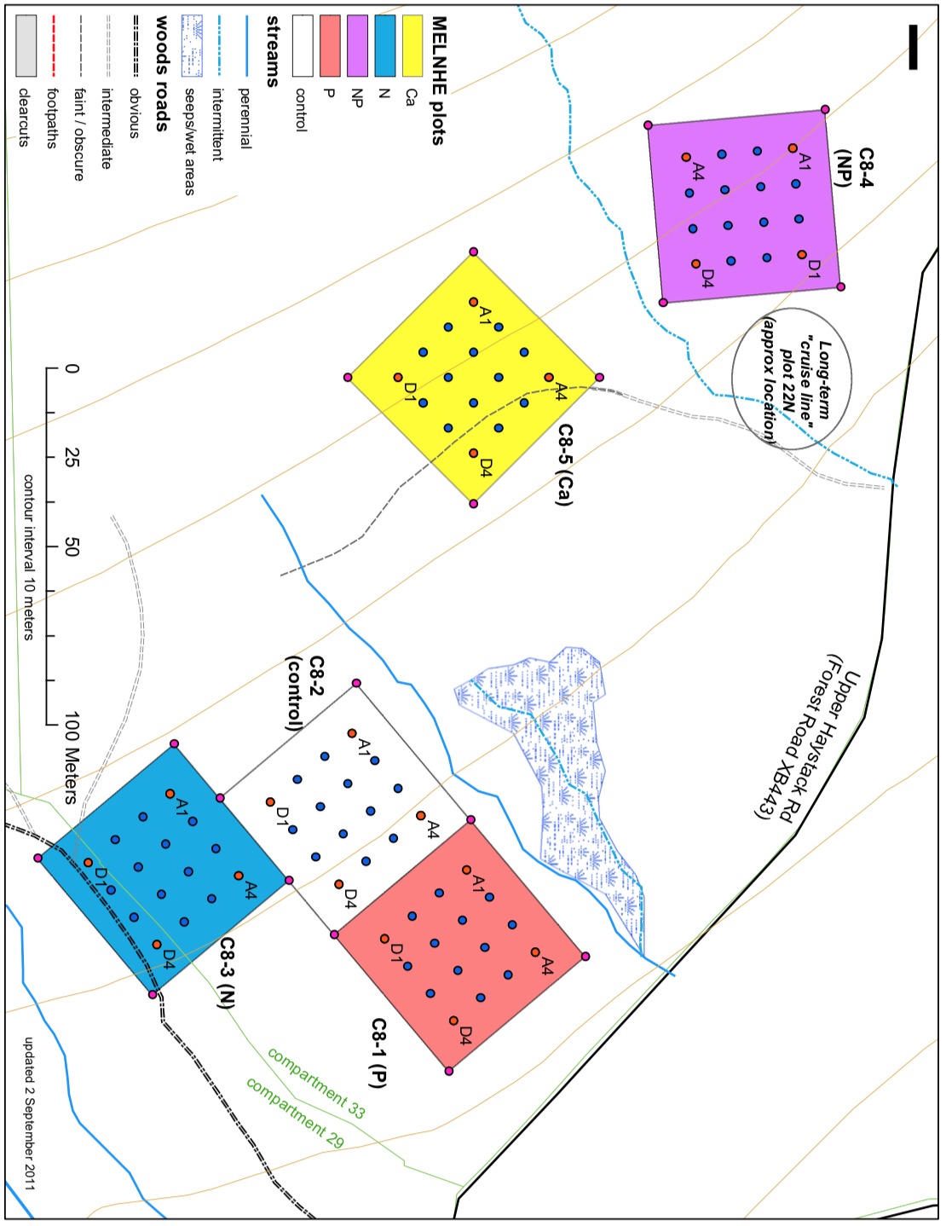
Figure 3. C8 Stand.
Figure 4. C9 Stand.

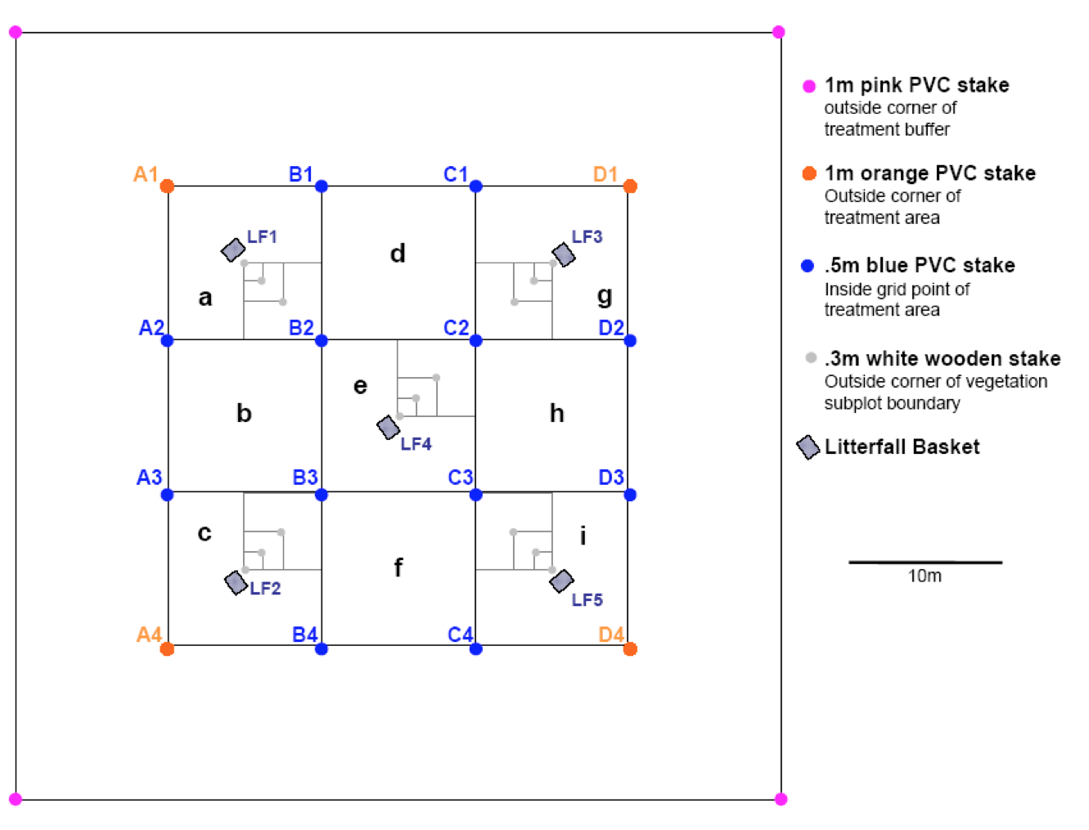
Figure 5. Plot layout.

Data sources

NEON airborne hyperspectral data collected in 2017 using a Visible to Shortwave Infrared (VSWIR) imaging spectrometer will be used as well as the aerial photo, LiDAR, and calculated vegetation indices. Previous stake and tree positions from the MELNHE research will be used and confirmed.

Ground truthing

The purpose of ground truthing is to gather empirical information to validate statistical models. An aerial RGB image of the plot will be taken to the field with “idealized” stake coordinates and tree stem locations overlaid. If stake locations need to be updated, a trimble GPS can be used to provide precise (sub-meter) accurate points. The stake locations are used as a reference for which tree stems are based on, and are crucial. The tree locations were mapped using the azimuth bearing for an angle from the lowest named stake in the subplot combined with the distance from the stake. The UTM coordinates of the tree stem were calculated from known stakecoordinates.

Within each subplot, each tree will be noted as a canopy tree or not using the unique tree ID code and species. Recorded diameter at breast height (DBH) will help with identification. It will be noted whether the previous stem locations are correct or not (and will be updated to improve the use-ability of the stem maps). The sunlit tree canopy area of individual trees and species will be sketched onto the RGB image. The area of canopy will be referenced by the stake locations and measured out using a digital hypsometer.

Processing

Confirmed stake locations will be mapped on ArcGIS using the same coordinate system.
Tree crown will be drawn on ArcGIS as a polygon feature and saved as a shapefile. Observed stem location will be updated in ArcGIS based on field observations. Confirmed crown area will be mapped in ArcGIS to link to the raster cell value of vegetation index and other NEON data to the tree species and its received nutrient addition. .

Analysis

Index values per tree per species per nutrient plot (C, N, P, N+P) will be compared. An ANOVA will test for differences in means of index values for each species in C, N, P and N+P. Analysis will also be performed by stand. (example figure)

Potential pitfalls and plans for remediation

It will be difficult to keep everything on the same coordinate system. Universal transverse mercator (UTM) coordinates will be used because that is what was used in previous plot and stem mapping. It will be difficult to see the top of the canopy when the understory might be blocking the view. If necessary trees will be accessed to get a better view of tree crowns.

Expected results

Insert example drawing over RGB image

Wavelength vs reflectance plot…

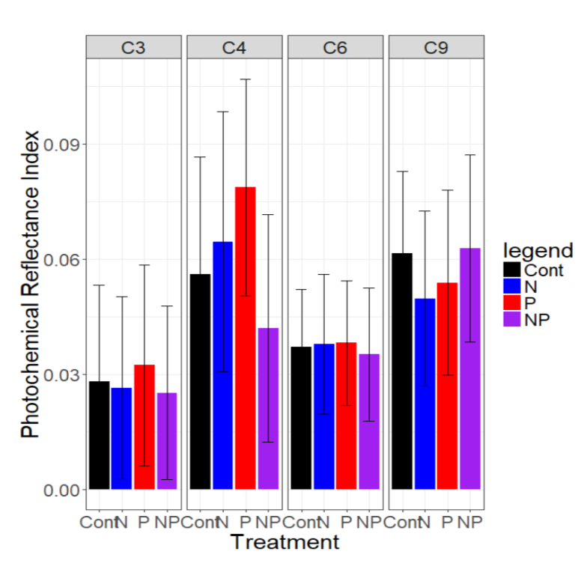
Example treatment vs photochemical reflective index

Timeline

Finish C9 to present on July 12. Finish C9, C8, C7 this summer.
Physically map two plots every week?

Budget

Will need help from Alexander Young in advising and in field work?

Monetary budget:
--Trimble ($5,000) available for free from ESF
-- Printer paper (provided from ESF
-- printer ink (~$15??)
-- NEON data (freely available to the public)
Cost of ArcGIS?

Materials and Supplies

Clipboard, compass, trimble gps, hypsometer, computer with arcmap and r.

Literature Cited

Asner & Martin 2017
Elser et. al. (2007) co limitation by nitrogen and phosphorus

Appendix II

Detecting foliar nutrient status from the sky:
Ground truthing NEON spectra in the MELNHE plots
Marissa L. Gabriel Drexel University
Alexander R. Young, Ruth D. Yanai SUNY ESF

Introduction
Remote sensing
Monitoring environmental health becomes more crucial as anthropogenic activities continue to alter natural resource availability and ecosystem stability. Developing technologies and fields such as spectronomics make assessing environmental health more accessible and efficient. Using remotely sensed data, entire landscapes can be observed from a desktop.

Aerial photography of species distribution across a landscape produces an image of visible red, green and blue (RGB) bands of light. In contrast, imaging spectroscopy records the intensity of electromagnetic radiation wavelengths that are reflected off the earth’s surface and can produce a detailed description of earth’s surface and vegetation characteristics.

Hyperspectral imaging captures a wider range of wavelengths across the electromagnetic spectrum than visible RGB bands. Monitoring the amount and type of light that is reflected by plant vegetation is an examination of efficiency of light harvested for photosynthesis. In an effort to increase the interpretation and decrease the size of remotely sensed hyperspectral data, vegetation indices have been established. Vegetation indices use the intensity of specific bands from their hyperspectral profile to calculate a numeric value which can be compared across time and space and use ratios that eliminate error common to the absolute measure of bands.

Functional traits of foliage are morphological and physiological parameters including leaf mass per area, leaf thickness, and chlorophyll content and can be inferred by differences in canopy reflectance. The functional traits of the canopy refer to elemental and molecular properties that influence the way photons reflect back to the viewer (Asner et al 2016). Functional traits and corresponding spectral properties of tree canopies are conserved across plant taxa, but can vary across space, time, and with respect to vegetation health. Remotely sensing forest canopies enables researchers to quantify foliar properties across a landscape.

Nutrient addition, MELNHE
In the Bartlett Experimental Forest, there is an ongoing, multiple element limitation in northern hardwood ecosystem (MELNHE) experiment that is manipulating nutrient availability in nine forest stands. Experimental nutrient treatments began in 2011 with an addition of 30 kg/ha/year of nitrogen (N) as NH₄NO₃, 10 kg/ha/year of phosphorus (P) as NaH₂PO₄, a combined treatment of both N and P, and a control treatment where no fertilizer was added. There are three stands that also examine calcium (Ca) with a one time fertilization of 1,150 kg/ha as CaSiO₂. The spectral properties of foliage are expected to differ with the nutrient status. Vegetation indices are calculated from the spectral profile of each pixel and could be correlated with changes in foliar chemistry associated with nutrient addition.

Objectives
As technology changes, new methods for modeling empirical observations are developed. This study aims to bridge the gap between traditional cartography and digital remote sensing by developing robust ground truthing methods.
This work will create a training dataset to classify tree crowns by tree species identity within the MELNHE stands based on their spectral reflectance values and aims to infer forest health of the Bartlett Experimental Forest. This research has the potential to determine which forested areas are most in need of conservation and management efforts.

This project will develop a ground truthing method to align specific tree crowns with their tagged tree within the MELNHE plots in Bartlett Experimental Forest using aerial imagery to identify trees in the field. The confirmed tree crown delineation with its specific identity will be plotted into ArcGIS which will co-locate spatially explicit areas to their corresponding spectral signature and resulting vegetation index values. Spectral profiles will be compared between trees that have been fertilized for seven years to identify remotely sensed signals of tree health across the northern hardwood landscape.

A preliminary analysis of variances will then be performed with multiple vegetation indices to quantify differences in index values across tree species and between nutrient treatments.

Methods
Site Description
There are nine MELNHE stands within the Bartlett Experimental Forest (Figure 1). The mature stands, C7 (Figure 2), C8 (Figure 3) and C9 (Figure 4), were clear cut in 1890, 1883, and 1890 respectively and will be used first for this study because older trees tend to be larger and spaced farther apart makes it easier to delineate their canopies. Older stands are also preferable over younger stands because the canopies undergo less growth year to year. The ultimate goal is to map all canopies within all stands. The stands are located in the White Mountains National Forest, New Hampshire, USA. Within each stand is a nitrogen (N) plot, a phosphorus (P) plot, a nitrogen and phosphorus (N+P) plot and a control (C). C1, C6, and C8 also have a fifth plot treated with calcium (Ca). Each plot is divided into nine 10 meter by 10 meter subplots surrounded by a 10 meter buffer (Figure 5).

Figure 1. MELNHE 9 Bartlett stands. Priority study sites include C7, C8 and C9.
Figure 2. C7 Stand. Figure 3. C8 Stand.

Figure 4. C9 Stand. Figure 5. Plot layout.

Data sources
We will use NEON airborne hyperspectral data collected in 2017 using a Visible to Shortwave Infrared (VSWIR) imaging spectrometer as well as the aerial photo and calculated vegetation indices including Normalized Difference Vegetation Index (NDVI) (Equation 1), Enhanced Vegetation Index (EVI) (Equation 2), Normalized Difference Nitrogen Index (NDNI) (Equation 3), Normalized Difference Lignin Index (NDLI) (Equation 4) and Photochemical Reflective Index (PRI) (Equation 5). Previous stake and tree positions from the MELNHE research will be used and confirmed during ground truthing.

Vegetation indices
The Normalized Difference Vegetation Index (NDVI) is a transformation of the ratio of near infrared (NIR) to visible (VIS) spectral reflectance. The calculated value per cell ranges between -1.0 and 1.0 with values between 0.2 and 0.8 indicating green vegetation. NDVI is used to distinguish vegetation areas from other land cover categories. Generally, if more of the reflected light is within NIR wavelengths than VIS wavelengths it signifies dense vegetation. NEON Imaging Spectrometer level 1B reflectance dataset (NIS1) bands at 648.2 nm for red and 858.6 nm for NIR are used for the NDVI algorithm.
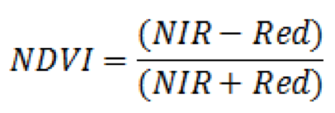 Eq. 1
The Enhanced Vegetation Index (EVI) works better for forested land as opposed to NDVI which can become over-saturated within areas of dense vegetation. EVI enhances interpretation by accounting for atmospheric interference. Calculated values range from -1.0 to 1.0 and are sensitive to canopy structure including leaf area index (LAI). NIS1 bands at 467.8 nm for blue, 648.2 nm for red, and 858.6 nm for NIR are used for the EVI algorithm.
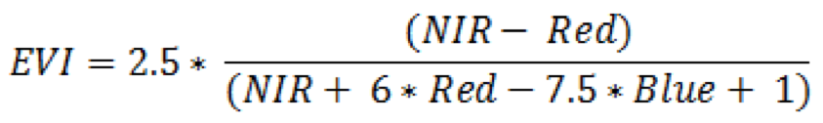 Eq. 2
Normalized Difference Nitrogen Index is an experimental index focused on leaf chemistry to determine nitrogen concentration in foliage with calculated values ranging from 0.0 to 1.0. NIS1 bands at 1,510 nm for nitrogen and foliage biomass and 1,680 nm for foliage biomass are used for the NDNI algorithm.
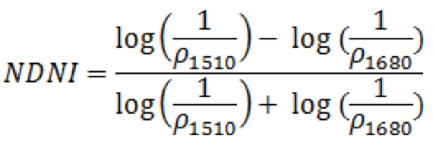 Eq. 3
Normalized Difference Lignin Index is also experimental and aims to quantify total canopy lignin content. NIS1 bands at 1,755.3 nm for lignin and foliage biomass and 1,680.1 nm for foliage biomass are used for the NDLI algorithm.
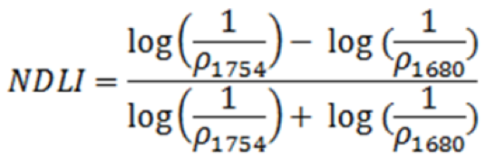 Eq. 4
Photochemical Reflective Index or Canopy Xanthophyll is sensitive to carotenoid pigments and is used as a proxy for photosynthetic light use efficiency, the rate of carbon dioxide uptake per unit energy absorbed. PRI values range from -1.0 to 1.0. PRI provides a physiologically meaningful interpretation of light use efficiency and is used to monitor vegetation productivity and stress. NIS1 bands at 532.9 nm and 538.0 nm are used for the PRI algorithm.
Eq. 5
Indices and equations as described by Huslander 2015 in the NEON Algorithm Theoretical Basis Document.

Ground truthing
The purpose of ground truthing is to gather empirical information to validate statistical models. An aerial RGB image of the plot will be taken to the field with idealized stake coordinates and tree stem locations overlaid. If stake locations need to be updated, a trimble GPS will be used to provide accurate and precise submeter points. The stake locations will be used as a reference for tree crown locations. The tree locations were mapped using the azimuth from the lowest named stake in the subplot combined with the stem’s distance from the stake. The UTM coordinates of the tree stem were calculated from known stake coordinates.

Within each subplot, each tree will be located and identified using the unique tree ID code and species and its canopy position will be recorded. Recorded diameter at breast height (DBH) will help with identification in the field by knowing the relative stem size. It will be noted whether the previous stem locations are correct or not and will be updated on the tree inventory to improve the use-ability of the stem maps. The sunlit tree canopy points of individual trees and species will be sketched onto the RGB image. The area of canopy will be referenced by the stake locations.

Processing
Tree crowns will be drawn in ArcGIS as point features and each stand will be saved as a feature class within one geodatabase. Confirmed crown points will be mapped in ArcGIS to link to the raster cell value of vegetation index and other NEON data to the tree species and its nutrient treatment. Confirmed stake locations will be mapped on ArcGIS using the same coordinate system as the NEON data. Observed stem location will be updated in ArcGIS based on field observations.

Analysis
Index values per tree per species per nutrient plot (C, N, P, N+P, Ca) will be compared. A factorial ANOVA blocked by stand will test for differences in the index values for each species in C, N, P, N+P, and Ca plots. Analysis will also be performed by stand.
Model statement: index ~ N + P + N*P + Ca + (1|Stand / Plot)

Potential pitfalls and remediations
- The tree stem positions are in Universal Transverse Mercator (UTM) coordinates and the NEON data is in World Geodetic System (WGS) coordinates. It will be necessary to match coordinate systems.
- It will be difficult to see the top of the canopy if the understory is full. If necessary trees will be accessed to get a better view of tree crowns from above.

Expected results
Figure 6. Example of field sketches on arial photos with stake locations overlaid. The points of canopies will be drawn into ArcGIS. There will be one of these maps for each plot, totaling 13 maps for the three stands.
Figure 7. Example of field notes on map of stake locations and tree stem positions. Notes will be replicated and detailed on the tree inventory.

Figure 7. Visualizing photochemical reflective index (PRI) extent for C7, C8, C9.
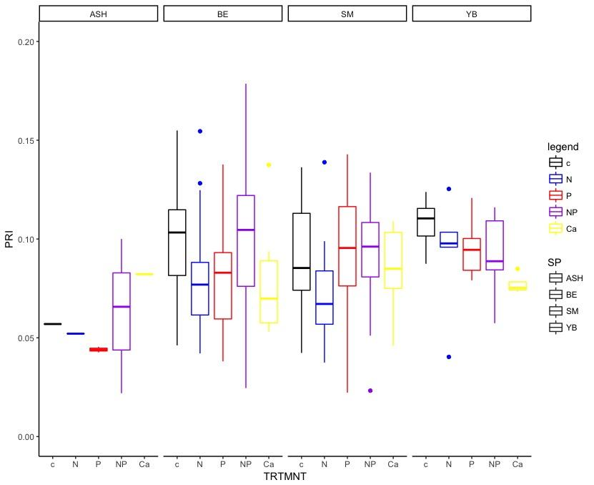
Figure 8. Example of treatment versus mean photochemical reflective index (PRI) for each nutrient treatment across four stands by species.
Timeline

June 14 Proposal due
June 15 Create all map print outs
June 18 - June 22 Print maps, field work at C7, C8, C9, data management
June 25 - June 29 Start feature class, enter points, finish ground truthing, begin R analysis
July 2 - July 6 Update proposal with methods, continue R analysis, create presentation
July 9 - July 13 Hubbard Brook meeting and presentation
July 16 - July 20 Soil pits at Hubbard Brook, sap flow
July 23 - 27 Field for mid and young stands
July 30 - August 3 Continued analysis
August 6 - August 10 Final report

Budget
Monetary budget:
- Trimble GPS, available from ESF
- Printer paper, available from ESF
- Printer ink, $15
- NEON data, open data
- ArcGIS, available from ESF

Labor budget:
- Alexander Young advising and field time
Materials and supplies
- Compass
- Trimble GPS
- Hypsometer
- Computer
- ArcMap: tree positions, stake positions, 2017 NEON Bartlett data
- R
- Clipboard
- Tree inventory
- Printed maps

Literature cited
Asner, G. and Martin, R. (2016). Spectranomics: Emerging science and conservation opportunities at the interface of biodiversity and remote sensing. Global Ecology and Conservation, 8, pp.212-219.

Chadwick, K. and Asner, G. (2018). Landscape evolution and nutrient rejuvenation reflected in Amazon forest canopy chemistry. Ecology Letters.

Hulslander, D. (2015). NEON Normalized Difference Vegetation Index (NDVI), Enhanced Vegetation Index (EVI), Atmospherically Resistant Vegetation Index (ARVI), Canopy Xanthophyll Cycle (PRI), and Canopy Lignin (NDLI) Algorithm Theoretical Basis Document. NEON Doc. # NEON.DOC.002391

