Proposal for Research: Investigating the Effects of N and P Fertilization on Available Base Cation Concentration in Soils
Griffin Walsh
Introduction
With the exception of sodium (Na⁺), the base cations calcium (Ca²⁺), magnesium (Mg²⁺), and potassium (K⁺) all serve important functions as macronutrients for plants, including enzyme regulation (Ca²⁺, Mg²⁺, K⁺), chlorophyll production (Mg²⁺), and cell organelle formation (Ca²⁺) (Barnes et al., 1998). Concentration of base cations is directly related to soil acidity, and this relationship is best described with percent base saturation, the percentage of cation exchange capacity (CEC) that consists of the base cations as opposed to the acid cations, aluminum (Al³⁺) and hydrogen (H⁺). Acid cations have a higher affinity for cation exchange sites and as such are retained more tightly. As a result, acid cations are less susceptible to leaching, acid cations are less likely to exchange with other cations, and are less likely to desorb in the presence of alternative sources of negative charge (Brady, 1974).
Base cations become available from weathering, where the dissolution of minerals results in an influx of ions in an available form for uptake (Brady, 1974). However, as weathering inputs decrease due to a nonrenewable supply of minerals and seeing as base cations are continually leached from the soil, atmospheric sources of these cations may become more important. In the Hawaiian Islands under a soil chronosequence study it was found that, through looking at ⁸⁷Sr/⁸⁶Sr ratio data (Sr is chemically similar to Ca), the atmosphere provided over 85% of Sr formerly believed to be from weathering. Forests may become P limited due to the low rates of atmospheric P deposition relative to base cation deposition (Kennedy et al., 1998), coupled with increases in N concentrations due to deposition from anthropogenic activities (Tilman and Lehman, 2001).
Soil nutrient concentrations in ecosystems vary based on a number of parameters (Barber, 1981). Human interference has been shown to influence soil chemistry with regard to base cations, where three years following clear cutting, base cation to H⁺ and Al³⁺ ratios decreased by 10% in the Oa, 5% in the E, and 3% in the Bh horizon at Hubbard Brook Experimental Forest (Johnson et al., 1989). The time since the clear cut has also been found toaffect base nutrient concentrations; following clear cutting, young stands increased in base cation concentrations, whereas old stands decreased in base cation concentrations, suggesting that initially the soil acts as a base cation sink, but eventually the soil becomes a source for these cations (Yanai et al., 1999). In addition, biotic forces play a direct role in base cation concentration. A study in northwestern Connecticut found that, beneath the canopies of individual trees, sugar maple had significantly higher exchangeable Ca and Mg than red maple, beech, red oak and eastern hemlock in the top 7.5 cm of the mineral layer (Finzi et al., 1998).
The addition of ammonium nitrate (NH₄NO₃) fertilizer to soils provides both the cation NH₄⁺ and the anion NO₃⁻, and likewise the addition of monosodium phosphate (NaH₂PO₄) provides the cation Na⁺ and anion H₂PO₄⁻. The addition of cations competing for exchange sites alters the composition of cations bound to soil colloids, which may affect the ability for soils to retain present base cations. Furthermore, the addition of NO₃⁻ (conjugate base of nitric acid, pK_{a}=-1.38), and weak acid H₂PO₄⁻ (pK_{a}=7.2) provide sources of negative charge in the soil, which may cause the desorption of cations from the clay and humus of the soil (University of Washington, n.d.). Availability of N-containing ions and H₂PO₄⁻ are not directly correlated to the amount of fertilizer per surface area applied (Fisk et al., 2014). During a study in Bartlett Experimental Forest, available N was higher in plots fertilized with both N and P than it was in plots solely fertilized with N, and likewise for P. It is unclear why nutrient mineralization is co-limited by N and P, however possible mechanisms include enzymatic feedback (e.g. P-mineralizing enzymes may require N) and stoichiometric balance within the soil, where adding one nutrient may encourage the uptake of the other (Fisk et al., 2014). Similarly, availability of base cations may be co-limited with N, P, or both N and P.
Objectives
- Investigate the effects of N, P, and NP fertilization on available base cation concentrations in soil.
- Describe the impact of time since clear cut on available base cation concentrations in soil.

Hypotheses
- Base cation concentrations will be lower in fertilized plots due to increased competing cations and additional sources of negative charge.
- Base cations will be lower in young stands and higher in old stands.
Methods
Soil from 9 stands in Bartlett Experimental Forest (BEF), New Hampshire will be analyzed for base cation concentrations. BEF soils are mostly spodosols developed in glacial drift, with slopes of 5-30% and elevation between 330-590 m. C1, C2, and C3 are young age (24-29 years since clear cut) stands, C4, C5, and C6 are intermediate age (33-38 years since clear cut) stands, and C7, C8, and C9 are old age (>100 years since clear cut) stands, and the young and intermediate stands originated following a clear cut harvest (Fisk et al., 2014). Within each stand, four 50x50 m plots were established, and fertilization treatments were assigned among plots randomly with some rejection criteria to avoid inter-plot contamination. Fertilization treatments were applied annually since 2011 and are as follows: 30 kg/ha year NH₄NO₃, 10 kg/ha year NaH₂PO₄, 30 kg/ha year NH₄NO₃ and 10 kg/ha year NaH₂PO₄, and no fertilizer (Kang et al., 2015).
In each plot, there are four subplots from which soil samples will be collected and composited to create a homogenized sample of the soil in each plot within the stand. Say that soil samples will be extracted…Ammonium chloride (NH₄Cl) will be used to replace cations at each cation exchange site, flushing available cations into an extraction. The extraction will then be analyzed using an inductively coupled plasma optical emission spectrometer (ICP-OES) to measure Na, Ca, Mg and K concentrations. To obtain concentration of each cation within each soil sample, concentration data from the ICP-OES will be multiplied by the extraction volume to obtain total mass of cations within the soil sample, and then divided by the mass of the soil sample to obtain concentration of cations in the soil (mg cation/kg dry soil). Data will be analyzed using a nested ANOVA with nesting for stand and age to determine if there is a treatment effect on base cation concentrations with fertilization.
Sample Results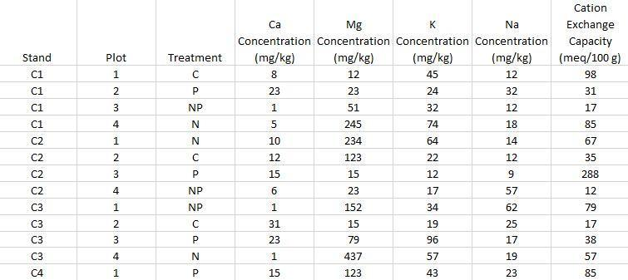

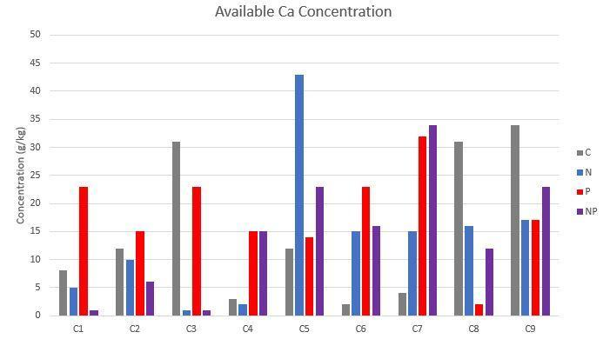
Budget
5 hours of ICP sample running: $150
Ammonium chloride (500g): $61.90
Filter Paper: $43.25
http://www.sigmaaldrich.com/catalog/product/sigald/31107?lang=en&region=US
http://www.sigmaaldrich.com/catalog/product/sigma/f6911?lang=en&region=US
Soil sampling will occur for 2 weeks starting on June 26th. Ammonium Chloride extraction of the samples should take a week and a half, and running the samples on ICP will take at least one day, but the samples need to be brought to a place with an ICP-OES, which, if they are not shipped, might require a trip to Syracuse. Can you do it when you get back in August?
Future Study
In addition to analysis of available base cation concentrations in response to fertilizer treatment, investigating total base cation concentrations would allow us to look at available to total concentration ratios to see if treatment is affecting conversion between available and unavailable concentrations in either direction. Studies looking at nutrient uptake regarding base cations into roots would also be useful, as treatments may affect the rate or capacity of roots to uptake base cations, which would have direct effect on soil concentrations. Investigating weak acid concentrations in the soil could also inform us about weathering rates, which would be useful for doing nutrient balances on base cations, and in a similar vein studying atmospheric deposition of base cations may prove useful as well. Fertilizing with base cations in addition to N and P through a factorial fertilization design may help us determine if there is a synergistic change in availability due to the presence of base cations in combination with N and/or P.
References
Barber, S. A., (1981). Soil Chemistry and the Availability of Plant Nutrients. In M. Stelly, D. M. Kral, and M. K. Cousin (eds.), Chemistry in the Soil Environment (pp. 1- 12). Madison, WI: American Society of Agronomy.
Barnes, B. V., Zak, D. R., Denton, S. R., & Spurr, S. H. (1998). Forest Ecology (4th ed.). New York, NY: John Wiley & Sons, Inc.
Brady, N. C. (1974). The Nature and Properties of Soils (8th ed.). New York, NY:
Macmillan Publishing Co., Inc.
Finzi, A. C., Canham, C. D., & Breemen, N. V. (1998). Canopy Tree-soil Interactions within Temperate Forests: Species Effects on pH and Cations. Ecological Applications 8(2), 447–454. Retrieved from http://people.bu.edu/afinzi/Species
%20effects%20on%20pH%20and%20cations.pdf
Fisk, M. C., Ratliff, T. J., Goswami, S., & Yanai, R. D. (2014). Synergistic soil response to nitrogen plus phosphorus fertilization in hardwood forests. Biogeochemistry 118, 195-204. Doi: 10.1007/s10533-013-9918-1
Johnson, C. E., Johnson, A. H., & Siccama, T. G. (1989). Whole-Tree Clear-Cutting Effects on Exchangeable Cations and Soil Acidity. Soil Science Society of America Journal 55(2), 502-508. Doi: 10.2136/sssaj1991.03615995005500020035x
Kang, H., Fahey, T. J., Bae, K., Fisk, M., Sherman, R. E., Yanai, R. D., & See, C. R. (2015). Response of forest soil respiration to nutrient addition depends on site fertility. Biogeochemistry 127(1). Doi: 10.1007/s10533-015-0172-6
Kennedy, M. J., Chadwick, O. A., Vitousek, F. M., Derry, L. A., & Hendricks, D. M. (1998). Changing sources of base cations during ecosystem development, Hawaiian Islands. Geology 26(11), 1015-1018. Retrieved from http://www.geo.cornell.edu/geology/research/derry/publications/HawaiiSr98.p df
Tilman, D. and Lehman, C. (2001). Human-caused environmental change: Impacts on plant diversity and evolution. Proceedings of the National Academy of Sciences of the United States of America 98(10), 5433-5440. Doi: 10.1073/pnas.091093198
University of Washington. (n.d.). Table of Acid and Base Strength. Retrieved from http://depts.washington.edu/eooptic/links/acidstrength.html
Yanai, R. D., Siccama, T. G., Arthur, M. A., Federer, C. A., & Friedland, A. J. (1999). Accumulation and Depletion of Base Cations in Forest Floors in the Northeastern United States. Ecology 80(8), 2774-2787. Retrieved from http://www.jstor.org/stable/177257

