American Beech and Sugar Maple Germinant Survival

Kate Bazany

Contents:
Report………………………………………………………………………………………………..2
Appendix 1……………………………………………………….………….To be added soon
Appendix 2………………………………………………………………………………………..12

Report

Kate Bazany
Mentors: Adam Wild, Ruth Yanai
Research Proposal
MELNHE, Summer 2018

Title:
Examining the Impacts of Nitrogen, Phosphorus, and Calcium Addition on Mortality of Sugar Maple and American Beech Germinants

Introduction:
Multiple Nutrient Limitation: Plant species niche space can be impacted by nutrient availability. Previously, species were thought to be limited by one limiting nutrient, but now there is evidence for multiple nutrient limitation in certain systems. Nutrients can impact systems additively, meaning that the impacts of adding multiple nutrients can be greater than the impacts of adding a single nutrient, or synergistically, meaning the impacts of adding multiple nutrients can be greater than the sum of the original responses (Goswami et al. 2018). Adding a limiting nutrient can shift limitation, for example adding phosphorus to a phosphorus limited system can shift the system towards nitrogen limitation and vice versa (Vitousek et al. 2010). Understanding the broad responses to nutrient addition can give us insight as to what nutrients are limiting on the ecosystem, community, and species population scales, as well as providing insight to the impacts of anthropogenic nutrient pollution. MELNHE (Multiple Element Limitation in Northern Hardwood Ecosystems) is a full factorial nutrient addition experiment that aims to answer a variety of questions about how nutrient limitation impacts forest functioning. MELNHE is examining the impacts of calcium, nitrogen, phosphorus, and nitrogen and phosphorus addition on northern hardwood ecosystems.

Impact on Germinants: Nutrient concentration can impact germinants by providing competitive advantages to certain species, leading to demographic shifts (Hecky and Kilman, 1988). Higher nutrient availability often leads to biodiversity declines, as additional nutrients can give a previously limited species a competitive advantage. In forest ecosystems, nutrient addition can either favor the germinant or the pathogens and herbivores that consume them by changing the nutrient profiles of the germinants making them more vulnerable to pathogens or more appealing to herbivores. Insect herbivory can alter germinant communities as insects preferentially consume certain species, and insect herbivory is often fatal to germinants (Brown and Gange, 1989). Plants with higher foliar carbon content, leaf thickness, and dry matter have greater resistance to pests and pathogens whereas more nutrient rich leaves with lower carbon contents are more vulnerable (Wright and Cannon, 2001).
Fertilization can impact foliar chemistry, which in turn can impact palatability of plants and vulnerability to pathogens and herbivores (Bryant et al. 1987). Nitrogen fertilization increases nitrogen content in leaves which increases leaf palatability, making high nitrogen leaves more vulnerable to insect herbivores (Bryant et al. 1987). Phosphorus addition increases the phosphorus content in plants (Tessier and Raynall, 2003) which increases vulnerability, but also increases plant biomass (Davidson et al. 2004). If germinants in phosphorus plots have larger leaf size, mortality rates could decrease as larger leaf size is linked to lower mortality rates in sugar maple germinants (Cleavitt et al. 2014). Leaf tissues with higher concentrations of nitrogen and phosphorus are more desirable to herbivores than nutrient poor leaves (Robinson and Gessner, 1999) suggesting that in spite of potential increases in leaf size, germinants in areas enriched with nitrogen and phosphorus will have higher mortality rates.
Calcium addition is expected to decrease germinant mortality as legacy effects of acid rain increase germinant mortality (Cleavitt et al. 2014) and calcium addition is used as an acid rain remediation technique that increases soil pH. Additionally CaSi₃ treatment results in greater silicate concentration in leaf tissues of trees (Wild and Yanai, 2015) which would increase the structural defense of germinants making them less vulnerable to insect herbivory (Bryant et al. 1987). Initial damage from insect herbivory or mechanical damage and infection from plant and soil pathogens was correlated with germinant death (Cleavitt et al. 2014).
2017 was a mast year, a year of high seed production, for both American beech and sugar maple, meaning there are a lot of germinants in 2018 (citation). Mast years for American Beech and sugar maple often overlap (Cleavitt and Fahey, 2017). Calcium addition has been shown to increase sugar maple seed production in some studies (Long et al. 2011). In others, seed production has been unaffected by nutrient addition (Cleavitt and Fahey, 2017).

Objective:
To determine the impact of nutrient addition on sugar maple (Acer saccharum) and American beech (Fagus grandifolia) germinant population per unit area, vulnerability to insect herbivory and pathogens, and probability of mortality.

Hypotheses:
(i) Initial germinant status will correlate with germinant survival across treatments. Initial larger leaf area and low damage scores will increase the probability of germinant survival while initial damage and presence of pathogens will increase the probability of germinant mortality.

(ii) Acer saccharum and Fagus grandifolia mortality in Nitrogen, Phosphorus, and Nitrogen and Phosphorous plots will be higher than in the control plots. Mortality will be lower in the Calcium addition plots. Evidence of insect herbivory and sap feeding will be highest in Nitrogen and Phosphorus addition plots, intermediate in control plots, and lowest in Calcium addition plots.

(iii) Nitrogen and phosphorus fertilization will increase initial germinant population density but will decrease survivorship. Calcium addition will increase survivorship of sugar maples. Germinant population will vary with germinant density.

Methods:
MELNHE Experimental Site Design: Experimental plots were established in 3 old stands (>100 years since clear cutting) in temperate hardwood forests in the Bartlett Experimental Forest in New Hampshire and 2 old stands offsite, one at Hubbard Brook and one at Jeffers Brook. Each stand has three, 30 by 30 meter experimental plots with 10 meter buffer zones—nitrogen addition (30 kg/ha/yr of NH₄NO₃), phosphorus (10 kg/ha/yr of NaH₂PO₄) addition, and nitrogen and phosphorous addition (same quantities of both)—and one control plot. Plots were established in 2010 and have been fertilized yearly. One old stand in Bartlett and the old stands at Hubbard and Jeffers Brook have additional treatment plots of one application of slow to weather wollastonite (1150 kg/ha of CaSi₃). Weather during the data collection period was dry at first and rainy towards the end of the season.

Field Data Collection: Sugar maple and American beech germinants will be counted in ten m^2 sub-plots in each treatment plot of the Bartlett old growth stands over an eight week period. 10 germinants of each species per germinant plot will be systematically selected, tagged, and tracked. Leaf size (15 size classes), percent leaf damage (5 damage classes), and cause of damage will be observed visually and recorded for each individual. Visual evidence of insect herbivory, sap feeders, fungal diseases, mechanical damage, and stem damage will be recorded for each tagged individual at each weekly site visit (table 1). Effort will be taken to minimize direct contact with germinants as pathogens and insects are easily spread from one individual to another (Packer and Clay, 2000). The total number of living germinants per seedling subplot will be recorded during each of three site visits for the duration of the experiment to determine germinant population and mortality per unit area.

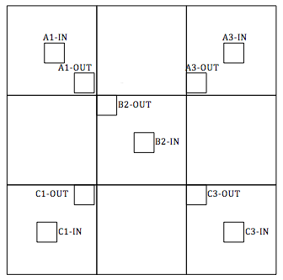
Figure 1: Germinant plot layout in relation to the treatment plot. Each small square is a one meter squared germinant plot. The total plot area is 30 meters squared. There is a buffer zone fertilized at the same concentration of the plot that extends 10 meters beyond each edge of the treatment area that is not pictured.

Germinants will be observed at the plot level in the two old stands in Hubbard and Jeffers Brook at the beginning and end of the study period. Each individual will be sized, assigned a damage class, and observed for type of damage though individuals will not be tagged. Data from Hubbard and Jeffers Brook stands will be observed at the seedling subplot level.

Table 1: Visual evidence of agents of mortality.
Caterpillar Herbivory- holes in the leaf tissue, generally with rounded edges | 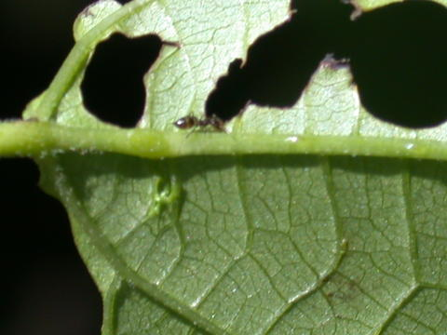  Photographer: Garcia, Humberto. Publisher: Morrison, Colin.
Thrips (sap feeder)- characterized by browning of the veins, especially at the tips. Common to sugar maple. | 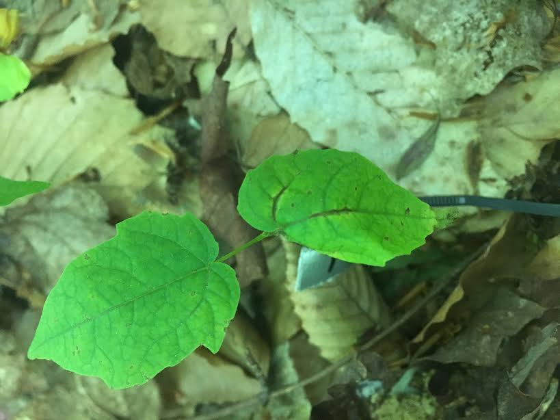
Wooly Aphids- white insects with a white, fuzzy appearance, generally found on the underside of leaves | 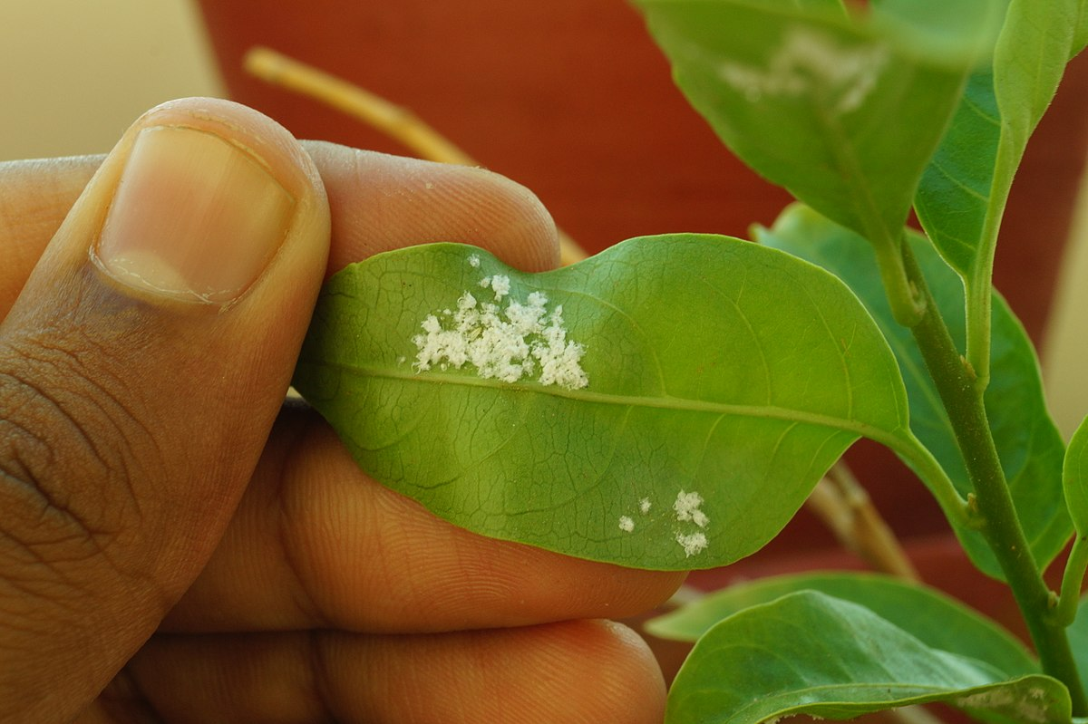
Root Rot- Fungal infection of the root, characterized by a yellowing then a browning of the leaf tissue. | 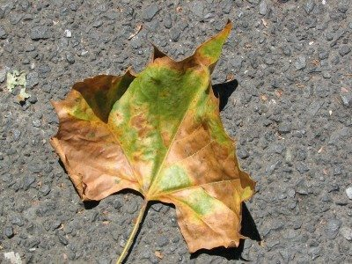  Photographer: Debra Roby
Mechanical Damage- issue with the opening of the leaves. Generally symmetrical damage to both leaves. | 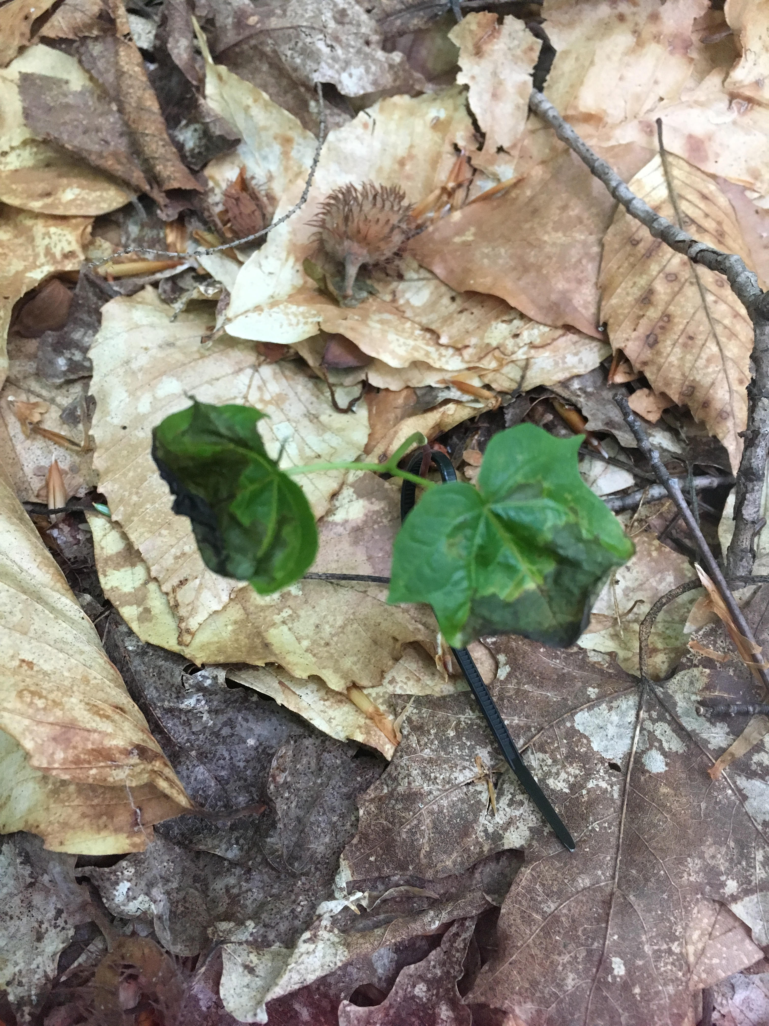

Statistical Analysis: The impacts of nutrient addition on seedling vulnerability to pathogens and mortality will be analyzed with a randomized complete block design with subsampling of germinant subplots and individuals of each species. Each stand will be considered a block, with four treatments in two blocks (N, P, NP, and C in two Bartlett stands) and five in three blocks (N, P, NP, C, and Ca in one Bartlett stand and in Hubbard and Jeffers Brook). Seedling mortality rates, pathogen frequency, and population density will be examined at the seedling subplot level of replication with seedling subplots being considered as within treatment subsamples. Relationships between specific factors ( leaf size, specific pathogen presence, initial damage class) and seedling mortality will be examined on an individual scale using linear regressions and chi-squared tests.

Table 2: Number of initially tagged individuals in each treatment plot.
Stand | Treatment | # Tagged American Beech | # Tagged Sugar Maple
C7 | C | 94 | 26
 | N | 100 | 87
 | P | 95 | 78
 | N + P | 100 | 28
C8 | C | 100 | 100
 | N | 86 | 83
 | P | 99 | 49
 | N + P | 94 | 68
 | Ca | 83 | 80
C9 | C | 78 | 100
 | N | 73 | 28
 | P | 26 | 39
 | N + P | 60 | 31

Results:

Germinant Population Data: Both species had high germinant density at the beginning of the field season (average of 200-20 germinants/m2) and ended with lower germinant densities (average of 70-10 germinants/m2) (figure 1). Germinant densities were highest in plots with added phosphorus for both species, but mortality was also highest in these plots (figure 1). Calcium plots had the lowest average number of germinants per meter for both species but this trend could be partially attributed to understory composition and to a lower number of replicates. Additionally mortality was lower in calcium added plots (figure 1).
Basal area of adults per treatment plot correlated with germinant populations (figure 2). An ANCOVA was run where stands were blocked and basal area for each species was considered as a covariate. Our model explained ~30% of the variation in sugar maple germinant density and ~40% of the variation in beech germinant density (Table 3). Round of collection was not significant for American Beech (F: 82.251, p<.001) or for sugar maple (F: 35.288, p< .001) and treatment was not significant for American beech (F: 5.255, p<.001) or for sugar maple (F: 15.301, p<.001) beyond what was explained by the covariate, basal area of American beech (F: 178.327, p<.001) and of sugar maple (F: 93.136, p<.001).

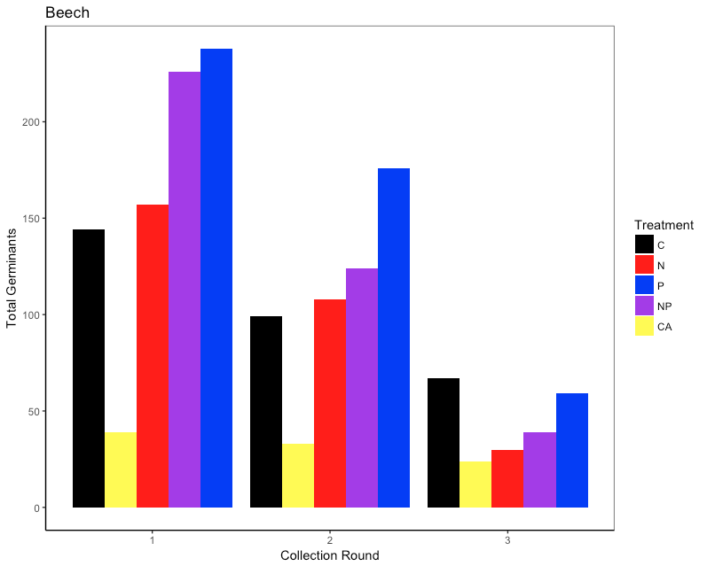
Figure 1: The total number of germinants varied with round of collection and with treatment. Plots with added phosphorus had higher initial beech populations but lower survivorship over the course of the study when compared to control plots. Plots with added calcium had lower beech population density but higher survivorship when compared to the control. Nitrogen addition alone did not impact initial population but decreased survivorship. The trends wiere similar for beech and sugar maple.

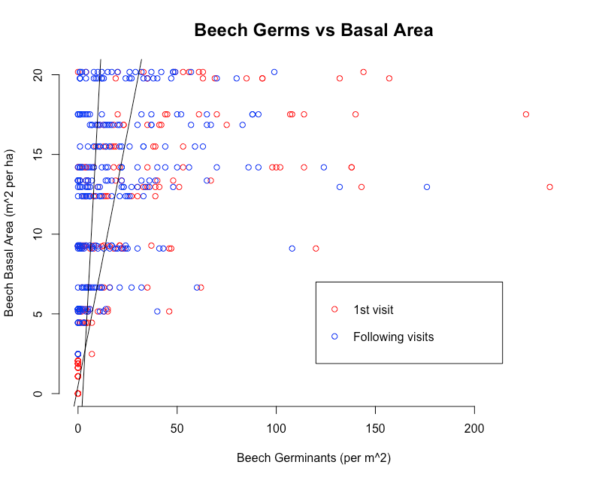
Figure 2: Germinant population correlates with basal area of the adult species for each plot. Basal area is more significant than treatment affect.

Table 3: ANCOVA testing the effects of nutrient addition treatment and round of collection on germinant population density. Basal area is treated as a covariate and results are blocked by stand.

 | R2 |  | F-statistic | p-value
Beech | .35 | Basal Area | 178.327 | <2.2*10^-16***
 |  | Stand | 10.372 | 4.142*10^-8***
 |  | Treatment | 5.255 | .00037***
 |  | Collection Round | 82.251 | <2.2*10^-16***
Sugar Maple | .29 | Basal Area | 93.136 | <2.2*10^-16***
 |  | Stand | 14.391 | 3.435*10^-11***
 |  | Treatment | 15.301 | 6.984*10^-12***
 |  | Collection Round | 35.288 | 5.003*10^-9***

Discussion and Future Directions:

Shinjini et al. (unpublished) found that nitrogen and phosphorus addition increased seedling mortality rates. Future research should clarify trends on the impacts of nutrient addition on germinant population, vulnerability and mortality.

Citations:
Brown, V. K., & Gange, A. C. (1989). Differential effects of above-and below-ground insect herbivory during early plant succession. Oikos, 67-76.
Bryant, J. P., Clausen, T. P., Reichardt, P. B., McCarthy, M. C., & Werner, R. A. (1987). Effect of nitrogen fertilization upon the secondary chemistry and nutritional value of quaking aspen (Populus tremuloides Michx.) leaves for the large aspen tortrix (Choristoneura conflictana (Walker)). Oecologia, 73(4), 513-517.
Cleavitt, N. L., Battles, J. J., Fahey, T. J., & Blum, J. D. (2014). Determinants of survival over 7 years for a natural cohort of sugar maple seedlings in a northern hardwood forest. Canadian Journal of Forest Research, 44(9), 1112-1121.
Cleavitt, N. L., Fahey, T. J., & Battles, J. J. (2011). Regeneration ecology of sugar maple (Acer saccharum): seedling survival in relation to nutrition, site factors, and damage by insects and pathogens. Canadian Journal of Forest Research, 41(2), 235-244.
Davidson, E. A., Reis de Carvalho, C. J., Vieira, I. C., Figueiredo, R. D. O., Moutinho, P., Yoko Ishida, F., ... & Tuma Sabá, R. (2004). Nitrogen and phosphorus limitation of biomass growth in a tropical secondary forest. Ecological Applications, 14(sp4), 150-163.
Hecky, R. E., & Kilham, P. (1988). Nutrient limitation of phytoplankton in freshwater and marine environments: a review of recent evidence on the effects of enrichment. Limnology and Oceanography, 33(4part2), 796-822.
Robinson, C. T., & Gessner, M. O. (2000). Nutrient addition accelerates leaf breakdown in an alpine springbrook. Oecologia, 122(2), 258-263.
Siemann, E., & Rogers, W. E. (2003). Herbivory, disease, recruitment limitation, and success of alien and native tree species. Ecology, 84(6), 1489-1505.
Tessier, J. T., & Raynal, D. J. (2003). Use of nitrogen to phosphorus ratios in plant tissue as an indicator of nutrient limitation and nitrogen saturation. Journal of Applied Ecology, 40(3), 523-534.
Wild, A. D., & Yanai, R. D. (2015). Soil nutrients affect sweetness of sugar maple sap. Forest Ecology and Management, 341, 30-36.
Wright, I. J., & Cannon, K. (2001). Relationships between leaf lifespan and structural defences in a low‐nutrient, sclerophyll flora. Functional Ecology, 15(3), 351-359.
Vitousek, P. M., Porder, S., Houlton, B. Z., & Chadwick, O. A. (2010). Terrestrial phosphorus limitation: mechanisms, implications, and nitrogen–phosphorus interactions. Ecological applications, 20(1), 5-15.

Appendix 2
(2nd Draft with comments from Ruth)

Kate Bazany
Mentor: Adam Wild, Ruth Yanai
Research Proposal
MELNHE, Summer 2018

Title:
Examining the Impacts of Nitrogen, Phosphorus, and Calcium Addition on Mortality of Sugar Maple and American Beech Germinants

Introduction:
Multiple Nutrient Limitation: Plant species niche space can be impacted by nutrient availability. Previously, species were thought to be limited by one limiting nutrient, but now there is evidence for multiple nutrient limitation in certain systems. Nutrients can impact systems additively, meaning that the impacts of adding multiple nutrients can be greater than the impacts of adding a single nutrient, or synergistically, meaning the impacts of adding multiple nutrients can be greater than the sum of the original responses (Goswami et al. 2018). Adding a limiting nutrient can shift limitation, for example adding phosphorus to a phosphorus limited system can shift the system towards nitrogen limitation and vice versa (Vitousek et al. 2010). Understanding the broad responses to nutrient addition can give us insight as to what nutrients are limiting on the ecosystem, community, and species population scales, as well as providing insight to the impacts of anthropogenic nutrient pollution. MELNHE (Multiple Element Limitation in Northern Hardwood Ecosystems) is a full factorial nutrient addition experiment that aims to answer a variety of questions about how nutrient limitation impacts forest functioning. MELNHE is examining the impacts of calcium, nitrogen, phosphorus, and nitrogen and phosphorus addition on northern hardwood ecosystems.

Impact on Germinants: Nutrient concentration can impact germinants by providing competitive advantages to certain species, leading to demographic shifts (Hecky and Kilman, 1988). Higher nutrient availability often leads to biodiversity declines, as additional nutrients can give a previously limited species a competitive advantage. In forest ecosystems, nutrient addition can either favor the germinant or the pathogens and herbivores that consume them by changing the nutrient profiles of the germinants making them more vulnerable to pathogens or more appealing to herbivores. Insect herbivory can alter germinant communities as insects preferentially consume certain species, and insect herbivory is often fatal to germinants (Brown and Gange, 1989). Plants with higher foliar carbon content, leaf thickness, and dry matter have greater resistance to pests and pathogens whereas more nutrient rich leaves with lower carbon contents are more vulnerable (Wright and Cannon, 2001).
Fertilization can impact foliar chemistry, which in turn can impact palatability of plants and vulnerability to pathogens and herbivores (Bryant et al. 1987). Nitrogen fertilization increases nitrogen content in leaves which increases leaf palatability, making high nitrogen leaves more vulnerable to insect herbivores (Bryant et al. 1987). Phosphorus addition increases the phosphorus content in plants (Tessier and Raynall, 2003) which increases vulnerability, but also increases plant biomass (Davidson et al. 2004). If germinants in phosphorus plots have larger leaf size, mortality rates could decrease as larger leaf size is linked to lower mortality rates in sugar maple germinants (Cleavitt et al. 2014). Leaf tissues with higher concentrations of nitrogen and phosphorus are more desirable to herbivores than nutrient poor leaves (Robinson and Gessner, 1999) suggesting that in spite of potential increases in leaf size, germinants in areas enriched with nitrogen and phosphorus will have higher mortality rates.
Calcium addition is expected to decrease germinant mortality as legacy effects of acid rain increase germinant mortality (Cleavitt et al. 2014) and calcium addition is used as an acid rain remediation technique that increases soil pH. Additionally CaSi₃ treatment results in greater silicate concentration in leaf tissues of trees (Wild and Yanai, 2015) which would increase the structural defense of germinants making them less vulnerable to insect herbivory (Bryant et al. 1987). Initial damage from insect herbivory or mechanical damage and infection from plant and soil pathogens was correlated with germinant death (Cleavitt et al. 2014).
2017 was a mast year, a year of high seed production, for both American beech and sugar maple, meaning there are a lot of germinants in 2018 (citation). Mast years for American Beech and sugar maple often overlap (Cleavitt and Fahey, 2017). Calcium addition has been shown to increase sugar maple seed production in some studies (Long et al. 2011). In others, seed production has been unaffected by nutrient addition (Cleavitt and Fahey, 2017).

Objective:
To determine the impact of nutrient addition on sugar maple (Acer saccharum) and American beech (Fagus grandifolia) germinant population per unit area, vulnerability to insect herbivory and pathogens, and probability of mortality.

Hypotheses:
(i) Initial germinant status will correlate with germinant survival across treatments. Initial larger leaf area and low damage scores will increase the probability of germinant survival while initial damage and presence of pathogens will increase the probability of germinant mortality.

(ii) Acer saccharum and Fagus grandifolia mortality in Nitrogen, Phosphorus, and Nitrogen and Phosphorous plots will be higher than in the control plots. Mortality will be lower in the Calcium addition plots. Evidence of insect herbivory and sap feeding will be highest in Nitrogen and Phosphorus addition plots, intermediate in control plots, and lowest in Calcium addition plots.

(iii) Nitrogen and phosphorus fertilization will increase initial germinant population density but will decrease survivorship. Calcium addition will increase survivorship of sugar maples. Germinant population will vary with germinant density.

Methods:
MELNHE Experimental Site Design: Experimental plots were established in 3 old stands (>100 years since clear cutting) in temperate hardwood forests in the Bartlett Experimental Forest in New Hampshire and 2 old stands offsite, one at Hubbard Brook and one at Jeffers Brook. Each stand has three, 30 by 30 meter experimental plots with 10 meter buffer zones—nitrogen addition (30 kg/ha/yr of NH₄NO₃), phosphorus (10 kg/ha/yr of NaH₂PO₄) addition, and nitrogen and phosphorous addition (same quantities of both)—and one control plot. Plots were established in 2010 and have been fertilized yearly. One old stand in Bartlett and the old stands at Hubbard and Jeffers Brook have additional treatment plots of one application of slow to weather wollastonite (1150 kg/ha of CaSi₃).

Field Data Collection: Sugar maple and American beech germinants will be counted in ten m^2 sub-plots in each treatment plot of the Bartlett old growth stands weekly over an eight week period. 10 germinants of each species per germinant plot will be systematically selected, tagged, and tracked over seven weeks. Leaf size (15 size classes), percent leaf damage (5 damage classes), presence of pathogens, and evidence of insect herbivory will be observed visually and recorded for each individual. Visual evidence of caterpillar herbivory, sap feeders, wooly aphids, root rot, mechanical damage, and stem damage will be recorded for each tagged individual at each weekly site visit (table 1). Effort will be taken to minimize direct contact with germinants as pathogens and insects are easily spread from one individual to another (Packer and Clay, 2000). The total number of living germinants per seedling subplot will be recorded weekly for the duration of the experiment to determine germinant population and mortality per unit area.

Figure 1: Germinant plot layout in relation to the treatment plot. Each small square is a one meter squared germinant plot. The total plot area is 30 meters squared. There is a buffer zone fertilized at the same concentration of the plot that extends 10 meters beyond each edge of the treatment area that is not pictured.

Germinants will be observed at the plot level in the two old stands in Hubbard and Jeffers Brook at the beginning and end of the study period. Each individual will be sized, assigned a damage class, and observed for type of damage. Data from Hubbard and Jeffers Brook stands will be averaged at the seedling subplot level.

Table 1: Visual evidence of agents of mortality.
Caterpillar Herbivory- holes in the leaf tissue, generally with rounded edges | Photographer: Garcia, Humberto. Publisher: Morrison, Colin.
Thrips (sap feeder)- characterized by browning of the veins, especially at the tips. Common to sugar maple.
Wooly Aphids- white insects with a white, fuzzy appearance, generally found on the underside of leaves
Root Rot- Fungal infection of the root, characterized by a yellowing then a browning of the leaf tissue. | Photographer: Debra Roby
Mechanical Damage- issue with the opening of the leaves. Generally symmetrical damage to both leaves.

Statistical Analysis: The impacts of nutrient addition on seedling vulnerability to pathogens and mortality will be analyzed with a randomized complete block design with subsampling of germinant subplots and individuals of each species. Each stand will be considered a block, with four treatments in two blocks (N, P, NP, and C in two Bartlett stands) and five in three blocks (N, P, NP, C, and Ca in one Bartlett stand and in Hubbard and Jeffers Brook). Seedling mortality rates, pathogen frequency, and population density will be examined at the seedling subplot level of replication with seedling subplots being considered as within treatment subsamples. Relationships between specific factors ( leaf size, specific pathogen presence, initial damage class) and seedling mortality will be examined on an individual scale using linear regressions and chi-squared tests.

Table 2: Number of initially tagged individuals in each treatment plot.
Stand | Treatment | # Tagged American Beech | # Tagged Sugar Maple
C7 | C | 94 | 26
 | N | 100 | 87
 | P | 95 | 78
 | N + P | 100 | 28
C8 | C | 100 | 100
 | N | 86 | 83
 | P | 99 | 49
 | N + P | 94 | 68
 | Ca | 83 | 80
C9 | C | 78 | 100
 | N | 73 | 28
 | P | 26 | 39
 | N + P | 60 | 31

Projected Results:

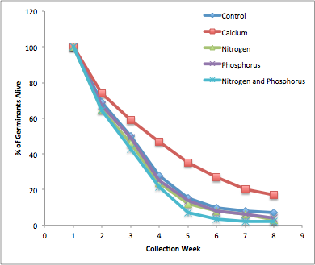
Figure 2: Initial individual counts are expected to be high and decrease roughly exponentially throughout the duration of the experiment with only ~7% of germinants surviving to the conclusion of the experiment (Cleavitt et al. 2014). The calcium silicate treatment is expected to increase seedling survival, where the other treatments are expected to decrease seedling survival. Treatments that include nitrogen are expected to decrease seedling survival slightly more than the phosphorus treatment.

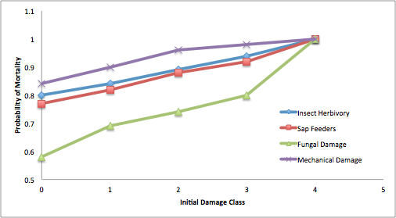
Figure 3: Probability of mortality is expected to increase with increasing initial damage class. Mechanical damage is expected to correlate with the highest probability of germinant mortality (Cleavitt et al. 2014). Insect damage (herbivory and sap feeding) is also expected to lead to a high probability of mortality, while fungal damage is expected to be the least fatal (Seimann and Rogers, 2003).

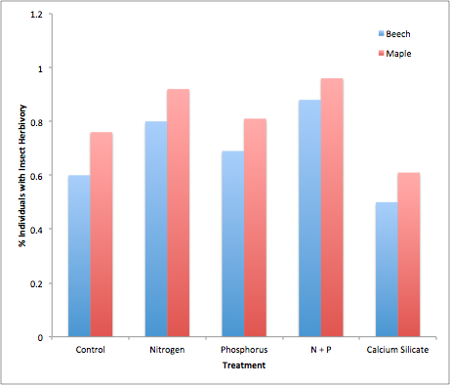
Figure 4: Insect herbivory is expected to be more frequent in sugar maple than in beech germinants for all treatments as sugar maples are a more palatable species (citation). Frequency of insect herbivory is expected to be lower in plots with calcium silicate addition and higher in plots with added phosphorus, nitrogen, or N and P when compared to the control plot.

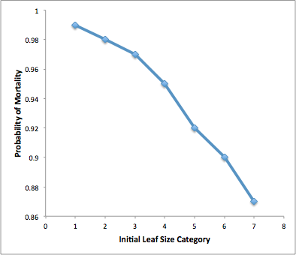
Figure 5: The probability of seedling mortality is expected to decrease with increasing initial leaf size class for all treatments (Cleavitt et al. 2014).

Timeline:
- Week of June 4: Plot set-up and initial data collection HBO and JBO and proposal writing
- Week of June 11 and 18: Plot set-up and initial data collection in Bartlett Stands (C7, C8, C9)
- Week of June 25- July 30: Week 2-6 of data collection and data entry
- Week of August 6: Statistics and Final Report Writing

Budget:
- Zip ties and electrical tape for marking seedlings- $40.00
- Paper and Ink for printing data sheets- $70.00
- Transportation- $200.00

Citations:
Brown, V. K., & Gange, A. C. (1989). Differential effects of above-and below-ground insect herbivory during early plant succession. Oikos, 67-76.
Bryant, J. P., Clausen, T. P., Reichardt, P. B., McCarthy, M. C., & Werner, R. A. (1987). Effect of nitrogen fertilization upon the secondary chemistry and nutritional value of quaking aspen (Populus tremuloides Michx.) leaves for the large aspen tortrix (Choristoneura conflictana (Walker)). Oecologia, 73(4), 513-517.
Cleavitt, N. L., Battles, J. J., Fahey, T. J., & Blum, J. D. (2014). Determinants of survival over 7 years for a natural cohort of sugar maple seedlings in a northern hardwood forest. Canadian Journal of Forest Research, 44(9), 1112-1121.
Cleavitt, N. L., Fahey, T. J., & Battles, J. J. (2011). Regeneration ecology of sugar maple (Acer saccharum): seedling survival in relation to nutrition, site factors, and damage by insects and pathogens. Canadian Journal of Forest Research, 41(2), 235-244.
Davidson, E. A., Reis de Carvalho, C. J., Vieira, I. C., Figueiredo, R. D. O., Moutinho, P., Yoko Ishida, F., ... & Tuma Sabá, R. (2004). Nitrogen and phosphorus limitation of biomass growth in a tropical secondary forest. Ecological Applications, 14(sp4), 150-163.
Hecky, R. E., & Kilham, P. (1988). Nutrient limitation of phytoplankton in freshwater and marine environments: a review of recent evidence on the effects of enrichment. Limnology and Oceanography, 33(4part2), 796-822.
Robinson, C. T., & Gessner, M. O. (2000). Nutrient addition accelerates leaf breakdown in an alpine springbrook. Oecologia, 122(2), 258-263.
Siemann, E., & Rogers, W. E. (2003). Herbivory, disease, recruitment limitation, and success of alien and native tree species. Ecology, 84(6), 1489-1505.
Tessier, J. T., & Raynal, D. J. (2003). Use of nitrogen to phosphorus ratios in plant tissue as an indicator of nutrient limitation and nitrogen saturation. Journal of Applied Ecology, 40(3), 523-534.
Wild, A. D., & Yanai, R. D. (2015). Soil nutrients affect sweetness of sugar maple sap. Forest Ecology and Management, 341, 30-36.
Wright, I. J., & Cannon, K. (2001). Relationships between leaf lifespan and structural defences in a low‐nutrient, sclerophyll flora. Functional Ecology, 15(3), 351-359.
Vitousek, P. M., Porder, S., Houlton, B. Z., & Chadwick, O. A. (2010). Terrestrial phosphorus limitation: mechanisms, implications, and nitrogen–phosphorus interactions. Ecological applications, 20(1), 5-15.

