Seedling work July-August 2013 (trained crew members: Joe Yahna, Erin MacPherson, Jo Kendrick)

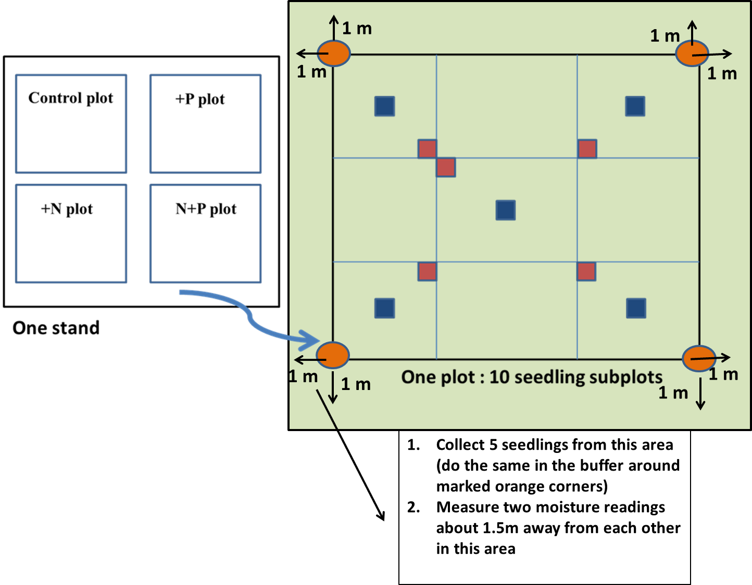
Fig 1. Diagram to explain where and what to do in the buffer area regarding seedling extractions and buffer soil moisture.
- Measure soil moisture (Inner measurement area: 2 readings from each subplot in any two diagonal corners; if one of the corners is on a shallow rock or a log, choose the other diagonal corners) in all seedling subplots (10 subplots: A1 in & out, A3 in & out, B2 in & out, C1 in & out, C3 in & out, in each treatment plot) in 11 MELNHE stands (except C3, C5 and C7) using LICOR in late July. Additionally since seedlings will be harvested from the buffer area of C8, C9, HBO and HBCa (buffer area was chosen to minimize disturbance in the inner measurement area), we need soil moisture data from the buffer areas of these stands. It will be efficient to take 2 moisture readings from each side of the plot (to get a total of 8 moisture readings from the buffer area of each plot in addition to the inner area moisture measurements). Go to the orange corner stake and move 1 m towards the two red flag and take 2 readings approximately 1.5m away from each other. This region is same as the area from where seedlings will be harvested (Fig 1.). Time sensitivity for this data collection: End of July (not while too much rain). Data entry responsibility: Jo K. It is worth thinking that if it does not stop raining within the next two weeks, just take soil moisture reading (inner subplots and buffer both) from C8, C9 , HBO (including HBCa) and JBO.

- Survivorship counts in all the seedling subplots for all the 11 MELNHE stands identified to species. During May this year we went and tagged (white zip ties) a cohort of seedlings that we are following from summer 2012 (mast year was 2011, and seedlings germinated in 2012; called “2012-cohort” after following Elizabeth Hane and Ruth Yanai’s suggestion). Seedlings were not tagged in the young stands (C1 and C2) where there were almost no seedlings surviving. For obtaining the survivorship data: count the number of seedlings that are tagged and also count and id the ones that are from an older cohort (only exceptions will be the seedlings that are bigger than 50 cm in height and are older than 4 years; check the number of bud scars and determine that). There are some older cohort seedlings that were tagged with black ties (in subplots where there were more than 20 seedlings of a species belonging to the 2011 cohort and/or in case of subplots where beech had root sprouts). Also count and id the number of seedlings that germinated in 2013 that were observed in some subplots while doing the May counts. It is interesting to note that sugar maple had a mast year in 2013, and those will possibly germinate in 2014 and there is potential to follow another cohort of seedlings for long term data (maybe “2014 cohort”?). Hence, I think it is necessary to mark the seedling subplots with better markers if we want to follow the survivorship patterns over time (red painted pvc stakes are preferred, but if time is too limited for maintenance, metal red pin flags at 4 corners of the seedling subplots will hold it on till next spring). This year’s priority is data collection. Time sensitivity for this data collection: End of july. Data entry responsibility: Joe Y and Eric M.

- Relative canopy cover estimates over all the seedling subplots using a GRS densitometer (loaned by John Battles; the instrument should be returned to Geoff Wilson at the end of summer). Stands chosen for this work are C8, C9, HBO (including HBCa) and JBO (due to timing constraints it is fine to obtain light availability measurements from the mature stands only; if time permits try to get the mid stands). We want to know if survivorship and growth patterns are affected by light availability. This instrument gives us an index of light availability in our seedling subplots (not an absolute light measurement). For every seedling subplot, take a tape and make a 2X2 m buffer area outside the seedling subplot and take 4 measurements at each 0.5 m from each side to get a total 16 observations for each subplot. It is a point count observation, so observation should be “Yes” or “No”. If we receive 16 “Yes”, the canopy cover is 100% for that subplot (it is percentage estimation). It is a practical low sensitivity method of characterizing the canopy directly overhead. Try to be consistent while doing this. Time sensitivity for this data collection: Any time from mid-july through august. Data entry responsibility: Jo K.

- Harvesting second year seedlings (belonging to the 2011 cohort; please check bud scars while harvesting) from the buffer area for stands C8, C9 and HBO (including HBCa). 10 seedlings of beech (5 for biomass and 5 for mycorrhizal analyses) and 10 of sugar maple (same as previous) will be randomly harvested from the buffer area of each treatment plot of the above stands. Go 1 m towards the red flag (check Fig 1. for the general area idea) and collect the five nearest seedlings of each species, making sure that they are from the “2012 cohort”. Same approach followed for the remaining 3 sides of the plot (so makes a total of 20 seedlings from each plot). In case of the control plots where there are no red buffer flags, make a mental note to be consistent with the other plots (follow Fig 1 and be consistent).

Since we want to estimate biomass it is important to not collect a seedling which has obvious physical damage due to trampling etc, but seedlings should not be canceled for harvesting if leaves are chewed to some extent (use your best judgment and be consistent as much as possible). It is essential to minimize our biasness and not just collect the best looking 20 seedlings; we definitely want to account for the natural variation in our data. This work needs patience and some practice, please be careful while extracting the seedlings (try not to break the root tip and if you are not sure what you did with it, please collect some extra seedlings). After collection--Pack the seedlings with damp paper towels (carry white paper towels and water to the field) inside gallon ziplock bags for each plot (try to keep the beech and sugar maples separate for a plot). This step is very important and we need to ensure minimum damage/ drying for the fine roots. Keep them in coolers while transporting and transfer them to refrigerator when in lab. It is recommended not to store the seedlings in the fridge for more than 12-16 hours before you start the lab work and processing (roots dry out very fast for the seedlings).
For lab processing each collected seedling should be scanned first (Matt is providing the scanner, so at the end of the season please contact Matt and return the scanner to him). Scanning is the absolute first step which should be done with care (try to spread out the leaves and roots as best as possible, we need to quantify the root and shoot lengths and the scanned image is our only data available; scan the image at 300dpi and save it as JPEG files). After scanning, snip the root and shoot parts for the 5 biomass seedlings for both species, obtain their fresh weights (Joe Y has the spreadsheet from last year, follow the same procedure) and then put them in labeled envelopes (use the #1 coin envelopes and label them properly with all the details possible, example: “HBO-1-buffer-BE/SM-a” and also write which tissue part it contains, example “R” for root, “S” for stem and “L” for leaves) and dry them in the oven at 60 degrees C. Obtain their dry weights after 3-4 days (check for two consecutive days to see if there are any further moisture losses). For the 5 mycorrhizal seedlings for both species, after scanning snip into root and shoot and obtain the fresh weights. Once weighed put the root system in scint vials (these will be shipped to Bartlett) with EtOH (Joe Y already has two bottles of EtOH and he also knows the stock EtOH carboy at PVF lab, if needed come and get more; recommended not to transfer the EtOH carboy to Bartlett lab). After weighing the shoot part, put them in envelope (longer one) and dry them similarly with the other biomass tissues and get their dry weights following the same procedure. Once all the tissues are dried, you can stack the envelopes (better to keep the same plot ones together with a rubber band) in a small sized cardboard box (properly labeled as “Dry seedling tissues 2013- SG/FISK”) and final storage should be at PVF lab corner along with the “FISK” labeled supplies (Joe Y knows the location). Seedling roots in the scint vials should also be stored in a box and properly labeled and kept along with the other stuff at PVF lab. The scanned image files should be emailed to me. Time sensitivity for data collection: From 29th july onwards. Data entry responsibility: Joe Y.

- Stem height measurements (total height from the ground and distance between the terminal bud and last year’s bud scar; also count the number of leaves) for the “2012-cohort” beech and sugar maple seedlings that are tagged in the seedling subplots. Stands chosen for this work are C8, C9, HBO (including HBCa) and JBO. Begin at plot A1 inner, and measure the five marked BE and five marked SM that are closest to the corners. Then proceed to the other subplots in this order: B2 IN, C3 IN, C1 IN, A3 IN, A1 OUT, C3 OUT, C1 OUT, A3 OUT. Stop measurements when you have 20 measured trees of each species (but continue measuring both species even if one has >20). Worth noting that someone can easily calculate % lost to herbivory by counting the leaves and observing the damage (almost always number of leaves should be two, but in some cases it might not be so and it should be fairly easy to track that over time and note the damage. For example: Two leaves with one leaf 30% eaten would give you a quick estimate of 1.7)
Try stem diameter at a high priority stand (start at C8). If it’s too much time drop it; Matt thinks it’s better to get some data across all high-priority stands rather than all data from a small number of stands.
Time sensitivity for data collection: anytime from mid-july through august. Data entry responsibility: Eric M.

