Rating Beech Bark Disease
Trey Turnblacer June 2017
Background:
For over a century, beech bark disease (BBD) has increased mortality in American beech (Fagus grandifolia) across the Northeastern United States (Cale et al. 2017). This disease is characterized by the presence of two beech scale insects (Cryptococcus fagisuga and Xylococculus betulae), and two fungal agents (Neonectria faginata and Neonectria ditissima) with the latter being the main cause of tree death (Houston 1998).
Progression of the disease follows three stages of development: advanced front (arrival of C. fagisuga), killing front (fungal infection and heavy mortality of large overstory trees), and the aftermath (more understory prevalence of F. grandifolia from clonal sprouting, low but established levels of C. fagisuga and Neonectria spp.) (Cale et al. 2017). In aftermath stands, ecosystem functions, such as nutrient cycling and regeneration of other, more valuable forest species, can be heavily disrupted by the increase of F. grandifolia sprouts (Cale et al. 2015). While the infestation by C. fagisuga is the most notable aspect of BBD development in the advance and killing fronts, susceptibility to the disease is often linked to other abiotic factors in aftermath stands (Motchula 2009).
During the 1940s, the White Mountains in New Hampshire began experiencing the first stages of BBD. Currently, the area is classified as an aftermath stand. The MELNHE project has established a total of 13 stands across the Bartlett Experimental Forest, Hubbard Brook Experimental Forest, and Jeffers Brook Experimental Forest. All are located within the White Mountains, and will serve as a template for aftermath zones in this study. The stands include young (~30 years), middle (~40 years), and old aged (>100 years) forests. Each stand contains plots that have been treated with nitrogen (N), phosphorus (P), N plus P, and calcium silicate (CaSiO₃), . One additional plot was left as an untreated control in each stand.
Factors such as tree size, stand age, and excessive levels of N deposition may contribute to the severity of BBD across aftermath stands in the Northeastern United States (Latty et al. 2003). Larger (DBH>20cm) trees are the most susceptible size class to developing the disease. Increased N levels are also cited as being a cause of BBD. Mature beech trees in undisturbed ‘old growth’ forest stands exhibit higher N concentrations in bole bark compared to those in second-growth stands, increasing the chance ofdeveloping BBD (Latty et al. 2003). Longevity of BBD in aftermath stands could lead to a secondary killing front, further impacting ecosystems, requiring more understanding of BBD to protect forest resources. (Cale et al. 2017). The stand types in the MELNHE project allow for the examination of interactions between these abiotic factors and the disease.
Hypotheses:
- Increases in N deposition should show higher rates of beech bark disease.
- Older trees and stands will show increased severity of the disease
Objectives:
All tagged American beech in the MELNHE plots will be rated for BBD. Data will be compared across stand and plot types. Additionally, I will compare my assessments with ratings made in 2015 by Aaliyah Jason. The unique structure of the stands will allow for a more comprehensive understanding of how different abiotic factors contribute to the prevalence of BBD.
Methods:
American beech will be measured for disease severity in MELNHE stands. Trees within the 30x30m plots that have been tagged (DBH >10cm) will be rated for BBD. Measurements will be based on the condition of the entire tree. Approximately half the tree must fit the criteria to receive that rating, otherwise the lower rating will be applied. Only 8 MELNHE stands will be appropriate for the project: C3, C4, C6-9, JBO, and HBO (each plot contains at least 5 tagged beech trees of desired size). Five beech trees will need to be tagged and recorded for a control near JBO (no beech trees of appropriate size exist in the control plot). If time permits, C1, C2, and C5 will also be measured for BBD. Additionally, beech saplings (2-10cm DBH) will be measured for BBD in previously established 5x5m subplots. DBH will be recorded for every tree.
I will be assessing the severity of BBD based on a previous protocol from a similar project rating used in the Federer Chronosequence stands in 2012. The systems will be used to rate the designated MELNHE stands.
(Wild et al. 2013) BBD Rating System:

- Scale:
- 0 - no colonies present
- 1 – Trace from one colony to light very scattered individual colonies. One or two larger colonies only
- 2 – Light, scattered colonies. Some larger colonies may be present
- 3 – Moderate infestation, many colonies visible. Substantial number of larger colonies may be present
- 4 – Heavy infestation. Many large colonies present. Some colonies coalescing.
- 5 – Very heavy infestation, most of bark conspicuously white.
- Fungal score:
- 0 – Absent.
- 1 – Sparse sunken lesions. Sparse localized perithecia (perithecia not always present) or few scattered circular infections.
- 2 – Few sunken lesions covering part of the tree.
- 3 – Sunken lesions covering most of tree.
- 4 – Sunken lesions covering the entire trunk.
- Tree condition:
- 1 – Good. Foliage green, <10% dead crown branches
- 2 – Fair. Foliage green to yellow green, 10-50% dead crown branches
- 3 – Poor. Foliage green to yellow green, >50% dead crown branches
- 4 – Dead. No foliage.

Budget:
Assessment of all beech trees located within the MELNHE stand will take approximately two weeks to complete. Daniel Hong and Adam Wild will be assisting with rating BBD. Two additional people may be required to independently rate trees to test for subjective bias on the rating system. Five nails and tags will be required to tag JBO control trees (material located in lab). A DBH tape will be needed to measure the trees. A measurement stick will be needed to establish the nails and tags at the proper height on the newly added JBO control beech for future DBH measurements.

Week  1 | Week  2 | Week 3 | Week 4 | Week  5 | Week 6 | Week 7 | Week 8 | Week 9 | Week 10
Fertilizing  Proposal | Begin rating | Finish rating |  | Pres  Building | HB

Expected Results:
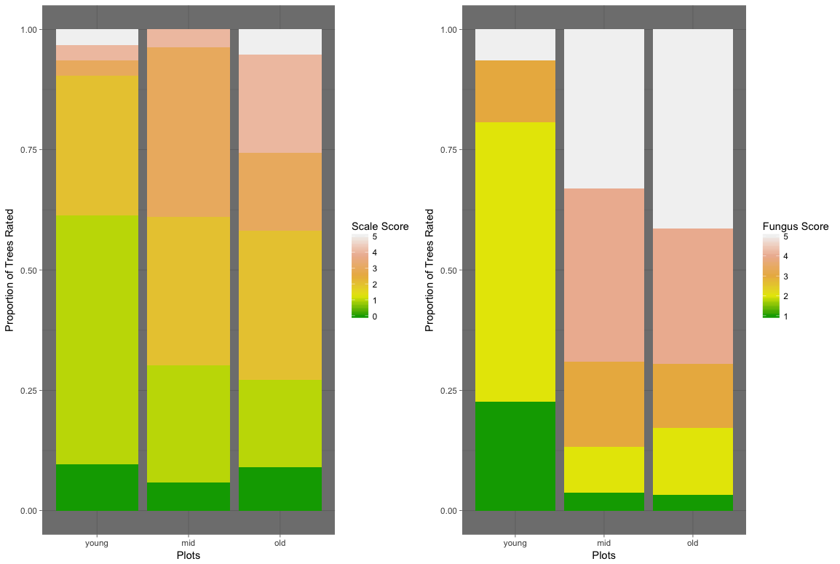
The progression of BBD in the advanced front is characterized by increased rate of beech scale before fungal lesions begin to occur (Houston 1998). However, aftermath forests, like the White Mountains, have lower rates of scale and increased severity of fungal infection (Figure 1). My study is looking to find a better method for predicting the severity of beech scale and fungal lesions by examining other abiotic factors. Trees located in old stands will likely have higher levels of BBD, while all trees located within the N plots will exhibit higher rates compared to others across all stands.
Figure 1: Proportion of rated trees in Federer Chronosequence stands. The older stands show a greater severity of BBD.

References
Cale, J. A., Teale, S. A., Johnston, M. T., Boyer, G. L., Perri, K. A., & Castello, J. D. (2015). New ecological and physiological dimensions of beech bark disease development in aftermath forests. Forest Ecology and Management, 336, 99–108. https://doi.org/10.1016/j.foreco.2014.10.019
Cale, J., Johnston, M., Teala, S., & Castello, J. (2017, March 31). Beech bark disease in North America: Over a century of research revisited (PDF Download Available). Retrieved June 5, 2017, from https://www.researchgate.net/publication/315833558_Beech_bark_disease_in_North_America_Over_a_century_of_research_revisited
Houston, D. R. ; (1998). Beech bark disease (pp. 8–10). Retrieved from https://www.treesearch.fs.fed.us/pubs/43140
Jason, A., Johnston, M., Wild, A., & Vadeboncoeur, M. (2016, June 8). BBD Rated Trees MELNHE Plots.
Latty, E. F., Canham, C. D., & Marks, P. L. (2003). Beech bark disease in northern hardwood forests: the importance of nitrogen dynamics and forest history for disease severity. Canadian Journal of Forest Research, 33(2), 257–268. https://doi.org/10.1139/x02-183
Motchula, T. L. (2009). Factors affecting the distribution of beech bark disease in two beech-maple forests in south-western Quebec. McGill University.
Wild, A., Johnston, M., & Vadeboncoeur, M. (2013, February 3).
Cronosequence Veg Data.

