Young Summer 2017 Proposal
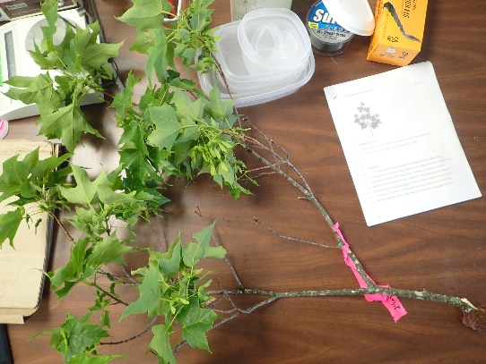
06.12.17
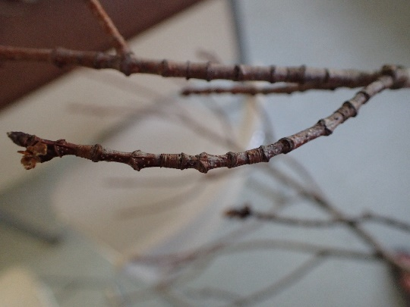
PROPOSAL TITLE
Vertical distribution of foliar response to nutrient amendment: Specific leaf area, specific twig length, and Chlorophyll a/b ratio in Sugar Maples

Introduction
In the past half-century Northeastern United States forest have experienced increasing acid rain deposition, nitrogen deposition, and increased atmospheric CO₂ concentration (Vitousek 1997, Galloway 2003). Acclimation to disturbance can be observed in nutrient allocation above or belowground, and may be especially visible if N enrichment induces secondary limitations to plant productivity (Naples and Fisk 2010) or if N limitation is converted to P limitated plant productivity (Vitousek et al. 2010). This should be especially visible in Sugar Maple (Acer saccharum) (Gradowski et al. 2006)
Plant productivity can be limited by irradiance, water availability, and nutrient availability. Plasticity in allocation patterns allows for shifting limitations over time and increased environmental tolerance (Liu 2016). According to the balanced-growth hypothesis, plants will preferentially allocate biomass to acquire the most limiting resources (Shipley and Meziane 2002). Given that tree trunk diameter is increasing faster phosphorous treated mid-aged and old plots, one interpretation follows that trees treated with phosphorous at 10 kg/ha monosodium phosphate are allocating more biomass to light acquisition than soil nutrients.
A greater understanding of nutrient cycling and acclimation to disturbance in Northeastern forests will improve management decisions, conservation efforts, and shed light on nutrient mediated plasticity in biomass allocation and utilization (Poorter et al. 2012). For example- seven years of fertilization with N, P, or both may initiate aboveground tree response in the vertical distribution of foliar traits increasing both stem biomass fraction and leaf biomass as compared to the control plot.
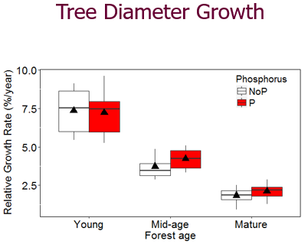
Figure 1. Relative growth rate was 13% higher in P plots in mid-age stands (p = 0.02) and 15% higher in mature stands (p = 0.07). ( Goswami 2017) unpublished.

Background
Shinjini Goswami (pers comm.) saw a slight but significant increase in relative growth rate (RGR) in mid-aged and old plots treated with P with no interaction of N and P (figure 1). This raises the question, why and how is P addition sufficient to increase growth rates in northern hardwood ecosystems? Generally, P is implicated in nucleic acids, phosphoproteins, phospholipids, enzymes, and energy-rich compounds including adenosine tri-phoshphate (ATP). Nitrogen is also implicated in DNA and protein synthesis, while also being the major building block of different photosynthetic pigment synthesis (chlorophylls, carotenoids, and others). However, plant survival is more complex than maximizing photosynthetic capacity and trees can partition resources in response to the nutrients and climate they experience, and variability in the plasticity of plant traits may constrain optimal biomass allocation (Evans 1989, Poorter 2012).

EQ 1: RGR= Unit Leaf Area x Specific Leaf Area x Leaf Mass Fraction (Poorters 2012)
Specific Leaf Area Investigation
The specific area of a leaf is a quantification of leaf thickness. Leaf area (cm²) is divided by the dry weight (g) of the leaf. However, the surface area of a given leaf is constrained at a threshold because the biomass investment per unit leaf area becomes restrictive.
Specific leaf area decreases as with height in a tree canopy (Marshall and Monserud 2003). If P addition increases growth rate, perhaps the SLA of canopy foliage will remain lower maybe the trees are investing less in expensive large leaves and producing more leaves that are thinner.

Specific Twig Length & Diameter Investigation
Aside from leaf mass fraction adjustments in biomass allocation, another aboveground response may be seen in the twig mass fraction. Specific twig length is calculated by the length of a twig node (cm) divided by the dry mass of the twig (g) (Schmitt et al. 1999). As light travels towards the ground its intensity attenuates making the positioning of leaves at the top of the canopy of utmost importance for maximum light interception. With competition from other trees and self-shading factors, stem length elongation may offer direct advantages to increasing carbon assimilation. There may also be a trade-off of fast growth and more brittle wood, resulting in longer but thinner twigs.
To create valid comparisons between twigs and twig ages,twigs will be classified as first order, second order, and third order twigs.
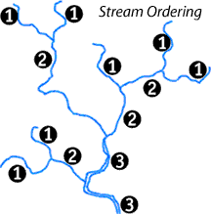
Figure 3. Branching order diagrams. Distal streams (“twigs”) are first order. When two first order twigs join, they become second order. However, when a first order and second order twig join, the resulting twig is still first order. A third order twig only results from two second order twigs joining.
( http://www.cotf.edu/ete/modules/waterq3/WQassess4b.html ) stream hydrology.

Chlorophyll a/b ratio Investigation
The ratio of Chlorophyll a (Chla) (the major photosynthetic pigment on photosynthesis) and chlorophyll b (Chlb) may be a useful indicator of N partitioning (Hikosaka 1995). In sun leaves with high irradiance availability, Chl a/b ratio should increase (Hogan 2003). However, Chl a/b may also increase with decreasing N availability, a response that maximizes Chla concentration over the secondary chlb protein (Hidaka and Kitayama 2009) even though the range of light absorption is slightly extended by Chlb and carotenoid pigments.
High a/b ratio | Low a/b ratio
Etiolated/ chlorotic leaves- 4.0-10 | Fully developed leaves- 2.5-3.5
Sun leaves- 3.0-5.0 | Shade leaves- 2.4-2.7
Table 1. Examples of Chl a/b ratio in different types of leaves.

Phosphorous availability may impact photosynthetic capacity more than previously considered, especially so in Sugar maple (Finizi 2009). Energy synthesis in plants involves both light reactions (photosynthesis) and “dark” reactions within the calvin cycle (figure 2). Ortho phosphate (Pi, H₂PO₄-) enables photosystem 2 (PS2) and PS1 to function, and may represent a phosphorous based limitation to photosynthetic capacity (Ellsworth et al. 2015).
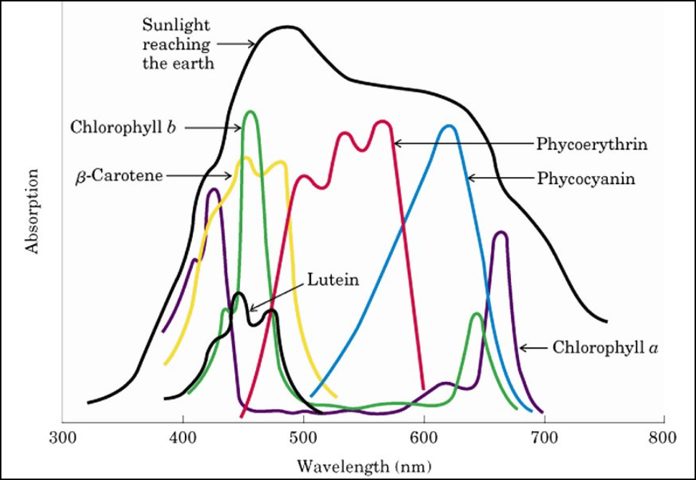
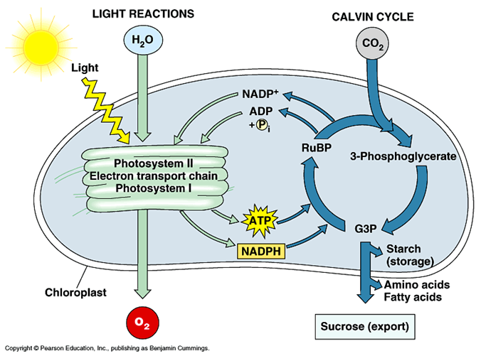

Figure 4. Absorbance frequencies of different photosynthetic pigments (left). A diagram of a chloroplast with molecular pathways (right). Orthophosphate (Pi) may play limit photosynthetic capacity when P is low (Ellsworth et al. 2015). Images courtesy of Dr. Nadine Schubert.

Objectives
Sugar maple leaves will be collected vertically through the canopy and assessed for specific leaf area, specific twig length & diameter. The goal of this study is to examine the response of biomass allocation after seven years of nutrient amendment with N (30 kg/ha NH₄NO₃₎, P (NaH₂PO₄₎, and both N and P on foliar traits and their distribution through the canopy. Stratified leaf collection may help visualize the interaction of light availability, nutrient mediated productivity, and subsequent strategies of biomass allocation.

Methods
Site description
This research will take place in the Bartlett Experimental Forest in New Hampshire, USA. Permanent research sites have been installed and are arranged across three successional stages of time since clear cut (Table 2.) Each stand has 50 by 50 meter plots that have received annual fertilization since 2011 with 30 kg/ha ammonium nitrate and 10 kg/ha monosodium phosphate in an N by P factorial.

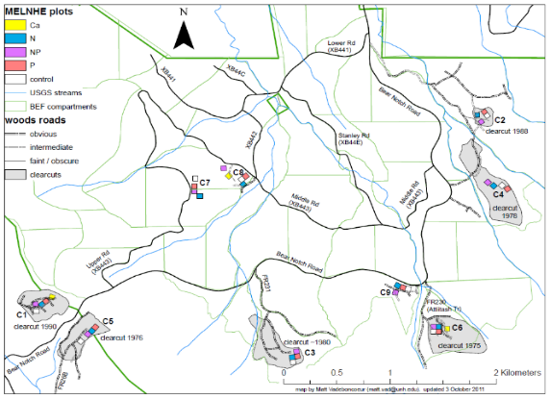
Figure 5. Location of C7, C8, C9 “old” stands. Each has a N, P, NP and control plots.

Field Methods
Sugar Maple within C9 will be accessed with static climbing rope following approved methods. If time allows, C7 and C8 will be included. A pole pruner will enable leaf collection above a branch anchor, and leaves will be stored zip lock bags and kept in a cooler while in the field. One branch with ~20 leaves be clipped every 2 meters throughout a tree canopy along a vertical transect.
After the intensive sampling to see where zonation in tree leaf morphology changes, sampling regiment may be updated to minimize un-needed sampling intensity.

Foliage Processing
A clipped branch diagram is shown at right.
- All leaves will be plucked by hand (with gloves) and stored in a paper bag in a freezer.
- Leaves with obvious galls or defects will be discarded.
- 15 leaves for SLA. Rest will be frozen (flattened, moist towel, and zip-locked, and transported to ESF for chlorophyll A/b/ nutrient analysis.)
Twig processing
Twigs will be cut by first, second, and third order twigs. Measure diameter, length. Oven dry for dry weight. Also count bud and leaf scars.
Specific Leaf Area
    - Give each leaf a unique ID, Take picture of leaves with a ruler for scale.
    - Use imageJ to get leaf area.
    - Dry leaf. Weigh with a scale.

Lab Methods
- Chlorophyll uv vis spectroscopy
  - Transport frozen leaves from NH to SUNY ESF
  - Place leaf onto ceramic tile (TLC, thin layer chromatography), Grind leaf material with a pestel-like device.
  - Use DMSO solvent to elute chl proteins from TLC plate. DMSO is preferred because Acetone can be dangerous, and Ethanol can under-estimate chlorophyll pigment (Pompelli et al. 2012)
  - Use a spectrometer to measure absorption at ~680 nm for chl a. and ~440 nm for chl b. (Lichtenthauler 2001).
Data Analysis: Repeated measures ANOVA- Each datum is collected in a similar fashion over the same space.
Block = 3 (stands)
Source | Df | equation
Block | 2 | r-1 (3 stands)
Fert | 3 | a-1
Fert error (1) | 8 | a(r-1)
Light | 5 | b-1
Fert * Light | 15 | (a-1)(b-1)
Error (2) | 40 | a(r-1)(b-1)
Total | 72 | r*a*b-1
Whole plot = 4 (N, P, NP, Control)
Light= Sub Plot = ~6 levels of leaf collection.

Expected Products and Outcomes
Quantify where leaf traits change vertically through the canopy, and the impact nutrient amendment has on biomass allocation and plasticity. I think the Phosphorus followed by NP amended trees will have lower SLA and higher Chl a/b ratio than the Nitrogen and control plots.
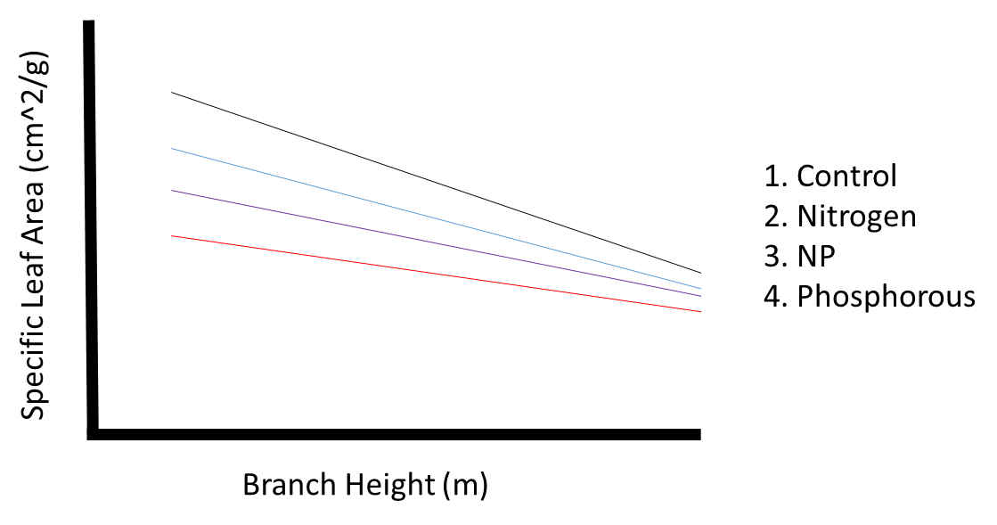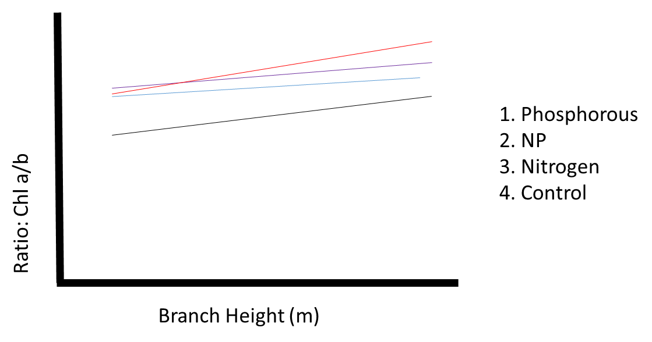
Relevance to the Organization’s Mission
Most all of the foliage sampling has been one snap shot of sun leaf sampled via shotgun. Canopy access, though time intensive, will visualize leaf characteristics and canopy architecture throughout the canopy in the nutrient treatment plots.
Timeline with specific activities

June 1 | Week 2 | Week 3 | Week 4 | July 5 | Week 6 | 7 | 8 | Aug  9 | Week  10
Fert. | Write proposal | Collect from one tree per plot in C9 | Collect a second set of 4 trees. Same stand as last week. | Prepare for HB meeting. Create graphs. | Decide on vertical height intensity. |  |  | Pu Ge comes to GPS plot boundaries!
 |  |  | Photosynthetic pigments stabilize in trees (Yang 2016)

Time budget & Personnel Required - (one ground support person)
- Time it takes for one tree = Three hours.
  - Rig Tree- 60 minutes
  - Climb to top- 30 minutes
  - Collect leaves- 50 minutes
  - Process leaves & place on cooler- 30 minutes
  - De-rig tree- 10
- 4 trees a day for a 12 hour work day.
- Personnel requirement: One climber, one ground safety supervisor
Lab time budget
- Pluck leaves off branch- 4 trees = 2 hours
- Leaf freezing- 5 samples per hour: 4 trees = 4 hours
- Leaf imaging: 70 leaves per hour- 4 trees = 4 hours
- Leaf drying and weighing = two loads of 48 hours in oven.= 96 hours
  - Two hours to weigh.
Monetary Budget
All of these Items are in the Bartlett HQ garage.
Item | Cost per unit | # units needed | Total cost
Gallon- Zip lock baggies |  |  | $5.00
Parachute Chord | 55.00 per 1,000 ft | 1 | $55.00
Trash bags |  | 12 | $5.00
Pole Pruner | $180 | 1 | Already Bought.

Acknowledgements
- Nadine Schubert (for a powerpoint download)
  - Instituto de Ciencias del Mar y Limnología de la UNAM
  - Unidad de Sistemas Arrecifales, Puerto Morelos, México
- Dr. Danilo Fernando
- Dr. John Drake
- Dr. Melany Fisk!
- Dr. Ruth Yanai!

Ellsworth, David S., Kristine Y. Crous, Hans Lambers, and Julia Cooke. 2015. “Phosphorus Recycling in Photorespiration Maintains High Photosynthetic Capacity in Woody Species.” Plant, Cell and Environment 38 (6): 1142–56. doi:10.1111/pce.12468.

Galloway, J. N., J. D. Aber, J. W. Erisman, S. P. Seitzinger, R. W. Howarth, E. B. Cowling, and B. J. Cosby. (2003). The nitrogen cascade. BioScience 53: 341–356.

Hidaka, Amane, and Kanehiro Kitayama. 2009. “Divergent Patterns of Photosynthetic Phosphorus-Use Efficiency versus Nitrogen-Use Efficiency of Tree Leaves along Nutrient-Availability Gradients.” Journal of Ecology 97 (5): 984–91. doi:10.1111/j.1365-2745.2009.01540.x.

Liu, Y., Dawson, W., Prati, D., Haeuser, E., Feng, Y., M. Kleunen. 2016. Does greater specific leaf plasticity help plants to maintain a high performance when shaded? Annals of Botany 118: 1329 -- 1336

Naples , B., M.C. Fisk. 2010. Belowground insights into nutrient limitation in northern hardwood forests. Biogeochemistry. 97: 109 -- 121

Poorter, H., Niklas, K.J., Reich, P.B., Oleksyn, J., Poot, P., L. Mommer. 2012. Biomass allocation to leaves, stems, and roots: meta-analyses of interspecific variation and environmental control. New Phytologist 193: 30–50 doi: 10.1111/j.1469-8137.2011.03952.x

Shipley, B., Meziane, D. 2002. The balanced-growth hypothesis and the allometry of leaf and root biomass allocation. Funct Ecol. 16: 326 - 331.

Pompelli, M. F., S. C. França, R. C. Tigre, M. T. de Oliveira, M. Sacilot, and E. C. Pereira. 2012. “Spectrophotometric Determinations of Chloroplastidic Pigments in Acetone , Ethanol and Dimethylsulphoxide.” Brazilian Journal of Bioscience 11 (1): 52–58.

Vitousek, P.M., J.D. Aber, R.W. Howarth, G.E. Likens, P.A. Matson, D.W. Schindler, W.H. Schlesinger, and D.G. Tilman. (1997). Human alteration of the global nitrogen cycle: sources and consequences. Ecological Applications 7: 737–750.

Vitousek, P. M., S. Porder, B. Z. Houlton, and O. A. Chadwick. 2010. Terrestrial phosphorus limitation: mechanisms, implications, and nitrogen–phosphorus interactions. Ecological Applications 20: 5–15.

