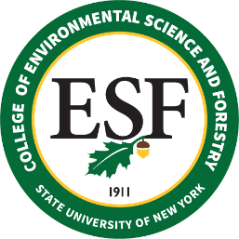

BOARD OF TRUSTEES MEETING
Friday, December 10, 2021

PROPOSED RESOLUTION

RESOLVED that (a) the following individuals be recommended for Continuing Appointment:

Samuel Mukasa
Provost and Professor – 12 Months
(Campus Title: Executive Vice President and Provost)
Provost’s Office
November 1, 2021

that (b) the following individuals be recommended for Permanent Appointment:

Kenneth Stvan
Supervising Programmer/Analyst (Campus Title: Manager of Information Systems)
Information Systems
October 15, 2021

Patricia Mayette
Senior Staff Associate
Business Affairs
October 18, 2022

Ryan Ash
Forest Property Manager II
Forest Properties
October 22, 2022

that (c) the following individuals be recommended for Emeritus Status:

John Hassett
Professor – 12 Months
Chemistry
October 4, 2021

Joseph Rufo
Vice President for Administration
(Campus Title: Vice President for Administration & Chief Financial Officer)
Administration
January 29, 2022

Susan Anagnost
Professor – 10 Months
Sustainable Resources Management
January 31, 2022

that (d) the following individuals be recommended for Sabbatical Leave:

SABBATICAL LEAVE, TITLE E – (none to report)

TITLE F LEAVE – (none to report)

