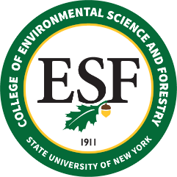

BOARD OF TRUSTEES MEETING
Friday, May 14, 2021

PROPOSED RESOLUTION

WHEREAS, the College has jurisdiction over real property known as Heiberg Memorial Forest, and the Department of Environmental Conservation (“DEC”) has jurisdiction over real property known as Kettlebail State Forest, a portion of which is adjacent to the College parcel; and

WHEREAS, the DEC has agreed to transfer jurisdiction over a portion of the Kettlebail State Forest, a 3.5 acre parcel located along Tully-Truxton Road in the Town of Truxton, Cortland County; and

WHEREAS, the College would benefit from this transfer because it would allow for better access to and maintenance of the Heiberg Forest, increasing trees to be used in production of maple products and generating additional revenues for use by the College; and

WHEREAS, the transfer of jurisdiction would occur by order of the Commissioner of General Services; now, therefore be it

RESOLVED, that the College of Environmental Science and Forestry Board of Trustees endorses the transfer of jurisdiction of such parcel from the DEC to the College, consistent with the presentation made to the Board.

