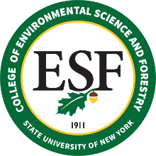

Board of Trustees Meeting
February 25, 2022

Proposed Resolution

WHEREAS, the Board intends to amend its Bylaws, removing the Sustainable Operations Committee from continuing as a Standing Committee, creating a new Facilities Committee, and allowing proposed amendments to be transmitted electronically to the Voting members of the Board; and

WHEREAS, the proposed amended Bylaws were shared with all voting members of the Board via electronic mail on February 17, 2022, providing all voting members of the Board with an opportunity to provide feedback on the amended Bylaws; now, therefore be it

RESOLVED, that the “Bylaws of the Board of Trustees of the State University of New York College of Environmental Science and Forestry” shall be amended as follows:

(a) Article III, Section 2 (“Standing Committees”), is amended to strike subsection (b), removing reference to the Sustainable Operations Committee; and

(b) Within Article III, Section 2, subsections (a), (c), and (d) shall remain as written, with subsection (c) being renamed as subsection (b) and with subsection (d) being renamed as subsection (c); and

(c) Within Article III, Section 2, a new subsection (d) shall be created, as follows:

“Facilities

i. Review and make recommendations regarding college facilities, systems and infrastructure, including opportunities for incorporating green and sustainable technologies and materials.”

and

RESOLVED, that a copy of the Bylaws, as previously amended and including the amendments within this Resolution, shall be made available to the Trustees (dated February 25, 2022).

