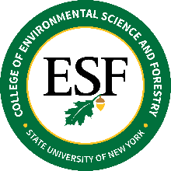
BOARD OF TRUSTEES
Diversity, Equity and Inclusion Committee Meeting
November 28, 2022 – 408 Baker Laboratory – 9:30 AM

A G E N D A

Invited guests:

Dr. Mary Grace Almandrez, VP for Diversity and Inclusion, Syracuse University
Dr. Shiu-Kai Chin, Professor, Electrical Engineering & Computer Science and Laura J. and L. Douglas Meredith Professor for Teaching Excellence, Syracuse University

- Call to Order and Welcome
- Approval of Minutes from April 14, 2022
- Update on BOT DEI Committee
- Update on CDO Search
- Update on the Office of Inclusion, Diversity and Equity (OIDE) Needs & Projects
  - Fall 2022
  - Spring 2023
- Update on Campus-based IDE Committee and Relationship to BOT DEI Committee
- Input from SU on their Strategic Efforts/Plans for DEI
  - Dr. Shiu-Kai Chin
  - Dr. Mary Grace Almandrez, SU VP for Diversity & Inclusion
- Discussion with/about the Acting CDO for SUNY Central and the Title IX Officer for SUNY on what do they expect from individual campuses relative to the SUNY 25 Point Plan and strategic efforts by individual campuses.
- BOT DEI Committee

