**Microcredential Proposal Form**

# Proposer Name: Paul Hirsch and Andrea Feldpausch-Parker

**Contact Email:** pahirsch@esf.edu; amparker@esf.edu

**Contact Phone:**

Department: Environmental Studies

1. **Microcredential Information:**

1.1. Microcredential Title: Public Engagement and Environmental Decision Making

1.2. Type of Proposal: New Revision

1. **Detailed Microcredential Description**

2.1. Microcredential alignment with ESF goals

*Describe why this microcredential (or revision) is needed to meet current or proposed goals and outcomes of the program or College. For revisions, provide explanation and/or justification for change.*

The creation of microcredentials is explicitly stated in ESF’s Strategic Plan (Pillar 1, Theme 1, Goal 8; Pillar 1, Theme 2, Goals 1 and 2; Pillar 2, Theme 2, Goal 3). Microcredentials should be shorter in duration than Degrees or Certificate/Advance Certificate and are designed to be a unique educational experience that provides the learner with a set of skills, competencies, and/or certifications specific to professional needs. The Public Engagement and Environmental Decision Making Microcredential meets the above requirements by offering learners a flexible and quick way to advance in their career by equipping them with the tools and strategies needed to manage disputes and make informed choices. This microcredential would be especially beneficial for NYS local officials/town boards, city councils; Municipal, State, and Federal employees; and people working in environmental NGOs.

2.2. Type of Microcredential: Credit Non-Credit

*Note: For credit-bearing microcredentials, complete section 2.17. For non-credit microcredentials, complete section 2.18. Complete either section 2.17 or section 2.18. If you intend to offer both credit bearing and non-credit versions of your microcredential, you must submit two separate Microcredential Proposal forms.*

# 2.3. Anticipated launch date/semester: Spring 2024

2.4. What is your anticipated enrollment? 10

# 2.5. Potential target audience(s):

* Current Students
* Prospective Students
* Adult Learners
* Alumni
* Faculty/Staff
* K-12 Partners

If either of the below, please specify:

* Business/Industry Partners
* Community Partners
  + NYS local officials/town boards and city councils
  + Municipal, State, and Federal employees
  + People working in environmental NGOs

2.6. Format of the microcredential program. Check all that apply.

* Online (synchronous)
  + Online (asynchronous)
  + Online (combined synchronous and asynchronous)
  + Hybrid
  + In-person
  + Other

If other checked above, please explain:

2.7. Is enrollment in this microcredential restricted to currently enrolled ESF students?

Yes No

2.8. Is this enrollment in this microcredential restricted to students who already hold a bachelor’s degree?

Yes No

2.9. Are there any other enrollment restrictions? If so, please describe.

No

# 2.10 Is this related to other microcredentials ESF offers? Yes No

If yes, list related microcredentials here:

2.11. Is this part of a series of microcredentials? Yes No

If yes, list other microcredentials in the series here:

# 2.12. Microcredential Description *(this will be used in marketing and posted to the microcredential website).*

*At the end of the description, tell the learner what they will be able to do once they complete the microcredential. For example: successful completion of this microcredential prepares you to apply for positions such as... OR - this microcredential is designed for existing professionals seeking to add specialized skills to enable them to... Be sure to explain if this is a graduate microcredential. Be sure to list if this prepares you to take an industry certification exam.*

This microcredential is tailored to empower individuals to become effective contributors in the environmental sector, whether as facilitators, decision makers, experts, advocates, or a blend of these roles. The 2-course graduate level sequence provides essential tools and strategies for addressing environmental challenges through effective decision making and public engagement techniques.

2.13. Connection to Labor Market *(These will be listed on the ESF and SUNY websites).*

*List in bulleted form specific skills and competencies that will be mastered.*

1. Environmental Decision-Making
2. Designing Public Engagement Processes for Environmental Problem-Solving
3. Conflict Management in Environmental Contexts
4. Strategies for Navigating Complex Environmental Issues
5. Environmental Advocacy and Facilitation Skills

2.14. Industry Partner(s) (Attach supporting documents to form)

*To ensure alignment to the workforce, supportive documentation demonstrating collaboration with business/industry, K-12, or community organizations needs to be included (letter of support, feedback from 5-year review report, etc.). Briefly describe your contact with an industry partner below, and attach supporting documentation to your submission.*

In the development of this proposal, we sought guidance from environmental professionals who were also graduates of Environmental Studies’ graduate programs. Several of these professionals completed one or more of our online advanced certificates, making their feedback highly relevant both from the perspective of the sector and in terms of their ability to evaluate the relevance of proposed courses and course combinations. As an output of an initial round of one-on-one conversations, we selected 608 and 635 as the two courses a) with the most relevant material in terms of meeting the needs of professionals in the field and b) that could be coherently combined together into a microcredential. After this initial selection, we sent a survey to a larger set of graduates / working professionals with the aim of honing in on key topics and on the best focus for the name of the microcredential. The names of those willing to share their information are below, followed by a graphic showing their collective input about key topics and

Microcredential name.

* Input from professionals, including:
  + Megan Ewald, Communications Manager, NOAA Fisheries Office of Aquaculture
  + Tess Clark, Assistant Director, Syracuse University Environmental Finance Center / Center for Sustainable Community Solutions
  + Erica Tauzer, policy analyst, EPA
  + Madeline Clark, Red Cross
  + Maria Andriano, MGA Media Group
  + JP Buchmeyer, Managing Director at M Booth (Public Relations Firm)

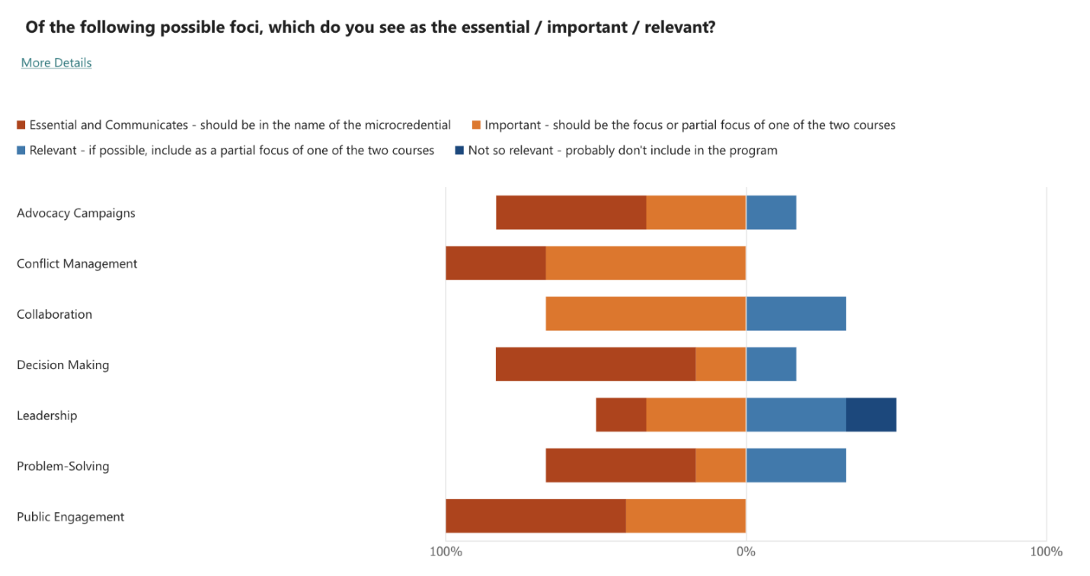

# 2.15. Microcredential Student Learning Outcomes (MSLOs)

*In order to complete the microcredential, the student will be able to do the following:*

1. Analyze an environmental problem and design an approach for clarifying important values, generating options, incorporating relevant knowledges, and dealing with uncertainty
2. Draw on appropriate theoretical perspectives to inform practice in environmental advocacy and decision making;
3. Evaluate the effectiveness of advocacy campaigns through examination of strategies and tactics;
4. Conduct a stakeholder analysis and analyze how stakeholders engage in conflict situations;
5. Design, outline, and facilitate environmental decision making and public engagement processes;

2.16. Assessment of MSLOs

*How will the MSLOs be assessed?*

* Formative evaluation via journal reflections, discussion boards, quizzes, and /or thought pieces based on readings and lectures
* Formative evaluation via instructor observation of group deliberations during in-class activities
* Summative evaluation of four key deliverables
  + Assessment of an Environmental Conflict *or* Advocacy Campaign
  + A Stakeholder Analysis
  + An Issue Analysis and Selection of Appropriate Decision Support Tool
  + A Public Engagement Strategy

*What* ***sharable artifacts*** *will students produce that demonstrate mastery?*

|  |  |
| --- | --- |
| **Course** | **Shareable Artifacts** |
| EST 608 | Assessment of an Environmental Conflict *or* Advocacy Campaign  A Stakeholder Analysis (group project) |
| EST 635 | Issue Analysis and Selection of Appropriate Decision Support Tool  Public Engagement Strategy (group project) |

# 2.17. Credit-bearing requirements, if applicable

For credit bearing Microcredentials

* # of Courses Required 2
* Total credit hours 6

|  |  |  |  |
| --- | --- | --- | --- |
| COURSE # | Course Title | Credits | Faculty /  Instructor/Sponsor |
| EST 608 | Environmental Advocacy Campaigns and Conflict Resolution Application | 3  Fall | Andrea Parker |
| EST 635 | Public Participation and Decision Making: Theory and Application | 3  Spring | Paul Hirsch |

*\*Attach draft of syllabi for any new courses*

Minimum course GPA (if different from 2.0) _______

Time to complete: 2 semesters

Learners who have completed the above courses no more than three years prior to the learner’s microcredential completion application may be awarded a microcredential, unless otherwise determined by the department. If you would like to determine a period of time other than three years, please specify here.

# 2.18. Non-credit requirements, if applicable

|  |  |  |  |
| --- | --- | --- | --- |
| **#** | Description | Anticipated Amount of Time to Complete | Faculty /  Instructor/Creator |
|  |  |  |  |
|  |  |  |  |
|  |  |  |  |
|  |  |  |  |

# *\*Attach draft of syllabi for any new offerings*

Total time to complete: ______ weeks | months | (circle one)

Time intensity: _______ hours per day | week (circle one)

# 2.19 Course Materials

If the materials are the same as an existing approved course outline, a note can be made below.

*Equivalent materials may be substituted.

|  |  |
| --- | --- |
| Cost | Title/Description |
|  |  |
|  |  |

2.20. Is grant funding available for this microcredential? If so, summarize the funding below.

No

# 2.21. Does this microcredential stack to another certificate or degree program? If so, which one(s)?

The microcredential is an on-ramp to two certificates and our online MPS (Master of Professional Studies) program.

* EST 608 is one of three courses required to complete the advanced graduate certificate in Science and Environmental Communication.
* EST 635 is one of three courses required to complete the advanced graduate certificate in Environmental Leadership.
* Both courses are required courses for our online MPS in Environmental Leadership, Justice, and Communication (which requires nine courses and a capstone experience).

2.22. Does this microcredential give the learner the opportunity to test for or otherwise earn an industry certification? If so, summarize the certification below.

No

2.23 What is the schedule of regular programmatic assessment and evaluation?  *(Best practice suggests completing program level assessment on a cycle no longer than 2-3 years, but some microcredentials might require shorter intervals).*

* Courses are evaluated and revised based on student feedback each semester
* Faculty teaching online courses meet regularly with each other and with the coordinator for our online graduate level programs
* A comprehensive program review of all departmental graduate level programs is conducted every 5-7 years

1. **New Institutional Impacts**

This section pertains to forecasting institutional resource needs to support the microcredential creation or revision. Consider things like staffing needs, classroom or technology resources, and/or transportation requirements and list any needed resources below. Note that, if this is a revision, only the impacts of the revision should be included.

3.1. Staffing needs: None; courses are taught by current instructors

3.2. Classroom resources (physical facilities in a laboratory, lecture hall, flexible space, academic computing): None

3.3. Technology resources (e.g., electron microscopes, UAVs, GPS receivers, survey equipment, etc.): None

3.4. Computing resources (software licensing, hardware, access): None

3.5. Library resources (subscriptions, services): None

3.6. Transportation requirements (budget, fees, fleet, vehicles): None

3.7. Forest properties or field practicum facilities (Note: Please contact Forest properties each semester to schedule): None

1. **Health and Safety Considerations**

Will any of the conditions or situations outlined below be present in association with the microcredential?

|  |  |  |
| --- | --- | --- |
|  | Yes | No |
| 4.1. Will substances with any of the following properties be used during instruction: flammability, toxicity, corrosivity, reactivity, registered pesticide, legally controlled, or other characteristics with the potential to cause harm or injury? |  | X |
| 4.2. Will any physical hazards be present during instruction? (e.g. machines that need safety guards; razor blades or syringes; compressed gases, etc.) |  | X |
| 4.3. Will any biological hazards be present during instruction? (e.g. handling animals [rabies or hantavirus]; cultures or stocks of infectious agents [fungal spores, viruses, bacteria, etc.]) |  | X |
| 4.4. Will any radiation hazards be present during instruction? (e.g. radiosotopes, X-rays, ultraviolet rays, lasers, etc.) |  | X |
| 4.5. Will any electrical equipment that, due to its design, location, or method of use, pose any threat to safety during instruction? (Give considerable thought to electrical use outdoors, or any potentially wet location) |  | X |
| 4.6. Will there be any personal safety issues related to the class? (e.g. due to time of day or location, at the end of any organized class exercise, will students be in danger of physical assault, etc.) |  | X |
| 4.7. Will any students be driving official state or research sponsored land or water vehicles during any class or instructional exercise? |  | X |
| 4.8. Will any type or personal protective equipment be necessary during class exercises? (e.g. hard-hats, eye/face protection, hearing protection, hand/foot protection, lab coat, visibility clothing, etc.) |  | X |

**6. SIGNATURES**

*Microcredentials that span disciplines, departments, or schools will require signatures from all stakeholders.

_________________________________________ ___________________

Author of microcredential

Date

_________________________________________ ___________________

Author of microcredential Date

_________________________________________ _________________  
Department Academic Affairs Committee Representative Date

_________________________________________ ___________________  
Department Chair Date

_________________________________________ ___________________

Provost Date