Characterizing Soil Profile Rocks by Bedrock Type in a Glacial Soil
Alexandrea Rice
SUNY College of Environmental Science and Forestry
Final Report to the Edna Bailey Sussman Foundation
2019
- Background
The soils that support our northern forests were formed in parent materials deposited by glaciers ~10,000 years ago. Clues to the direction and distance of glacial movement, obtained from glacial erratics and striations on bedrock, allowed Scott Bailey, my internship supervisor, to develop a model that predicts the source of the glacial till at any point on the landscape. This till source model is important because traditional methods of determining site fertility require time-consuming and expensive sampling and analysis of soils. Predicting the source of parent materials would enable improved characterization of soil fertility, which is key to sustainable forest production. Forest biomass in the form of renewable biofuels is a key strategy in reducing CO2 release to the atmosphere. Forest productivity can be limited by site fertility as repeated harvesting removes essential nutrients. Validating this model will provide a tool for foresters to determine sustainable rates of harvest removal for specific sites.

- Proposed Work
I proposed to validate the source till model by identifying rocks from 3 soil pits in each of 9 stands previously sampled in the White Mountains of New Hampshire. A subset of the rocks excavated from all 9 stands will be characterized by mapping unit (e.g. Conway Granite, Rangeley Formation) by cleaning and cutting the rocks. To test the value of the till source model, the till composition will be related to soil properties characterized at all 16 stands. The soils from the stands will be sequentially extracted to determine nutrient availability, bringing the dataset to the total 16 stands. Thus, we can validate the ability of the model to determine site fertility in addition to parent material.
- Methods
  - Site Description
Twenty-six northern hardwood stands ranging in age from 28-135 years were studied across four sites in the White Mountain National Forest, New Hampshire, USA (Table 1). Selected stands contained similar elevation, landscape position, and parent material. The climate is humid continental, with a mean annual temperature of 4.4 ⁰C. Annual precipitation is 140 cm, evenly distributed throughout the year (Smith & Martin, 2001). The Spodosol (Haplorthod) soils developed on glacial till parent material derived from granitic and metamorphic rock and are well to moderately drained (Vadeboncoeur et al., 2014). Dominant tree species among the sites are American beech (Fagus grandifolia), sugar maple (Acer saccharum), and yellow birch (Betula alleghaniensis) with some white birch (Betula papyrifera) (Fatemi et al., 2011; Table 1).
Table 1. Site descriptions of each soil pit that the rocks were excavated from. This includes stand location, age, elevation, bedrock the stand is on, years that pits were excavated, and the most abundant species present.
Site | Stand | Latitude | Longitude | Elevation | Age (years) | Bedrock | Years Excavated (# of pits) | Stand Composition
Bartlett
Experimental
Forest

 | C1 | 44˚ 02' N | 71° 19' W | 570 | 28 | Mt. Osceola Granite | 2004 (3),  2010 (1) | American beech, pin cherry, white birch
 | C2 | 44˚ 04' N | 71° 16' W | 340 | 30 | Conway Granite | 2004 (3),  2010 (1) | American beech, pin cherry, white birch
 | C3 | 44º 02' N | 71° 18' W | 590 | 39 | Conway Granite | 2004 (3),  2010 (1) | American beech, pin cherry, white birch
 | C4 | 44˚ 03' N | 71° 16' W | 410 | 40 | Conway Granite | 2004 (3),  2010 (1) | American beech, pin cherry, white birch, yellow birch
 | C6 | 44˚ 02' N | 71° 16' W | 460 | 43 | Conway Granite | 2004 (3),  2010 (1) | American beech, red maple, striped maple, yellow birch
 | C8 | 44˚ 03' N | 71° 18' W | 330 | 135 | Mt. Osceola Granite | 2004 (3),  2010 (1) | American beech, sugar maple, yellow birch
 | C9 | 44˚ 03' N | 71° 17' W | 440 | 128 | Conway Granite | 2004 (3),  2010 (1) | American beech, sugar maple, yellow birch
Hubbard Brook Experimental Forest | HBM | 43˚ 93' N | 71º 73' W | 500 | 47 | Rangeley Schist | 2018 (3) | American beech, pin cherry, sugar maple, white birch, yellow birch
 | HBO | 43˚ 93' N | 71˚ 73' W | 500 | ~ 108 | Rangeley Schist | 2018 (3) | American beech, sugar maple, yellow birch
  - Pit Locations
Pits varied in date of excavation (Table 1). All pit locations were determined using the following criteria:
● No more than 50% surface rock coverage of the 0.5 m2 pit area
● Pit center was 50 cm or further from trees greater than 10 cm in diameter at breast height (DBH)
● No obvious recent mechanical or natural disturbances
● Reference frame was able to sit flush against the forest floor and at least three stakes were able to be drilled 50 cm deep into the soil to secure the frame

In the locations where the pits were accepted, a frame was secured on the ground by centering the frame in the middle of the plot and securing the frame with rebar. Four pieces of rebar, three short and one long, were forced through holes in the frame and into the ground with a steel mallet. Once the rebar was in place, U-clamps were attached to the rebar to secure the frames to the ground.
  - Processing of Rocks
Rocks were cleaned using tooth brushes and dish soap to provide clean faces for identification. Once dry, the clean rocks were identified by rock formation using microscopes and hand lens. Key factors in identification were the minerology of the rocks by color, shape, and luster. Once identified, weights in grams were recorded by rock formation for each stand. Rock composition of each stand were compared in relative weight instead of actual weights since the rocks analyzed were a subset of all the rocks excavated.
- Work Completed
Analyses suggest that the bedrock for each stand is not a predictor of the formation fragments found within each stand (Figure 1). Most of the rock fragments found within the “C” stands were Rangeley Formation which is a schist, whereas, the bedrock type for these stands were either Conway or Mt. Osceola Granites. In the “HB” stands, Kinsman Formation rock fragments which are a granitic rock dominated the soil profile. The underlying bedrock for these two areas were Rangeley formation. Our results conclude that using bedrock as a predictor in ecosystems models such as determining soil nutrients is not ideal. This is especially important in areas of glacial till parent material as rock fragments from areas to the north west were carried to these locations and are the nutrients in which the current day soils formed from.
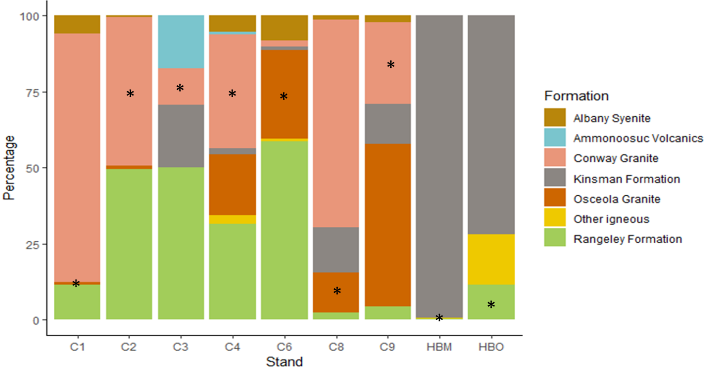
Figure 1. Rock formation composition of each of the excavated stands. The “*” indicates the formation that characterizes the underlaying bedrock.
- Future Work
Due to the amount of time it took to clean and identify each rock, I was unable to determine if the rocks found within each stand could be validated by the glacial till model. Future work will include using these data to validate Scott Bailey’s glacial till model. If the model does not accurately predict the rock composition of these stands, I will be able to provide a more accurate model for this specific area. An improved model will help with determining the weathering rate of soil nutrients. I will also be able to use the chemical makeup of the rock fragments within the stands and correlate them to soil exchangeable, extractable and total nutrient pools. These pools were also analyzed during this summer, however, the results are still be finalized. Future work will finalize the summery of nutrient pools within each stand. This will provide information that can be used as an explanatory variable in other studies conducted within this area.
- Acknowledgements
I would like to thank the Edna Bailey Sussman Foundation for their support in starting this project. I would also like to thank my supervisor, Scott Bailey, for all his help identifying rock formations. My advisor Ruth Yanai deserves a thank you for aiding in the planning of this research and encouraging me to apply. I thank the 2018 summer field crew for helping collect the rocks that were identified. A special thanks to Christopher Marshall for helping me figure out the most efficient way to wash the rocks. Siqi Li, high school students in the Forest Ecology Lab, and Ethan Smith deserve a thank you for their help in the laboratory.
- References
Fatemi, F. R., Yanai, R. D., Hamburg, S. P., Vadeboncoeur, M. A., Arthur, M. A., Briggs, R. D., … Arthur, M. (2011). Allometric equations for young northern hardwoods: the importance of age-specific equations for estimating aboveground biomass. Canadian Journal of Forest Research, 41, 881–891. https://doi.org/10.1139/X10-248
Nezat, C. A., Blum, J. D., Yanai, R. D., & Park, B. B. (2008). Mineral Sources of Calcium and Phosphorus in Soils of the Northeastern United States. Soil Sci. Soc. Am. J, 72, 1786–1794.
Schaller, M., Blum, J. D., Hamburg, S. P., & Vadeboncoeur, M. A. (2010). Spatial variability of long-term chemical weathering rates in the White Mountains, New Hampshire, USA. Geoderma, 153(3–4), 294–301. https://doi.org/10.1016/j.geoderma.2009.10.017
Smith, M.-L., & Martin, M. E. (2001). A plot-based method for rapid estimation of forest canopy chemistry. Canadian Journal of Forest Research, 31(3), 549–555. https://doi.org/10.1139/x00-187
Vadeboncoeur, M. A., Hamburg, S. P., Blum, J. D., Pennino, M. J., Yanai, R. D., & Johnson, C. E. (2012a). The Quantitative Soil Pit Method for Measuring Belowground Carbon and Nitrogen Stocks. Soil Science Society of America Journal Soil Sci. Soc. Am. J, 76, 2241–2255. https://doi.org/10.2136/sssaj2012.0111
Vadeboncoeur, M. A., Hamburg, S. P., Blum, J. D., Pennino, M. J., Yanai, R. D., & Johnson, C. E. (2012b). The Quantitative Soil Pit Method for Measuring Belowground Carbon and Nitrogen Stocks. Soil Science Society of America Journal Soil Sci. Soc. Am. J, 76, 2241–2255. https://doi.org/10.2136/sssaj2012.0111
Vadeboncoeur, M. A., Hamburg, S. P., Yanai, R. D., & Blum, J. D. (2014). Rates of sustainable forest harvest depend on rotation length and weathering of soil minerals. Forest Ecology and Management, 318, 194–205. https://doi.org/10.1016/j.foreco.2014.01.012

