Summer Internship Final Report

Recipient’s name: Anna L. Conklyn
Address: 134 Bassett St., Apt. 1 Syracuse, NY 13210
Email: alconkly@syr.edu
Telephone number: (315)708-6751
Date: November 4, 2022
Faculty sponsor: Dr. John M. Farrell
Graduate program and degree sought: PhD

St. Lawrence Ecosystem Stressors: Round Gobies and VHSV
Introduction

Viral Hemorrhagic Septicemia Virus (VHSV) is a World Organization for Animal Health (OIE) reportable fish pathogen found across the northern hemisphere (OIE 2019). A novel lineage, VHSV-IVb, was detected in the Great Lakes basin following sizeable fish kills in the mid-2000’s. The emergence of VHSV coincides with dramatic declines of spotted muskellunge, an apex predatory fish in the St. Lawrence River. One threat to their recovery is invasion of nursery bays by large abundances of round gobies (Neogobius melanostomus). These invasive fish harbor VHSV, and are regarded as essential for the amplification, spread, and evolution of the virus. Environmental factors that influence VHSV persistence are not well understood, requiring further investigation into reservoir hosts that maintain the pathogen and the continued risk associated with VHSV-IVb in the Great Lakes watershed. RNA viruses are known to exploit mutation to achieve variations in host range or escape antibody responses; therefore, knowledge of evolutionary relationships is fundamental to predict recurrence patterns (Domingo et al. 1998; Stepien et al. 2015).
The Thousand Islands is a section of the Great Lakes basin that has been particularly impacted by VHSV-IVb. In this region, consistently high prevalence in surveys of the virus, frequently observed fish kills and suppressed populations of muskellunge have been observed since the mid-2000’s (Farrell et al. 2017). Further, this area supports large populations of round gobies that are implicated in providing an environment suitable to rapid viral reproduction, evolution of new viral isolates, and dissemination of those isolates to the native community (Cornwell et al. 2012; Cornwell et al. 2014; Eckerlin et al. 2011; Farrell et al. 2017, Stepien & Niner 2020). This research project is using VHSV’s endemicity in the upper St. Lawrence to assess the pathogen’s evolutionary patterns within a limited geographic range, to investigate the physical and biological drivers of VHSV persistence and change.
The goal of my research accomplished through support from the Edna Bailey Sussman Foundation is to investigate differences in viral characteristics (i.e., prevalence, viral load, viral genetic sequence) between 1) round gobies of different population demographics 2) round goby populations in different years and sites and 3) round gobies compared to native host species. My doctoral dissertation research is striving to understand what environmental and biological factors contribute to determining annual viral prevalence and change into new variants in nursery bays of the Thousand Islands region.

Methods
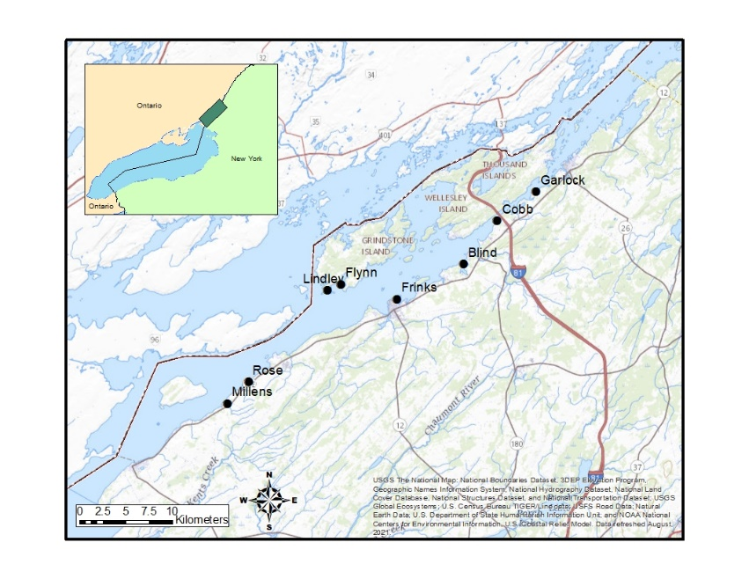
Fish were collected using trapnets during the last two weeks of May 2018-2022 in 10 bays in the Thousand Islands region of the St. Lawrence River (Figure 1). Round goby, yellow perch, rock bass, Lepomis sunfish, and brown bullhead were the host species targeted for viral surveillance. Fish were dissected for pooled organ (liver, kidney, spleen) and brain samples that were stored in an RNA preservation buffer and frozen at -20ºC until VHSV testing by molecular methods.
Figure 1. Map of sampled index nursery sites in the Thousand Islands region of the St. Lawrence River
Molecular testing was completed in the Fish Health Laboratory at the Cornell College of Veterinary Medicine. Extraction of nucleic acids was performed using a MagMax magnetic bead extraction system, and RNA was stored at -20ºC until viral diagnosis and quantification. Eluted RNA was tested in duplicate to determine nucleic acid quantity and quality using a qRT-PCR assay with a NanoVue spectrophotometer.
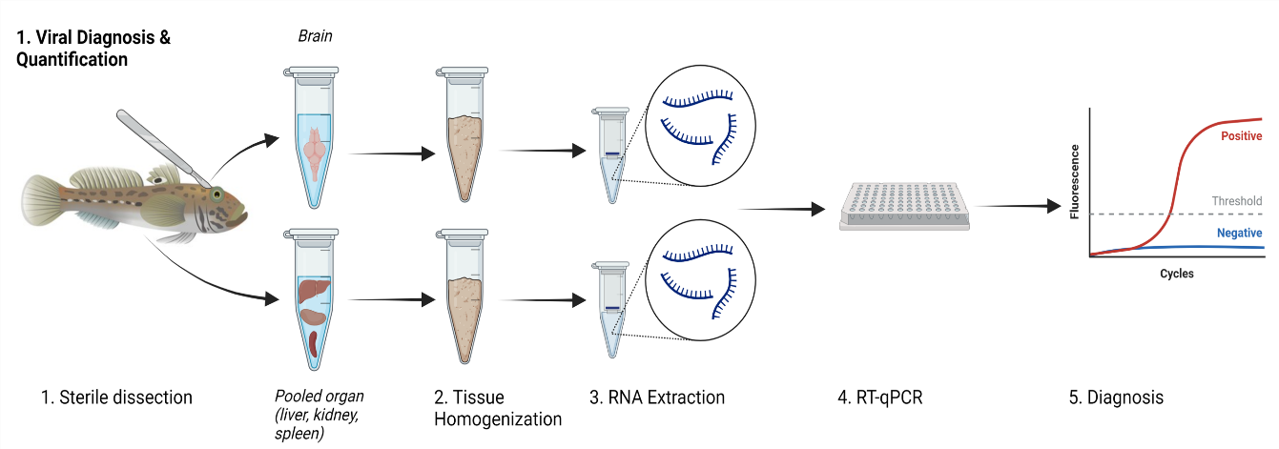
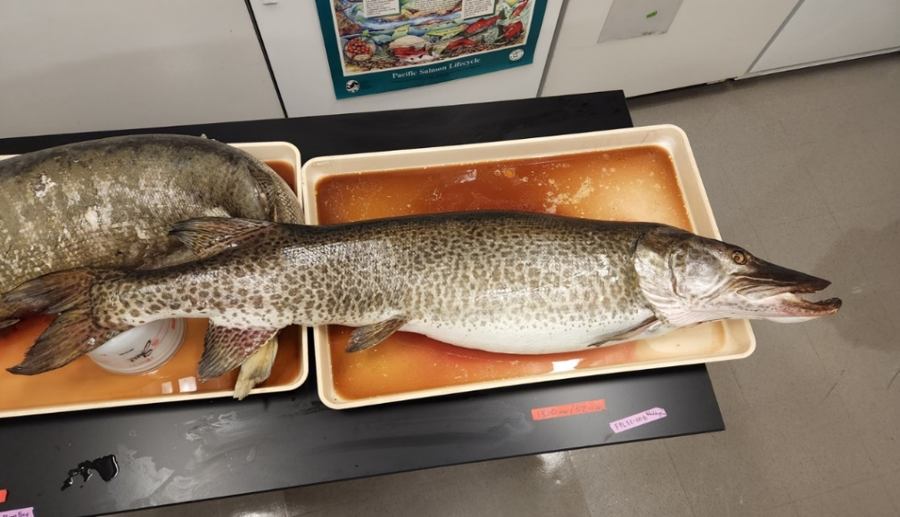
During the summer 2022 internship supported by the Sussman Foundation, approximately 2500 tissue samples that were collected and preserved from 2020-2022 were homogenized and extracted for their viral RNA, and 2100 of them were completed of their molecular diagnosis via qRT-PCR. Additionally during the internship period of 2022, three adult female muskellunge mortalities were recovered and brought to Cornell, where I participated in their full necropsy and conducted VHSV testing on these additional fish (Figure 2). In the months following conclusion of the internship, the remaining samples for molecular diagnosis have been completed.
Figure 2. Workflow for VHSV diagnosis and quantification completed during the 2022 Sussman internship
Figure 3. Picture of female muskellunge mortality recovered from St. Lawrence during 2022
Results
A total of 420 tissue samples tested positive for VHSV during the extent of this research project, demonstrating prevalent infections of this pathogen across years, sites, and host species. 1/3 of the recovered muskellunge mortalities in 2022 were diagnosed with VHSV as the presumed cause of death based on histological evidence.
In comparing round goby demographics, male round gobies experienced higher infection prevalence than females (z-test, figure 4a), but the distribution of their viral titers were not significantly different (Kruskal-Wallis, figure 4b). Viral prevalence (z-test, figure 5a) and viral titers (Kruskal-Wallis, figure 5b) were not significantly different across age groups of round gobies.
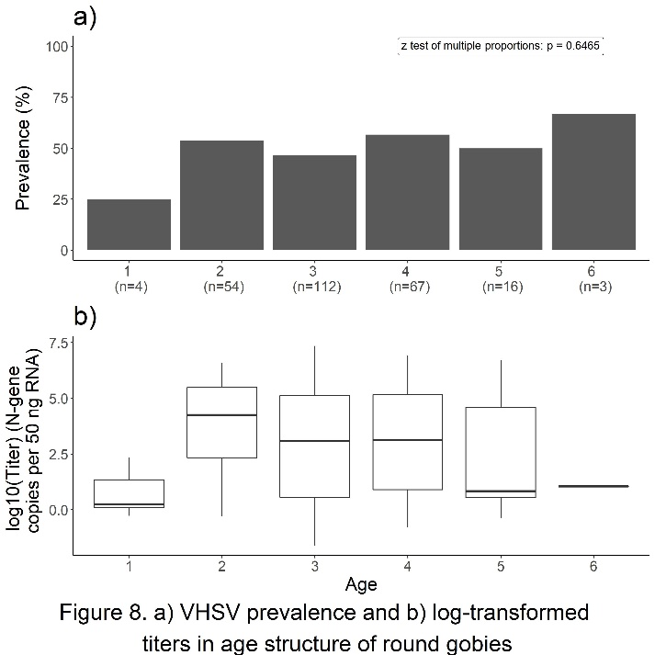
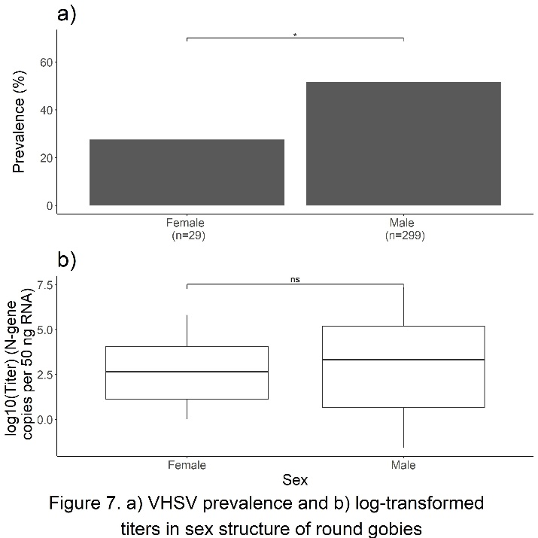
Temporal comparisons show that 2018 had significantly lower prevalence than all other years (z-test, figure 6a). Viral titers were significantly higher in 2020-2021 than in 2018-2019 (Kruskal-Wallis, Dunn test, figure 6b). VHSV prevalence was significantly different between several bays (z-test, figure 7a), while viral titer distributions were only different between Blind and Garlock Bays (Kruskal-Wallis, Dunn test, figure 7b).
Figure 5. a) VHSV prevalence and b) log-transformed titers in age structure of round gobies
Figure 4. a) VHSV prevalence and b) log-transformed titers in sex structure of round gobies
Round gobies experience significantly higher rates of viral infection compared to any of the native host species examined (z-test, figure 8a). However, round goby titers were significantly higher than infected rock bass, but not significantly different than any of the other tested species (Kruskal-Wallis, Dunn test, figure 8b).
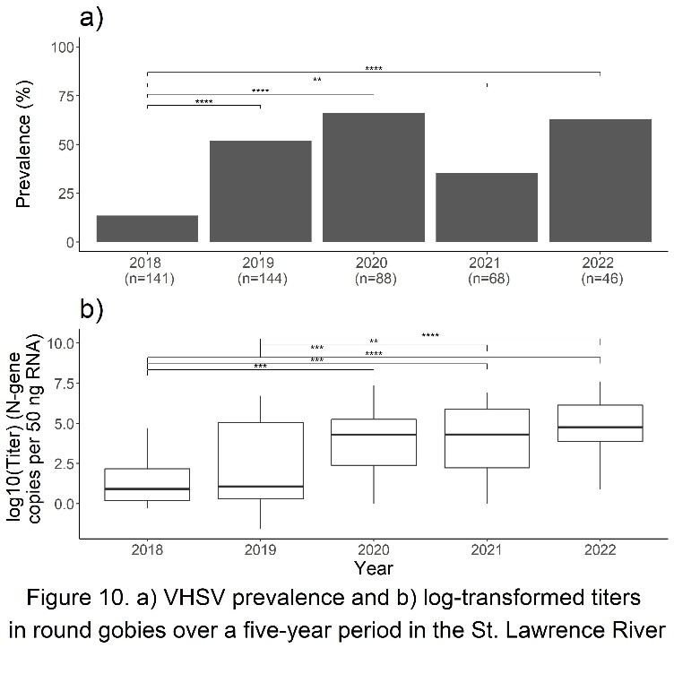
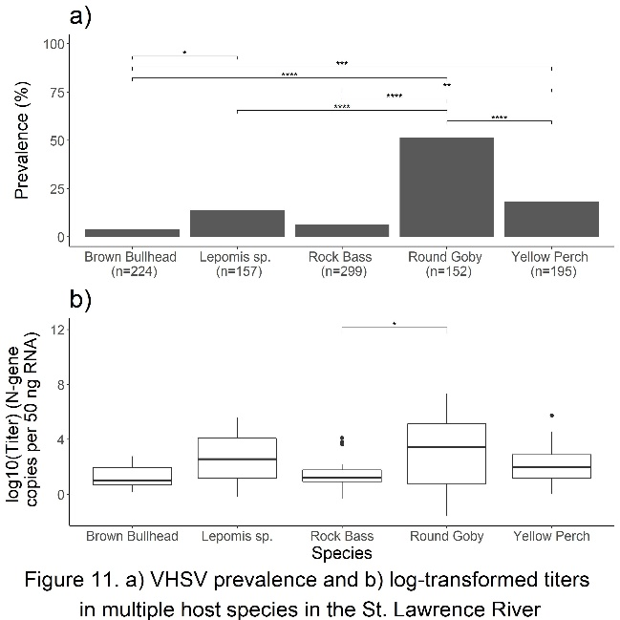
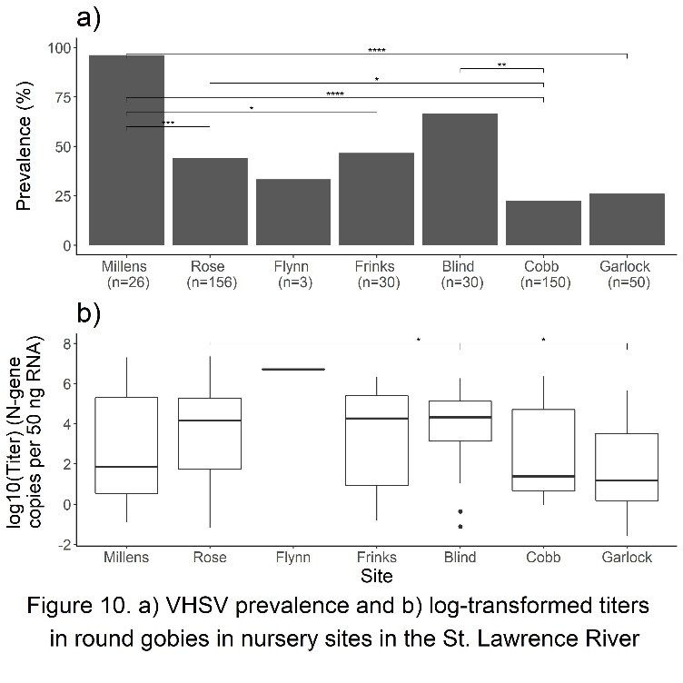
Figure 6. a) VHSV prevalence and b) log-transformed titers in round gobies over a five-year period in the St. Lawrence River
Figure 8. a) VHSV prevalence and b) log-transformed titers in multiple host species in the St. Lawrence River
Figure 7. a) VHSV prevalence and b) log-transformed titers in round gobies in nursery sites in the St. Lawrence River
Future Work
There is much statistical analysis and modelling work to be completed with the data collected during this internship. Predictive models for likelihood of infection and viral copy number will be developed to investigate the influence of physical and biological covariates. The results associated with this research will be written up as multiple dissertation chapters and journal publications over the next academic year. This work will also be the topic of several conference talks and other science communication products. The support of the Enda Bailey Sussman foundation will be acknowledged in all products from this work.
384 out of the 420 total VHSV-positive RNA samples collected from 2018-2022 have been selected across years, sites, and species for further analysis of whole genome sequences. These next steps will uncover much about the evolutionary trajectory of VHSV in the St. Lawrence River.
Acknowledgement
I would sincerely like to thank the Sussman foundation for funding this incredibly productive and successful summer. The advances in my doctoral dissertation research during this internship has been critical in maintaining my degree timeline.

References
Cornwell, E. R., Eckerlin, G. E., Thompson, T. M., Batts, W. N., Getchell, R. G., Groocock, G. H., Bowser, P. R. (2012). Predictive factors and viral genetic diversity for viral hemorrhagic septicemia virus infection in Lake Ontario and the St. Lawrence River. Journal of Great Lakes Research, 38(2), 278–288.

Cornwell, E. R., Primus, A., Wong, P. T., Anderson, G. B., Thompson, T. M., Kurath, G., Getchell, R. G. (2014). Round gobies are an important part of VHS genotype IVb ecology in the St. Lawrence River and eastern Lake Ontario. Journal of Great Lakes Research, 40(4), 1002–1009.

Domingo, E. (1998). Quasispecies Structure and Persistence of RNA Viruses. Emerging Infectious Diseases, 4(4), 521–527.

Eckerlin, G. E., Farrell, J. M., Casey, R. N., Hope, K. M., Groocock, G. H., Bowser, P. R., & Casey, J. (2011). Temporal Variation in Prevalence of Viral Hemorrhagic Septicemia Virus Type IVb among Upper St. Lawrence River Smallmouth Bass. Transactions of the American Fisheries Society, 140(3), 529–536.

Farrell, J. Getchell, R., Kapuscinski, K., LaPan, S. (2017). Long-Term Trends of St . Lawrence River Muskellunge: Effects of Viral Hemorrhagic Septicemia and Round Goby Proliferation Creates Uncertainty for Population Sustainability. American Fisheries Society Symposium.

Getchell, R. G., E. J., Bogdanowicz, S. M., Andrés, J. A., Schulman, A. T., Kramer, J., Marquis, H. (2019). Investigation of round goby viral haemorrhagic septicaemia outbreak in New York. Journal of Fish Diseases, 42(7), 1023–1033.

OIE (Office of International Epizooties) (2019). Manual of diagnostic test for aquatic animals: chapter 2.3.10 viral haemorrhagic septicaemia. Edited by World Organization of health.

Stepien, C. A., Pierce, L. R., Leaman, D. W., Niner, M. D., Shepherd, B. S., & Chen, T. Y. (2015). Gene diversification of an emerging pathogen: A decade of mutation in a novel fish Viral Hemorrhagic Septicemia (VHS) substrain since its first appearance in the Laurentian Great Lakes. PLoS ONE, 10(8), 1–26.

Stepien, C. A., & Niner, M. D. (2020). Evolutionary trajectory of fish Piscine novirhabdovirus (=Viral Hemorrhagic Septicemia Virus) across its Laurentian Great Lakes history: Spatial and temporal diversification. Ecology and Evolution, 10(18), 9740–9775.

