Influence of isolated ectomycorrhizal trees and soil inoculation on the establishment and mycorrhizae of tree seedlings in post-agricultural forests
Andrew Cortese
Department of Environmental Biology
SUNY College of Environmental Science and Forestry, Syracuse, NY

INTRODUCTION
Much of the current forest cover in the Northeastern United States has regenerated from abandoned farmland. By the turn of the 20th century it is estimated that about half of the original forest cover in the Northeast was converted to agricultural land (Irland, 1999). During the Great Depression, many farms were left abandoned and secondary forests grew on the fallow land (Foster, 2002). Following disturbance, plant communities transition from early colonizing to late successional stages (Chapin et al., 2002). Windthrow is the most common natural disturbance in the Northeastern United States (Bormann & Likens, 1979), but conversion of land to agriculture is a much more pervasive and intense disturbance; the systematic clearing and plowing of land removes biological legacies that influence reorganization of plant communities (Flinn & Vellend, 2005) and prevent a return to the pre-disturbance state (Bengtsson et al., 2003; Schaefer, 2009). These post-agricultural forests do not resemble the pre-settlement forests; they exhibit persistent legacies and are often comprised of even-aged stands dominated by successional tree species like Acer rubrum, Fraxinus americana, and Prunus spp. (Foster et al., 2003). Residual forests that were never cleared for agriculture often feature multiple age classes of trees (Foster et al., 1998). These forests, which occupy much less of the landscape than post-agricultural forests, are often dominated by late successional species such as Tsuga canadensis and Fagus grandifolia (Thompson et al., 2013) and provide important wildlife habitat (Yamasaki et al., 2000).
A mycorrhiza is the symbiotic relationship between plant roots and fungi, in which a plant transfers a portion of their photosynthetic product to the fungus, which provides increased water and nutrient uptake abilities to the plant (Smith & Read, 2010). Most land plants, including the tree genera Acer, Prunus, and Fraxinus form arbuscular mycorrhizae (AM). Since AM fungi generally do not exhibit strong host specificity and are present even in highly disturbed systems, AM trees are often not limited by the availability of suitable AM fungi (Klironomos, 2000; Cortese & Bunn, 2017). In contrast, many ecologically important and historically dominant tree genera such as Tsuga, Pinus, Betula, Fagus, and Quercus, are obligate ectomycorrhizal (EM) hosts (Brundrett, 2009). Since establishment of EM plants in a site is dependent on the availability of suitable EM fungi, a lack thereof can result in negative plant-soil feedbacks that prevent the establishment of EM plants (Nuñez et al., 2009; Bennett et al., 2017).
Mycorrhizal networks are formed when two or more plants are connected by the mycelial network of at least one ectomycorrhizal fungus (Selosse et al., 2006), in which the transfer of nutrients between plant hosts belowground can occur (He et al., 2003). Mycorrhizal networks allow nearby EM seedlings to have access to the benefits of EM fungi while the associated carbon costs are subsidized by overstory trees (Teste & Simard, 2008). Seedling performance can be enhanced by mycorrhizal networks (Booth & Hoeksema, 2010), but benefits decrease when distance from established EM trees increases (Dickie et al., 2012; Grove et al., 2019). In absence of established EM networks, inoculation with EM fungi from a desired reference site can enhance establishment of planted EM seedlings (Maltz & Treseder, 2015). Even a small amount of soil collected near healthy EM conspecifics can improve EM colonization, survivorship, growth, and foliar nutrient status of planted seedlings (Amaranthus & Perry, 1987; Cortese & Bunn, 2017). Since young forests tend to support low EM fungal diversity relative to mature forests (Twieg et al., 2007), inoculation may have the added benefit of increasing the species richness and subsequent functional diversity of EM fungi in post-agricultural forests.
Restoration of degraded forests is critical in the mitigation of biodiversity loss and anthropogenic climate change. Applied nucleation is a restoration strategy where patches of native vegetation are planted to serve as focal point from which natural recruitment can originate through facilitation (Franks, 2003), which is cheaper to implement and more structurally diverse compared to single-species plantations (Corbin & Holl, 2012). While the concept of applied nucleation has been used for above-ground restoration of vegetation, I suggest that scattered EM trees existing within a matrix of AM dominated forest can function as the nucleus from which EM seedlings can establish via isolated EM networks (Nara, 2006; Grove et al., 2019). In areas completely devoid of EM trees, inoculation with soil from EM dominated forests may be required to ensure successful establishment. By utilizing EM networks and soil propagules from residual forests, the ability to introduce valuable, late successional EM tree species into post-agricultural forests may be enhanced.
My research is investigating if scattered birch trees may support a greater diversity and abundance of EM fungi compared to the surrounding maple forest, and whether they exert a positive influence on the establishment of different species of tree seedlings. I planted a total of 700 hemlock, pine, and oak seedlings in 20 plots near birch trees and 20 plots in the surrounding maple-dominated forest at the Mianus River Gorge (MRG) in Bedford, New York as well as two additional sites in Central New York. In each plot, half of my seedlings were treated with soil collected from an adjacent hemlock, pine, and/or oak dominated reference forest to reintroduce EM fungus spores into the second-growth forest soils. My results will determine how EM fungal communities are distributed, and whether suitable EM fungi are missing from second-growth forests. This will be determined through measurements of survivorship and growth of my planted seedlings as well as the DNA-based identification of EM fungi from their roots. My results will provide guidance for the restoration of pre-agriculture forest composition, which is a mission of MRG.
WORK COMPLETED
Funding provided by the Edna Bailey Sussman Foundation supported my summer 2021 field and laboratory work. Over the summer, I monitored seedlings at all three of my field sites and was able to measure monthly survival, conduct routine maintenance, as well as collect an annual light measurement at each of my forty plots. I also measured and mapped every tree and sapling in a 15 m radius from 8 plots at one of my Central New York field sites. At the end of the growing season, I also measured seedling heights at every plot. Funding also allowed me to harvest and process all 161 surviving seedlings from the 16 plots at MRG. Seedling shoots were dried and weighed and foliage was prepared for nutrient analysis. Oak seedlings had images and weights of leaves taken to calculate specific leaf area, which is a physiological response to biotic and abiotic conditions (Figure 1). Root systems were assessed for colonization by ectomycorrhizal fungi (Figure 2), in which individual root tips were determined to either mycorrhizal or non-mycorrhizal. Each mycorrhizal root tip was counted and separated by morphological type (Figure 3) and then preserved in DNA buffer for molecular analysis to be conducted in winter/spring 2022.
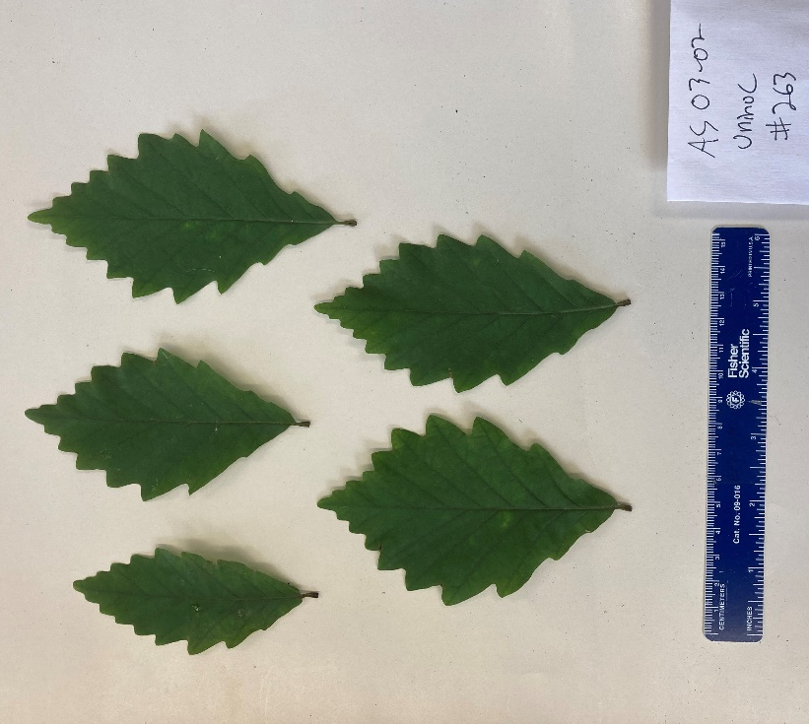
Figure 1. Image of oak (Quercus montana) leaves used for measurement of specific leaf area. Leaf area will be measured using image analysis software.
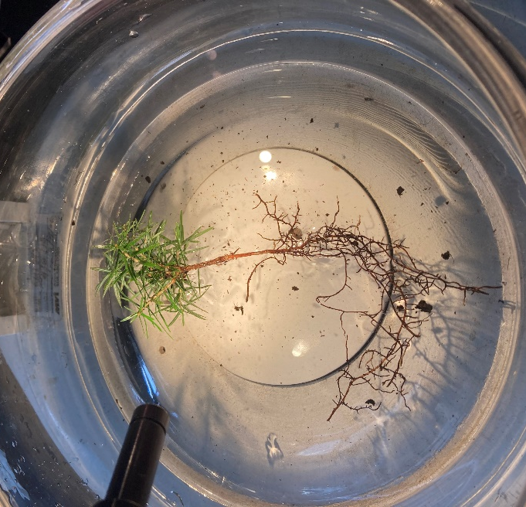
Figure 2. Eastern hemlock seedling (Tsuga canadensis) prepared for assessment of ectomycorrhizal colonization under dissecting microscope

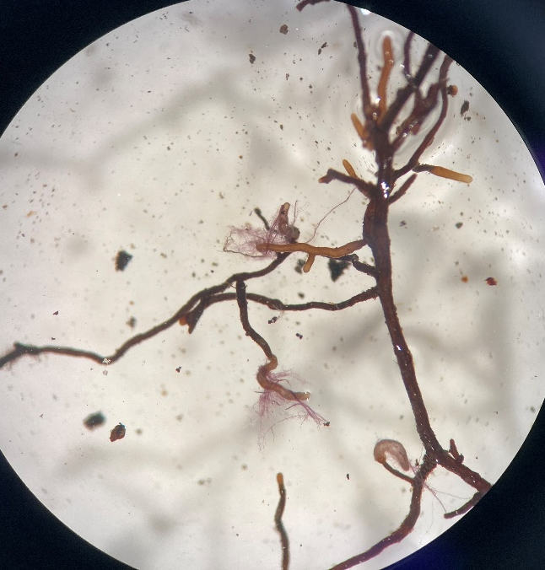
Figure 3. Examples of ectomycorrhizal root tips on eastern hemlock (Tsuga canadensis) that were preserved for DNA analysis
CONCLUSIONS
This project has provided me with invaluable experience planning and conducting a field experiment at multiple sites and collaborating with private and public land managers. While I am still in the process of entering, curating, and analyzing data, I am confident that my experiment will yield novel results. Empirical observation of my seedlings and their root systems suggests that isolated birch trees can support a greater abundance of mycorrhizal fungi compared to the rest of the maple-dominated forest. My results will enhance the knowledge of basic fungal ecology and will provide information critical for the restoration of pre-settlement forest composition in post-agricultural forests.
ACKNOWLEDGEMENTS
My project would not have been made possible without funding from the Edna Bailey Sussman Foundation, as well as the MRG RAP fellowship, and Lowe-Wilcox awards. I am also grateful for the staff at MRG, NYS DEC, and Heiberg Memorial Forest for their support. Lastly, I am indebted to my steering committee for valuable feedback for experimental design and numerous friends and undergraduate students for assistance in the field and laboratory.

