Scott Dai
2022 Edna Bailey Sussman Report: Effects of Nitrogen and Phosphorus Availability on Herbaceous Plants in Northern Hardwood Forests

Introduction
While the herbaceous layer comprises less than 1% of total biomass in northeastern hardwood ecosystems, it plays important roles in forest function. Up to 90% of a forest’s plant diversity is contained in the herbaceous layer, due to hardwood forests containing fewer tree species than herb species (Gilliam, 2007). Additionally, herbaceous plants play key roles in cycling nutrients (Muller, 2003), producing litter biomass (Gilliam, 2007), and supporting insect communities (Proctor et al., 2012). The sensitivity of the herb layer to disturbances allows for a rapid assessment of site nutrient availability and past history of disturbances, making it a valuable tool for forest management (Gilliam et al., 2016; Small & McCarthy, 2005). For instance, changes in nutrient regime may be more easily detected in herbaceous tissue chemistry than in foliage – a study in Mediterranean savanna ecosystems found significant increases in herbaceous tissue chemistry after two years of fertilization, but no detectable differences were observed in foliar nutrients of trees (El-Madany et al., 2021). The importance of nitrogen (N) availability to herbaceous communities has been well documented, but phosphorus (P) and calcium (Ca) also play important roles in herbaceous plants. Understanding how herbaceous plants respond to changes in these key nutrients as a result of human activities may help forest managers and researchers better understand forest ecosystem responses to environmental changes.
Work Completed
During my summer internship, I was mentored by Dr. Elizabeth Hane from the Rochester Institute of Technology. I surveyed the herb layer of ten forest stands distributed across three sites in a long-term NxP factorial experiment in the White Mountains of New Hampshire. Four 50 m x 50 m plots in each stand were randomly assigned N, P, N and P, or no fertilizer (as a control) treatments, with annual fertilization beginning in 2011. Seven stands also received a one-time Ca treatment in 2011.
For my internship this summer, I replicated a pretreatments survey of herbaceous plants in our plots by recording the number of species, number of individuals of each species, and area each species occupied in twenty-five 1-m² quadrats in each plot. I also measured leaf area index in stands where herb transects were conducted to assess how light availability influences herbaceous communities alongside N and P availability. To better detect species presumed to have been lost since 2010, I performed a species inventory of the entire plot area to assess if the existing transect design adequately characterizes the total number of species at the plot level. I presented my findings at the 2022 Hubbard Brook Cooperators’ Meeting in July.

Results
From sampling a subset of plots from 2021, the number of species observed in 2022 was similar to 2021, suggesting that interannual variation is not a major source of uncertainty (Figure 1). Compared to pretreatment (2010) data, I observed fewer species in plots that received N addition in 2021 and 2022. These results align with previous research that suggest N addition reduces the number of species, as those adapted to N-limited conditions are outcompeted by species that are able to grow in N-rich conditions (Gilliam, 2019).
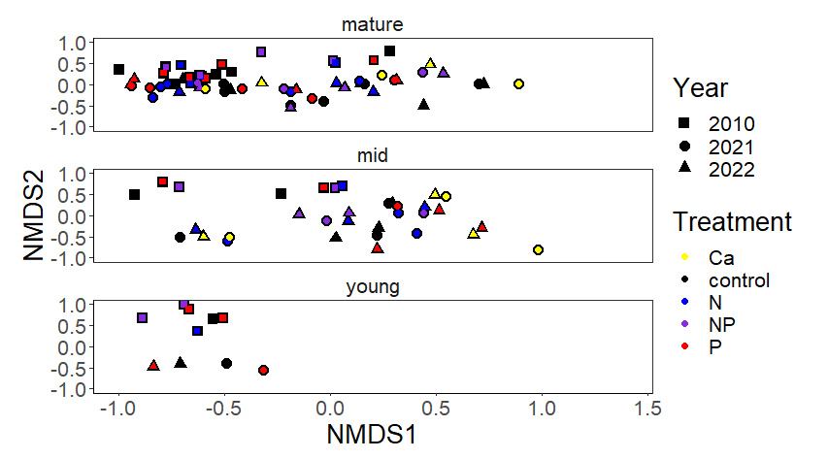
Figure 1: Non-metric multidimensional scaling plot visualizing herbaceous communities in 2010, 2021, and 2022 in mature, mid-aged, and young stands of the MELNHE project. Points that are closer together are similar in species composition and species abundances, while points that are farther apart from each other are more dissimilar in species composition and species abundances.
a)
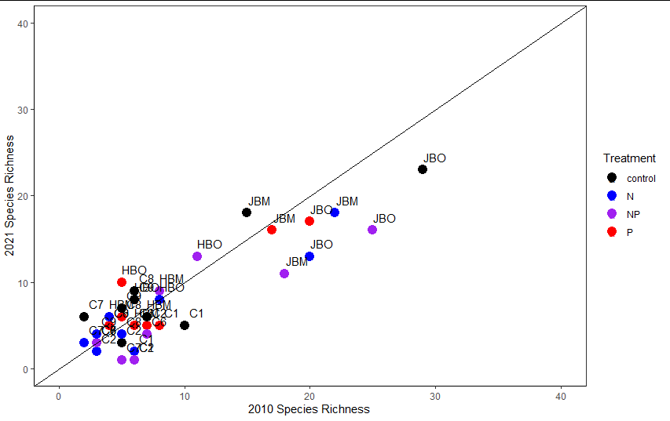
b) 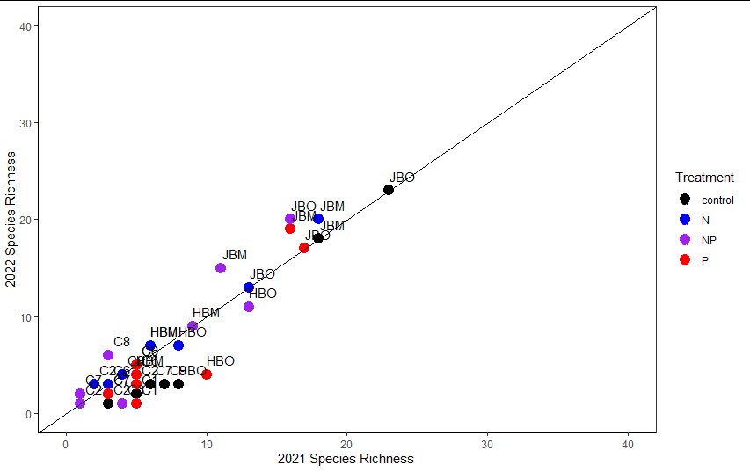
Figure 2: Total number of species (species richness) observed at each stand in a) 2010 and 2021 and b) 2021 and 2022.
Pretreatment carbon (C) and N were analyzed to assess herb tissue C and N content before fertilization began (Figure 3). Samples collected in 2022 will be analyzed to describe how fertilization has increased the concentrations of these elements – I would expect to see increases in N concentration for herbs in plots that receive either N or N and P addition. Nitrogen addition may also decrease P concentration depending on species, as seen in research on foliar chemistry from our stands (Hong et al., 2022).
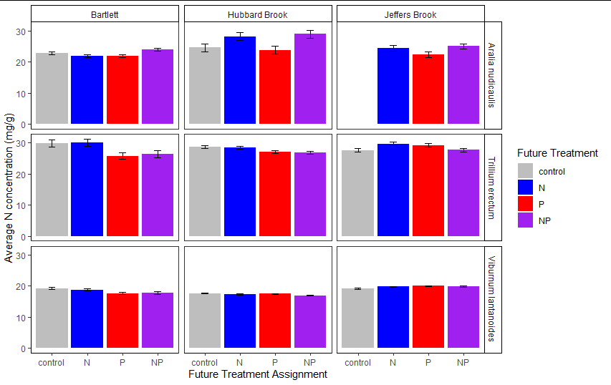
Figure 3: Bar graph depicting average N concentrations (milligrams per gram of leaf tissue) in Aralia nudicaulis L., Trillium erectum L., and Viburnum lantanoides Michx., at each study site. Error bars represent the standard error of the mean concentration values.
Ongoing Work and Future Directions
In Spring 2023, I will compare herbaceous tissue chemistry from 2022 with that from 2010, to determine how N and P availability influences chemical makeup of herbaceous leaves. I will expand my data analysis to compare the number of observed species in herb transects versus species found in the entire plot, to assess if my herbaceous transects are accurate at characterizing herbaceous communities at each plot.
Acknowledgments
Data and sample collection for this project was aided by Finley O’ Connor, Jacob Beidler, Isaac Roter, Erin Cornell, Jenna Zukswert, Emelia Sargent, April Zee, Sandip Rijal, Joe Nash, and Kelley Gilhooly. I would also like to thank my advisor, Dr. Ruth Yanai, along with my committee members, Dr. Elizabeth Hane, Dr. Martin Dovciak, and Dr. Matt Vadeboncoeur for guiding me throughout this project. Lastly, I would like to thank Jeff Merriam for carbon and nitrogen analysis of 2010 herb tissues. All future publications and presentations on this project will acknowledge the Edna Bailey Sussman Fund for supporting this research.
Literature Cited
El-Madany, T. S., Reichstein, M., Carrara, A., Martín, M. P., Moreno, G., Gonzalez-Cascon, R., Peñuelas, J., Ellsworth, D. S., Burchard-Levine, V., Hammer, T. W., Knauer, J., Kolle, O., Luo, Y., Pacheco-Labrador, J., Nelson, J. A., Perez-Priego, O., Rolo, V., Wutzler, T., & Migliavacca, M. (2021). How Nitrogen and Phosphorus Availability Change Water Use Efficiency in a Mediterranean Savanna Ecosystem. Journal of Geophysical Research: Biogeosciences, 126(5), e2020JG006005. https://doi.org/10.1029/2020JG006005
Gilliam, F. (2019). Excess Nitrogen in Temperate Forest Ecosystems Decreases Herbaceous Layer Diversity and Shifts Control from Soil to Canopy Structure. Forests, 10, 66. https://doi.org/10.3390/f10010066
Gilliam, F. S. (2007). The Ecological Significance of the Herbaceous Layer in Temperate Forest Ecosystems. BioScience, 57(10), 845–858. https://doi.org/10.1641/B571007
Gilliam, F. S., Billmyer, J. H., Walter, C. A., & Peterjohn, W. T. (2016). Effects of excess nitrogen on biogeochemistry of a temperate hardwood forest: Evidence of nutrient redistribution by a forest understory species. Atmospheric Environment, 146, 261–270. https://doi.org/10.1016/j.atmosenv.2016.04.007
Hong, D. S., Gonzales, K. E., Fahey, T. J., & Yanai, R. D. (2022). Foliar nutrient concentrations
of six northern hardwood species responded to nitrogen and phosphorus fertilization but did not predict tree growth. PeerJ, 10, e13193. https://doi.org/10.7717/peerj.13193
Muller, R. (2003). The Herbaceous Layer in Forests of Eastern North America. Oxford University Press.
Proctor, E., Nol, E., Burke, D., & Crins, W. J. (2012). Responses of insect pollinators and understory plants to silviculture in northern hardwood forests. Biodiversity and Conservation, 21(7), 1703–1740. https://doi.org/10.1007/s10531-012-0272-8
Small, C. J., & McCarthy, B. C. (2005). Relationship of understory diversity to soil nitrogen, topographic variation, and stand age in an eastern oak forest, USA. Forest Ecology and Management, 217(2), 229–243. https://doi.org/10.1016/j.foreco.2005.06.004

