Urban Food Forest Establishment as an Ecological Regulator of European Buckthorn (Rhamnus cathartica L.): Final Report to the Edna Bailey Sussman Foundation, Fall 2021
Garrett Maynard
SUNY College of Environmental Science and Forestry
Introduction:
Since its introduction to the United States in the late 19th century, European buckthorn has spread to urban areas throughout most of the country, becoming a ubiquitous urban invader. Unfortunately, Syracuse, NY has not been immune to buckthorn’s spread and many of the city’s urban parks have become inundated with monocultural thickets of buckthorn. The presence of these thickets can weaken the urban forest network in many ways, such as public access, carbon sequestration, climate resiliency, wildlife habitat, food availability, community safety, forest health, and more. Currently, the most effective method of buckthorn management is through herbicide application following cutting, which halts basal sprout development. Although herbicide is effective in combatting this invader, herbicides alone do not offer ways toward reinstituting ecological and human health. To progress beyond simple eradication, my research for this internship is focused on investigating a novel buckthorn management strategy: planting urban food forests after buckthorn removal.
By planting native edible plants, not only is the health of the forest being immediately restored, but these restoration plants will ideally cofunction to slow buckthorn invasions and create a more climate-resilient forest containing foraging resources for city residents. The central goals for my research during the time of this internship include gathering qualitative and quantitative data about the establishment of the restoration plants in the presence and absence of buckthorn as well as the regeneration capacity of buckthorn when exposed to the following three treatments: (1) control, (2) competition with the restoration plants, and (3) herbicide application following removal. In addition to these goals, models will be created depicting the carbon sequestration capacities of buckthorn thickets when compared to forests restored with edible plants. The information garnered from this research will prove valuable to urban land managers grappling with buckthorn, food insecurity, climate change, and urban forest health by providing ways forward that put both ecological and human health at the forefront.
Completed & Continued Work:
At the end April 2021, two large sectors (375m² each) of buckthorn thickets were cleared at Schiller Park in Syracuse, NY and each sector was further divided into fifteen 5x5m subplots (Figure 1). In five subplots of each sector, restoration plants were planted in a random arrangement (one of each of the following species: persimmon, pawpaw, red mulberry, downy serviceberry, chokecherry, and spicebush); in five other subplots, Garlon 4 was applied directly to the exposed buckthorn stumps within minutes of removal; and the five other subplots were left alone as controls. A third sector without the influence of buckthorn was planted with 18 trees (three subplots with restoration plants) to contrast restoration efficacy in the presence and absence of buckthorn. With all three sectors included, 78 edible trees and shrubs were planted in Schiller Park and monitored alongside 298 buckthorn stumps from mid-May through late October of 2021.
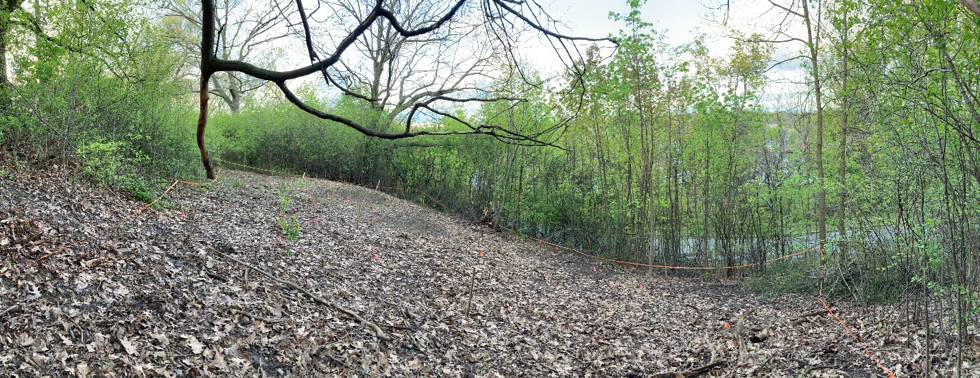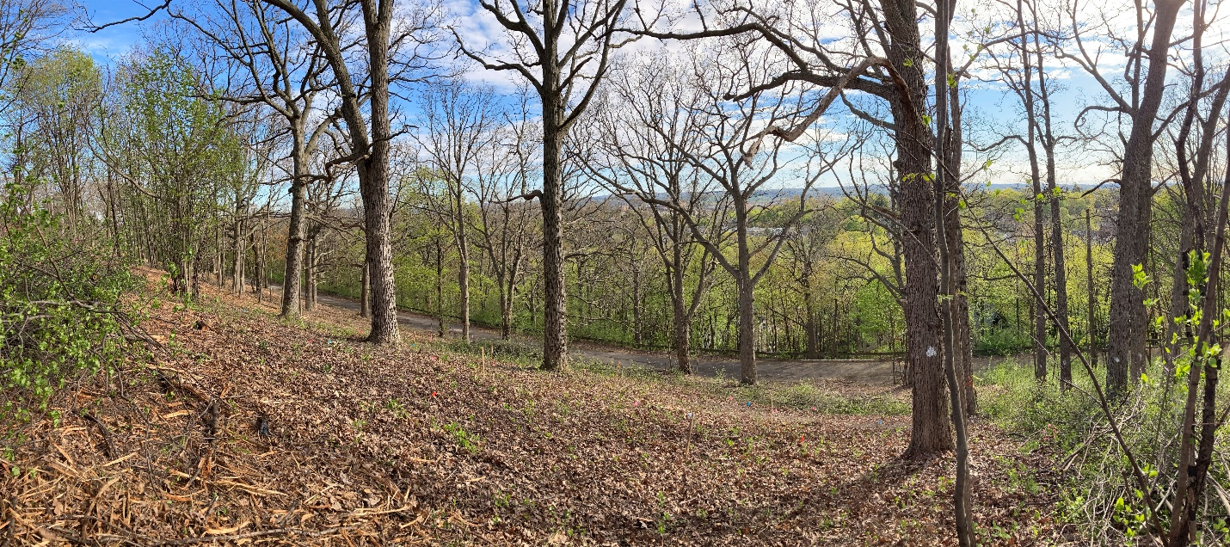
Figure 1. The two major sectors of land cleared in Schiller Park, Syracuse, NY: the northeast-facing side of the drumlin (top) and the southwest-facing side of the drumlin (bottom).
The plants were monitored throughout the 2021 growing season, with some variables measured more frequently than others due to time constraints. Data for site characteristics such as slope, hardwood species density, percent canopy cover, canopy height (oak overstory), and understory height (buckthorn thicket) was each gathered when time allowed and is currently being analyzed. On an approximately weekly basis, each of the 78 restoration plants were assessed concerning their height, diameter at ground level (DGL), and physical qualities (i.e. percent live foliage, herbivory, biotic disease, wilting, and more); the leaves of each tree were counted individually on a roughly biweekly basis. The 298 buckthorn stumps were monitored individually on an approximately biweekly basis regarding the number of the sprouts being produced and the length of the largest sprout present. Some buckthorn plants hosted more than 50 sprouts and many reached lengths greater than 40 inches.
Without a doubt, the herbicide application was the most effective treatment to inhibit buckthorn regeneration in this study (as predicted); however, field observations suggest that the restoration plants have had a minor impact in reducing buckthorn regeneration when compared to the control and that the plants not exposed to buckthorn have established most effectively. To support these observations with quantitative evidence, all the data mentioned above is currently being compiled, processed, and run through statistical testing.
Concluding Statements:
This internship enabled me to work hand-in-hand with Stephen Harris, the City-County Arborist at the Syracuse Department of Parks, Recreation & Youth Programs, to develop, orchestrate, and implement a research project that will add value to the current body of scientific literature and the city of Syracuse. As a result of this research and other related efforts, the city of Syracuse plans to allocate more resources into restoration efforts like this that go beyond just invasive species removal and incorporate community needs with ecological priorities. Specifically, the city plans to expand my plantings at Schiller Park and establish more food forest groves in city properties. Once statistical testing is complete, the results from this internship research will be shared with the city and published in a peer-reviewed journal to provide an empirical foundation for future urban restoration work.
Acknowledgments:
It has been humbling to be the recipient of the Edna Bailey Sussman Foundation’s generosity for the 2021 summer research season. Therefore, I would like to thank the Foundation for the substantial funding, which has enabled me to create, coordinate, and execute a large research project of my own and gain valuable experience working hand-in-hand with Stephen Harris, among others. I would also like the thank the Syracuse Department of Parks, Recreation & Youth Programs for providing me access to city property and for access to field resources throughout the growing season – without this generosity, this research would have never happened. I would also like to thank my advisor, Dr. Stewart Diemont, for guiding me through the research process; and I would also like to thank the undergraduate research assistants who helped me get the project off the ground while the snow was still falling.

