Forest Composition Assessment from High-Resolution Remotely Sensed Imagery
A final report submitted to the Edna Bailey Sussman Foundation 2021
- Abishek Poudel
- Introduction
Forest monitoring activities are critical to sustainable forest management with emerging concerns over climate change, biodiversity conservation, and ecosystem services. One crucial element of this type of monitoring program is assessing vegetation monitoring. Timely and accurate assessment of vegetation is critical for foresters to make decisions related to future stand management. Furthermore, effective silvicultural treatment choices are dependent on stand stocking levels, health, and competing species abundance. Traditional field-based forest and vegetation monitoring can be time and cost-prohibitive. Advancements in technologies have enabled vegetation assessment and offered a wide variety of possibilities for monitoring. Evaluation of new methodologies to improve monitoring efficiency is an essential and valued research activity. Remote sensing techniques provide comprehensive and accurate information and enable researchers to collect information on forest composition at high spatial and temporal resolution.
This internship study involved a suite of remote-sensing data to estimate, classify, compare, and visualize spatial patterns of forest in study sites managed by Molpus Woodlands Group. Remotely sensed data, USDA National Agricultural Imagery Program (NAIP), and (2) New York State (NYS) orthoimagery, were used to quantify and classify forest vegetation. Even though NAIP and NYS orthoimagery data are of low resolution compared to imagery derived from a drone or Unmanned Aerial Vehicles (UAV), it provided sufficient information to quantify and understand spatial patterns in a forested landscape. The results from this study will enable us to compare the cost efficiency and effectiveness of using open source remotely sensed data with high-resolution UAV imagery in the future. All the tasks and work related to this internship was performed remotely.
- Materials and Methods
Study Area
The study was conducted in north-western Adirondack on forest properties managed by Molpus Woodlands Group, a timberland investment management organization (TIMO). The study area includes 231392 acres of forested land distributed mostly on the central and western part of Adirondack Park in New York (Figure 1). These areas comprise a variety of species composition, forest classes, and stand structures.

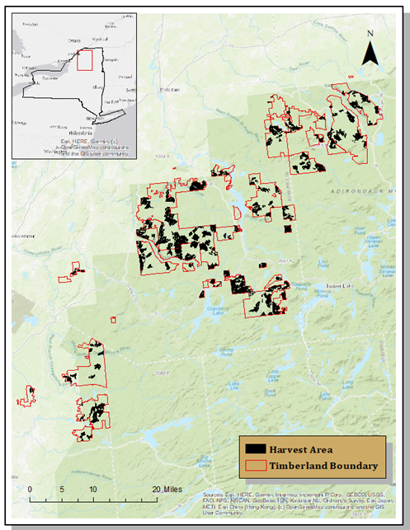
Figure 1: Distribution of timberland and harvest areas. Inset map of NY state and extent indicator for Molpus Woodands Group forest properties in Adirondack NY (Top left).
Data Products
National Agriculture Imagery Program (NAIP) high-resolution aerial photographs were used for this study. Imagery acquired by NAIP during November 2015 was used for this study. The NAIP imagery and data products consist of around 330000 scenes covering the United States. The NAIP data are 4-band multispectral imagery with spectral bands of near-infrared (Band 4), visible red (Band 1), visible green (Band 2), and visible blue (Band 3) with 8 bits radiometric resolution. The spatial resolution is the 1-meter ground sampled distance (GSD). The NAIP images are radiometrically corrected, ortho-rectified, and geometrically rectified to UTM Zone 18N NAD 83. These imagery products were downloaded at no cost from USGS, The National Map-Advanced Viewer (https://apps.nationalmap.gov/viewer/). The timberland boundary shapefile was uploaded on a national map-advanced viewer, and Imagery-NAIP Plus was selected to limit the search criterion within study areas (Figure 2). The downloaded image tile is provided as a Geo-TIFF file set. The coverage of the study area required obtaining and utilizing 89 NAIP raster images files of around 10 gigabytes. The NAIP imagery tiles were mosaicked together using ESRI ArcGIS Pro, which helped to validate the downloaded imagery with timberland boundary.
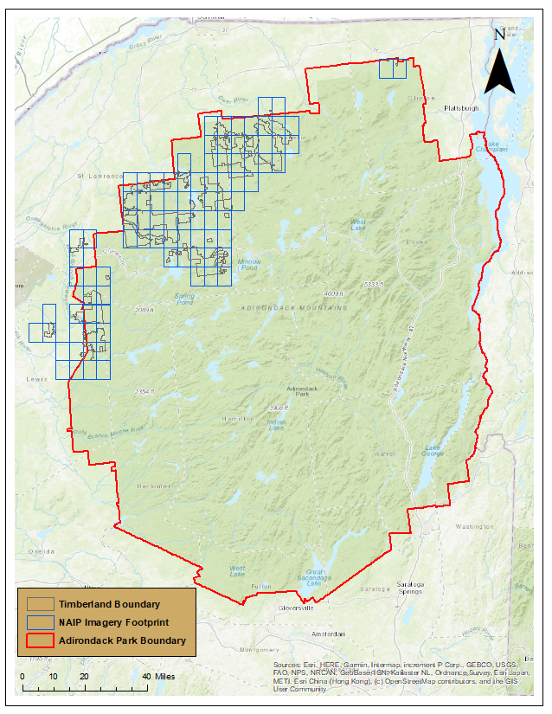 Figure 2: NAIP imagery footprint on Molpus Woodlands properties
Classification Schema
Classification schema was developed in ArcGIS Pro with five levels of classification. Those classifications included: Conifer, Hardwood, Water, Open Space, and Road. The classification was limited to only one timberland area due to limited processing time for entire forest properties. One of the timberlands was selected randomly, and a raster composite band was created for the selected study site. Training samples were made with five levels of classification.
Supervised Classification
Supervised image classification was performed in ArcGIS Pro. Classification schema, training sample, and the composite band were the input datasets, and a support vector machine classifier was chosen to perform classification.
- Preliminary Results
Initial results on supervised pixel-based image classification worked reasonably well on classifying the vegetation composition. It did not work very well for classifying open space and roads (Figure 3). The problem might be due to the limited roads inside the study. Another reason could be due to a few training and reference samples. Open space merged into hardwood and conifer forest.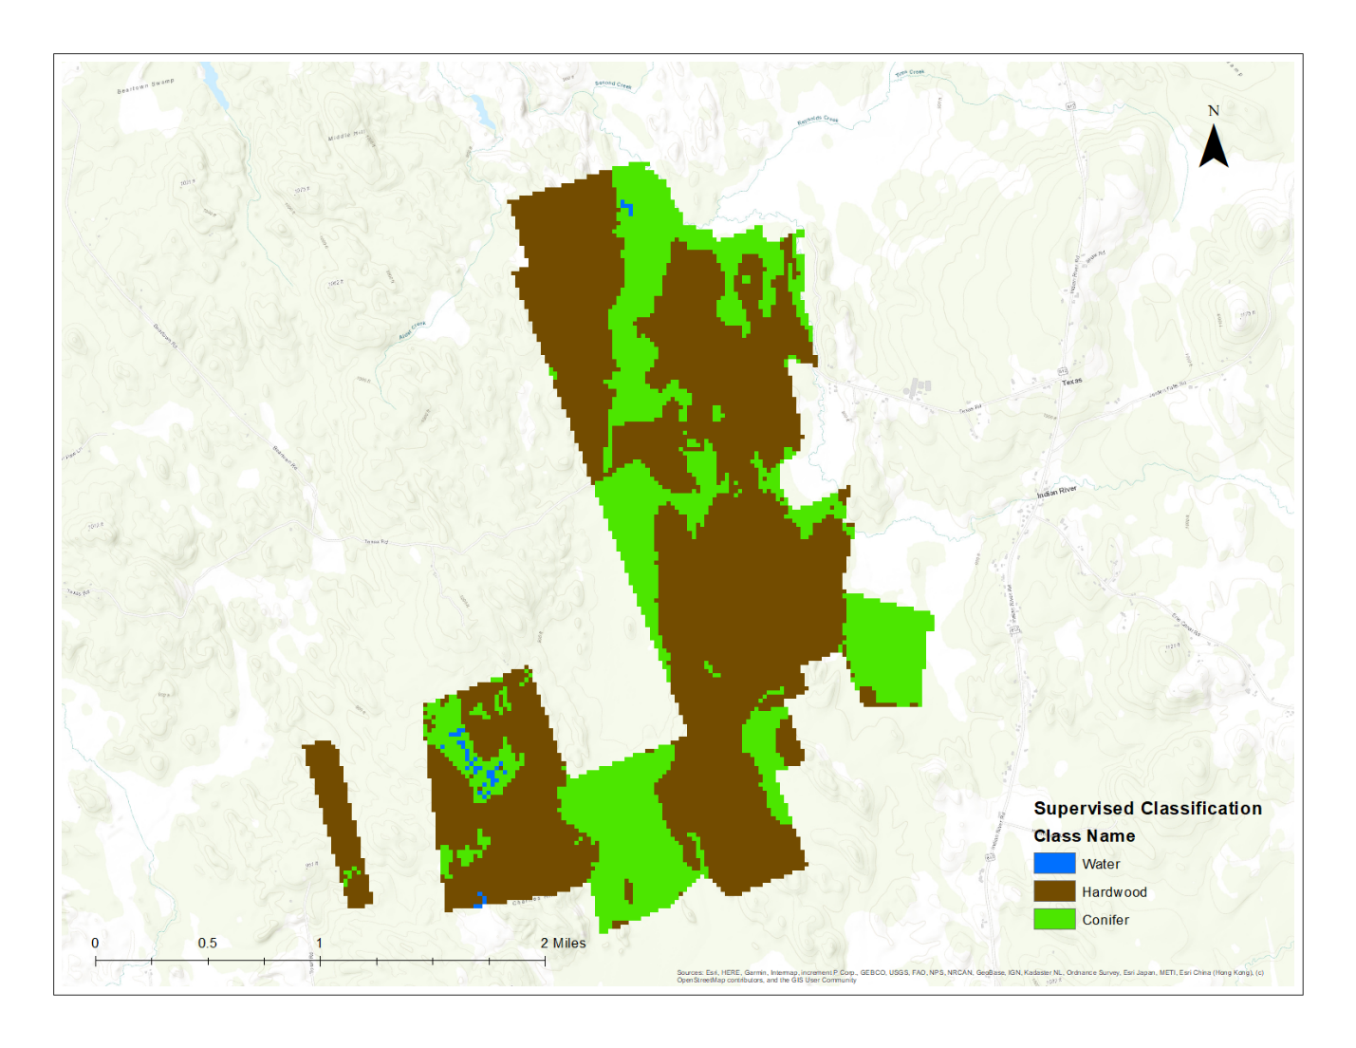
Figure 3: Supervised Image Classification

- Discussion:
The forest composition assessment procedures required a significant amount of time downloading and processing NAIP imagery and NY state orthoimagery. Pre-processing raster datasets for whole study areas consumed a considerable amount of time. It led to pre-processing only one of the recently harvested forest properties only. Current results show that remote sensing imagery such as NAIP imagery and NY state orthoimagery have the potential for forest vegetation classification and assessment and can perform better if additional data is utilized for image classification.
- Future Work
Further analysis of NAIP imagery and orthophotos could help in making inferences on vegetation classification for whole properties. This study can be enhanced by incorporating Lidar data and high-resolution UAV imagery and inferring at the individual tree level.

Acknowledgments
I am thankful to my advisor, Dr. Eddie Bevilacqua, for his guidance throughout my internship. I am also grateful to Jeff Denkenberger and Brice Young from Molpus Woodlands Group for allowing me to conduct this research and providing datasets concerned to the study. I want to thank the Edna Bailey Sussman Foundation for giving me this opportunity to work on my area of interest. The foundation will be acknowledged in my dissertation and poster, presentations, and publications based on this study.

