Comparative Mortality from Parasitism in a Rapidly Expanding and Long-Stable Population of the Invasive Browntail Moth
Eric Swiecki
SUNY College of Environmental Science and Forestry
Final Report to the Edna Bailey Sussman Foundation
2021
Background: The establishment of the browntail moth (Euproctis chrysorrhoea, hereafter BTM) in North America ranks as one of the most enigmatic case studies in invasion biology. Accidentally imported in the 1890s (Fernald and Kirkland 1903), its range quickly expanded to encompass 150,000 km² by 1914. Soon after however, it began to steadily decline and by the early 1970’s was found exclusively in two relict coastal enclaves, Casco Bay, Maine, and Cape Cod, Massachusetts (Schaefer 1974). Despite occasional fluctuations, populations remained constrained to these areas until very recently. In 2015, populations in Maine spread inland and by 2021, encompassed an area not seen since its 1914 peak (DCAF, MFS 2021). This dramatic expansion received much public attention as not only do BTM larvae defoliate an array of tree species, they also possess lightweight, venomous hairs which cause weeping, poison-ivy-like rashes in humans (Fernald and Kirkland 1903). Given their ecological impacts on sensitive coastal vegetation and substantive economic impact on Maine’s tourist industry, identification of the drivers of BTM’s return is a priority for the public, managers, and scientists alike.
Widespread range contractions in well-established invasive species are exceedingly rare (Simberloff and Gibbons 2004), and the underlying cause for the collapse of BTM after 1914 has never been conclusively determined. A leading explanation is that mortality from a suite of insect parasitoids introduced as part of biological control efforts in the early 1900s eventually restricted BTM to coastal areas (Elkinton et al. 2006). One species, Compsilura concinnata (Meig.), caused considerable mortality in inland BTM populations in the past (Burgess and Crossman 1929, and experimental populations established outside the current range of BTM were heavily attacked by this species (Elkinton et al. 2006). The recent and rapid range re-expansion in Maine is all the more puzzling in that the Cape Cod population has remained within the same geographic footprint occupied since at least the late 1960’s. Thus, comparative analysis of mortality patterns in the Cape Cod population may provide insight into why BTM populations are no longer stable in Maine.
The overarching objective of my Sussman research was to evaluate whether larval mortality in BTM caused by insects released for biological control had declined in importance in Maine allowing ecological ‘escape’ from regulation. A reduction in one or more biological control agents or a change in their diversity may coincide with this sudden range expansion.
Objectives: The primary objectives for this project were to 1) re-sample BTM larvae within Cape Cod National Seashore from plots established and sampled 20 and 50 years ago. This population has been stable for >50 years, 2) Collect BTM larvae in Maine populations first sampled <50 years ago (Maine coast) and from inland Maine populations that have expanded dramatically in the last 5 years, and 3), compare mortality factors among the stable (Cape Cod and Maine coast) and unstable, expanding (Maine inland) populations.
Methods:
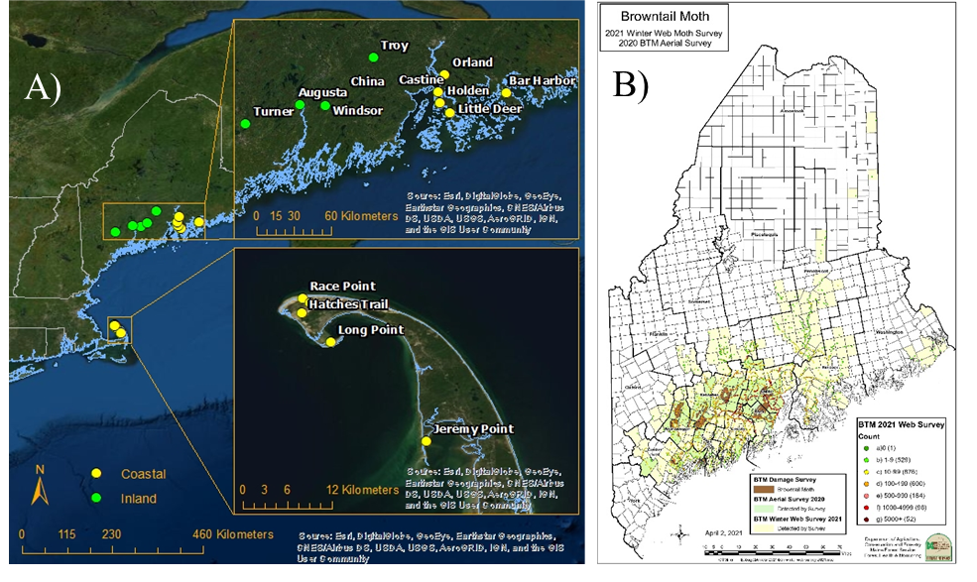
I classified inland and coastal regions as >1 and <1 km from a coast, respectively. Distance was measured from the GPS locality of study sites in ArcGIS using the Measure tool. In Cape Cod I sampled plots used in previous BTM studies conducted ~20 and 50 years ago (Fig. 1a, Elkinton et al. 2006, Schaefer 1974). As outer Cape Cod is a narrow peninsula, the entirety of the habitat occupied by BTM is coastal. Annual winter web surveys issued by the Maine Forest Service provided valuable guidance for sampling in both coastal and inland Maine (Fig. 1b, DCAF, MFS 2021). Sites were sampled within the time constraint imposed by the presence of BTM’s late-stage larvae on the landscape to best estimate parasitism levels in the three regional habitats.
Figure 1. (A) BTM larval sampling sites in 2021. Green dots indicate inland sites and yellow dots indicate coastal sites. (B) Example of winter web survey produced annually by Maine Forest Service
Weather stations near study sites were used to determine optimal sampling times (using a degree-day model to estimate larval development to the final instar), providing a standard sampling time for each site, reducing bias from sampling too early or late. Larvae were field collected in early June when each site had accumulated ~ 200 degree days, returned to the laboratory for processing, and then reared at ambient outdoor temperatures in the SUNY-ESF insectary. Upon arrival at the lab, they were reared singly in plastic cups with an artificial agar-based diet amended with 15% black cherry as a feeding stimulant. Larvae were transferred to fresh diet every 2-3 days until caterpillars died or successfully pupated. Any emerged parasitoid adults or puparia were identified using the keys of McAlpine et al. (1987), Tschorsnig and Herting (1994), Townes (1969), Simons et al. (1974), and the reference collection of D. Parry (SUNY-ESF). BTM larvae were dissected to determine the presence of latent parasitoids if none emerged before death. Percentage of larval mortality was calculated for the major parasitoids C. concinnata, Carcelia laxifrons (Vill.), and Townsendiellomyia nidicola (Towns.), as well as hymenopteran parasitoids. All mortality sources were quantified at each site and averaged for the regional habitat. Single-factor ANOVA was used to assess overall differences in parasitism between regional habitats with Fisher’s LSD for means comparisons among regional habitats.
Results and Discussion
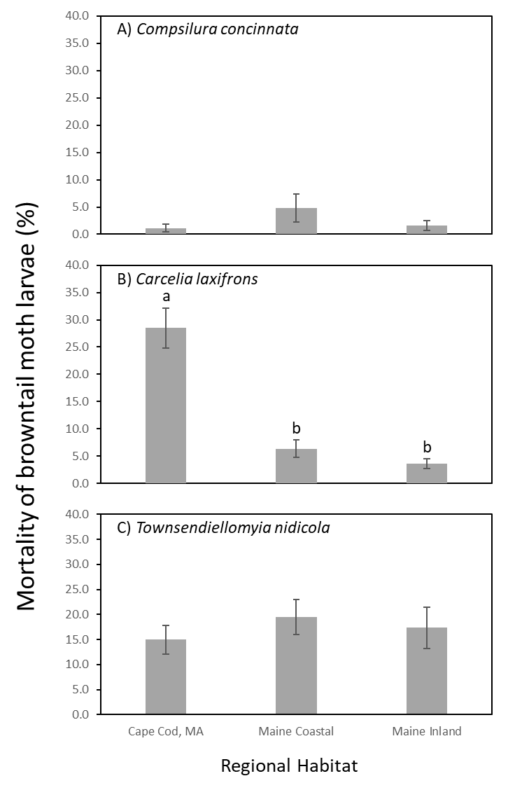
A total of 771 BTM larvae were collected from 15 sites, five in each regional habitat (Maine Coastal, Maine Inland, and Cape Cod) with 50-56 individuals sampled per site. Parasitism by C. concinnata, C. laxifrons, and T. nidicola was observed in every habitat (Fig. 2) although not at every site. Parasitism did not differ for T. nidicola (F_{2,12} = 0.3, p = 0.72) among regions. In contrast to the relative abundance of T. nidicola, the generalist species C. concinnata was not reared from BTM at 7 of the 15 sites and parasitism was very low where it was collected (Fig. 2). The other specialist species, C. laxifrons parasitized significantly more BTM larvae on Cape Cod than in either of the Maine regional habitats (Fisher LSD, F_{2,12} = 26.7, p < 0.001) (Fig. 2). A subset of the collected tachinids were unidentifiable as they died before emerging or were malformed, but these accounted for only a small portion of the mortality (mean +/- SE = 1.5 ± 1.0 on Cape Cod, inland Maine = 6.3 ± 1.2, and coastal Maine = 6.7 ± 3.8). Only six hymenopteran parasitoids were recovered in total, one each from Cape Cod and a single Maine inland site, and two from Inland Maine sites, comprised of two introduced species, Meteorus versicolor (Wesm.) and Monodontomerus aereus (Wlkr.), as well as the native generalist Itoplectis conquisitor (Say). Hymenoptera comprise a relatively small portion of the mortality in BTM and have never been recorded as an important source of mortality.
Figure 2. Parasitism of BTM larvae (mean +/- SE) by three tachinid parasitoids (C. concinnata, C. laxifrons, and T. nidicola) from Cape Cod, MA, and coastal and inland Maine regional habitats (see Fig. 1). Different letters indicate significant differences among means (Fisher’s LSD test).

Historical data on parasitism in BTM from Maine is limited to a single site (Burgess and Crossman 1929, Schaefer 1974) making comparisons with contemporary collections difficult. Parasitism by the BTM specialist T. nidicola was 7% higher in my study than recorded in either previous studies, where T. nidicola parasitism averaged 10%. Parasitism by C. laxifrons was 9% higher than was observed in 1923 (Burgess and Crossman 1929) and about 13% higher in my study than in Schaefer (1974). The big change was in parasitism by the generalist C. concinnata which was nearly 25% lower than recorded in 1923 by Burgess and Crossman (1929), when BTM range and density was declining, although it currently causes mortality similar to levels found in 1974, when BTM had reached its current distribution, prior to recent expansion.
Only C. laxifrons parasitism significantly differed between Cape Cod and either regional habitat in Maine. Much higher levels (>30%) of parasitism by this species were also recorded by Elkinton et al. (2006). While elevated parasitism from C. laxifrons on Cape Cod may contribute to BTM’s coastally constrained populations now, C. laxifrons historically parasitized relatively few larvae when BTM’s invasive range was in its declining phase and once it reached its contemporary relict distribution (Burgess and Crossman 1929, Schaefer 1974). In these studies, parasitism by C. laxifrons was similar to current levels in Maine.
Surprisingly, the species causing the least parasitism among all three sites was the generalist C. concinnata. This species has been hypothesized as a driving force in the regional decline in BTM after 1914 (Elkinton et al. 2006). Although annual fluctuations in this species have been recorded (Schaefer 1974), it has caused significant mortality, sometimes exceeding 75% of BTM larvae (Burgess and Crossman 1929). Recent studies indicate that C. concinnata may have undergone a large-scale population collapse across the eastern US (Baranowski et al. 2019, Manderino 2021, Parry and Siegert, unpublished). While these observations suggest a mechanism for the change in the stability of Maine’s population, the lack of any apparent expansion of Cape Cod’s population challenges this as a ready explanation. Although my study provides novel information on BTM and its relationship with parasitoids, it does not explain the change in Maine and further study is required to understand BTMs enigmatic population dynamics, something that has eluded explanation for more than a century. My research does suggest that a change in parasitism does not seem to be the driver of inland expansion.
Relationship of Internship to Sussman Foundation Objectives
Funding from the Sussman Foundation was critical in accomplishing the objectives of the project. The internship through the US Forest Service (Dr. Nate Siegert) facilitated access to 20 and 50 yr. old sampling locations on Cape Cod. Furthermore, an extensive delve into Forest Service archives, retrieved important unpublished or non-peer reviewed data sets from the Northeast prior to and during the collapse of BTM populations. My relationship with the sponsor agency also opened doors to state and federal agency personnel (Maine Forest Service, Cape Cod National Seashore) that assisted with the logistics of sampling across two states. The Sussman Foundation will be prominently recognized in all products generated from this research including presentations and publications.
Future Work and Dissemination
I will couple data collected from this research with two additional years of data to provide a more comprehensive assessment of the role of parasitism in the inland expansion of BTM in Maine. These data and analyses will form one chapter of my master’s thesis to be defended in Spring 2022.
Acknowledgments
I am grateful for the generous funding from the Edna Bailey Sussman Foundation. I would like to extend my gratitude to Dr. Dylan Parry, my major professor, for mentorship and insight, and Dr. Nathan W. Siegert (US Forest Service) and Dr. Melissa K. Fierke for serving as steering committee members. Michael Parisio (Maine Forest Service) for advice and support in Maine BTM sampling. Additional thanks to the Parry lab technicians, Julia Rushton, Rose Uriarte, Guinevere Wilkens, and Victoria DeFreece.
References
Baranowski, A. K., Conroy, C., Boettner, G. H., Elkinton, J. S., & Preisser, E. L. (2019). Reduced Compsilura concinnata parasitism of New England saturniid larvae. Agricultural and Forest Entomology, 21(3), 346-349.
Burgess, A. F., & Crossman, S. S. 1929. Imported insect enemies of the gipsy moth and the brown-tail moth (No. 1488-2016-125041).
Elkinton, J. S., Parry, D., & Boettner, G. H. 2006. Implicating an introduced generalist parasitoid in the invasive browntail moth's enigmatic demise. Ecology, 87(10), 2664-2672.
Fernald, C., and A. Kirkland. 1903. The brown-tail [sic] moth, Euproctis chrysorrhoea: a report on the life history and habits of the imported brown-tail [sic] moth. Wright and Potter Printing, Boston, MA.
Manderino, R. 2021. Environmental drivers modulate parasitism of native giant silk moths by an exotic biological control agent. PhD Dissertation. State University of New York, College of Environmental Science and Forestry, Syracuse, NY.
MDACF, 2020. Maine Department of Conservation Agriculture and Forestry. Browntail Moth Euproctis chrysorrhoea (L.) [maine.gov]. Retrieved from https://www.maine.gov/dacf/mfs/forest_health/invasive_threats/browntail_moth_info.htm
MDACF, 2021. Maine Department of Conservation Agriculture and Forestry. Browntail Moth 2021 Winter Web Survey. [maine.gov]. Retrieved from https://www.maine.gov/dacf/mfs/forest_health/documents/Browntail%20Moth%202021%20Winter%20Web%20Moth%20Survey.pdf
Schaefer, P. W. 1974. Population Ecology of the Browntail Moth (Euproctis chrysorrhoea L.)(Lepidoptera: Lymantriidae) in North America. The University of Maine.
Simberloff, D., & Gibbons, L. (2004). Now you see them, now you don't!–population crashes of established introduced species. Biological Invasions, 6(2), 161-172.

Strazanac, J S, C D Plaugher, T R Petrice, and L Butler. 2001. New Tachinidae (Diptera) host records of Eastern North American forest canopy Lepidoptera: Baseline data in a Bacillus thuriengiensis Variety kurstaki nontarget study. Journal of Economical Entomology. 94: 1128-1134.

