COMPARISONS OF MORPHOLOGY AND FEEDING EFFICIENCY BETWEEN WILD AND GAME-FARM MALLARDS

Susannah L. Halligan
SUNY College of Environmental Science and Forestry
Final Report to the Edna Bailey Sussman Foundation
2022

INTRODUCTION

The mallard (Anas platyrhynchos) is a dabbling duck endemic to Eurasia and North America and is the most globally widespread waterfowl (Baldassarre 2014). Of all ducks, mallards are the most abundant and studied in the world (Miller 1975). Mallards have been documented in the Atlantic Flyway as early as 1587 by French colonist René Goulaine de Laudonnière during an expedition to Florida (Heusmann 1991). The migration pattern for U.S. Atlantic coast mallards follows the Atlantic flyway, in which they flock to their principal wintering range along the Atlantic Coast (Baldassarre 2014). While common today, mallards were somewhat rare in the Atlantic Coast states before the 1900s due to a 50% to 90% reduction in their population through intense market hunting between 1880 and 1910 (Heusmann 1991). This incentivized game commissioners and private farmers to establish regulated hunting seasons and to breed mallards in captivity and release them into the wild to stock wild populations (Heusmann 1991). Additional construction of marshes, regulated hunting seasons, and deforestation in the Northeastern United States allowed mallards to not only recover their numbers, but also to nest in areas that the species had not previously (Heusmann 1991). Through these efforts, the mallard population of the Atlantic Flyway between 1970 and 1999 increased from 100,000 to over one million birds (Kaminski et al. 2013).
Mallards are an agriculturally important domestic duck, grown and harvested for their eggs, down, meat, and used as captive-reared game-farm birds raised for release into the wild for later recreational harvest (Feng et al. 2021). Ducks domesticated for egg production, such as Shaoxing ducks, have a small body size, mature early, and most importantly, have high egg production and have been used since the Song Dynasty around 1000 years ago (Feng et al. 2021). To accommodate human needs, domestic mallards used for food were artificially selected for earlier egg production, larger body sizes, and decreased aggression toward humans (Feng et al. 2021). In contrast, contemporary selection of game-farm mallards produced for release aims for faster growth rates and agile flight with smaller final body size; This allows for quicker sale which reduces costs associated with production (M. Schummer, personnel communication; Frost Mallards 2022). Even when sampled a decade apart, harvested mallards show consistent mitochondrial haplotypes. suggesting mitochondrial introgression can be captured and persist within lineages for much longer than previously thought (Davis et al. 2022).
In addition to possible reductions in overall body size, another possible impact of artificial selection on game-farm mallards reduced lamellae capacity because they are not fed natural food items in captivity. Captive mallards are typically fed grains such as corn and wheat and they gradually handle fewer smaller plant seeds and aquatic invertebrates. In other words, captive mallards may be more prone to “grab” larger agricultural seeds and rely less on filtering food items through their lamellae. Since the 1970s, for example, supplemental stocking of mallards in Europe increased concomitantly with increasing popularity of commercial hunting estates (Champagnon et al. 2016). Under artificial selection in captivity, these European game-farm mallards have had reductions in body size, bill length, density of lamellae, and increased bill height (Söderquist et al. 2014). The modified diet (e.g., agricultural seeds) has reduced the selective pressure of dense lamellae, resulting in game-farm birds with reduced lamellar density compared with wild conspecifics (Champagnon et al. 2010). Reduced lamellar density has been detected in the proximate part of the bill, where water is expelled during filtration and where lamellae typically are densest (Champagnon et al. 2010). Moreover, European game-farm mallards also had shorter and taller bills, resulting in a comparable goose-like bill (Anser spp.) (Söderquist et al. 2014). These traits introgress into the European wild populations via significant rates of hybridization occurring in modern mallards, such as in mallards harvested from the Camargue of southern France (Champagnon et al. 2013).
In North America, hundreds of thousands of game-farm mallards are annually released by state agencies and private individuals. Today, game-farm mallards continue to be released annually by private individuals to supplement wild stocks and for recreational harvest (Virginia DNR 2007, USFWS 2013). These releases have resulted in Atlantic flyway mallards being a hybrid swarm of wild and game-farm mallard genes, with many areas of the Atlantic coast exceeding 90% Old World A, game-farm haplotype (Lavretsky et al. 2020). This is concerning because negative effects (e.g., bill morphology) of frequent interbreeding of game-farm with wild congeners may be evident in only two generations later (Araki et al. 2007, Ellison and Burton 2008). Differences in body size and bill morphology between wild and game-farm mallards and changes in bill morphology from introgression of game-farm into the wild mallard population is well-documented in Europe (Champagnon et al. 2010, Čížková et al. 2012, Söderquist et al. 2014). However, potential morphological differences in North American mallards, despite nearly 100 years of releases of game-farm into wild mallard populations, have not been investigated.
My goal was to determine if morphology differed between wild and game-farm mallards. Consistent with Söderquist et al. (2014), I predicted that wild mallards would have greater overall body size than game-farm mallards because breeders want quickly growing ducks for sale. Similarly, to European literature, I also predicted that bills of game-farm mallards would be shorter, taller, and wider than wild mallards, possibly serving as a benefit when feeding on grains and pellets in captivity where straining is not needed like in the wild. I expected variation in morphology to be less in game-farm than wild mallards because of lower genetic diversity among individuals. I additionally aimed to determine if feeding efficiency differed between wild and game-farm mallards. I predicted that wild mallards would feed more efficiently than game-farm mallards in substrate with seeds mimicking natural conditions. I further predicted the more goose-like bills of game-farm mallards (i.e., shorter, taller, and wider than wild mallards), would reduce their capacity to extract foods from substrate relative to wild mallards.

METHODS

DETERMINING VARIANCES IN BODY MORPHOLOGY
I conducted my study at the captive waterfowl facility of the Forbes Biological Station in Havana, Illinois, May – August 2021 and 2022 and February – June 2022 and at Pinola Aviary, Shreveport, Louisiana, March 2021 to May 2022. I obtained 12 female and 11 male game-farm mallards from a commercial breeder in Hanover Illinois for year one of my study (May – August 2021). Using traps baited with corn in Illinois and Tennessee, we aimed to capture a similar number of wild birds, resulting in 9 males and 8 females. For year two (March – July 2022), I obtained 18 female and 18 male game-farm mallards from the same breeder and used 21 male and 14 female wild mallards captured in Tennessee using the same trapping technique. A concurrent, identical study was conducted at Mississippi State University in 2022, which obtained 25 from J Mallard Farms in Williston, Tennessee. Of this group, 8 female and 12 male game-farm birds would participate in the study. Eggs of wild mallards were also obtained in Colusa and Sutter counties in California through a California Waterfowl Association egg salvage program and hatched as 7 females and 13 males at Pinola Aviary. Mallards were housed in outdoor pens that meets Institutional Animal Use and Care Committee (IACUC) Protocols from the University of Illinois (IACUC protocol # 18170) and SUNY ESF (IACUC # 200604).
To determine genetics of my sample, I took blood samples from each mallard and analyzed their nuclear DNA to assign true sex and ancestry. Prior to measurements, all mallards were sacrificed by cervical dislocation as described by AMVA guidelines and referenced by the American Ornithologists’ Union and following SUNY ESF Animal Protocol. Following dispatch, I measured the length of the entire culmen, the length of the culmen from the tip to the start of the nares, bill height and width at the middle of the nares, head length, flattened wing chord length, tarsus length, and body length (± 1mm; Champagnon et al 2010, Dzubin and Cooch 1992, Söderquist et al. 2014).

STATISTICAL ANALYSIS OF VARIANCES IN MORPHOLOGY
I determined Pearson correlation coefficients between morphometrics and conducted a Principal Component Analysis (PCA) to develop an index of structural size. PC1 accounted for 82.2% of variation in body size. I use linear model regression and tested if PC1 was influenced by source (wild or game-farm), sex, and source × sex. I also included year × location (Forbes or Pinola) combinations as 3 different categories to account for differences in environmental conditions potentially influencing growth and structural size. When PC1 varied by source I followed by conducting univariate tests of body morphologies to determine if they were influenced by source (wild or game-farm), sex, and source × sex I visualized studentized residuals of model outputs and they approximated a normal distribution. All analyses were conducted in R (RStudio Team, 2020). All tests were considered significant at α = 0.05.

DETERMINING VARIANCES IN FEEDING EFFICIENCY
Prior to feeding trials, I acclimated mallards between May 28th – June 22nd 2021 (Forbes study year 1), March 14th – April 24th 2022 (Forbes study year 2) and December 16th 2021 – February 24th 2022 (Pinola study) to feeding from standardized trays (8.25cm × 7.62cm ×1.43cm) filled with food items, and 80g of clay and 180mL of water to simulate wetland substrate. Foods included whole kernel corn, Japanese millet (Echinochloa frumentacea), lentils, or amaranth (Amaranthus spp.). Once the ducks had acclimated to feeding trials after each participated in 3 pilot trials over one month, I used one food type each week in feeding trials, and systematically provided ducks with a different food item each week until all food types had been fed and then repeated the order. For the large item, I fed lentils to the birds in the 2021 Illinois study, and corn to the birds in the 2022 Mississippi and Illinois studies. Once acclimated, feeding trials used in data analysis were conducted between July 7th – December 1st 2021 (Forbes study year 1), April 26th – June 28th 2022 (Forbes study year 2), and February 28th – May 19th 2022 (Pinola study). During feeding trials, I used the same standardized trays with individual food items to determine foraging efficiency in grams consumed per second by wild and game-farm mallards among these items. To determine genetics of my sample, I took blood samples from each bird and analyzed their nuclear DNA to assign true sex and ancestry. Before each feeding trial, ducks were housed in groups of 10 to18 for a fasting period of 5 hours, after which they were weighed using a digital scale to monitor body condition. Any bird that weighted 75% of their initial mass at the start of each field season was placed back into the aviary to gain weight and reduce stress. Each bird was placed in a cubic 76.2 × 76.2 × 45.7 cm welded-wired isolation cage. Prior to trials, I soaked food items for 24 hours in water to ensure they mixed with clay substrate and did not float during feeding trials. I then filled each tray with a known amount of one food type in a standard volume of substrate made with 180mL of water and 80g of silt. I used pilot feeding trials and determined that 40g of food could not be depleted to zero during feeding trials lasting 5 min. To ensure the same environmental conditions during each feeding trial, I paired wild and game-farm birds in adjacent isolation cages. I provided ducks 10 min to begin feeding and observed individual ducks using GoPro Hero 4 cameras mounted to isolation cages to accurately determine the time each duck spent actively attempting to feed with their bill in the substrate (± 1 sec). I used a maximum of 5 min of active feeding during trials. At the end of a feeding trial, I rinsed all clay and remaining food from the feeding tray through a 250 µm sieve and dried remaining food at 60−80°C for 24 to 48 hours to a constant mass.

STATISTICAL ANALYSIS OF VARIANCES IN FEEDING EFFICIENCY
Using RStudio, I performed mixed model regression to test for differences in feeding efficiency by source and sex (RStudio Team, 2020). Feeding efficiency (g/second) was my dependent variable and my independent variables included source (wild or game-farm), sex, date, food item, and the interaction of source × sex. I considered independent variables significant at α = 0.05. I included category of study location, date, and food item to control for study location, seasonal effects, and item size, respectively. To determine how many trials were needed to test for statistical differences in feeding efficiency between source and sex (Dingemanse and Dochtermann 2013) This power analysis indicated that I did not have enough trials to test for effects of food item on feeding efficiency, but seeds in my study spanned the general range of sizes available to mallards in the wild. I included duck identification as a repeated measure to control for entering the same individual into feeding trials multiple times (Dingemanse and Dochtermann 2013). I further tested for a threshold in feeding efficiency in my wild mallard treatment by percentage wild mallard DNA using a piecewise regression (i.e., “broken stick”) (Negovetich and Webster 2010). My aim was to determine if feeding efficiency remained relatively constant in mallards obtained from the wild until a certain percentage wild mallard DNA, when I predicted feeding efficiency would begin to decline.

RESULTS

MORPHOLOGY COMPARISONS
The morphometric study surveyed 28 male and 26 female mallards, along with 41 male and 37 female game-farm mallards. The total number of birds surveyed N = 132. Comparisons of various body and bill morphologies among game-farm and wild mallards were determined via Pearson Correlation Coefficients. These indicated a strong positive correlation between culmen length and length of culmen from nares to tip in game-farm mallards (Pearson’s r = 0.92, P = < 0.001). A similar strong positive correlation between total culmen length and culmen length from nares to tip was found among wild mallards (Pearson’s r = 0.88 , P = < 0.001). Additionally, wild mallards showed a strong positive correlation between culmen width and bill height (Pearson’s r = 0.73, P = < 0.001) and between body length and head length (Pearson’s r = 0.78, P = < 0.001).
Loading scores from the principal components analysis determined that body length, wing chord length, and head length respectively most heavily influenced PC1, with PC1 accounting for 82.2 % of variance in morphometrics within the model (Figure 2.1). The Eigen values of the PCA ranged from 0.20 to 686.52 (Table 2.1). In a generalized linear model, PC1 significantly varied by source and sex (X_{Source} = 17.28 ± 2.28 [SE], X_{Sex} = -40.31 ± 2.91, F = 64.56 , df = 3 and 128 , P = < 0.001) (Table 2.2). We see higher variation in PC1 among wild mallards when compared to game-farm mallards (Figure 2.1).

FEEDING EFFICIENCY TRIALS
My feeding trials yielded a total of 515 successful trials, with game-farm females being the most frequent participants (Table 3.1). An ANOVA showed that the most variance in feeding efficiency rates was explained by source (Table 3.2), although feeding efficiency was definitively shown to be significantly influenced by both source (X_{Game-Farm} = -0.10 g/s. ± 0.02 [SE], F = 10.86, df = 8 and 506 and , P = < 0.001, adjusted R² = 0.13) and sex (X_{Female} = -0.06 g/s. ± 0.02 [SE], F = 10.86, df = 8 and 506, P = < 0.001, adjusted R² = 0.13) (Table 3.3, Figure 3.1). Wild mallards showed a 51% higher efficiency rate than their game-farm counterparts, with wild males out-performing all other groups (Table 3.1). Conversely, game-farm females showed the lowest feeding efficiency rates, despite showing the highest frequency of participation (Table 3.1, Figure 3.1). Additionally, feeding efficiency rates varied by food type (Figure 3.2). Across sources and sex, the mallards tended to have higher efficiency rates when feeding on larger food particles, except for corn (Table 3.3), although efficiency rates vary by source and sex (Figure 3.2). Across sex, wild birds eat the smallest food particle used in the study, amaranth, approximately 53% more efficiently than their game-farm counterparts (Figure 3.2).

Table 2.1. Principal Component Loadings for Analysis of Body and Bill Morphology in Wild and Game-Farm Mallards

Morphometric | PC1 | PC2 | PC3
Bill Height | 0.03 | -0.001 | 0.01
Culmen Nares | 0.05 | -0.007 | -0.39
Culmen Width | 0.03 | 0.01 | 0.04
Culmen Length | 0.06 | 0.001 | -0.47
Head Length | 0.12 | -0.07 | -0.76
Body Length | 0.92 | 0.36 | 0.10
Tarsus Length | 0.06 | 0.05 | 0.16
Wing Chord | 0.35 | -0.93 | 0.12
Eigen Values | 685.48 | 168.42 | 19.28
Cumulative Variance Explained | 78% | 97% | 99%

Table 2.2. Generalized Linear Model Comparing Body and Bill Morphology Principal Component 1 Between Male and Female Wild and Game-Farm Mallards

Predictor | Parameter Estimate | Standard Error | Student-T Value | Pr(>|t|)
(Intercept [Wild]) | 17.28 | 2.28 | 6.2 | < 0.001
Source (Game-farm) | 3.76 | 2.96 | 1.3 | 0.21
Category (Pinola) | -1.10 | 3.43 | -0.3 | 0.75
Sex (Female) | -40.37 | 2.91 | -13.8 | < 0.001

Residual Deviance = 35736 on 128 degrees of freedom
AIC = 1123.9

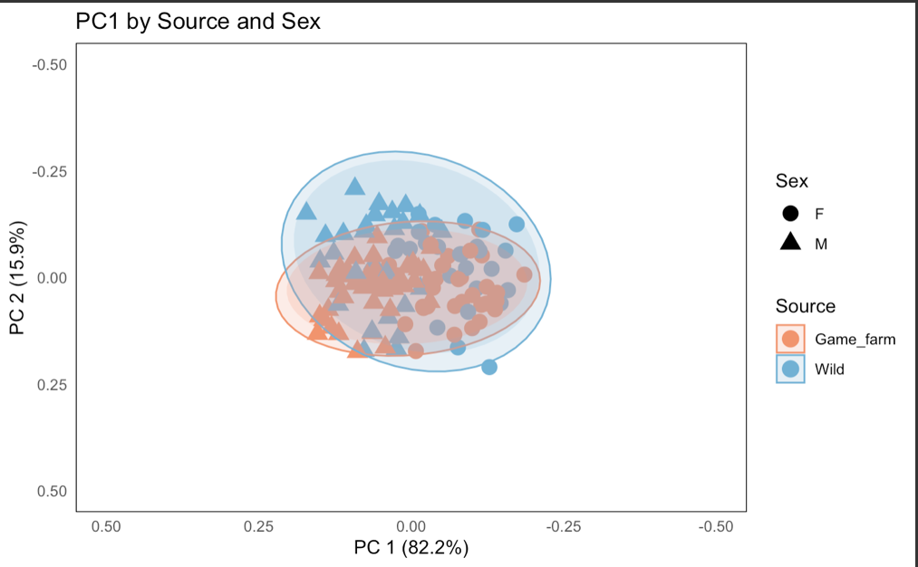
Figure 2.1. Plot of Principal Component Analysis of Wild and Game-farm Mallard Body and Bill Morphologies by Source and Sex. Comparing PC1 vs. PC2.

Table 3.1. Descriptive Statistics of Wild and Game-farm Mallard Participants in Feeding Efficiency Trials.

Characteristic Group | Number of participants | N¹ | Mean² | Standard Deviation | Minimum | Maximum
Wild Female | 20 | 76 | 0.26 | $±$ 0.30 | 0.01 | 1.80
Wild Male | 16 | 75 | 0.25 | $±$ 0.20 | 0.02 | 1.10
Game-farm Female | 40 | 198 | 0.09 | $±$ 0.11 | 0.001 | 0.75
Game-farm Male | 36 | 166 | 0.18 | $±$ 0.25 | 0.003 | 1.50
1 = Number of successful feeding trials (including repeat participants)
2 = average feeding efficiency rate (grams/second)

Table 3.2. Wild and Game-farm Mallard Feeding Efficiency Model ANOVA by Source and Sex, Accounting for Date, Food Type, and Study Group (Category).

Predictor | DF | Sum SQ. | Mean SQ. | F-value | Pr(>F)
Source | 1 | 1.63 | 1.63 | 39.29 | < 0.001
Category | 1 | 0.46 | 0.46 | 11.14 | < 0.001
Sex | 1 | 0.44 | 0.44 | 11.14 | 0.001
Julian Date | 1 | 0.369 | 0.76 | 18.42 | < 0.001
Food | 3 | 0.229 | 0.08 | 1.85 | 0.140

Table 3.3. Wild and Game-farm Mallard Feeding Efficiency Mixed-Regression Model by Source and Sex, Accounting for Date, Food Type, Study Group (Category), and Bird ID.

Predictor | Parameter Estimate | Standard Error | Student -T Value | Pr(>|t|)
(Intercept [Wild]) | 0.13 | 0.05 | 2.6 | 0.01
Source (Game farm) | -0.095 | 0.02 | -4.3 | < 0.001
Category (Pinola) | 0.205 | 0.055 | 4.3 | < 0.001
Sex (Female) | -0.059 | 0.018 | -3.3 | 0.001
Julian Date | 0.0006 | 0.045 | 4.3 | < 0.001
Food (Lentils) | -0.03 | 0.04 | -0.7 | 0.51
Food (Amaranth) | -0.06 | 0.03 | -1.8 | 0.07
Food (Millet) | -0.02 | 0.03 | -0.7 | 0.50

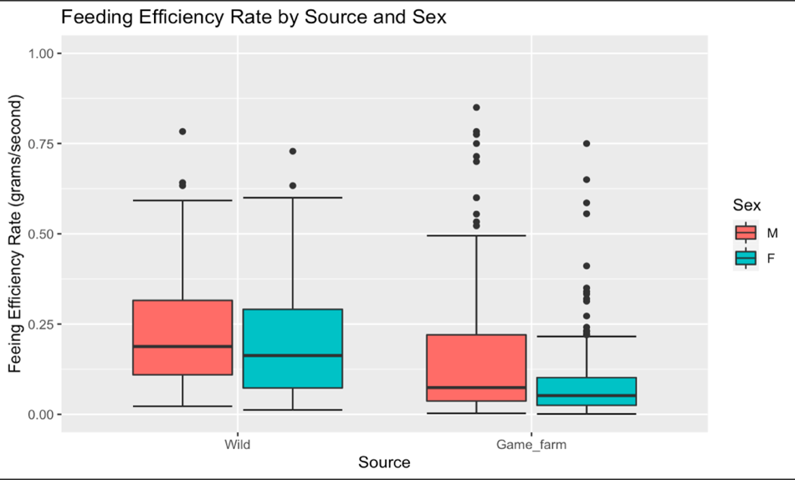

Figure 3.1. Box and Whisker Plot Comparing Wild and Game-farm Mallard Feeding Efficiency Rate in Grams of Food per Second by Source and Sex.

CONCLUSIONS

This study revealed that mallards across sources and sex were quite different morphologically and functionally, suggesting that artificially selected mallards may be play a significant role in the ways they interact with their environments. Based on our study design we expected to see a reduced capacity for feeding efficiency among managed game-farm mallards, who we expected to be morphologically distinct from their wild counterparts.
The results presented above provides insight into the reduced feeding efficiency of game-farm mallards released into the wild. They are consistent with ducks lacking adaptation to the wild (ie. Shorter heads, shorter culmens, reduced lamellar density), which may be occurring through artificial selection. If game-farms are releasing birds with reduced capacity to feed efficiently into a wild setting, these birds may consequently not build as many lipid stores as their wild counterparts (Gloutney and Clark 1991, Champagnon et al. 2012). As suggested by Champagnon 2012, this reduced body condition in addition to maladaptive morphological traits like reduced wing chord length in farm-raised mallards may cause low survivorship and reduced distances traveled during migration. Even if a farm-raised female survives to breeding season, her lipid stores may not be as substantial as a wild female’s, which directly impacts egg quality and production rates (Cheng et al. 1980). The data contributes a clearer understanding of the consequences of population management techniques that do not consider thousands of years of mallard domestication. While previous research has focused on body condition and morphological differences between wild and game-farm mallards, these results could be the result of artificial selection, demonstrating the functional consequences of maladaptive artificially selected traits.
Keeping differences between wild and game-farm mallards at a minimum is difficult in a farm setting but can be minimized through a variety of techniques. Mallard breeders can offer their birds foods that better resembles their natural diets to maintain selective pressure for denser lamellae. Additionally, breeders can provide the females of their domestic stock with open pens that only allow for wild birds to enter the breeding facility. This allows for the introgression of wild traits into the domestic stock and not allow for introgression of domestic traits into wild stock.

LITERATURE CITED
Araki, H., B. Cooper, and M. S. Blouin (2007). Genetic Effects of Captive Breeding Cause a Rapid, Cumulative Fitness Decline in the Wild. Science 318:100–103.
Baldassarre, G. (2014). Ducks, Geese, and Swans of North America. JHU Press.
Champagnon, J., P.-A. Crochet, J. Kreisinger, D. Čížková, M. Gauthier-Clerc, G. Massez, P. Söderquist, T. Albrecht, and M. Guillemain (2013). Assessing the genetic impact of massive restocking on wild mallard. Animal Conservation 16:295–305.
Champagnon, J., M. Guillemain, J. Elmberg, K. Folkesson, and M. Gauthier‐Clerc (2010). Changes in Mallard Anas platyrhynchos bill morphology after 30 years of supplemental stocking. Bird Study 57:344–351.
Champagnon, J., P. Legagneux, G. Souchay, P. Inchausti, V. Bretagnolle, F. Bourguemestre, L. Van Ingen, and M. Guillemain (2016). Robust estimation of survival and contribution of captive-bred Mallards Anas platyrhynchos to a wild population in a large-scale release programme. Ibis 158:343–352.
Čížková, D., V. Javůrková, J. Champagnon, and J. Kreisinger (2012). Duck’s not dead: Does restocking with captive bred individuals affect the genetic integrity of wild mallard (Anas platyrhynchos) population? Biological Conservation 152:231–240.
Davis, J. B., D. C. Outlaw, K. M. Ringelman, R. M. Kaminski, and P. Lavretsky (2022). Low levels of hybridization between domestic and wild Mallards wintering in the lower Mississippi Flyway. Ornithology 139:ukac034.
Dingemanse, N. J., and N. A. Dochtermann (2013). Quantifying individual variation in behaviour: mixed-effect modelling approaches. Journal of Animal Ecology 82:39–54.
Ellison, C. K., and R. S. Burton (2008). Interpopulation Hybrid Breakdown Maps to the Mitochondrial Genome. Evolution 62:631–638.
Feng, P., T. Zeng, H. Yang, G. Chen, J. Du, L. Chen, J. Shen, Z. Tao, P. Wang, L. Yang, and L. Lu (2021). Whole-genome resequencing provides insights into the population structure and domestication signatures of ducks in eastern China. BMC Genomics 22:401.
Heusmann, H. W. (1991). The History and Status of the Mallard in the Atlantic Flyway. Wildlife Society Bulletin (1973-2006) 19:14–22.
Kaminski, M. R., G. A. Baldassarre, J. B. Davis, E. R. Wengert, and R. M. Kaminski (2013). Mallard survival and nesting ecology in the Lower Great Lakes Region, New York. Wildlife Society Bulletin 37:778–786.
Lavretsky, P., N. R. McInerney, J. E. Mohl, J. I. Brown, H. F. James, K. G. McCracken, and R. C. Fleischer (2020). Assessing changes in genomic divergence following a century of human-mediated secondary contact among wild and captive-bred ducks. Molecular Ecology 29:578–595.
Miller, M. R. (1975). Gut Morphology of Mallards in Relation to Diet Quality. The Journal of Wildlife Management 39:168–173.
Negovetich, N. J., and R. G. Webster (2010). Thermostability of Subpopulations of H2N3 Influenza Virus Isolates from Mallard Ducks. Journal of Virology 84:9369–9376.
Söderquist, P., J. Norrström, J. Elmberg, M. Guillemain, and G. Gunnarsson (2014). Wild Mallards Have More “Goose-Like” Bills Than Their Ancestors: A Case of Anthropogenic Influence? PLOS ONE 9:e115143.

