Presence and Trophic Level of Freshwater Jellyfish (Craspedacusta sowerbii), a Cryptic Invader in the Hudson River Basin, NY
Jacob Moore
SUNY College of Environmental Science and Forestry
Final Report to the Edna Bailey Sussman Foundation
Advisor: Dr. Donald J. Stewart

Introduction
Invasive species represent a growing threat to aquatic resources, displacing native species and altering ecological processes. Invasive impacts on native species radiate out to people who have social or economic investment in native systems (Pejchar and Mooney, 2009). To combat these negative effects, scientists, managers, and citizens have invested significant finances and time in invasive species-focused programs. The Freshwater Jellyfish (Craspedacusta sowerbii) is an invasive species originating from the Yangtze River Basin, China (Dumont, 1994). Freshwater Jellyfish are not true jellyfish but exhibit similar life stages, including a sessile polyp and free-swimming medusa stage (DeVries, 1992).
Most knowledge on the ecology and occurrence of C. sowerbii is derived from observations of the larger medusae, rather than the tiny polyp stage (Jankowski, 2001). However, formation of C. sowerbii medusae in a system is sporadic and unpredictable, and the species may exist only as polyps for years before they are reported (Dumont, 1994). Therefore, C. sowerbii have most likely invaded significantly more freshwater systems than presently recorded. Relatively few studies have been conducted on the ecology of Freshwater Jellyfish, but feeding experiments and gut-content analyses suggest that the species demonstrates size-selective feeding on zooplankton, and that could shift relative dominance among plankton taxa in a native community (Spadinger and Meier, 1999; Smith and Alexander Jr., 2008). Prior research demonstrated that C. sowerbii is capable of killing and eating larval fishes, though it is currently unknown if medusae are significant predators of fish (Dendy, 1978; Dodson and Cooper, 1983). Although their ecological role is currently uncertain, C. sowerbii have the potential to disrupt invaded food webs.
In New York State (NYS), there have been reports of Freshwater Jellyfish in over 100 different systems (Peard, 2018). Despite the widespread occurrence of C. sowerbii in NYS, species information is not found on the NYS Department of Environmental Conservation website (NYSDEC, 2019). Presently, C. sowerbii is understudied by scientists, and its spread is unchecked by managers; it most likely will continue to spread and impact additional lake ecosystems as increasingly warm summer temperatures opens new niches for the species.

Study Objectives
My first study objective was to test new detection methods for Freshwater Jellyfish. One emerging technology that circumvents the sporadic nature of C. sowerbii is the use of environmental DNA (eDNA) to detect free-floating genomic materials in water or sediment for otherwise cryptic or rare invasive species (Rees et al., 2014). By using available sequences and tools from GenBank, we have developed DNA primers (see below) suitable for detecting eDNA from C. sowerbii (GenBank, 2019). Species-specific sensitivity tests were conducted to reduce the risk of false positives in environmental samples.
Forward Primer: 5'- GAA TCA GAA TAG GTG CTG ATA GAG AAT C -3'
Reverse Primer: 5'- CTA ATC ACG GCC TTC CTT CTG G -3'
My second study objective was to apply new methods to investigate the ecological role of C. sowerbii in invaded systems. Past research has focused on gut content analyses and feeding experiments of medusae. Stable isotope analyses of different trophic levels in a system allows scientists to assess relatively longer-term dietary behavior of animals in their natural habitat (Hamilton et al., 1992).

Methods

Field Sampling
Ten lakes within the Hudson River watershed were selected for this study (Figure 1), as 42 sites in the area have already reported sightings of Craspedacusta sowerbii. Five sites were in northern Adirondack areas, and five were located within southern areas.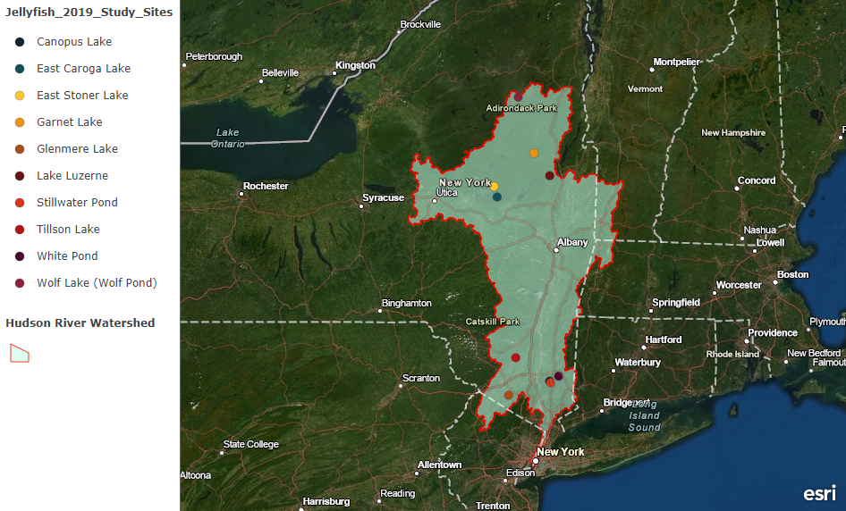
Figure 1: Field Sites for 2019 sampling season in the Hudson River Watershed
From late June – early July 2019, each site was revisited to collect samples and deploy Hester-Dendy settlement plate samplers. These 15x15 square settling plates were constructed based on a design tested successfully in the field (Dr. Terry Peard, personal communication). Three plate samplers were deployed at each site and georeferenced. Plankton nets of 20 µm and 750 µm mesh size were towed off the side of a canoe at 1.5 m depth for 5-10 minutes to collect plankton, fish larvae, and any medusae present. Fish larvae and medusae density was measured in the 750 µm net using a General Oceanics 2030R mechanical flowmeter. Three 10-15 mL samples of surface sediment were also collected at each site with a handmade PVC-Steel gravity corer for eDNA analysis, and sterile technique was followed to ensure contamination of samples did not occur. Sediment was preserved in 3M sodium acetate and 95% ethanol on-site before transport and storage at -80°C.
Late-summer sampling occurred mid-August – mid September 2019. Additional 750 µm plankton net tows were conducted for 5-10 minutes to collect large zooplankton, fish larvae, and any medusae present. New measurements of water quality were also conducted with the YSI probe. Three 2 L whole water samples were collected at each site and filtered onto 47 mm Whatman glass fiber filters in an effort to detect free-floating eDNA shed by medusae (excepting Glenmere Lake and East Caroga Lake, as they were not accessible at the time). Filter samples were put on ice immediately and stored at -80°C within 24 hours. At this time, plate samplers were also retrieved and preserved in 70% ethanol bags for visual observation under a dissecting scope. If potential C. sowerbii polyps were observed on a plate, they were extracted with tweezers and placed aside for DNA confirmation using the Qiagen DNeasy™ Blood and Tissue Kit and SYBR qPCR analysis.

eDNA assessment
Sediment eDNA samples were thawed and DNA was extracted using the MP Bio FastDNA™ SPIN Kit for Soil. Filters with eDNA samples had DNA extracted using the Qiagen DNeasy™ Blood and Tissue Kit. After DNA samples were extracted, total DNA concentration was measured using a Invitrogen Qubit 4 Fluorometer. Following confirmation of quality DNA, 2 µL of each sample was placed in a well with 23 µL of a mix containing the developed C. sowerbii-specific primer markers on a 96-well qPCR plate. The plate was run with SYBR fluorescence in a QuanStudio 3 machine along with a standard and several sample blanks. Results were exported and analyzed in QuantStudio design and analysis software.

Stable Isotope Analyses
To conduct stable isotope analyses, C. sowerbii medusae, large zooplankton (from 750 µm tow samples), fish larvae, and small plankton samples (taken from 20 µm net tows and sieved within a 2-500 µm size range) were euthanized with MS-222 (250 mg/ml) and preserved in 95% ethanol on-site. Samples were then brought to the NYSDEC Forest Health Diagnostic Lab in Delmar, NY for sorting, ID and measurement. Following sorting, specimens were rinsed in DI water, dried in a 60°C oven, and pulverized in the laboratory using a mortar and pestle (Feuchtmayr, and Grey, 2003). After specimen preparation was complete, samples were shipped off to the Cornell University Stable Isotope Laboratory for analysis of δ¹³C and δ¹⁵N isotope ratios. δ¹⁵N was corrected using an Atmospheric reference, and δ¹³C levels were corrected from the primary Vienna Pee Dee Belemnite reference. Specimens were only included in lakes where medusae were successfully collected and analyzed.

Results and Discussion

eDNA and Traditional Detection
No specimens of C. sowerbii appeared in plankton net tows until mid-August, when a few individuals were collected from Tillson Lake, Lake Luzerne, and Garnet Lake. Additional net tows in September also yielded specimens in Stillwater Pond. Estimated medusae densities ranged from 0.018 (Luzerne) to 0.24 medusae/m³ (Stillwater). Collected medusae ranged in size from 1.5 - 15 mm. During retrieval, several settlement plate samplers were lost, most likely due to theft, boat propeller damage, or movement due to storm conditions. Visual observation of plate samplers was a fairly, time-intensive process, and at this time only 10 samplers have been observed. Of the observed samplers, 80% had potential C. sowerbii polyps, and 20% were confirmed to have polyps using qPCR analysis. C. sowerbii could only be detected in Wolf Lake and Glenmere Lake using plate samplers.
Sediment samples tested for eDNA had only 2/30 samples return with positive detection (all triplicates returning amplification above the threshold). These samples were both from Canopus Lake. However, there were samples with partial detection in several other lakes. Filtered water eDNA samples returned positive detection in 11/24 samples. These samples were within East Stoner Lake, Tillson Lake, White Pond, Wolf Lake, Garnet Lake, Canopus Lake, and Stillwater Pond. Again, several eDNA samples returned with partial detection of C. sowerbii DNA. These reason for these partial detections may be due to the estimated concentration of C. sowerbii DNA, ranging from 0.0035-2.7 DNA copies/µL in sediment and 0.038-7.5 DNA copies/µL in filtered water. These relatively low concentrations may have led to many samples resulting in amplification below the threshold value.
Overall, eDNA assessment using filtered water was the most sensitive detection method for C. sowerbii. This is likely due to the time of sampling, as medusae are typically reported to be most abundant in Late Summer, when water temperatures have been in the mid 20s°C. Recommendations for future use of eDNA assessment of waterbodies for C. sowerbii will focus on sampling during weeks when medusae are likely present, with surface water temperatures having been above 20°C for several weeks to allow polyps to produce medusae wherever possible.

Stable Isotope Analyses
Results of stable isotope analyses were variable between lakes, with samples from Tillson Lake having a relatively unique δ¹³C signature, and elevated small plankton δ¹⁵N levels of 5.26 and 5.56 ppt (Figure 2). Tillson Lake small plankton and separated copepods had δ¹³C 4-5 ppt lower than in Medusae. Regarding fish larvae and Medusae, in both sites where enough biomass was able to be collected to obtain a value, δ¹³C was within 2 ppt, but in neither case was δ¹⁵N higher in Medusae than fish larvae. In Garnet Lake, Medusae δ¹⁵N was within 1 ppt of both larval fish and Leptodora kindtii, and higher (5.74 ppt) than Bosmina (4.11 ppt) and small plankton (2.08 – 2.18 ppt).

Figure 2: Scatterplot of δ¹⁵N vs. δ¹³C Stable Isotope Analyses of Summer 2019 samples from Garnet Lake, NY (G), Stillwater Pond, NY (S), and Tillson Lake, NY (T). Analysis conducted by the Cornell University Stable Isotope Laboratory (COIL).
Altogether, these data suggest a few things about C. sowerbii in NY lakes. For one, δ¹⁵N values suggest medusae do not feed at a trophic level above larval fish, rather feeding at a similar planktivorous level along with Leptodora kindtii (Leite et al., 2002). δ¹³C results may also illustrate that these Medusae will not feed preferentially on Copepods, even though prior feeding experimentation has demonstrated the opposite (Smith and Alexander Jr., 2008). However, these results rely on very few data points due to the sparsity of medusae samples available and should not be considered conclusive without additional sampling and isotope analysis in support of these observations

Conclusions
As professionals and students contemplate options to locate Craspedacusta sowerbii for research, management, or other purposes, this study may be useful as a guide comparing the effectiveness of several methods of detection. In consideration of the elusive nature of C. sowerbii, application of the eDNA assay developed and tested in this study would be a helpful option as many lakes can be sampled and tested relatively quickly. Relying solely on eyewitness reports and traditional methods (such as plankton tows) will likely result in relative unawareness regarding this species and its spread. The impact that C. sowerbii has on US lakes remains largely unknown, though observations from isotope results (e.g. the apparent lack of predation on fish larvae) should be useful to future research on the species.

Acknowledgements
I would like to offer my appreciation to the Edna Bailey Sussman Foundation for financial support of my summer research, and their encouragement of interaction with the NYSDEC; among whom I would like to especially thank Catherine McGlynn for her involvement and Dr. Steven Pearson for support in the field and lab. I also thank the staff and faculty of Huntington Wildlife Forest for their assistance in researching Wolf Lake. I also thank Dr. Hyatt Green for his advisement and encouragement in my work. Finally, I thank Dr. Donald Stewart for his many hours working with me to help overcome a variety of obstacles associated with the project.

Literature Cited
Dendy, J. S. (1978). Polyps of Craspedacusta sowerbyi as predators on young striped bass. The Progressive Fish-Culturist, 40(1), 5-6.
DeVries, D. R. (1992). The freshwater jellyfish Craspedacusta sowerbyi: a summary of its life history, ecology, and distribution. Journal of Freshwater Ecology, 7(1), 7-16.
Dodson, S. I., & Cooper, S. D. (1983). Trophic relationships of the freshwater jellyfish Craspedacusta sowerbyi Lankester 1880. Limnology and Oceanography, 28(2), 345-351.
Dumont, H. J. (1994). The distribution and ecology of the fresh-and brackish-water medusae of the world. Studies on the Ecology of Tropical Zooplankton, 1-12. Springer, Dordrecht.
Feuchtmayr, H., & Grey, J. (2003). Effect of preparation and preservation procedures on carbon and nitrogen stable isotope determinations from zooplankton. Rapid Communications in Mass Spectrometry, 17(23), 2605-2610.
Fritz, G. B., Pfannkuchen, M., Reuner, A., Schill, R. O., & Brümmer, F. (2009). Craspedacusta sowerbii, Lankester 1880-population dispersal analysis using COI and ITS sequences. Journal of Limnology, 68(1). 46-52.
GenBank. Retrieved from: https://www.ncbi.nlm.nih.gov/genbank/
Hamilton, S. K., Lewis, W. M., & Sippel, S. J. (1992). Energy sources for aquatic animals in the Orinoco River floodplain: evidence from stable isotopes. Oecologia, 89(3), 324-330.
Jankowski, T. (2001). The freshwater medusae of the world–a taxonomic and systematic literature study with some remarks on other inland water jellyfish. Hydrobiologia, 462(1-3), 91-113.
Leite, R. G., Araújo‐Lima, C. A. R. M., Victoria, R. L., & Martinelli, L. A. (2002). Stable isotope analysis of energy sources for larvae of eight fish species from the Amazon floodplain. Ecology of Freshwater Fish, 11(1), 56-63.
NYSDEC. (2019). Aquatic Invasive Species in New York State. Retrieved from: https://www.dec.ny.gov/animals/50121.html
Peard, T. P. (2018, August 29). Freshwater Jellyfish. Retrieved from: http://freshwaterjellyfish.org/
Pejchar, L., & Mooney, H. A. (2009). Invasive species, ecosystem services and human well-being. Trends in Ecology & Evolution, 24(9), 497-504.
Qiagen. (2019). DNeasy Blood & Tissue Handbook. Retrieved from: https://www.qiagen.com/mx/resources/resourcedetail?id=6b09dfb8-6319-464d-996c-79e8c7045a50&lang=en
Rees, H. C., Maddison, B. C., Middleditch, D. J., Patmore, J. R., & Gough, K. C. (2014). The detection of aquatic animal species using environmental DNA–a review of eDNA as a survey tool in ecology. Journal of Applied Ecology, 51(5), 1450-1459.
Smith, A. S., & Alexander Jr, J. E. (2008). Potential effects of the freshwater jellyfish Craspedacusta sowerbii on zooplankton community abundance. Journal of Plankton Research, 30(12), 1323-1327.
Spadinger, R., & Maier, G. (1999). Prey selection and diel feeding of the freshwater jellyfish, Craspedacusta sowerbyi. Freshwater Biology, 41(3), 567-573.

