Evaluating the Effects of Drought Stress on Riparian Vegetation Within the Santa Clara River, Ventura County, California
Jared williams
SUNY College of Environmental Science and Forestry
Final Report to the Edna Bailey Sussman Foundation, 2019
I. Introduction:
My research based internship aims to provide insight into how groundwater-dependent riparian ecosystems are threatened, but may persist through times of drought stress. This information will be used to guide habitat restoration projects along the Santa Clara River (SCR), Ventura, California. Results from the project may also help determining groundwater extraction limits for bordering agricultural practices during times of continuing climate change. The SCR system is the largest river in Southern California that maintains its natural hydrology, and the area is home to more than 30 threatened and endangered species. Specific project goals include determining drought tolerant versus susceptible species, identifying water sources that species use in times of stress (surface water, groundwater or soil moisture), and quantifying a threshold of groundwater depletion beyond which individuals, populations, or whole forest stands will experience mortality. These topics will guide restoration along the SCR and ensure beneficial species and locations are selected for The Nature Conservancy’s ongoing restoration projects taking place on over 3,300 acres of SCR floodplain.
My research internship investigates the history and impacts of drought on SCR vegetation using retrospective (backward-looking) analysis of annual tree rings. This involves collecting tree cores from a range of species and locations along the river to be used for dendrochronology and isotope analysis. More simply, I bored into trees (without harming them) to get strips of wood that will be used to determine historical growth under varying conditions and analyze carbon isotopes to evaluate changes in stress level and resource use efficiency over the last decade. This information will be combined with weather records and vegetation surveys (tree density, size, and health) to understand how individual trees, species, and habitats are differentially affected by water limitation, giving insight into their potential to persist through climate change and inform management of groundwater-dependent ecosystems.
II. Work Completed
Support provided by the Edna Bailey Sussman Foundation allowed me to work with The Nature Conservancy on their properties within the SCR in the summer of 2019. The Sussman Foundation supported many aspects of this internship which would not have been possible without their contribution. Over the course of the summer, 453 tree cores were collected from 225 trees spread across 7 sites and over 20 miles of the SCR. In addition, three vegetation surveys were conducted at each site for a total of 21 surveys. Following the completion of fieldwork, all cores were mounted and sanded in preparation for tree ring measurements and isotope analysis. Measurements of annual growth are currently underway using specialized core stands, microscopes, and computer software. After measuring annual ring widths for all tree cores, annual ring segments will be carefully cut and prepared to be sent to an isotope laboratory to determine carbon isotope content in each year. Carbon isotope content will be used as an indicator of tree stress and resource use efficiency. In addition to tree core data, I have also compiled data from various sources on climate conditions and groundwater depth. This information will be used in statistical analyses as factors to explain changes in annual growth and carbon isotope content of trees as well as to explain differences in vegetation composition among sites.
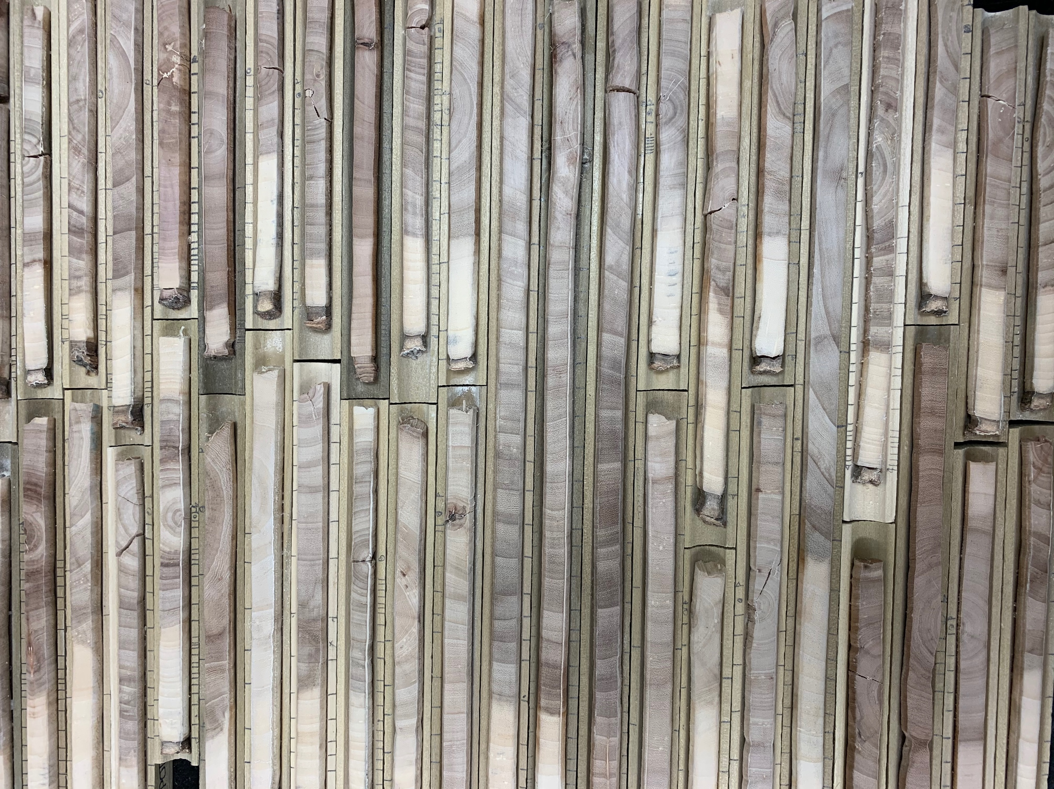
Figure 1. Mounted and sanded tree cores.

III. Conclusion:
This project has provided me with invaluable experience in planning and implementing a research project, as well as in collaborating with a large environmental non-profit organization such as The Nature Conservancy. Although analysis of data collected over the summer is still underway, the number of trees included in the study and their broad distribution throughout the length of the SCR lead The Nature Conservancy and myself to be confident in the usefulness of our results. As The Nature Conservancy continues in its efforts of land acquisition and restoration throughout the watershed, results from this internship project will be incorporated into their future restoration projects and also applied to the adaptive management of current properties in the region.
IV. Acknowledgments:
I would like to thank the Edna Bailey Sussman Foundation for their important contribution to my research internship experience. I would also like to thank The Nature Conservancy for allowing me to collaborate with them on this project and for providing access to their properties along the Santa Clara River.

