Biocultural Restoration at the Wampanoag Common Lands: An Internship with the Native Land Conservancy
Final Report to the Edna Bailey Sussman Foundation, Fall 2022
Olivia Kurz
Department of Environmental Biology
SUNY College of Environmental Science and Forestry
Introduction:
Indigenous leadership and land stewardship are crucial to meeting the goals of conservation, restoration, and climate adaptation. Healing the earth and human relationships to place, Native land stewardship reconnects people with ecosystems. Indigenous management practices and land use have fostered biodiversity and healthy ecosystems for time immemorial. Parcels of land are increasingly being returned to Indigenous stewardship, and much of this land is damaged. The need for research on culturally relevant, holistic biocultural restoration, integrating traditional ecological knowledge and Western science, is ever more pressing. In an internship with the Native Land Conservancy, Inc. in Mashpee, MA, I supported the crucial work of not only restoring healthy, culturally significant, biodiverse, and climate resilient ecosystems, but also of restoring human relationships with the land.
The focus of the biocultural restoration is a 32-acre site, acquired in 2021 by the NLC in Kingston, MA. The site, the Wampanoag Common Lands (WCL) at Muddy Pond, harbors high biodiversity along with significant human degradation, as 15 buildings were recently removed. The site is located close to the site of first contact between Indigenous peoples and settlers, and thus has high historical significance. WCL is closed to the public, with the land being open to the Wampanoag community for cultural practices and revitalization. The conservation and return of this land to Indigenous stewardship is especially important, as this area is experiencing increasing pressure from tourism and development. This region is full of biodiversity, with WCL containing a rare sandplain grassland ecosystem as well as being part of the Pine Barrens Ecoregion. WCL hosts several endangered and globally rare insects and plants, including the Plymouth Gentian and New England Boneset. WCL’s population of these two plants are the largest in the area and some of the only in the world.
Completed Work
Funding from the Edna Bailey Sussman Foundation graciously supported my work with the Native Land Conservancy over the summer of 2022. This allowed me to have a wide range of experiences, including research, GIS and mapping, networking, land trust operations, learning about local ecosystems, along with helping to develop a biocultural restoration plan.
- Historical ecology research. I conducted research on historical ecology, including animal and plant species who are currently missing from the landscape at WCL and from the region at large. I also researched Indigenous place names, historical maps, land ownership and land use history in the area. This work is ongoing as part of my dissertation work.
- Biocultural Restoration Plan for WCL. In collaboration with other interns, NLC staff and board, we began developing biocultural restoration options for WCL, including plant species, management practices, soil erosion prevention, endangered species, and methods for increasing harvests for some of the culturally significant plants such as cranberries, huckleberries, and blueberries. I plan to continue work on this topic as part of my dissertation research.
- Invasive Species Management. I mapped the current invasive species populations using a GPS receiver and drafted a document with management options for invasive species on the site, including alternatives to herbicide and holistic ideas for using and working with invasive plants. This included photos of each species at various life stages for easy identification by staff and future interns. Each species was prioritized and short-term as well as long-term management strategies were offered. I also co-planned two invasive species community workdays where we removed Japanese Knotweed and Asiatic Bittersweet. This was also an opportunity for community building and for Wampanoag community members to spend time on the land.
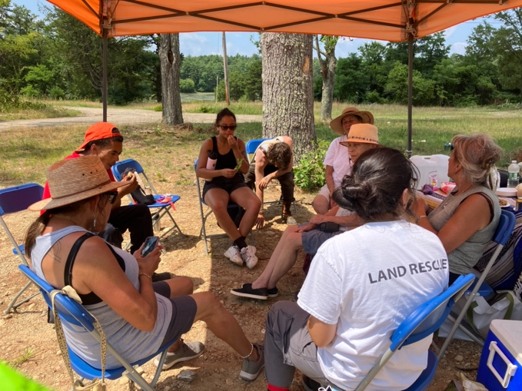
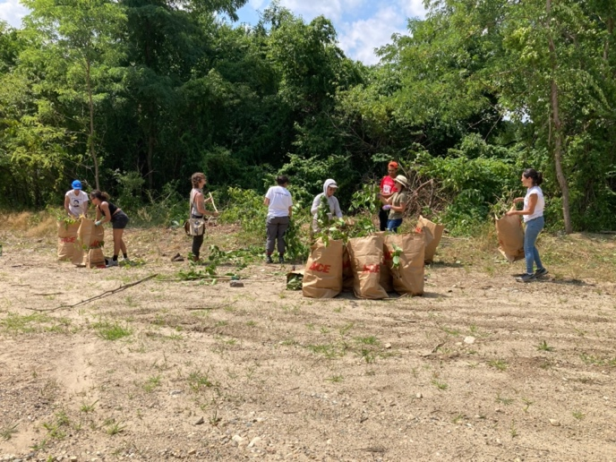
Left: removing invasive plants on invasive removal workday. Right: building community and talking with elders and young people at invasive removal workday at WCL.
- Bat Monitoring. I assisted with installing acoustic bat monitoring, as the site hosts the endangered Tricolored Bat.
- Species Lists. We began the process of certifying the vernal pools on site, so that they would be further protected. We began to catalog the aquatic species present in the vernal pools as well as develop plans for future, more in-depth monitoring. I also assisted in cataloging plant and insect species present on site using iNaturalist, with plans to carry out community Bioblitzes in the future.
- Capacity Building. I assisted the NLC with capacity building by aiding in crucial operational tasks, thereby learning about the inner workings of a land trust.
- Community Building Events. In addition to the two invasive plant community workdays, I assisted with several other community events, including a Herring Run celebration, the annual Mashpee Wampanoag PowWow, and Wampanoag Common Lands Homecoming Day, which included native plantings of culturally significant plants.
- Developed opportunities for further research. Through my work and relationship-building with NLC and meeting other organizations and people engaged in conservation and restoration work in the region, I identified directions for further research and areas of interest for my own graduate research, as well as questions that are pertinent to local communities. I plan to focus on biocultural restoration of culturally significant wetland plants and their associated fungi, with a focus on former commercial cranberry bogs and culturally significant plants within those systems.
Conclusions
Funding from the Edna Bailey Sussman Foundation allowed me to gain a variety of experiences this summer, including research to support biocultural restoration of the Wampanoag Common Lands in Kingston, MA. I made lasting connections, identified areas of future research, and gained valuable knowledge about local ecosystems and the inner workings of land trusts. My research from the summer is currently ongoing and I plan to continue to work closely with the NLC on my research, with arrangements to return next summer.
Acknowledgements
Thank you to the Edna Bailey Sussman Foundation, without the support of which I would not have been able to have this invaluable experience, which has enriched my research and professional skills. I would like to thank my advisor, Dr. Stew Diemont, for guiding me through the research process. Thank you to Dr. Diana Ruiz for her excellent guidance, knowledge, and investment in my internship over the summer. I would also like to thank Ramona Peters for all of the work she has put into NLC, her dedication to land rescue, and for the wisdom and knowledge she generously shared with me. Thank you to Leslie Jonas for her encouragement and enthusiasm, and for brainstorming with me. I’m grateful to Gail Melix, Hazel Currence, Kitty Hendricks, Miles Burnadette-Peters, Marlene Lopez, Fin Jonas, Asa Peters, Dave Fryxell and Tim Simmons for teaching me so much throughout the summer.
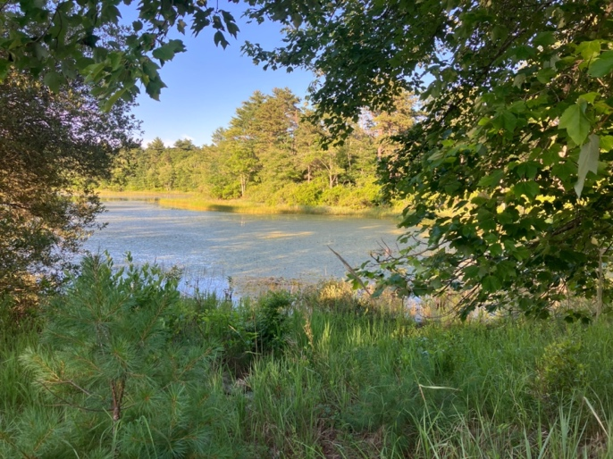
A view of Muddy Pond from the shore at WCL.

