Beech Bark Disease Induced Changes to Forest Composition and Coarse Woody Debris in the White Mountains, New Hampshire
Joe Nash
SUNY College of Environmental Science and Forestry
Final Report for the Edna Bailey Sussman Fund 2021
- Background
Northern hardwood forests have been irreversibly changed by the invasion of forest pests
over the last century or more. Beech bark disease occurs when a non-native scale insect feeds on
American beech (​Fagus grandifolia Ehrh.​) trees, permitting infection from canker-causing fungi. The fungal infection weakens the wood, inhibits nutrient transport, and eventually kills the tree (Cale et al. 2017). Dying beech trees produce sprouts from their roots, resulting in thickets of regenerating beech so dense as to inhibit the regeneration of other native species such as sugar maple (​Acer saccharum Marsh.)​. Changes in regeneration are an important control over future forest composition, which in turn affects the capacity of forests to respond to climate change. Furthermore, mortality from beech bark disease has resulted in an increased presence of American beech wood within coarse woody debris assemblages (McGee 2000).
Coarse woody debris is an integral component of forest ecosystem processes including carbon (C) and nutrient cycling (Harmon et al. 2020; Lasota et al. 2018). Changes in mortality of specific species over time and the relative contribution of these species to the total coarse woody debris pool in a stand has important implications for the release of C during decomposition, as species differ in their decomposition rate (Arthur et al. 1992).
- Proposed Work
I proposed to quantify forest composition using a chronosequence approach; a space for time substitution in which sites of different ages can represent change over time. In this case, the sites developed under similar environmental and edaphic conditions but vary in time since clear-cutting (30-145 years). This is important in the case of beech bark disease, as the disease is known to affect large trees first. There are inherent difficulties associated with the chronosequence approach, namely that the differences among sites can be falsely attributed to differences in treatment year (Yanai et al. 2000). Previous assessments of beech bark disease in these sites from 2012, along with stand inventory, will make it possible to describe the development of the disease and test whether the interpretation provided by the chronosequence truly predicts change over time. Thus, we aim to project future forest composition as beech die and their sprouts affect the recruitment of other species. Coarse woody debris inventories were utilized to supplement the live tree inventories and to determine if sites have accumulated more American beech coarse woody debris as they have aged.
- Methods
The chronosequence sites were sampled in the summers of 2004 and 2020 for coarse woody debris and summer of 1994, 2004, and 2012 for a full live tree inventory. In the summer of 2021, we re-visited the chronosequence sites and conducted live tree inventories, regeneration counts, and beech bark disease analysis, which were previously conducted in 2012.

  - Site Description
The chronosequence consists of fourteen northern hardwood sites in the White Mountains of New Hampshire that were harvested between ~1875 and 1990 (Federer 1984) (Table 1). The 14 re-sampled chronosequence sites occur within the White Mountain National Forest (WMNF) at approximately 41° N 71° W and developed on similar post-glaciation soils (Federer 1984). Five sites are within Bartlett Experimental Forest (BEF), one site is within Hubbard Brook Experimental Forest (HBEF), and the remaining seven sites are in the adjacent White Mountain National Forest (WMNF).
Table 1: Chronosequence site descriptions. White Mountain National Forest, New Hampshire.
Site | Age in 2014 | Age in 2020 | Silvicultural Treatment | Treatment year
CC2 | 15 | 31 | Clear-cut | 1989
H6 | 20 | 36 | Clear-cut | Winter 1984
M6 | 24 | 40 | Clear-cut | Winter 1979-80
M5 | 27 | 43 | Clear-cut, followed by timber stand improvement thinning | Winter 1976-77
101 | 34 | 50 | Clear-cut | November 1970
H5 | 37 | 53 | Clear-cut strips, scarified | 1967
T20 | 46 | 62 | Heavily cut, with some cull trees girdled | 1958
M4 | 54 | 70 | Clear-cut | 1949-50
T30 | 56 | 72 | Intensity of cut unknown | 1948
H1 | 65 | 81 | Clear-cut after 1938 hurricane, removing all stems >2” diameter | 1939
H4 | 70 | 86 | Clear-cut. Thinning in 1959 - 45% of basal area removed | 1933-35
M3 | 94 | 110 | Presumed clear-cut | 1910
H2 | ~129 | ~145 | Clear-cut, used as pasture. Thinned in 1936 - 20-30% removed | ~1875
H3 | ~129 | ~145 | Clear-cut, used as pasture | ~1875

  - Tree Inventory
Tree inventories were conducted in summer of 1994, 2004, 2012, and 2021 using the same methodology. Tree inventories were conducted along five 50 m long transects that were pre-established and monumented by an orange PVC post at each end. Within 5 m on either side of each transect all trees ≥10 cm were identified, and diameter at breast height (dbh) and status (alive or dead) was noted. Temporary 5x5 m plots were evenly placed on alternating sides of each transect, starting on the right at 0 m. All trees 2-10 cm dbh were measured in the five 5x5 m plots, while all seedling and shrubs <2 cm dbh but >50 cm height were counted in five nested 2x2 m subplots. All seedlings and shrubs < 50 cm height were counted in five 1x1 m subplots. There were exceptions to the standard transect layout detailed above for sites that were limited in size (H1 and CC2) or where skid trails within the site did not permit the standard transect layout (M5, T20, and T30).
  - Coarse Woody Debris Inventory
Coarse woody debris was surveyed with the line intersect sampling method (LIS) used by the U.S Forest Service for Forest Inventory Analysis (FIA) (Van Wagner 1968; U.S Forest Service 2019). Within each stand, we established three permanent clusters, each composed of three 25-m transects diverging from a randomly placed center point. The three transects which make up a cluster diverge from the center point at three randomly selected azimuths, with 120° between them (20, 140, 260, or 120, 240, 360, for example).
Within two of the sites (CC2 and T20) an alternative sampling design to the standard cluster was used due to limitations in site size (CC2), and obstruction of a skid road (T20). At CC2 transects were arranged in a box with each edge a 25 m transect, and two 25 m transects diagonally within the box. Transects within T20 were arranged similarly to CC2, with an additional adjusted cluster due to the increased size of the stand.

- Work Completed
As expected, the basal area (m²/ha) in each of the sites increased over the sampling periods with several notable dips due to stand disturbances (Figure 1). Additionally, American beech basal area has increased in the younger sites more rapidly than sugar maple basal area (Figure 2).

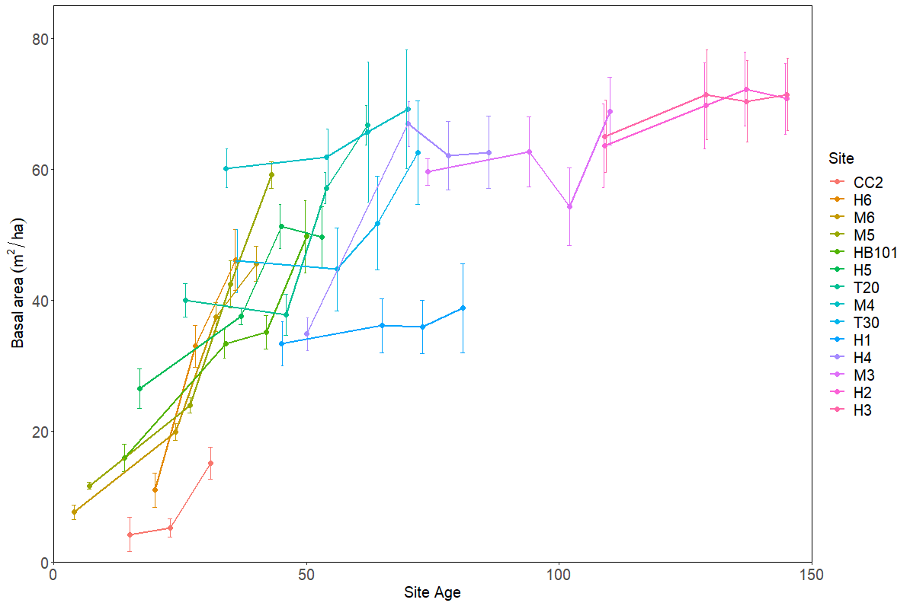
Figure 1. Progression of basal area (m²/ha) in each of the chronosequence sites, sampled in 1994, 2004, 2012, and 2021. Error bars represent mean ± standard error.

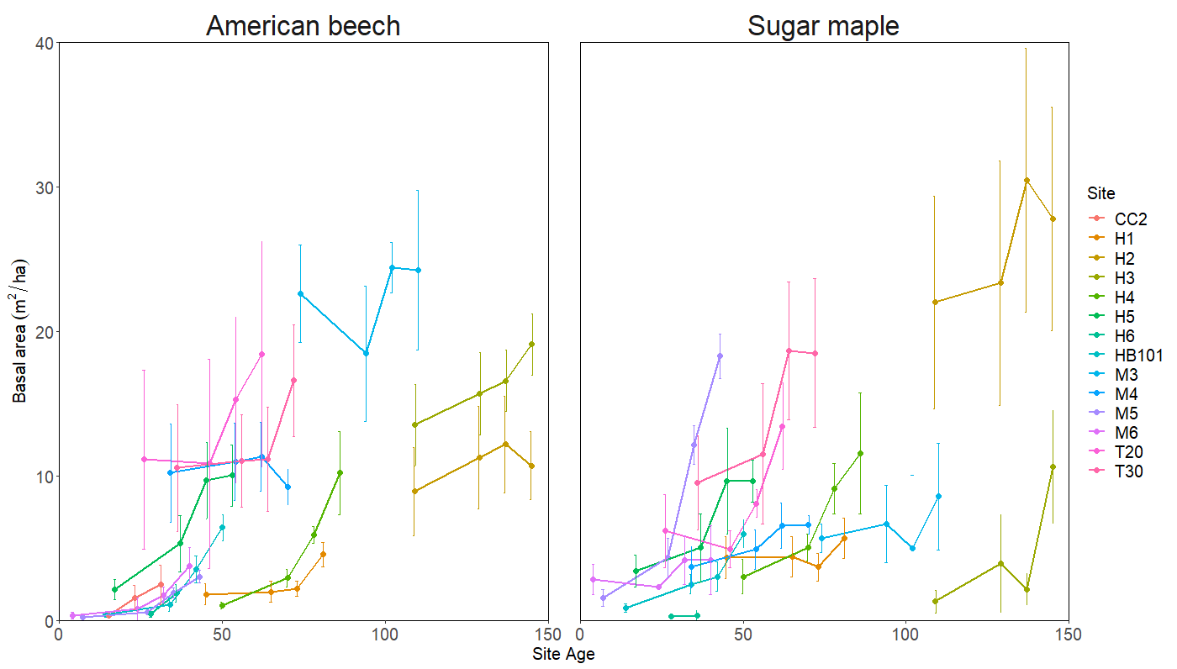
Figure 2. Progression of American beech (left) and sugar maple (right) basal area (m²/ha) in each of the chronosequence sites, sampled in 1994, 2004, 2012, and 2021. Error bars represent mean ± standard error.

Although the total basal area in the oldest chronosequence sites is approaching a plateau (Figure 1), the volume of coarse woody debris is still increasing (Figure 3). 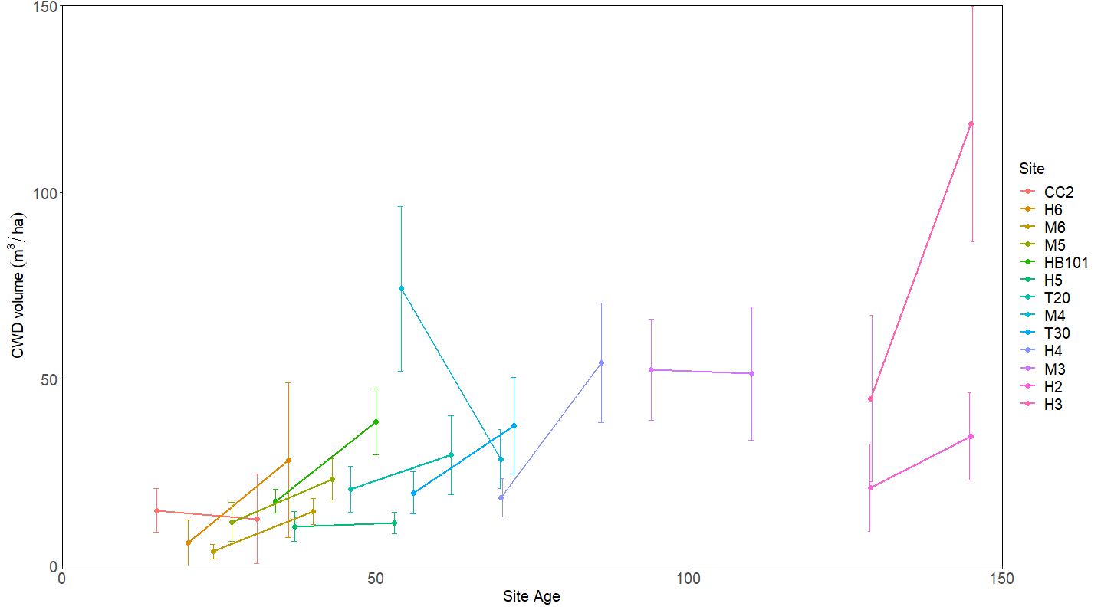
Figure 3. Progression of coarse woody debris (CWD) volume (m³/ha) in each of the chronosequence sites, sampled in 2004, and 2020. Error bars represent mean ± standard error.
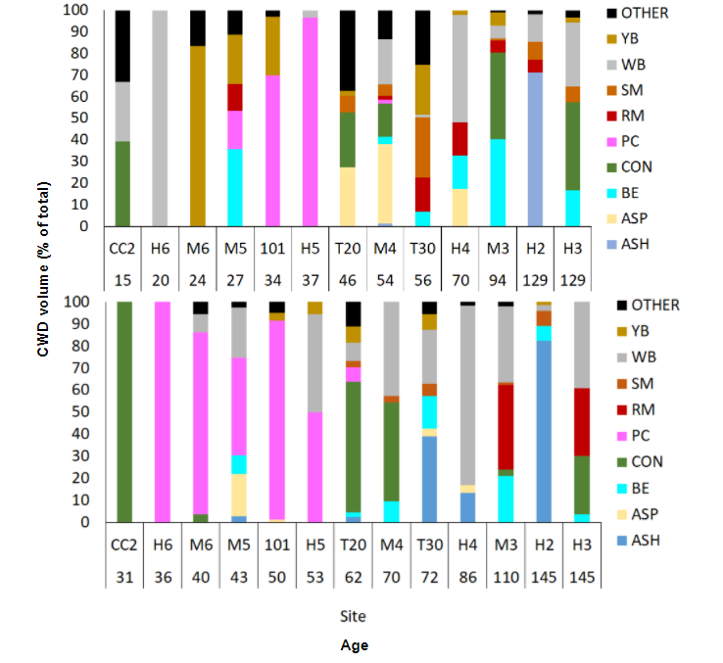
The contribution of specific species to the total volume of coarse woody debris within each site shows the influence of stand development self-thinning. A progression from residual coarse woody debris that was left behind from the previous overstory consisting namely of coniferous species is replaced with pin cherry and other hardwoods as the sites age and actively contribute to the coarse woody debris within the site (Figure 4).
Figure 4. Contribution of each species to the total coarse woody debris (CWD) volume (m³/ha) in each of the chronosequence sites in 2004 (top) and 2020 (bottom).

- Acknowledgements
I would like to thank the Edna Bailey Sussman Foundation for their support with this project. I would also like to thank my supervisor Chris Woodall and my thesis committee members Russ Briggs and Greg McGee for their insight throughout the project. This project would not have been possible without those who came before me to work in the chronosequence, namely Tony Federer, Matt Vadeboncoeur, Marty Acker, and Adam Wild among many others. Another thanks to my advisor Ruth Yanai for encouraging me to apply and for always believing in me. A very special thank you to the summer field crews that made this work possible, especially during the tree inventory of 2021.
- References
Arthur, M.A., Tritton, L.M., Fahey, T.J. 1992. Dead bole mass and nutrients remaining 23 years
after clear-felling of a northern hardwood forest. Canadian Journal of Forest Resources
23: 1298-1305.
Cale, J.A., Garrison-Johnston, M.T., Teale, S.A., Castello, J.D. 2017. Beech bark disease in
North America: over a century of research revisited. Forest Ecology and Management
394: 86-103.
Federer, C.A. 1984 Organic matter and nitrogen content of the forest floor in even-aged northern
hardwoods. Canadian Journal of Forest Resources 14: 763-767.
Harmon, M.E., Fasth, B.G., Yatskov, M., Kastendick, D., Rock, J., Woodall, C.W. 2020. Release
of coarse woody detritus-related carbon: a synthesis across forest biomes. Carbon
Balance and Management 15:1
Lasota, J., Blońska, E., Piaszczyk, W., Weicheć, M. 2018. How the deadwood of different
species in various stages of decomposition affected nutrient dynamics. Journal of Soils
Sediments 18: 2759-2769.
McGee, G.G. 2000. The contribution of beech bark disease-induced mortality to coarse woody
debris loads in northern hardwood stands of Adirondack Park, New York, USA.
Canadian Journal of Forest Research 30(9): 1453-1462.
Yanai, R.D., Arthur, M.A., Siccama, T.G., Federer, C.A. 2000. Challenges of measuring forest
floor organic matter dynamics: repeated measures from a chronosequence. Forest
Ecology and Management 138: 273-283.

