Analyzing mitochondrial respiration in transgenic, non-transgenic, and hybrid
American chestnut plants in Pennsylvania
Anuli Onwumelu
SUNY College of Environmental Science and Forestry
Final Report to the Edna Bailey Sussman Foundation, 2019
Background
The American chestnut (Castanea dentata) has an important history within the Eastern US. Historically a dominant member of forests within this range, the American chestnut was devastated by the fungal disease chestnut blight (caused by the pathogen Cryphonectria parasitica), beginning in the early 20th century.^{[1,2]} In the century since this event, groups like The American Chestnut Foundation (TACF) have been involved in efforts to restore American chestnuts in the Eastern US using various methods to develop blight-resistant American chestnuts. In a series of plots representing a climate gradient spanning from New York to Pennsylvania and Virginia, TACF has begun an experiment this year designed to test which environment (between open field and shelterwood plots) would be best suited to growing transgenic American chestnuts that have been genetically engineered to contain the oxalate oxidase (OxO) gene for blight resistance.^{[1]}
Introduction
As part of the climate gradient experiment based on the TACF plots, the research completed for this internship focused on comparisons between the physiology of transgenic and non-transgenic (wild-type) chestnuts and conventionally-bred chestnut hybrids, within the plot found at Pennsylvania State University (40°39'51.8"N 77°55'29.8"W). The hypothesis for this research was as follows: OxO transgene insertion causes the transgenic chestnut plants to have an increased metabolic burden associated with producing the OxO enzyme, such that the transgenic plants would be expected to have a greater rate of respiration than their non-transgenic counterparts. The measurements used to test this hypothesis were rates of mitochondrial respiration in the dark (R_{dark}). Respiration in the dark is measured in the absence of light to determine the amount of carbon dioxide being released as a byproduct of the process of generating chemical energy, without the complexity of estimating respiration in the presence of light while photosynthesis simultaneously occurs.^{[3,4,5]}
Three genotypes were measured out of the six genotypes found in the plot (Figure 1): transgenic, non-transgenic, and Hampchuria conventional hybrid American chestnuts. A hybrid was used for further comparison to the transgenic and non-transgenic plants, and the Hampchuria was chosen because its genetic makeup confers it with more American chestnut characteristics than the Sleeping Giant hybrid.
As part of this internship, a data-logging weather station (the HOBO U30 USB Weather Station Starter Kit) was also installed west of the plot, that will be able to remotely transmit and save environmental data for the site into the future.
Methods
Site Description
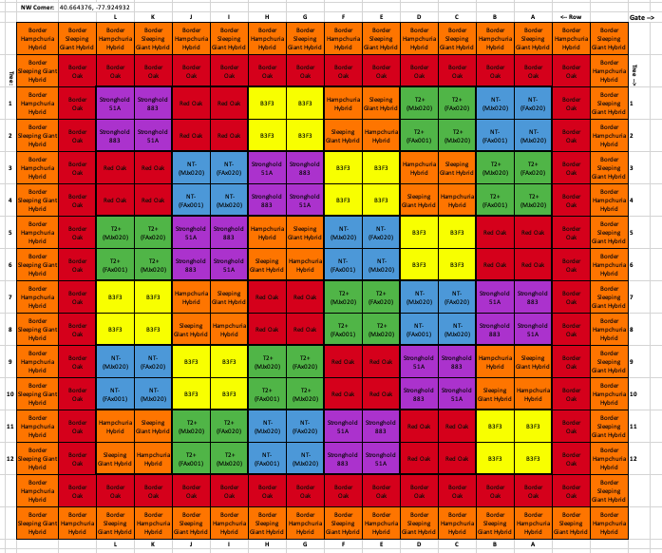
Figure 1. The design for the Pennsylvania plot. Surrounded by 2 border rows of red oak and 2 varieties of conventionally-bred American chestnut hybrids, there are a total of 6 genotypes (color-coded): Stronghold chestnuts which were mutated in a blight resistance attempt, B₃F₃ backcrossed American-Chinese chestnut hybrids, conventional hybrids, transgenic chestnuts (“T2+”), non-transgenic chestnuts (“NT-”), and red oak for comparison.

Field Methods
Field measurements were collected using the Licor-6800 portable photosynthesis system, a gas-exchange machine that allows factors such as the amount of light and humidity exposed to the leaf to be controlled while measuring. For the R_{dark} measurements, the environmental conditions for each leaf measured were set as follows: a flow rate of 400 μmol/s, a leaf temperature exchange rate (Txchg) of 25°C, relative humidity=40-60%, a CO₂ concentration of 400 μmol CO₂ m⁻² s⁻¹, and light=0 μmol photons m⁻² s⁻¹. Under these conditions, respiration rates were determined from the rate of carbon flux through the leaf. One leaf for each of two plants per genotype within each Block were measured, resulting in a total of 36 measurements.
Data Analysis
Statistical analysis of the data was performed using the ‘lme’ package in R to generate a linear mixed effects model. A linear mixed effects model was used to examine how R_{dark} responded to the factors of Site and Genotype, while also applying random effects of Block and Grouping to account for potential differences associated with the randomized locations of the genotypes across the plot. Block applied six different groups to the plot, as pairs of rows going vertically down the plot (i.e. rows 1 and 2 formed Block 1, etc.), and Grouping (nested within Block) paired plants within each genotype by their shared mother tree. A subsequent post-hoc Tukey’s test for comparisons was run with the R functions `HSD.test` and `glht’ to test the differences between the genotypes for the bars of the plot found in Figure 2.
Results
Respiration measurements were averaged by genotype and can be found below in Figure 2. No significant difference in average respiration rate occurred between the three genotypes, as indicated by the Tukey’s test letters on top of each bar. These results are not consistent with the hypothesis that transgenic plants would have a higher rate of respiration than the non-transgenic plants, and also demonstrate that the transgenic plants did not have a higher rate of respiration than the hybrid either.
Figure 2. Average rates of respiration in the dark (R_{dark}) for plants of each of three genotypes measured in the PA plot, as a function of genotype.

Future Work
Future studies should collect R_{dark} measurements for all three TACF plots and compare the plots over the course of successive years. This would provide conclusive evidence of any consistent differences in respiration that may exist between the genotypes of the chestnut plants, along this climate gradient. Additionally, regarding the weather station capable of measuring environmental conditions such as wind speed and air temperature, this data could be used to determine average climate conditions at the site for further climate gradient studies.

Literature Cited
- Zhang B, Oakes AD, Newhouse AE, Baier KM, Maynard CA, Powell WA. 2013. A threshold level of oxalate oxidase transgene expression reduces Cryphonectria parasitica-induced necrosis in a transgenic American chestnut (Castanea dentata) leaf bioassay. Transgenic Research.
- Anagnostakis SL, Hillman B. 1992. Evolution of the chestnut tree and its blight. Arnoldia (Jamaica Plain).
- Reich PB, Sendall KM, Stefanski A, Wei X, Rich RL, Montgomery RA. 2016. Boreal and temperate trees show strong acclimation of respiration to warming. Nature 531: 633–636.
- O’Leary BM, Asao S, Millar AH, Atkin OK. 2018. Core principles which explain variation in respiration across biological scales. New Phytologist.
- Trichez D, Auriol C, Baylac A, Irague R, Dressaire C, Carnicer-Heras M, Heux S, François JM, Walther T. 2018. Engineering of Escherichia coli for Krebs cycle-dependent production of malic acid. Microbial Cell Factories 17: 113.

