Forests on the Move: Tracking Climate Change in Montane Forests of the Northeast

Jordon Tourville
SUNY College of Environmental Science and Forestry
Final Report to the Edna Bailey Sussman Foundation
2021

Introduction
Global change drivers, such as climate change acting in concert with competition, have the potential to greatly influence the spatial distribution of plant species (Lenoir et al. 2009). Such changes in species distributions have already been demonstrated and are predicted to continue in the coming century (Iverson et al. 2008). Tree species will be especially susceptible to changes in climate given their slow growth, dependence on climate sensitive dispersal agents, and slow adult population turnover (Aitken et al. 2008; McKenney et al. 2007). Trees perform a wide array of important ecosystem services including nutrient cycling, carbon sequestration, and habitat provisioning, thus, understanding how they will be affected by global change drivers is of paramount importance for ecosystems and humans alike (Beck et al. 2011).
A large body of research has been devoted to detecting shifts in tree ranges, possible proximal causes of such shifts, and their ecosystem level consequences (Wason & Dovciak 2017; Woodall et al. 2009). Spatial gradients that covary with climatic variables are useful as natural experimental settings and have been used as backdrops for exploring plant range shifts (Brown & Vellend, 2014; Jump et al. 2009). Gradients of elevation along mountain slopes are seen as sensitive indicators of forest community change driven by highly correlated gradients of temperature, precipitation, and edaphic variables (Beckage et al. 2008; Harsch et al. 2009).
The mountains of the northeastern US are expected to experience increased temperatures and fluctuating precipitation regimes over the next several decades as climate change accelerates (Janowiak et al. 2018). While prevailing theory suggests that trees of lower elevations will need to expand upslope to keep pace with regional warming trends (Janowiak et al. 2018) there is mixed evidence of this from field observations (Iverson et al. 2008; Wason & Dovciak 2017). Some studies do find a dramatic upslope shift in tree species distribution (Beckage et al. 2008; Boisvert-Marsh et al. 2014), while others find no supporting evidence (Fei et al. 2017; Foster & D’Amato 2015). Other studies note a slow expansion that does not keep pace with climate warming, suggesting some other inhibitory mechanism (Alexander et al. 2018; Liang et al. 2018; Sittaro et al. 2017).
High elevation forests and mountain alpine zones are an integral part of the cultural heritage and physical landscape of the northeastern US. These areas harbor rare species, provide important ecological services, and are known nationally for their contribution to conservation and recreation. The treeline, which defines the transition between these high elevation forests and mountain alpine zones, has often been used as a barometer for the impact of climate change, both regionally in the Northeast and across the globe. As the climate warms, treelines are expected to advance upslope as the unique and diverse alpine plant communities of mountain summits retreat. The rate of this advance serves as an indicator of ecosystem sensitivity in this important system to changing climate. In partnership with the Appalachian Mountain Club (AMC), and supervised by AMC Assistant Director of Research Dr. David Publicover, I used current and historical imagery provided by the organization from the Presidential Range of New Hampshire and Katahdin Range of Maine to quantify the advance of treelines over the past 40 years. I hypothesized that treelines on both ranges have advanced upslope during this period as climate change has accelerated.

Methods
This study was conducted on montane alpine slopes in the northeastern United States in two states (New Hampshire and Maine – Figure 1). This region encompasses diverse forests associated with the transition between the broadleaf deciduous temperate forest biome to the south and the boreal evergreen conifer forest to the north (Janowiak et al. 2018). The region is within the Adirondack-New England highlands which is characterized by a highly variable terrain (generally ranging from 150 to 1,220 meters above sea level), rocky spodosol soils, and continental forest climate with warm summers and cold and snowy winters (mean annual temperatures between 3 and 11˚C; mean length of the frost-free period ~100 days; mean annual snowfall > 2,550 mm) and evenly distributed precipitation (annual mean precipitation of 890 mm, Albany, New York) (Janowiak et al. 2018).
Physical copies of historical aerial imagery were acquired from the AMC. Imagery for the Presidential Range was taken in 1978 and for Katahdin in 1991. Images were photo scanned and converted to TIFF format at 300 dpi. Contemporary landscapes comparisons were facilitated by 2018 false-color near-infrared NAIP imagery using a NAD1983 datum. Using ArcGIS 10.9, historic imagery was ortho- and georectified using newer imagery via a spline function, and then converted into one orthomosaic image. All areas above treeline were manually digitized and then converted to a raster format for both new and historic imagery. Alpine rasters were multiplied by a 1m resolution DEM for the region in order to calculate elevation of treelines. A total of 200 random sampling points were selected along treelines on the new NAIP imagery. Differences between the elevation of these points and the elevation of the nearest treeline location on historic ranges were calculated to quantify mean treeline advance over the intervening time period.
In addition to the spatial analysis, field sampling was done to characterize the forest community occurring at treeline. A total of 54 belt transects (33 in the Presidential Range, 21 in the Katahdin Range) were established. Each transect was 100 m in length and was placed vertically in elevation running from forest interior to beyond the treeline. Trees were recorded that intersected the transect. Tree species, dbh, height, and position to and along the transect were recorded. Additionally, at 20 m intervals I recoded slope, aspect, elevation, and soil depth to bedrock. GPS points were taken at the start and end of each transect.

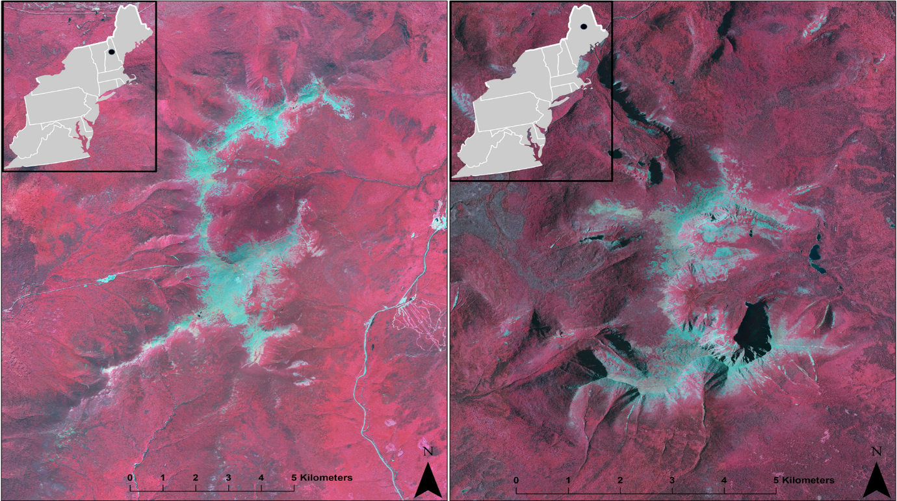
Figure 1: False-color near-infrared images of the Presidential Range (left) and Katahdin Range (right) and their locations within the northeastern United States. Red areas represent forest canopy cover and lighter areas are generally exposed rock or low-lying alpine vegetation.
Results
Treelines have advanced in the Presidential Range an average of ~12 m in the last 40 years. Treelines have also advanced on Katahdin approximately ~8 m in the last 30 years, however, this is not statistically significant (Figure 2, Tables 1 and 2). Forest trees have encroached on all aspects of both ranges, but more so on western aspects (Figure 3). Treelines seem to be constrained somewhat by soil depth (Figure 4). Lastly, total potential area for alpine vegetation has decreased on both ranges, but most dramatically in the Presidentials (14.3% reduction – Table 2).

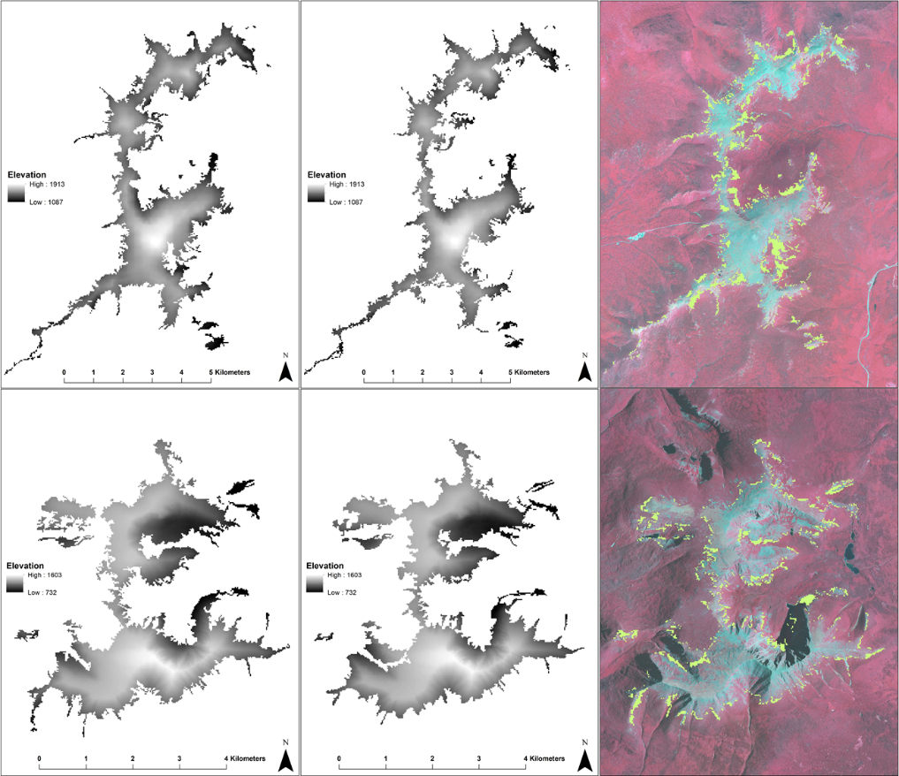
Figure 2: Top panels – Presidentials; bottom panels – Katahdin. Left panels are rasters of alpine areas derived from historic images; middle panels are rasters of alpine areas derived from contemporary images; right panels show areas of forest encroachment in the intervening time periods (highlighted in yellow).

Table 1: Statistics of forest cover and treeline locations for historic and new imagery.
Range | 2018 Max Elevation (m) | 2018 Min Elevation (m) | 2018 Mean Elevation (m) | Historic Max Elevation (m) | Historic Min Elevation (m) | Historic Mean Elevation (m) | Change in Mean Elevation (m)
Presidentials | 1769.6 | 1111.2 | 1462.8 | 1759.2 | 1087.4 | 1440 | 22.8
Katahdin | 1429.1 | 732.7 | 1157.1 | 1410.8 | 732.7 | 1152.2 | 4.9

Table 2: Statistics of treeline elevation based on randomly distributed sampling points for historic and new imagery.
Range |  | Elevation Change (m ±SE) | Area Above Treeline (ha, 2018) |  | Area Above Treeline (ha, Historic) |  | Area of Forest Gained (ha) |  | Area of Forest Gained (% of Total from Historic Imagery)
Presidentials | 11.77±1.65 |  |  | 1536.6 |  | 1789.4 |  | 252.8 |  | 14.13
Katahdin | 8.39±11.12 |  |  | 1008.7 |  | 1016.7 |  | 8.0 |  | 0.79

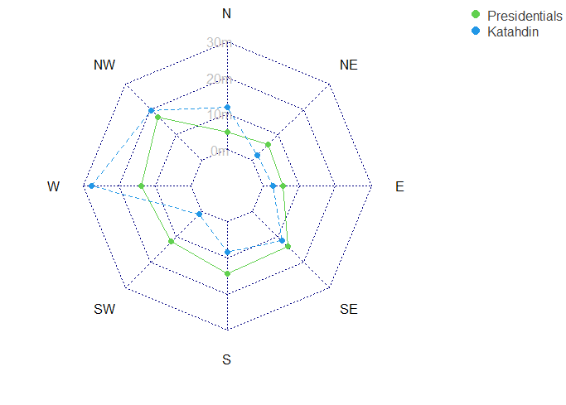
Figure 3: Radar plot of treeline elevation change by aspect (direction slope faces).

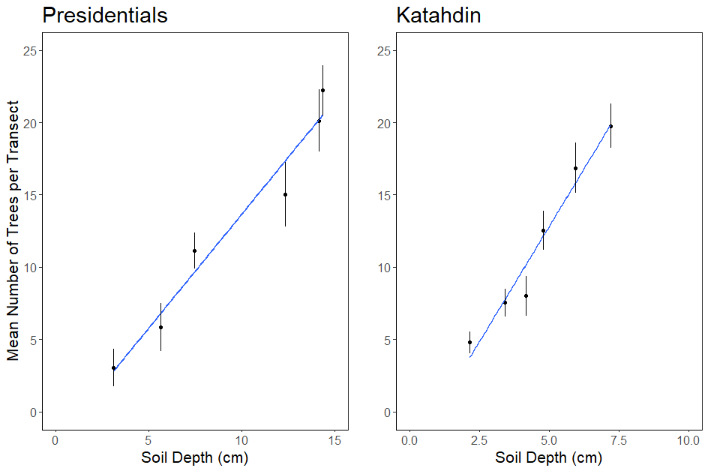
Figure 4: Positive linear relationship between tree density at treeline and soil depth to bedrock (Presidentials: R² = 0.95, p < 0.001; Katahdin: R² = 0.95, p < 0.001)
Conclusions
The results of this study suggest that treelines in the Presidential Range and Katahdin Range have shifted upslope over the past several decades, consistent with observations and ecological theory which posits that trees will migrate upslope as climate change causes increased temperatures. The magnitude of this shift was greater in the Presidentials than on Katahdin, as is the area of potential alpine habitat lost as a result of warming. It is not clear from this study why treeline advance between these two ranges are so different, although other studies have found significant treeline variation within the same region (Greenwood et al. 2014).
Field data also allow us to speculate on some of the drivers that can act to facilitate or limit upslope shifts. Westerly aspects allowed for greater change in treeline position in general. These aspects are more sheltered from direct solar radiation but more exposed to prevailing winds from the atmospheric jet stream. This could promote greater recruitment of tree seedlings beyond treeline. However, soil depth severely limited tree densities, suggesting that exposed bedrock at higher elevations can act to stall upslope shifts in treeline.
Mapping treeline locations can contribute valuable knowledge to the AMC’s longstanding mountain research program and serve as a baseline to promote better management of regional mountain communities. It is clear that a loss of alpine area is extremely detrimental to sensitive and rare alpine vegetation. My results are foundational for researchers and land managers in prescribing potential climate adaptation strategies and to conserve these sensitive species and communities. Most importantly, the people who enjoy these irreplaceable areas will benefit from the improved conservation and understanding of mountain peaks in a warming world.

Acknowledgments
I’d thank the Appalachian Mountain Club for permits, access to sites, and logistic support for this research. Specifically, I’d like to thank David Publicover and Sarah Nelson for their assistance with this project. This research was partly supported by research grants and awards from the US National Science Foundation, the Botanical Society of America, the New York Flora Association, and largely by support from the Edna Bailey Sussman Fund.
Literature Cited
Aitken, S. N., Yeaman, S., Holliday, J. A., Wang, T., & Curtis-McLane, S. (2008). Adaptation, migration or extirpation: climate change outcomes for tree populations. Evolutionary Applications, 1(1), 95–111. https://doi.org/10.1111/j.1752-4571.2007.00013.x
Alexander, J. M., Chalmandrier, L., Lenoir, J., Burgess, T. I., Essl, F., Haider, S., Kueffer, C., McDougall, K., Milbau, A., Nuñez, M. A., Pauchard, A., Rabitsch, W., Rew, L. J., Sanders, N. J., & Pellissier, L. (2018). Lags in the response of mountain plant communities to climate change. Global Change Biology, 24(2), 563–579. https://doi.org/10.1111/gcb.13976
Beck, P. S. A., Juday, G. P., Alix, C., Barber, V. A., Winslow, S. E., Sousa, E. E., Heiser, P., Herriges, J. D., & Goetz, S. J. (2011). Changes in forest productivity across Alaska consistent with biome shift. Ecology Letters, 14(4), 373–379. https://doi.org/10.1111/j.1461-0248.2011.01598.x
Beckage, B., Osborne, B., Gavin, D. G., Pucko, C., Siccama, T., & Perkins, T. (2008). A rapid upward shift of a forest ecotone during 40 years of warming in the Green Mountains of Vermont. Proceedings of the National Academy of Sciences of the United States of America, 105(11), 4197–4202. https://doi.org/10.1073/pnas.0708921105
Boisvert-Marsh, L., Périé, C., & De Blois, S. (2014). Shifting with climate? Evidence for recent changes in tree species distribution at high latitudes. Ecosphere, 5(7), 1–33. https://doi.org/10.1890/ES14-00111.1
Brown, C. D., & Vellend, M. (2014). Non-climatic constraints on upper elevational plant range expansion under climate change. Proceedings of the Royal Society B: Biological Sciences, 281(1794). https://doi.org/10.1098/rspb.2014.1779
Fei, S., Desprez, J. M., Potter, K. M., Jo, I., Knott, J. A., & Oswalt, C. M. (2017). Divergence of species responses to climate change. Science Advances, 3(5). https://doi.org/10.1126/sciadv.1603055
Foster, J. R., & D’Amato, A. W. (2015). Montane forest ecotones moved downslope in northeastern USA in spite of warming between 1984 and 2011. Global Change Biology, 21(12), 4497–4507. https://doi.org/10.1111/gcb.13046
Greenwood, S., Chen, J. C., Chen, C. T., & Jump, A. S. (2014). Strong topographic sheltering effects lead to spatially complex treeline advance and increased forest density in a subtropical mountain region. Global Change Biology, 20(12), 3756–3766. https://doi.org/10.1111/gcb.12710
Harsch, M. A., Hulme, P. E., McGlone, M. S., & Duncan, R. P. (2009). Are treelines advancing? A global meta-analysis of treeline response to climate warming. Ecology Letters, 12(10), 1040–1049. https://doi.org/10.1111/j.1461-0248.2009.01355.x
Iverson, L. R., Prasad, A. M., Matthews, S. N., & Peters, M. (2008). Estimating potential habitat for 134 eastern US tree species under six climate scenarios. Forest Ecology and Management, 254(3), 390–406. https://doi.org/10.1016/j.foreco.2007.07.023
J Lenoir, JC Gégout, JC Pierrat, JD Bontemps, J. D. (2009). Differences between tree species seedling and adult altitudinal distribution in mountain forests during the recent warm period (1986-2006). Ecography, 66(1), 152–171.
Janowiak, M. K., D’Amato, A. W., Swanston, C. W., Iverson, L., Thompson, F. R., Dijak, W. D., Matthews, S., Peters, M. P., Prasad, A., Fraser, J. S., Brandt, L. A., Butler-Leopold, P., Handler, S. D., Shannon, P. D., Burbank, D., Campbell, J., Cogbill, C., Duveneck, M. J., Emery, M. R., … Templer, P. H. (2018). New England and Northern New York Forest Ecosystem Vulnerability Assessment and Synthesis : A Report from the New England Climate Change Response Framework Project. January, 234.
Jump, A. S., & Peñuelas, J. (2005). Running to stand still: Adaptation and the response of plants to rapid climate change. Ecology Letters, 8(9), 1010–1020. https://doi.org/10.1111/j.1461-0248.2005.00796.x
Liang, Y., Duveneck, M. J., Gustafson, E. J., Serra-Diaz, J. M., & Thompson, J. R. (2018). How disturbance, competition, and dispersal interact to prevent tree range boundaries from keeping pace with climate change. Global Change Biology, 24(1), e335–e351. https://doi.org/10.1111/gcb.13847
McKenney, D. W., Pedlar, J. H., Lawrence, K., Campbell, K., & Hutchinson, M. F. (2007). Potential impacts of climate change on the distribution of North American trees. BioScience, 57(11), 939–948. https://doi.org/10.1641/B571106
Sittaro, F., Paquette, A., Messier, C., & Nock, C. A. (2017). Tree range expansion in eastern North America fails to keep pace with climate warming at northern range limits. Global Change Biology, 23(8), 3292–3301. https://doi.org/10.1111/gcb.13622
Wason, J. W., & Dovciak, M. (2017). Tree demography suggests multiple directions and drivers for species range shifts in mountains of Northeastern United States. Global Change Biology, 23(8), 3335–3347. https://doi.org/10.1111/gcb.13584
Woodall, C. W., Oswalt, C. M., Westfall, J. A., Perry, C. H., Nelson, M. D., & Finley, A. O. (2009). An indicator of tree migration in forests of the eastern United States. Forest Ecology and Management, 257(5), 1434–1444. https://doi.org/10.1016/j.foreco.2008.12.013

