Filling the littoral gap: characterizing benthic cyanobacteria in the nearshore habitats of lakes using artificial substrate
Abby M. Webster, PhD student
Department of Environmental Biology
SUNY College of Environmental Science and Forestry
December 2021

Introduction
Harmful algal blooms (HABs) caused by cyanobacteria are an increasing threat to freshwater quality. Cyanobacteria are capable of producing toxins that are harmful to humans and animals by ingestion, inhalation, or physical contact. HABs have received more attention in recent years as they are increasing in frequency and severity and are occurring in waterbodies where they have not before. Most of the attention surrounding HABs has been given to those visible in the water column (planktonic cyanobacteria), and much less attention has been given to their benthic counterpart (attached cyanobacteria). Very little is known about the growth and ecology of benthic cyanobacteria, especially in lentic systems, like lakes, where no standardized sampling methods exist (Gaget et al. 2020). Benthic species can attach to rock, sediment, macrophytes, and other available substrate and are also capable of producing harmful toxins (Wood et al. 2020). This presents an understudied yet critical research area of benthic cyanobacteria and their contribution to HABs.
The Finger Lakes of New York State (Figure 1) are an ideal location to study HABs and benthic cyanobacteria as all eleven Finger Lakes have experienced HABs in recent years despite their range in trophic states (oligotrophic, mesotrophic, and eutrophic). Nationally, models predict the largest increase in HABs will be in the northeast (Chapra et al. 2017), which emphasizes the need to study their occurrence in waterbodies such as the Finger Lakes.

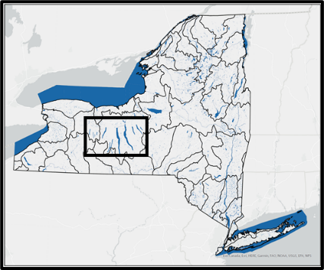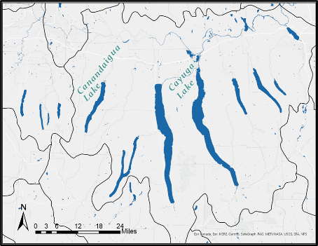
Figure 1 The eleven Finger Lakes of New York State.

My research aims to develop appropriate sampling, monitoring, and assessment methods for benthic cyanobacteria. The objectives for my research are to 1) identify the main drivers and predictors of benthic cyanobacteria mats using water quality data and pigment and protein measurements, 2) determine the extent to which benthic cyanobacteria in the Finger Lakes contribute to HABs through toxin production, and 3) identify the microbial composition of benthic algal mats and which species of benthic cyanobacteria are present in the Finger Lakes.

Work Completed
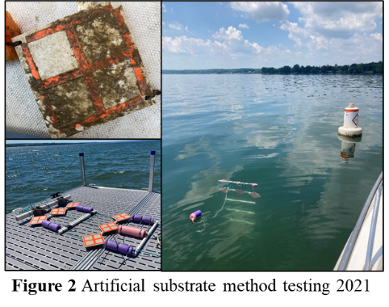
As this was the first field season of my PhD, this summer (2021) was primarily focused on method development. I designed and deployed an artificial substrate to collect benthic cyanobacteria in two mesotrophic Finger Lakes, Canandaigua Lake and Cayuga Lake. The artificial substrate “rack” stands vertically underwater and has two depths for potential attachment of benthic algae: near surface and near bottom (Figure 2). The rack is made of simple materials: PVC, paracord, and ceramic tiles. Each rack maintains its position in the nearshore zone (5 – 8 feet deep), neutrally buoyant with a small anchor and underwater floats.
Racks were deployed in June at three nearby sites in each lake and checked monthly (July – October) for attachment. The substrate tiles were delineated into four squares for four “incubation” periods: June – July, June – August, June – September, and June – October. Each month, the attached algae (biofilm) from the appropriate squares were read in the field using a handheld fluorometric instrument, the BenthoTorch, (bbe Moldaenke) to quantify the three benthic algal groups (cyanobacteria, diatoms, and green algae) present on the tiles. The BenthoTorch gives a reading (in µg/cm²) of chlorophyll-a (used to estimate biomass) and is the first look at learning what is attaching to the substrate and making up the benthic community. Biofilms were then scraped and collected for pigment, toxin, and genetic analyses. In addition to the biofilm samples, surface and bottom water was collected for a suite of analyses: pigments, total nitrogen and total phosphorus concentrations, total suspended solids, toxins, and genetics. We also collected water samples for FluoroProbe analysis (bbe Moldaenke), which works similarly to the BenthoTorch, and fluorometrically quantifies (in µg/L) the four planktonic algal groups (cyanobacteria, diatoms, green algae, and cryptophytes) present in the water. An integrated passive sampling method, Solid Phase Adsorption Toxin Tracking (SPATT), was used to monitor cyanobacteria toxins throughout the summer in each lake in addition to the biofilm and water analyses.
All BenthoTorch and FluoroProbe data were analyzed, and relative proportions of algal groups were compared between the two sample types. All water samples were analyzed for cyanobacterial toxins using LC-MS/MS at SUNY ESF.

Preliminary Results
Analytical work is ongoing, but preliminary results show interesting trends. Figure 3 shows BenthoTorch readings (Average Chl-a µg/cm²) of the three benthic algal groups for each site in each lake sampled in 2021. Benthic cyanobacteria were detected at all sites and in both lakes. Overall, diatoms were the dominant benthic algae on the tiles in both lakes. To our surprise, green algae were not readily attached and made up a small proportion of the benthic community collected from the tiles. Cayuga Lake had consistently higher quantities of benthic algae than Canandaigua Lake, which was expected as chlorophyll-a concentrations are typically higher in Cayuga Lake than Canandaigua Lake. Late summer sampling (August – October) had the highest BenthoTorch average chlorophyll-a readings indicating that this is an important period of the growing season for benthic algae. Differences in surface and bottom tile attachment were observed at all sampling sites, indicating that light attenuation is a likely factor in determining the benthic algal community. Generally, the benthic composition differed between sites in each lake despite the three sites in each lake being relatively close to one another (within 0.5 miles).

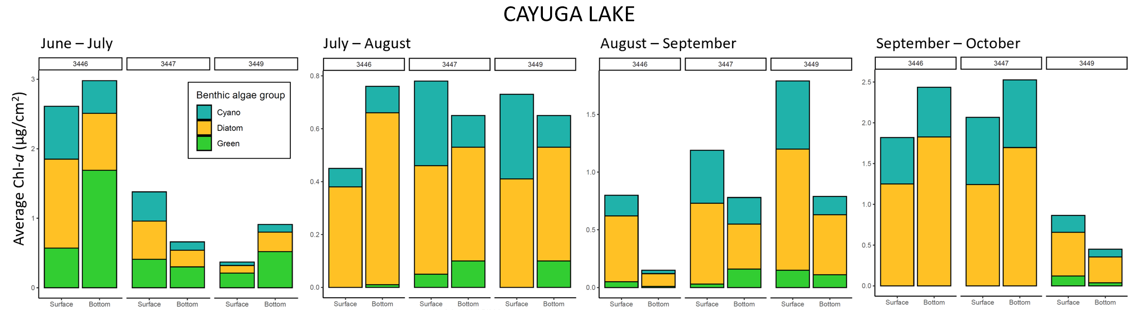
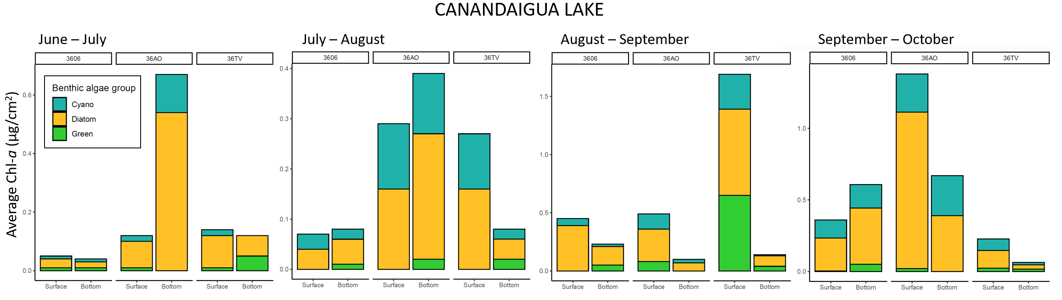
Figure 3 BenthoTorch readings (Average Chl-a µg/cm²) of the three benthic algae groups for each site in each lake sampled in 2021. Numbers “3446”, “3447”, and “3449” represent the three different sites at Cayuga Lake, and “3606”, “36AO”, and “36TV” represent the three sites at Canandaigua Lake. Benthic algal attachment is shown for four monthly periods for Cayuga Lake (top panel) and Canandaigua Lake (bottom panel) to illustrate shifts in the benthic community throughout the growing season.

While we cannot directly compare readings between the FluoroProbe (water samples) and BenthoTorch (attached biofilm) due to unequal units, we could compare the relative proportions of the algal groups in the two sample types. This showed differences in the relative proportions of cyanobacteria, diatoms, and green algae in planktonic (water) samples and benthic (biofilm) samples collected at the same time and from the same depth. We expected this result, because planktonic and benthic algae species often differ regardless of being under the same conditions.
Initial planktonic toxin analyses (from water samples) indicated that Canandaigua Lake generally has higher cyanobacteria toxin concentrations than Cayuga Lake. The only toxin detected in the samples was microcystin (and its congeners). Microcystin concentrations were not high enough to cause concern for public health on the days sampled.

Future Work
In the coming months before the next field season, all remaining analyses will be completed. Pigments in biofilm samples and in water samples will be read fluorometrically at the Finger Lakes Institute. Traditionally, chlorophyll-a has been used to estimate algal biomass, but because chlorophyll-a is produced by all plants, it may not be the most appropriate measure to estimate cyanobacterial biomass. The phycobiliprotein pigments phycocyanin and phycoerythrin may be a more appropriate measure, as they are produced by cyanobacteria but not widely produced by other algae or plant types. I will compare pigment concentrations in planktonic and benthic samples to determine which is best in estimating cyanobacteria biomass based on the relative proportions of cyanobacteria measured by the BenthoTorch (in biofilm) and the FluoroProbe (in water).
Toxin and genetic analyses of biofilm will be completed to identify which cyanobacteria may be producing toxins, which toxins they are producing, and the extent of their toxicity. Toxin analyses will be done at SUNY ESF, and genetic characterization will be done at Cornell University. Water quality parameters (nutrient concentrations and total suspended solids) will be paired with these data to better understand the drivers and conditions of benthic cyanobacteria growth.
These methods will be repeated next field season (summer 2022) and expanded to include additional Finger Lakes to cover a range of trophic states.

Acknowledgements
The work originally proposed to the Edna Bailey Sussman Fund was focused on identifying drivers and predictors of HABs in the Finger Lakes and was originally part of a Masters thesis plan. Since awarded the Sussman Fund, the proposed project plan was altered to reflect my shift from an MS to a PhD program, thus expanding the opportunity to study Finger Lakes HABs and water quality. This work will continue as the primary research focus of my PhD and allow us to address the understudied area of benthic cyanobacteria and their relationship to HABs in a thorough way.
This work could not be completed without support from the Edna Bailey Sussman Fund. Thank you to Dr. Roxanne Razavi (MP) for providing supplies, assistance with data organization, and supporting the expansion of this work to a PhD thesis. Special thanks to Dr. Lisa Cleckner, Nadia Harvieux, Trevor Massey and team at the Finger Lakes Institute at Hobart and William Smith Colleges (HWS, Geneva, NY) for their collaboration, providing supplies, laboratory analyses, and boat access. Thanks to Dr. Greg Boyer (SUNY ESF) and his students for completing toxin analyses and providing guidance on analytical techniques. Thanks to undergraduate students at HWS and SUNY ESF for their assistance with sampling and laboratory work. Finally, a big thank you to lake residents of Cayuga Lake and Canandaigua Lake who welcomed my research and allowed access to sampling sites to complete this work.

References
Chapra SC, Boehlert B, Fant C, Bierman VJ, Henderson J, Mills D, … Paerl HW. (2017). Climate change impacts on harmful algal blooms in U.S. freshwaters: A screening-level assessment. Environmental Science & Technology, 51(16), 8933-8943. doi:10.1021/acs.est.7b01498
Gaget V, Hobson P, Keulen A, Newton K, Monis P, Humpage AR, … Brookes JD. (2020). Toolbox for the sampling and monitoring of benthic cyanobacteria. Water Research, 169, 115222. doi:10.1016/j.watres.2019.115222
Wood SA, Kelly LT, Bouma‐Gregson K, Humbert J, Laughinghouse HD, Lazorchak J, … Davis TW. (2020). Toxic benthic freshwater cyanobacterial proliferations: Challenges and solutions for enhancing knowledge and improving monitoring and mitigation. Freshwater Biology, 65(10), 1824-1842. doi:10.1111/fwb.13532

