Development of environmental DNA (eDNA) methods for the monitoring of muskellunge (Esox masquinongy) in the St. Lawrence River, NY

Maxwell Wilder
SUNY College of Environmental Science and Forestry
Final Report to Edna Bailey Sussman Foundation
December 2019

Background and Summary of Proposed Work
Muskellunge (Esox masquinongy) are a large, predatory fish critical to recreational fisheries throughout the Northeast and Great Lakes regions. Factors such as overharvesting, disease, and habitat degradation, especially the loss of pristine spawning sites, have caused populations to decline from historical levels. Decline is particularly substantial in the upper St. Lawrence River, where populations have decreased dramatically since 2005 as a result of viral hemorrhagic septicemia virus (VHSv) (Farrell et al. 2017). Subsequently, agencies have sought to develop robust efforts to restore muskellunge populations through stocking initiatives and the preservation of habitat critical to spawning and nursery.
In order to successfully develop and implement management plans for muskellunge, reliable data is needed to determine current abundance and assess habitat use. Methods for large fishes such as muskellunge usually rely on direct count data obtained through traps and nearshore netting, angler catch reports, and visual survey. Such methods are often cost and labor intensive, can introduce stress and physical harm to both the target species and surrounding habitat, and result in data biases as fish may exhibit avoidance behaviors and shifts in habitat preference in response to certain techniques. These traditional approaches may be especially problematic for species that exhibit cryptic behavior and are present in low density, as is the case for muskellunge in the St. Lawrence. Thus, in order for fisheries scientists to obtain reliable data while efficiently allocating project resources, novel approaches that serve to supplement and improve traditional methodology are necessary.
Detection of environmental DNA (eDNA), or cellular debris introduced to the water as waste, mucus, skin, etc. using molecular techniques provides a reliable, noninvasive, and relatively low-cost method for species detection. eDNA is also particularly useful for the detection of rare, cryptic species which are less receptive to traditional techniques. Therefore, we seek to develop eDNA techniques for the assessment of muskellunge populations which will improve monitoring efforts for this species.
The work proposed through the Sussman program had three primary objectives; (1) Pair eDNA sampling with spotlight surveys to assess the utility of a combined technique for the observation of spawning events and identification of spawning sites, (2) Conduct environmental sampling for eDNA at sites with known muskellunge populations as well as sites where the presence of the species is uncertain, and (3) Carry out a series of aquaria studies to assess shedding and decay rates of eDNA from muskellunge at various developmental stages.

Work Completed

Objective One
Spotlight surveys for spawning activity are reliant on extremely calm, still water and clear weather conditions. Unfortunately, due to a high frequency of storms, strong winds, and otherwise unfavorable conditions in the St. Lawrence region during the 2019 spring spawning season, spotlight surveys were unable to be performed.

Objective Two
Water sampling for eDNA was conducted throughout the late Spring and early Summer in five bays that represented favorable spawning habitat. In four of these bays, live trapping for muskellunge was conducted throughout the study period as part of a long-term monitoring effort by the Thousand Islands Biological Station (TIBS). Live trapping was not conducted in the fifth survey bay and this location was not host to any previously known monitoring efforts.
On each sampling day, three 1L water samples were collected from study bays and filtered through 0.4 um polycarbonate filters. Filters were then frozen and stored for extraction/processing at SUNY ESF campus at the conclusion of the field season. Each site was sampled 4-5 times throughout the spring spawning season for a total of 69 environmental samples. Additional water samples were collected at other bays where muskellunge had been trapped to serve as environmental positive controls.

Objective Three
Aquaria sampling was carried out to determine shedding and decay rates of eDNA from muskellunge embryo (fertilized egg), larvae, and juveniles. Each life stage was housed in flow through aquarium systems for a period of five days to one week. Water samples ( 3 X 500 mL) were collected at several time points and were filtered and processed in the same manner as environmental samples. At the conclusion of the shedding study period, muskellunge were removed from the tanks. Tanks were then sampled for an additional week, without the presence of muskellunge, to assess the rate of eDNA loss. Two replicate tanks of each life stage at two different biomass levels were sampled to assess the impact of biomass on eDNA shedding and correlate number of individuals to eDNA concentration. An additional tank, to which muskellunge were not introduced, was sampled concurrently to serve as a negative control.

Preliminary Results
The processing and analysis of samples collected for this project is ongoing, however, preliminary findings indicate that muskellunge was able to be detected from a number of environmental samples. Initial results from aquaria experiments indicate that eDNA can be detected from muskellunge at larval and juvenile life stages but not from embryo. eDNA concentrations appear to be highest immediately following introduction to the study tanks followed by a relatively rapid decline and eventual stabilization (Figure 1).

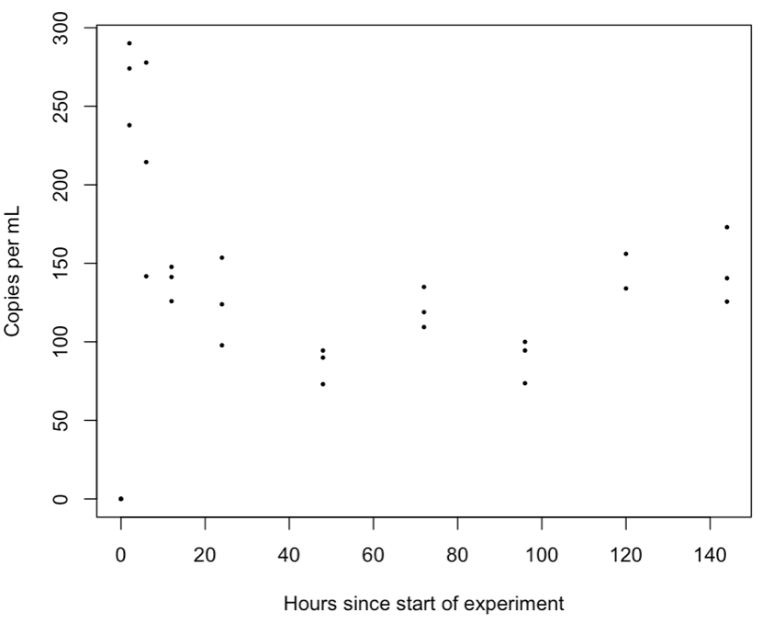
Fig 1. eDNA concentration over time in controlled aquaria containing 75 larval muskellunge. DNA quantified with genomic DNA standards.

Future Work
Sample processing and analysis will continue in winter 2019/early 2020. Shedding and decay data for larval and juvenile muskellunge will be incorporated into quantitative models in an attempt to extrapolate fish biomass from eDNA concentrations detected in the environment. Following an analysis of data collected from the series of experiments discussed previously, future sampling may be conducted alongside traditional monitoring methods (e.g. spotlight surveys) to assess the effectiveness of eDNA applications and determine where this methodology can be most appropriately applied in management efforts.

Acknowledgements
This project was made possible through the Edna B. Sussman foundation. I would like to thank the foundation for its financial support. I would also like to thank Chris Legard of the NYSDEC for sponsoring my work. I would like to thank my advisor, Dr. Hyatt Green, and committee member, Dr. John Farrell, for their advice and support as well as the field crew at TIBS for their help with sample collection.

References

Farrell JM, Getchell, RG, Kapuscinski KL, and LaPan SR. 2017. Long-term trends of St . Lawrence River Muskellunge : effects of viral hemorrhagic septicemia and Round Goby proliferation creates uncertainty for population sustainability. Page K. L. Kapuscinski, T. D. Simonson, D. P. Crane, S. J. Kerr, J. S. Diana, and J. M. Farrell, editors Muskellunge management: fifty years of cooperation among anglers, scientists, and fisheries biologists. American Fisheries Society, Symposium 85, Bethesda, Maryland.

