**Identifying Priority Buy-out Properties for Wetland Restoration in New York City**

**Final Report to the Edna Bailey Sussman Foundation**

Yi Wang

SUNY-ESF

**Introduction**

Urban natural resources, such as green spaces and wetlands, are the essential providers of ecosystem services in urban environments. While it is increasingly recognized that ecosystem services valuation (ESV) has specific contributions to decision-making process, the values of ecosystem services are typically not fully considered. To maximize ecosystem services, natural resource management in urban area must face the challenges of the uncertainty nature of ecosystem and management the complex political, environmental, economic and social demands (Green et al., 2016). Adaptive management links social and ecological systems and recognizes the uncertainty of ecological responses and the complexity of managing ecological resources in urban context (Green et al., 2016). Recent years, there are significantly increasing amount of research and pilot projects that carried out through collaborations among researchers and different stakeholders from multi-disciplinary fields. There is still a significant gap between the concept of ecosystem services and actual planning and management practice.

In the wake of natural disaster and climate change, land acquisition and buy-out programs become common to reduce the risk from future flooding in coastal cities such as New York. Buy-out lands are often maintained in undeveloped state for public use. While some suggest that buy-out lands may add value and ecological benefits to communities through the development of wetland restoration (Siders, 2013), due to small parcel sizes and lack of indication that these parcels would provide critical ecosystem services in NYC, buy-out programs are mainly operating in response to storm damage and serve as a strategy to mitigate risk for NYC coastal communities. The buy-out lands are not used for natural resource restoration. New York City Department of Parks and Recreation Division of Natural Resources (the Natural Resources Group, NRG) Wetland Team seeks potentials from the buy-out land to enhance the ecosystem services of coastal wetlands to people as well as preserve natural resources in the city. Wetland Team offered to host me at their office and assist the research project of identifying priority buy-out properties in the city suitable for wetland restoration projects.

With the Edna Bailey Sussman Foundation’s support, I took advantage of this opportunity. This internship allowed me to gain an insider’s understanding of current urban green space planning and management processes in NYC for my research as well as study how adaptive management may help enhance ecosystem services of urban natural resources management in practice. This research project also allowed me to assist NRG wetland team’s larger effort to understand and quantify the benefit of urban natural resources and climate change effects.

**Work Completed**

With Edna Bailey Sussman Foundation’s support, I joined NRG’s wetland team with 3 tasks, 1) research current literature on urban salt marsh ecosystem services; 2) develop visualizations of changes in tidal wetlands and assess wetland loss rate and vulnerability using ArcGIS; and 3) analyze the Sea Level Affecting Marshes Model (SLAMM) results for NYC public and private properties. I involved in NYC SLAMM re-run meetings and studied the nature of SLAMM dataset. I designed data process modules and explored three data cleaning methods to mitigate potential error for current and future SLAMM dataset. I then analyzed and visualized the SLAMM dataset to identify overall conditions of predicted regularly flooded developed land and wetland migration area in New York City from 2008 (time-zero) to 2100. I also identified which neighborhoods and land use types are facing the most regular-flooding stress and which neighborhoods have the most potential for future wetland migration. I also involved in wetland team’s adaptive management implementation process and designed data management functions to accommodate past, on-going and future wetland projects. Furthermore, I conducted a series of literature research and designed buy-out projects’ assessment conceptual framework for wetland restoration projects as well as the larger conceptual framework for adaptive management. I, then, identified a set of ecosystem services valuation indicators and corresponding quantifiable variables for wetland restoration in NYC. Finally, I presented this research as a part of in-house “Science of the Living City” lecture series. I plan to continue my research on urban natural resource management and further develop data management methods and tools for identifying priority buy-out projects under a larger framework of adaptive management.

**Conclusion and Future Work**

Adaptive management for natural resources refers to a learning-by-doing process in the constantly changing environment. It requires consistent monitoring strategy for natural resources and visualizing data for planning and management decision-making purposes. Working on this project was a huge step forward for my research on adaptive natural resource management and prioritizing ecosystem services in urban environments. I was able to familiarize with the workflow of wetland restoration projects and maintenance processes, collect available data and identify gaps between adaptive management implementation and ecosystem services valuation in practice.

Understanding the functioning of coastal wetland ecosystems depends both on the collection of good long-term sets of real-time data on the changes of social and physical environments. Typically, AM management begins by bringing together interested parties (stakeholders) in workshops to discuss the management problem and the available data and then to develop computer models that express participants' collective understanding of how the system operates. The models are used to assess the significance of data gaps and uncertainties and to predict the effects of alternative management actions. The stakeholders develop a management plan that will help to meet management goals and generate new information to reduce critical gaps and uncertainties. The management plan is then implemented along with a monitoring plan. As monitoring proceeds new data are analyzed and management plans are revised as we improve our understanding of how the system works. While NRG is building towards standardized adaptive management system, there’s still some gap in management processes and data management. Thanks to the Edna Bailey Sussman Foundation’s support, this project has allowed me to confirm and study urban natural resource/wetland management practice gaps and helped me gain a valuable experience as an environmental planning professional. I was able to collect data on continuing building a systematic yet practical data management and analysis methods to complement the management strategies. Figure 1 is an adaptive management framework that overlooks current wetland management projects in NYC. My future research will be focusing on utilize current wetland management procedures and data and further explore the steps for adaptive natural resource management that maximizing developing ecosystem services for urban wetland projects.

Figure 1 A potential adaptive management framework overlooking current wetland management projects in NYC

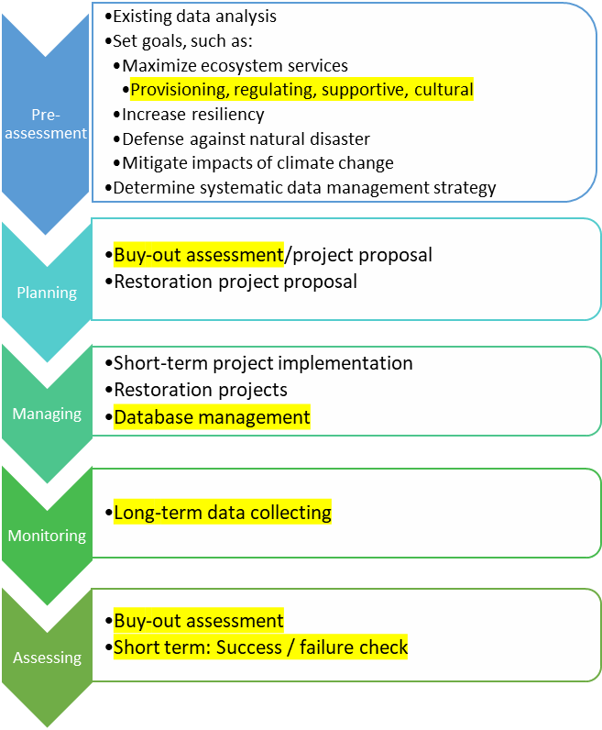

**Acknowledgement**

I would like to thank the Edna Bailey Sussman Foundation for their generous support and New York City Department of Parks and Recreation Division of Natural Resources for offering this valuable opportunity. I would also like to thank my advisor Dr. Margaret Bryant for the guidance along this project. I’m especially grateful to have Chief Marit Larson, Dr. Novem Auyeung and Mr. Christopher Haight as my supervisors for this project and many colleagues at Arsenal North, Urban Field Station and Olmsted.

**References**

Ahern, J., Cilliers, S., & Niemela, J. (2014). The concept of ecosystem services in adaptive urban planning and design: A framework for supporting innovation. Landscape and Urban Planning, 125, 254-259. Retrieved from http://dx.doi.org/10.1016/j.landurbplan.2014.01.020

Green, O. O., Garmestani, A. S., Albro, S., Ban, N. C., Berland, A., Burkman, C. E., . . . Shuster, W. D. (2016). Adaptive governance to promote ecosystem services in urban green spaces. Urban Ecosyst, 77-93. doi:10.1007/s11252-015-0476-2

Johnson BL (1999) The role of adaptive management as an operational approach for resource management agencies. ConservEcol 3(2):8. <URL:http://www.consecol.org/vol3/iss2/art8/>

Siders, A.R.. (2013). Anatomy of a Buyout Program -- New York Post-Superstorm Sandy. Retrieved from: https://www.researchgate.net/publication/308518538_Anatomy_of_a_Buyout_Program_--_New_York_Post-Superstorm_Sandy