The Effects of Long-Term Nitrogen and Phosphorus Addition on Foliar Nutrients and Traits
Jenna Zukswert
SUNY College of Environmental Science and Forestry
Final Report for the Edna Bailey Sussman Fund 2022

- Background
Foliar nutrients are often used to diagnose nutrient deficiencies and growth limitation in trees, but the relationships between foliar nutrients and environmental conditions can be complex. Species vary in how they respond to changes in nutrient availability in ways that reflect diverse resource acquisition strategies, ranging from having “fast” rates of resource acquisition to “slow” (Reich 2014). This means that species that acquire nutrients quickly may also take up water quickly and increases in photosynthetic rate often accompany an increase in water uptake and subsequent water loss through leaves. By monitoring the response of foliar nutrients and traits in trees over time in a fertilization study, which is a common method used to determine and study the implications of nutrient limitation (Güsewell 2004), we can better understand how individual trees, and species, respond to changes in nutrient availability.

- Objectives
For this project, I measured foliar nutrients and both physical and physiological traits (specific leaf area, leaf dry matter content, and ¹³C isotopic signature, which relates to water-use efficiency) to ask 1) how do tree species respond to changes in nutrient availability and 2) do foliar nutrients and traits change with nutrient addition in a consistent way that reflects species’ resource acquisition strategies?
In summer 2021, I collected foliage from dominant tree species at two sites (Jeffers Brook and Hubbard Brook Experimental Forest) in the Multiple Element Limitation in Northern Hardwood Ecosystems (MELNHE) study. This past summer, as part of a Sussman-funded internship through the Earth Systems Research Center at the University of New Hampshire, I started analyzing the data collected last summer before collecting foliage from the remaining plots at the third MELNHE site: Bartlett Experimental Forest. Bartlett has less fertile soil than Jeffers Brook and Hubbard Brook; in this way, sampling at Bartlett expanded the scope and relevance of my research.

- Work Completed
I started my internship by aiding in routine tasks in the MELNHE study that help keep the study running, namely fertilization and litterfall collection. Fertilization of nitrogen (as ammonium nitrate), phosphorus (as monosodium phosphate), and both combined is done meticulously by hand in all 52 50×50-m plots across the MELNHE study. We also collect litter from five litterfall collectors in each plot at this time; this litterfall collection represents the “spring” collection, which consists primarily of American beech (Fagus grandifolia Ehrh.) leaves that the trees retained over winter and dropped in the spring, a process called marcescence (Otto and Nilsson 1981).
For the next month, I continued making measurements of stomatal density from the foliage samples I had collected the summer before. I focused on sugar maple (Acer saccharum Marshall) and yellow birch (Betula alleghaniensis Britton), since these species previously demonstrated a response in sap flow to nutrient addition in MELNHE (Harrison 2015). For each tree, I had pressed and air-dried three leaves. I painted an approximately 1×1-cm square of clear nail polish on three spots of each leaf and mounted each nail-polish film to a slide; each slide had three films. I photographed one spot on each film and counted the number of stomata per view, which I converted to stomata per square millimeter.
I also began to analyze the data I had collected from Hubbard Brook and Jeffers Brook. I explored the response of foliar nutrients N, P, calcium (Ca), and potassium (K), specific leaf area, leaf dry matter content, δ¹³C (isotopic signature, which is negatively correlated with ¹³C discrimination) and stomatal density to nutrient addition. Species examined include sugar maple, yellow birch, red maple (Acer rubrum L.), white birch (Betula papyrifera Marshall), and American beech (Fagus grandifolia Ehrh.); one bigtooth aspen (Populus grandidentata Michx.) and several quaking aspen (Populus tremuloides Michx.) trees were also sampled, but were only used in data visualization, not statistical analysis. I also explored the relationships between foliar nutrients to nutrients of leaf litter from the same species and plots collected in October 2021. In addition to visualizing the data graphically, I performed linear mixed-effects models for each trait. I presented my preliminary results in a 5-minute talk at the Annual Hubbard Brook Cooperators Meeting in Plymouth, New Hampshire in July.
Near the end of the internship, I sampled foliage from six stands at Bartlett Experimental Forest. Doing so increased my sample size from 205 trees to 504 trees. Foliage was sampled from at least two sunlit areas of the canopy of dominant or codominant trees in each plot using a shotgun (Youngentob et al. 2016). Three trees per species were sampled in each plot when possible, taking care to re-sample trees that had been previously sampled in the 2008-10 (pre-treatment) and 2014-16 (first post-treatment) sampling campaigns to minimize variation due to genetics. Species studied include the five mentioned earlier as well as pin cherry (Prunus pensylvanica L.f). Foliage samples were refrigerated and processed within a week for fresh weight and leaf area. Leaves selected for analysis had whole petioles and no obvious signs of insect herbivory or disease.
I ended my internship by oven-drying and grinding the 299 foliage samples I had collected this summer using a Wiley mill with a 40-mesh screen. Once ground, the samples were ready to be subsampled and analyzed for carbon (including stable carbon isotopes) and N by the University of New Hampshire Earth Systems Research Center and ready to be acid-digested and analyzed using inductively coupled plasma optical emission spectroscopy (ICP-OES) to obtain P, Ca, Mg, and K concentrations.

- Preliminary Analysis of Jeffers Brook and Hubbard Brook Data
Nutrients
As expected, N fertilization increased foliar N concentrations and P fertilization increased foliar P concentrations (Figure 1). Under single-nutrient limitation, we would expect that concentrations of the limiting nutrient might further decrease following the addition of the other nutrient (Bracken et al. 2015). We did not find evidence for this in our study overall, though it is worth further exploring the data for red maple, which did seem to exhibit a decrease in N concentrations following P addition, and white birch, which seemed to exhibit a decrease in P concentrations following N addition (Figure 2). One mechanism of nutrient co-limitation of a community can occur when species are limited by different nutrients (Güsewell 2004); this possibility warrants further exploration in my study. N:P ratios were also largely between 10 and 20, which is often used to indicate co-limitation of N and P (Güsewell 2004), but this designation has recently been considered an oversimplification (Ostertag and DiManno 2016).
Over time, I observed that N and P concentrations continued increasing under their respective nutrient addition treatments from 2008-10 to 2014-16 to my study. I also noticed, however, that manganese, which was not a focal element but was measured using ICP-OES, seemed to have increased over time. I am still exploring this phenomenon, but possible reasons for it include climate change (Fernando and Lynch 2015) or artifacts of a change in methodology during acid digestion.
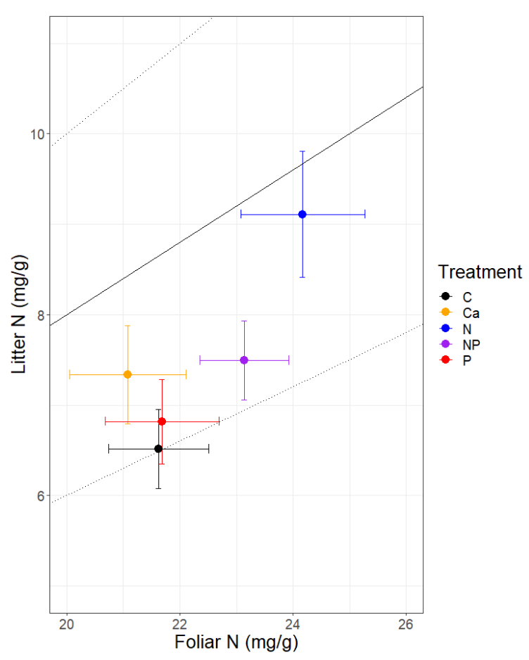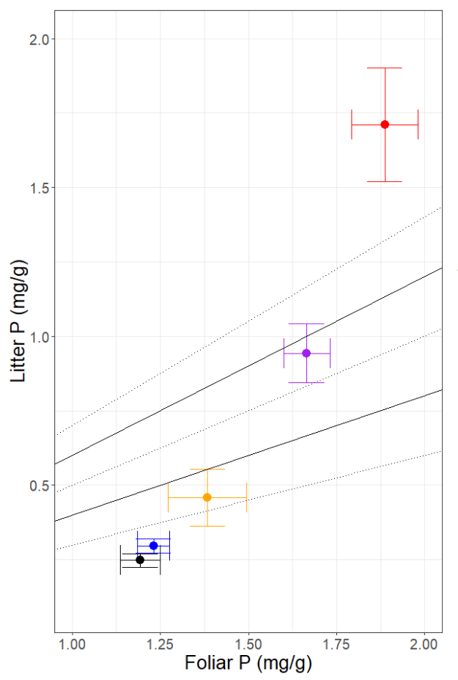
70%
50%
30%
70%
60%
50%
Figure 1. Relationships among foliar N and litter N (left), and foliar P and litter P (right), in leaves of trees present in plots that had been treated with nitrogen, phosphorus, both nutrients, calcium, and no nutrients (control). Dashed and solid lines represent relative, uncorrected resorption rates (e.g., 70% means that 70% of the foliar nutrient concentrations are resorbed; litter nutrient concentrations are 70% lower).
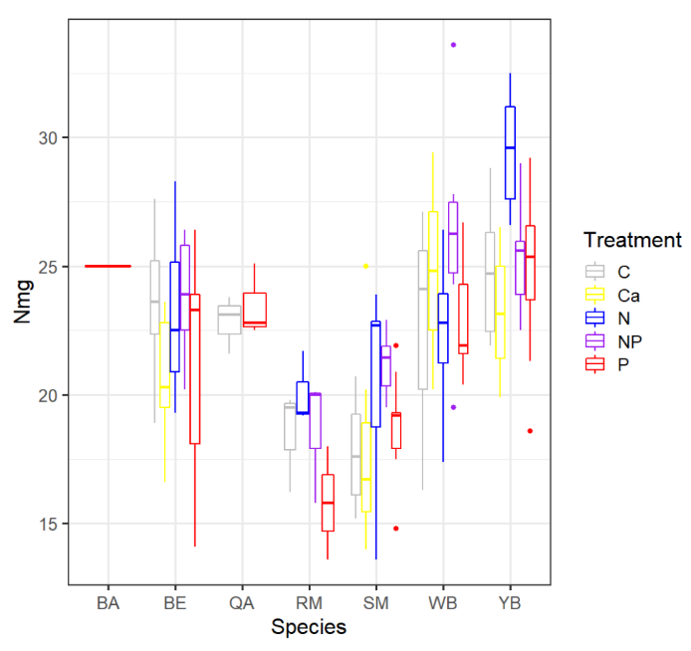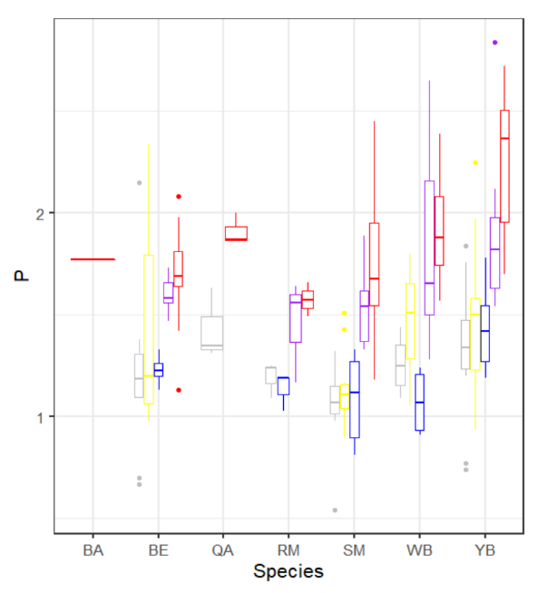
Figure 2. Species differences in foliar N (left) and foliar P (right) following nutrient addition. Species include bigtooth aspen (BA), beech (BE), quaking aspen (QA), red maple (RM), sugar maple (SM), white birch (WB), and yellow birch (YB).
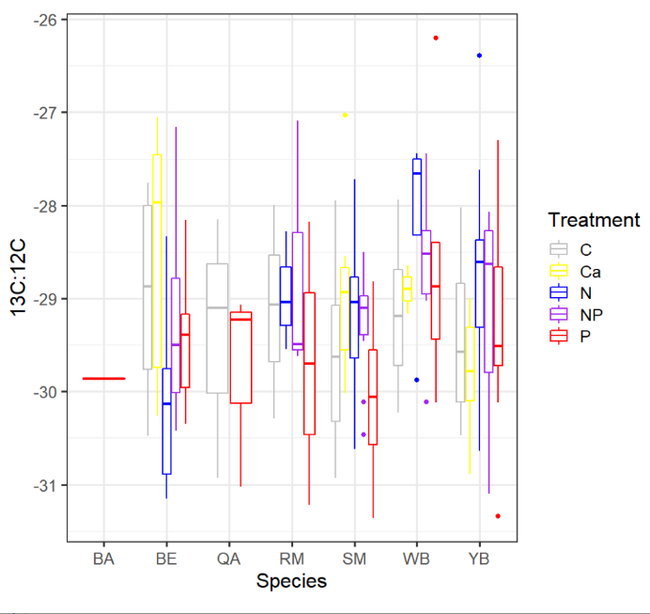
Physical and Physiological Traits
Figure 3. Species differences in isotopic signature (essentially the ratio of 13C to 12C) among treatments in the MELNHE study.
Physical traits such as leaf area, leaf dry matter content, and specific leaf area differed among species, as expected, but did not demonstrate differences related to nutrient-addition treatment. Overall, δ¹³C did not differ among treatments, but further attention towards white birch and yellow birch may be warranted, as these appear to have higher ¹³C:¹²C ratios with N addition, suggesting less ¹³C discrimination and therefore potentially lower stomatal conductance and greater water use efficiency (Figure 3).
Stomatal density differed significantly by species, being lower in yellow birch than in sugar maple (Figure 4). While there were no statistically significant differences in stomatal density due to treatment across the stands sampled in 2021 at the tree level, there were differences among plots within stands. More often than not, stomatal density was slightly higher in stands receiving N addition (N and NP), and was higher in stands receiving Ca addition for yellow birch (Figure 4).

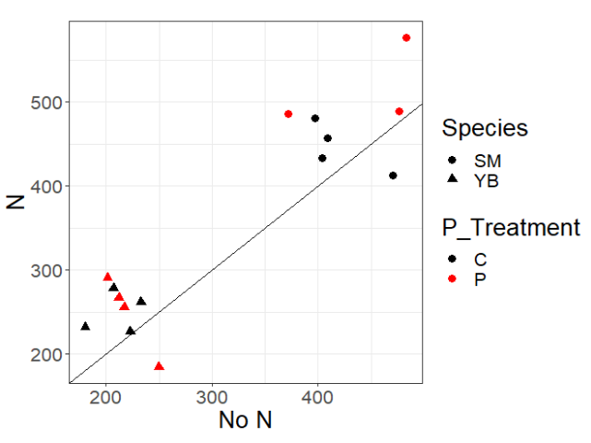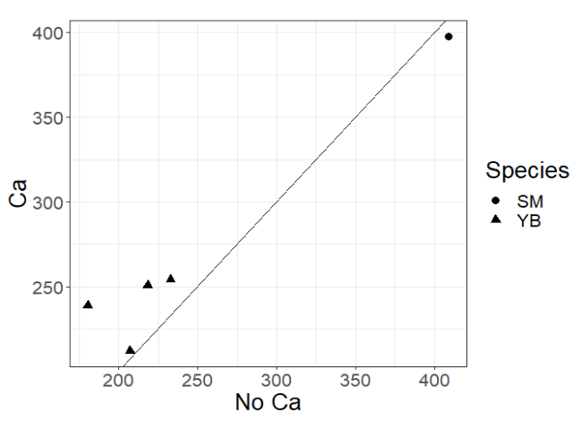

Figure 4. Comparison of stomatal density (stomata per mm²) in plots receiving N addition vs. no N addition (left) and in plots receiving Ca addition vs. no Ca addition (right) of data available for trees at Hubbard Brook and Jeffers Brook. Circles represent sugar maple and triangles represent yellow birch. Data represents the plot mean for each species. The black line represents a 1:1 line. In the plot on the left, black points represent control vs. N comparisons and red points represent P vs. N+P comparisons.

- Next Steps
Upon returning to SUNY College of Environmental Science and Forestry following my summer fellowship, I processed the ground foliage samples collected this summer and collected fresh leaf litter samples from the same plots in October. I am nearing the completion of data collection and will be in the position to repeat my linear mixed-effects model using data from all plots. I also aim to explore differences among species in more depth, particularly as they relate to potential differences in nutrient limitation.
- Acknowledgements
I would like to thank the Edna Bailey Sussman Foundation for their support of this research, and for the special merit award, which I used to purchase a new laptop and access to an online workshop through The Analysis Factor entitled Introduction to Generalized Linear Mixed Models. I would also like to thank my internship supervisor Matt Vadeboncoeur, my PhD advisor Ruth Yanai, and my other dissertation committee members Russ Briggs and Tim Fahey for their continued support and guidance for this research. Foliage sampling by shotgun was made possible by the hard work of Tanner Frost, Adam Wild, and Isaac Roter, and was supported by Jake Beidler, Erin Cornell, Scott Dai, Kelley Gilhooly, Finn O’Connor, Sandip Rijal, and April Zee, who all got to experience “leaf catching”. Chemical analysis of foliar samples was greatly aided by Chuck Schirmer, Deb Driscoll, Matt Vadeboncoeur, and Erin Cornell. Sydney Weimer assisted with stomatal density calculations.

- References

Bracken MES, Hillebrand H, Borer ET, et al. 2015. Signatures of nutrient limitation and co-limitation: Responses of autotroph internal nutrient concentrations to nitrogen and phosphorus additions. Oikos 124: 113–21.
Fernando DR and Lynch JP. 2015. Manganese phytotoxicity: New light on an old problem. Ann Bot 116: 313–9.
Güsewell S. 2004. N:P ratios in terrestrial plants: Variation and functional significance. New Phytol 164: 243–66.
Harrison SL. 2015. Increased sap flow in a northern hardwood forest treated with wollastonite (CaSiO₃). [Undergraduate thesis, University of Michigan].
Ostertag R and DiManno NM. 2016. Detecting terrestrial nutrient limitation: A global meta-analysis of foliar nutrient concentrations after fertilization. Front Earth Sci 4: 1–14.
Otto C and Nilsson L. 1981. Why do beech and oak trees retain leaves until spring? Oikos 37: 387–90.
Reich PB. 2014. The world-wide “fast-slow” plant economics spectrum: A traits manifesto. J Ecol 102: 275–301.
Youngentob KN, Zdenek C, and Gorsel E van. 2016. A simple and effective method to collect leaves and seeds from tall trees. Methods Ecol Evol 7: 1119–23.

