Monitoring Isle Royale’s Mammal Community Following the Introduction of Wolves
Hailey Boone
State University of New York College of Environmental Science and Forestry

Introduction
Isle Royale National Park is home to twelve terrestrial mammal species. Moose (Alces alces), the largest present mammal, came to island in the early 20th century by potentially swimming over from the mainland (Clark 1995, Mech 1996). Grey wolves (Canis lupus) came to Isle Royale via ice bridge somewhere between 1948 and 1950 (Vucetich et al. 2012). With the colonization of wolves, wolf-caused predation significantly lowered the number of moose on the island (Wilmers et al. 2006; Vucetich et al. 2012). From 1980 to 1983, the wolf population dropped from approximately 50 individuals to 12 due to the introduction of canine parvovirus (Peterson et al. 1998). Following the introduction of the virus and greater risk of inbreeding among wolves due to less individuals, the wolf population eventually dwindled to 2 individuals by 2017 (NPS unpublished data). In Isle Royale’s relatively simple and closed off system, wolves acted as the primary apex predator and limitation to the moose population (Peterson et al. 1998). With the decline in the number of wolves’ present, the moose population increased to approximately 5 moose/km² by the 1980s (Vucetich et al. 2012). The high concentration of moose resulted in the over-browsing of some vegetation, such as balsam fir (Abies balsamea), and the increase chance of winter tick (Dermacentor albipictus) infestations (Brandner et al. 1990; Delgiudice et al. 1997). In response, the national park service and collaborators began an initiative in 2018 to slowly introduce approximately 30 wolves onto the island. Currently there are potentially 14 to 17 wolves on the island due to the introductions and reproductive success.
With the introduction of wolves back into a system that has no other competing apex predators, there is potential for the wolves’ spatial use to alter how other mammals use the landscape. Some studies have shown support that Elk alter their habitat selection to avoid wolves (Creel et al. 2005; Fortin et al. 2005) and that potential risk of depredation could cause trophic cascades in a system (Ripple and Beschta 2004; Flagel et al. 2017). The monitoring Isle Royale’s mammal community while the wolf introductions are occurring allows for the opportunity to investigate how prey groups (bull moose, calf + cow moose, snowshoe hare, and beaver) as well as scavengers (red fox and marten) respond to wolves.
Summary of Proposed Work
The aim of this internship was to help establish and coordinate a standardized long-term camera array to provide the Isle Royale National Park Service density information on the mammal community, visitor distribution, and vegetation structure at reoccurring points. Additionally, I was to assist in the organization of wolf movement data and collecting information regarding predation patterns, kill rates, and spatial composition of kills
Methods
Study Area
Isle Royale National Park is located in the middle of Lake Superior. The island has an area of approximately 544km² (Figure 1). Visitors can only access the island from May to October every year and access is limited to boat or seaplane. Wildlife can emigrate or immigrate on and off the island using occasional ice bridges that can form during the winter months. Isle Royale is home to twelve terrestrial mammal species: moose (Alces alces), grey wolf (Canis lupus), beaver (Castor canadensis), snowshoe hare (Lepus americanus), river otter (Lontra canadensis), red fox (Vulpes vulpes), red squirrel (Tamiasciurus hudsonicus), muskrat (Ondatra zibethicus), deer mouse (Peromyscus maniculatus), mink (Mustela vison), ermine (Mustela erminea), and marten (Martes americana). Grey wolves act as the apex predator in this system.
Methodology
During fall 2019, 156 camera traps were deployed on and off Isle Royale’s trail network (Figure 1). Due to rapid camera deployment, camera set up was not standardized and were not arranged to maximize the potential for cameras to detect all mammal species. From June to August 2020, these cameras were checked and established to follow a standardized protocol. Each camera was reassessed to be able to detect the smallest species on the island, such as marten and mink while also obtaining information on sex and age of the larger mammals, such as wolves and moose. At each camera, deployment site-specific details, vegetation and visual obstruction measurements were taken. Additionally, a pilot study was preformed establishing a grid at each camera site and taking measurements where animals were previously detected by the camera from the earlier camera survey.
Preliminary Results and Future Work
From the summer of 2020, we were able to obtain ~850,000 images from the cameras previously placed. The cameras detected 10 out of the 12 terrestrial mammals on the island. These included: grey wolf, moose, marten, river otter, beaver, red fox, deer mouse, muskrat, snowshoe hare, and red squirrel. Although we only had 14-17 wolves present on the island during the survey window, we obtained numerous detections of the wolves with the cameras. From these images, we are matching the photographed wolves with the wolves’ location data to determine individuals, pack establishment, social structure, and information on wolf reproduction. Using the camera array, we were able to get another form of confirmation of multiple wolf pups born in both 2019 and 2020. While establishing the camera grid, I was also able to aid in carcass searches and scat collection for genetic information on the wolves, fox, and marten.
Additionally, the work I conducted over the summer will allow me to investigate three primary research topics for my Ph.D. work. 1.) Do prey and scavengers prioritize minimizing risk of depredation over resource maximation in high wolf use areas? 2.) Does prey and scavenger groups’ probability of spatial use change in response to wolf spatial use and social packing over a long term? 3.) Do prey species use a human shield to minimize the potential risk of depredation from wolves? I will be able to investigate these questions by combining the data collected from the cameras with the wolf GPS collar data and vegetation measurements also collected this summer.
Furthermore, this fellowship allowed me the opportunity to pilot a new methodological approach to estimate densities of animals using camera traps. The method has the potential to give precise estimates of density regardless of if the animal has markings for identification or not. This method will allow better estimates for species that are gregarious. Because of the potential for this method to be paired with artificial intelligence when processing the data, it can also be used for large data projects.

Figures
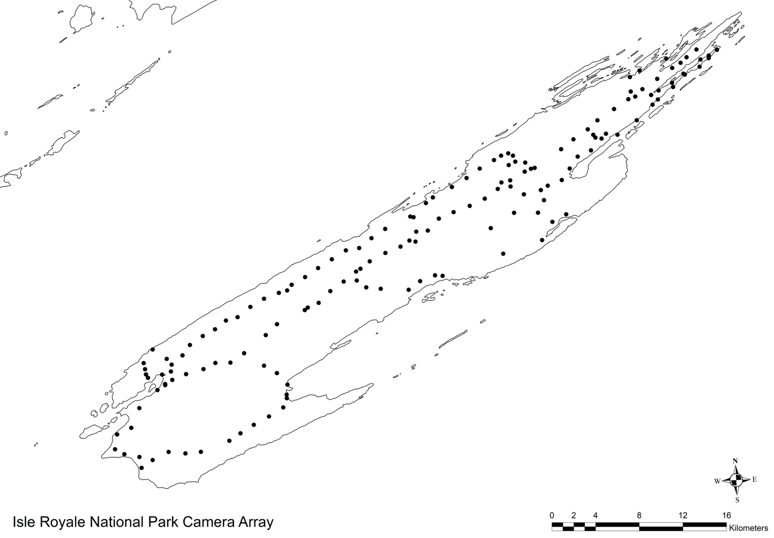

Fig. 1. Map of Isle Royale National Park’s camera array. Cameras are placed on and off the trial network. Placement of the cameras is >500m apart from one another. Each camera runs year-round.

Acknowledgements
I thank Dr. Elizabeth Orning, Leah McTigue, Julia Olsen, Nate Wehr, and Isle Royale National Park’s staff for their assistance with data collection and organization as well as Dr. Jerrold Belant and Mark Romanski for their assistance in developing project ideas, managing logistics, and serving as my internship advisers. Thank you to the Isle Royale National Park Service for allowing me to conduct my internship there this summer.

Literature Cited

Brandner, T. A., R. O. Peterson, and K. L. Risenhoover. 1990. Balsam Fir on Isle Royale: effects of moose herbivory and population density. Ecology 71(1): 155-164.
Clark, C. P.1995. Archaeological survey and testing at Isle Royale National Park, 1987-1990 seasons. Lincoln, Nebraska, Midwest Archaeological Center, USNPS.
Creel, S., J. Winnie Jr., B. Maxwell, K. Hamlin, and M. Creel. 2005. Elk alter habitat selection as an antipredator response to wolves. Ecology 86(12): 3387-3397.
Delgiudice, G. D., R. O. Peterson, and W. M. Samuel. 1997. Trends of winter nutritional restriction, ticks, and numbers of moose on Isle Royale. The Journal of Wildlife Management 61(3):895-903.
Flagel, D. G., G. E. Belovsky, M. J. Cramer, D. E. Beyer Jr., and K. E. Robertson. 2017. Fear and loathing in a Great Lakes forest: cascading effects of competition between wolves and coyotes. Journal of Mammalogy 98: 77-84.
Fortin, D., H. L. Beyer., M. S. Boyce, D. W. Smith, T. Duchesne, and J. S. Mao. 2005. Wolves influence elk movements: behavior shapes a trophic cascade in Yellowstone National Park. Ecology 86(5): 1320-1330.
Mech, L. D. 1966. The wolves of Isle Royale. National Park Service Fauna Series no. 7. Washington, DC: National Park Service.
Peterson, R. O., N. J. Thomas, J. M. Thurber, J. A. Vucetich, and T. A. Waite. 1998. Population limitations and the wolves of Isle Royale. Journal of Mammalogy 79:828-84.
Ripple, W. J. and R. L. Beschta. 2004. Wolves and the ecology of fear: can predation risk structure ecosystems? BioScience 54(8): 755-766
Vucetich, J. A., M. P. Nelson, and R. O. Peterson. 2012. Should Isle Royale Wolves be Reintroduced? A Case Study on Wilderness Management in a Changing World. The George Write Forum 29(1): 126-147.
Wilmers, C. C. E. S. Post, R. O Peterson, and J. A. Vucetich. 2006. Predator disease outbreak modulates top-down, bottom-up and climatic effects on herbivore population dynamics. Ecology Letters 9: 383-389.

