Assessing Plant Species Regeneration in Response to Buckthorn Management Strategies in Urban Forest Restorations
Jacob Erle
SUNY College of Environmental Science and Forestry
Final Report to the Edna Bailey Sussman Foundation, 2020

Background
Numerous invasive plant species are widespread in the City of Syracuse, from protected parks to people’s backyards. Conversion of natural spaces for anthropogenic use causes fragmentation of mature forest communities (Pickett et al., 2001). The density and distribution of trees planted in cities contrast greatly from naturally occurring habitats (Lodge, 1993). There is less connectivity between planted “islands” with an altered density and distribution of tree species. The conversion of forested spaces into impervious surfaces yields less opportunity to mitigate chemical runoff from homes and roads.
Urban forest stands are under developmental pressure for other land use activities, such as recreation, mitigating noise pollution and waste management (Airola and Buchholz, 1984). The relationship between urban planted areas and the surrounding environment of these urban plantings can have benefits as well as drawbacks. Such drawbacks are evident in many neighborhood parks where species that once coexisted are now separated and unable to interact due to construction of roads and housing establishments. Rising deposits of nitrogen from fertilizers and chemical runoff disable species adapted to nitrogen-deficient habitats and can enhance success rates of plant invasions (Dukes and Mooney, 1999).
Common buckthorn, (Rhamnus cathartica), henceforth buckthorn, is one of the dominant invasive plants found in Syracuse parks. Buckthorn is a non-native shrub or understory tree that has thrived in the United States. It was introduced to North America in the early 19th century and was used extensively as a hedge plant (Kurylo and Endress, 2012). Since then, buckthorn has spread widely across the North American continent by invading a variety of habitat types and producing dense thickets (Fagan and Peart 2004). Buckthorn plants present multiple negative impacts to ecosystems, natural and anthropogenic. Buckthorn is highly shade tolerant and does well in moist, shady sites (Archibold et al., 1997) where it out-competes native plant species for sunlight and space (Dovčiak et al., 2003). Its leaf buds emerge earlier in the spring than most native woody species; leaves remain on plants longer than native species (Stokdyk and Herrman, 2014). The prolonged presence of leaves aids to increased buckthorn growth rates before canopy leaves emerge, and enhanced buckthorn dominance in the understory compared to other plants that have yet to leaf out (Harrington et al., 1989). In places of high buckthorn abundance, the plants shade out the understory; this prohibits new plant recruits from receiving sunlight crucial for photosynthesis and inhibits regeneration of native tree seedlings (Frappier et al., 2004). With support provided by the Sussman Foundation I was able to conduct more extensive research on invasive species removal, initiate efforts for habitat restoration, and continue invasive plant removal from Schiller Park in Summer 2020.
Work Completed
The coronavirus pandemic (COVID-19) that began in March 2020 significantly impacted progress done. With Onondaga Earth Corps (OEC) and Syracuse Parks and Recreation (SYR P & R) limited to 50% working capacity they were unable to assist with any field operations until the last week of July. There was too great an area to remove plant material working by myself, never mind how extracted plants would be removed from the park site. Much of the time that was initially planned for clearing other sections of buckthorn from the park was devoted to three tasks: 1.) Analyze preliminary field data gathered before further summer 2020 field work occurred; 2.) Research current methods used for invasive species removal and urban forestry restoration; 3.) Analyze site characteristics via ArcGIS and plot locations for native species to be planted when conditions permitted (see Figure 1).
Between July 27 – August 27, 2020, field work was done with OEC to remove plants from Schiller Park and initiate measures to suppress buckthorn regeneration mechanically via buckthorn bags in the Mechanical treatment study site and Combination study site (i.e., Mechanical and Chemical). The independent herbicide contractor was unable to chemically treat our project sites at Schiller due to hindrances caused by COVID-19, which meant no native species could be planted at the park site. Planting some species in some sites but not others would affect results by not measuring all plant responses at the same time. Field monitoring was done to describe physical characteristics of Schiller Park that shows species diversity was low in the five plots where data was recorded (Table 1). Field monitoring efforts will continue for Spring 2021 and expand to other park sites, as well.
Expected Future Work
While developments for project progress did not go as planned due to COVID-19, our project team adapted and adjusted. I entered collaborations with a fellow graduate student in Fall 2020, whose project goals complement my own. They plan to test the response of selected trees and shrubs to buckthorn treatments across a yet-to-be determined abiotic gradient (e.g., slope, elevation, soil drainage). We have begun recruiting other undergraduates to assist in gathering data in 2021, remove invasive plants, and planting native species. Working with another graduate student enables this project to expand to other park locations, which will increase the scale of the study and potentially yield more meaningful results in data collected. These additional measures will enhance results already gathered and extend the project objective of this study to apply to other urban forests within the city of Syracuse. Data collected in Spring and Summer 2021 will concentrate on present characteristics of each of the parks being restored and the responses plants exhibit to different treatment methods for managing buckthorn growth.
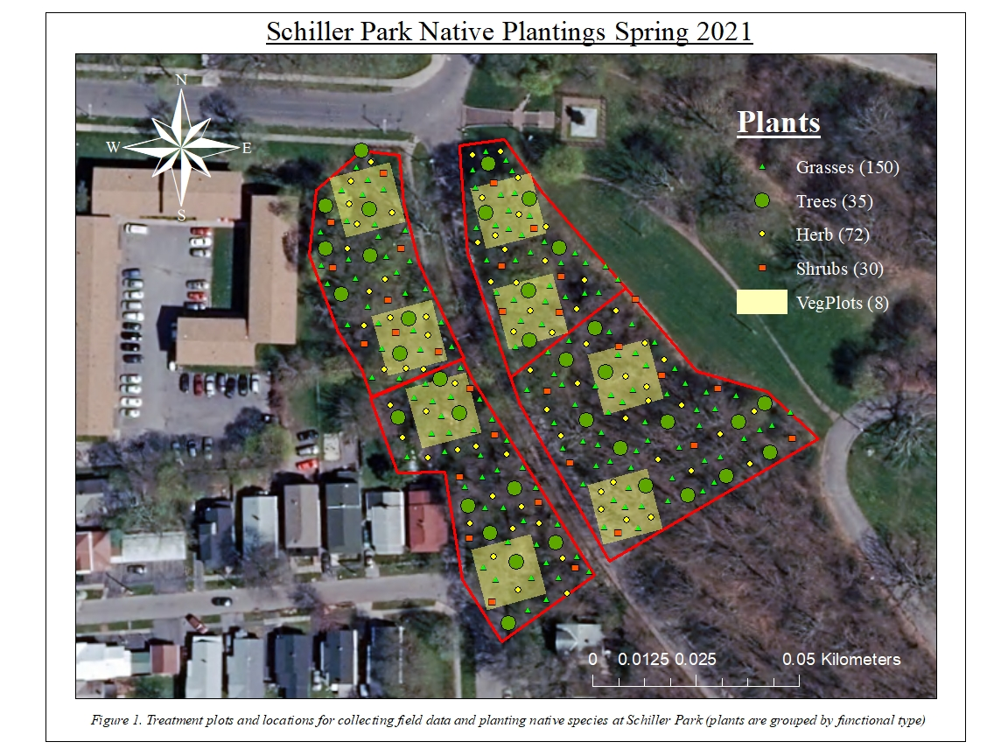
 | Plants Observed
Trees (11) | Vines/Shrubs (11) | Herbaceous (5)
Acer plantanoides | Acer campestre | Aster sp.
Acer saccharum | Amelanchier sp. | Carex sp.
Carya sp. | Berberis vulgaris | Hemerocallis sp.
Catalpa speciosa | Cornus racemosa | Lysimachia nummularia
Fraxinus americana | Crataegus sp. | Solidago sp.
Juglans nigra | Forsythia ×intermedia
Prunus padus | Ligustrum vulgare
Prunus serotina | Lonicera sp.
Quercus alba | Rubus occidentalis
Quercus rubra | Viburnum acerifolium
Ulmus sp. | Vitis sp.
Table 1) Plants identified at Schiller Park, other than buckthorn, observed during preliminary monitoring efforts and categorized upon growth habit and how many of each category were present

Acknowledgement
I sincerely thank the Edna Bailey Sussman Foundation for their assistance, as well as the Syracuse Parks and Recreation Department and their help with this challenging and engaging project. I thank the members of my graduate steering committee for their guidance in navigating the development of this project through unprecedented circumstances caused by COVID-19: Stephen Arborist, Arborist for Onondaga County, Dr. Russell Briggs, and my chief advisor Dr. Donald Leopold. I also owe much thanks to the OEC staff, who I worked with during the summer field season and managed to remove an extensive concentration of invasive plants from the field site in a short span of time.
References
Airola, T.M., and K. Buchholz. 1984. Species structure and soil characteristics of five urban forest sites along the New Jersey Palisades. Urban Ecology 8(1-2): 149–164.
Archibold, O.W., Brooks, D. and Delanoy L. 1997. An investigation of the invasive shrub European buckthorn, Rhamnus cathartica L., near Saskatoon, Saskatchewan. Canadian Field-Naturalist 111 (4): 617-621.
Dovčiak, M., P.B. Reich, and L.E. Frelich. 2003. Seed rain, safe sites, competing vegetation, and soil resources spatially structure white pine regeneration and recruitment. Canadian Journal of Forest Research 33(10): 1892–1904.
Dukes, J.S., and H.A. Mooney. 1999. Does global change increase the success of biological invaders? Trends in Ecology & Evolution 14(4): 135–139.
Fagan, M., and D. Peart. 2004. Impact of the invasive shrub glossy buckthorn (Rhamnus frangula L.) on juvenile recruitment by canopy trees. Forest Ecology and Management 194(1-3): 95–107.
Frappier, B., R.T. Eckert, and T.D. Lee. 2004. Experimental removal of the non-indigenous shrub Rhamnus frangula (glossy buckthorn): effects on native herbs and woody seedlings. Northeastern Naturalist 11:333-342.
Harrington, R.A., B.J. Brown, P.B. Reich, and J.H. Fownes. 1989. Ecophysiology of exotic and native shrubs in southern Wisconsin. Oecologia 80(3): 368–373.
Kurtz, C. M. 2013. An assessment of invasive plant species monitored by the Northern Research Station Forest Inventory and Analysis Program, 2005 through 2010. Gen. Tech. Rep. NRS-109. Newtown Square, PA: U.S. Department of Agriculture, Forest Service, Northern Research Station. 70 p.
Kurylo, J., and A. Endress. 2012. Rhamnus cathartica: Notes on its early history in North America. Northeastern Naturalist 19 (4): 601 – 610.
Lodge, D.M. 1993. Biological invasions: Lessons for ecology. Trends in Ecology & Evolution 8(4): 133–137.
Pickett, S.T.A., M.L. Cadenasso, J.M. Grove, C.H. Nilon, R.V. Pouyat, W.C. Zipperer, and R. Costanza. 2001. Urban ecological systems: linking terrestrial ecological, physical, and socioeconomic components of metropolitan areas. Annual Review of Ecology and Systematics 32(1): 127–157.
Stokdyk, J.P., and K.S. Herrman. 2014. Short-term impacts of Frangula alnus litter on forest soil properties. Water, Air, & Soil Pollution 225(2000): 1–9.

