Response of Wild Bee Assemblages to Management of Restored Wetlands in an Agricultural Landscape

Molly Jacobson
SUNY College of Environmental Science and Forestry
Final Report to the Edna Bailey Sussman Foundation – 2020

Introduction
Pollination services performed by insects, mainly bees, are indispensable for our food supply and critical for the persistence of ecosystems (Klein et al. 2007, Gallai et al. 2009). However, global declines have been observed in many species of wild bees in recent decades, due largely to habitat loss as a result of agricultural intensification, along with pesticide use and pathogen spillovers associated with agricultural activities (Potts et al. 2010, Cameron et al. 2011). Each species of native bee possesses a unique combination of diet and nesting requirements that governs its abundance, distribution, and ecological niche. Yet, this basic information is still poorly understood for many of the nearly 4,000 species present in North America, creating challenges for conservation efforts. Much of the contemporary focus of habitat management for pollinators is on the reclamation of farm field margins, prairies, and suburban gardens (Pywell et al. 2006, M’Gonigle et al. 2015). While these habitats may provide the resources necessary for some generalist species, recent research has suggested that diverse landscapes with many cover types (i.e., mature forest, young forest, fields, wetlands) are required to support the full diversity of native pollinators (Mandelik et al. 2012, Rubene et al. 2015). In the last century, shifts in attitude towards wetlands have prompted the restoration of farmed or degraded wetlands for wildlife management, primarily of waterfowl. Management regimes consist in part of “drawdowns” which seasonally remove all or part of the water from an impoundment to mimic natural flooding and drying of historically connected water bodies, which in turn promotes the growth of plant communities favored for wildlife as judged to meet management goals (Fredrickson and Taylor 1982). Yet despite an abundance of unique wetland-adapted flowering plants, little is known about pollinator assemblages in wetlands, or how current management techniques promote or influence pollinator use of these habitats. Such information has high potential value for improving pollinator conservation efforts to meet the needs of a wider diversity of species, as well as providing land managers with data that can be incorporated into future wetland management decisions. The goals of this project are to gain new insight into the bee species which utilize wetlands, and determine the impact, if any, of drawdown treatments on the floral resources available for bees and the diversity and composition of wetland bee assemblages.

Methods
All 2020 fieldwork was carried out in accordance with COVID-19 safety requirements as outlined in a Fieldwork Plan submitted to SUNY-ESF in spring of this year. Labwork in 2020 was performed entirely remotely using a microscope and pinning supplies from the lab of Dr. Melissa Fierke.

Study Site
This study took place over the course of two field seasons (2019-2020) primarily within the Montezuma Wetlands Complex, a 50,000 acre patchwork of state, federal, and private protected land across three counties in the Finger Lakes region of Central New York, containing nearly 10,000 acres of wetland habitat restored from agriculture. Thirty-three sites were selected in a complete block design to represent the three types of drawdown management: 1) passive (Fig 1), where water is held at or near full-service level (maximum designed capacity) throughout the growing season with no active drawdown of water (water loss is solely through evaporation), 2) partial drawdown, where 20% to 50% of the basin is exposed by August 1st using active water drawdown, and 3) full drawdown, where nearly 100% of the basin is exposed by August 1st with the only remaining water located in the borrow ditch. Of these, thirty were located within the Complex, while three were part of the Seneca Meadows Wetlands Preserve in Seneca County. The portion of this project funded by the Edna B. Sussman Foundation encompassed those sites in the 2020 field season located at the Montezuma National Wildlife Refuge.

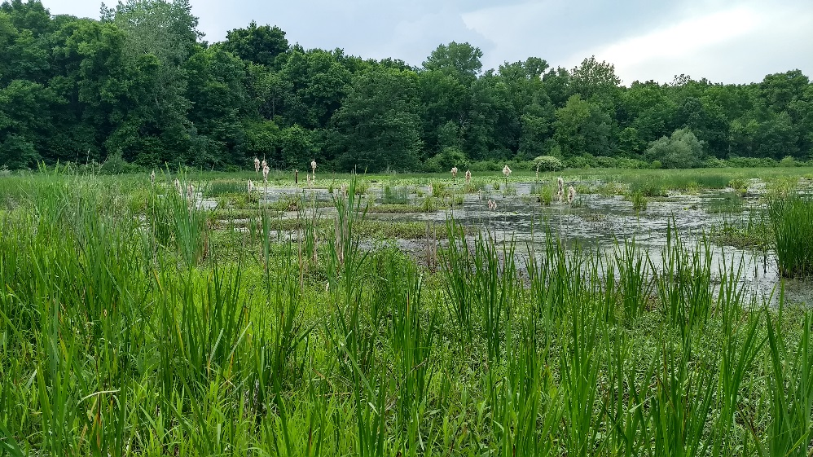
Vegetation and Pollinator Surveys
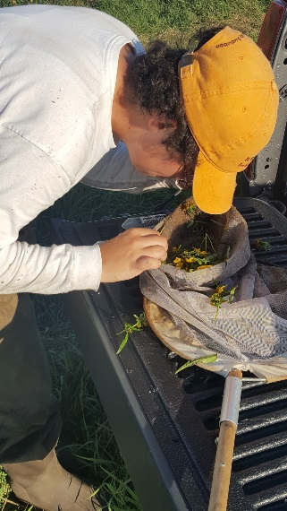
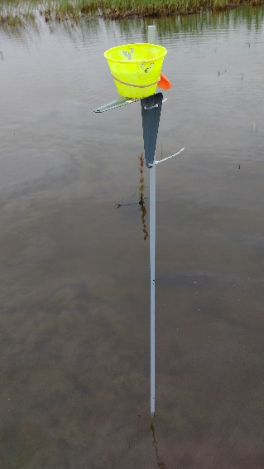

Figs. 1-3 (left to right). 1) An example of a passively managed wetland study site, ‘Lost Pond.’ 2) Setup for passive bee collection method, known as ‘bee bowls’ or pan traps. 3) The researcher sifting through contents of a floral sweep of nodding beggarsticks (Bidens cernua), photo by Shianne Lindsay.

Data collection took place monthly from June through September, on consecutive fair weather days for a period of approximately two weeks per month. Vegetation surveys utilized a point-intercept method, with 40 points established equidistant along 2-4 transects per site, the specifics of which were determined by the unique dimensions of each site. At each point, plant richness, species identities, vegetation height, water depth, and presence of open water or mudflat if applicable were recorded. Bees (and other wild pollinators) were collected using standardized pollinator survey procedures described in detail by Droege (2015) and modified for use in wetland environments. Alternating neon-painted pan traps (‘bee bowls’) in yellow, white, and blue were fastened to fiberglass stakes and deployed at 24 of the 40 vegetation survey points in each site (eight of each color). Bowls were filled with a solution of two-thirds soapy water and one-third propylene glycol (to prevent evaporation), and were retrieved after 24 hours (Fig 2). In addition to this passive method, the active collection method of sweep-netting was used to supplement pan trap catch and provide plant-pollinator association data used to establish ecological roles for bee species (Fig 3). Monotypic patches of flowering plants were thoroughly swept during peak bee activity hours, generally 10:00am – 2:00pm, to capture a complete representation of insect visitors. All specimens from pan traps and sweeps were stored in 70% ethanol until processing took place.

Specimen Processing
Pollinator specimens were cleaned, dried, and pinned during non-sampling weeks and the beginning of autumn. Bees were identified to the species level using relevant literature and keys, with the exception of ‘morphologically monotonous’ genera like Lasioglossum sweat bees which require examination by an expert and/or gene sequencing to confirm ID. Non-bee pollinators such as flower flies (Diptera: Syrphidae), yellowjackets (Hymenoptera: Vespidae) and square-headed wasps (Hymenoptera: Crabronidae) were taken to species when possible. All individuals were given unique identifiers and collection metadata in a digital database, and will be given physical labels when time permits.

Results
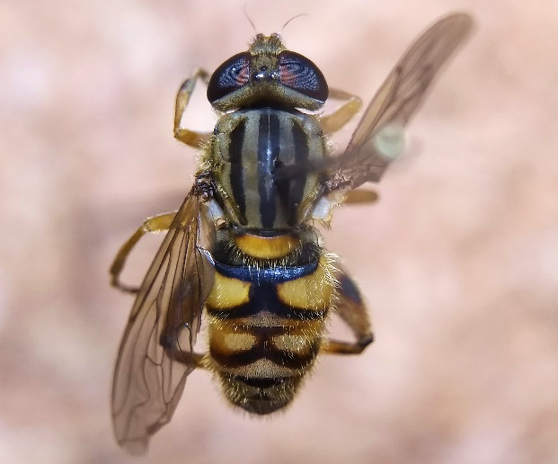
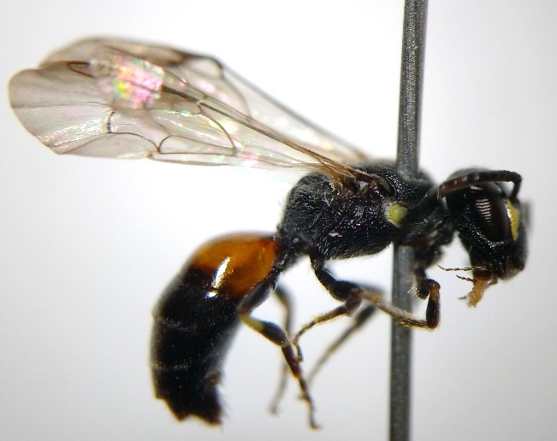
Work Completed

A total of 10,762 pollinators were collected in this survey, including 4,984 in 2020. Of these, 9,046 were bees. Five of the six bee families present in New York were documented, with the exception of Melittidae, specialists which are considered rare and local in their distribution. Representation of these families was dominated by Halictidae (sweat bees), which accounted for 75.2% of all specimens, followed by Apidae (bumble bees, long-horned bees, the non-native honeybee) at 21.2%, with the remaining three families (Colletidae – cellophane and masked bees, Andrenidae – mining bees, and Megachilidae – leafcutter bees) comprising just 2.8%, .4%, and .2% respectively. Overall, at least 79 distinct morphospecies of bees were identified, with likely over a dozen more nestled within the genera Lasioglossum and Nomada which could not be separated. 17.3% of pollinators were collected from sweeps of 61 different flowering plant species, while 82.7% were caught in pan traps. Both are effective methods that should be paired in surveys to capture the widest possible range of bee diversity; for example, nearly 90% of bumble bees were caught in sweeps whereas 96.5% of Lasioglossum sweat bees were caught in pan traps. A complete depiction of bee species collected in the survey can be seen in Fig 7. In addition, many non-bee pollinators were documented, including 1,124 flower flies and 383 wasps. While these were not the primary focus of the survey, their prevalence and diversity suggest they play a significant role in the pollination of wetland plants.
Figs. 4-5. Notable species collected in the survey: 4) Hylaeus nelumbonis, a masked bee. 5) Parhelophilus divisus, a flower fly.
As to be expected, most pollinators found in the survey were common or fairly common generalists (those that visit a range of flowers), however some rare or specialized species of note were collected which validate the importance of wetland ecosystems for hosting unique communities of flora and fauna. Hylaeus nelumbonis (Colletidae; see Fig 4) is a poorly known wetland habitat specialist. 137 individuals were collected, and 14 floral hosts were recorded, which adds valuable information to our understanding of this species and its role in these systems. Parhelophilus divisus, the yellow-legged bog fly (Syrphidae; see Fig 5), is a rare pollinating fly known only from scattered records in the eastern US. 65 individuals were collected, which serves as a testament to the potential value of restored wetlands to act as functional, high-quality habitat for species with narrow diet and habitat requirements.
While statistical analysis has not yet been performed on the data, some evident trends can be examined. Passive and full drawdowns exhibited distinct differences in water depth, and vegetative structure and composition, additionally influenced by time of year, as drawdowns took effect in midsummer and dormant seeds exposed to the appropriate conditions germinated. Flowering plants tolerant of constant inundation such as white waterlily (Nymphaea odorata) and pickerelweed (Pontederia cordata) were common in passive wetlands, whereas “moist-soil” flowers like beggarsticks (Bidens spp.) and Joe-Pye weed (Eutrochium maculatum) preferred full drawdowns that lacked any standing water by August (Fig 6). Consequently, specialists on such plants were only collected in the sites subject to the drawdown that promoted their hosts. Partial drawdowns did not appear to provide any substantial ‘best of both worlds’ benefit or host a higher diversity of pollinators than the other treatments. Many passive wetlands achieved a partial drawdown state through evaporation alone and thus the treatment itself is potentially unnecessary from a management perspective. Given that the majority of pollinator species documented were generalists found in a variety of habitats, it is highly likely that wetlands act as a seasonal source of supplementary resources for upland-nesting bees, while hosting some endemic specialists that nest in or adjacent to the wetland. Restoring wetlands from agriculture enriches the landscape, and when made a component of a heterogeneous complex of cover types, can provide critical late-summer/fall floral resources for a wide variety of pollinators to thrive (see Fig 8 for a graphical representation of the seasonal turnover of bee families).

Future Work
Statistical analysis of combined vegetation and pollinator data from both field seasons has begun and will continue through winter 2020-2021. Analyses will be performed in R and utilize permutational ANOVAs and non-metric multidimensional scaling (NMDS) ordination to test for and visualize any multivariate relationships between drawdown treatment, environmental variables, flowering plants, and wild bee assemblages. Data from sweeps will be used to assess community function and better understand species niches through the creation of plant-pollinator visual interaction networks in R using package bipartite. Through such analyses, I will be able to more thoroughly meet the goals of the internship and determine how current management regimes for restored wetlands result in unique sets of floral resources for bees and consequently host different assemblages of pollinators. The results will be presented to the Montezuma National Wildlife Refuge and will culminate in an M.S. thesis and journal publication.

Acknowledgements
This work was made possible by the generous financial support of the Edna Bailey Sussman Foundation. I thank the continued guidance of my advisors Dr. Michael Schummer and Dr. Melissa Fierke, committee member Dr. Donald Leopold, and internship sponsor Linda Ziemba at the Montezuma National Wildlife Refuge. I would also like to acknowledge the NYSDEC, Friends of Montezuma, Seneca Meadows, Cargill, and Ducks Unlimited for additional financial support in 2019 and 2020. Lastly, thank you to my field technicians who made sure I never got swallowed up by a muddy ditch!

Literature Cited
Cameron S.A., Lozier J.D., Strange J.P., Koch J.B., Cordes N., Solter L.F., Griswold T.L., and Robinson G.L. 2011. Patterns of widespread decline in North American bumble bees. Proceedings of the National Academy of Sciences of the United States of America 108(2):662-667.

Droege S. 2015. The very handy manual: how to catch and identify bees and manage a collection. USGS Native Bee Inventory and Monitoring Lab.

Fredrickson L.H. and Taylor T.S. 1982. Management of seasonally flooded
impoundments for wildlife. U.S. Fish and Wildlife Service, Resource Publication
148, Washington, D.C., USA.

Gallai N., Salles J.M., Settele J., and Vaissière B.E. 2009. Economic valuation of the vulnerability of world agriculture confronted with pollinator decline. Ecological Economics 68:810-821.

Klein A.M., Vaissière B.E., Cane J.H., Steffan-Dewenter I., Cunningham S.A., Kremen C., Tscharntke T. 2007. Importance of pollinators in changing landscapes for world crops. Proceedings of the Royal Society B 274:303-313.

M’Gonigle L.K., Ponisio L.C., Cutler K., and Kremen C. 2015. Habitat restoration promotes pollinator persistence and colonization in intensively managed agriculture. Ecological Applications 25(6):1557-1565.

Mandelik Y., Winfree R., Neeson T., and Kremen C. 2012. Complementary habitat use by wild bees in agro-natural landscapes. Ecological Applications 22(5):1535-1546.

Potts S.G., Biesmeijer J.C., Kremen C., Neumann P., Schweiger O., and Kunin W.E. 2010. Global pollinator declines: trends, impacts, and drivers. Trends in Ecology and Evolution 25(6):345-353.

Pywell R.F., Warman E.A., Hulmes L., Nuttall P., Sparks T.H., Critchley C.N.R., and Sherwood A. 2006. Effectiveness of new agri-environment schemes in providing foraging resources for bumblebees in intensively farmed landscapes. Biological Conservation 129:192-206.

Rubene D., Schroeder M., and Ranius T. 2015. Diversity patterns of wild bees and wasps in managed boreal forests: effects of spatial structure, local habitat and surrounding landscape. Biological Conservation 184:201-208.

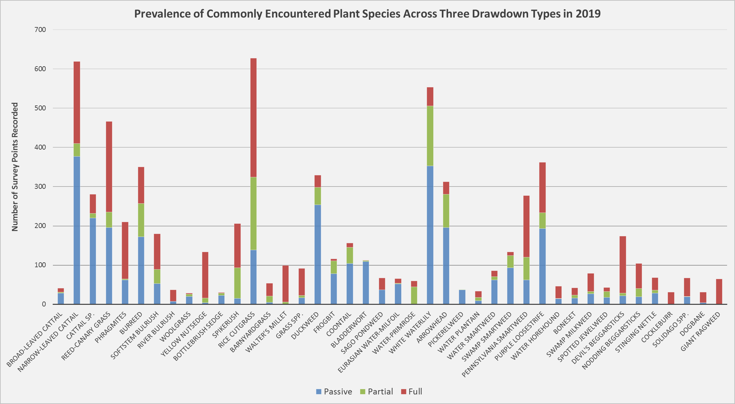

Figure 6. Plant species most commonly recorded during 2019 vegetation surveys and their frequencies in each of the three drawdown treatments. Species included are those with >30 abundance, and are organized by functional group (e.g., submerged aquatic vegetation, flowering emergent vegetation, graminoids). Drawdown outcomes for 2020 were not yet available at the time of this report.

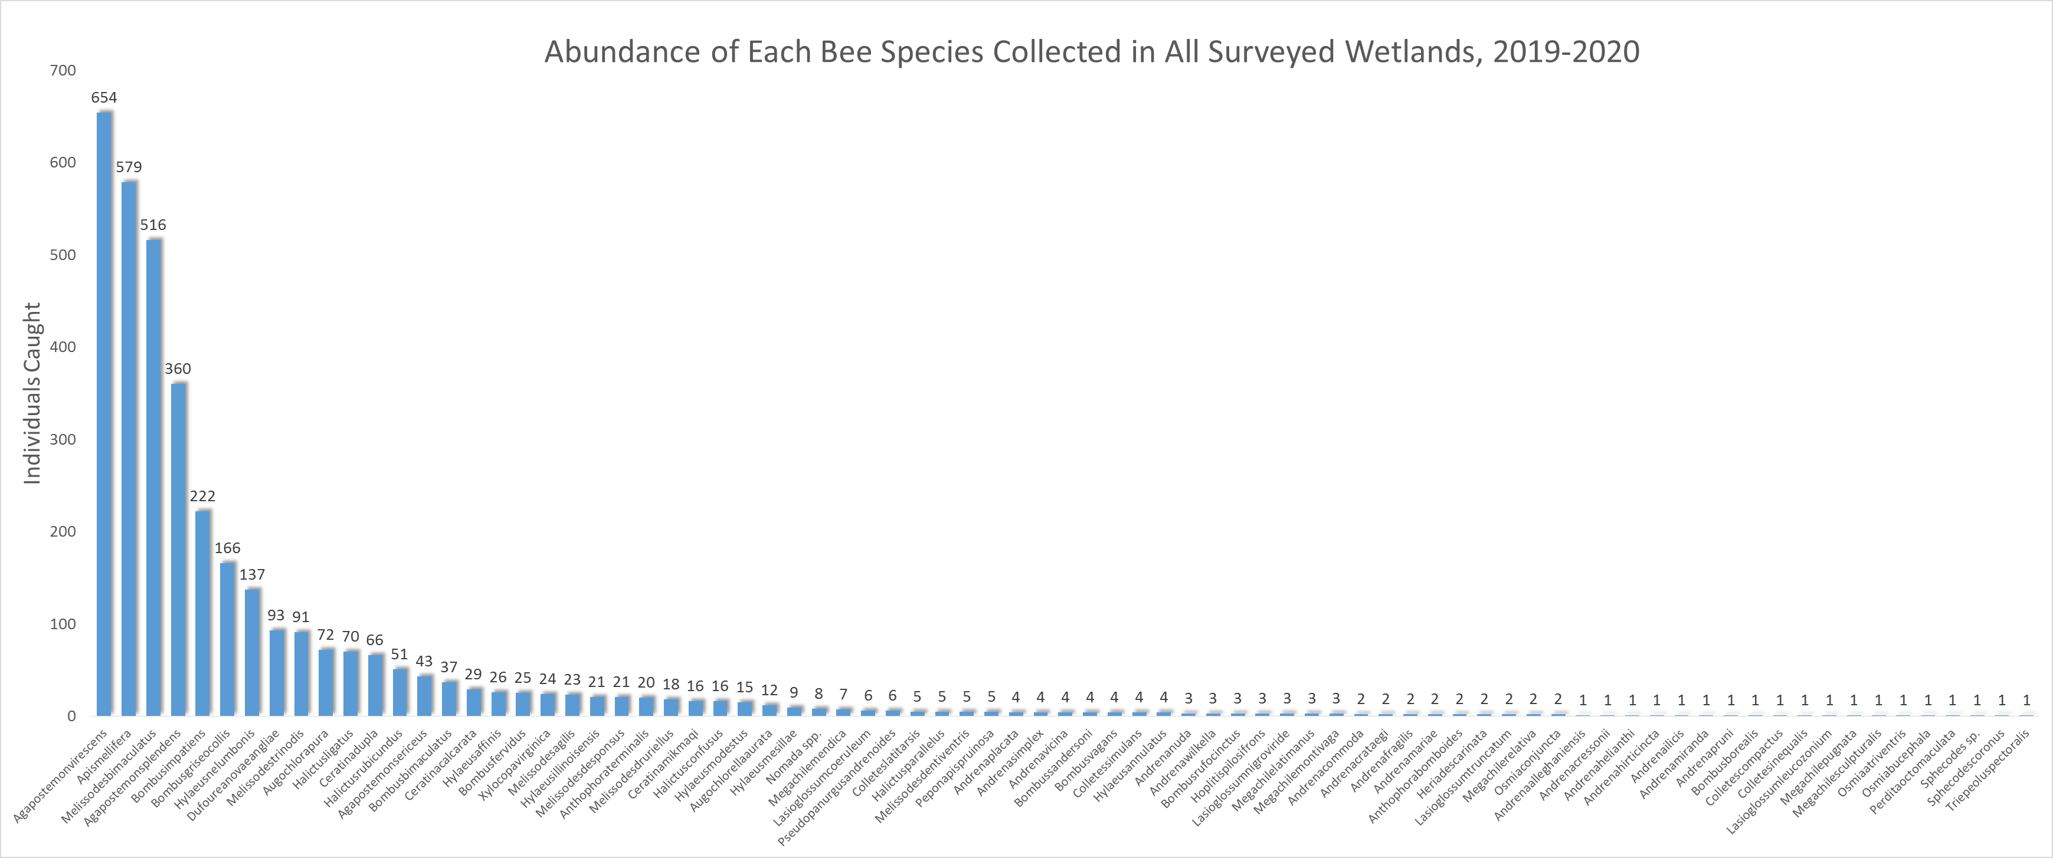

Figure 7. Raw abundances of all bee species or morphospecies collected in the study in descending order, with all study sites and treatments pooled over both field seasons. Specimens not identified past genus, including the highly abundant and taxonomically challenging Lasioglossum (5,412 individuals), are excluded, with the exception of cuckoo bee representatives Sphecodes sp. and Nomada spp.

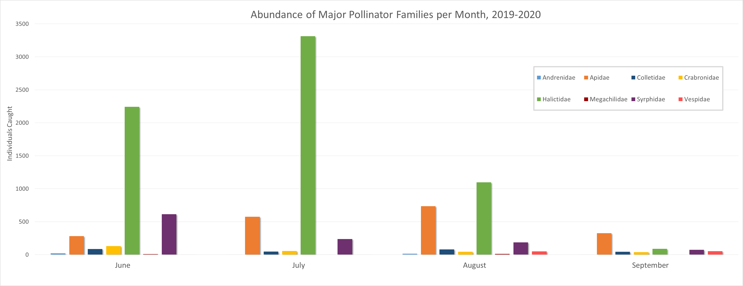

Figure 8. Seasonality of the major families of insect pollinators from pan trap and sweep data across the months of this survey. Chart includes three commonly encountered non-bee pollinator families: Crabronidae (square-headed and sand wasps), Vespidae (yellowjackets and potter wasps), and Syrphidae (flower flies).

