Examining how the soil catena, along with other factors, influences northern hardwood regeneration
Poonam Joshi
SUNY College of Environmental Science and Forestry
Final Report for the Edna Bailey Sussman Fund 2022

Background
The most common type of forest in the northeastern United States is a northern hardwood forest, which is mostly made up of sugar maple (Acer saccharum Marsh.), American beech (Fagus grandifolia Ehrh.), and yellow birch (Betula alleghaniensis Britton). They provide significant ecological and financial benefits in these areas (Leak et al., 2014). The existence of various age groups of seedlings, saplings, and trees determines the forest's capacity for regeneration and production (Chauhan et al., 2008). In northern hardwood forests, a large diversity of tree species can be found, each with its biological niche and, most notably, differing light requirements and tolerances (Burns & Honkala, 1990). As a result, the species composition of a stand changes during the successional stages, and the regeneration patterns that are specific to each species composition call for diverse silvicultural techniques (McClure & Lee, 1993). It is necessary to use measurements that will accurately predict the future of stand composition to assess the efficacy of gap-based silvicultural systems in regenerating tree species (Bilodeau-Gauthier et al., 2020). The success of post-harvest regeneration, whether it occurs naturally or through a plantation, has long been difficult for forest managers to guarantee (Brand et al., 1991; Hobbs, 1992).
Various factors play major role in regenerating tree species. One of them is competition from unwanted species such as American beech. Since the onset of beech bark disease (BBD) in eastern North America, the commercial value of American beech has declined (Cale et al., 2017). Although beech is no longer a major component of the overstory, it has increased in dominance relative to other species in the understory (Bose et al., 2017). Other factors influencing regeneration studied in this research are soil pH, and competition from woody shrubs, and herbaceous plants.

Proposed Work
I proposed to investigate the regeneration of a northern hardwood forest following a shelterwood harvest in the Watershed Agricultural Council’s (WAC) Model Forest at the Frost Valley YMCA. I hypothesized that the shelterwood-treated area promotes adequate regeneration of desirable northern hardwood species. I examined several factors that may lead to null hypothesis rejection, such as variation in soil pH across the soil catena position, competition from woody shrubs and herbaceous plants, and American beech. While many of these factors have been studied, they rarely have been examined altogether as a complex.

Methods

Site Description
The study site was 34.8 hectares (86 acres) area of a stand in Frost Valley YMCA (Figure 1), situated in Clareville, New York, part of the Catskill Mountains. A shelterwood cut was applied on the site in 2019. Dominant tree species include sugar maple (Acer saccharum), American beech (Fagus grandifolia), and yellow birch (Betula alleghaniensis). The understory of this stand had sugar maple, yellow birch, pin cherry, black cherry regeneration, and beech sprouts. Some areas had a high percentage of hay-scented fern cover showing the presence of intense deer pressure. The origin of this stand was a naturally occurring stand that originated from abandoned agricultural land in the early 1900s.
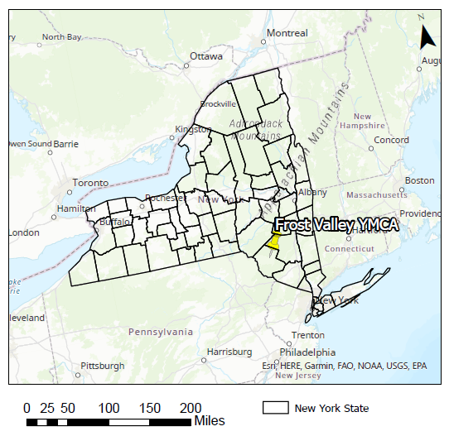
Figure 1: A location map of the study site

Plot Establishment
I established a 40-m grid along the soil catena (back slope and foot slope were the positions of soil catena observed in this site) and sampled 102 plots of 2 m² to collect regeneration data within three size classes: <1ft, 1-3 ft, and >3ft. The percent of woody shrubs, ≤1.0 m height herbs, and exposed rock was measured visually by dividing the 2 m² plots into four equal quadrants and estimating the percent ground cover of each category across the entire plot. Tree species, dbh, and the crown class were recorded within each plot and determined using the BAF 10 prism at the center of each sampling plot. Analysis of propagule sources of American beech (origin from seed, root sucker, or stump sprout) was also revealed. In addition, soil samples were collected at a random location within each sampling plot from 0-20 cm soil depth.

Preliminary Results
The overstory data showed that the study site comprised total of 9.3 stems per acre and total basal area of 18.9 sq. ft./ac. According to the species, there were 6.6 sugar maple stems per acre with basal area of 14.2 sq. ft./ac, 2.1 yellow birch stem per acre with basal area of 3.2 sq. ft./ac, 0.3 red maple stems per acre with basal area of 0.9 sq. ft./ac, 0.2 black cherry stems per acre with basal area of 0.5 sq. ft./ac and 0.1 American beech stems per acre with basal area of 0.1 sq. ft./ac.
Three years post-harvest, the study site recorded over 2,200 sugar maple stems per acre, 2,700 yellow birch stems per acre and 1,100 red maple stems per acre all under <1ft height class whereas American beech stems per acre was less than 1,000 stems per acre (Figure 2) from which 71% of the beech stems originated from root suckers, 19% from stump sprouts and 10% from seed.
*Species include American beech (AB), quaking aspen (QA), black cherry (BC), pin cherry (PC), red maple (RM), sugar maple (SM), striped maple (StM), white ash (WA) and yellow birch (YB).
Figure 2. Stems per acre at Frost Valley YMCA
Overall, there was not a significant difference (p-value 0.215) in the mean number of total stems of desired commercial species in the back slope and foot slope at the Frost Valley YMCA. Also, there was not a significant interaction (p-value 0.583) between soil catena position and the origin of American beech stems. Moreover, no significant difference was found in the mean number of stems of beech according to the soil catena position.
But the mean number of American beech stems based upon their origin (seed, root sucker, and stump sprout) was significantly different (p-value <0.001) with the significantly high number of stems via root sucker origin (Figure 3).
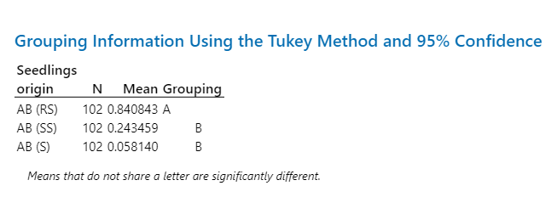
Figure 3: Grouping of the mean number of American beech stems with respect to their origin
All these analyses indicate that the shelterwood-treated area promoted regeneration of the desirable northern hardwood species. This also showed that the regeneration in this study site did not differ according to their position in the soil catena. However, it was observed that the regeneration of American beech was significantly high via root sucker origin.

Acknowledgments
I would like to thank the Edna Bailey Sussman Foundation and the internship host organization (WAC) for their support in this research. I would also like to thank my advisor Dr. Rene Germain and my thesis committee members Dr. Christopher A Nowak and Dr. Greg McGee for their insight throughout this research. Other thanks to my internship supervisor, Dr. Kristopher Brown (Forestry Research and Evaluation Specialist for WAC) and Dan DeChellis (Natural Resources and Environmental Science Director at Frost Valley YMCA), and other members of Frost Valley YMCA for their support in data collection. I would like to thank especially to my friends Anusha Lamsal for assisting me in the field and Ben Gartenberg for assisting me in the analysis and my family for their consistent love and support.

Appendix
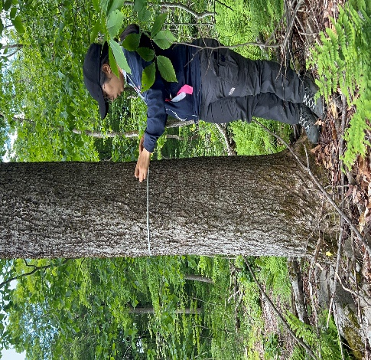
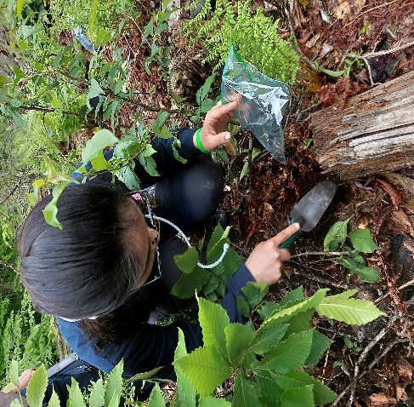
Collecting soil samples
Measuring dbh of a tree

References
Bilodeau-Gauthier, S., Bédard, S., & Guillemette, F. (2020). Assessing post-harvest regeneration in northern hardwood and mixedwood stands: Evolution of species composition and dominance within 15-year-old group selection and patch cutting. Forests, 11(7), 742.
Bose, A. K., Weiskittel, A., & Wagner, R. G. (2017). Occurrence, pattern of change, and factors associated with American beech-dominance in stands of the northeastern USA forest. Forest Ecology and Management, 392, 202–212.
Brand, D. G., Leckie, D. G., & Cloney, E. E. (1991). Forest regeneration surveys: Design, data collection, and analysis. The Forestry Chronicle, 67(6), 649–657.
Burns, R. M., & Honkala, B. H. (1990). Silvics of North America: 2 Hardwoods (Vol. 2, p. 877).
Cale, J. A., Garrison-Johnston, M. T., Teale, S. A., & Castello, J. D. (2017). Beech bark disease in North America: Over a century of research revisited. Forest Ecology and Management, 394, 86–103.
Chauhan, P. S., Negi, J. D. S., Singh, L., & Manhas, R. K. (2008). Regeneration status of Sal forests of Doon Valley. Annals of Forestry, 16(2), 178–182.
Hobbs, S. D. (1992). Reforestation practices in southwestern Oregon and northern California.
Leak, W. B., Yamasaki, M., & Holleran, R. (2014). Silvicultural guide for northern hardwoods in the northeast. Gen. Tech. Rep. NRS-132. Newtown Square, PA: US Department of Agriculture, Forest Service, Northern Research Station. 46 p., 132, 1–46.
McClure, J. W., & Lee, T. D. (1993). Small-scale disturbance in a northern hardwoods forest: Effects on tree species abundance and distribution. Canadian Journal of Forest Research, 23(7), 1347–1360.

