**Physiological response of *Epipactis helleborine* to lower irradiance**

Julian Koob  
SUNY College of Environmental Science and Forestry  
Final Report to the Edna Bailey Sussman Foundation  
2020

**Background**

*Epiapctis helleborine* (broad-leaved helleborine) is an introduced orchid that grows widely in forest understories. Native to Europe, *E. helleborine* was first recorded in Syracuse, New York (NY) in 1879. It is now naturalized and grows across North America. Knowledge of orchid biology can be expanded without disturbing rare endemic species by researching adaptations contributing to the success of the non-native and common *E. helleborine* in NY. Orchids form underground relationships between their roots and fungi, known as mycorrhizal symbiosis. This is typically a mutually beneficial association (e.g., in trees and many other plants), where the plant donates carbon to the fungus, providing it with energy, and receives mineral nutrients in return. However, all orchid seedlings initially take carbon resources from mycorrhizal fungi for energy for early germination and growth, and *E. helleborine* differs by continuing to augment its photosynthesis with carbon from its mycorrhizal fungi as adult plants.

This parasitic method of carbon acquisition from its fungi likely aids seedling growth in low light forest understories. Some recent evidence suggests that many forest orchids also employ this physiological strategy. *E. helleborine* can serve as a beneficial model for researching orchid life history without damaging native orchids. The goal of the present study was to examine if *E. helleborine* exhibits a flexible physiological strategy in its introduced range in order to help elucidate the adaptions that orchids growing in forest understories use to be successful. Here, a shading experiment was used to examine if *E. helleborine* adjusts its mechanisms of nutrient acquisition under light limited conditions by measuring several physiological responses related to autotrophy or heterotrophy. It was predicted that orchids in the shaded condition would change their physiology to be more heterotrophic and less autotrophic than the unshaded group. My internship ranged from May 18th—August 23rd 2020 and was supervised by Dr. Tim Howard from the New York State Natural Heritage Program (NYNHP). Dr. Howard monitored my progress and provided me with guidance through virtual meetings due to the coronavirus pandemic.

**Summary of Proposed Work**

In order to evaluate the hypothesis that *E. helleborine* exhibits physiological plasticity and can acquire more carbon from its fungal hosts under shadier conditions, I proposed to pursue the following objectives:

1. Experimentally manipulate light availability with shade cloth to reduce photosynthesis and force greater reliance on mycorrhizal fungi of *E. helleborine*.  
2. Compare how *E. helleborine* individuals in different light conditions meet their energy needs by measuring photosynthetic and respiration rates.  
3. Quantify mycorrhizal fungus colonization in *E. helleborine* roots, and stable isotope abundances in leaves, under different light levels as an indication of parasitism by the plant on the fungus.

**Work Completed**

Site descriptions and methods  
 In late May 2020, several forest habitats within central NY were evaluated for their potential as experimental sites. Ultimately the shading treatment was applied to applied to *E. helleborine* plants shortly after their emergence on June 6th and 7th at three sites, Svend O. Heiberg Memorial Forest (HMF) in Tully NY, Nelson Swamp (LYR) in Cazenovia NY, and Baltimore Woods (BWS) in Marcellus NY. At each site, a total of 16 *E. helleborine* (8 shaded, 8 unshaded) were selected for this experiment. Replicate paired samples (shaded-unshaded pairs) were spaced at a minimum distance of 5 m apart**.** The plant that received the shade cloth was selected randomly using a number generator. Additionally, at each site three autotrophic reference tree seedlings were shaded to assess the baseline site-specific stable isotope response to shading as in Hynson *et al.* (2012). *E. helleborine* leaves and autotrophic reference leaves were collected before and after shading to determine the effects of shading on stable isotope abundances. Tree seedling leaves and *E. helleborine* leaves for stable isotope analysis were dried and preserved on silica gel for future analysis (see below). *E. helleborine’s* aboveground physiological activity (i.e., photosynthesis, respiration, and related parameters) were assessed throughout its growing season with use of a Li-6800 Portable Photosynthetic System.

When plants were harvested, the number of flowers were recorded as a measure of fitness, and above-ground portions were dried and weighed for above-ground biomass measurements. Mycorrhizal roots were preserved for future quantification of colonization. At harvest, a ThetaProbe ML1 soil moisture probe was used to record the volumetric soil moisture at each plant. All statistical tests were conducted in R and means of response variables are presented ± standard error of the mean. The significance level for each test was set at 0.05. The package “nlme” was used to generate linear mixed effect models including plot nested within the random effect of site to test each response variable against the shading treatment. Model residuals were checked for homogeneity of variance and normality, and transformations were applied to rectify the response variables when assumptions were violated. Specifically, mean photosynthetic rate and stomatal conductance were log transformed, mean respiration rate and biomass were square root transformed. For all linear mixed effect models, an ANOVA was performed on the result of the model to extract significance.

Initial results  
 Shading cages effectively reduced irradiance: on average, shaded plants received 3.58±0.72 µmol s-1 m-2 of light while unshaded plants received 39.56±11.71 µmol s-1 m-2 of light, which is a 90.94% decrease in the available light at the forest floor. The larger standard error in the light that unshaded plants received is due to high temporal variance in the light environment, with values ranging from a minimum of 4.08 to a maximum of 260.99 µmol s-1 m-2. For comparison, average light level in full sun (i.e., not under canopy where the unshaded plants grew) was 1163.81±46.54 µmol s-1 m-2 of light, meaning that even the unshaded plants are excluded from 96.6% of total incident light. Soil moisture did not differ between shaded and unshaded plants (paired t-test: t = 0.035, df = 21, p-value = 0.971), indicating that this environmental variable does not contribute to differences in physiological responses.  
 Figure 1 displays the average photosynthetic and respiratory rates of shaded and unshaded plants across all sites. The net assimilation of CO2 under saturating light is considered to be the photosynthetic rate, Asat, while the production of CO2 in darkness is treated as the respiration rate, Rdark. The shading treatment caused a significant reduction (F(1,42)= 57.65, p< 0.001) in the average photosynthetic rate of shaded plants (Asat, shaded= 1.42±0.13 µmol CO2 m-2 s-1) as compared to the average photosynthetic rate of unshaded plants (Asat, unshaded= 3.11±0.19 µmol CO2 m-2 s-1). Shading also caused a significant reduction (F(1,42)= 19.13, p< 0.001) in the average respiration rates of the shaded plants (Rdark, shaded= -0.232±0.016 µmol CO2 m-2 s-1) as compared to the average photosynthetic rate of unshaded plants (Rdark, unshaded= -0.355 ±0.023 µmol CO2 m-2 s-1). Furthermore, shaded plants had significantly lower stomatal conductance (0.034±0.005 mol H2O m-2 s-1) than the unshaded plants (0.084±0.008 mol H2O m-2 s-1), which affects the rate at which CO2 and water are diffused through stomatal openings (Figure 2). These results indicate that shading reduced the capacity of *E. helleborine* to photosynthesize, with plants downregulating their metabolism to account for lower light availability, effectively reducing their investment in photosynthetic appendages. Furthermore, shaded plants exhibited significantly lower maximum photosynthetic rates (p< 0.001) when exposed to decreasing irradiance levels (Figure 3), a technique used to assess the light compensation point (LCPT). LCPTs represent the irradiance level where the photosynthesis is equal to the rate of respiration; shaded plants on average had lower LCPT than unshaded plants, but the effect was not significant (Mean LCPTshaded= 6.97±0.46, Mean LCPTunshaded= 8.17±0.59, p= 0.157). Despite the lack of a significant decrease, lower LCPTs suggest that the shaded plants adjusted their physiological strategy to become more shade tolerant, with lower respiration rates that allow for some photosynthesis to occur at low light levels.

Shaded and unshaded plants did not differ significantly in aboveground biomass (p=0.355) or number of flowers produced (p=0.215), which suggests that reduction of photosynthetic physiology is not manifested in negative effects on plant fitness, or that shaded plants were able to produce growth and reproductive output similar to unshaded plants due to nutritional mechanisms not based in photosynthesis. It is possible that fungal carbon buffered the reduction in assimilation of carbon through photosynthesis, and future analyses will test if shaded plants acquired more fungal nutrients than unshaded plants.

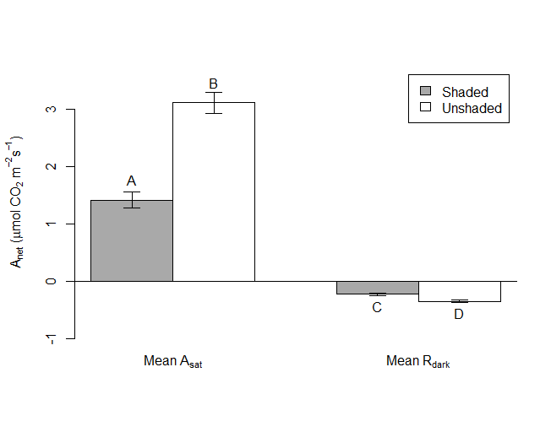

Figure 1. Average photosynthetic and respiratory rates in shaded and unshaded E. helleborine plants over the growing season. Capital letters indicate a significant difference (p < 0.001) between means as assessed by ANOVA. Error bars are standard error of the mean.

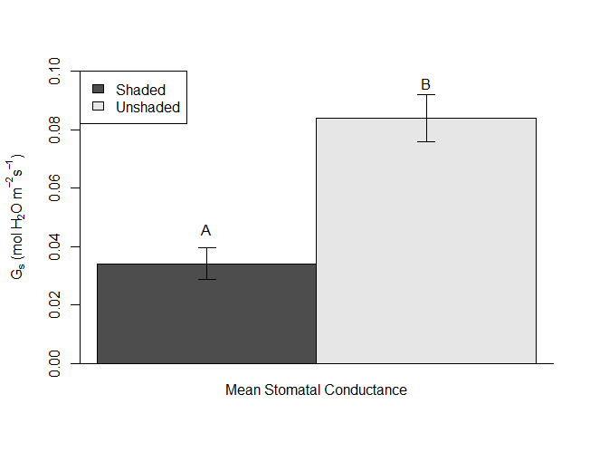

Figure 2. Average stomatal conductance in shaded and unshaded E. helleborine plants. Capital letters indicate a significant difference (p < 0.001) between means as assessed by ANOVA. Error bars are standard error of the mean.

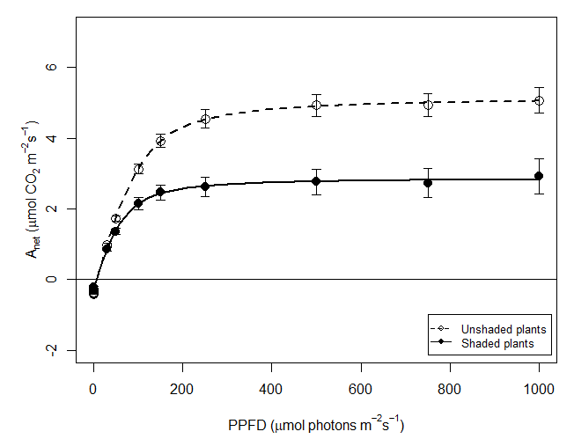

Figure 3. Average light response curves for shaded and unshaded E. helleborine plants. Error bars are standard error of the mean.

**Future work**

Work from this project is ongoing, and the focus has changed from field-based research to using molecular techniques and elemental analysis finalize data related to *E. helleborine’s* degree of parasitism. With the changes in *E. helleborine’s* aboveground physiology established, the next phase of this project is to determine if downregulation of photosynthetic activity is accompanied by an increase in acquisition of fungal carbon. Mycorrhizal fungi colonization in preserved root material from *E. helleborine* will be quantified to examine if the shaded plants had more fungal pelotons. This would show that in lower light conditions *E. helleborine* employs a mechanism of inducing greater fungal colonization, and therefore carbon transfer. Similarly, stable isotope abundances of δ15N and δ13C will be quantified from preserved *E. helleborine* leaves. Mycorrhizal fungi are enriched in these compounds as compared to neighboring plants, so mixotrophic plants like *E. helleborine* are less depleted (i.e., enriched) in δ15N and δ13C as compared with fully autotrophic plants. Shading plants typically causes a depletion of δ13C in leaf tissues, but if shaded *E. helleborine* plants acquire more fungal carbon, they will not exhibit this depletion in δ13C but instead an enrichment or values similar to unshaded plants. This would indicate that the loss of photosynthetically derived carbon is buffered by an increased uptake of carbon resources from mycorrhizal fungi, and that *E. helleborine’s* physiological plasticity operates both above and belowground.

**Acknowledgments**

This work was made possible by generous support of the Edna B. Sussman foundation. I am deeply thankful for their support which enabled completion of a portion of my master’s thesis. I would also like to thank my Sussman supervisor, Dr. Tim Howard, who provided excellent guidance and novel ideas that improved the quality and rigor of the project. I also thank my advisor, Dr. Thomas Horton, for his wisdom, advice, and support throughout the project, as well as the members of the Horton lab for helpful conversations.