Effect of Dynamic Forest Restoration on Songbird Communities in Southwestern Pennsylvania

Cameron J. Fiss
SUNY College of Environmental Science and Forestry
Final Report to the Edna Bailey Sussman Foundation
2021

Introduction

Forest birds have undergone drastic population declines over the past half-century, culminating
in the loss of approximately 20% of all individuals (Rosenberg et al. 2019). Research aimed at conserving declining bird species has focused overwhelmingly on nesting habitat. This bias is in part due to the more conspicuous behaviors of birds during this stage of the breeding season as they establish and defend their territories and acquire mates. However, recent advances in radio-transmitter technology have allowed researchers to investigate more cryptic components of the breeding season (e.g., the post-fledging period; Naef-Daenzer and Gruebler 2016, Cox et al. 2014). A prominent pattern across studies that evaluate post-fledging habitat, is the apparent shift away from the vegetation features associated with nesting (Anders et al. 1998, King et al. 2006). Further investigations have sought to explain these findings by evaluating what resources led to this pattern of habitat shifts. Specifically, such studies utilized mist-nets to passively sample avian communities during the post-fledging period across multiple forest age classes (Pagen et al. 2000, Marshall et al 2003). Notably, these studies have documented an even broader array of forest bird species using vegetation conditions not traditionally associated with their nests. Dynamic habitat selection patterns and the occurrence of species outside their nesting habitat during the post-fledging period allude to the idea that forest birds could benefit from forest age-class mosaics (i.e., dynamic forest restoration).

The notion that forest birds could benefit from forest age-class mosaics has been considered for some time. Several decades ago, researchers recognized how each stage of aspen stand development was used by Ruffed Grouse (Bonasa umbellus) during different portions of its annual cycle (Gullion and Svoboda 1972); and forest landscapes with heterogenous age structure have now become a widely accepted component of their overall habitat requirements (Devers et al. 2007, Rachelle 2011). Ruffed Grouse researchers recognized the important role of evolutionary history in shaping this dynamic habitat use pattern. Indeed, aspen forest and much of eastern deciduous forests were historically a disturbance driven ecosystem, whereby fire, wind, and beaver (Castor canadensis) activity led to frequent stand turnover and thus naturally occurring mosaics of forest age classes (Degraaf and Yamasaki 2003, King et al. 2014). The current suppression of natural disturbances by humans and resultant homogeneity of forest landscapes is considered one of the main contributing factors of Ruffed Grouse population declines (Dessecker and McAuley 2001, Blomberg et al. 2009). It is reasonable to expect, in a similar fashion, the widespread decline in the broader suite of forest birds (Rosenberg et al. 2019), may in part be driven by the loss of forest age class mosaics. Understanding how and when species utilize forest age class mosaics and the extent to which they depend on these landscapes is critical for future forest management planning and wildlife conservation.

I developed a study to evaluate songbird community response to dynamic forest management intended to create forest age class mosaics by comparing bird diversity in forested landscapes managed for wildlife and commercial timber, including State Game Lands 111 (SGL 111) and the Blue Hole tract of Forbes State Forest (BH) to unmanaged forested landscapes. All four of these landscapes occur within close proximity (~ 40 km radius) in southwestern Pennsylvania (PA). Because two of PA’s State Parks including Ohiopyle (hereafter OP) and Laurel Ridge (hereafter LR) are currently unmanaged but scheduled to undergo dynamic forest management in the future, I used these landscapes to gather baseline data for future before-after-control studies, but also as sites to compare against nearby managed forest sites (SGL 111 and BH). My main objectives were to 1) gather baseline avian community data for OP and LR State Parks and 2) compare avian community richness and composition between unmanaged and managed landscapes to determine potential effects of dynamic forest management in LR and OP.

Methods

To monitor the response of forest bird communities and target focal species to forest management within forest blocks in southwestern PA, I employed standard passive point count methodology throughout each block (Ralph et al. 1995). My team and I surveyed all locations between May 15 and June 15; starting surveys 30 minutes before sunrise and ending all surveys at 10:00 am to align with peak avian breeding activity. We surveyed each point count location for 10 minutes and recorded each species heard or seen, subsequently detected individuals were counted. In addition, surveyors recorded the time interval (1-min) in which a species was first detected. This will allow for the use of time-to-detection methods to estimate detection probability and allow for only one site-visit per point. Such methodology will allow for future comparison of these same blocks. Point count locations were randomly placed throughout each block. All survey locations were >250 apart to avoid double counting individuals. In blocks that had already undergone forest management, I randomly stratified survey locations across forest age classes. This approach should allow for the maximum number of points to be surveyed efficiently, but also to determine avian response to individual management scenarios and forest age classes in the future.
I used species accumulation curves to evaluate the species pools (richness) expected in each landscape while accounting for unequal sample sizes. Additionally, I used non-metric multidimensional scaling to compare community composition and evaluate community differences and similarities across different landscape types.

Preliminary Results

My team and I surveyed a total of 564 locations across two unmanaged landscapes (OP N=166, LR N=151) and two managed forest landscapes (BH N=129, SGL111 N=118) in southwestern PA during Spring/Summer 2021. Across all four landscapes we detected a total of 82 forest songbird species. Two species were unique to managed landscapes and eight species were unique to unmanaged landscapes. For instance, we only detected Red Breasted Nuthatch (Sitta canadensis) in OP, an unmanaged landscape, but Eastern Kingbirds (Tyrannus tyrannus) were only detected in SGL111, a managed forest landscape. Notably, we detected Cerulean Warbler (Setophaga cerulean), a state listed species of greatest conservation need, in both managed and unmanaged landscapes. These locations and potential management options to improve Cerulean Warbler habitat have already been shared with DCNR biologists and are actively being incorporated into dynamic forest block restoration plans for OP and LR. In addition to sharing data for sensitive species, this work has already resulted in a meeting with Pennsylvania Department of Conservation and Natural Resources (PA DCNR) forest managers and park staff. Additional meetings are being planned early next year in which we will further elaborate on results from our preliminary data set as the parks move towards an ecological forestry approach to management.

Species accumulation curves indicate that species pools were similar across sites but tended to be slightly higher in unmanaged landscapes (particularly OP; Figure 1). Similarly, jackknife estimators of overall species pools for each forest block suggest a similar richness with the estimated number of species 90.9 ± 3.9 (OP), 75.9 ± 2.6 (LR), 76.9 ± 3.3 (SGL 111), and 69.0 ± 2.8 (BH). Thus, species pools were statistically similar in LR (unmanaged) and SGL 111 (managed), but OP (unmanaged) had significantly greater species richness and BH (managed) had significantly lower species richness than the remaining sites. Community composition was not significantly different amongst managed or unmanaged landscapes (Figure 2). Indeed, early successional obligate nesting species (e.g., CSWA, EATO) we’re commonly found in both landscape types. A few rarely encountered early successional species including Field Sparrow (FISP; Spizella spusilla) and Prairie Warbler (PRAW; Setophaga discolor), were only detected in LR and OP respectively.

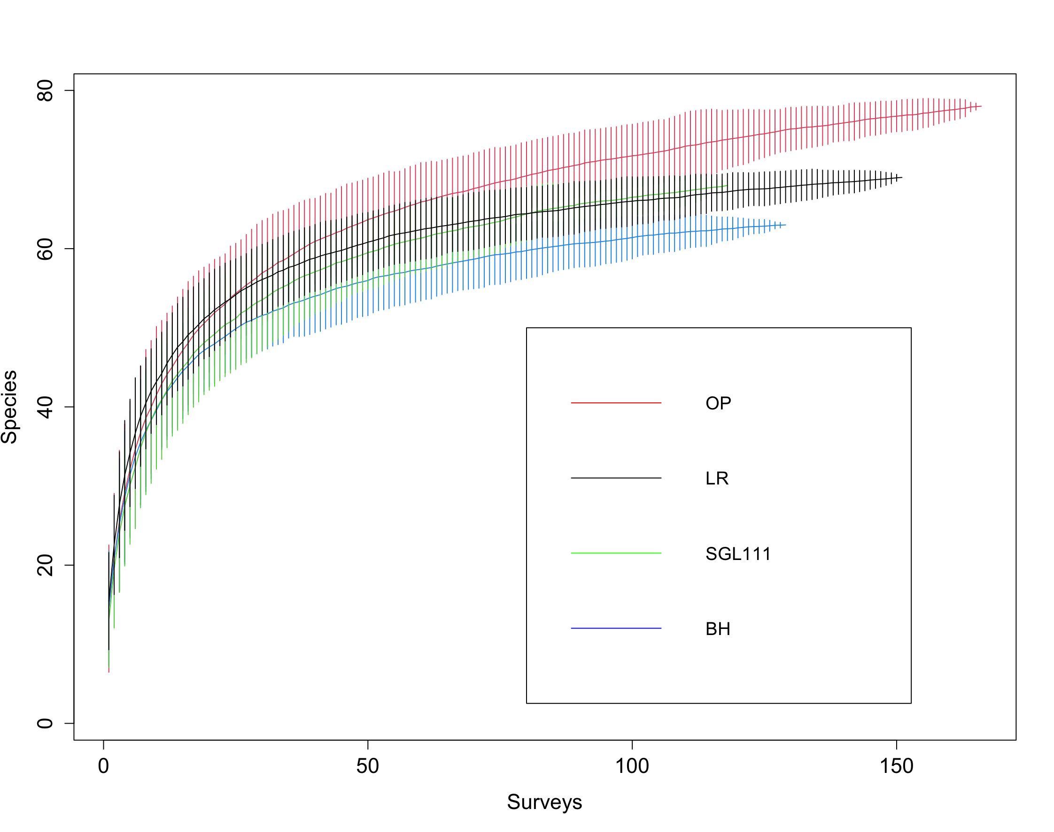

Figure 1. Species accumulation curves for unmanaged (OP, LR) and managed (BH, SGL 111) forest landscapes in southwestern PA based on data gathered during the 2021 breeding season. Error bars represent standard error. Curve lengths are based on the number of samples at each study site.

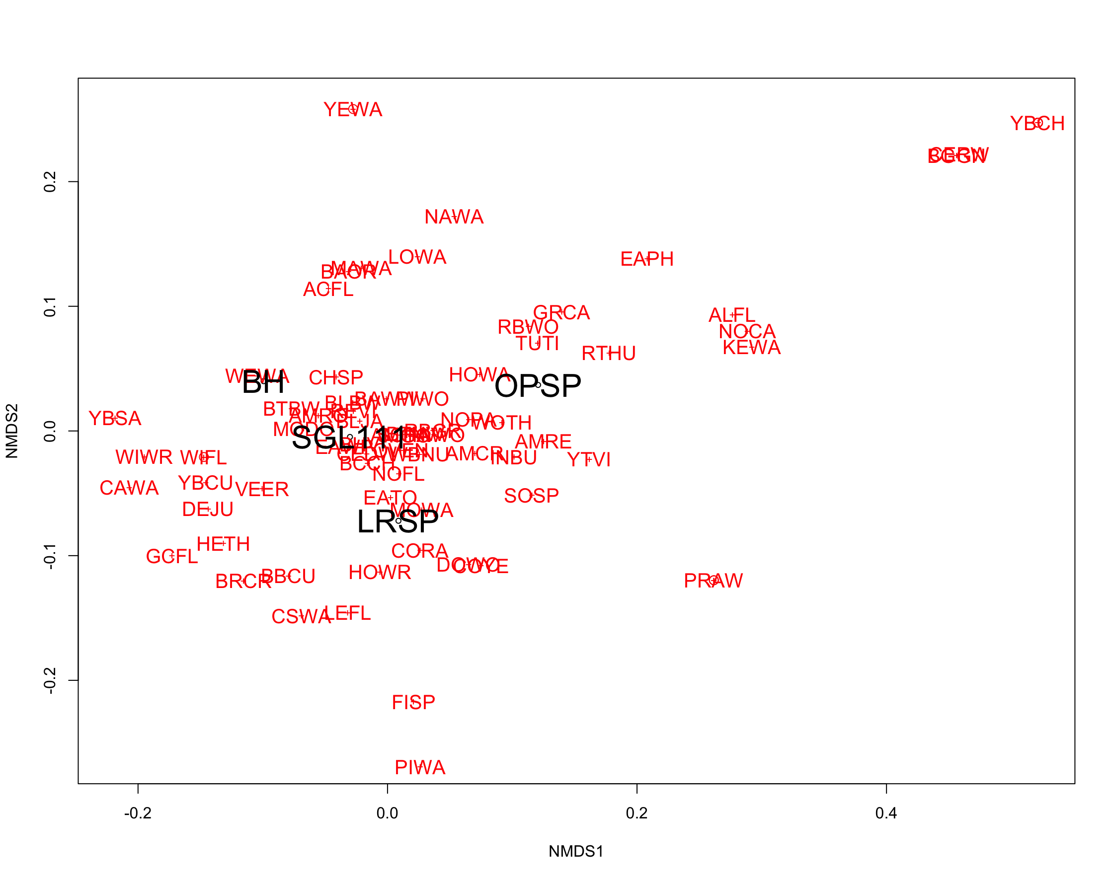
Figure 2. Non-metric multidimensional scaling for community composition across unmanaged (OP, LR) and managed (BH, SGL 111) forest blocks based on data gathered during the 2021 breeding season in southwestern PA. Distance between study sites indicates the degree of dissimilarity among sites. Avian species codes are provided in red.

Conclusions

This study revealed that avian communities across four study sites were quite similar regardless of management status, suggesting that avian communities in this region may be quite robust to levels of forest management such as those seen in SGL 111 and BH. Based on our study design we expected to see a richer early-successional avian community in managed forest landscapes, but we did not detect significant difference based solely on naive community composition values. Future analysis should use models that account for imperfect detection to evaluate community composition across these sites. Indeed, we surveyed OP and LR earlier in the breeding season than SGL 111 and BH and this may have biased our detections positively towards the prior (unmanaged) landscapes. The fact that managed landscapes likely have greater vegetation density in younger forest stands may also have lowered our detection probability in managed landscapes. Our baseline species presence and abundance results should serve as an important resource to forest managers in these regions and will hopefully play an integral role in informing management decisions in the near future.

Acknowledgements

I would like to foremost thank the Enda Bailey Sussman Foundation for supporting this work. I would like to express sincere gratitude to the Ohiopyle State Park staff for hosting my field team and I especially thank Mike DiRinaldo for sponsoring this research. Finally, thanks to my advisors Dr. Jonathan Cohen and Dr. Jeff Larkin for providing input and advice regarding this project.

Literature Cited

Anders, A. D., Faaborg, J., & Thompson III, F. R. (1998). Postfledging dispersal, habitat use, and home-range size of juvenile Wood Thrushes. The Auk, 115(2), 349-358.

Blomberg, E. J., Tefft, B. C., Endrulat, E. G., & McWilliams, S. R. (2009). Predicting landscape-scale habitat distribution for ruffed grouse Bonasa umbellus using presence-only data. Wildlife Biology, 15(4), 380-394.

Cox, W. A., Thompson III, F. R., Cox, A. S., & Faaborg, J. (2014). Post‐fledging survival in passerine birds and the value of post‐fledging studies to conservation. The Journal of Wildlife Management, 78(2), 183-193.

DeGraaf, R. M., & Yamasaki, M. (2003). Options for managing early-successional forest and shrubland bird habitats in the northeastern United States. Forest Ecology and Management, 185(1-2), 179-191.

Devers, P. K., Stauffer, D. F., Norman, G. W., Steffen, D. E., Whitaker, D. M., Sole, J. D., ... & Tefft, B. C. (2007). Ruffed grouse population ecology in the Appalachian region. Wildlife monographs, 168(1), 1-36.

Dessecker, D. R., & McAuley, D. G. (2001). Importance of early successional habitat to ruffed grouse and American woodcock. Wildlife Society Bulletin, 29(2), 456-465.

Gullion, G. W., & Svoboda, F. J. (1972). The basic habitat resource for ruffed grouse. US Department of Agriculture Forest Service, General Technical Report NC-1, 113-119.

King, D. I., Degraaf, R. M., Smith, M. L., & Buonaccorsi, J. P. (2006). Habitat selection and habitat‐specific survival of fledgling ovenbirds (Seiurus aurocapilla). Journal of Zoology, 269(4), 414-421.

King, D. I., & Schlossberg, S. (2014). Synthesis of the conservation value of the early-successional stage in forests of eastern North America. Forest Ecology and Management, 324, 186-195.

Marshall, M. R., DeCecco, J. A., Williams, A. B., Gale, G. A., & Cooper, R. J. (2003). Use of regenerating clearcuts by late-successional bird species and their young during the post-fledging period. Forest Ecology and Management, 183(1-3), 127-135.

Naef‐Daenzer, B., & Grüebler, M. U. (2016). Post‐fledging survival of altricial birds: Ecological determinants and adaptation. Journal of Field Ornithology, 87(3), 227-250.

Pagen, R. W., Thompson III, F. R., & Burhans, D. E. (2000). Breeding and post-breeding habitat use by forest migrant songbirds in the Missouri Ozarks. The Condor, 102(4), 738-747.

Rachelle, M. 2011. Bonasa umbellus. In: Fire Effects Information System, [Online]. U.S. Department of Agriculture, Forest Service, Rocky Mountain Research Station, Fire Sciences Laboratory (Producer). Available: www.fs.fed.us/database/feis/ [2021, September 6].

Ralph, C. J., Sauer, J. R., & Droege, S. (1995). Monitoring bird populations by point counts. Gen. Tech. Rep. PSW-GTR-149. Albany, CA: US Department of Agriculture, Forest Service, Pacific Southwest Research Station. 187 p, 149.

Rosenberg, K. V., Dokter, A. M., Blancher, P. J., Sauer, J. R., Smith, A. C., Smith, P. A., ... & Marra, P. P. (2019). Decline of the North American avifauna. Science, 366(6461), 120-124.

