Seasonal Habitat Selection of Coastal North Woods Wolves
in Relation to Ungulate Migration and Parturition
Nathaniel H. Wehr
State University of New York College of Environmental Science and Forestry

Introduction
Competition for resources has been a keystone of ecological theory since Charles Darwin described his theory of evolution in On the Origin of Species (Darwin 1859). Since then, innumerable publications have been set forth by the scientific community establishing a core set of hypotheses guiding present ecological research, such as the competitive exclusion principle (Hardin 1960), apparent competition (Holt 1977), and the Red Queen hypothesis (Van Valen 1973). These concepts of competition can be translated from their effect on food resources to space as a resource resulting in concepts stemming from ideal free distribution theory (Fretwell and Lucas 1970) including the ideas of wolf buffer zones (Mech 1977; Mech 1994), leapfrog effect (Sih 1998), and safety matching (Hugie and Dill 1994). However, while possible to test these concepts experimentally using controlled mesocosms, testing these concepts at larger scales is challenging.
Assisting researchers in overcoming this challenge of scale for studying predator-prey interactions, Isle Royale, Michigan is the most studied island throughout the Great Lakes (Nelson et al. 2011). Separated from the mainland of Minnesota and Ontario by 22 km of water, movements of large mammals to the island are associated with ice formations connecting the island to the mainland during winter (Licht et al. 2017). While other species inhabited the island historically (Krefting 1974), since the 1950s gray wolves (Canis lupus) have represented the only terrestrial mid- to large-sized carnivore on the island with moose (Alces alces) serving as their principal food source, followed by beaver (Castor canadensis) and snowshoe hare (Lepus americanus) (Krefting 1974; Peterson 1977). As such, wolves are dependent on moose for their survival with wolf abundance directly associated with the abundance of moose >9 years old due to the importance of these moose as winter food (Vucetich and Peterson 2004). Therefore, spatial examination of these interrelationships presents an excellent opportunity for improved study of ecological theory.
In comparison to Isle Royale, the large mammal community of the Grand Portage Indian Reservation on the mainland of Minnesota adjacent to Isle Royale is more diverse and represents a complex ecosystem more typical of boreal forests. Here, the terrestrial mid- to large carnivore community includes not only wolves but also black bears (Ursus americanus), coyotes (Canis latrans), and bobcats (Lynx rufus). Moose, white-tailed deer (Odocoileus virginianus), beaver, snowshoe hares, and small mammals serve as mammalian prey (Kurta 2017). Wolves are the apex predator in this ecosystem. This dominance was exhibited using 30 years of survey data from Minnesota demonstrating wolves displacing coyotes via competition but not red foxes (Vulpes vulpes) due to limited dietary overlap (Levi and Wilmers 2012). Describing the dominance of wolves further, trophic cascades in Wisconsin were associated with wolves whereby snowshoe hare populations were greater in high wolf use areas due to competitive exclusion of coyotes (Flagel et al. 2017), and saplings grew taller and more densely in areas with high wolf use due to wolves’ influence on white-tailed deer movements (Flagel et al. 2016). Similarly, bobcats have been shown as subordinate to wolves when preying on ungulates in Michigan (Kautz et al. 2020). However, while the diet of Minnesota’s black bears consists primarily of foods high in nutrients and low in cellulose (Noyce et al. 1997; Rogers 1987; Rogers et al. 1988), neonatal moose and white-tailed deer are black bears’ only source of depredated food in the region (Popp et al. 2018; Rogers 1987; Rogers et al. 1988). Further, despite evidence that black bear habitat selection does not change during fawn births in Michigan (Svoboda et al. 2019), their impact on populations may be important; in central Ontario about 20% of moose calf mortalities were attributed to black bears, which comprised about 50% of total predations (Patterson et al. 2013).

Methods
Study Area
The 192 km² Grand Portage Indian Reservation (47.9614° N, 89.7594° W) is located in northeastern Minnesota bordering Lake Superior to the southeast, Ontario to the north, and a mix of federal, state, and private properties to the west (Fig. 1). The reservation is characterized by steep ridges and broad valleys with elevations from 183 to 553 m above sea level. There are 68 km of permanent streams, 89 km of intermittent streams, 3.3 km² of open water, and 29 km² of wetlands (Chenaux-Ibrahim 2015). Climate varies seasonally; mean January minimum temperatures are -17.8 ± 3.5 C° and mean July maximum temperatures are 23.3 ± 1.7 C° with 281.9 ± 11.7 cm of precipitation annually including 351.6 ± 80.8 cm of snowfall (NOAA 2020). The plant community, except where timber has been recently harvested, is composed of dense forests. These forests are categorized as aspen/birch, upland spruce/fir, pine, lowland brush/swamp hardwood, swamp conifer, northern white cedar, or northern hardwood (Teager 2020).
Isle Royale National Park, Michigan (47.9959° N, 88.9093° W) is located in northwestern Lake Superior roughly 22 km from the mainland of Minnesota and Ontario (Fig. 1). The main island, Isle Royale, is 544 km² and surrounded by around 400 smaller islands. Similar to Grand Portage, the island is characterized by rocky terrain with several steep parallel ridges and low lying areas forming inland lakes. Elevations range from 183 to 425 m above sea level. Climate is similar to Grand Portage with mean January minimum temperatures of -13.4 ± 3.1 C° and mean July maximum temperatures of 24.2 ± 1.8 C° (NOAA 2020). Unlike Grand Portage, where wildlife can immigrate or emigrate on and off the reservation, the open water between Isle Royale and the mainland limits this interchange. However, occasional formation of ice bridges between the island and mainland allows periodic movements of wildlife during winter. As in Grand Portage, the habitat is composed of forests typical of the North Woods containing balsam fir (Abies balsamea), white spruce (Picea glauca), quaking aspen (Populus tremuloides), and other hardwood species (Licht et al. 2017).

Methodology
This project is reliant on the use of spatial data collected from GPS collars affixed to wolves, moose, white-tailed deer, and black bears. In Grand Portage, wolves have been collared since 2008, moose since 2010, white-tailed deer since 2006, and the first black bear was collared in 2020. Comparatively, wolves and moose have been collared on Isle Royale since 2018. Additional animals are being captured and collared currently for the continued collection of data to be used as part of this project. I will be organizing the data collected from these collars and combining it with satellite-derived landscape data including habitat characteristics, road maps, trail maps, and more. I will then analyze this data using RStudio statistical software (RStudio Team 2020).

Future Work
In 2020, the Sussman Foundation Internship supported my efforts to assist the Grand Portage Band of Lake Superior Chippewa in affixing collars to wolves and black bears as part of this research project. Additionally, the internship program afforded me the opportunity to progress my skillset by working on remote camera deployments and data organization and analysis associated with Grand Portage and Isle Royale National Park. I will spend summer 2021 working in these locations to collect additional data toward completion of my doctoral dissertation.
Thus far, I have proposed three primary research objectives associated with this work, which will be analyzed after data collection is complete. 1) I will analyze year-round habitat selection patterns of wolves as the large mammal community, and therefore availability of prey, fluctuates seasonally. Expected changes to the large mammal community include seasonal range-shifts by moose and white-tailed deer, hibernation by black bears, and parturition by all four study species. This analysis will then be expanded by analyzing seasonal changes associated with moose following green-up across Isle Royale. 2) I will focus specifically on wolves’ use of ungulate migration corridors in Grand Portage and on Isle Royale. This analysis will examine wolves’ adaptions to using high traffic corridors during ungulates’ spring shift off the reservation and winter return toward the coast of Lake Superior. 3) I will test the hypotheses of leapfrog effect and safety matching in reference to large mammals. In brief, leapfrog effect suggests wolves will select habitats preferred by moose and safety matching suggests moose will choose habitats in which they are least likely to be depredated. Further, I will test whether these hypotheses are supported in the presence of multiple predators versus single predators by including black bears as a second predator in Grand Portage during ungulate parturition.

Figures

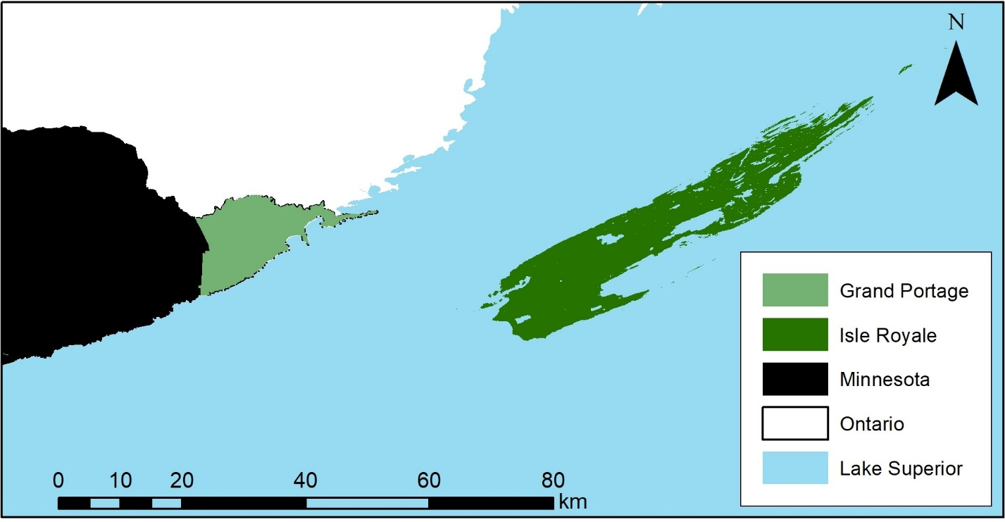
Fig. 1. Map including Isle Royale National Park and the Grand Portage Indian Reservation.

Acknowledgements
I thank Hailey Boone, Poe Deschampe, E.J. Isaac, and Dr. Elizabeth Orning for their assistance with data collection and organization as well as Dr. Jerrold Belant, Dr. Seth Moore, and Mark Romanski for their assistance in developing project ideas, managing logistics, and serving as my internship advisers. I also thank the Grand Portage Band of Lake Superior Chippewa and the National Park Service for granting me access to the study sites and historical data.

Literature Cited
Chenaux-Ibrahim Y (2015) Seasonal diet composition of gray wolves (Canis lupus) in northeastern Minnesota determined by scat analysis. Thesis, University of Minnesota, Minneapolis, MN.
Darwin C (1859) On the origin of species by means of natural selection, or the preservation of favoured races in the struggle for life. John Murray, London, United Kingdom.
Flagel DG, Belovsky GE, Beyer Jr DE (2016) Natural and experimental tests of trophic cascades: gray wolves and white-tailed deer in a Great Lakes forest. Oecologia 180:1183-1194
Flagel DG, Belovsky GE, Cramer MJ, Beyer Jr DE, Robertson KE (2017) Fear and loathing in a Great Lakes forest: cascading effects of competition between wolves and coyotes. Journal of Mammalogy 98:77-84
Fretwell S, Lucas H (1970) On territorial behaviour and other factors inftuencing habitat distribution in birds. Acta Biotheoretica 19:1-6
Hardin G (1960) The competitive exclusion principle. Science 131:1292-1297
Holt RD (1977) Predation, apparent competition, and the structure of prey communities. Theoretical Population Biology 12:197-229
Hugie DM, Dill LM (1994) Fish and game: a game theoretic approach to habitat selection by predators and prey. Journal of Fish Biology 45:151-169
Kautz TM, Belant JL, Beyer Jr DE, Strickland BK, Duquette JF (2020) Influence of body mass and environmental conditions on winter mortality risk of a northern ungulate: evidence for a late‐winter survival bottleneck. Ecology and Evolution 10:1666-1677
Krefting LW (1974) The ecology of the Isle Royale moose with special reference to the habitat. Technical Report, University of Minnesota, Minneapolis, MN.
Kurta A (2017) Mammals of the Great Lakes region. University of Michigan Press, Ann Arbor, MI.
Levi T, Wilmers CC (2012) Wolves–coyotes–foxes: a cascade among carnivores. Ecology 93:921-929
Licht DS, Moen RA, Romanski M (2017) Modeling viability of a potential Canada lynx reintroduction to Isle Royale National Park. Natural Areas Journal 37:170-177.
Mech LD (1977) Wolf-pack buffer zones as prey reservoirs. Science 198:320-321
Mech LD (1994) Buffer zones of territories of gray wolves as regions of intraspecific strife. Journal of Mammalogy 75:199-202
Nelson MP, Vucetich JA, Peterson RO, Vucetich LM (2011) The Isle Royale wolf–moose project (1958-present) and the wonder of long-term ecological research. Endeavour 35:30-38.
NOAA (2020) National Centers for Environmental Information: data tools. Retrieved 11/1/2020 < https://www.ncdc.noaa.gov/cdo-web/datatools/findstation >.
Noyce KV, Kannowski PB, Riggs MR (1997) Black bears as ant-eaters: seasonal associations between bear myrmecophagy and ant ecology in north-central Minnesota canadian. Journal of Zoology 75:1671-1686
Patterson BR, Benson JF, Middel KR, Mills KJ, Silver A, Obbard ME (2013) Moose calf mortality in central Ontario, Canada. The Journal of Wildlife Management 77:832-841
Peterson RO (1977) Wolf ecology and prey relationships on Isle Royale. National Park Service Scientific Monograph Series 11:1-210.
Popp J, Hamr J, Larkin J, Mallory F (2018) Black bear (Ursus americanus) and wolf (Canis spp.) summer diet composition and ungulate prey selectivity in Ontario, Canada. Mammal Research 63:433-441
Rogers LL (1987) Effects of food supply and kinship on social behavior, movements, and population growth of black bears in northeastern Minnesota. Wildlife Monographs 97:3-72
Rogers LL, Wilker GA, Allen AW (1988) Managing northern forests for black bears. pp36-42 in Proceedings of the Society of American Foresters National Convention of 1988, Minneapolis, MN.
RStudio Team (2020) RStudio: integrated development for R. PBC, Boston, MA.
Sih A (1998) Chapter 10: game theory and predator–prey response races, in Game theory and animal behavior. Eds Dugatikin LA, Reeve HK. Oxford University Press, New York, NY. pp221-238.
Svoboda NJ, Belant JL, Beyer Jr DE, Duquette JF, Lederle PE (2019) Carnivore space use shifts in response to seasonal resource availability. Ecosphere 10:e02817
Teager K (2020) Habitat composition and spatial response of white-tailed deer to forestry treatments in moose range, Grand Portage Indian Reservation, Minnesota. Thesis, Lakehead University, Thunder Bay, Canada.
Van Valen L (1973) A new evolutionary law. Evolutionary Theory 1:1-30.
Vucetich JA, Peterson RO (2004) Chapter 18: grey wolves-Isle Royale, in The biology and conservation of wild canids. Eds MacDonald DW, Sillero-Zubiri C. Oxford University Press, Oxford, United Kingdom. pp285-296.

