February 2018 Thesis Proposal to committee members:
Nutritional Effects on Causal Organism of Beech Bark Disease in Aftermath Forests

Graduate Student: Gretchen Dillon (Lasser), SUNY-ESF
Major Professor: Ruth Yanai, SUNY-ESF
Steering Committee Members: Mariann Johnston

Project Goals and Supporting Objectives
The goal of this study is to assess the dynamics of beech bark disease (BBD) by quantifying beech scale density and identifying Neonectria species present in the first full factorial NxP manipulation experiment located in Bartlett Experimental Forest, in New Hampshire, USA. Both native and invasive beech scale density will be quantified using image analysis and Neonectria species will be identified using microscopy and genetic analysis. Conducting this study will provide information on whether nutrient additions of nitrogen (N), phosphorus (P), or a combination of N+P are associated with patterns of Neonectria and beech scale.

Project Justification and Relevance
BBD is an invasive pathogenic complex that causes high mortality of American beech trees (Fagus grandifolia Ehrh.) in northern hardwood ecosystems (Mason et al., 2013). BBD involves both insect and fungal components. An invasive beech scale, Crytococcus fagisuga Lind., is a sap-feeding insect that was introduced from Europe (Houston 1994) that feeds on the inner bark and cork cambium. It is believed that this activity predisposes beech to canker-causing fungal infection by Neonectria ditissima and Neonectria faginata (Kasson & Livingston, 2009). The fungi create lesions of dead tissue that develop into cankers on the tree (Mason et al., 2013). The fungi eventually girdle the tree causing secondary effects such as dehydration and transportation disruption. This lowers the tree’s overall ability to fight off infection and invaders, ultimately killing it (Cale et al., 2015).
BBD is deadly. The initial killing front, designated as 1 to 19 years after the arrival of the scale infection, has a 50% mortality rate. Almost all American beech in the northeastern United States are infected; less than 1% of all beech has shown resistance (Mason et al, 2013). The final phase, called the aftermath forest phase, results in an ecological accommodation to the disease, resulting in either a change in species composition or the death of re-emergent beech (McCaskill & Morin, 2012).
The precise factors that influence the BBD disease process are unknown. Cale et al. (2015) found that bark chemistry characteristics, such as low levels of P, were a significant predictor of N. faginata or N. ditissima infection. These bark nutrient levels presumably result from corresponding levels of soil nutrients. This study serves as an investigation of nutrient manipulation on BBD causal organisms to attempt to verify these findings. If Cale et al. (2015) is correct in their correlation than I expect trees in P plots to show lower density of beech scale and Neonectria lesions, with higher densities in N plots. Additionally, the N+P treatment plots of the MELNHE experiment (see site description) allow for an examination into nutrient colimitation; an interaction would further support the claim that elevated nutrient levels impact lesion development, and whether this process may be due to additions of P relative to N. Presently there are no such projects that assess the interaction of N+P or serve to support or refute Cale et al.’s findings.

Research Approach and Methodology
Site Description
This project takes advantage of an existing study of Multiple Element Limitation in Northern Hardwood Ecosystems (MELNHE, http://www.esf.edu/melnhe) in Bartlett Experimental Forest (BEF) located in the White Mountain National Forest in New Hampshire, USA, with nutrient treatment plots across three forest stand age classes: young (C2, C3), mid-aged (C4, C6), and old (C7, C8). Stands regenerated naturally following clearcutting and ranged in age from 32-134 years old in 2017 at the time of sampling. In each stand there were four treatment plots, each a quarter hectare with treatments of N, P, N+P, and a control. Applications of N and P began in June 2011 and continue at the rate of 30 kg N/ha/yr (as NH4NO3) and 10 kg P/ha/yr (as NaH2PO4).

Field Methods
Beech Tree Description
Five beech trees per plot were selected for imaging and Neonectria sampling. Within each plot the five trees were selected to be as far apart from each other as possible, ideally 20m, to reduce the chance of sampling genetically identical individuals. Trees with conks of decay fungi were avoided. Ideal sample trees were 20-35cm DBH and exhibited a range of symptoms of BBD. Larger trees and trees proximate to each other (<20m) were used the target sample characteristics were unavailable.

Neonectria and Beech Scale Description
In the field, the fruiting body of Neonectria is visually identified on trees as red, round structures called perithecia, which can contain groups of white asexual spores called sporodochia. Lesions of mature Neonectria develop in oval-shaped groupings that can be visually distinct or diffuse, with individual lesions being sometimes difficult to discern. Sexual ascospores are contained within perithecia and asexual macroconidia are contained within sporodochia. Each can be measured microscopically in a lab setting to determine fungi species. Both species of scale insect, Crytococcus fagisuga and Xylococculus betulae, can be readily identified on the bark of American Beech. C. fagisuga appears as white wax masses on the bark surface while X. betulae is easily identified by its characteristic excretory tube that looks like a fine white hair.

1. Neonectria Collection and lesion counts
From September 22, 2017 to November 5, 2017, 306 samples were collected every other week from 75 trees over four weekend trips to the collection site in New Hampshire. Collections were performed in dry weather conditions as perithecia were difficult to locate during rain events. Up to three lesions per tree were collected, with the blunt blade for collection being sterilized between each lesion collection with a lighter. The blade was used to gently scrape the perithecia and sporodochia into a vial. A small pea-sized amount (< .25g) was considered sufficient material for analysis but as much material was collected as possible from individual lesions. Vials were then agitated to dislodge the material into the sterile water or solution. The vial was then capped, labelled, and placed on ice.
In addition to collecting physical samples, the following information was also collected: tree DBH (cm), approximate lesion density on bole up to 2m (recorded in classes of 5; 0-5, 5-10, etc.), location of collected lesion on bole (classes of 0.5m; 0-.5, .5-1.0, etc.), and aspect of collected lesion.

2. Beech Scale Density Imaging
In July and August 2017, photos of tree bark were taken from the four cardinal directions at each of two heights. 1.5 m and 0.5 m above the ground, for a total of eight photos per tree. No flash was used and the camera was centered directly in front of lesions to be imaged. This imaging process occurred during dry weather or after waiting 24 hours from a heavy rain event to allow bark to dry.

Laboratory Methods
1. Neonectria Identification
a. Microscopy (Start date 2/15/18, anticipated completion 5/15/18)
A total of 203 samples of Neonectria will be identified to species via microscopy by visual assessment of the mature sexual and asexual states, the ascospores and macroconidia (Castlebury et al. 2006). In this technique, the mean length of at least 25 ascospores from 2 to 3 perithecia per lesion are measured and then averaged to produce a reliable assessment (Cotter and Blanchard, 1981). Slides will be prepared using a squash mount and viewed at 1000X using oil immersion.
Table 1: Morphological characteristics from Castlebury et al. 2006.
 | N. ditissima | N. faginata
Ascospore description: | Ellipsoid to fusiform, smooth to very fine spinulose | Ellipsoid to broadly ellipsoid and ornamented with regularly scattered warts
Ascospore size: | (14.9-18.9) x (6.5-8.3) μm  (avg. 16.9 x 7.4μm) | (10.4-12.0) x (5.2-6.4) μm  (avg. 11.0 x 5.5 μm)
Ascospore ornamentation  (scale bar = 10μm) | 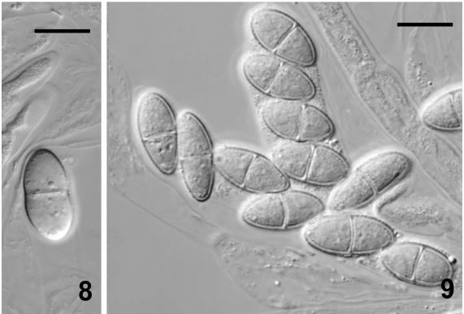 | 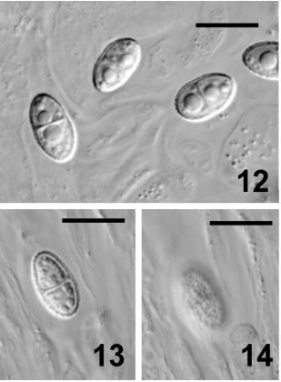
Macroconidia description | Shorter, straight, and rarely slightly curved | Very long, up to 120 μm and strongly curved
Macroconidia ornamentation  (scale bar = 20μm) | 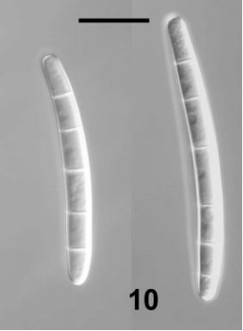 | 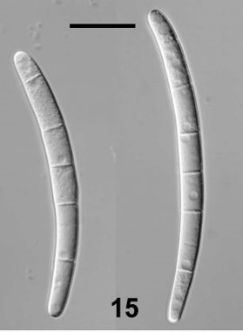

b. DNA Analysis (start date 2/26/18, anticipated completion date 3/9/18)
With expert guidance and equipment from Tom Horton’s lab at SUNY-ESF, up to 77 samples collected in an cetyltrimethyl ammonium bromide (CTAB) extraction buffer will be subjected to DNA extraction and polymerase chain replication (PCR) and identified to species using restriction fragment length polymorphisms (RFPLs) and direct sequencing. Focus is on the translational elongation factor (tef1) locus, using forward and reverse sequences with the following primers: Ef1-728 forward: CAT CGA GAA GTT CGA GAA GG Ef1-1567 reverse: ACH GTR CCR ATA CCA CCR ATC TT for distinguishing the two Neonectria species. Each tree will be classified for the presence or absence of fungi species (none, N. ditissima, N. faginata, both).

2. Beech Scale Density Quantification (Start date 1/20/18, anticipated completion 5/20/18)
All eight images per tree was cropped to 5x10cm using Image-J software to quantify both species of beech scale on trees. We will be using a modified point sampling method to quantify both species of beech scale on trees rather than use previous techniques of randomly selecting two 1x1cm squares to be analyzed (Teale et al., and Wieferich, Hayes, and McCullough 2013). The point sampling method involves overlaying a grid onto the 5x10cm image and tallying when scale is present at a gridline intersection. This proved to be less time consuming than random sampling and direct counting and was a more accurate assessment of the variable spatial distributions of scale populations on tree bark. Results from the photos will be averaged to provide per-tree density estimates of X. betulae bark wounds and C. fagisuga wax masses.

Data analysis (start date June 2018, anticipated completion December 2018)
The following will be analyzed: scale/lesion density as a function of treatment, scale/lesion density as a function of elevation, Neonectria as a function of scale, scale/lesion density as a function of aspect, and lesion density as a function of bole height.
Independent variables: treatment, stand age, elevation
Dependent variables: lesion density (recorded in classes), scale density, Neonectria type
Analysis of variance to test the relationship between nutrient addition, trip/date, and BBD (blocked by stand). Multivariate and univariate regression of dependent variables with plots nested in stands. Paired t-tests (PROC t-test, SAS) were used to test differences in the ratio of fungi to fungi and scale to scale between each nutrient plot.
Ex. Aov (scale~ Ntrt * Ptrt + age + elevation + (1 | stand/plot)
Ex. Aov (Neonectria sp~ Ntrt * Ptrt + age + elevation + (1 | stand/plot)

Budgets
Monetary:
1. PCR and DNA extraction: Price negligible per conversation between M. Johnston and T. Horton
2. DNA primers ($20, already purchase)
3. Additional sterile 1ml pipette ($40/box 500 count, already purchased)

Timeline:
February – May 2018: 8 undergraduate participants
- 2 undergrads on DNA analysis (takes < 1 week)
- 2 undergrads on Image sorting and scale quantification:
  - Left to sort: stands 6, 7, 8 (sorting takes 5 mins an image…time remaining is ~4 hours per plot= 12 hours of work)
  - Quantification: current method (random sampling) takes 13 hours per stand or 78 hours total. Need new time estimate for line intersect method (will be shorter).
- 5 undergrads on microscopy for Neonectria identification (no current estimate for time)
  - 226 samples *30 mins/sample (precise time unvarified) = 6,780 mins = 113 hours
    - 113 hrs/ 5 students = 22.6 hrs per student
    - This sample number is inflated to look at maximum needed budget
- Extra time? Start Stats!
June 2018 – December 2018: Stats work
July 2018 – July 2019: MPA adventures at SU. No ESF classes.
- During this time I can oversee other projects (<10 hr/week) if needed
September – December 2019: writing journal article for publication. Prepare chapters 1 and 3.
December 2019: Thesis.

APPENDIX:
1. Acknowledgements
I would especially like to thank the esteemed faculty at SUNY-ESF including Dr. Mariann Johnston, Dr. Ruth Yanai, and Dr. Thomas Horton for their patient assistance, and Greg McGee for securing microscopes and bench space. Thank you to my dedicated lab cohort, Yang Yang, Daniel Hong, Madison Morley, Alex Young, and Alexandrea Rice, for countless Crayola crayon exercises and emotional support. This project could not have been completed without the help of the following undergraduate (u), high school (h), and citizen scientist (c) volunteer research technicians: Michael Mahoney^{u}, Vizma Leimanis^{c}, Jason Stoodley^{c}, Grace Lockwood^{h}, Imani Diggs^{h}, Emma Tucker^{h}, Bryn Giambona^{u}, Allison Laplace McKenna^{u}, Julie Romano^{u}, Shaheemah Ashkar^{u}, Steve Abrams^{c}, and Madeleine Desrochers^{u}.

1. Future applications
Field samples may be reused for an undergraduate project to attempt to culture Neonectria onto agar plates infused with varying levels N, P, and N+P to further assess impacts of nutrient additions on Nectria growth.

2. Comments on research methods
For imaging, colored pushpins were gently pressed into the bark to indicate the cardinal direction (red for north, white for east, blue for south, and yellow for west); this served as an aid to easy photo sorting. Photo order on the camera was: an introductory picture to indicate a new day of photos, the tree tag, top level in north, east, south, west then lower level in north, east, south, west order. A minimum of three pictures per L were taken with as many taken as needed to obtain a possible clear one. No photos were deleted in the field. Photos were sorted out of the field so that one photo per frame, eight per tree, remain.
For collections, typical stand collection schedule was Saturday (C3, C2, C4) and Sunday (C6, C8, C7). Stem maps prepared in GIS were used when available, trees pre-selected based on distance from each other were first visited. If BBD was not present neighboring trees were investigated until trees with perithecia were located. Once a tree was collected from it was not revisited for collection, however, nutrient plots were revisited until all possible trees were collected from (up to 5).

3. Undergraduate technician quality assurance
Quality control involving the collaborative efforts of a dozen volunteer technicians involved a series of practices including: verbal and written instruction out the field, in-field and in-lab demonstrations, in-field and in-lab coached training, and random quality checking of work once the technician was independent. Technicians were asked to both demonstrate techniques as well as explain techniques and theory to peers to assess quality of skill and knowledge. When in doubt, collections or identifications were repeated to ensure accuracy.

4. Background information for thesis (chapter one)
Fagus grandifolia are the only trees directly affected by the disease but there are indirect effects on overall forest health. When beech root systems die they send out root sprouts, genetically identical individuals known as ramets, creating dense thickets of monocultures (Ostrofsky 1986). Disease-affected stands experience shifts in species composition due to the increase in beech and canopy gaps created by dead beech that fall. The sprouts, which often develop with defects due to early initiation of cankers (Houston, 1975), then compete for the nutrients and resources that other species (sugar maple, red maple, etc.) use for growth and survival. This can eventually lower the overall biomass and presence of key species in northeastern forests.

References:
Cale, J., Teale, S., Castello, J., Johnston, M., Boyer, G., & Perri, K. (2015). New ecological and physiological dimensions of beech bark disease development in aftermath forests. Forest Ecology and Management 33699-108. doi:10.1016/j.foreco.2014.10.019
Castlebury, L.A., Rossman, A.Y., Hyten, A.S. (2006). Phylogenetic relationships of Neonectria/Cylindrocarpon on Fagus in North America. Canadian Journal of Botany 84, 1417–1433.
Houston, D.R. (1975). Beech bark disease: The aftermath forests are structured for a new outbreak. Journal of Forestry 73: 660-663.
Houston, D.R. (1994). Temporal and spatial shift within the Nectria pathogen complex associated with beech bark disease of Fagus grandifolia. Canadian Journal of Forest Research 24: 960-968.
Kasson, M. T., & Livingston, W. H. (2009). Spatial distribution of Neonectria species associated with beech bark disease in northern Maine. Mycologia, 101(2), 190-195. doi: 10.3852/08-165
Mason, M. E., Koch, J. L., Krasowski, M., & Loo, J. (2013). Comparisons of protein profiles of beech bark disease resistant and susceptible American beech (Fagus grandifolia). Proteome Science, 11, 2. http://doi.org/10.1186/1477-5956-11-2
Ostrofsky, W.D., and M.L. McCormack, Jr. (1986). Silvicultural management of beech and the beech bark disease. Northern Journal of Applied Forestry 3: 89-91.
Teale, S. A., Letkowski, S., Matusick, G., Castello, J. D., & Stehman, S. V. (n.d). Quantitative, Nondestructive Assessment of Beech Scale (Hemiptera: Cryptococcidae) Density Using Digital Image Analysis of Wax Masses. Environmental Entomology, 38(4), 1235-1240.
McCaskill, G. L., Morin, R. S., (2012). Beech status in New England's aftermath forests. Moving from status to trends: Forest Inventory and Analysis (FIA) symposium 2012; Retrieved from https://www.fs.usda.gov/treesearch/pubs/42735
Wieferich, D. J., Hayes, D. B., & McCullough, D. G. (2013). Evaluation of digital photography for quantifying Cryptococcus fagisuga (Hemiptera: Eriococcidae) density on American beech trees. Journal of Economic Entomology, 106(3), 1324-1330. DOI: 10.1603/EC12381
Wisconsin Department of Natural Resources. (2008). Preparing Wisconsin’s forests for beech bark disease. pg. 1-2. Retrieved from dnr.wi.gov

