An Nguyen - June 2016

Beech Bark Disease – a case of hidden actors/dynamics

Background
Beech Bark Disease (BBD) of the American beech Fagus grandifolia first appeared in the Americas in the early twentieth century in a northeast corner of Maine, Nova Scotia, and has since spread south and west. Despite not being given as much attention and press as, say, the emerald ash borer, BBD poses a serious problem to woodlands ecosystems. Beech being one of the two species co-dominating northeastern hardwood forests along with sugar maple, its declining guarantees that chain-reaction changes in ecosystem dynamics will occur, if they have not already.
The “disease complex” consists of two scale insect species, one invasive and one native, respectively Crytococcus fagisuga and Xylococculus betulae (Cale et al. 2015), and two native? non native? fungal species, Neonectria ditissima and Neonectria faginata. It is yet unclear how these four actors interact with each other. Studies generally presuppose that Cryptococcus fagisuga infestation precedes and predisposes beech to fungal infection, perhaps by means of weakening the bark barrier against fungal entrance, although the exact mechanism remains unclear. According to Kasson and Livingston (2009), N. ditissima, due to its ability to successfully infect non-beech trees common to northeastern America, initially dominates the “advancing front” of BBD. N. faginata, on the only hand, is found only on beech (Castlebury 2006). However, as the disease becomes established, which happened in Maine around the 1960s and other areas progressively at later dates, N. faginata becomes the dominant fungal infection (Kasson and Livingston 2009).
The literature on linkage between Xylococculus betulae and BBD is very sparse. I have found none that differentially links either of the two Neonectria species with the scale insects.
A wealth of studies have looked at the ecological, spatial dynamics of BBD infection, how the BBD front moves through a forest’s beech population. Cale et al. (2015) took a different approach, looking at bark composition as a predisposing factor. Beech with lower P relative to N were more susceptible to BBD.
MELNHE sites serve as excellent study sites for this line of study, because N and P concentrations are closely monitored. In past years, preliminary data collection have been collected on the MELNHE plots. This summer’s work continues that and will serve as basis for more rigorous study of BBD in the MELNHE stands.

Questions and Hypotheses
Broader questions:
How does the disease move through an aftermath forests? Are scale insect infestation and fungal infection always coupled in this scenario?
Questions at hand:
- Is severity/progression of BBD correlated with N:P balance?
- Is progression since last data collection (in June 2015) correlated with anything?
- What is the relative abundance overall and/or density per infected tree of the two different causal fungi in MELNHE plots? Any correlations with N/P treatment(s)?

Materials and methods
Add site description. Where are these stands? How big are the plots? What are the treatments?
Stand and Tree selection

I will first sample from C6 (a mid-aged stand) and C8 (old-aged). If time allows, work will expand to include C7 and HBM. Within each stand, American beech trees will be selected, ideally from a subset of trees inventoried (and tagged) by the MELNHE project. It follows that the study trees’ DBH will range between 10 and 50cm. Five trees will be chosen per plot for a total of 20 trees per stand (25 if there’s a Calcium plot).
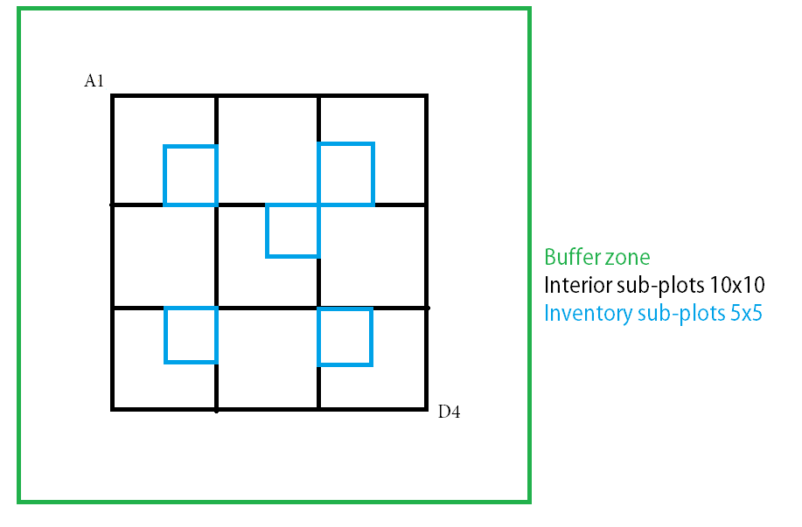
Figure 1: Inventory scheme in MELNHE regular plots. Trees with DBH 10 cm or above in the blue sub-plots are tagged and inventoried.
To avoid selecting genetically similar individuals, or sprouts from the same parent tree, selected trees need to stand at least 20 m apart. With our small sample size, doing this ensures that the sample pool draws from a non-skewed pool of genetic resistance. In the regular plots (see Fig. 1 above) this requirement means that I will not always be able to sample trees in the plots proper.

Establishment of Monitor Frames
For each tree, I will locate eight 5x10cm frames at two heights (1.5m and 0.5m from ground) and facing four cardinal directions. Frames will be painted and photographed for monitoring and possible future digital analysis.
Visual Inspection of BBD progression
I plan to use the rating scale for BBD used by Adam Wild, to be consistent with Aaliyah Jason’s work in summer of 2015. The rating scale includes a tree condition rating, a fungal infection rating, and counts of C. fagisuga wax masses and X. betulae excretory tubes.
Tree condition rating
1 | Tree in good condition. Foliage green. Less than 10% crown branches dead.
2 | Tree in fair condition. Foliage green to yellow-green. 10% to 50% crown branches dead.
3 | Tree in poor condition. Foliage yellow-green to mostly yellow. More than half crown branches dead.
fungal infection rating
0 | Absent.
1 | Sparse sunken lesions. Sparse localized perithecia or few scattered circular infections.
2 | Few sunken lesions covering part of tree.
3 | Sunken lesions covering more than half of tree.
4 | Sunken lesions covering the entire trunk.
Figure 2: Tree condition and fungal infection rating scales.
C. fagisuga wax masses in the four frames at 1.5m height will be counted. Number of X. betulae craters and excretory tubes will be recorded as well.

Bark Sampling and Fungal Identification
Three visible lesion cankers from this year will be selected on each tree sampled. I will use a narrow blade, sterilized between each use with a butane lighter, to collect sporodochia (asexual reproductive structures) into sterile 5 ml vials. Vials will be kept cool for lab identification.
Proposed Timeline
Last week of June: tree selection, visual inspection, and frame painting.
First half of July: photograph and collect samples from trees.
Second half of July: fungal identification in the Bartlett lab.
Further Work
Culturing samples in Syracuse.
Image analysis.

Add a section on data analysis, you want to know what you need before you collect the data.

Add expected results, it might help you decide what data to collect.

References
Cale J.A., Teale S.A., Johnston M.T., Boyer G.L., Perri K.A., and Castello J.D., 2015. New ecological and physiological dimensions of beech bark disease development in aftermath forests. Forest Ecology and Management 336:99-108.
Castlebury L.A., Rossman, A.Y., and Hyten A.S., 2006. Phylogenetic relationships of Neonectria/Cylindrocarpon on Fagus in North America. Canadian Journal of Botany 84:1417-1433.
Kasson, Matthew T., and William H. Livingston. "Spatial distribution of Neonectria species associated with beech bark disease in northern Maine." Mycologia 101.2 (2009): 190-195.

