**NSF Award 0949854 – Collaborative Research: Nutrient co-limitation in young and mature northern hardwood forests**

**Progress Report, year 2 (6/30/11 - 7/1/12), Cornell University**

Christine Goodale, Department of Ecology & Evolutionary Biology (EEB)

Timothy Fahey, Department of Natural Resources (DNR)

**Project Collaborators:**

Ruth Yanai, Project Lead PI, SUNY-ESF, Syracuse, NY

Ed Rastetter, Ecosystems Center, Marine Biological Lab, Woods Hole, MA

Melany Fisk, Miami University, Oxford OH

Joel Blum, University of Michigan, Ann Arbor, MI

**Cornell-Associated Personnel:**

***Fine Root and Soil Respiration Work***

Timothy Fahey, Professor, Cornell University, Department of Natural Resources (DNR)

Kikang Bae. PhD candidate, SUNY-ESF, kbae02@syr.edu

Natalie Cleavitt, research associate, Cornell University, DNR, nlc4@cornell.edu

Ang Li, MS candidate, Cornell University, DNR, al654@cornell.edu

Cynthia Wood, technician, Cornell University, DNR

Alexis Heinz, technician, Cornell University, DNR

***Soil Carbon and Nitrogen Pools***

Christine Goodale, Associate Professor, Cornell University, EEB, clg33@cornell.edu

April Melvin, PhD candidate, Cornell University, EEB, amm243@cornell.edu

Gavin Mackellar, BS 2011, Cornell University, DNR, gmm64@cornell.edu

Guinevere Fredriksen, Research Support Specialist, EEB, gf44@cornell.edu

Moustafa Abu Areda, BS 2012, Cornell University, EEB, mma75@cornell.edu

***Modelling, Multiple Element Limitation (MEL) model***

R. Quinn Thomas, PhD candidate, Cornell University, EEB, rqt2@cornell.edu

**Project Activities and Findings**

Our efforts during the initial phase of the project were directed towards site characterization prior to the initiation of treatments in spring 2011, including characterization of fine roots, soil respiration, and soil C and N stocks. Most of financial support for these activities was received in year 1, with modest support in year 2 for continued sample processing.

During 2011 and early 2012 Fahey et al. worked with collaborators to complete analysis of pre-treatment data on fine root biomass (FRB) in the upper 20 cm of soil in 52 experimental plots across the thirteen research sites. As of this writing FRB analysis has been completed for ten of the thirteen sites (40 plots, 400 soil cores; see Table 1). Not surprisingly, FRB is much lower in young forests (30-35 yr) than mature stands and slightly lower in more fertile than infertile sites. We collaborated on the analysis of pre-treatment data for total soil respiration (TSR) and total belowground carbon allocation across the sites. For example, we developed models based on soil temperature to explain seasonal variation in TSR across the three study areas (Fig. 1). These relationships will be compared with post-treatment sampling in coming years to evaluate fertilization effects.

Table 1. Summary of pre-treatment data for mid-aged (30-35 yr) and old (> 80 yr) forest stands at three study areas: fine root biomass, leaf litterfall, total soil respiration and estimated TBCA.

|  |  |  |  |  |  |  |  |
| --- | --- | --- | --- | --- | --- | --- | --- |
| **Forest age** | **Site** | **Fine root biomass (g m-2)** | | | **Leaf litter (gC m-2)** | **Total soil respiration (gC m-2)** | **BCA**  **(gC m-2)** |
| 0 – 1 mm | 1 – 5 mm | 0 – 5 mm |
|  | BEF | 277 ± 20 | 211 ± 22 | 488 ± 30 | 143 ± 6 | 807 ± 40 | 664 ± 20 |
| **Mid-aged** | HBEF | 270 ± 12 | 181 ± 21 | 451 ± 34 | 181 ± 21 | 868 ± 16 | 686 ± 29 |
|  | JB | 195 ± 24 | 248 ± 20 | 443 ± 28 | 122 ± 9 | 735 ± 26 | 613 ± 60 |
|  | BEF | 463 ± 38 | 335 ± 35 | 798 ± 33 | 140 ± 4 | 938 ± 48 | 798 ± 54 |
| **Old** | HBEF | 406 ± 19 | 377 ± 20 | 783 ± 53 | 152 ± 0.3 | 924 ± 33 | 772 ± 16 |
|  | JB | 432 ± 16 | 273 ± 12 | 706 ± 22 | 148 ± 2 | 763 ± 37 | 615 ± 38 |



Bartlett stands



Hubbard Brook stands



Jeffers Brook stands

Figure 1. Measured (blue) and modeled (red, based on soil temperature) total soil respiration in pre-treatment years 2009-2010 for three study sites.

We analyzed the relationships between fine root biomass and midsummer TSR across 36 study plots at the three study areas (Fig. 2a). Although fine root respiration accounts for a significant proportion of TSR in these forests (35-40%), the relationship was surprisingly weak, indicating high residual variation probably associated with differences in heterotrophic respiration and specific root respiration rate. Similarly, fine root biomass showed only a moderately strong relationship with estimated total belowground carbon allocation (Fig 2b). We anticipate that these relationships will be greatly modified by changes in respiration and allocation associated with fertilization treatments. For example, pre-treatment data indicated fairly large declines in TSR across plots depended primarily on soil N availability as indexed by net nitrogen mineralization assays (Figure 3).

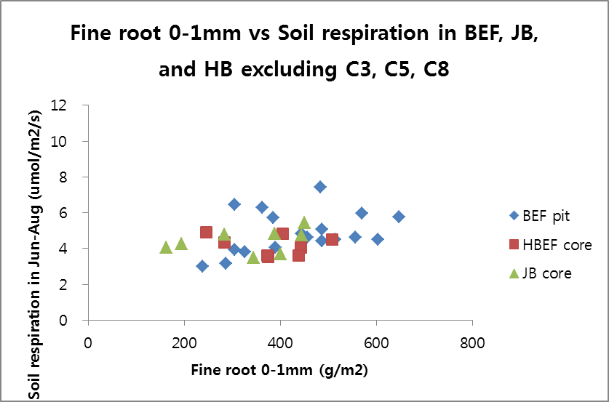

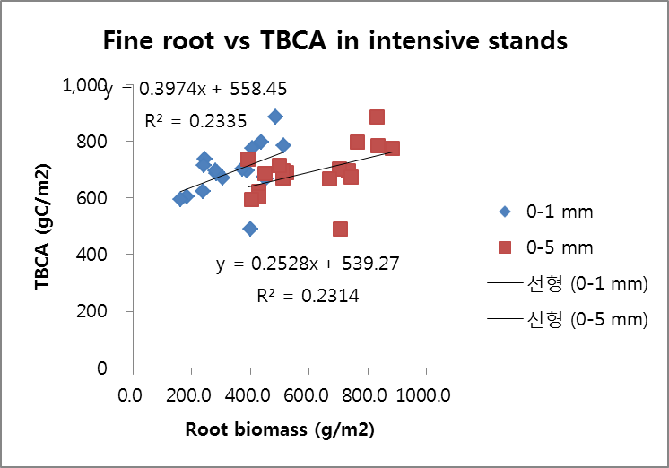

Figure 2. A. Pre-treatment data for a relationship between fine root biomass (< 1 mm) and midsummer total soil respiration for 36 study plots at three study sites. B. Relationship between estimated total belowground C allocation (TBCA) and fine root biomass (0-1 mm or 0-5 mm) for 18 study plots.

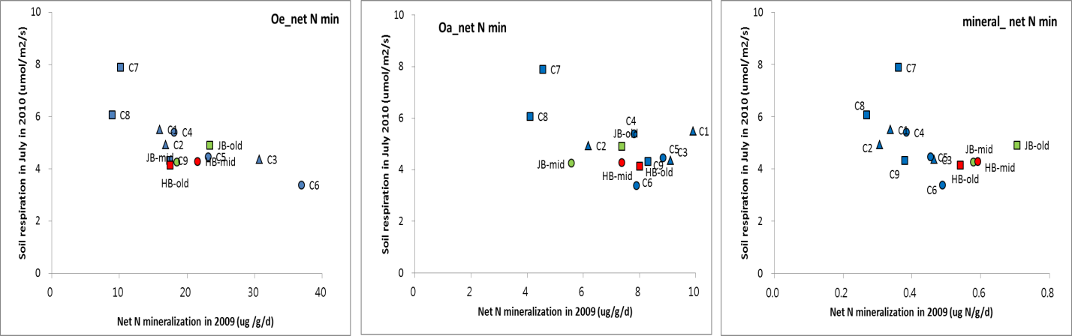

Figure 3. Pre-treatment data for thirteen stands across three study areas, illustrating the relationship between soil N mineralization and total soil respiration. Values represent means across three plots per stand and five soil collars per plot.

We have completed installation, pre-treatment observation and methods development for quantifying fine root dynamics and mycorrhizal colonization. A total of 160 minirhizotron access tubes were installed during summer 2010 and pre-treatment measurements were conducted during the snow-free season in 2011.Macroscopic approaches for quantifying relative changes in ectomycorrhizal vs. arbuscular mycorrhizal colonization of fine root tips have been successfully developed for pre-treatment samples on two selected plots. We will utilize these methods to compare the proportions of root tips that are ectomycorrhizal, arbuscular mycorrhizal or non-mycorrhizal in the control and treated plots beginning in the third year, post-treatment.

Goodale et al. are responsible for characterizing pre-treatment soil carbon and nitrogen stocks across all plots. In summer 2010, prior to fertilization, we sampled all 24 plots, or 4 plots located at each of the six sites: Hubbard Brook Mid-Aged, Hubbard Brook Old, Jeffers Brook Mid-Aged, Jeffers Brook Old, Bartlett C5, and Bartlett C7. Soil cores were collected from five locations per plot: four locations were located in the buffer (to-be-fertilized) area near the plot corners, and one location near the center of the plot, for a total of 120 soil cores (6 sites x 4 plots/site x 5 cores/plot). At each coring location the Oi/Oe and Oa forest floor layers were manually removed in a 15 cm x 15 cm area using a pin-block device. Mineral soil samples were taken from beneath the removed forest floor using an engine-driven, diamond-tipped coring device (Rau et al. 2011; *Soil Sci*) with an internal diameter of 9.5 cm, in 4 depth increments: 0-10 cm, 10-20 cm, 20-30cm, and 30-50 cm. For the 30-50 cm increment, roots were removed in the field or in the lab immediately following collection, then frozen. The remaining soil for this depth increment was split in half and the root subsample bag was frozen. Processing of the 480 mineral soil samples included air-drying, sieving (to 2 mm), and then grinding to a fine powder with a ball mill in preparation for C and N analysis on a vario-EL III (Elementar Analysensysteme, Hanau, Germany). The forest floor was sieved to 6 mm, and otherwise processed similarly as the mineral soil. This processing and analysis was completed by the end of spring 2012.

Figures 4 summarizes measurements of soil C and N stocks across all 24 plots. This pre-treatment data is essential to discerning changes in soil C and N stocks in response to fertilization. Preliminary assessment indicates that pre-treatment soils contained on average 142 tC/ha to 50 cm depth, a value broadly similar to measurements of whole-profile soil C stocks (160 tC/ha) at watershed 5 at Hubbard Brook prior to its clearcutting, estimated through > 60 quantitative pits (Johnson 1995; *CJFR*). Soil C stocks varied markedly from site to site, ranging from 109 tC/ha at Bartlett stand C7 to 194 tC/ha, or nearly twice as much C, at the Old Hubbard Brook stand (Figure 4). Nitrogen stocks in pre-treatment soils averaged 7.0 tN/ha, again similar to N stocks of 7.2 tN/ha measured at Hubbard Brook W5 by Johnson (1995). Both of the Bartlett sites, C5 and C7, contained smaller N stocks (4.2 to 6.7 tN/ha) than the Jeffers Brook and Hubbard Brook sites (7.0 to 10.8 tN/ha). In coming months, this pre-treatment C and N stock information will be finalized and combined with other root, soil, and plant information.





Figure 4. Pre-treatment mean (+ SD) soil C (top) and N (bottom) stocks for the six stands receiving N and P amendments. Values represent means of five soil cores per plot.