Nutrient limitation and soil carbon dynamics
in northern hardwood forests

Abstract
Carbon allocation to fine roots and rhizosphere microbes is a key mechanism by which ecosystems rebalance the cycling of limiting nutrients in the face of changing availability and demand. Thus, soil health and carbon storage depend on how stocks and fluxes of carbon and nutrients in the soil respond to nutrient limitation of both above and belowground processes. In 2011 we began the first long-term NxP fertilization experiment in temperate forests, in 13 New Hampshire northern hardwood stands spanning a range of ages and native soil fertility. Aboveground growth responded positively to P addition by 2014, and to N+P addition by 2019. Surprisingly, fine root biomass and growth were not reduced by nutrient addition; in fact, root growth was enhanced by N addition in mature stands and by N+P addition in successional stands. A complete view of the allocation responses to nutrient availability requires also quantifying rhizosphere C inputs. We propose to continue fertilization to test the transience of limitation of aboveground growth and belowground C inputs to soil, which will enable us to address our overarching hypothesis that nutrient limitation influences the relationship between forest productivity and soil C accumulation via its effects on allocation to root and rhizosphere processes. The Multiple Element Limitation model will be used to integrate data from the various components of the study, advance understanding of nutrient limitation, and extrapolate the results to predict soil carbon storage and forest productivity in the face of increasing CO₂, changing climate, and a legacy of atmospheric deposition.

Introduction
A healthy soil includes a living system of roots, symbiotic and free-living microbes, and micro- and meso-fauna, which together regulate fluxes of water, carbon, and nutrients between the ecosystem and the wider environment. Forest soils thereby provide a range of critical ecosystem services, including supporting aboveground wood production that can be sustainably harvested, sequestering carbon belowground, retaining nutrients deposited via atmospheric pollution, and regulating quantity and quality of hydrologic fluxes. The potential of forest soils to sequester carbon, in particular, is mediated by their ability to supply limiting nutrients demanded by trees for primary production, and the influence of nutrient limitation on the relative proportions of C inputs to forest floor and soil from fine litter, fine root turnover, mycorrhizal production, and rhizosphere exudation. Resilience to harvesting or natural disturbances requires adequate stocks of limiting nutrients that can be mobilized when the normal tight recycling of limiting nutrients is interrupted (Lovett et al. 2018).
Carbon allocation in forest ecosystems is determined both by growth and resource-acquisition strategies of tree species and by plastic responses to changing availability of resources including light, CO₂, water, and nutrients. These plastic responses not only allow individual trees and ecosystems to adapt to specific site conditions (e.g., an unusually shallow or especially rich soil), but also to respond to changing conditions, (e.g., a warming or drying climate, increased atmospheric CO₂, or chronic atmospheric deposition). The dynamic nature of these responses, and the long time periods required for forest ecosystems to equilibrate to new conditions, make long-term, carefully designed, and replicated experiments necessary for understanding the relationships between changes in relative nutrient availability and outcomes for soil health, including the sequestration of carbon and organically-bound pools of nutrients.
In this proposal, we continue our ongoing work testing nutrient limitation of forest productivity and we address long-standing questions about the relationship between productivity and soil C storage by testing the effects of nutrient availability on allocation, C inputs from different above- and belowground sources, and C accumulation in forest floor and mineral soil. The research is based on a long-term field experiment consisting of N and P fertilization of forests in full-factorial design. Thirteen northern hardwood forest stands of varying age and site quality have received annual, low-level nutrient addition since 2011. This experiment provides a rich template for addressing our overall goal of better understanding the complex interactions among soil nutrient availability, forest productivity, and soil C accumulation.

Nutrient Limitation and Co-Limitation
Managing nutrient supply to support ecosystem productivity was once understood to depend on identifying the most limiting nutrient, and perhaps the nutrients subsequently revealed to be next most limiting (von Leibig, 1840). In forests, this meant that fertilization trials in regions presumed to be N limited (e.g., hardwoods in the northeastern USA) included N addition and occasionally N+P addition (Vadeboncoeur 2010), while in regions of phosphorus limitation (e.g., pines in the southeastern USA) the common treatments were P addition and P+N addition (Fox et al 2007), but there was no reason to test the response to a single nutrient presumed not to be limiting. Without trials involving both elements separately, we cannot determine which element is more limiting, nor whether above- and below-ground production might be limited by different nutrients. With the inclusion of a treatment including both N and P, we can also test for co-limitation.
While ecosystem N can be fixed from the atmosphere (and is deposited in the form of pollutant-derived ammonium and nitrate), P stocks in ecosystems are predominantly derived from the weathering of minerals in the soil parent material. It is therefore generally understood that productivity of terrestrial vegetation is limited by P on old soils and by N on young soils, as primary mineral P is depleted, and organic N accumulates with soil development (Walker and Syers 1976). However, N is not always the sole limiting nutrient in forests on geologically young soils (Vadeboncoeur 2010), and recent demonstration of the global prevalence of N and P co-limitation across many ecosystem types (Elser et al. 2007, Harpole et al. 2011) has stimulated interest in the processes regulating nutrient limitation of productivity across a wide range of natural and managed ecosystems.
Organisms and ecosystems have mechanisms to help them maintain balanced mineral nutrition. These mechanisms, the accumulation of nutrients within ecosystem cycles, and the consequent synchronization of those cycles should operate to minimize limitation by any single nutrient (Bloom et al. 1985, Chapin et al. 1987, Rastetter et al. 2013), thereby maintaining a condition near nutrient co-limitation (Elser et al. 2007), within the strategy constraints of the plant and microbial communities, and the resource constraints inherent to a given site.
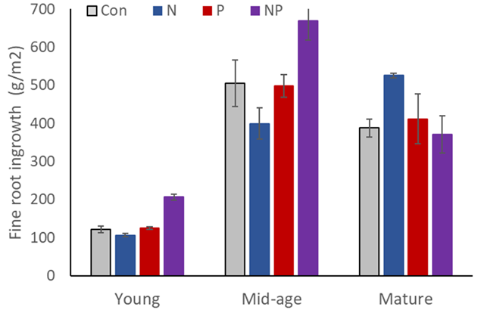
Figure 1. Fine root ingrowth rates were highest in response to NP treatment in 2 young stands and 3 mid-aged stands and highest in N treated plots in 3 mature stands, although we expected growth to be reduced by nutrient addition.

Belowground allocation and soil C accumulation
The key role played by roots and mycorrhizae in the formation and stabilization of soil C is now well established (Rasse et al. 2005, Frey 2019), and therefore soil C accumulation depends on belowground C allocation by vegetation. The acquisition of C by foliage and water and nutrients by roots and mycorrhizae is balanced by the adjustment of allocation to assure sufficient light and soil resource capture in the face of competition and soil resource scarcity. Thus, root:shoot ratios and belowground C allocation are expected to decline in response to fertilization, and aboveground growth is maximized by increasing allocation of C to shoots, according to the functional balance theory (Thornley 1991). This allocation theory has been questioned by Simon and others (2017), who suggested that increases in soil nutrient supply might enhance the C sink strength of roots and C allocation belowground. Results to date from our experiment appear to support this suggestion: we observed significantly higher fine root growth in nutrient addition plots than controls in all our stands (Fig. 1). This result appears to be tied to nutrient co-limitation in a complex way as the response was to N+P in successional stands (Li et al. 2023) and to N in mature stands (Shan et al. 2012). We suggest that the former result reflects the aforementioned co-limitation of productivity whereas the latter may signal a switch from co-limitation to P limitation under high N supply, thereby requiring increased allocation belowground.

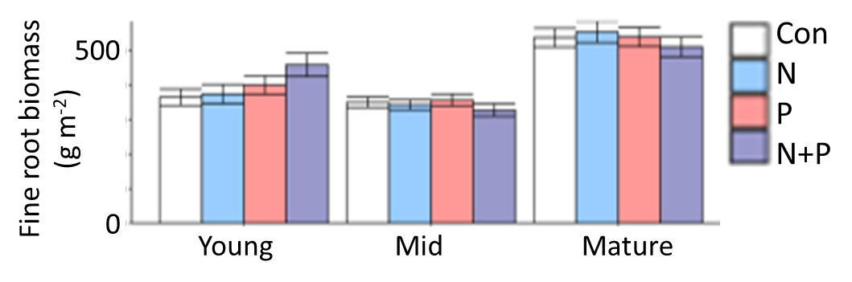
Figure 2. There was no consistent effect of nutrient addition on fine root biomass (0-30 cm depth) across all 13 stands (3 young, 5 mid-aged, and 5 mature). Fine root biomass was lowest in mid-aged stands (p = 0.01).
Carbon fluxes to mycorrhizae can be as large or greater than to fine root production (Ouimette et al 2018; 2020). Mycorrhizal associations undoubtedly play an important role in belowground C allocation and the balance of N and P limitation in these forests. Of particular importance to soil health, mycorrhizal fungi play a critical role in the stabilization of soil organic matter, via exudates and necromass, while sometimes simultaneously promoting the decomposition of organic matter to liberate limiting nutrients (Frey 2019; Vadeboncoeur et al. 2015). The net balance of these processes in terms of soil C sequestration is therefore dependent on C allocation to mycorrhizal fungi of different functional types via roots at a range of soil depths (Phillips et al. 2013). All 13 of our study stands are composed of mixtures of ectomycorrhizal (EM) and arbuscular mycorrhizal (AM) trees (Table 2). These different mycorrhizal types differ in their carbon-nutrient tradeoffs, but the situation is complex as C, N and P limitation of both plant and fungus can be involved (Hoeksema et al. 2010). The known effects of AM vs EM on soil C processes suggest EM effects on forest floor C and AM effects in mineral soil (Craig et al. 2018).
Net belowground carbon input via roots, mycorrhizae, and exudates has been measured by a variety of indirect methods (Frey 2019, Ouimette et al. 2020), with studies showing a range of differences between AM and EM-dominated communities, some finding greater overall C input flux in AM stands (Keller et al. 2021), while others variously find that EM communities accelerate decomposition (Brzostek et al. 2015; Carteron et al. 2022), or result in greater (Averill et al. 2013) or perhaps simply shallower (Craig et al. 2018) stocks of soil organic matter. Better understanding the relationships between these processes and soil health functions such as soil organic matter dynamics is critical in the face of ongoing N deposition, CO₂ increases, and observed increases in the dominance of AM tree species relative to EM species (Jo et al. 2019).

Experiments investigating co-limitation
While challenging to establish and maintain, long-term soil experiments provide critical data about the responses of slowly equilibrating processes (e.g. accumulation of soil organic matter) to changes in ecosystem management and external forcings (Richter et al. 2007), with consequences both for the sustainable provision of forest products and for ecosystem services. We are aware of only two full-factorial studies of response to N and P in temperate forests, and these were both short term with very high rates of nutrient additions (Mainwaring et al. 2014, Finzi 2009). Adding nutrients to test for limitation disrupts the balance among linked biogeochemical cycles regulating the supply and acquisition of different nutrients. Responses may change in magnitude or even direction over time, depending on how rapidly various processes can re-equilibrate, as has been documented in other ecosystem-scale experiments in forests (e.g. Melillo et al 2017, Paschalis et al. 2017). Therefore, a full understanding of the limitations to forest productivity, and especially the consequences of changing belowground processes for slowly accumulating soil C, requires experiments that are sufficiently long-term to accommodate adjustments by biota over a range of time scales - from soil enzyme production, to changes in biomass allocation aboveground and belowground, to resynchronization of nutrient
cycles, and eventually tree species replacement.

Our team has undertaken the world’s first long-term NxP factorial nutrient manipulation in temperate forests, initiated in 2011 in 13 stands of three ages distributed across three research sites in the White Mountains of New Hampshire. By adding relatively low levels of N and P over a long time period, we can monitor the development of nutrient limitation of temperate forest productivity both aboveground and belowground, including the contribution of rhizosphere C flux, and the consequences of these factors on the rate of soil C accumulation with depth. Simultaneously with these treatments, as with all long-term experiments, atmospheric CO₂ concentrations continue to rise, layering an additional long-term resource manipulation on top of our fertilization experiment. In general, increasing CO₂ is expected to intensify competition for belowground resources including N and P (Rogers et al. 1994, Pourmokhtarian et al. 2012), with possible consequences for the ratio of Callocated belowground. Meanwhile, reductions across the eastern US in inorganic N and especially S deposition relative to late-20th century
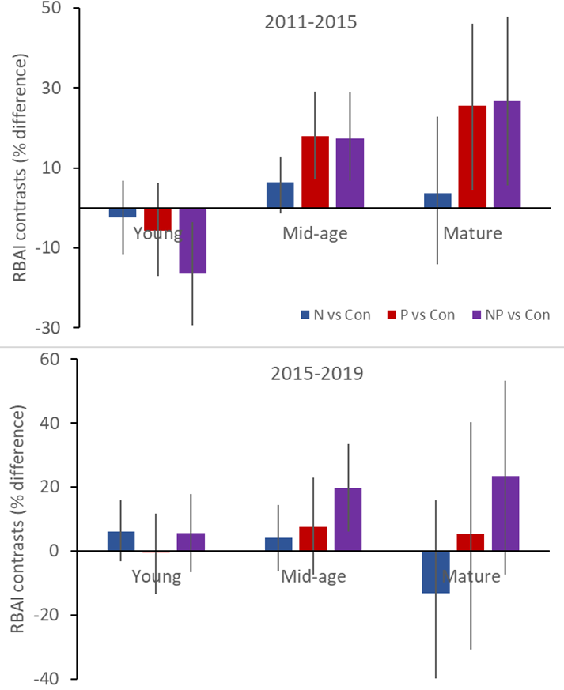
Figure 3. Aboveground growth (average tree relative basal area increment) in treatment plots compared to controls. Across all 13 stands (3 young, 5 mid-aged, and 5 mature) tree growth responded to P addition from 2011-2015 but to NP addition from 2015-2019. Error bars are 90% highest posterior density intervals.
peaks is resulting in the slow de-acidification of soil (Tominaga et al. 2010, Likens and Buso 2012), which may ameliorate P deficiency.

Ongoing and Completed Activities
A summary of the findings from this work demonstrates the productivity of our research team and the value of continuing to build upon this knowledge base (Table 1). Here, we highlight some key results that motivate the current proposal.
In the early successional stands we found high tree mortality. This likely contributes to the finding of low root growth relative to root biomass (Figs. 1,2), suggesting slow root turnover. The strong allocation aboveground and dependence on high nutrient availability in young forests (Fahey et al 1998) suggests that the rhizosphere C flux is also relatively low. In mid-successional stands, root growth was much greater than in young stands (Fig. 1), suggesting relatively high input from roots relative to aboveground sources at this successional stage.
Stem and root growth both appeared to be N+P co-limited on average in successional stands (Figs. 2,3), although variation aboveground was high among stands in the youngest forests (Goswami et al. 2018, Li et al. 2023). Depending on whether rhizosphere inputs respond in opposing or complementary ways to root responses (Bergmann et al. 2020), these results may indicate that high availability of N and P together promote soil C accumulation; we expect this effect to be most pronounced in mid-successional forests where belowground inputs are proportionately more important.
Despite much higher root growth in N+P plots, fine root biomass is not significantly different among treatments (Fig. 2), indicating that root turnover is much higher in N+P plots. Higher fine root N concentrations are usually associated with shorter root lifespans (McCormack et al. 2012, Withington et al. 2006), but sometimes the opposite is found (Burton et al. 2000). If root turnover is driven by high metabolic cost, then the effects of tissue N concentration on turnover should depend on P limitation status. In mature forests, aboveground growth was slow relative
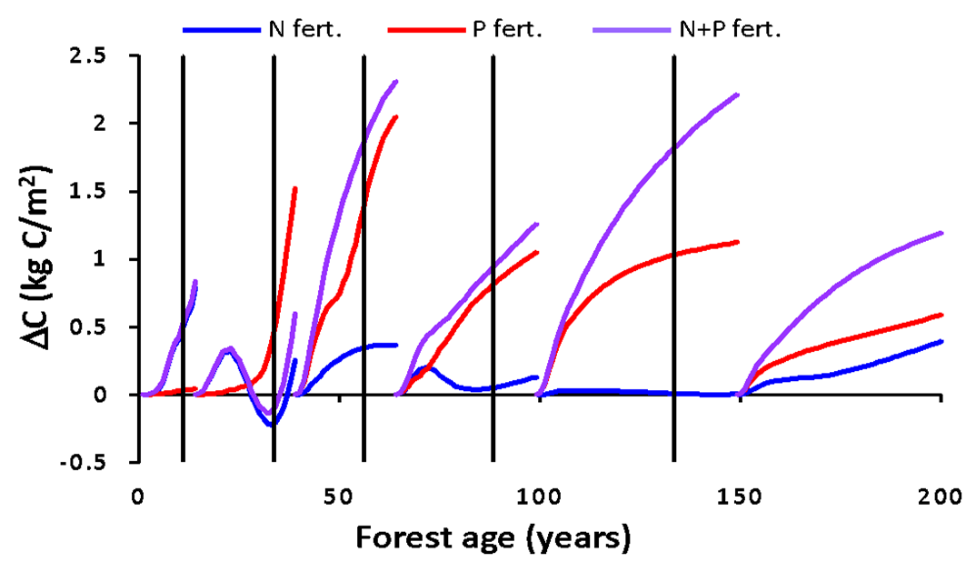
Figure 4. Response of forest biomass relative to the control to modeled additions of N (30 kg/ha/yr), P (10 kg/ha/yr) or N+P beginning at various ages since clearcutting (vertical lines) (Rastetter et al. 2013). The greater response to N in young stands and to P in mid-aged and older stands is consistent with our observations (Fig. 3).
to successional forests (Fig. 3), tree mortality was highly heterogeneous in time and space, and, while responses to N and P were variable (Goswami et al. 20018, Hong et al. 2022), they suggest N+P colimitation most recently (Fig 3). Root growth appeared N-limited, but only in the absence of P (Shan et al; 2022 Fig. 1), suggesting single-nutrient limitation of belowground inputs. Rhizosphere inputs are expected to be high at this age and, again, we need to know how they compare to root growth, in terms of quantity and direction of response to nutrition, to predict total belowground response to N and P and hence inputs contributing to C storage.
We have coupled this experimental work with the MEL model, which was used to predict changes in nutrient limitation and productivity following harvest of northern hardwoods (Fig. 4, Rastetter et al. 2013). Comparing our results to date with MEL predictions reveals needed conceptual refinements in model parameters. For example, increased root growth in response to alleviating limitation contrasts with the representation of resource optimization that underlies root:shoot responses in the MEL model. Development of NP co-limitation on a much shorter timeline than expected based on MEL model output also suggests a need to refine model parameters influencing the nutrient recycling processes that dictate the re-synchronization of N and P cycles.
The MELNHE project has produced 38 journal articles (since 2004) and 13 theses and dissertations (since 2010) and involved an impressive array of early career scientists and potential scientists, including 30 graduate students, 111 undergraduate students and hundreds of high school students. High school students have processed root samples from various soil depths, sorted leaf litter by species, evaluated herbivory by insects, analyzed soils, identified snails, built sap flow sensors, and learned data entry and analysis. Undergraduate student interns have participated in our summer field crews for most of the past two decades. These students are key to sustaining our experimental infrastructure: they help weigh and apply fertilizer, collect spring and summer litter, monitor soil respiration, and maintain equipment and location markers in our sites. Each intern, guided by more experienced mentors, also leads a modest individual project investigating an as-yet unexamined aspect of ecosystem responses to the treatment experiment. Past interns have studied decomposition and nutrient immobilization rates in decomposing wood and litter substrates, fertilization effects on tree seed production and seedling establishment, changes in understory plant diversity, the abundance of ectomycorrhizal mushrooms, and new approaches to analyzing and combining existing data sets. Some of these past projects have contributed directly to the ideas and data presented in this proposal.

Rationale and Significance
Understanding the limitations of soil nutrient supply to productivity is critical in forests, which are quintessentially low-input production systems. Northern hardwoods (beech-birch-maple) extend across much of the northeastern and upper midwestern USA (Godman 1992), and provide substantial timber, fiber, and non-timber value to their communities, including, for example, maple syrup and tourism income. These forests are relatively slow-growing and have typically been managed without fertilization (Nyland 2016; Rogers et al. 2022). However, repeated harvesting depletes the soil stores of available nutrients (Federer et al. 1989, Vadeboncoeur et al. 2014), and the intensity of removal increases dramatically when biomass removal for energy is maximized, compared to harvesting for maximum timber value (Mann et al. 1988, Yanai 1998). Understanding the feedbacks between active allocation of carbon and nutrients by forest ecosystems–and the ecosystem services provided by forest soils–can be studied by experimentally manipulating nutrient availability over long time periods and watching ecosystems respond and re-equilibrate. Simulation modeling can be used to represent the current state of knowledge and test whether observations are consistent with theory.
The Multiple Element Limitation (MEL) model has has played a foundational role in the development of nutrient limitation theory, the synchronization of nutrient cycles within ecosystems, and the coupling of nutrient cycles with energy, carbon, and water fluxes (Rastetter and Shaver 1992, Rastetter et al. 1997, 2001, 2005, 2013). The MEL model simulates interactions among C, N, P, light, and water in terrestrial ecosystems based on resource optimization theory (Bloom et al 1985, Chapin et al. 1987). Under constant conditions, plants and ecosystems adjust toward a condition where all resources are equally limiting.
We adapted and parameterized MEL for northern hardwood forests (Rastetter et al. 2013, 2022) and will continue to test model predictions of responses to the long-term nutrient addition experiment described in this proposal (Fig. 4). MEL predicted that over successional time in a harvested northern hardwood forest, N and P co-limitation would eventually develop as the cycles of these limiting nutrients were re-synchronized, correcting the disruption of synchrony
Table 1. Selected previous work in our study sites, including pre-treatment soil and vegetation characterization and measured ecosystem responses to fertilization.
Pre-treatment
- Root ingrowth cores suggesting P limitation in mid-aged stands (Naples and Fisk 2010)
- Pretreatment root chemistry differing with soil depth and site (Yanai et al. 2018).
- Characterization of among-stand variation in soil nutrients (Vadeboncoeur et al. 2012, 2014), weathering rates (Schaller et al. 2010), root biomass (Yanai et al. 2006, Park et al. 2007), and aboveground biomass and nutrient stocks (Fatemi et al. 2011)
- An improved version of the Multiple Element Limitation (MEL) model based in part on data from these stands, showing changes in limiting nutrients and shifts in optimal allocation with stand age and management (Fig. 4, Rastetter et al. 2013)
- Stand-scale nutrient depletion budgets with implications for sustainable forest management (Vadeboncoeur et al. 2014)
- Variation in foliar nutrient resorption (See 2013, See et al. 2015) and soil respiration (Bae 2013, Bae et al. 2015) showing significant effects related to stand age and nutrients
- Coupling of soil N and P availability across all study sites (Ratliff and Fisk 2016)
- AM and EM colonization rates declined differentially with soil depth (Nash et al. 2022)

Treatment effects
- Soil microbial responses indicating limitation by P and suppression by N of microbial respiration (Fisk et al. 2015); this pattern continues until the present.
- Responses of foliar chemistry and sugar content of maple sap, showing greater sap sweetness in response to N addition (Wild 2014, Wild and Yanai 2015)
- Responses of foliar chemistry of 10 species in 10 stands to nutrient treatment (Hong et al. 2022) and to nutrient treatment as a function of depth in the crown (Young et al. 2023)
- Foliar N and P resorption reflect treatment effects on the relative demand for N and P (Gonzales et al. 2019, 2023)
- Sap flow responses in multiple species in a subset of stands and treatments (Hernandez-Hernandez 2015, Zahor 2014, Rice et al. 2022)
- Negative effects of N and P treatments on survivorship of maple and beech germinants, corresponding with improved N and P nutrition and greater leaf damage (Goswami 2017)
- Initial post-treatment soil respiration, showing a greater response to N addition where soil N availability was low (Kang et al. 2016)
- Responses by resin-available soil nutrients, showing that treatments elevate nutrient availability and that P addition suppresses N availability (Fisk et al. 2014; Goswami 2017)
- Growth of trees post treatment, indicating aboveground P limitation of the average tree (Fig. 3, Goswami et al. 2018), but N limitation of the largest trees (Hong et al. 2022).
- Root growth was enhanced by N addition in mature stands (Shan et al. 2022) and by N+P addition in the youngest stands (Li et al. 2023).
- Mycorrhizal fungal communities on beech seedlings post-treatment (Barner 2016) and in soil ingrowth bags (Horton et al. 2018).
- Community composition of herbs (Dai 2023) and of fruiting bodies of ectomycorrhizal fungi (Victoroff 2020) reflected N and P addition.
associated with nutrient losses during and after harvest (Rastetter et al. 2013). The model predicted greater N limitation in early stages of recovery (stands 0 or 15 years old grew more with N or N+P addition than P addition), but P limitation later (stands 40 years old grew more in response to P or N+P addition than N addition); the greatest advantage of N+P addition was predicted in stands over 100 years old (Fig. 4). The MELNHE experiment has provided some support for the model, with weak evidence for N limitation in early succession and significant P limitation in older forests as of 2014 and progress towards co-limitation by 2019 Fig. 3).

This work takes on particular importance in the rapidly changing northern forest environment. Decreased loading of atmospheric pollutants, especially acid deposition and N (Bernal et al. 2012), are interacting with CO₂ fertilization and changing climate to alter soil nutrient availability with highly uncertain consequences for forest production and health.
An improved mechanistic understanding and ability to model and predict changes in belowground allocation and consequent changes in carbon sequestration as soil organic matter will improve management outcomes by enabling recommendations for forest managers. For example, this work may inform silvicultural management to preferentially regenerate the mix of species with belowground strategies that increase sequestration of soil organic matter under nutrient-limitation trajectories predicted for a specific class of sites. Additionally, guidelines could be developed based on our data and models that would better identify nutrient limitation and thereby predict trajectories of soil C storage following management. Finally, if carbon markets develop that can incentivize more costly forest management practices (Kim and Langpap, 2015) to enhance the strength of managed forests as a C sink (for example, application of inorganic fertilizers, wood ash, or basalt; Sedjo and Sohngen 2012, Beerling et al. 2020, Buss et al. 2021, Lewis et al. 2021), then our model would be extremely useful in understanding the results of such amendments, estimating the timeframe of such sequestration, and identifying soils and species mixtures best suited for such interventions.

Approach
We propose to continue plot-scale fertilization in 13 forest stands distributed across three sites in the White Mountain National Forest of New Hampshire. At the Bartlett Experimental Forest (BEF), we have six successional (third-growth) stands ranging in age from 33 to 48 and three mature (second-growth, 110+ year-old) stands. At both Hubbard Brook Experimental Forest (HB) and Jeffers Brook (JB) we have one mature and one successional stand (Table 2). Differing mineralogy of the glacial till at the three sites (see Methods, below) leads to a gradient in soil nutrient availability (Vadeboncoeur et al. 2014, See et al. 2015, Ratliff and Fisk 2016). These sites were chosen to represent a wide range of environmental conditions representative of northern hardwood ecosystems across northern New England. Thus responses to treatment could vary significantly across our sites (Kang et al. 2016), and our detailed characterization of soil fertility and tree nutrition prior to treatment will allow us to evaluate relationships between site quality and treatment responses. This is a strength of our study, as the generality of results from this experiment will be greater than from a typical single-site nutrient addition experiment. Each stand has four plots treated with N (30 kg N/ha/yr as NH₄NO₃), P (10 kg P/ha/yr as NaH₂PO₄), both N and P, and control, added annually since spring 2011.
This long-term factorial fertilization experiment, with its extensive pre-treatment characterization and post-treatment monitoring, can be leveraged to answer new questions about how nutrient limitation of forest ecosystems can affect soil health in terms of nutrient cycling and carbon sequestration. Our proposed work addresses the overarching hypothesis that changes in nutrient limitation alter the relationship of productivity to soil C via effects on belowground allocation.

Objective I. Test for limitation of above- and belowground productivity

Hypothesis 1: Aboveground productivity is co-limited by N and P.
We will inventory tree diameters in 2024 to compare with 2011, 2015, and 2019 inventories, and we will continue to monitor litter production in litter traps, which we have done annually since 2008. Continued measurements of resin-available N and P will extend our time series describing fertilization effects on the relative availability of these nutrients in each plot.
Prediction: Tree diameter growth and aboveground productivity will be greatest in response to N+P, consistent with theories of co-limitation and with the results of the 2019 inventory.
Alternative Prediction: Aboveground productivity will be greatest in response to N addition, consistent with N oligotrophication and with the trajectory from P limitation in 2014 to N+P colimitation in 2019.
Alternative Prediction: Aboveground productivity will be greatest in response to P addition. Oscillations between N and P limitation were predicted by the MEL model, but at longer time scales (Rastetter et al. 2013).

Hypothesis 2: Root biomass and growth are least when nutrient limitation of aboveground growth is relieved.
We will finish processing fine root biomass from root cores collected in 2021 and 2022, which will be compared with data from 2010 (pretreatment) and 2015-16 (Fig. 2). We will measure root ingrowth into root-free cores in 2024-25, expanding on preliminary work (Tables 1, 3).
Prediction: Root biomass and root growth will be reduced in response to addition of the element(s) most limiting to aboveground growth. According to optimization theory, alleviating nutrient limitation should reduce allocation of effort belowground.
Alternative Prediction: The response of root biomass and growth will mirror that of responses to aboveground productivity, increasing in response to the same nutrient that increases aboveground productivity.
Alternative Prediction: The response of root biomass and growth will depend on the type of mycorrhizal association, with relative increases in AM roots in response to N fertilization and in ECM roots in response to P fertilization.

Hypothesis 3: Root N and P concentrations reflect nutrient limitation of root growth
We will analyze nutrients in roots collected from all 13 stands in 2010, 2016-18, and 2021-22. Stable N isotope analysis of a subset of root samples will provide an estimate of soil depth from which root biomass nitrogen was sourced.
Prediction: Root nutrient concentrations will parallel those of foliar nutrient concentrations: N and P will be increased by addition of that element, but reduced by addition of the other element, reflecting luxury consumption and dilution, respectively, as expected in a system close to co-limitation.
Alternative Prediction: Root N and P concentration responses will differ from those of foliage, due to differences in growth limitation above- and belowground. Specifically, in successional stands, N and P concentrations will not be reduced by the addition of the other element, and in N+P addition, increases will be minimal, consistent with enhanced root growth. In mature stands, concentrations will reflect N limitation of root growth.
Prediction: The depth distribution of N and P concentration will reflect greater N availability in surface soil and greater P availability at depth.
Prediction: Natural-abundance stable N isotope ratios in deeper roots will show an increased reliance on N sourced from shallow soil depths in P-fertilized plots but a reduction in N-fertilized plots.

Objective II. Determine effects of nutrient availability on soil C pools and fluxes

Hypothesis 4: Root turnover is increased by nutrient addition
Root turnover rates will be indicated by the ratio of root ingrowth to standing biomass (Hypothesis 2).
Prediction: Root N concentration is the best predictor of root turnover, as has commonly been observed and attributed to higher metabolic activity associated with higher uptake rates.
Alternative prediction: Root turnover will be sensitive to P and not just N, consistent with root growth results if balanced nutrition is necessary to optimize metabolic activity.

Hypothesis 5: Belowground carbon allocation is proportional to belowground root growth.
Belowground carbon allocation will be measured as soil respiration minus aboveground litter input and change in soil carbon stocks. Rhizosphere fluxes of root-derived carbon to the soil will be quantified in an additional set of ingrowth cores filled with ¹³C-enriched soil.
Prediction: Belowground carbon allocation will be increased by increased root growth (measured to test Hypothesis 2)
Prediction: Soil rhizosphere flux will be increased by increased root growth
Alternative prediction: Soil rhizosphere flux will be inversely related to root growth, since mycorrhizal fungi can functionally substitute for the functions of higher-turnover fine roots
Prediction: Residual variation in root rhizosphere flux not explained by root growth will be explained by mycorrhizal status, being greater in cores dominated by AM than by EM roots.

Hypothesis 6: Soil carbon pools respond to rhizosphere carbon flux
Pre-treatment soil carbon pools were characterized with quantitative soil pits and power cores. We will re-measure changes in soil carbon concentration in each depth increment and use the previous estimates of soil volume and bulk density to scale these up to carbon stocks and fluxes.
Prediction: Soil carbon pools are sensitive to belowground carbon allocation to a greater degree than by root production, consistent with the greater stability of carbon in root exudates and mycorrhizal fungal necromass.
Alternative prediction: Changes in soil carbon pools are best explained by root production across the sites, stands, and nutrient addition treatments.
Prediction: Residual variation in accumulation of soil carbon not explained by root production or belowground carbon allocation will be explained by the mycorrhizal type of the nearby trees and will be greater in AM than EM dominated soils.

Objective III. Evaluate improved understanding of co-limitation via the MEL model
The MEL model will serve as means to synthesize results of the project and link those results to the large volume of data already available from northern hardwood forest ecosystems. Underlying questions to be addressed in these syntheses are: Do all the data currently available fit together in a self-consistent representation of the linked C, nutrient and water dynamics of northern hardwood forests? If not, why not, and how does MEL have to be changed to accommodate the discrepancies?
Mixed effects models will also aid in synthesizing results from our field experiments to test hypothesized pathways of plant and soil contributions to tree growth and soil organic matter responses. Quantitative predictive outcomes from these models will contribute to refining parameters of the MEL model, which serves as a means to examine the whole-ecosystem consequences of our experimental results. For example, we expect the results to show differences both among our sites and in response to the nutrient additions in aboveground and belowground biomass and productivity. These changes can be studied in the model by changing the parameterization of the affected processes. In the model, these parameter changes will result in changes in process rates, which will then have effects that propagate all through the system. Do such changes result in ecosystem-level feedbacks that dampen or amplify the direct effects? If the parameter changes can be associated with other dynamics in the model (e.g., increased light use efficiency as the canopy closes), then the parameters can be replaced by equations describing the association, thereby allowing a more dynamic examination of the long-term consequences of our findings. An improved MEL model will allow us to explore the importance of resource limitation to future forest productivity and soil carbon responses to continued anthropogenic N deposition, increasing CO₂, and changing precipitation and temperature scenarios.

Methods

Study Sites
We will test our hypotheses by making measurements in a previously established plot-scale fertilization experiment in the White Mountain National Forest in New Hampshire. The experiment involves three sites separated by ~50 km (Fig. 5). Soils are Spodosols and Inceptisols developed in glacial till; the complex geology of the White Mountains results in varied soil mineralogy. Due to the lack of earthworms or other macrofauna to vertically mix the surface soil, forest floors of these soils include an Oa layer comprised of humus averaging 60% organic matter which is 2 - 8 cm thick (Vadeboncoeur et al. 2012), and contains 34% of total root biomass (Yanai et al. 2006, Park et al. 2007). Soil fertility (in pools that are available at a range of different time scales, e.g. exchangeable, organic, and primary mineral pools) varies widely among stands and was well characterized prior to the initiation of fertilization treatments (Vadeboncouer et al. 2014, Ratliff and Fisk 2016).
The climate is humid continental. Precipitation has been increasing, with an average precipitation of 1400 mm, and continuous snow cover from December to April (Hamburg et al. 2013, Campbell et al. 2022). Average monthly temperature ranges from -9 to 18 C. Soils are predominantly well-drained; soil moisture differs across stands, but no significant treatment effect on soil moisture has been observed. Study stands range in age from 30 to >130 years (Table 2) and naturally regenerated following logging for even-aged management, a common silvicultural system in this forest type. Composition is typical of northern hardwoods, dominated by sugar maple (Acer saccharum), American beech (Fagus grandifolia), and yellow birch (Betula alleghaniensis) in mature stands. Pin cherry (Prunus pensylvanica), white birch (Betula papyrifera), and red maple (Acer rubrum) dominate the younger stands (Table 2).

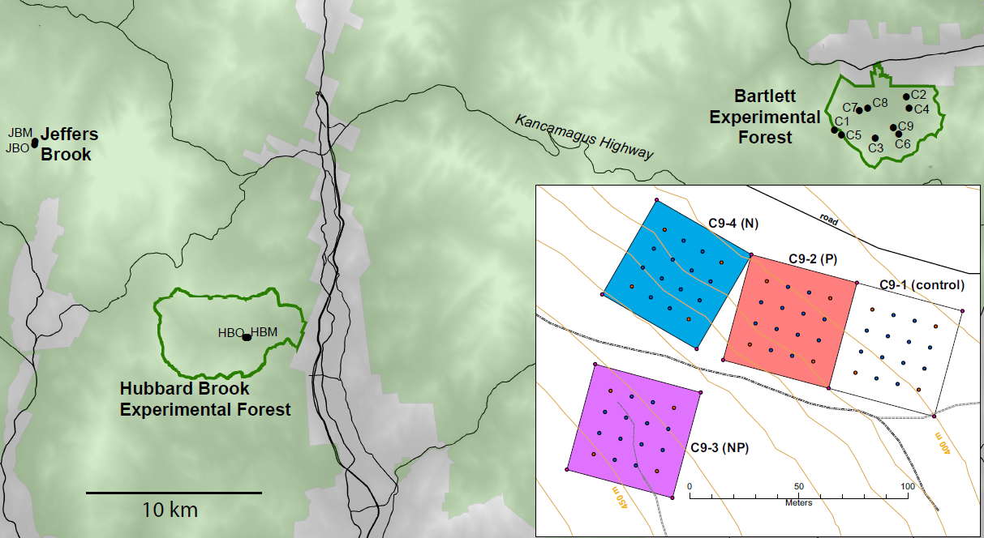
Figure 5. MELNHE is a factorial N x P fertilization experiment replicated in 13 stands: 2 at Jeffers Brook, 2 at Hubbard Brook Experimental Forest, and 9 at Bartlett Experimental Forest. Light green shading shows the White Mountain National Forest, and green outlines delineate the two experimental forests. The inset shows the layout of the four 50 x 50 m treatment plots at an example stand (C9); within each stand treatments were assigned randomly to each of four plots, selected to be similar in species composition, topography and disturbance history.

Table 2. Selected characteristics of the 13 stands. x indicates dominant species: FAGR = beech, BEPA = white birch, BEAL = yellow birch, ACSA = sugar maple, ACRU = red maple, PRSE= pin cherry.

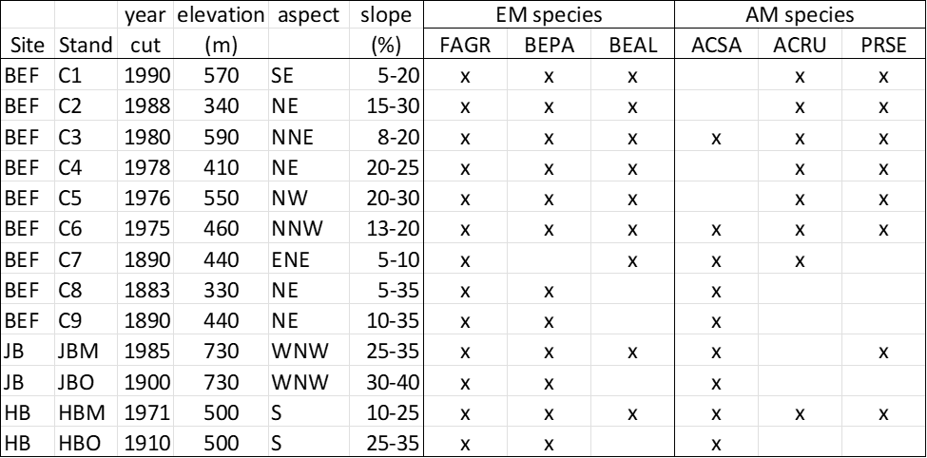

Nutrient Manipulations
Each stand has four plots (e.g. Fig 5 inset) treated with N (30 kg N/ha/yr as NH₄NO₃), P (10 kg P/ha/yr as NaH₂PO₄), or both, and a control. The form of nutrient addition is important: our P source does not contain Ca, unlike most P fertilizers. Annual additions of N and P began in spring 2011 and will be continued throughout this proposed research. These relatively modest rates (relative to single-event fertilization studies, e.g. as reviewed by Lebauer and Treseder 2008, Vadeboncoeur 2010) are designed to alter site fertility and maximize nutrient retention over the long term while minimizing acute artifacts associated with high doses of fertilizer.
All study plots are 50 x 50 m, except in two successional stands where 30 x 30 m plots were the largest that fit within the even-aged management unit. In all plots, we avoid the edges of the treated area and conduct both aboveground and belowground measurements at least 10 m from plot boundaries (5 m in plots that are only 30 x 30 m).

Methods for Objective I:
Test for co-limitation of aboveground and belowground productivity

Hypothesis 1: Aboveground productivity is co-limited by N and P

Tree growth. We measured trees by species and size class (>10 cm, 2-10 cm, and < 2 cm DBH) in the 30 x 30 m measurement area within each study plot prior to initiating treatments (2008-2011) and in 2015 and 2019. We will repeat these measurements in 2024, the 14th year of treatment, to test for continued growth response to treatments. Tree biomass (by component part) will be estimated for all trees in the measurement area of each plot using the allometric equations developed and validated in the White Mountains for northern hardwood species in early- and late-successional forests (Whittaker et al. 1974, Siccama et al. 1994, Fahey et al. 1998, Arthur et al. 2001), supplemented by allometric equations developed for the young stands in our study (Fatemi 2007; Fatemi et al. 2011). These allow us to estimate the growth increment of biomass of perennial tissues (woody biomass production). All trees > 10 cm DBH are tagged, allowing net biomass increment to be separated into growth and turnover, by species and plot.
Foliar production. Litterfall is collected in all 13 stands three times per year, in 5 traps per plot, systematically located in the center and four corner subplots (Mann 2021, Mann et al. in review). Leaf litter and other fine litter (excluding twigs and branches) is dried at 60C and weighed. In a subset of past years, leaf litter has been sorted to species which is useful for distinguishing foliar production of AM vs EM functional groups. These trends are currently under analysis for a PhD dissertation and will be useful to interpreting our results.
Aboveground net primary productivity will be calculated as the sum of woody biomass production and fine litter production.

Hypothesis 2: Root growth is least when nutrient limitation is relieved

Fine root biomass was collected by soil coring at about the time of peak biomass (Fahey and Hughes 1994) in all 13 stands in late summer 2010 (pretreatment), 2015-16, and 2021-22. Soil cores were extracted from each plot to 30 cm depth using a PVC corer). Roots are hand-sorted from cores for the 0-10 and 10-30 cm depth increments and classified by diameter (<1.0 mm, 1-5 mm). Dead roots are separated from live roots based on morphological criteria (Bledsoe et al. 1999). Samples collected in the first two sampling rounds have been completely processed; the roots collected in 2021-2022 will be completed in the time frame of this proposal.
Root ingrowth cores (Vogt and Persson 1991, Fahey and Hughes 1994) will be used to quantify root growth responses to treatments. In late summer 2024, 10 replicate soil cores (6 cm diameter, 30 cm deep) will be extracted from each plot and replaced with uniform mixtures of root-free soil collected from the treated buffer zone within each plot, divided into Oa and mineral horizons, and re-filled based on the mean depth of the Oa at each stand. Ingrowth cores will be collected after 12 months, following methods previously used with success in a subset of these study sites (Naples and Fisk 2010, Shan et al. 2022; Li et al. 2023). Fine root ingrowth (< 1 mm diameter) will be quantified by measuring the biomass and length of roots colonizing cores. Ingrowth root samples will be sorted (Yanai et al. 2008 Vadeboncoeur et al. 2023) to distinguish roots of AM vs EM tree species. Although the ingrowth core technique does not give unbiased quantitative estimates of fine root production (Tierney and Fahey 2007; Ouimette et al. 2020), it will provide a reliable assessment of relative root growth responses to the treatments.

Hypothesis 3: Roots can be limited by a different nutrient than shoots

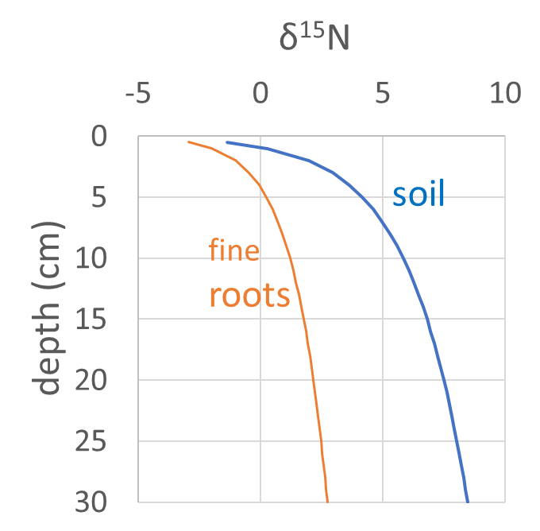
Figure 6: Root and soil depth profiles of ẟ¹⁵N, measured in 8 hardwood stands at the Bartlett Experimental Forest. Greater ¹⁵N depletion of fine roots relative to soil with depth is interpreted as being due to a net downward translocation of shallow-soil N to growing roots at depth. Data from Ouimette et al. (2020)
Foliar N:P ratios have been used as an indicator of N vs. P limitation of primary production, with varying success (Hong et al. 2022). We will explore the analogous indicator of nutrient limitation of belowground production. As with foliage, fine root nutrient concentrations can be highly plastic (Kramer-Walter and Laughlin 2017) responding to variation in soil properties; for example, Yuan et al. (2011) observed a latitudinal pattern of decreasing fine root N:P that reflected differences in relative availability of the two nutrients. However, relationships of root tissue chemistry to forest productivity can be complex (Alvarez-Clare and Mack 2015). The large variation in fine root growth across our plots and treatments (Fig. 1) affords an opportunity to explore these relationships, including the possibility that unbalanced nutrition can constrain fine root production.
Fine root nutrient concentrations will be measured in the roots collected for biomass, which have been archived for the two earlier collection dates and are still being processed for the most recent collection. Roots will be composited by plot, diameter class, and depth class. Nitrogen concentrations will be determined with a FlashEA 1112 analyzer (Thermo Scientific). Phosphorus concentrations will be obtained by inductively coupled plasma optical emission spectroscopy with an Optima 5300 DV (Perkin-Elmer) after ashing and digestion with 6N nitric acid.
Depth profiles of stable N isotopes in fine roots Strong depth gradients of nitrogen isotope ratios (ẟ¹⁵N) are common across many terrestrial forest soils (Högberg et al. 1996, Hobbie and Ouimette 2009, Nel et al. 2018, Vadeboncoeur et al. 2023), caused by progressively greater microbial processing of organic matter with depth, as well as greater importance of mycorrhizal fungal biomass at depth. These patterns have been used to infer effective differences in depth of nitrogen uptake among co-occurring plant species (Kohzu et al. 2003, Houle et al. 2014). When examined together, fine root ẟ¹⁵N of shallow soil layers generally closely tracks the ẟ¹⁵N of the surrounding soil, with an offset associated with fractionation via the fungal mycorrhizal partner. In preliminary data collected outside our study stands at BEF, we have observed that the gap in ẟ¹⁵N between roots and the surrounding bulk soil increases with depth (Fig. 6). A major driver of this gap is likely the decoupling of N uptake and the site of assimilation in fine root tissue, i.e. that deeper fine roots are a net sink for N acquired in more shallow parts of the soil profile. We will analyze intact roots in 3 soil profiles in 6 study stands, and pair these data with measurements of bulk soil ẟ¹⁵N, as well as the ẟ¹⁵N of resin-available ammonium and nitrate (Gurmesa et al. 2022) to estimate the contribution of shallow (<10 cm depth soil) to root biomass N at a standardized maximum sampling depth of 30 cm.

Methods for Objective II:
Determine effects of nutrient availability on soil C pools and fluxes

Hypothesis 4: Root turnover is increased by nutrient addition

We use the ratio of growth rate to standing biomass as an index of root turnover; methods for both of these measurements are described above for Hypothesis 2.

Hypothesis 5: Belowground carbon allocation is proportional to belowground root growth

Soil respiration will be estimated in each plot as CO₂ efflux using a LI-COR 8100. Seven permanent soil collars in each plot have been monitored since 2009. Standard precautions to minimize bias will be taken (Davidson et al. 2002, Fahey et al. 2005). Measurements will be taken every three weeks throughout the snow-free period (April-November). Soil temperature and moisture will be measured at each sampling. To estimate annual soil respiration we will rely on year-round measurements from the HBEF to impute fluxes in winter (Fahey et al. 2005).
Belowground carbon allocation (Nadelhoffer and Raich 1992) will be calculated as soil respiration minus aboveground litter production (measured for Hypothesis 1, above), accounting for changes in soil carbon storage (measured for Hypothesis 5, below).
Flux of root-derived carbon into the soil will be measured in a parallel set of 10 replicate root-ingrowth cores per plot, filled with uniform mixtures of root-free soil collected from a New Hampshire agricultural field with many decades of corn production (a C4 plant, estimated soil ẟ¹³C = -18‰). Ingrowth soil will be mixed with carbonate-free sand to the degree needed to match the texture of the surrounding soil. The ẟ¹³C difference between the isotopically enriched ingrowth soil and the C3-derived inputs from roots (including exudates and allocation to extraradical biomass of mycorrhizae, estimated at -29‰) will allow a simple mixing model to determine plot-level differences in the exudation of stabilizable carbon (Martinez et al 2016, Zhang et al. 2018, Keller et al. 2021) over 24 months. This method is especially sensitive to measuring plot-scale differences in these fluxes, and complements the parallel ingrowth core approach using native soil collected from within each plot. While there are methodological biases inherent in all ingrowth core approaches (and other in-situ methods for measuring belowground C and nutrient fluxes), they provide a strong basis for comparison of differences between well-paired plots receiving different treatments. In particular, if ingrowth to the isotopically enriched soil differs from the cores filled with native soil, rhizosphere carbon fluxes can be expressed by scaling to the root ingrowth observed in the native soil ingrowth cores.

Hypothesis 6: Soil carbon pools are affected by rhizosphere carbon flux
We will re-sample forest floor (Oie and Oa horizon) C and N content in all 13 stands for comparison to pre-treatment samples (Vadeboncoeur et al. 2012, 2014, Levine et al 2012, plus additional unpublished data). From each plot, 12 forest floor samples will be collected as blocks, consistent with past sampling efforts (Yanai et al. 2000, 2003). Samples will be dried at 60 C, homogenized, and analyzed for total C and N. Below each forest floor sample, we will sample mineral soils, again replicating sampling procedures used previously (Levine et al. 2012) in increments of 0-10 cm and 10-30 cm below the top of the mineral soil. A subset of samples (3 per plot) will include an additional 30-50 cm depth increment. We will calculate net C and N sequestration from 2010 to 2024 based on the change in C and N concentrations and the pretreatment bulk density and coarse fraction (cf. Clancy et al. 2023), because we are not likely to detect changes in these properties. Detecting net change in soil carbon in heterogeneous forest soils derived from rocky till can be challenging (Vadeboncoeur et al. 2012), but previous (similarly intensive) soil monitoring efforts at Hubbard Brook have shown significant changes in soil carbon (and subsequent reversal of these changes) following experimental forest harvest over an equivalent 15-year time period (Hamburg et al 2019).
Dominance of EM and AM tree species will be described by the size, proximity, and species of trees within 10 m of each sample location, using the sum of the arctangent of tree diameter and distance from the sampling point (Contreras et al. 2011, Rouvinen et al. 1977). We will use data from the tree inventory conducted for Hypothesis 1 and our existing maps of stem locations augmented by ingrowth since the last inventory.

Methods for Objective III:
Evaluate improved understanding of co-limitation via the MEL model

The MEL model is designed to simulate ecosystem changes in biogeochemical stocks and fluxes as a consequence of dynamic changes in plant allocation towards optimizing acquisition of limiting resources. It uses a mass-balance approach to couple ecosystem C, nutrient, and water fluxes (Rastetter et al. 2013, Pearce et al. 2015) and operates at a plot scale with daily output using a variable time-step, 4th/5th order Runge-Kutta integrator to solve a system of first order differential equations (Press et al. 1986). It partitions vegetation allometrically into active (leaves plus fine roots) vs. woody biomass. The active biomass is partitioned between leaves and fine roots based on the relative limitation by canopy (CO₂ and light) vs. soil resources (nutrients and water). The model partitions detritus into Phase I and Phase II soil organic matter (SOM; Melillo et al. 1989) and debris (coarse woody debris and standing dead plant material). The debris is gradually converted to Phase I material where it begins to decompose. Phase I SOM represents the young, more active, organic matter and implicitly includes microbial biomass. Phase I SOM both mineralizes and immobilizes nutrients and turns over relatively quickly. Phase II SOM does not immobilize nutrients but continues to mineralize nutrients and release C at a slow rate.
The heart of the MEL model is a dynamic algorithm that allocates plant assets (such as biomass, enzymes, carbohydrates, etc.) toward the uptake of resources from the environment (light, CO₂, H₂O, NH₄, NO₃, DON, N-fixation, and PO₄). These assets are implicitly represented as an aggregate uptake potential that is assumed to increase in proportion to the active vegetation biomass. The allocation algorithm calculates changes in the fraction of these uptake assets (effort) allocated toward acquiring each resource based on the resource optimization hypothesis (Bloom et al. 1985, Chapin et al. 1987) This algorithm will drive the model toward a state where the ratio of acquisition to requirement is the same for all resources and in that sense toward a state where all resources are equally limiting (Bloom et al. 1985, Chapin et al. 1987). We have already calibrated and used the model to assess the synchronization of N and P cycles in our study system (Fig. 4, Rastetter et al. 2013).
Recent applications of MEL include assessing the synchronization of N and P cycles in hardwood forest through secondary succession (Rastetter et al. 2013), the recovery of tundra from thermokarst (Pearce et al. 2015) and from fire (Jiang et al. 2015), a 3-site comparison of recovery from disturbance (Kranabetter et al. 2016), and a 12-site comparison of response to climate change (Rastetter et al. 2022).
Mixed effect models will be used to test treatment effects on forest productivity, belowground C inputs, and soil C accumulation, and to test the relative importance of the various C inputs (leaf, stem, root, mycorrhizae), sites, forest age, and soil N and P availability as predictors of soil C accumulation. The outcomes of this framework will be used to refine parameters and further develop the MEL model to better connect predictions of nutrient availability controls of allocation, productivity, and soil C dynamics.
Our growing understanding of the importance of rhizosphere and other labile C inputs to soil C needs to be incorporated into MEL. Based on the analysis of empirical results from our field experiment we will adjust the allocation of effort towards belowground acquisition of N and P. We will use the improved model to explore the importance of ecosystem acclimation on different soil types to changing resource limitation under various scenarios of N deposition, elevated CO₂, and climate change. Understanding the limits to resource optimization, as tested in our field experiments, will direct the future development of ecosystem theory as well as improve management of forest ecosystems under changing environmental limitations.

Outputs and Communication of Results

Continued treatments and measurements on these plots will contribute to better understanding of the transient and long-term responses of processes affecting nutrient co-limitation in forests of varying successional stage and initial fertility. This information is important to managers and policymakers as well as to the scientific research community. To ensure that the results of the proposed research reach this broader audience, we will use extensive and ongoing relationships with forest managers (White Mountain National Forest), the general public (Hubbard Brook Science Links Program), and K-12 educators (Environmental Literacy Program and Forests For Every Classroom), facilitated by the Hubbard Brook Research Foundation (http://hubbardbrookfoundation.org).
Of interest to the scientific community, we will produce 2 master’s theses and one PhD dissertation, and publications on above and belowground production, nutrient limitation of root growth and turnover, rhizosphere carbon fluxes and changes in soil carbon stocks with treatments manipulating nutrient limitation. Publications will be targeted to journals read both by researchers and by forestry professionals, such as Plant and Soil, SSSAJ, Canadian Journal of Forest Research, Forest Ecology and Management, and Journal of Forestry. Presentations will be made at regional and national meetings attended by the scientific community and forestry professionals (e.g ESA, AGU, SSSA, as well as SAF and NESAF). We will continue our tradition of MELNHE sessions at the annual Hubbard Brook Cooperator’s meeting, which have proven fruitful for engaging interest from scientists with a wide variety of ecological expertise, some of whom have collaborated on investigating additional ecosystem-scale responses and improving methods. Other products of this work will include data sets, provided on our project web site and the Environmental Data Initiative; archived samples, located in the Long-Term Storage system at SUNY-ESF and in the physical archive building at Hubbard Brook; and code and compiled software for the MEL model, hosted by the Ecosystems Center at MBL.

Project Timeline
Table 3. Schedule summarizing more than two decades of activities in the MELNHE experiment including the proposed 3 years of the project. Plots were established and characterized beginning in 2004; fertilization began in 2011. Some listed measurements do not directly relate to soil outcomes but provide the ecosystem- scale context necessary for understanding processes closely tied to changes in soil health.
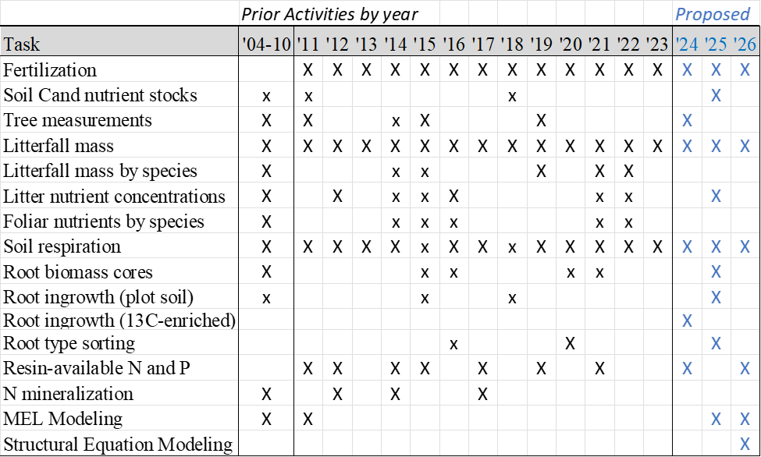

Key: X – measurements in all stands; x – measurements in selected stands.

References

Allison, S.D., M.N. Weintraub, T.B. Gartner, and M.P. Waldrop. 2011. Evolutionary-Economic principles as regulators of soils enzyme production and ecosystem function. Pages 230-243 in Soil Biology Volume 22: Soil Enzymology, Shukla, G., and A. Varma editors. Springer Verlag, Berlin.
Alvarez-Clare S, Mack MC (2015) Do Foliar, Litter, and Root Nitrogen and Phosphorus Concentrations Reflect Nutrient Limitation in a Lowland Tropical Wet Forest? PLoS One 10:e0123796.
Arthur, M.A., S.P. Hamburg and T.G. Siccama. 2001. Validating allometric estimates of aboveground living biomass and nutrient contents of a northern hardwood forest. Canadian Journal of Forest Research 31:11-17.
Averill, C., & Hawkes, C. V. (2013). Ectomycorrhizal fungi slow carbon cycling. Ecology Letters, 53(9), 1689–1699.
Bae, K., T.J. Fahey, R.D. Yanai, and M.C. Fisk. 2015. Soil nitrogen availability affects belowground carbon allocation and soil respiration in northern hardwood forests of New Hampshire. Ecosystems 18:1179-1191. DOI: 10.1007/s10021-015-9892-7.
Bae, K. 2013. Belowground carbon fluxes respond to nutrient availability in a Northern Hardwood forest. State University of New York, College of Environmental Science and Forestry, Syracuse, NY. PhD Dissertation.
Barner, J. 2016. Ectomycorrhizal Fungi Contribution to Nutrient Cycling of Nitrogen, Phosphorus, and Calcium in Northern Hardwood Forests. State University of New York, College of Environmental Science and Forestry, Syracuse, NY. Master thesis.
Bergmann J, Weigelt A, van der Plas F, Laughlin DC, Kuyper TW, Guerrero-Ramirez N, Valverde-Barrantes OJ, Bruelheide H, Freschet GT, Iversen CM et al. 2020. The fungal collaboration gradient dominates the root economics space in plants. Science Advances 6: 27–27.
Beerling DJ, Kantzas EP, Lomas MR, Wade P, Eufrasio RM, Renforth P, Sarkar B, Andrews MG, James RH, Pearce CR, Mercure J-F, Pollitt H, Holden PB, Edwards NR, Khanna M, Koh L, Quegan S, Pidgeon NF, Janssens IA, Hansen J, Banwart SA. 2020. Potential for large-scale CO₂ removal via enhanced rock weathering with croplands. Nature 583:242–248.
Bernal, S., L.O. Hedin, G.E. Likens, S. Gerber, and D.C. Buso. 2012. Complex response of the forest nitrogen cycle to climate change. Proceedings of the National Academy of Sciences. 109(9):3406-3411.
Blanke, V., C. Renker, M. Wagner, K. Füllner, M. Held, A.J. Kuhn, and F. Buscot. 2005. Nitrogen supply affects arbuscular mycorrhizal colonization of Artemisia vulgaris in a phosphate-polluted field site. New Phytologist 166: 981-992.
Bliss, K.M., R.H. Jones, R.J. Mitchell and P.P. Mou. 2002. Are competitive interactions influenced by spatial nutrient heterogeneity and root foraging behavior? New Phytologist 154: 409-417.
Bledsoe, C.S., T.J. Fahey, F.P. Day, and R.W. Ruess. 1999. Measurement of Static Root Parameters: Biomass, Length, and Distribution in the Soil Profile. Pages 437-455 in G.P. Robertson, D.C. Coleman, C.S. Bledsoe, and P. Sollins, editors. Standard Soil Methods for Long Term Ecological Research. Oxford University Press, New York.
Bloom, A.F., F.S. Chapin III, and H.A. Mooney. 1985. Resource limitation in plants – an economic analogy. Annual Review of Ecology and Systematics 16: 363-392.
Blum, J.D., A. Klaue, C.A. Nezat, C.T. Driscoll, C.E. Johnson, T.G. Siccama, C. Eagar, T.J. Fahey and G.E. Likens. 2002. Mycorrhizal weathering of apatite as an important calcium source in base-poor forest ecosystems. Nature 417: 729-731.
Brzostek, E. R., Dragoni, D., Brown, Z. A., & Phillips, R. P. (2015). Mycorrhizal type determines the magnitude and direction of root‐induced changes in decomposition in a temperate forest. New Phytologist, 206(4), 1274–1282.
Burton, A., Pregitzer, K. & Hendrick, R. (2000). Relationships between fine root dynamics and nitrogen availability in Michigan northern hardwood forests. Oecologia, 125, 389–399.
Buss W, Yeates K, Rohling EJ, Borevitz J. 2021. Enhancing natural cycles in agro-ecosystems to boost plant carbon capture and soil storage. Oxford Open Clim Chang 1.
Campbell, John L; Driscoll, Charles T; Jones, Julia A; Boose, Emery R; Dugan, Hilary A; Groffman, Peter M; Jackson, C Rhett; Jones, Jeremy B; Juday, Glenn P; Lottig, Noah R; Penaluna, Brooke E; Ruess, Roger W; Suding, Katharine; Thompson, Jonathan R; Zimmerman, Jess K. 2022. Forest and Freshwater Ecosystem Responses to Climate Change and Variability at US LTER Sites. BioScience. 72(9): 851-870.
Carrino-Kyker SR, Kluber LA, Petersen SM, Coyle KP, Hewins CR, DeForest JL, Smemo KA, Burke DJ 2016. Mycorrhizal fungal communities respond to experimental elevation of soil pH and P availability in temperate hardwood forests Anderson I (ed). FEMS Microbiol Ecol 92:fiw024
Carteron A, Cichonski F, Laliberté E. 2022. Ectomycorrhizal Stands Accelerate Decomposition to a Greater Extent than Arbuscular Mycorrhizal Stands in a Northern Deciduous Forest. Ecosystems 25:1234–1248.
Chapin, F.S. III, A.J. Bloom, C.B. Field, and R.H. Waring. 1987. Plant responses to multiple environmental factors. BioScience 37: 49-57.
Clancy, M. A., Ruffing, B. E., Jarmain, C., & Byrne, K. A. 2023. A novel method incorporating large rock fragments for improved soil bulk density and carbon stock estimation. Soil Science Society of America Journal, in press.
Contreras MA, Affleck D, Chung W. 2011. Evaluating tree competition indices as predictors of basal area increment in western Montana forests. For Ecol Manage 262:1939–1949.
Contreras, M. A., Affleck, D., Chung, W. 2011. Evaluating tree competition indices as predictors of basal area increment in western Montana forests. Forest Ecology and Management 262(11), 1939-1949.
Craig ME, Turner BL, Liang C, Clay K, Johnson DJ, Phillips RP. 2018. Tree mycorrhizal type predicts within‐site variability in the storage and distribution of soil organic matter. Glob Chang Biol 24:3317–3330.
Davidson, E. A., K.V. Savage, L.V. Verchot, and R. Navarro. 2002. Minimizing artifacts and biases in chamber-based measurements of soil respiration. Agricultural and Forest Meteorology, 113(1): 21-37.
Elser, J.J., M.E.S. Bracken, E.E. Cleland, D.S. Gruner, W.S. Harpole, H. Hillebrand, J.T. Ngai, E.W. Seabloom, J.B. Shurin, and J.E. Smith. 2007. Global analysis of nitrogen and phosphorus limitation of primary producers in freshwater, marine and terrestrial ecosystems. Ecology Letters 10: 1135–1142.
Fahey, T.J., G.L. Tierney, R.D. Fitzhugh and G.F. Wilson. 2005. Soil Respiration and Soil Carbon Balance in a Northern Hardwood Forest Ecosystem. Canadian Journal of Forest Research 35: 244-253.
Fahey T.J., J.J. Battles, and G.F. Wilson. 1998. Response of early successional northern hardwood forests to changes in nutrient availability. Ecological Monographs 68:183-212.
Fahey, T.J, and J.W. Hughes. 1994. Fine root dynamics in a northern hardwood forest ecosystem, Hubbard Brook Experimental Forest, NH. Journal of Ecology 82: 533-548.
Fatemi, F.R., R.D. Yanai, S.P. Hamburg, M.A. Vadeboncoeur, M.A. Arthur, R.D. Briggs and C.R. Levine. 2011. Allometric equations for young northern hardwoods: the importance of age-specific equations for estimating aboveground biomass. Canadian Journal of Forest Research 41: 881-891. doi: 10.1139/x10-248.
Fatemi, F.R. 2007. Aboveground biomass and nutrients in developing northern hardwood stands in New Hampshire, USA. State University of New York, College of Environmental Science and Forestry, Syracuse, NY. Master thesis.
Federer, C.A., J.W. Hornbeck, L.M. Tritton, C.W. Martin, R.S. Pierce, and C.T. Smith. 1989. Long-term depletion of calcium and other nutrients in eastern US forests. Environmental Management 13(5): 593-601.
Finzi, A.C. 2009. Decades of atmospheric deposition have not resulted in widespread phosphorus limitation or saturation of tree demand for nitrogen in southern New England. Biogeochemistry 92: 217-229.
Fisk M.C., S. Santangelo, and K.J. Minick. 2015. Carbon mineralization is promoted by phosphorus and reduced by nitrogen addition in the organic horizon of northern hardwood forests. Soil Biology and Biochemistry 81: 212-218.
Fisk, M.C., T.J. Ratliff, S. Goswami, and R.D. Yanai. 2014. Synergistic soil response to nitrogen plus phosphorus fertilization in hardwood forests. Biogeochemistry 118(1-3): 195-204. DOI: 10.1007/s10533-013-9918-1.
Fox, T.R., H. Lee Allen, T.J. Albaugh, R. Rubilar, and C.A. Carlson. 2007. Tree nutrition and forest fertilization of pine plantations in the southern United States. Southern Journal of Applied Forestry, 31(1): 5-11.
Frey S.D. (2019) Mycorrhizal Fungi as Mediators of Soil Organic Matter Dynamics. Annu Rev Ecol Evol Syst 50:237–259.
George E., H. Marschner, I. Jakobsen. 1995. Role of arbuscular mycorrhizal fungi in uptake of phosphorus and nitrogen from soil. Critical Reviews in Biotechnology 15: 257-270.
Godman, R.M. 1992. In: Hutchinson, Jay G., ed. Northern hardwood notes. St. Paul, MN.: U.S. Dept. of Agriculture, Forest Service, North Central Forest Experiment Station. 1.01.
Gonzales, K.E., R.D. Yanai, T.J. Fahey, and M.C. Fisk. 2023. Evidence for P limitation in eight northern hardwood stands: Foliar concentrations and resorption by three tree species in a factorial N by P addition experiment. Forest Ecology Management, 529: 120696, DOI: 10.1016/j.foreco.2022.120696
Gonzalez, K.E. 2017. Effects of calcium, nitrogen, and phosphorus fertilization on foliar nutrient dynamics of three northern hardwood tree species. State University of New York, College of Environmental Science and Forestry, Syracuse, NY. Master thesis.
Goswami S., M.C. Fisk, M.A. Vadeboncoeur, M. Johnston, R.D. Yanai, and T.J. Fahey. 2018. Phosphorus limitation of aboveground production in northern hardwood forests. Ecology 99(2): 438-449.
Goswami, S. 2017. Investigating nutrient limitation in northern hardwood forests. Miami University, Ohio. PhD Dissertation.
Gurmesa GA, Hobbie EA, Zhang S, Wang A, Zhu F, Zhu W, Koba K, Yoh M, Wang C, Zhang Q, Fang Y 2022. Natural 15N abundance of ammonium and nitrate in soil profiles: New insights into forest ecosystem nitrogen saturation. Ecosphere 13:1–14.
Hamburg, S. P., Vadeboncoeur, M. A., Richardson, A. D., & Bailey, A. S. 2013. Climate change at the ecosystem scale: a 50-year record in New Hampshire. Climatic Change, 116(3–4), 457–477.
Hamburg, S.P., Vadeboncoeur, M.A., Johnson, C.E. et al. 2019. Losses of mineral soil carbon largely offset biomass accumulation 15 years after whole-tree harvest in a northern hardwood forest. Biogeochemistry 144, 1–14.
Harpole, W.S., J.T. Ngai, E.E. Cleland, E.W. Seabloom, E.T. Borer, M.E.S. Bracken, J.J. Elser, D.S. Gruner, H. Hillebrand, J.B. Shurin, and J.E. Smith. 2011. Nutrient co-limitation of primary producer communities. Ecology Letters 14: 852-862.
Hartman, W.H., and C.J. Richardson. 2013. Differential nutrient limitation of soil microbial biomass and metabolic quotients (qCO₂): is there a biological stoichiometry of soil microbes? PLOS One 8: 1-14.
Hernández-Santana, V., A. Hernández-Hernández., M.A. Vadeboncoeur, and H. Asbjornsen. 2015. Scaling from single-point sap velocity measurements to stand transpiration in a multi-species deciduous forest: uncertainty sources, stand structure effect, and future scenarios impacts. Canadian Journal of Forest Research 45(11): 1489-1497 doi:10.1139/cjfr-2015-0009.
Hobbie EA, Ouimette AP. 2009. Controls of nitrogen isotope patterns in soil profiles. Biogeochemistry 95:355–371.
Hoeksema, J.D., V.B. Chaudhary, C.A. Gehring, N.C. Johnson, J. Karst, R.T. Koide, A. Pringle, C. Zabinski, J.D. Bever, J.C. Moore and Wilson, G.W., 2010. A meta‐analysis of context‐dependency in plant response to inoculation with mycorrhizal fungi. Ecology Letters 13(3): 394-407.
Högberg P, Högbom L, Schinkel H, Högberg M, Johannisson C, Wallmark H. 1996. 15N abundance of surface soils, roots and mycorrhizas in profiles of European forest soils. Oecologia 108:207–214.
Hong D.S., K.E. Gonzales, T.J. Fahey, and R.D. Yanai. 2022. Foliar nutrient concentrations of six northern hardwood species responded to nitrogen and phosphorus fertilization but did not predict tree growth. PeerJ, 10:e13193. DOI: 10.7717/peerj.13193
Horton, T.R., J. Lamit, P. Kennedy, R.D. Yanai. Using MiSeq on DNA extracted from in-growth bags to observe ectomycorrhizal fungi with N, P and N+P additions in mixed hardwood forests at Bartlett Experimental Forest, New Hampshire. International Mycological Association11, San Juan, Puerto Rico, July 16-21, 2018.
Houle D, Moore JD, Ouimet R, Marty C. 2014. Tree species partition N uptake by soil depth in boreal forests. Ecology 95:1127–1133.
Jiang, Y, E.B. Rastetter, A.V. Rocha, A.R. Pearce, B.L. Kwiatkowski, G.R. Shaver. 2015. Modeling carbon-nutrient interactions during the early recovery of tundra after fire. Ecological Applications 25:1640-1652.
Jo I, Fei S, Oswalt CM, Domke GM, Phillips RP. 2019. Shifts in dominant tree mycorrhizal associations in response to anthropogenic impacts. Sci Adv 5. doi:10.1126/sciadv.aav6358
Johnson, N.C., Rowland, D.L., Corkidi, L., Egerton-Warburton, L.M., Allen, E.B., 2003. Nitrogen enrichment alters mycorrhizal allocation at five mesic to semiarid grasslands. Ecology 84: 1895-1908.
Jones, M.D, D.M. Durall, and P.B. Tinker. 1998. A comparison of arbuscular and ectomycorrhizal Eucalyptus coccifera: growth response, phosphorus uptake efficiency and external hyphal production. New Phytologist 140: 125-134.
Kang, H., T.J. Fahey, K. Bae, M. Fisk, R.E. Sherman, R.D. Yanai, and C.R. See. 2016. Response of forest soil respiration to nutrient addition depends on site fertility. Biogeochemistry 127(1) DOI: 10.1007/s10533-015-0172-6.
Keller AB, Brzostek ER, Craig ME, Fisher JB, Phillips RP. 2021. Root‐derived inputs are major contributors to soil carbon in temperate forests, but vary by mycorrhizal type. Ecol Lett 24:626–635.
Kim T, Langpap C. 2015. Incentives for Carbon Sequestration Using Forest Management. Environ Resour Econ 62:491–520.
Kohzu A, Matsui K, Yamada T, Sugimoto A, Fujita N. 2003. Significance of rooting depth in mire plants: Evidence from natural ¹⁵N abundance. Ecol Res 18:257–266.
Kramer-Walter KR, Laughlin DC. 2017. Root nutrient concentration and biomass allocation are more plastic than morphological traits in response to nutrient limitation. Plant Soil 416:539–550.
Kranabetter, J, K. McLauchlan, S. Enders, J. Fraterrigo, P. Higuera, J. Morris, E. Rastetter, R. Barnes, B. Buma, D. Gavin, L. Gerhart, L. Gillson, P. Hietz, M. Mack, B. McNeil, and S. Perakis. 2016. A framework to assess biogeochemical response to ecosystem disturbance using nutrient partitioning ratios. Ecosystems 19: 387-395.
Leake, J. R., Duran, A. L., Hardy, K. E., Johnson, I., Beerling, D. J., Banwart, S. A., & Smits, M. M. 2008. Biological weathering in soil: the role of symbiotic root-associated fungi biosensing minerals and directing photosynthate-energy into grain-scale mineral weathering. Mineralogical Magazine, 72(1), 85–89.
LeBauer, D. S., & Treseder, K. K. 2008. Nitrogen limitation of net primary productivity in terrestrial ecosystems is globally distributed. Ecology, 89(2), 371–379
Levine, C.R., R.D. Yanai, M.A. Vadeboncoeur, S.P. Hamburg, A.M. Melvin, C.L. Goodale, B.M. Rau, and D.W. Johnson. 2012. Assessing the suitability of using rotary corers for sampling cations in rocky soils. Soil Science Society of America Journal. 76 (5): 1707-1718
Lewis AL, Sarkar B, Wade P, Kemp SJ, Hodson ME, Taylor LL, Yeong KL, Davies K, Nelson PN, Bird MI, Kantola IB, Masters MD, DeLucia E, Leake JR, Banwart SA, Beerling DJ. 2021. Effects of mineralogy, chemistry and physical properties of basalts on carbon capture potential and plant-nutrient element release via enhanced weathering. Appl Geochemistry 132:105023.
Li, S., M.C. Fisk, R.D Yanai, and T.J. Fahey. Co-limitation of root growth by nitrogen and phosphorus in early successional northern hardwood forests. Ecosystems (in press)
Likens GE, Buso DC (2012) Dilution and the elusive baseline. Environ Sci Technol 46:4382–4387.
Lilleskov, E.A., E.A. Hobbie and T.J. Fahey. 2002. Ectomycorrhizal fungal taxa differing in response to nitrogen deposition also differ in pure culture organic nitrogen use and natural abundance of nitrogen isotopes. New Phytologist 154: 219-231.
Lovett GM, Goodale CL, Ollinger S V, Fuss CB, Ouimette AP, Likens GE. 2018. Nutrient retention during ecosystem succession: a revised conceptual model. Front Ecol Environ 16:532–538.
Mainwaring, D.B., D.A. Maguire, and S.S. Perakis. 2014. Three-year growth response of young Douglas-fir to nitrogen, calcium, phosphorus, and blended fertilizers in Oregon and Washington. For. Ecological Management 327: 178-188.
Mann, L.K., D.W. Johnson, D.C. West, D.W. Cole, J.W. Hornbeck, C.W. Martin, H. Riekerk, C.T. Smith, W.T. Swank, L.M. Tritton, and D.H. Van Lear. 1988. Effects of whole-tree and stem-only clearcutting on postharvest hydrologic losses, nutrient capital, and regrowth. Forest Science 34(2): 412-428.
Mann, T.A., R.D. Yanai, T. J. Fahey, A. Reinmann. 2023. Independent and interactive effects of nitrogen and phosphorus addition on soil respiration in northern hardwood forests. Ecosystems (in review)
Mann, Thomas A. 2021. Independent and interactive effects of nitrogen and phosphorus addition on forest soil respiration. MS. Syracuse, NY: SUNY College of Environmental Science and Forestry.
Martinez, C., Alberti, G., Cotrufo, M. F., Magnani, F., Zanotelli, D., Camin, F., Rodeghiero, M. 2016. Geoderma Belowground carbon allocation patterns as determined by the in-growth soil core ¹³C technique across different ecosystem types. Geoderma, 263, 140–150. https://doi.org/10.1016/j.geoderma.2015.08.043
McCormack L M, Adams TS, Smithwick EAH, Eissenstat DM. 2012. Predicting fine root lifespan from plant functional traits in temperate trees. New Phytol 195:823–831.
Melillo, J. M., Frey, S. D., DeAngelis, K. M., Werner, W. J., Bernard, M. J., Bowles, F. P. Grandy, A. S. 2017. Long-term pattern and magnitude of soil carbon feedback to the climate system in a warming world. Science, 358(6359), 101–105.
Melillo, J.M., J.D. Aber, A.E. Linkins, A. Ricca, B. Fry, and K.J. Nadelhoffer. 1989. Carbon and nitrogen dynamics along the decay continuum: Plant litter to soil organic matter. Plant and Soil 115(2): 189.
Nadelhoffer, K.J. and J.W. Raich. 1992. Fine root production estimates and belowground carbon allocation in forest ecosystems. Ecology 73: 1139-1147.
Naples, B.K. and Fisk, M.C. 2010. Belowground insights into nutrient limitation in northern hardwood forests. Biogeochemistry 97: 109–121.
Nash, J.M., F.M. Diggs, and R.D. Yanai. 2022. Length and colonization rates of roots associated with arbuscular or ectomycorrhizal fungi decline differentially with depth in two northern hardwood forests. Mycorrhiza, 32:213-219. DOI:10.1007/s00572-022-01071-8
Nel JA, Craine JM, Cramer MD (2018) Correspondence between δ¹³C and δ¹⁵N in soils suggests coordinated fractionation processes for soil C and N. Plant Soil 423:257–271.
Nyland, R.D., 2016. Silviculture: concepts and applications. Waveland Press
Ouimette AP, Ollinger SV, Richardson AD, Hollinger DY, Keenan TF, Lepine LC, Vadeboncoeur MA. 2018. Carbon fluxes and interannual drivers in a temperate forest ecosystem assessed through comparison of top-down and bottom-up approaches. Agric For Meteorol 256–257:420–430.
Ouimette AP, Ollinger SV, Lepine LC, Stephens RB, Rowe RJ, Vadeboncoeur MA, Tumber-Davila SJ, Hobbie EA. 2020. Accounting for carbon flux to mycorrhizal fungi may resolve discrepancies in forest carbon budgets. Ecosystems, 23: 715-729.
Park, B.B., R.D. Yanai, M.A. Vadeboncoeur, and S.P. Hamburg. 2007. How best to estimate root biomass: pits, cores, or allometric equations? Soil Science Society of America Journal 71: 206-213.
Paschalis A, Katul GG, Fatichi S, Palmroth S, Way D;. 2017. On the variability of the ecosystem response to elevated atmospheric CO₂ across spatial and temporal scales at the Duke Forest FACE experiment. Agric For Meteorol 232:367–383.
Pearce, A.R, E.B. Rastetter, W.B. Bowden, M.C. Mack, Y. Jiang, and B.L. Kwiatkowski. 2015. Recovery of arctic tundra from thermal erosion disturbance is constrained by nutrient accumulation: a modeling analysis. Ecological Applications 25:1271-1289.
Phillips RP, Brzostek E, Midgley MG (2013) The mycorrhizal‐associated nutrient economy: a new framework for predicting carbon–nutrient couplings in temperate forests. New Phytol 199:41–51.
Press, W.H., B.P. Flannery, S.A. Teukoisky, and W.T. Vetterling. 1986. Numerical Recipes, Cambridge University Press, Cambridge, UK.
Rasse, D. P., Rumpel, C., & Dignac, M. F. (2005). Is soil carbon mostly root carbon? Mechanisms for a specific stabilisation. Plant and Soil, 269(1-2), 341-356.
Rastetter, E.B., B.L. Kwiatkowski, D.W. Kicklighter, A. Barker Plotkin, H. Genet, J. B. Nippert, K. O'Keefe, S.S. Perakis, S. Porder, S.S. Roley, R.W. Ruess, J.R. Thompson, W.R. Wieder, K. Wilcox, and R.D. Yanai. 2022. N and P constrain C in ecosystems under climate change: role of nutrient redistribution, accumulation, and stoichiometry. Ecological Application, e2684.
Rastetter, E.B., R.D. Yanai, R.Q. Thomas, M.A. Vadeboncoeur, T.J. Fahey, M.C. Fisk, B.L. Kwiatkowski, and S.P. Hamburg. 2013. Recovery from disturbance requires resynchronization of ecosystem nutrient cycles. Ecological Applications 23: 621-642.
Rastetter, E.B., S.S. Perakis, G.R. Shaver, and G.I. Ågren. 2005. Carbon sequestration in terrestrial ecosystems under elevated CO₂ and temperature: Role of dissolved organic N loss. Ecological Applications 15: 71-86.
Rastetter, E.B., P.M. Vitousek, C. Field, G.R. Shaver, D. Herbert, G.I. Ågren. 2001. Resource optimization and symbiotic N fixation. Ecosystems 4: 369-388.
Rastetter, E.B., G.I. Ågren and G.R. Shaver. 1997. Responses of N-limited ecosystems to increased CO₂: A balanced-nutrition, coupled-element-cycles model. Ecological Applications 7: 444-460.
Rastetter, E.B., and G.R. Shaver. 1992. A model of multiple element limitation for acclimating vegetation. Ecology 73: 1157-1174.
Ratliff, T.J., and M.C. Fisk. 2016. Phosphatase activity is related to N availability but not P availability across hardwood forests in the northeastern United States. Soil Biology and Biochemistry 94: 61-69.
Rice, A.M., Johnston, M.T., Libenson, A.J., and Yanai, R.D. 2022. Tree variability limits the detection of nutrient treatment effects on sap flux density in a northern hardwood forest. PeerJ, 10:e14410
Richter D deB., Hofmockel M, Callaham MA, Powlson DS, Smith P (2007) Long-Term Soil Experiments: Keys to Managing Earth’s Rapidly Changing Ecosystems. Soil Sci Soc Am J 71:266–279.
Roumet C, Birouste M, Picon‐Cochard C, Ghestem M, Osman N, Vrignon‐Brenas S, Cao K, Stokes A. 2016. Root structure–function relationships in 74 species: evidence of a root economics spectrum related to carbon economy. New Phytol 210:815–826. https://nph.onlinelibrary.wiley.com/doi/10.1111/nph.13828
Rouvinen, S., Kuuluvainen, T. 1997. Structure and asymmetry of tree crowns in relation to local competition in a natural mature Scots pine forest. Canadian Journal of Forest Research 27(6), 890-902.
Schaller, M., J.D. Blum, S.P. Hamburg, and M.A. Vadeboncoeur. 2010. Spatial variability of long-term chemical weathering rates in the White Mountains, New Hampshire, USA. Geoderma 154: 294-301.
Sedjo R, Sohngen B. 2012. Carbon Sequestration in Forests and Soils. Annu Rev Resour Econ 4:127–144.
See, C.R., R.D. Yanai, M.C. Fisk, M.A. Vadeboncoeur, T.J. Fahey, and B.A. Quintero. 2015. Soil nitrogen affects phosphorus recycling: foliar resorption and plant-soil feedbacks in a northern hardwood forest. Ecology 96: 2488-2498.
See, C.R. 2013. Foliar resorption in a northern hardwood forest. State University of New York, College of Environmental Science and Forestry, Syracuse, NY. Master thesis.
See CR, Yanai RD, Fisk MC, Vadeboncoeur MA, Quintero BA, Fahey TJ (2015) Soil nitrogen affects phosphorus recycling: foliar resorption and plant-soil feedbacks in a northern hardwood forest. Ecology 96:2488–2498.
Shan, S., H. Devens, T.J. Fahey, R.D. Yanai, and M.C. Fisk. 2022. Fine root growth increases in response to nitrogen addition in phosphorus-limited northern hardwood forests. Ecosystems. DOI: 10.1007/s10021-021-00735-4
Shifley, S. R., F.X. Aguilar, N. Song, S.I. Stewart, D.J. Nowak, D.D. Gormanson, W.K. Moser, S. Wormstead, and E.J. Greenfield. 2012. Forests of the Northern United States. Gen. Tech. Rep. NRS-90. Newtown Square, PA: U.S. Department of Agriculture, Forest Service, Northern Research Station. 202 p.
Siccama, T.G., S.P. Hamburg, M.A. Arthur, R.D. Yanai, F.H. Bormann, and G.E. Likens. 1994. Corrections to allometric equations and plant tissue chemistry for Hubbard Brook Experimental Forest. Ecology 75: 246-248.
Smits, M. M., Bonneville, S., Benning, L. G., Banwart, S. A., & Leake, J. R. (2012). Plant-driven weathering of apatite - the role of an ectomycorrhizal fungus. Geobiology, 10(5), 445–456.
Tierney, G.T. and T.J. Fahey. 2007. Estimating belowground primary productivity. Pages 120-141 in T.J. Fahey and A.K. Knapp, editors. Principles and Standards for Measuring Primary Production. Oxford University Press, Inc., New York.
Tominaga K, Aherne J, Watmough SA, Alveteg M, Cosby BJ, Driscoll CT, Posch M, Pourmokhtarian A 2010. Predicting Acidification Recovery at the Hubbard Brook Experimental Forest, New Hampshire: Evaluation of Four Models. Environ Sci Technol 44:9003–9009.
Treseder, K.K. 2004. A meta-analysis of mycorrhizal responses to nitrogen, phosphorus, and atmospheric CO₂ in field studies. New Phytologist 164:347-355.
Vadeboncoeur, M.A. 2010. Meta-analysis of fertilization experiments indicates multiple limiting nutrients in northeastern deciduous forests. Canadian Journal of Forest Research 40: 1766-1780.
Vadeboncoeur, M.A, S.P. Hamburg, J.D. Blum, M.J. Pennino, R.D. Yanai, and C.E. Johnson. 2012. The quantitative soil pit method for measuring belowground carbon and nitrogen stocks. Soil Science Society of America. Journal 76(6):2241-2255
Vadeboncoeur, M.A., S.P. Hamburg, R.D. Yanai, and J.D. Blum. 2014. Rates of sustainable forest harvest depend on rotation length and weathering of soil minerals. Forest Ecology and Management 318: 194-205.
Vadeboncoeur, M. A., Ouimette, A. P., Hobbie, E. A. 2015. Mycorrhizal roots in a temperate forest take up organic nitrogen from ¹³C- and ¹⁵N-labeled organic matter. Plant and Soil, 397(1–2), 303–315.
Vadeboncoeur, M.A., S.J. Tumber-Dávila, and A.P. Ouimette. 2023. Soil physical, chemical, and root data from forest stands at Thompson Farm in Durham, NH ver 1. Environmental Data Initiative. DOI:10.6073/pasta/cb301b6626b614506cd95c8174a48401
van Scholl, L., Kuyper, T. W., Smits, M. M., Landeweert, R., Hoffland, E., & van Breemen, N. (2008). Rock-eating mycorrhizas: their role in plant nutrition and biogeochemical cycles. Plant and Soil, 303(1–2), 35–47.
Victoroff, C. N. 2020. Response of ectomycorrhizal fungal fruiting to nitrogen and phosphorus additions in Bartlett Experimental Forest, New Hampshire. MS Thesis. Syracuse, NY: SUNY College of Environmental Science and Forestry.
Vogt, K.A., and H. Persson. 1991. Root Methods. pp. 477-502. In: (J.P. Lassoie and T.M. Hinckley, eds.) Techniques and Approaches in Forest Tree Ecophysiology. CRC Press. Boca Raton, Florida.
Von Liebig, J. (1840) Die Organische Chemie in ihre Anwendung auf Agricultur und Physiologie. F. Vieweg und Sohn, Braunschweig, Germany.
Walker T.W. and J.K.Syers. 1976. The fate of phosphorus during pedogenesis. Geoderma 15:1-19.
Whittaker, R.H., F.H. Bormann, G.E. Likens, and T.G. Siccama. 1974. The Hubbard Brook Ecosystem study: forest biomass and production. Ecological Monographs 44: 233-252.
Wild, A.D., and R.D. Yanai. 2015. Soil nutrients affect sweetness of sugar maple sap. Forest Ecology and Management 341: 30-36. DOI: 10.1016/j.foreco.2014.12.022.
Wild, Adam D. 2014. Soil nutrients affect sweetness of sugar maple sap. State University of New York, College of Environmental Science and Forestry, Syracuse, NY. Master thesis.
Withington JM, Reich PB, Oleksyn J, Eissenstat DM . 2006. Comparisons of structure and life span in roots and leaves among temperate trees. Ecol Monogr 76:381–397.
Yanai, R.D. 1998. The effect of whole-tree harvest on phosphorus cycling in a northern hardwood forest. Forest Ecology and Management 104: 281–295.
Yanai, R.D., M.A. Arthur, T.G Siccama, and C.A. Federer. 2000. Challenges of measuring forest floor organic matter dynamics: repeated measures from a chronosequence. For. Ecol. Manage. 138:273-283.
Yanai, R.D., W.S. Currie, and C.L. Goodale. 2003. Soil carbon dynamics following forest harvest: an ecosystem paradigm reviewed. Ecosystems 6:197-212.
Yanai, R.D., B.B. Park, and S.P. Hamburg. 2006. The vertical and horizontal distribution of roots in northern hardwoods of varying age. Canadian Journal of Forest Research 36(2): 450-459.
Yanai, R.D., M.C. Fisk, T.J. Fahey, N.L. Cleavitt, and B.B. Park. 2008. Identifying roots of northern hardwood species: patterns with diameter and depth. Canadian Journal of Forest Research 38(11): 2862-2869.
Yanai, R.D., G.E. Walsh, Y. Yang, C.A. Blodgett, K. Bae, and B.B. Park. 2018. Nutrient concentrations of roots vary with diameter, depth, and site in New Hampshire northern hardwoods. Can. J. For. Res., 48:32-41. DOI: 10.1139/cjfr-2017-0223
Young, A.R., R. Minocha, S. Long, J. E. Drake, and R.D. Yanai. 2023. Responses of physical, chemical, and metabolic leaf characteristics to depth within mature sugar maple crowns and to nitrogen and phosphorus addition. Tree Physiology, 43:1118-1129.
Zahor, Lily E. 2014. The impact of calcium on transpiration in an acid rain impacted forest. Plymouth State University, Plymouth, NH. Master thesis.
Zhang Z, Xiao J, Yuan Y, Zhao C, Liu Q, Yin H (2018) Mycelium- and root-derived C inputs differ in their impacts on soil organic C pools and decomposition in forests. Soil Biol Biochem 123:257–265.

