White Mountain National Forest
Research Project Proposal Review and Approval Cover Sheet

Lead: Erica Roberts

Date: 8/2/2021

Research Proponent Information:
Enter information of primary research proponent.
Name | Joe Nash (Ruth Yanai, PI)
Affiliation | SUNY ESF
Mailing Address | 3785 Timber Trail, Liverpool, NY 13090
Email Address | jnash@esf.edu
Phone Number | (810) 841-7758

Project Proposal Information:
Enter sufficient detail to summarize the project for the decision maker.
Insert a map of project location(s) on next page.
Title | Downed wood and tree inventory in a chronosequence of northern hardwood forests in the White Mountains
Abstract | To determine the forest stand structures (e.g., basal areas, diameter distributions, volumes and biomass of coarse woody debris), and recruitment dynamics (including regeneration densities) in a chronosequence of northern hardwood stands, including in old-growth forests using sample sites within a prime example of these communities: Mt. Pond. Mt. Pond is a great example for comparing downed wood and recruitment in northern hardwood forests to a true old-growth stand.
General Location | One-Two 70.7m^2 (0.5 hectare) plots in the northern hardwood portion of the forest surrounding Mountain Pond (Saco)
Start Date | 8/2/2021
End Date | 12/31/2021

Project Proposal Review and Approval Team:
Enter names of only those individuals who reviewed and approved the proposed project.
For the Lead and Team Members, list their name followed by their resource in parentheses.
Lead | Erica Roberts (Research Coordination)
Team Members | Dan Sperduto (Botany), Stan Carte (Recreation), Leighlan Prout (Wildlife), Robert Colter (Soils), Roger Boyer (Forestry)
District Ranger(s) | Jim Innes (awareness only)

Project Location Map:
Click the center icon to insert a map of the project location(s) (can only insert picture formats, not PDFs). The extent of the map should be set to include sufficient reference points to allow for easy identification of the area in the WMNF context.
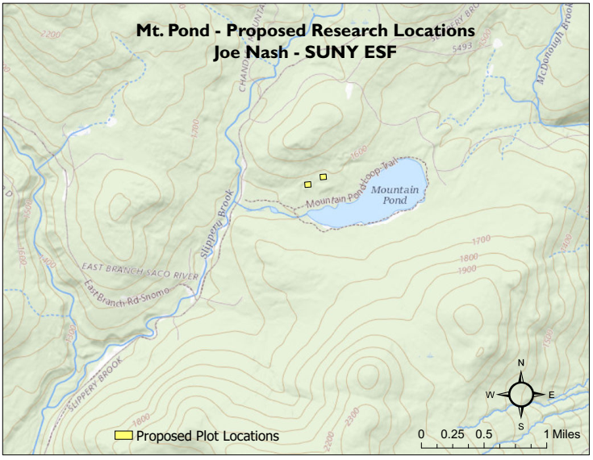
Map 1 of 2:

Map 2 of 2:
