Effects of Long-Term Nutrient Addition on Sap Flow in Mature and Sapling Beech Trees

Alexandrea Rice, SUNY-ESF
Mentor: Ruth Yanai and Mariann Johnston

1. Background
Terrestrial ecosystems have long been thought to be nitrogen (N) limited. Since N deposition has more than doubled over the past century, these N limited ecosystems are expected to increase biological demand for other elements such as phosphorus (P), resulting in other nutrients becoming limiting in the ecosystem ( Galloway et al. 2003; Vitousek et al. 2010; Cleveland et al. 2013). The addition of N to a N limited system, is expected to stimulate net primary productivity (NPP), which could affect the carbon cycle (Aber et al. 2003). An increase in productivity could affect transpiration rates in individual trees, which could also have an effect on plot-scale transpiration. Transpiration comprises the majority of the non-runoff loss of water from a watershed, and is sensitive to forest nutrition (Barbour et al. 2004; Ford et al. 2007; Phillips et al. 2001).
Transpiration measurements in the xylem flow of the tree can be used to estimate diurnal fluctuations help explain forest water use (Granier 1987). Xylem sap is composed of water, nutrients, and minerals that are transported upwards from the roots to branches and leaves by the pressure, tension, and osmotic gradients created in the sapwood. A variation in this tension or pressure in the xylem is easily detected because of its hydraulic continuity (Joly and Dixon 1894). Sap ascent can be affected by soil water availability, vapor pressure deficit, and stomatal control in the tree leaves (Meinzer et al. 2004). When stomata are open during photosynthesis, water is pulled under tension from the soil, through the stem, and to the leaves based on the vapor pressure deficit of the atmosphere. Water moves through the sapwood through cohesion and adhesion of water molecules combined with negative pressure produced during photosynthesis (Joly and Dixon 1894).
In the Multiple Element Limitation in Northern Hardwood Ecosystem (MELNHE) plots, preliminary sap flow measurements were taken in the summer of 2012, 2014, and 2015. In 2012 and 2014, the studies were conducted on sugar maple, American beech, and yellow birch on the wollastonite and control plots in a mature stand at Hubbard Brook and Bartlett Experimental Forest. These studies found that transpiration increased during the day and decreased at night, consistent with the diurnal opening and closing of the stomata during daylight hours. Both studies also showed that wollastonite increased transpiration, supporting the idea that wollastonite could potentially alter the watershed water cycle as theorized by Green et al. (2013). The 2015 study examined one species, white birch, on all five nutrient treatments in a middle-aged stand at Bartlett Experimental Forest. While the wollastonite effect was not as pronounced during the 2015 study, there did appear to be a significant reduction in transpiration on the P plot, suggesting that P may contribute to increased water use efficiency (Johnston et al. unpublished data). This finding, as well as the potential decrease in the effect of wollastonite on transpiration as time since treatment increases, warrant further investigation.
2. Objectives
The goal of this study is to determine the effect of nutrient additions (N, P, N+P) and an untreated control plot on transpiration in mature beech trees and beech saplings. I hypothesize that nutrient additions will increase sap flow which increases transpiration. I also hypothesize that the mature trees will have the highest rate of sap flow and be most affected by nutrient additions.
3. Methods
3.1 Site Description
This study will be conducted in the Bartlett Experimental Forest located in the White Mountain National Forest, New Hampshire, USA (44.05⁰N, 71.28⁰W). As part of the larger study, MELNHE, the specific plot the samples will be taken from is referred to as C8 which is a mature stand that is more than 130 years old. The climate in this area is humid continental, with a mean annual temperature of 7 ⁰C. Annual precipitation is 1270 mm that is evenly distributed throughout the year. The late-successional forest is composed of sugar maple ( Acer saccharum Marsh), American beech (Fagus grandifolia Ehrh), yellow birch (Betula alleghaniensis Britt.), red maple (Acer rubrum L), and some white birch ( Betula papyrifera Marsh) (Leak 1991). The soils are spodosols (Haplorthods) that were developed from regional glacial till. Soil pH is relatively low at 4.2 to 4.9 in the top 10 cm of the mineral soil.
To aid in understanding nutrient limitation and its effects on various hardwood forest ecological processes, the MELNHE study was implemented. In 2011, the MELNHE study was established and built upon the already present Northern Hardwood Calcium Cycling Project that was established in 2003. The MELNHE study includes 30 m x 30 m plots with a 10 m buffer. In the Bartlett Experimental Forest, there are 9 stands that receive nutrient treatments. Each plot receives treatments of either 30 kg N ha⁻¹yr⁻¹, 10 kg P ha⁻¹yr⁻¹, both N and P combined, or are a non-fertilized plot. The calcium addition plot was a one-time application of wollastonite (CaSiO₂) of 1000 kg Ca ha⁻¹ in 2003 with no other application dates.
This study will focus on one of the nine treated stands, C9. This site was chosen because the stand composition is predominantly beech. The beech in the five treatment plots within stand C8 are close together, allowing for shorter distance in cables from the data logger to the tree which decreases the possibility of equipment failures.
3.2 Field Methods
Sap flow will be measured using the Granier method (Granier 1987). This method uses a heating probe that releases a constant rate of heat, and a reference probe (Figure 1). This allows for a temperature difference between the probes to be measured. The change in temperature is influenced by the sap flow rate, such that increased sap flow decreases the temperature difference between the two probes which can then be used to estimate tree respiration and the rate of sap flow.
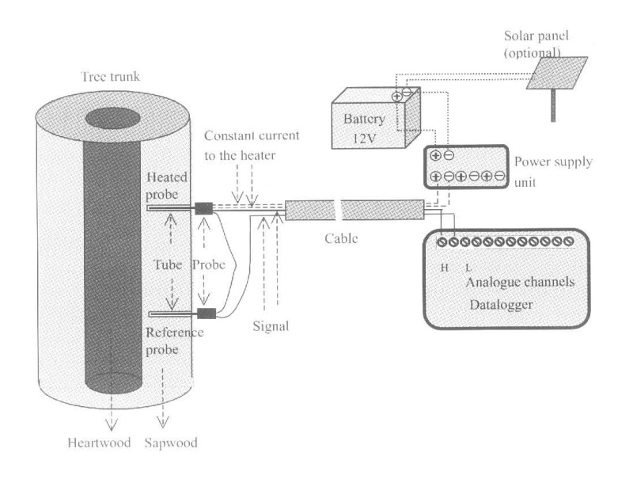
Figure 1. Granier sap flow set up (Lu et al. 2004)
3.2.1 Field setup
Sap flow will be measured in four mature American beech trees with similar diameters and four American beech saplings with similar diameters per each treatment plot, a total of 40 trees in the month of July 2017. In each of the trees, two 2.8 mm diameter holes that are 21 mm deep and 10 cm apart will be drilled for the sensor pair. The holes will be drilled on the south-facing side of the tree at breast height (Figure 1). Twelve-volt marine batteries will be be used to power the data loggers and heat the reference probe in each sensor pair. Temperature differences between the probes will be recorded every 30 seconds and an average recorded every 15 minutes. Since weather conditions also affect the rate of sap flow, photosynthetically active radiation (PAR), wind speed, air temperature and relative humidity data will be used from an eddy flux tower monitored by a nearby NEON site. Data will be recorded concurrently on all trees and plots for a seven-day period. The temperature differential data will be converted to sap flow using a Baseliner.
3.3. Statistical Analyses
A two-way analysis of covariance (ANCOVA) will be conducted using Statistical Analysis System (SAS) software to determine statistical differences in sap flow between treatments (Control, N, P, N+P, Ca) and trees type (mature vs. sapling). The time of day will be the covariance from 8am to 10pm. Significance will be determined by α < 0.05.
4. Expected Results and Implications
Previous studies have found an increase in sap flow with nutrient addition (Harrison 2015; Green et. al 2013). Results from this study are expected to follow this trend, however, the co-limiting nutrient in these plots (N and P) would be expected to show the greatest effect on sap flow (Figure 2). This is because the main purpose of the sap flow through the xylem is to transport important nutrients and minerals for growth. I would also expect to see the highest sap flow rates in the mature trees since they have more leaves and stomata, creating a much larger and stronger negative pressure gradient. The results of this study would clarify how sap flow by diurnal fluctuations is linked to transpiration. By understanding the effects of nutrient addition on stand transpiration, a better understanding of forest water cycling will allow for a more accurate water budget to be calculated for watersheds dominated by American beech trees.
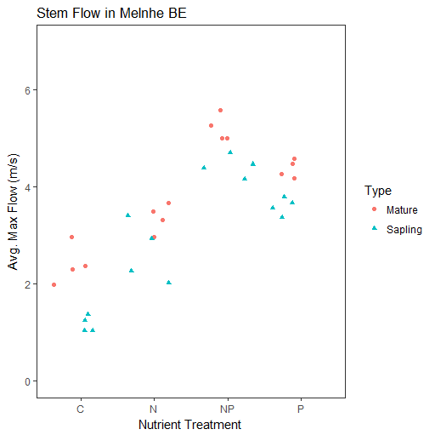
Figure 2. Average sap flow per each treatment. Points are displayed by tree type.
5. Budget and Timeline
5.1 Timeline
Date | Task to be completed
June 12-16 | Charge all batteries and order new ones; download test data from loggers; Make sap flow sensors  - will need 3 people all day for 2-3 days (preferably beginning of week)
June 19-23 | Test all the data loggers to ensure all connections are correct and that they are collecting data; Determine location in C9 where the data logger will sit and the distance to the trees that will be monitored  -will need 1-2 people to go into field with me so the time in each plot decreases
June 26-30 | Assemble sap flow sensors keeping extras in mind because they are fragile  -will need 1 extra person for 1-2 days
July 3-7 | Sap flow sensors will be set up in respective predetermined trees. This will be early in the week. This collection will be on mature Beech trees.  -will need 1- 2 extra people
July 10-14 | Sap flow sensors will continue to collect data so that there is 1 week of data collected. Sap flow sensors for sapling monitoring will be made during this data collection time.
July 17-21 | Data from the mature trees will be downloaded and set up in the predetermined sapling locations. Monitoring will start and continue for approximately 1 week.  -Will need 2-3 people to take out sensors and on a later day 1-2 extra people
July 24-28 | Data loggers will be downloaded and the data will be converted to sap flow measurements. With this data an ANOVA test will be ran to determine statistical differences and interactions.  Will need 2-3 extra people to help take out sensors.
July 31-Aug 4 | A results write up section will be produced with graphs from this project.

5.2 Budget
Item | Price
Deep-cycle Marine Batteries (15) | $1000
Solder Tool | $39.99
Cordless Drill | $59.99
Total | $1099.98

6. Excel Table Setup
Date | Tree ID | Tree type | Stand | Treatment | DBH | Temperature Difference | Velocity (m/s)

7. References
Granier, A. (1987). Evaluation of transpiration in a Douglas-fir stand by means of sap flow measurements. Tree Physiology 3: 309-320.
Fatemi, F.R., Yanai, R.D., Hamburg, S.P., Vadeboncoeur, M.A., Arthur, M.A., Briggs, R.D., and Levine,
C.R. (2011). Allometric equations for young northern hardwoods: the importance of age-specific
equations for estimating aboveground biomass. Can. J. For. Res. 41(4): 881–891.

Leak, W.B. 1991. Secondary forest succession in New Hampshire, USA. Forest Ecology and
Management 43: 69–86.
Lu, P., Urban, L., and Zhao, P. (2004). Granier's thermal dissipation probe (TDP) method for measuring sap flow in trees: Theory and practice. Acta Botanica Sinica, 46(6), 631–646.
Green, M.B., Bailey, A.S., Bailey, S.W., Battles, J.J., Campbell, J.L., Driscoll, C.T., Fahey, T.J., Lepine, L.C., Likens, G.E., Ollinger, S.V., and Schaberg, P.G.(2013). Decreased water flowing from a forest amended with calcium silicate. National Academy of Sciences 110 (15): 5999-6003.
Harrison, S.L. (2015). Increased sap flow in a northern hardwood forest treated with wollastonite (CaSiO₃). University of Michigan: Unpublished
Joly, J. and Dixon, H.H. (1894). On the ascent of sap. Annals of Botany, 8, 468–470.

Meinzer, F., et al. (2004). Dynamics of transpiration, sap flow and use of stored water in tropical forest canopy trees. Tree Physiology, 24, 901–909.
Cleveland, C. C., B. Z. Houlton, W. K. Smith, A. R. Marklein, S. C. Reed, W. Parton, S. J. Del Grosso, and S. W. Running. (2013). Patterns of new versus recycled primary production in the terrestrial biosphere. Proceedings of the National Academy of Sciences USA 110: 12733–12737.
Galloway, J. N., J. D. Aber, J. W. Erisman, S. P. Seitzinger, R. W. Howarth, E. B. Cowling, and B. J. Cosby. (2003). The nitrogen cascade. BioScience 53: 341–356.
Vitousek, P. M., S. Porder, B. Z. Houlton, and O. A. Chadwick. 2010. Terrestrial phosphorus limitation: mechanisms, implications, and nitrogen–phosphorus interactions. Ecological Applications 20: 5– 15.
Vitousek, P.M., J.D. Aber, R.W. Howarth, G.E. Likens, P.A. Matson, D.W. Schindler, W.H. Schlesinger, and D.G. Tilman. (1997). Human alteration of the global nitrogen cycle: sources and consequences. Ecological Applications 7: 737–750.
Barbour, M.M., Hunt, J.E., Walcroft, A.S., Rogers, G.N.D., McSeveny, T.M., and Whitehead, D. (2004) Components of ecosystem evaporation in a temperate coniferous rainforest, with canopy transpiration scaled using sapwood density. New Phytologist 165(2):549-558.
Ford CR, Hubbard RM, Kloeppel BD, Vose JM (2007) A comparison of sap flux-based evapotranspiration estimates with catchment-scale water balance. Agrie For Meteoro I 145(3-4): 176-1 85.

Phillips N, Bergh J, Oren R, Linder S (2001) Effects of nutrition and soil water avail- ability on water use in a Norway spruce stand. Tree Physiol 21(12- 13):851- 860.

