Does seed production and viability depend on nutrient availability? Quantifying red maple (Acer rubrum) seed production in nutrient manipulated stands in northern hardwood ecosystems

Donna Riner 2018

Collaborators: Adam Wild, Alex Rice, Alex Young, Ruth Yanai

Table of Contents
Page `1 - 10: Final Report
Page 11 - 26: Appendix I: Ruth’s comments on initial draft
Page 27 - 38: Appendix II: First draft of proposal

Introduction
Seed production is an integral part of forested ecosystems because seeds contain the genetic material for the next generation of offspring. Seeds are also an important food source for wildlife. Trees use nutrients to produce seeds and seed production is influenced by weather cues and internal resource availability (Cleavitt & Fahey, 2017). Studies also demonstrate that the survival of seedlings is significantly affected by seed mass, meaning that seedlings emerging from heavier seeds show better growth when compared to lighter seeds (Upadhaya, Pandey, & Law S, 2006). To produce seeds, we know that trees allocate nutrients and energy but the impact of nutrient availability on seed mass and viability is not well understood (Pearse, Koenig, & Kelly, 2016). My study asks, is red maple seed mass and viability dependent on nutrient abundance?
I will test this question by utilizing a fully factorial nitrogen (N) and phosphorus (P) addition experiment, Multiple Element Limitation in Northern Hardwood Ecosystems (MELNHE) in Bartlett Experimental Forest. I hypothesize that total seed production will not be influenced by nutrient addition but I expect to see greater air dried seed mass and seed viability in plots where N and N+P is added. I expect to see this because Naples and Fisk (2009) demonstrate that net N mineralization potential was greatest in the mid-aged stands (C4, C5, C6) showing that N is in greater abundance within these plots. I expect to see a response in the seeds collected from the mid-aged stands where N and N+P is added because trees need nutrients to produce seeds and there is more available N within the treatment plots where I sampled as demonstrated by Naples and Fisk (2009).

Objectives:
I propose that addition of N and N+P will have no effect on the total quantity of red maple seeds produced but addition of N and N+P will increase seed mass and percent viability. I expect there to be a strong positive correlation between basal area of red maples and seed data because when density of red maples in the plot is higher, I expect more seeds to fall into the seed traps.

1) Quantify the production (mass/count) of red maple seeds after 7 years of nutrient treatment.
2) Determine if viability is dependent on nutrient availability.

Methods
Seed traps were placed about 0.25 m from the base of red maple trees with a diameter at breast height (DBH) greater than 10 cm in nutrient manipulated mid-aged stands in Bartlett Experimental Forest. The experimental nutrient treatments began in 2011 with an addition of 30 kg/ha/year of soluble N (NH₄NO₃), 10 kg/ha/year of soluble P (NaH₂PO₄), and a combined treatment of N+P in the same quantities. The total area of the treatment plots is 50 meters squared. A 10 m buffer area surrounds the 30 meter squared area to ensure complete fertilization of the main treatment area. A control plot with the same dimensions is established in each stand where no fertilizer is added.
I utilized Hughes et al (1987) seed trap design to collect red maple seeds. The trap has a 0.25 m circular collection area that funnels into a grain bag, set roughly 0.25 m above the ground using six stiff wires. Seed traps were placed beneath 5 red maples per treatment plot (n=3, N=65). Red maples were chosen by meeting DBH requirement and having a visible canopy from the forest floor because it may increase likelihood of seeds falling directly into seed trap. When fewer than 5 red maples were found in the treatment plot, I chose red maples inside the 10 m buffer area outside of the main treatment area. When there were fewer than 5 red maples per treatment plot, multiple seed traps were deployed beneath individual trees inside the plot.
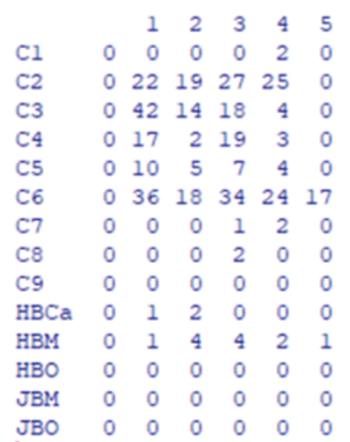
Seed traps were deployed June 9th and 11th. Collection of seeds occurred after two weeks of deployment on June 19th and 21st. I collected seeds once after a heavy rain storm with lots of wind. All seeds and other fallen debris was placed in individually labeled gallon plastic bags. In the lab, collected seeds were separated from fallen debris and placed in paper bags to be dried in an oven at 60 degrees. Seeds were counted and weighed to quantify red maple seed production and mass. I tested viability by pinching the seeds to determine if the seed cavity was filled with a seed.

Figure 1. MELNHE inventory of red maples by stand and treatment plot.

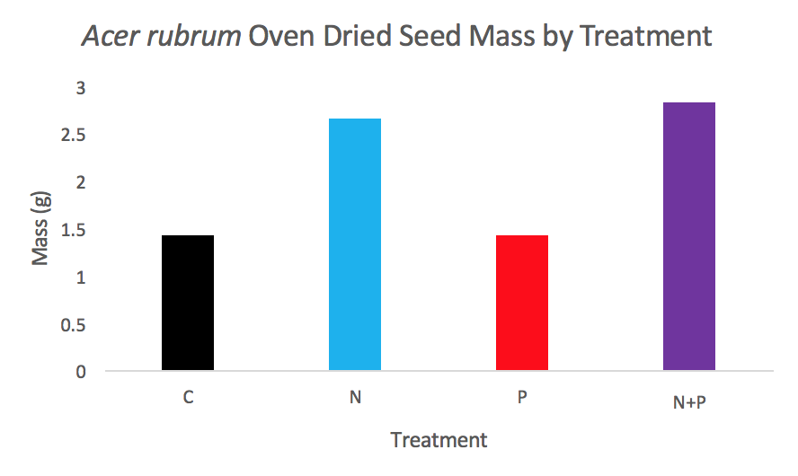
Figure 2. Bartlett species inventory updated in 2012 by Shinjini Goswami.

Figure 3. “A better seed and litter trap” (Hughes, Fahey, & Browne, 1987).
Timeline
June 9th Deployed seed traps in C6
June 11th Deployed seed traps in C4 and C5
June 18th Prepared for seed collection day by labeling plastic bags
June 19th Collected seeds in C6
June 21st Collected seeds in C4 and C5
June 22nd– 24th Processed (sorted, dried, and counted) seeds
July 1st– 5th Analysis of results
July 11th – 12th Hubbard Brook Meeting & Presentation
August 2nd Seed traps removed from the field
Budget & Materials
● Seed traps: All seed traps were repurposed from a prior seed study. The seed traps were collected from C7, C8, and C9 and deployed in C4, C5, and C6.
● Gallon plastic bags: I reused plastic bags that were washed and dried in the lab. I used a total of 65 one gallon plastic bags.
● Paper bags: I used a total of 65 paper bags to dry the seeds in the drying oven.
● Drying Oven: Seeds were placed in oven for 48-72 hours at 60 degrees Celsius before seed processing.
● Sharpies: I used sharpies to label each plastic bag with the stand, plot number, and tree tag to prepare them for seed collection. Previous labels on reused plastic bags were crossed out to prevent confusion in the field.
● Labor: I needed help collecting seeds from C4, C5, and C6. I was assisted by getting a ride to and from the sites, measuring tree DBH, tagging trees, and collecting seeds from traps. Members of the field crew also assisted removing the seed traps from the field.

Results
Seed Count
I ran an ANCOVA with basal area (m^2) as my covariate and found no significant treatment effect on average seed count by treatment (Fig 4). I confirmed the expectation that average seed count was significantly correlated withbasal area of red maples within the treatment plots (p = 0.0001, Fig 5).
Viable Seed Count
I ran an ANCOVA with basal area (m^2) as my covariate and found no significant treatment effect on average viable seed count (Fig 6). Again, I found that viable seed count was significantly correlated with red maple basal area (Fig 7).
Seed Mass
I ran an ANCOVA with basal area (m^2) as my covariate and found a marginally significant N*P treatment effect on average seed mass (Fig 8). Basal area was also correlated significantly with seed mass (Fig 9).
Viable Mass
I ran an ANCOVA with basal area (m^2) as my covariate and found a marginally significant N*P treatment effect on viable mass (Fig 10). Again, basal area was correlated with viable mass (Fig 11).

Figures
Figure 4. Graph depicting seed count by treatment and by stand. Error bars indicate range (n=3, N=65).
Figure 5. Graph depicting the positive correlation between average seed count and meters squared basal area.
Figure 6. Graph depicting viable mass (mg) by treatment and by stand. Error bars indicate range. (n=3, n=65).
Figure 7. Graph depicting the positive correlation between average viable count and meters squared basal area.
Figure 8. Graph depicting average seed mass (mg) by treatment and by stand (n=3, n=65).
Figure 9. Graph depicting the positive correlation between average seed mass and meters squared basal area.
Figure 10. Graph depicting viable mass (mg) by treatment and by stand (n=3, N=65).
Figure 11. Graph depicting the positive correlation between average viable mass and meters squared basal area.

Discussion of Results
My hypothesis that total seed production would not be influenced by nutrient addition was supported because I found no significant treatment effect on average seed count by treatment. I found a marginally significant N*P treatment effect on average seed mass (p=0.10) but I think this result is skewed by how few seeds were collected in C4 and C5. Because I collected the greatest number of seeds from C6, the average mass per seed varied significantly more than in C4 and C5 which had fewer seeds collected. I am not surprised by the findings because red maple has been described as a “super generalist” which can thrive in a wide variety of environments and has shown to have low resource requirements(Abrams, 1998).
The large variation between stands can be attributed to additional factors such as tree size and timing of seed trap deployment. Studies demonstrate that red maples with diameters ranging 5-20 cm generally produce 12,000 to 91,000 seeds annually. Larger trees (>30 cm) commonly produce 1,000,000 seeds during production (Abott 1974). Depending on the size of the tree, seed production varies tremendously. The mean range of DBH in red maples I sampled from was 16 cm, demonstrating how DBH varied between the trees seeds were collected. To account for the wide range in DBH of the red maples, I used basal area as a covariate in my statistical analysis because the data was strongly correlated with total basal area per plot. Using basal area as a covariate accounts for some of the spatial variation associated with collecting windblown seeds that can be strongly influenced by density of red maples.
It is also important to recognize how deployment of seed traps occurred a week after red maple seeds began to drop. A conversation with small mammal researchers in Bartlett Experimental Forest confirmed my suspicion as they reported collecting thousands of red maple seeds in the first week of June. I also observed red maple seed fall when deploying seed traps in C5 and C6, confirming that red maple seeds had already been falling when deployment occurred.If I were to repeat this experiment, I would place seed traps beneath RM in early spring before trees produce seeds to reduce temporal variation and collect data representative of total seed production rather than just part of the seed fall period. Another consideration for seed research is that if seeds are collected in the fall, the traps can be relocated after fall collection under trees that produce seeds in the spring. Hughes et al. (1987) documents the ability of his seed trap design to withstand winter conditionsby compressing under the weight of snow instead of breaking/tearing.

Acknowledgements
I would like to thank the 2018 MELNHE field crew, especially my field crew leaders, Alex Rice and Alex Young for all their mentorship this summer. I would also like to thank Adam Wild for his tremendous support preparing and executing this research project. Finally, I would like to thank Ruth Yanai for making my summer research experience here on the MELNHE field crew possible and sharing with all of us her awesome dance moves!

Works Cited
Abrams, M. D. (1998). The red maple paradox. BioScience. https://doi.org/10.2307/1313374
Cleavitt, N. L., & Fahey, T. J. (2017). Seed production of sugar maple and American beech in northern hardwood forests, New Hampshire, USA. Canadian Journal of Forest Research. https://doi.org/10.1139/cjfr-2017-0096
Hughes, J. W., Fahey, T. J., & Browne, B. (1987). A better seed and litter trap. Canadian Journal of Forest Research. https://doi.org/10.1139/x87-248
Pearse, I. S., Koenig, W. D., & Kelly, D. (2016). Mechanisms of mast seeding: resources, weather, cues, and selection.New Phytologist. https://doi.org/10.1111/nph.14114
Upadhaya, K., Pandey, H. N., & Law S, P. (2006). The Effect of Seed Mass on Germination, Seedling Survival and Growth in Prunus jenkinsii Hook.f. &amp; Thoms. Turk J Bot, 31, 31–36. Retrieved from http://journals.tubitak.gov.tr/botany/issues/bot-07-31-1/bot-31-1-4-0605-3.pdf

Appendix I: Ruth’s comments on initial draft

Is Seed Production and Viability Independent of Nutrient Availability?

Quantifying Red Maple (Acer rubrum) seed production in nutrient manipulated stands in northern hardwood ecosystems

Donna Riner 2018

Collaborators:
Adam Wild, Alex Rice, Alex Young, Ruth Yanai

Introduction
Seed production is an integral part of all ecosystems because seeds provide food for wildlife while also sustaining growth and regeneration. Assessing the quantity, quality, and timing of seed dispersal/production in forested ecosystems enables researchers and land managers to assess both biodiversity and future land maintenance considerations (McDonald 1992). Quantifying masting (synchronous, highly variable seed production among
years in a population of perennial plants) events gives land managers knowledge about future plant and animal diversity, and this knowledge enables inference about future proportions of species (Kelly et al 2012). Understanding population dynamics of forested ecosystems can help land managers make predictions about the availability of valuable wood resources.
Trees allocate nutrients and energy to produce seeds but the mechanisms which initiate masting events are still highly debated (Pearse et al 2016). The resource budget model (RB) assumes that plants store resources over several years before masting. The model assumes that an individual plant requires more resources to flower and fruit than it gains in a single year, and therefore only flowers when a specific threshold amount of stored resources is surpassed (Kelly et al 2012). Additional hypotheses suggest seed production is influenced by nutrient availability, weather cues, pollination efficiency, and/or predator satiation (Crone et al 2014, Kelly et al 2012, Han et al 2017) There is also evidence suggesting that seasonal variation such as winter cold, variability in spring temperature and regional rainfall alters seed production but trends are inconsistent in the data (Kelly et al 2012). The role of additional mechanisms such as nutrient availability in seed production are also highly contested (Han et al 2017).
I am testing the hypothesis that when nutrients are more available, trees may not need to expend as much energy preparing for seed production. I will test this hypothesis by utilizing a fully factorial nitrogen (N) and phosphorus (P) addition experiment, Multiple Element Limitation in Northern Hardwood Ecosystems (MELNHE) in Bartlett Experimental Forest.
MELNHE is an experiment testing nutrient co-limitation in forested ecosystems. The experimental nutrient treatments began in 2011 with an addition of 30 kg/ha/year of soluble N (NH₄NO₃), 10 kg/ha/year of soluble P (NaH₂PO₄), and a combined treatment of N+P in the same quantities. A control treatment is established in each stand where no fertilizer is added. My project quantifies seed production and viability of Acer rubrum seeds and asks: is seed production and viability independent of nutrient manipulation? I hypothesize that total seed production will not be influenced by nutrient addition but I expect to see greater air dried seed mass and seed viability in plots where N and N+P is added. Support of my hypothesis would suggest series co-limitation of Acer rubrum in northeastern hardwood ecosystems.
Study Species
I chose Acer rubrum as my study species because seed research is ongoing with Fagus grandifolia and Acer saccharum in Bartlett Experimental Forest and addition of Acer rubrum will strengthen the ongoing research. My research will contribute to an extensive data set tracking forest response to nutrient manipulation and will benefit United States Forest Service (USFS) knowledge and practices.
Acer rubrum is a deciduous tree that grows 30 to 90 feet (9-28 m) tall and up to 4 feet (1.6 m) in diameter (Chapman et al 1990, Duncan et al 1987). The bark is smooth and gray but darkens and becomes furrowed in narrow ridges with age (Chapman et al 1990, Godfrey et al 1988). The tree produces small flowers are borne in slender-stalked, drooping axillary clusters (Batra et al 1985, Chapman et al 1990, Duncan et al 1988, Hosie et al 1969). The fruit is a paired, winged samara, approximately 0.75 inch (1.9 cm) long (Hosie et al, 1969). Samaras are red, pink, or yellow (Godfrey et al 1988).
Red maple can bear seed as early as 4 years of age and produces good or better seed crops over most of its range in 1 out of 2 years (Olson et al 1974, Godman et al 1976). Red maples with diameters ranging 5-20 cm generally produce 12,000 to 91,000 seeds annually. Larger trees (>30 cm) commonly produce 1,000,000 seeds during production (Abott et al 1974). Acer rubrum has also been described as a “super generalist” which has “low resource requirements and does many things well in a wide variety of ecological conditions” (Abrams 1998). this species thrives in a wide variety of soil conditions and climates (Walters et al. 1990) documents how. Acer rubrum has an extensive range and can grow in varying pH soils with low nutrient content or contaminated soils, as seen in the industrially damaged woodlands near Sudbury, Ontario where heavy metals are abundant in the soil (James et al, 1985).
soil nutrient content influences plant growth. For example, soil nutrient concentrations (NPK) increased seed mass and viability of an herbaceous species, Peucedanum oreoselinum (Kołodziejek 2017). Quantifying seed production and viability in nutrient manipulated stands could reveal how Acer rubrum responds to varying nutrient availability throughout the Northeastern United States. Using Acer rubrum in this study can provide relevant information to land managers across the Eastern United States by providing insight into future regeneration of important woody species. I predict total seed production will not be affected by increased nutrient availability, but viability and seed mass will be affected. If an effect is demonstrated, the response would show an exaggerated response in a plant that survives in a wide range of environmental conditions. Significant statistical effects could reveal how Acer rubrum thrives in such a wide range across the Eastern US.
I propose that addition of N and N+P will have no effect on total RM seed production but addition of N and N+P will increase seed mass and percent viability. I predict P to have no effect on total seed production, dried mass, and viability.
Objectives:
1) Quantify the production (total mass and count of seeds) of red maple seeds after 7 years of nutrient treatment (30 kg/ha/yr) including N, P and N+P. All seeds will be counted, weighed and recorded. Using this data, I will assess whether RM seed production is altered by nutrient manipulation.
2) Assess viability of RM seeds following nutrient addition by squeezing the seeds (pinching the dried seed between my fingers) and sorting out the aborted seeds. Using this data, I will assess whether RM seed viability is altered by nutrient manipulation.
3) Measure DBH of selected RM trees (and the nested trees) to calculate total basal area of RM and use this information to calculate relative area per seed trap. I will use this data to determine if seed production is correlated to greater DBH.
Methods
Start with site description (did you have this up above?)
Seed collection traps were placed at the base of RM trees with a diameter at breast height (DBH) greater than 10 cm in nutrient manipulated mid-aged stands in Bartlett Experimental Forest. I utilized Hughes et al. (1987) seed trap design and selected 5 RM per treatment plot. RM were chosen by meeting DBH requirement and having a visible canopy from the forest floor. I chose RM with a visible canopy because it may increase likelihood of seeds falling directly into seed trap. I placed seed traps 0.25 meters off the ground to discourage predation and beneath the visible RM canopy (Hughes et al. 1987).
When fewer than 5 RM were found in the treatment plot, I chose RM inside the 20m buffer area outside of the measurement area. Selected buffer trees were initially tagged with orange flagging tape and then retagged using a more permanent metal tree tag. DBH of all trees was measured during collection of seeds from the traps. I collected seeds after a heavy rain storm with lots of wind and placed the seeds and all other fallen debris into individually labeled gallon plastic bags.
Seed traps were deployed June 9th and 11th. Collection of seeds occurred after two weeks of deployment. All leaf litter debris was removed and all collected seeds were placed in 5 Duro paper bags and placed in the oven at 60 degrees Celsius overnight. Seeds were counted and weighed the following day to quantify RM seed production and mass. I tested viability by pinching the seeds to determine if the seed cavity was filled with a seed. Seeds will be considered viable when the embryo fills 50% or more of the seed cavity.
After seeds were processed, all seeds were placed in small envelopes and labeled with the corresponding seed trap and RM tag number.

Deployment
The MELNHE tree inventory helped me determine which stands to deploy seed traps in. I chose the mid-aged stands, C4, C5, and C6, to deploy seed traps. I originally thought mid-aged red maples would be sexually mature and producing seeds. Later I learned that RM can produce seeds as early as 4-5 years (Olson et al 1974). If I could repeat this experiment, I would also place seed traps in C2 and C3 because red maple reaches sexual maturity early and there is an abundance of RM in C2 and C3. I also chose C4, C5, and C6 because there is foliar nutrient data available on the MELNHE database.
I also chose these mid-aged stands, despite low density of RM in plots 2 & 4 in C4 and C5, because I hoped to use the foliar nutrient concentration data collected in 2016 and correlate seed production to available foliar nutrient data. In the field I looked for the specific tagged trees that correspond with the foliar nutrient data, but only 2 of the trees that data was collected were found.

Figure 1. MELNHE inventory of RM by stand and treatment plot.

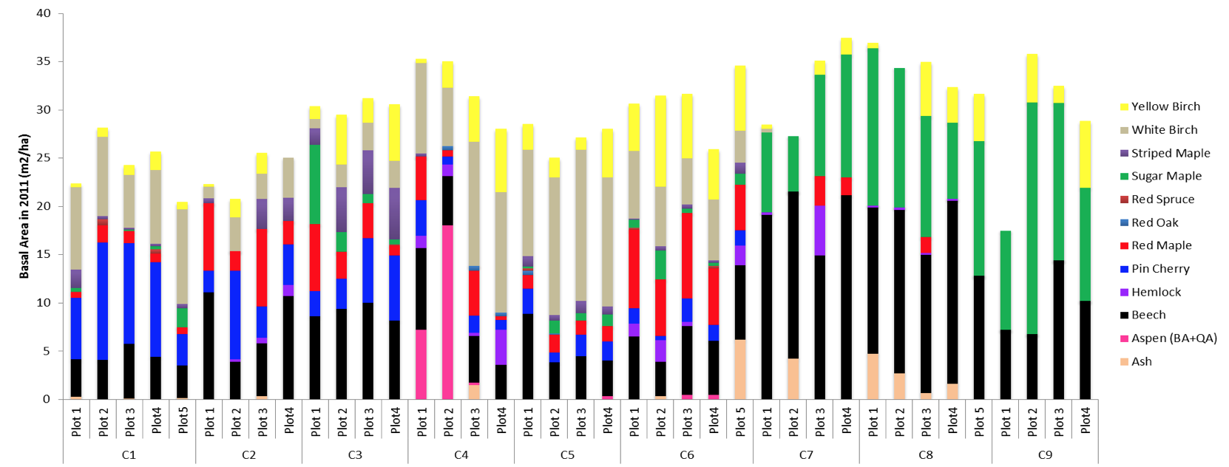
Figure 2. Bartlett species inventory updated in 2012 by Shinjini Goswami.
Timeline
June 9th - 11th Seed trap deployment.
June 12th Proposal due.
June 13th - 18th Prepare for seed collection day by labeling plastic bags.
June 19th Collect seeds in C6 and measure DBH.
June 21st Collect seeds in C4 and C5, measure DBH, and tag trees in the buffer.
June 22th - 24th Process (sort, dry, and count) seed collection.
July 1st - 5th Statistical analysis of results.
July 6th - 9th Prepare presentation.
July 10th Practice presentation.
July 11th – 12th Hubbard Brook Meeting.
Budget & Materials
- Seed traps: All seed traps were repurposed from a prior experiment. The seed traps were collected from C8 and C9 and deployed in C4, C5, and C6.
- Gallon plastic bags: I reused plastic bags from fertilization week in the lab. I used a total of 65 one gallon plastic bags.
- Sharpies: I used a sharpie to label each plastic bag and prepare them for seed collection. Previous labels on reused plastic bags were crossed out with sharpie to prevent confusion in the field.
- Labor: I needed help collecting seeds from C4, C5, and C6. I was assisted by getting a ride to and from the sites, measuring tree DBH, tagging trees, and collecting seeds from traps. I am currently working with my field crew leaders to run statistical analyses in R.
Pitfalls
Deployment of seed traps occurred a few days after RM seeds began to drop. Due to this, I was unable to quantify total RM seed production. I suspect that deployment of seed traps was a week late and anything in the traps fell at the tail end of RM seed dispersal. A conversation with small mammal researchers in Bartlett Experimental Forest confirmed my suspicion as they reported collecting thousands of RM seeds in the first week of June. If I were to repeat this experiment, I would place seed traps beneath RM in May before any seeds fall. Another consideration for seed research is that if seeds are collected in the fall, the traps can be relocated after fall collection under trees that produce seeds in the spring. Hughes et al. (1987) documents the ability of his seed trap design to withstand winter conditions by compressing under the weight of snow instead of breaking/tearing.
The density of RM varied significantly between stands. For example, the density of RM in the P treatment plot in C4 is extremely low and I set up two seed traps on one tree and three on another. I am currently working on using the DBH measurements to calculate RM basal area per seed trap.
Expected Results & Hypotheses
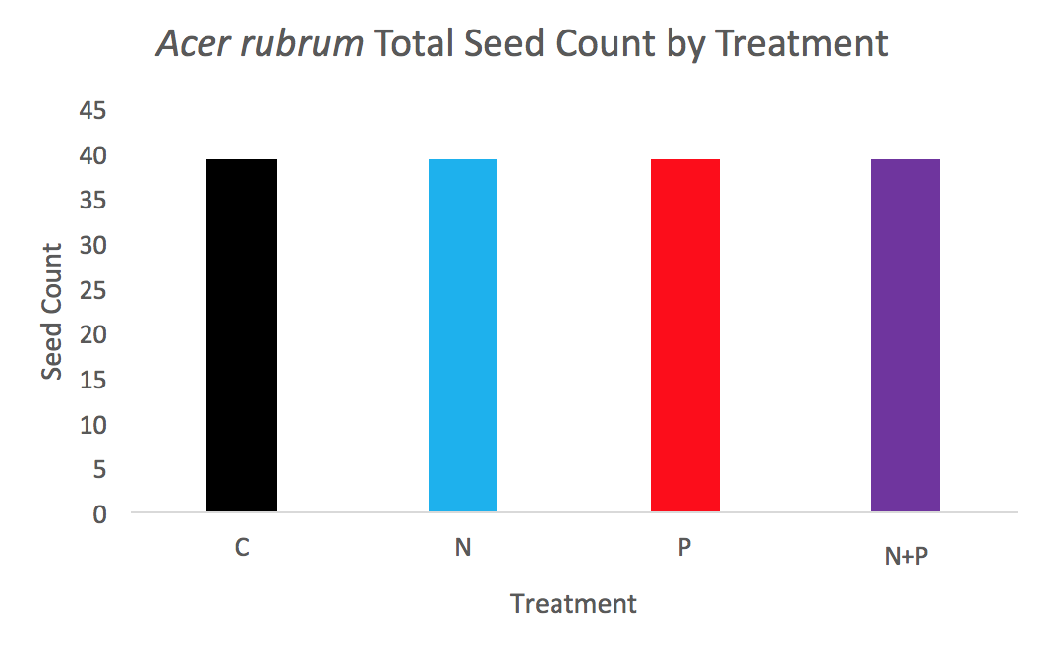
Figure 3. Expected counts of Acer rubrum seed production with a DBH greater than 10 cm in nutrient manipulated mid-aged stands in Bartlett Experimental Forest. I do not expect total RM seed production to differ between stands because RM can thrive in a wide variety of environmental conditions.
Figure 4. Expected mass of Acer rubrum seeds in nutrient-manipulated stands in Bartlett Experimental Forest. I expect RM seed dried mass to increase upon addition of N and N+P.
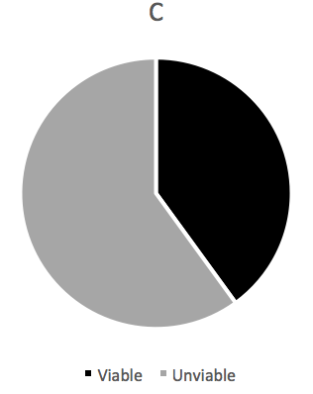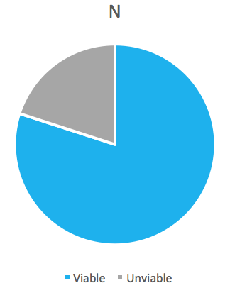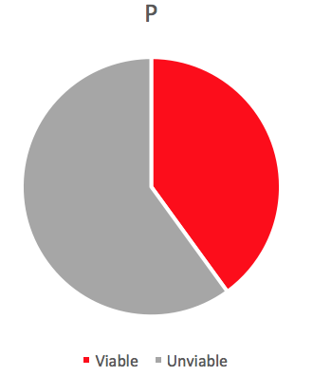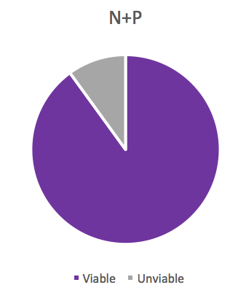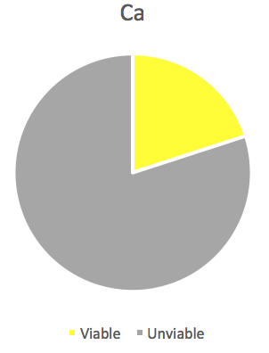
Figure 5. Prediction of viability of Acer rubrum seeds.
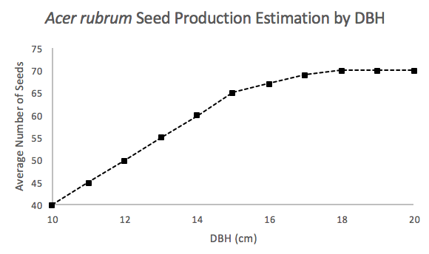
Figure 6. I estimate seed production to increase as DBH increases, but I expect seed production to plateau after the tree reaches full-grown.

Discussion of Expected Results
I do not expect red maple seed production to differ between treatment stands because RM has been described as a “super generalist” that thrives in a multitude of environmental conditions (Abrams, 1998). I expect air dried mass to differ between stands, with the greatest mass present within N and N+P stands. I expect P and C to have smaller total air dried seed mass. I also expect percent viability to be greater in N and N+P stands but smaller in C and P stands. My hypotheses follow in accordance to the series co-limitation hypothesis proposed by Harpole et al 2011. I hypothesize that N is the primary limiting nutrient and P is the secondary limiting nutrient in northern hardwood ecosystems. My hypothesis is that addition of N will increase seed mass and viability and addition of N+P together will also increase seed mass and viability greater than N and P alone (Fig 5). I also expect total oven dried seed mass to increase with addition of N and N+P (Fig 4). I expect seed mass to be correlated with percent total viability (>50% of embryo inside seed cavity). I also expect RM with greater DBH to produce more seeds than RM with smaller DBH (Fig 6).
Preliminary Results
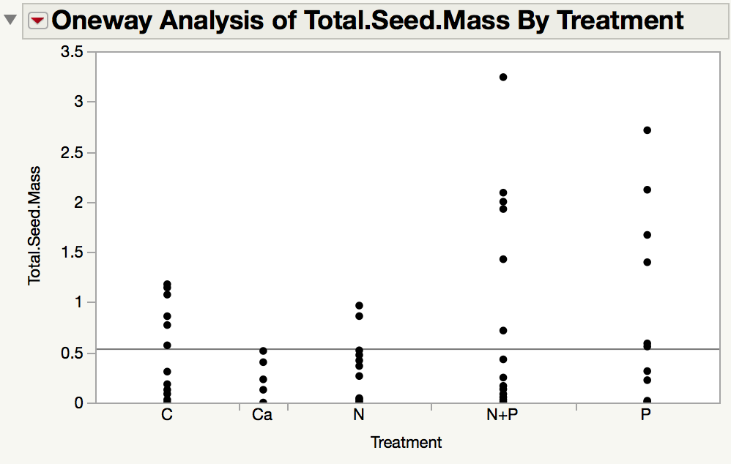
Figure 7. Preliminary graph showing total oven dried seed mass by treatment.
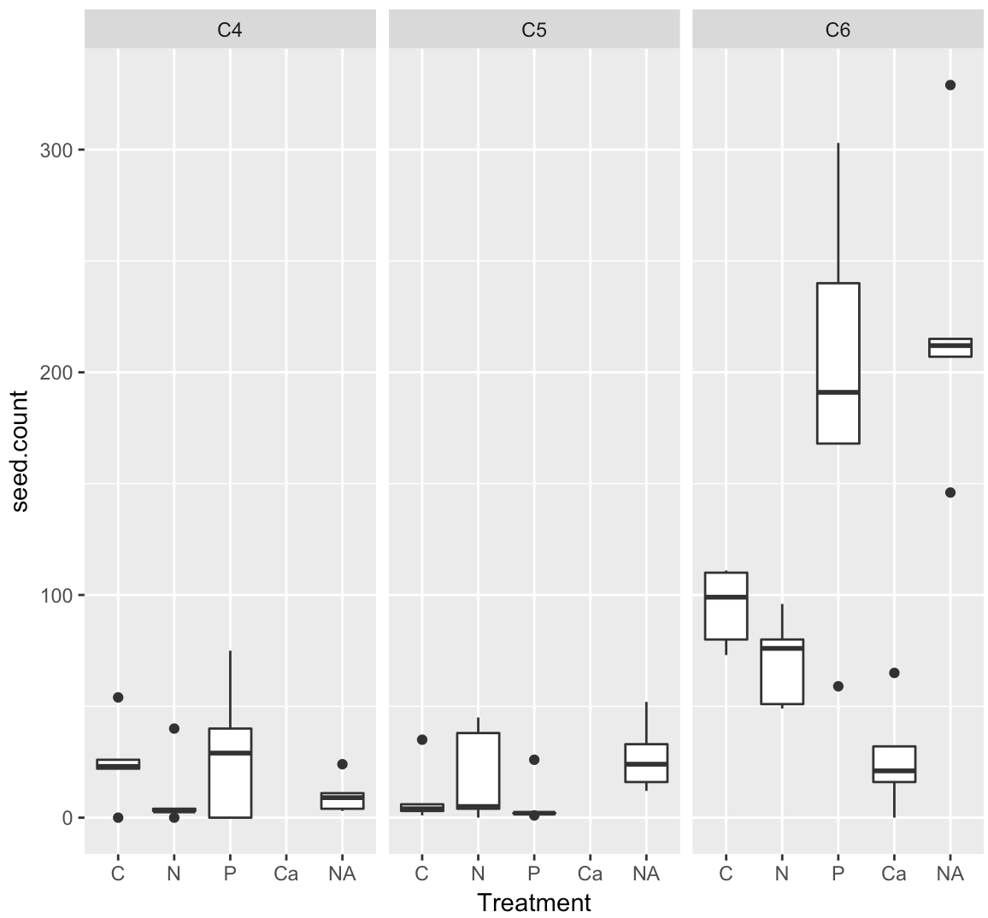
Figure 8. Preliminary graph showing seed count by treatment by stand.

Statistical Analysis
The data are highly variable and nonparametric analyses or transformations are necessary to analyze results. I suspect that late deployment of seed traps caused the data to be unrepresentative of total seed production.
Recommendations for the Future
I recommend that seed traps be deployed long in advance of Acer rubrum seeds falling. Given that the seed trap design is sturdy enough to withstand winter conditions, I suggest keeping the seed traps in the field and positioning the traps underneath trees of interest prior to the season when seed production is studied.

Works Cited
Abbott, Herschel G. 1974. Some characteristics of fruitfulness and seed germination in red
maple. Tree Planters' Notes. 25(2): 25-27. [12435]
Abrams MD. 1998. The Red Maple Paradox - What explains the widespread expansion of red
maple in eastern forests? Bioscience Vol. 48. No. 5:355-364.
Batra, S. W. T. 1985. Red maple (Acer rubrum L.), an important early spring food resource for
honey bees and other insects. Journal of the Kansas Entomological Society. 58(1):
169-172. [12666]
Chapman, William K.; Bessette, Alan E. 1990. Trees and shrubs of the Adirondacks. Utica, NY:
North Country Books, Inc. 131 p. [12766]
Cleavitt NL & Fahey TJ. 2017. Seed production of sugar maple and American beech in
northern hardwood forests, New Hampshire, USA. Can. J. For. Res. 47:985-990.
Crone EE & Rapp JM. 2014. Resource depletion, pollen coupling, and the ecology of mast
seeding. Ann. N.Y. Acad. Sci. 1322:21-34.
Duncan, Wilbur H.; Duncan, Marion B. 1987. The Smithsonian guide to seaside plants of the
Gulf and Atlantic Coasts from Louisiana to Massachusetts, exclusive of lower peninsular
Florida. Washington, DC: Smithsonian Institution Press. 409 p. [12906]
Godfrey, Robert K. 1988. Trees, shrubs, and woody vines of northern Florida and adjacent
Georgia and Alabama. Athens, GA: The University of Georgia Press. 734 p. [10239]
Godman, Richard M.; Mattson, Gilbert A. 1976. Seed crops and regeneration problems of 19
species in northeastern Wisconsin. Res. Pap.NC-123. St. Paul, MN: U.S. Department of
Agriculture, Forest Service, North Central Forest Experiment Station. 5 p. [3715]
Harpole, W. S. et al. 2011. Nutrient co-limitation of primary producer communities. Ecology
Letters. Blackwell Publishing. 14:852-862.
Hosie, R. C. 1969. Native trees of Canada. 7th ed. Ottawa, ON: Canadian Forestry Service,
Department of Fisheries and Forestry. 380 p. [3375]
Hughes JW, Fahey TJ & Browne B. 1987. A better seed and litter trap. Canadian Journal for
Forest Research. 17:1623-1624.
James, G. I.; Courtin, G. M. 1985. Stand structure and growth form of the birch transition
community in an industrially damaged ecosystem, Sudbury, Ontario. Canadian Journal
of Forest Research. 15(5): 809-817. [12630]
Kelly, D., Geldenhuis, A., James, A. Holland, E.P., Plank, M.J., Brockie, R.J., Cowan, P.E., Harpe,
G.A. Lee, W.G., Maitland, MJ., Mark, A.F. Mills, J.A. Wilson, P.R. 2013. Of mast and
mean: differential-temperature cue makes mast seeding insensitive to climate change.
Ecology Letters. Blackwell Publishing. 16:90-98.
McDonald PM. 1992. Estimating seed crops of conifer and hardwood species. Can. J. For. Res.
22:832-838.
Olson, David F., Jr.; Gabriel, W. J. 1974. Acer L. maple. In: Schopmeyer, C. S., technical
coordinator. Seeds of woody plants in the United States. Agric. Handb. 450. Washington,
DC: U.S. Department of Agriculture, Forest Service: 187-194. [7462]
Pearse IS, Koenig WD, Kelly D. 2016. Mechanisms of mast seeding: resources, weather, cues,
and selection. New Phytologist. 212:546-562.

Appendix II: First proposal draft

Is Seed Production and Viability Independent of Nutrient Availability?

Quantifying Red Maple (Acer rubrum) seed production in nutrient manipulated stands in northern hardwood ecosystems

Donna Riner 2018

Collaborators:
Adam Wild, Alex Rice, Alex Young, Ruth Yanai

Introduction
Seed production is an integral part of all ecosystems because seeds provide food for wildlife while also sustaining growth and regeneration. Assessing the quantity, quality, and timing of seed dispersal/production in forested ecosystems enables researchers and land managers to assess both biodiversity and future land maintenance considerations (McDonald 1992). Quantifying masting (synchronous, highly variable seed production among
years in a population of perennial plants) events gives land managers knowledge about future plant and animal diversity, and this knowledge enables inference about future proportions of species (Kelly et al 2012). Understanding population dynamics of forested ecosystems can help land managers make predictions about the availability of valuable wood resources.
Trees allocate nutrients and energy to produce seeds but the mechanisms which initiate masting events are still highly debated (Pearse et al 2016). The resource budget model (RB) assumes that plants store resources over several years before masting. The model assumes that an individual plant requires more resources to flower and fruit than it gains in a single year, and therefore only flowers when a specific threshold amount of stored resources is surpassed (Kelly et al 2012). Additional hypotheses suggest seed production is influenced by nutrient availability, weather cues, pollination efficiency, and/or predator satiation (Crone et al 2014, Kelly et al 2012, Han et al 2017) There is also evidence suggesting that seasonal variation such as winter cold, variability in spring temperature and regional rainfall alters seed production but trends are inconsistent in the data (Kelly et al 2012). The role of additional mechanisms such as nutrient availability in seed production are also highly contested (Han et al 2017).
I am testing the hypothesis that when nutrients are more available/abundant, trees may not need to expend as much energy preparing for seed production. I will test this hypothesis by utilizing a fully factorial nitrogen (N) and phosphorus (P) addition experiment, Multiple Element Limitation in Northern Hardwood Ecosystems (MELNHE) in Bartlett Experimental Forest.
MELNHE is an experiment testing nutrient co-limitation in forested ecosystems. The experimental nutrient treatments began in 2011 with an addition of 30 kg/ha/year of soluble N (NH₄NO₃), 10 kg/ha/year of soluble P (NaH₂PO₄), and a combined treatment of N+P in the same quantities. A control treatment is established in each stand where no fertilizer is added. My project quantifies seed production and viability of Acer rubrum seeds and asks: is seed production and viability independent of nutrient manipulation? I hypothesize that total seed production will not be influenced by nutrient addition but I expect to see greater air dried seed mass and seed viability in plots where N and N+P is added. Support of my hypothesis would suggest series co-limitation of Acer rubrum in northeastern hardwood ecosystems.
Study Species
I chose Acer rubrum as my study species because seed research is ongoing with Fagus grandifolia and Acer saccharum in Bartlett Experimental Forest and addition of Acer rubrum will strengthen the ongoing research. My research will contribute to an extensive data set tracking forest response to nutrient manipulation and will benefit United States Forestry Service (USFS) knowledge and practices.
Acer rubrum is a deciduous tree that grows 30 to 90 feet (9-28 m) tall and up to 4 feet (1.6 m) in diameter (Chapman et al 1990, Duncan et al 1987). The bark is smooth and gray but darkens and becomes furrowed in narrow ridges with age (Chapman et al 1990, Godfrey et al 1988). The tree produces small flowers are borne in slender-stalked, drooping axillary clusters (Batra et al 1985, Chapman et al 1990, Duncan et al 1988, Hosie et al 1969). The fruit is a paired, winged samara, approximately 0.75 inch (1.9 cm) long (Hosie et al, 1969). Samaras are red, pink, or yellow (Godfrey et al 1988).
Red maple can bear seed as early as 4 years of age and produces good or better seed crops over most of its range in 1 out of 2 years (Olson et al 1974, Godman et al 1976). Red maples with diameters ranging 5-20 cm generally produce 12,000 to 91,000 seeds annually. Larger trees (>30 cm) commonly produce 1,000,000 seeds during production (Abott et al 1974). Acer rubrum has also been described as a “super generalist” which has “low resource requirements and does many things well in a wide variety of ecological conditions” (Abrams 1998). Walters et al. (1990) documents how this species thrives in a wide variety of soil conditions and climates. Acer rubrum has an extensive range and can grow in varying pH soils with low nutrient content or contaminated soils, as seen in the industrially damaged woodlands near Sudbury, Ontario where heavy metals are abundant in the soil (James et al, 1985).
Researchers have demonstrated how soil nutrient content influences plant growth. For example, Kołodziejek (2017) demonstrated how soil nutrient concentrations (NPK) significantly impacted seed size and germination in Peucedanum oreoselinum. Kołodziejek found that greater nutrient quantity in the soil increased seed mass and viability of this herbaceous species (Kołodziejek 2017). Quantifying seed production and viability in nutrient manipulated stands could reveal how Acer rubrum responds to varying nutrient availability throughout the Northeastern United States. Using Acer rubrum in this study can provide relevant information to land managers across the Eastern United States by providing insight into future regeneration of important woody species. I predict total seed production will not be affected by increased nutrient availability, but viability and seed mass will be affected. If an effect is demonstrated, the response would show an exaggerated response in a plant that survives in a wide range of environmental conditions. Significant statistical effects could reveal how Acer rubrum thrives in such a wide range across the Eastern US.
I propose that addition of N and N+P will have no effect on total RM seed production but addition of N and N+P will increase seed mass and percent viability. I predict P to have no effect on total seed production, dried mass, and viability.
Objectives:
1) Quantify the production (total mass and count of seeds) of red maple seeds after 7 years of nutrient treatment (30 kg/ha/yr) including N, P and N+P. All seeds will be counted, weighed and recorded. Using this data, I will assess whether RM seed production is altered by nutrient manipulation.
2) Assess viability of RM seeds following nutrient addition by squeezing the seeds (pinching the dried seed between my fingers) and sorting out the aborted seeds. Using this data, I will assess whether RM seed viability is altered by nutrient manipulation.
3) Measure DBH of selected RM trees (and the nested trees) to calculate total basal area of RM and use this information to calculate relative area per seed trap. I will use this data to determine if seed production is correlated to greater DBH.
Methods
Seed collection traps were placed at the base of RM trees with a diameter at breast height (DBH) greater than 10 cm in nutrient manipulated mid-aged stands in Bartlett Experimental Forest. I utilized Hughes et al. (1987) seed trap design and selected 5 RM per treatment plot. RM were chosen by meeting DBH requirement and having a visible canopy from the forest floor. I chose RM with a visible canopy because it may increase likelihood of seeds falling directly into seed trap. I placed seed traps 0.25 meters off the ground to discourage predation and beneath the visible RM canopy (Hughes et al. 1987).
When fewer than 5 RM were found in the treatment plot, I chose RM inside the 20m buffer area outside of the main treatment area. Selected buffer trees were initially tagged with orange flagging tape and then retagged using a more permanent metal tree tag. DBH of all trees was measured during collection of seeds from the traps. I collected seeds after a heavy rain storm with lots of wind and placed the seeds and all other fallen debris into individually labeled gallon plastic bags.
Seed traps were deployed June 9th and 11th. Collection of seeds occurred after two weeks of deployment. All leaf litter debris was removed and all collected seeds were placed in 5 Duro paper bags and placed in the oven at 60 degrees Celsius overnight. Seeds were counted and weighed the following day to quantify RM seed production and mass. I tested viability by using a “squeeze method” which included pinching the seeds between my finger and determining if > 50% of the seed cavity was filled with a seed. Seeds will be considered viable when the embryo fills 50% or more of the seed cavity.
After seeds were processed, all seeds were placed in small envelopes and labeled with the corresponding seed trap and RM tag number.
Deployment
The MELNHE tree inventory helped me determine which stands to deploy seed traps in. I chose the mid-aged stands, C4, C5, and C6, to deploy seed traps. I originally thought mid-aged red maples would be sexually mature and producing seeds. Later I learned that RM can produce seeds as early as 4-5 years (Olson et al 1974). If I could repeat this experiment, I would also place seed traps in C2 and C3 because red maple reaches sexual maturity early and there is an abundance of RM in C2 and C3. I also chose C4, C5, and C6 because there is foliar nutrient data available on the MELNHE database.
I also chose these mid-aged stands, despite low density of RM in plots 2 & 4 in C4 and C5, because I hoped to use the foliar nutrient concentration data collected in 2016 and correlate seed production to available foliar nutrient data. In the field I looked for the specific tagged trees that correspond with the foliar nutrient data, but only 2 of the trees that data was collected were found.

Figure 1. MELNHE inventory of RM by stand and treatment plot. Figure 2. Bartlett species inventory updated in 2012 by Shinjini Goswami.
Timeline
June 9th - 11th Seed trap deployment.
June 12th Proposal due.
June 13th - 18th Prepare for seed collection day by labeling plastic bags.
June 19th Collect seeds in C6 and measure DBH.
June 21st Collect seeds in C4 and C5, measure DBH, and tag trees in the buffer.
June 22th - 24th Process (sort, dry, and count) seed collection.
July 1st - 5th Statistical analysis of results.
July 6th - 9th Prepare presentation.
July 10th Practice presentation.
July 11th – 12th Hubbard Brook Meeting.
Budget & Materials
- Seed traps: All seed traps were repurposed from a prior experiment. The seed traps were collected from C8 and C9 and deployed in C4, C5, and C6.
- Gallon plastic bags: I reused plastic bags from fertilization week in the lab. I used a total of 65 one gallon plastic bags.
- Sharpies: I used a sharpie to label each plastic bag and prepare them for seed collection. Previous labels on reused plastic bags were crossed out with sharpie to prevent confusion in the field.
- Labor: I needed help collecting seeds from C4, C5, and C6. I was assisted by getting a ride to and from the sites, measuring tree DBH, tagging trees, and collecting seeds from traps. I am currently working with my field crew leaders to run statistical analyses in R.
Pitfalls
Deployment of seed traps occurred a few days after RM seeds began to drop. Due to this, I was unable to quantify total RM seed production. I suspect that deployment of seed traps was a week late and anything in the traps fell at the tail end of RM seed dispersal. A conversation with small mammal researchers in Bartlett Experimental Forest confirmed my suspicion as they reported collecting thousands of RM seeds in the first week of June. If I were to repeat this experiment, I would place seed traps beneath RM in May before any seeds fall. Another consideration for seed research is that if seeds are collected in the fall, the traps can be relocated after fall collection under trees that produce seeds in the spring. Hughes et al. (1987) documents the ability of his seed trap design to withstand winter conditions by compressing under the weight of snow instead of breaking/tearing.
The density of RM varied significantly between stands. For example, the density of RM in the P treatment plot in C4 is extremely low and I set up two seed traps on one tree and three on another. I am currently working on using the DBH measurements to calculate RM basal area per seed trap.

Expected Results & Hypotheses
Figure 3. Expected counts of Acer rubrum seed production with a DBH greater than 10 cm in nutrient manipulated mid-aged stands in Bartlett Experimental Forest. I do not expect total RM seed production to differ between stands because RM can thrive in a wide variety of environmental conditions.
Figure 4. Expected oven dried mass of Acer rubrum seed production with a DBH greater than 10 cm in nutrient manipulated mid-aged stands in Bartlett Experimental Forest. I expect RM seed dried mass to increase upon addition of N and N+P.
Figure 5. Prediction of percentage seed collections per treatment with > 50% viability of Acer rubrum seeds.
Figure 6. I estimate seed production to increase as DBH increases, but I expect seed production to plateau after the tree reaches full-grown.

Discussion of Expected Results
I do not expect red maple seed production to differ between treatment stands because RM has been described as a “super generalist” that thrives in a multitude of environmental conditions (Abrams, 1998). I expect air dried mass to differ between stands, with the greatest mass present within N and N+P stands. I expect P and C to have smaller total air dried seed mass. I also expect percent viability to be greater in N and N+P stands but smaller in C and P stands. My hypotheses follow in accordance to the series co-limitation hypothesis proposed by Harpole et al 2011. I hypothesize that N is the primary limiting nutrient and P is the secondary limiting nutrient in northern hardwood ecosystems. My hypothesis is that addition of N will increase seed mass and viability and addition of N+P together will also increase seed mass and viability greater than N and P alone (Fig 5). I also expect total oven dried seed mass to increase with addition of N and N+P (Fig 4). I expect seed mass to be correlated with percent total viability (>50% of embryo inside seed cavity). I also expect RM with greater DBH to produce more seeds than RM with smaller DBH (Fig 6).

Works Cited

Abbott, Herschel G. 1974. Some characteristics of fruitfulness and seed germination in red
maple. Tree Planters' Notes. 25(2): 25-27. [12435]
Abrams MD. 1998. The Red Maple Paradox - What explains the widespread expansion of red
maple in eastern forests? Bioscience Vol. 48. No. 5:355-364.
Batra, S. W. T. 1985. Red maple (Acer rubrum L.), an important early spring food resource for
honey bees and other insects. Journal of the Kansas Entomological Society. 58(1):
169-172. [12666]
Chapman, William K.; Bessette, Alan E. 1990. Trees and shrubs of the Adirondacks. Utica, NY:
North Country Books, Inc. 131 p. [12766]
Cleavitt NL & Fahey TJ. 2017. Seed production of sugar maple and American beech in northern
hardwood forests, New Hampshire, USA. Can. J. For. Res. 47:985-990.
Crone EE & Rapp JM. 2014. Resource depletion, pollen coupling, and the ecology of mast
seeding. Ann. N.Y. Acad. Sci. 1322:21-34.
Duncan, Wilbur H.; Duncan, Marion B. 1987. The Smithsonian guide to seaside plants of the
Gulf and Atlantic Coasts from Louisiana to Massachusetts, exclusive of lower peninsular
Florida. Washington, DC: Smithsonian Institution Press. 409 p. [12906]
Godfrey, Robert K. 1988. Trees, shrubs, and woody vines of northern Florida and adjacent
Georgia and Alabama. Athens, GA: The University of Georgia Press. 734 p. [10239]
Godman, Richard M.; Mattson, Gilbert A. 1976. Seed crops and regeneration problems of 19
species in northeastern Wisconsin. Res. Pap.NC-123. St. Paul, MN: U.S. Department of
Agriculture, Forest Service, North Central Forest Experiment Station. 5 p. [3715]
Harpole, W. S. et al. 2011. Nutrient co-limitation of primary producer communities.
Ecology Letters. Blackwell Publishing. 14:852-862.
Hosie, R. C. 1969. Native trees of Canada. 7th ed. Ottawa, ON: Canadian Forestry Service,
Department of Fisheries and Forestry. 380 p. [3375]
Hughes JW, Fahey TJ & Browne B. 1987. A better seed and litter trap. Canadian Journal for
Forest Research. 17:1623-1624.
James, G. I.; Courtin, G. M. 1985. Stand structure and growth form of the birch transition
community in an industrially damaged ecosystem, Sudbury, Ontario. Canadian Journal
of Forest Research. 15(5): 809-817. [12630]
Kelly, D., Geldenhuis, A., James, A. Holland, E.P., Plank, M.J., Brockie, R.J., Cowan, P.E., Harpe,
G.A. Lee, W.G., Maitland, MJ., Mark, A.F. Mills, J.A. Wilson, P.R. 2013. Of mast and
mean: differential-temperature cue makes mast seeding insensitive to climate change.
Ecology Letters. Blackwell Publishing. 16:90-98.
McDonald PM. 1992. Estimating seed crops of conifer and hardwood species. Can. J. For. Res
22:832-838.
Olson, David F., Jr.; Gabriel, W. J. 1974. Acer L. maple. In: Schopmeyer, C. S., technical
coordinator. Seeds of woody plants in the United States. Agric. Handb. 450. Washington,
DC: U.S. Department of Agriculture, Forest Service: 187-194. [7462]
Pearse IS, Koenig WD, Kelly D. 2016. Mechanisms of mast seeding: resources, weather, cues,
and selection. New Phytologist. 212:546-562.

