Sophie Harrison
19 June 2014
REU Field Project Proposal

Background
Calcium (Ca) is an important nutrient in northern hardwood ecosystems. Within trees, it is necessary for cell structure and physiological functions like stomatal regulation and stress signaling (McLaughlin and Wimmer, 1999). On an ecosystem level, soil Ca impacts biogeochemical cycling and can limit forest primary production (McLaughlin and Wimmer, 1999). In the fall of 1999, a whole-watershed wollastonite (CaSiO₃) addition was implemented at Watershed 1 (W1) in Hubbard Brook Experimental Forest (HBEF) in order to investigate the effects of Ca depletion linked to acid rain. This had unexpected impacts on the water balance; compared to untreated watersheds, evapotranspiration increased significantly five months after the addition, remained high for three years, then decreased to lower levels than in the untreated watersheds (Green et al., 2013). Increased transpiration appeared to be due to fine root growth, Ca uptake with water, and primary production. Possible explanations for the switch are thought to be more efficient water use from improved stomatal functioning or a secondary limitation effect, but these remain puzzling (Green et al., 2013).
In 2011, additional Ca fertilization plots were established by the Multiple Element Limitation in Northern Hardwood Ecosystems project (MELNHE) with aim to clarify underlying mechanisms of the HBEF whole-watershed transpiration response. Wollastonite (CaSiO₃) was applied at Bartlett, Hubbard Brook and Jeffers Brook Experimental Forests in sites of varying stand age. Measuring xylem sap flow is one technique for estimating tree transpiration, and diurnal variation in sap flow can reveal mechanisms for efficient water use. Thus, sap flow measurements could give insight into the Ca fertilization effect on water cycling (Granier, 1987).
Preliminary sap flow measurements were taken in two MELNHE plots in the summer of 2012, the Ca addition and control plots in a mature stand at Hubbard Brook. Results showed sap flux increases during the day and decreases at night, with an overall increase in sap flux among American beech, sugar maple, and yellow birch trees in Ca plots relative to control (Zahor et al., 2013). This suggests that trees in the fertilized plots are experiencing increased transpiration in accordance with the trends observed at W1, and they also seem to be transpiring more efficiently. However, this data is limited, and the influence of Ca and Si on transpiration mechanisms remains unclear.

Objectives
More complete and up-to-date sap flow measurements in the MELNHE plots are needed to gain a better understanding of the wollastonite effects on transpiration, and whether they appear to be following a similar timeline to those observed in W1. One hypothesis is that increased sap flux density will be observed in the Ca versus the control plot, particularly during the day, if trees are photosynthesizing and transpiring more due to improved stomatal regulation. Results would inform the role of Ca and Si in sap flux fluctuations, transpiration and productivity among trees in the MELNHE plots. Such results would shed light on the mechanisms behind the HBEF whole-watershed response.

Methodology
Sap flow will be measured using the Granier method, which involves a reference probe and a heating probe with a constant rate of heat. Each probe contains a thermocouple, and the two thermocouples are wired together in opposition. This allows the system to measure the temperature difference (ΔT) between probes. ΔT is influenced by sap flux density, which can be used to estimate total sap flow and tree transpiration using the Granier method. Increased sap flow decreases the measured temperature difference because circulating sap cools the heating probe by convection (Granier 1987).
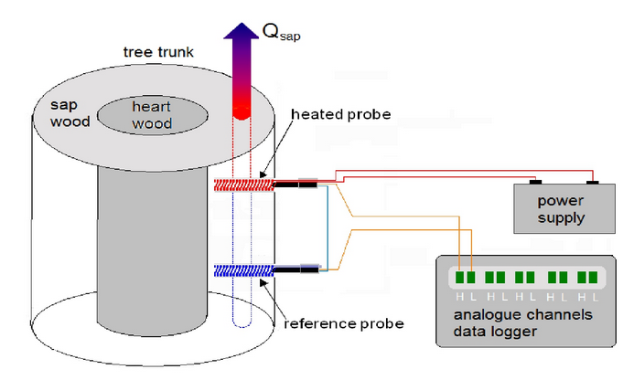

Figure 1. Granier sap flow method (Max Planck Institute for Biogeochemistry)

Measurements will be taken at three mature MELHNE stands in Bartlett, Hubbard Brook, and Jeffers Brook, with a Ca (wollastonite) treated and control plot tested at each site. Each plot is 50 m x 50 m, and wollastonite plots were treated in 2011 (1000 kg Ca/ha). Sap flow will be measured in nine canopy trees: three American beech, three sugar maple and three yellow birch, of similar size within species. The pair of sensors are inserted into 3.2 mm diameter holes drilled 2.5cm into the tree on its south-facing side at breast height, with the reference probe directly 10cm below the heating probe (Figure 1). Cables from the nine trees connect to a data logger powered by four 12V batteries that takes measurements every 30 seconds and records an average every 15 minutes. Weather conditions will be monitored closely in order to use data collected during days of comparable photosynthetically active radiation (PAR). Five days of data will likely be collected at each plot.

Expected Results and Broader Implications
Results may show increased overall sap flux if the MELNHE plots are in a stage of increased transpiration following the wollastonite addition. However, a comparable length of time to when decreasing transpiration began to be observed in W1 has passed in the MELNHE plots, so results could potentially be in accordance with this. Variability in sap flow between species can be expected. Results could clarify how diurnal fluctuations in sap flux is linked with overall sap flow and transpiration between wollastonite and control plots. ANOVA statistical analysis will be used to determine significance of sap flux differences between plots and between species. This research will lead to more thorough understanding of water cycling in relation to varying Ca nutrient conditions, which could inform forest management techniques amidst acid rain, deforestation, and climate change.

References
Granier, A. (1987). Evaluation of transpiration in a Douglas-fir stand by means of sap flow measurements. Tree Physiology 3: 309-320.
Green, M.B., et al. (2013). Decreased water ﬂowing from a forest amended with calcium silicate. Proceedings of the National Academy of Sciences 110(15):5999-6003.
McLaughlin S.B., Wimmer R. (1999). Tansley review no. 104 calcium physiology and terrestrial ecosystem processes. New Phytol 142(3):373–417.

