The Hitchhiker’s Guide to Stem Mapping
Project Proposal
Grace Haynes
MELNHE Bartlett Experimental Forest

The Hitchhiker’s Guide to Stem Mapping
Introduction
Bartlett Experimental Forest, located New Hampshire, is currently home to the MELNHE project. This project examines the role of nitrogen and phosphorus, as well as calcium, in limiting northern hardwood ecosystem productivity. MELNHE has been conducting nutrient manipulations since fall of 2010, and it is on track to contribute a great deal of knowledge to the scientific community regarding how nutrient limitation works. A study conducted by Elser et. al. (2007) began exploring the idea of ecosystem co-limitation by both nitrogen and phosphorus, but temperate forest ecosystems were underrepresented in the study. The MELNHE project was established in order to further explore the idea of co-limitation in temperate forest ecosystems.
Through extensive research conducted in the Bartlett Experimental Forest, the MELNHE project has explored co-limitation in a number of different ways. As researchers bring their planning into the field, they may not know precisely what the layout of each stand is. Some studies, such as those analyzing beech sap or beech bark disease, focus only on one species of tree or require clusters of trees. For others, it is crucial to know the proximity of the trees or soil cores to respiration collars or soil plots within each plot. Studies that require tree climbing or dominant canopy trees must know which trees’ DBH is greatest. A map of tree species, size, and distribution will enable remote planning of almost every study and ensure that researchers’ time in the field is used as efficiently as possible. Over the past few years, data was collected with the goal of generating exact maps of each plot within the project’s stands. The data has been collected in UTM, or Universal Transverse Mercator, coordinates. As described by Steven Dutch, this system uses cartesian coordinates to indicate positions on the Earth’s surface. It was invented for military use with the intention of minimizing map inaccuracies and distortions typical of the familiar Mercator projection by dividing the Earth into narrow grid zones, ensuring each one is an accurate projection (2000). In MELNHE stands, UTM locations have been collected, but they have yet to be made into usable maps. Maps of this data will be a vital asset to any study conducted in this forest. Over the next ten weeks, I will be undertaking a mapping project, plotting the data gathered on the locations, sizes, and species of trees within the MELNHE stands and extending the data to include trees in the buffers of MELNHE plots as well.
Objectives and Hypothesis
My first and most important objective for this project is to generate more accurate and usable maps. I will do so using data collected in previous projects and additional data (location, size, and species of trees in the buffer zones) that I plan to collect this year. All other studies conducted in these stands will be easier to complete with accurate and navigable maps. Each tree will be easier to monitor with a unique identification number, species classification, DBH in centimeters, and exact location within each stand. The data collected in the past give us a wealth of data to work from, but they could be improved upon for accuracy and ease of use.
My second goal will be to examine the spatial patterns of tree distribution in the MELNHE mid-aged and mature plots. I will analyze tree spacing to determine whether tree growth occurs more randomly or evenly. I hypothesize that trees will be more likely to spread evenly, as this makes more sense in terms of resource distribution--it is unlikely that two large trees could acquire the resources they need while inhabiting a tight space together.
Methods
Site Description. The Bartlett Experimental Forest is one of the sites in which the MELNHE project conducts nutrient manipulations, beginning field treatments in fall of 2010, in order to examine their effects on stand characteristics. Within the forest, there are nine stands, labeled C1 through C9. Each stand consists of four or five plots, each 30 by 30 meters with a buffer zone of ten meters in each direction, or a total of 50 by 50 meters. The plots are subdivided again, using stakes of different colors to designate the location within the plot. The corners of the buffer zone are marked by four pink stakes. The plot itself has four orange stakes, one in each corner, with a blue stake set out every ten meters in a grid throughout the inside of the plot. The subdivisions of the plots, marked between orange and blue stakes, are called subplots, and there are nine within each plot (not including the buffer zone).
My stem mapping project will examine the placement of trees with a DBH of greater than ten centimeters in the buffer zones and main plots of MELNHE mid-aged and mature stands. Stands C4, C5, and C6 are all mid-aged stands, last disturbed in 1978, 1976, and 1975 respectively. Stands C7, C8, and C9 are mature stands, undisturbed since the late 1800s. Because of time limitations, I will begin in the mature stands--stands C9, C8, and C7--which have fewer trees due to their successional age. I will generate maps stand by stand, to perfect my mapping method. This will also ensure that I contribute concretely to the MELNHE project’s goals in years to come by perfecting a method for mapping, if not the maps themselves.
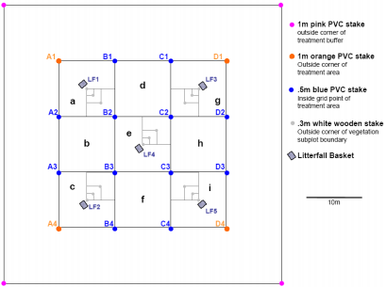
As seen in the diagram below (taken from the unpublished Shoestring Survival Guide 2017 created for new additions to the MELNHE project), each stake within the plot (as opposed to the buffer zone) is labeled with number and letter systems. The subplots are named for the lowest letter-number combination of the four stakes that make up each of them. The buffer zones are also divided into ten by ten meter subplots, labeled with red flags in addition to the stakes already present for the main plot.

Field Methods. The stands I plan to visit and map this year already have raw data from previous years but do not have trees in the buffer zones logged. I will be checking the ground truth of the tree locations logged in previous years, as well as translating data into usable maps and extending it to include trees in buffer zones. Each stake within a plot has had its UTM coordinates measured and recorded. Within each subplot (named for the lowest letter-number combination of the four stakes at its corners), each tree with a DBH of over ten centimeters has had its azimuth and distance from the lowest alphanumerical stake recorded. Each tree within the inner plot has its own unique identification number which has been attached to it with a physical tag.
In order to improve upon accuracy from last year, I plan to measure the angle and distance of each tree from two stakes in each buffer subplot, rather than only one. I will use a hypsometer to measure trees’ distances and a compass to measure azimuth, or compass bearing. Stand by stand, I will expand tree data to include buffer zone trees. Buffer zones can also be divided into ten meter by ten meter subplots, and as each ten by ten meter subplot has only two stakes to begin with, I will use those as the points from which I measure azimuth and distance in order to place each tree.
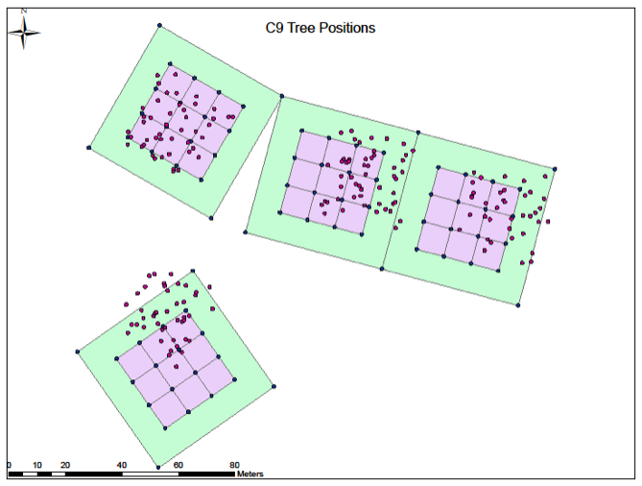
Data Analysis. Using the UTM coordinates of the tagged trees and stakes dividing plots into subplots, I will map trees’ locations using ArcGIS, a type of Geographic Information System. To ensure clarity of information and ease of use, I will denote differing species using shapes as well as colors. The maps generated thus far are unclear. They display an entire stand on a page, rather than a single plot, which makes it difficult to discern which trees are in which subplots. Furthermore, many of the UTM coordinates calculated for trees do not fall within experimental plot boundaries. My data analysis will involve recalculating UTM coordinates based on distance and azimuth from stakes. I will then update the maps that have already been created. My maps will have grid lines to help visually delineate the subplot in which each tree is located, and each species of tree will be assigned a shape and color to make their distinction visually apparent. Tree identification numbers will be written next to them. They will be larger than last year’s maps, with a plot occupying a page, instead of a stand (of four or five plots) occupying that same space.
Map of Stand C9 generated
from last year’s data
Once tree locations have been accurately recorded and mapped, I will be able to use ArcGIS functions designed to analyze spatial data and investigate distribution patterns of trees. I will be able to support or contradict my hypothesis that trees will tend to grow evenly distributed or randomly.
Budget and Timeline
For this project, the materials I need include mapping materials (compass and hypsometer) as well as diameter tape to measure DBH of trees. I will need a clipboard with which to collect and record organized data while in the field. Finally, I will need ArcGIS software in order to transform raw data into usable maps. Several MELNHE graduate students have ArcGIS installed on their computers, allowing me access to the software for the mapping of MELNHE plots.
In total, six stands need to be mapped, each of which have four or five plots. My project will involve the mapping of twenty-six plots, including a ten-foot buffer. Mapping will involve visiting each plot and measuring the azimuth and distance from the subplot’s stakes to each tree within it, including the processing and mapping of the data. A crew of two people requires approximately 30 minutes to verify tree locations in each subplot using a tape measure and compass. With a hypsometer, this time should diminish, but mapping six stands is still likely to be a project that spans more than one summer field season. Luckily, my project is not time-sensitive--tree DBH and locations will not vary significantly from year to year, unlike many research subjects. I will aim to map one stand every two weeks.
Expected Results
By August, I will have generated as many usable maps as possible within my time constraints. The maps I generate will be visually discernible and contain accurate data points, and I will have developed a concrete system of stem mapping in order to enable future MELNHE interns to continue to construct quality stem maps.
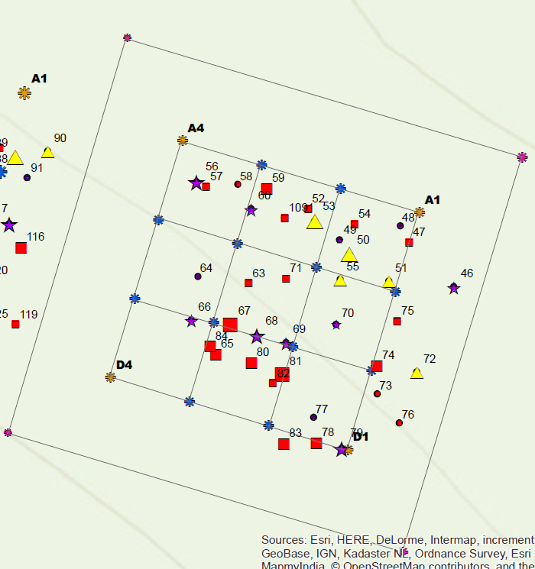
Maps of this sort will enable remote planning of field work for almost every project MELNHE is likely to undertake in the future. For instance, a project that examines beech bark disease will be able to plan which plots to visit based on distribution of beech trees, and a project examining tree sap will be able to locate appropriate locations for its machinery based on proximity of trees of the same species. I look forward to generating and presenting data that will have such a positive impact on the research being conducted in Bartlett Experimental Forest.
Example of Stand C9 Map
to be generated this year
References
Dutch, S. (2000, January 11). The Universal Transverse Mercator System. Retrieved June 12, 2017, from https://www.uwgb.edu/dutchs/FieldMethods/UTMSystem.htm
Elser, J. J., Bracken, M. E., Cleland, E. E., Gruner, D. S., Harpole, W. S., Hillebrand, H., . . . Smith, J. E. (2007). Global analysis of nitrogen and phosphorus limitation of primary producers in freshwater, marine and terrestrial ecosystems. Ecology Letters, 10(12), 1135-1142. doi:10.1111/j.1461-0248.2007.01113.x

Feedback from Mentors
Mary Martin
I did read through your doc file quickly, and I noticed that you said you
were going to use GIS instead of R, and then that you were going to use R?
One recommendation that I would make is that if you are using GIS, you
might want to look into QGIS. I find that that works well for students on
site at Hubbard Brook during the summer, since it works on all platforms
and doesn't require any license or $$.
Matt Vadeboncoeur
My biggest comment is that I strongly advise against tagging the trees
in the buffers. Tags require periodic maintenance, especially on young,
fast-growing trees, so we should have a strong justification if we want
to use them. There should almost twice as many trees in the 1600m2
buffers than in the 900m2 measurement plots ... that's a lot of tags,
and we already have thousands to manage!

I think we should only tag trees that have long-term data associated
with them. If you do the mapping well enough, the tags will not be
needed in any case!

Also attached is an example of a "detail" map for a couple of the sites,
where I tried to include some extra equipment and landmarks. I don't
think these have not been used much, and you can see how busy stuff
starts to get. If you're interested, I can try to get you the
shapefiles for all this extra stuff if it's not on the website.

I'm also attaching an example of a site map that I made for a different
project, as an example of a workable species color-coding scheme.

